AION · UX DEVELOPER · PSYCHOLOGICAL UX DESIGN AND NEURO-UX
DAY 8 · TASK 1 AND TASK 2 · ROUTES 1 AND 2 · LEVELS 1 TO 3
GreenHome: UX Analysis File and UX Strategy Memo
Describe the effect, choose the measures as a team member, and decide as Chief Experience Officer
AI notice · KI-Hinweis
This document was produced with the help of an AI language model (Claude, Anthropic). The AI drafted the text and tables and built the pictures and working examples of the lab. The content was then read, corrected and approved by the reviewer named below, who is responsible for its accuracy. Every picture carries an AI label on the image. Check figures and sources before you quote them.
KI-Hinweis: Dieses Dokument wurde mit Unterstützung eines KI-Sprachmodells (Claude, Anthropic) erstellt. Texte und Tabellen wurden von der KI entworfen, die Abbildungen sind KI-gestützt erstellt und am Bild gekennzeichnet. Die fachliche Prüfung und Freigabe erfolgte durch die unten genannte Person.

Day | Day 8 · Module 4 (day 2 of 3): Storytelling in UX/UI design
Document | Task (worksheet with answer spaces). Task 1 (UX Analysis File) and Task 2 (UX Strategy Memo).
Route and level | Task 1 = Route 1, Levels 1 and 2 (draws on Materi A). Task 2 = Route 2, Level 3 (draws on Materi B).
Time | Task 1 about 33 min · Task 2 about 20 min
Neuro-UX Lab (website) | https://aion-ux-lab.vercel.app/day/8/
Case | GreenHome, the day's case study; other products appear as warm-ups
Version | 1.0 · release date 29.10.2026
Review and approval | Muhammad Muchson, Mentor (subject-matter review and approval)

ABOUT THIS DOCUMENT
In class we also use the Neuro-UX Lab, the course website, as the place to practise and learn. Its address is at the end of this document.
This is the worksheet for Day 8. Read the case once, study the evidence printed in this document, and write your answers in the boxes and tables. You can work through it on paper or type into the document. All blocks are Core. There are no answer keys and no scores; the reason you give matters more than the choice.

IN THIS DOCUMENT
Lesson plan: ten teaching units (Ablaufplan)
Case study and transfer project at a glance
The case: three platforms on the UX team's desk, and GreenHome
Block 1.1 · Recognise the narrative potential of a digital offer: StartSmart · JUDGED · Core · about 10 min
Block 1.2 · Rate storytelling approaches under conflicting goals: FutureSkills · JUDGED · Core · about 8 min
Block 2.1 · Case study: redesigning the GreenHome onboarding · JUDGED · Core · about 15 min
The situation: the provider behind GreenHome, processes that work and journeys that do not
Block 3.1 · A narrative UX strategy for digital user journeys · JUDGED · Core · about 20 min

Day at a glance
Day 8 has ten teaching units (UE). This document is the worksheet; it is used in UE2 to UE6 (Task 1) and UE8 to UE10 (Task 2). The day is built from three documents and the Neuro-UX Lab: Materi (study material), Task (worksheet) and Trainer (coaching, feedback and model solutions), plus the course website.

Lesson plan: ten teaching units (Ablaufplan)
UE | Min | Plan item | What happens | Material | Format
1 | 45 | Knowledge transfer · Level 1 | The trainer presents the cards of Materi A (A1, A2, A3, A4, A5, about 60 min of cards) in the Neuro-UX Lab; participants follow in the handout. | Materi A (Route 1) | Presentation + Handout
2 | 45 | Level 1 · Task 1 | Individual work on Block 1.1 (Core, about 10 min): the first product of the day is read and its effect described. Pairs then compare their results and the trainer collects open questions. | Task 1 · Part 1 · Block 1.1 | Handout (or in the lab)
3 | 45 | Level 1 · Task 2 | Three options are rated on the same criteria and one is chosen under the stated conditions: Block 1.2 (Core, about 8 min). | Task 1 · Part 1 · Block 1.2 | Handout (or in the lab)
4 | 45 | Coaching · transition from Level 1 to Level 2 | Trainer-led. A short talk on the day's coaching focus, then the reflection questions in pairs. The bridge: from describing an effect to a decision you answer for. There is no worksheet block in this unit. | Trainer document, section Coaching | Trainer only
5–6 | 90 | Level 2 · Case study GreenHome (2 UE) incl. model solution | UE5: the trainer presents the case; participants work on Block 2.1 (Core, about 15 min). UE6: groups compare their results and defend them; the trainer closes with the model solution. | Task 1 · Part 2 · Block 2.1  Trainer document, section Case study | Handout; model solution shown after the work
7 | 45 | Level 2 + 3 · Feedback round with a management perspective | Groups present their reasoning, not only their result. The trainer asks the day's Level 3 input questions and leads the discussion. | Trainer document, section Feedback round | Presentation by the groups; Trainer only
8 | 45 | Level 3 · Transfer project, Chief Experience Officer (3 UE: UE8–10) | The trainer presents Materi B (B1, B2, B3; use the "In plain words" and "How to decide" boxes, the rest is handout) and sets the role and the situation. | Materi B (Route 2) | Presentation + Handout
9 | 45 | Level 3 · Transfer project | Individual work or in pairs on Block 3.1 (Core, about 20 min): the strategy memo. | Task 2 · Block 3.1 | Handout (or in the lab)
10 | 45 | Level 3 · Transfer project | Participants present their decision and what they give up, including the one decision made under uncertainty; the trainer debriefs with the model solution. | Task 2 · Block 3.1  Trainer document, section Transfer project | Handout; model solution shown after the work

One UE is counted as 45 minutes here; breaks are not shown. The times are a guide for the trainer. The Core blocks are enough for a complete answer.

Case study and transfer project at a glance
Component | UE | Duration | Participants work in | Model solution in
Level 2 case study (GreenHome) | UE5–6 | 2 UE · 90 min | Task 1 · Part 2 (Block 2.1) | Trainer document, section Case study
Level 3 transfer project (Chief Experience Officer) | UE8–10 | 3 UE · 135 min | Materi B and Task 2 (Block 3.1) | Trainer document, section Transfer project

Which plan item each block answers
UE | Plan item (Strukturplan, Day 8) | Block in this document
UE2 | Level 1, task 1 · Recognise the narrative potential of a digital offer: StartSmart | Block 1.1 (Core)
UE3 | Level 1, task 2 · Rate storytelling approaches under conflicting goals: FutureSkills | Block 1.2 (Core)
UE4 | Coaching: from describing to deciding | A classroom talk led by the trainer; not a worksheet block
UE5–6 | Level 2 case study · Case study: redesigning the GreenHome onboarding | Block 2.1 (Core)
UE7 | Feedback round with a management perspective | A classroom discussion led by the trainer; not a worksheet block
UE8–10 | Level 3 transfer project · A narrative UX strategy for digital user journeys | Block 3.1 (Core), in Task 2

Your name
Write your full name here. Use the same name on every Task document this week; it is how your work is matched.

Task 1 · Route 1 · UX Analysis File: find the missing story, then decide what to change

The case: three platforms on the UX team's desk, and GreenHome
Read once · about 3 min
You work in the UX team of a digital agency. This week three products land on your desk. Two are warm-ups: StartSmart, a platform for start-up advice and funding applications, and FutureSkills, a further-training platform that has three journeys for its users. The main case is GreenHome, the onboarding of a provider of sustainable energy solutions, for advice, product selection and funding support. It is complete, but users find it sober, long-winded and not very motivating; many start it and abandon it before the end.
What the plan gives you | How the task runs · three blocks
• Block 1.1: StartSmart, with much information but no recognisable journey, an entry that explains functions but not the path or the goal, no transitions or motivating stopovers, no visible progress or milestones, factual help that does not connect to the user's situation, and successful steps that are not picked up  • Block 1.2: three journeys for FutureSkills; working people with little time, the wish to look professional and inspiring, a limited budget, release in 10 weeks, marketing wants more activation and the department high clarity, no user tests  • Block 2.1: GreenHome, with €155,000 and 12 weeks, contents and specialist logic largely kept, inspiring but serious, partial user data, and no complete relaunch | • Block 1.1: find the narrative gaps from the user's side. Describe the effect on a first-time user, name five places where narrative guidance is missing, sort them into six categories, write three effect statements and pick the two biggest weaknesses.  • Block 1.2: rate three journeys under conflicting goals. Rate each on five criteria, choose one, name the conflicts between efficiency and dramaturgical guidance and the remaining risks, and write a recommendation to the project lead.  • Block 2.1: the case study. The central narrative and dramaturgical deficits, sorted into six categories, four measures, justified on four criteria, a decision for the first 12 weeks and a recommendation to the division management.

What is known and what is open
In the brief | Clear · Case assumption | Open · on purpose
• StartSmart: much information without a journey, an entry about functions, no transitions, no progress, help that does not connect, successful steps not picked up.  • FutureSkills: three journeys in words; working people with little time; no tests; 10 weeks; activation against clarity.  • GreenHome: complete but sober and long-winded, many abandon; €155,000 and 12 weeks; contents and logic stay; no relaunch. | • You review StartSmart and FutureSkills as an agency would: from their screens, with no access to their data.  • GreenHome's onboarding has five steps: your home, your energy use, the products, funding, and the summary.  • Support at GreenHome often hears: “How much more is there?” and “What do I get at the end?”  • Help texts in GreenHome are written by the specialist department and are correct. | • Where exactly people abandon GreenHome's onboarding: the user data is only partial.  • Which FutureSkills journey the target group would prefer: there are no tests.  • How much more effort Journey C would take: the plan says only “somewhat higher”.  • How much of the €155,000 each measure would take: the plan does not say.

As in most projects, not everything is known. Decide anyway, and say what you assume.
Case assumption
The brief says: StartSmart with much information but no journey, an entry about functions, no transitions or stopovers, no progress or milestones, help that does not connect and successful steps not picked up; FutureSkills's three journeys for working people with little time, a professional and inspiring brand, a limited budget, 10 weeks, activation against clarity and no tests; GreenHome sober, long-winded and unmotivating, with many who abandon, an entry without benefit or goal, an administrative sequence, barely visible progress, help that does not motivate, steps that do not feel like progress, a form instead of a journey, €155,000, 12 weeks, logic kept and no relaunch. Those are the plan's facts and its only figures. Everything else is made up for this exercise: the agency, the pictures, the simulations and the facts marked “Clear”.

Part 1 · Find the narrative gaps and weigh journeys · Level 1 · Knowledge

Block 1.1 · Recognise the narrative potential of a digital offer: StartSmart · JUDGED · Core · about 10 min
Draws on: A1 · Why people experience a process as a story · A2 · The elements of narrative guidance · A3 · Telling a story or guiding with one · A4 · Orientation, motivation and memorability, and the risk of overload.
You receive the description of a fictional platform, StartSmart, for start-up advice and funding applications. Open it and use it as someone who wants to found a business: find out what you need and start an application. You need no prior knowledge: notice whether you know where you are going and how far you have come, not only whether the steps work. The aim is to recognise narrative gaps in the experience and tell them apart from a purely functional presentation of a process.
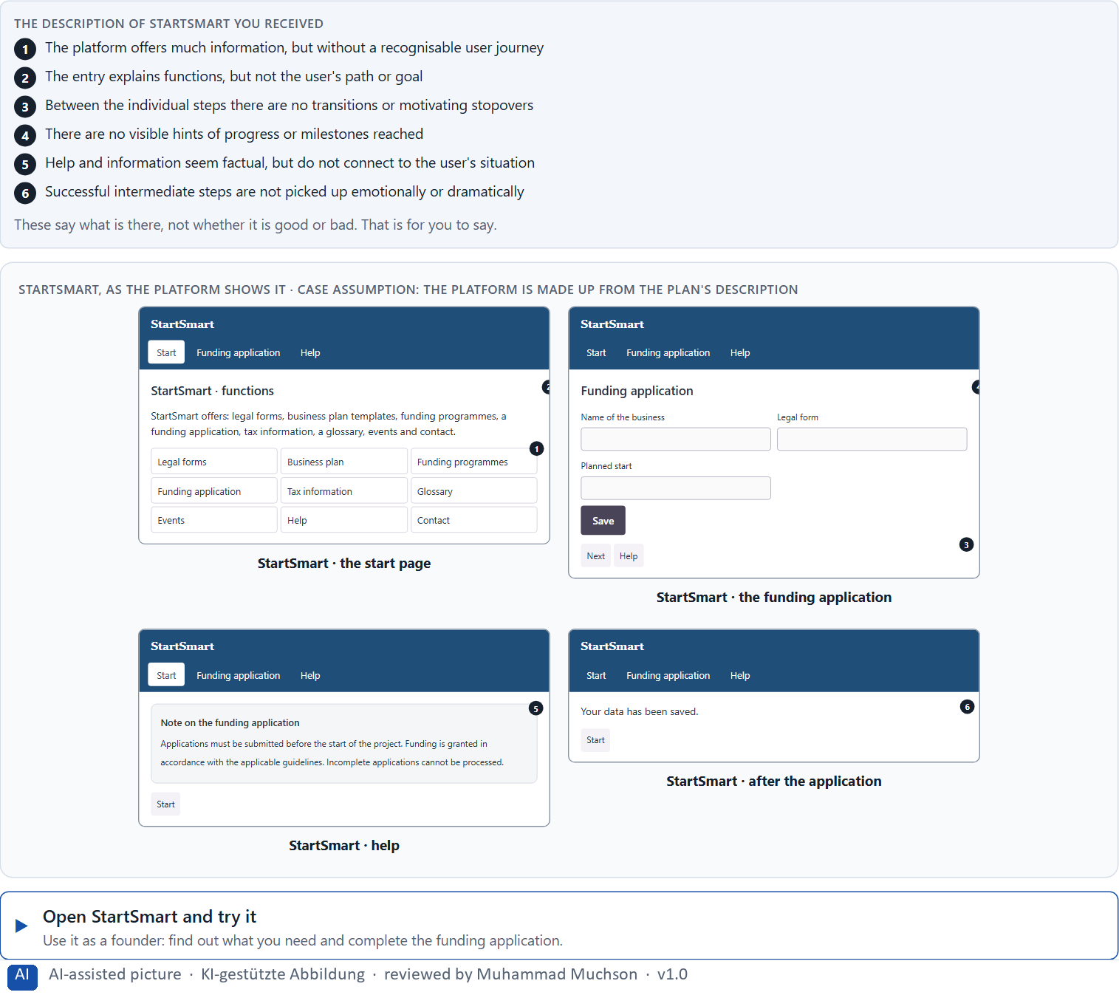
Figure 1 · StartSmart, as the platform shows it.
Question 1 of 5 · Describe the effect the offer could have on a first-time user
Two to four sentences: how it feels to start, where the feeling comes from, and what a first-time user might do.
How to build the answer:
- Open StartSmart, look for what you need to found a business and start an application.
- Write how it feels: do you know where you are going, how far you have come, why each step matters?
- Add where the feeling comes from and what you might do next.

Question 2 of 5 · Name at least 5 places where narrative guidance is missing or could be improved
How to build the answer:
- Go through your visit: the entry, the steps, the moments between them, the help, the end of a step.
- For each place, say what is missing and what it would give the user.
Write them as a list, one place per line, and say what is missing and what it would give the user.

Question 3 of 5 · Assign the observations to the categories entry, orientation, motivation, transition, progress and completion
Write the observations that belong to each category in a few words. One may fit two categories; put it where its effect is strongest.
How to build the answer:
- Take your places from question 2.
- Ask which part of the journey each one belongs to, and write it there.
- Each of the six is touched by StartSmart.
Category | The observations in this category
Entry
Orientation
Motivation
Transition
Progress
Completion

Question 4 of 5 · Write an effect statement for three points: “For users this could mean that …”
How to build the answer:
- Pick three places from question 2.
- Finish the plan's sentence with what the user would feel, do or fail to do.
Write them as a list, one statement per line, each starting with the observation and ending with what it could mean for users.

Question 5 of 5 · Prioritise the two biggest weaknesses with regard to emotionally connecting user guidance
How to build the answer:
- Look at your places with one question: which gap would make a first-time founder stop or not come back?
- Pick the two that weigh most and say why.
Write them as a list, the bigger weakness first, each with why it weighs most.

Block 1.2 · Rate storytelling approaches under conflicting goals: FutureSkills · JUDGED · Core · about 8 min
Draws on: A3 · Telling a story or guiding with one · A4 · Orientation, motivation and memorability, and the risk of overload · A5 · Embedding an action in its context, and weighing a measure.
FutureSkills is a further-training platform. Three journeys for its users are described in words: A) factual and efficient, with clear steps, but little emotional embedding or motivation; B) strongly narrative and emotionally activating, but with more text and longer guidance; C) a balanced mix of clarity, motivating address and visible progress, but with a somewhat higher implementation effort. The conditions: the target group is working people with little time, the company wants to look professional and inspiring, the budget is limited, the release is in 10 weeks, marketing demands stronger activation while the department demands high clarity, and there are no user tests yet. Decide anyway, and say what you assume.
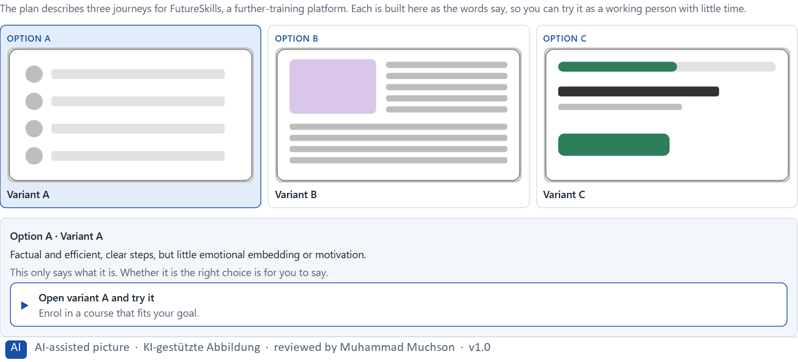
Figure 2 · The product to read, as the lab shows it (journeys).
Question 1 of 5 · Rate each variant on orientation, motivation, relevance, efficiency and experience quality
Write a few sentences for each variant that cover all five criteria. Many teams rate each criterion Low, Medium or High with a reason; you may do that or write it in your own words.
How to build the answer:
- Take one variant at a time and keep the target group in mind: working people with little time.
- For each criterion, say how the variant does and why.
- Use the same five criteria for every variant, so you can compare them.
Variant | Orientation | Motivation | Relevance | Efficiency | Experience quality
Variant A · factual and efficient, little motivation
Variant B · strongly narrative, more text, longer
Variant C · balanced, visible progress, more effort

Question 2 of 5 · Decide which variant is the most viable under the given conditions
Choose one variant, then give your reason below. There is no single right choice; the reason has to rest on the users and the conditions.
How to build the answer:
- Say which condition weighs most for you.
- Say how your choice meets it better than the other two.
Tick one:
☐ Variant A · factual and efficient, little motivation
☐ Variant B · strongly narrative, more text, longer
☐ Variant C · balanced, visible progress, more effort
Why this variant, under these conditions?
Give your reason with the conditions: working people with little time, professional and inspiring, a limited budget, 10 weeks, marketing against the department, no tests.
How to build the answer:
- Name the condition that weighs most for you.
- Say how your variant meets it and why the other two meet it less well.
- Say what your choice gives up and how you would deal with its weakness.

Question 3 of 5 · Name the conflicts of goals between efficiency and dramaturgical guidance
Name at least two conflicts, each as a goal of efficiency against a goal of dramaturgical guidance.
How to build the answer:
- Look at what efficiency needs (few steps, little text) and what dramaturgy needs (a goal, transitions, confirmation).
- Write each conflict as “… against …” and say who stands for each side.

Question 4 of 5 · Which risks remain despite your decision?
Name at least one risk that remains and who would feel it.
How to build the answer:
- Think of what your chosen variant is weak at.
- Say who would notice and what would happen.

Question 5 of 5 · Formulate a recommendation to the project management
Two to four sentences: what you recommend, why, and what you will check next.
How to build the answer:
- Lead with the recommendation.
- Give the one reason the project management can follow.
- Say what you will check after the release.

Part 2 · The case study · Level 2 · Application · Case study (2 UE)
Case study: 2 teaching units (UE5–6)
This part is the day's Level 2 case study. It takes 2 UE (about 90 minutes): UE5 for the briefing and your own work, UE6 for comparing your results with your group and for the trainer's closing. The block below needs about 15 minutes of writing; the rest of the time is discussion.

Block 2.1 · Case study: redesigning the GreenHome onboarding · JUDGED · Core · about 15 min
Draws on: A1 · Why people experience a process as a story · A2 · The elements of narrative guidance · A3 · Telling a story or guiding with one · A4 · Orientation, motivation and memorability, and the risk of overload · A5 · Embedding an action in its context, and weighing a measure.
A company for sustainable energy solutions offers GreenHome, a digital platform for advice, product selection and funding support. The onboarding is functionally complete, but users experience it as sober, long-winded and not very motivating. Many start the process but abandon it before the end. The company wants to make it emotionally more connecting and dramaturgically clearer, without losing specialist clarity. The observed problems: the entry explains functions, but not the personal benefit or the goal for users; the sequence of steps feels administrative rather than developmental; intermediate states and progress are barely visible; help and hints explain but do not motivate; finishing a step does not feel like progress; and the whole feels like a form process rather than an accompanied journey. The conditions: a budget of €155,000, 12 weeks for the implementation, contents and specialist logic must largely be kept, the company wants to look inspiring but serious, user data is only partly available, and a complete relaunch is not possible. You work through six steps.
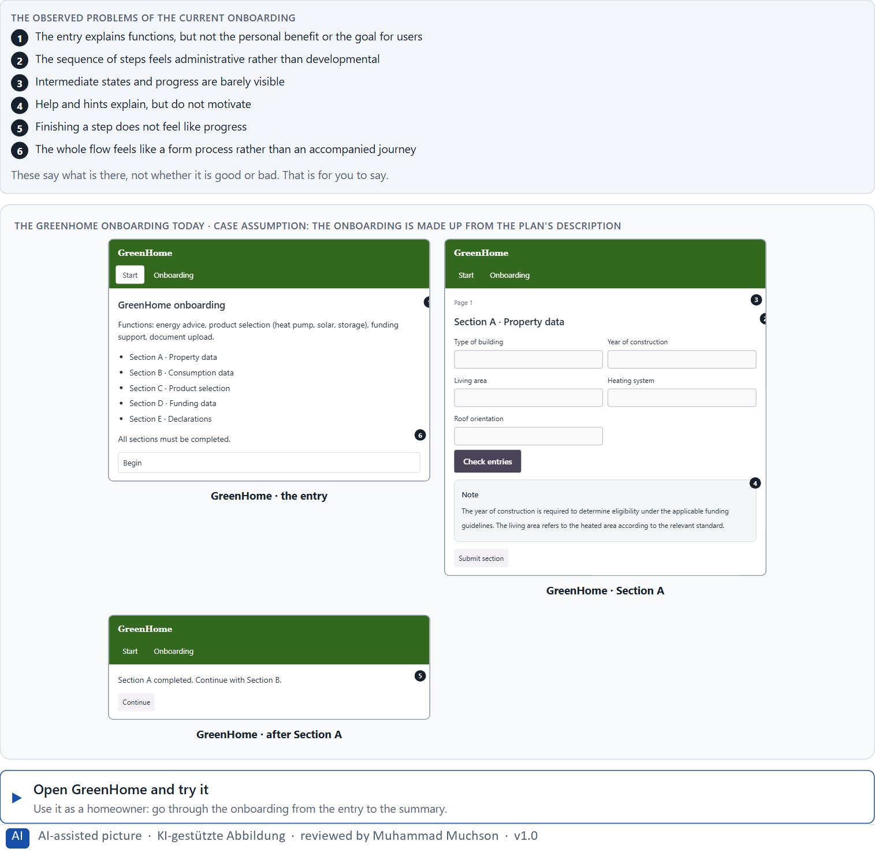
Figure 3 · The GreenHome onboarding today.
Question 1 of 6 · Analyse the central narrative and dramaturgical deficits of the onboarding
How to build the answer:
- Open GreenHome and go through the onboarding as a homeowner would, from the first screen to the summary.
- Write one deficit per line as a missing part of the journey and what it does.
Write them as a list, one deficit per line, each as a missing part of the journey. At least five.

Question 2 of 6 · Assign the problems to the categories entry, relevance, transitions, progress, motivation and completion
Write the problems that belong to each category in a few words. A problem may fit two categories.
How to build the answer:
- Take your problems from question 1.
- Ask which of the six categories each one affects most, and write it there.
Category | The problems in this category
Entry
Relevance
Transitions
Progress
Motivation
Completion

Question 3 of 6 · Develop 4 prioritised measures for improvement
How to build the answer:
- Turn each group of problems into something you could change within 12 weeks, keeping the contents and specialist logic and without a relaunch.
- Put them in order: what gives people a reason to start and to go on first.
Write them as a numbered list, the first priority first, each with what it changes for users.

Question 4 of 6 · Justify your selection using effect on users, feasibility, risk and time pressure
Use all four criteria and say how they support your selection and its order.
How to build the answer:
- Say for your first measures what they change for starting and finishing.
- Say what is feasible while the contents and logic stay, and the risk of each.
- Keep the serious brand and the 12 weeks in mind.

Question 5 of 6 · Make a prioritisation decision for the first 12 weeks
Say what you do in the first 12 weeks, in which order, and what you leave for later, with the reason.
How to build the answer:
- Say what comes first and why.
- Say what you do in parallel and what waits.
- Say how you keep the specialist clarity.

Question 6 of 6 · Formulate a recommendation to the division management
Three to five sentences: what you recommend, what has priority, and what you expect to change.
How to build the answer:
- Lead with the recommendation.
- Name the priorities.
- Say what you expect to change for users and for the company.

Task 2 · Route 2 · UX Strategy Memo: decide as Chief Experience Officer

The situation: the provider behind GreenHome, processes that work and journeys that do not
Read once · about 2 min
You take the perspective of the Chief Experience Officer of the sustainable-energy provider that runs GreenHome. The company has a website, an advisory platform and self-service flows. Its digital processes work, but they create little relevance and bond: users complete their tasks but experience the journey as administrative, interchangeable and not very motivating. Inside the company, storytelling is seen only as a means of communication, not as part of the UX architecture. The management expects a sound strategy for integrating narrative structure and dramaturgical guidance systematically into the digital offers. You are not to write beautiful texts but to develop a sound decision architecture for storytelling, user relevance and dramaturgical guidance.
The framework | How the task runs · one block
• The budget is limited  • Several stakeholders pursue different goals  • Specialist clarity must not be lost  • Not all journeys can be revised at the same time  • The data is partly incomplete  • First improvements must be visible at short notice  • Wrong decisions can lengthen processes, weaken credibility or deter users | • Block 3.1 asks seven questions: a guiding vision for narrative UX, three strategic decisions, a prioritised architecture of measures, a risk analysis, a governance model, one decision under uncertainty and a management statement.

What is known and what is open
In the brief | Clear · Case assumption | Open · on purpose
• A website, an advisory platform and self-service flows.  • The processes work, but feel administrative, interchangeable and not very motivating.  • Inside, storytelling counts as communication, not part of the UX architecture.  • Specialist clarity must stay; first improvements must show soon. | • The company is the sustainable-energy provider behind GreenHome in Route 1.  • Marketing tells the brand's story on the website; the product teams build the flows step by step from the specialist logic.  • The self-service flows include changing a tariff, reporting a meter reading and applying for funding. | • How large the budget is: “limited” is all the plan says.  • Where people abandon each journey: the data is partly incomplete.  • How users would react to a narrative journey: never tested.

As in most projects, not everything is known. Decide anyway, and say what you assume.
Case assumption
The brief says: a company with a website, an advisory platform and self-service flows, processes that work but create little relevance and bond, journeys experienced as administrative, interchangeable and not very motivating, storytelling seen inside only as communication, a limited budget, several stakeholders, specialist clarity that must stay, not all journeys at once, partly incomplete data, first improvements soon, and the warning that wrong decisions can lengthen processes, weaken credibility or deter users. Those are the plan's facts. That the company is the provider of Route 1 and the facts marked “Clear” are made up for this exercise.

The memo is addressed to: The management. Subject: A narrative UX strategy for our digital user journeys.

Part 3 · Level 3 · Management decision · Transfer project (3 UE)
Transfer project: 3 teaching units (UE8–10)
UE8: the trainer presents Materi B and sets the role. UE9: you write the memo. UE10: you present the decision and what you give up; the trainer debriefs.

Block 3.1 · A narrative UX strategy for digital user journeys · JUDGED · Core · about 20 min
Draws on: B1 · Narrative UX as experience architecture, not communication · B2 · Efficiency against story · B3 · Who owns narrative UX, and deciding without seeing where people stop.
Develop a strategic concept for the provider. Your desk holds what the management, marketing, the specialist department and the data say. Open it, then answer the seven questions; your answers build the memo below.
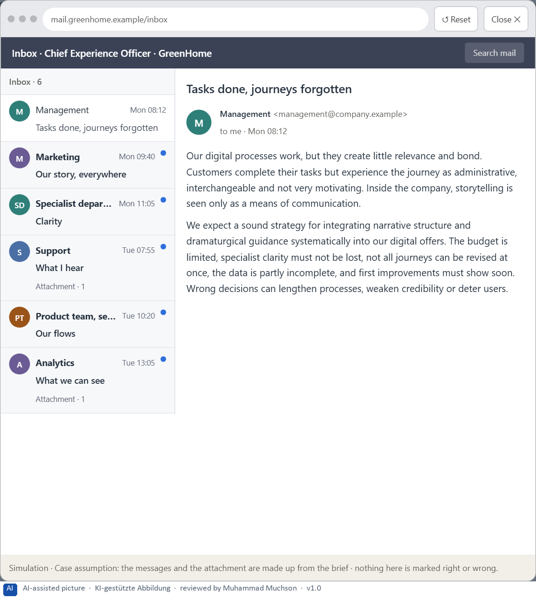
Figure 4 · Your desk: the messages that wait for you, shown in the lab as a mailbox (1 of 6).
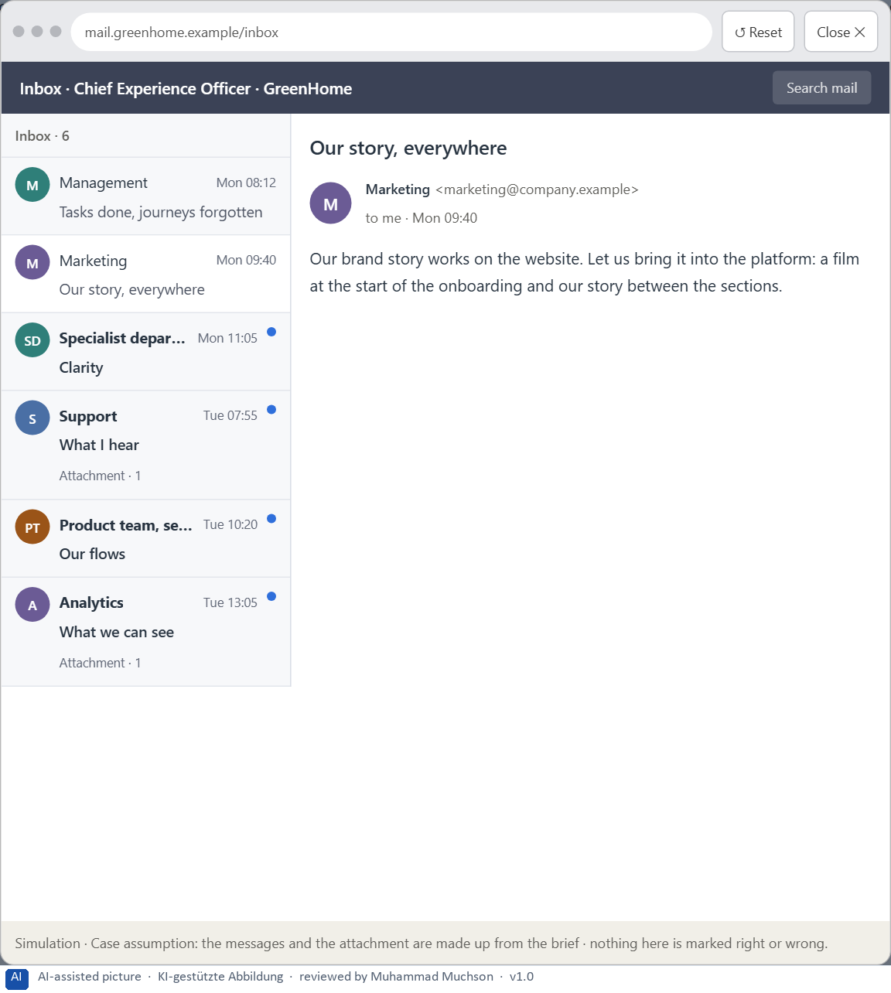
Figure 5 · Your desk: the messages that wait for you, shown in the lab as a mailbox (2 of 6).
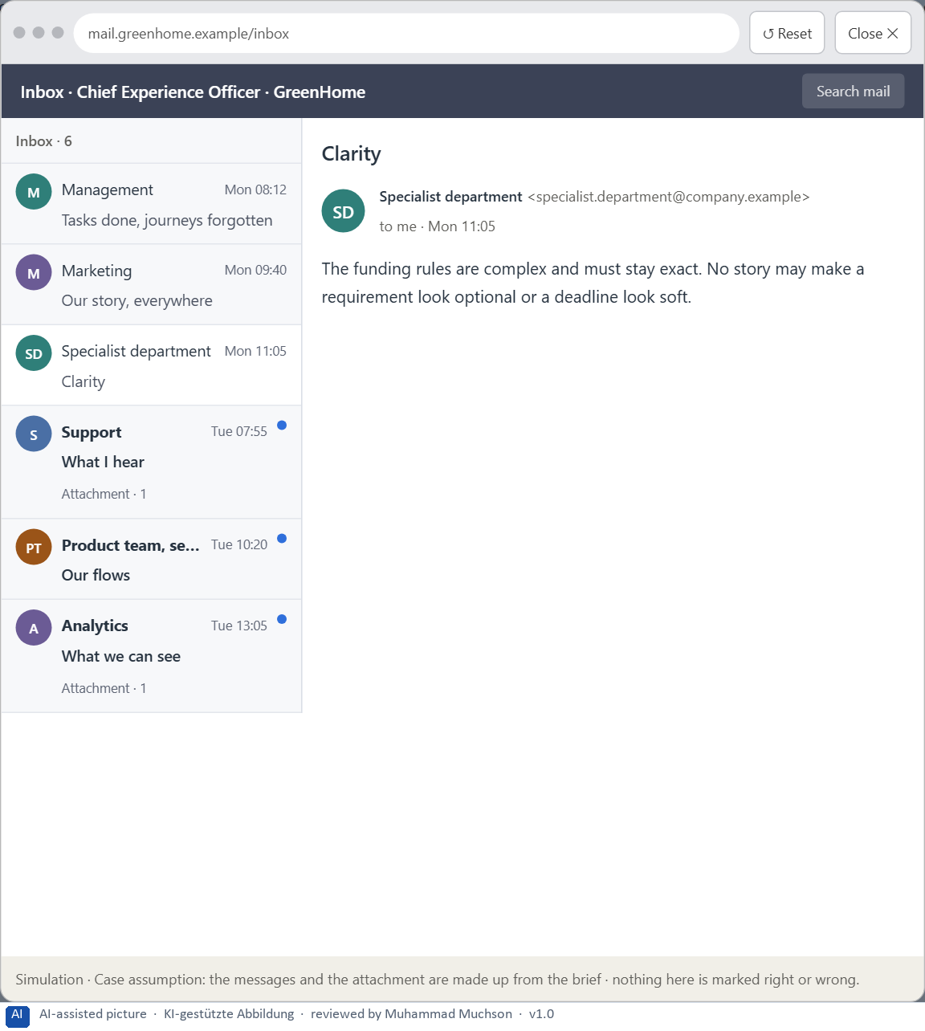
Figure 6 · Your desk: the messages that wait for you, shown in the lab as a mailbox (3 of 6).
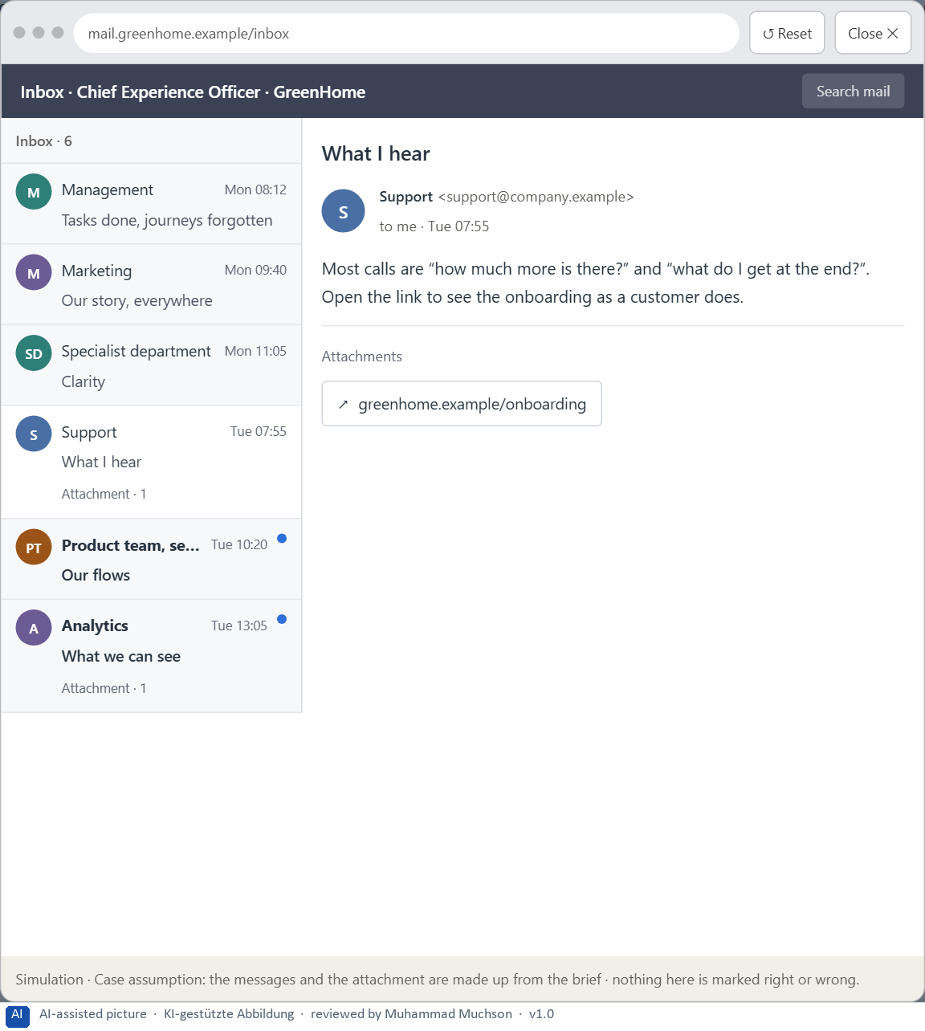
Figure 7 · Your desk: the messages that wait for you, shown in the lab as a mailbox (4 of 6).
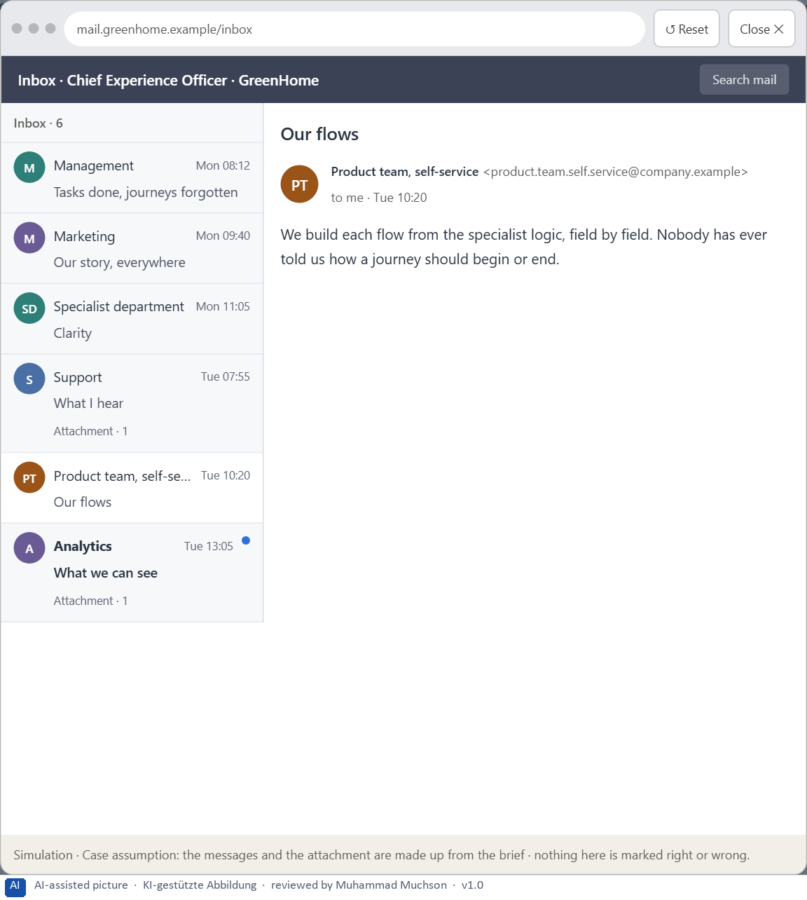
Figure 8 · Your desk: the messages that wait for you, shown in the lab as a mailbox (5 of 6).
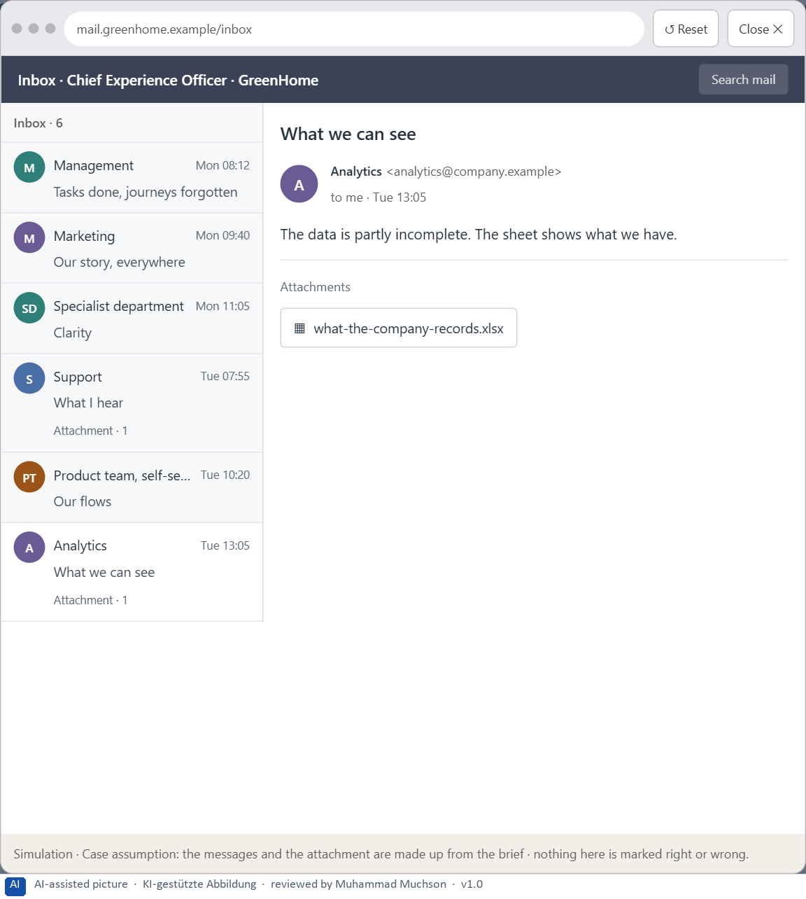
Figure 9 · Your desk: the messages that wait for you, shown in the lab as a mailbox (6 of 6).
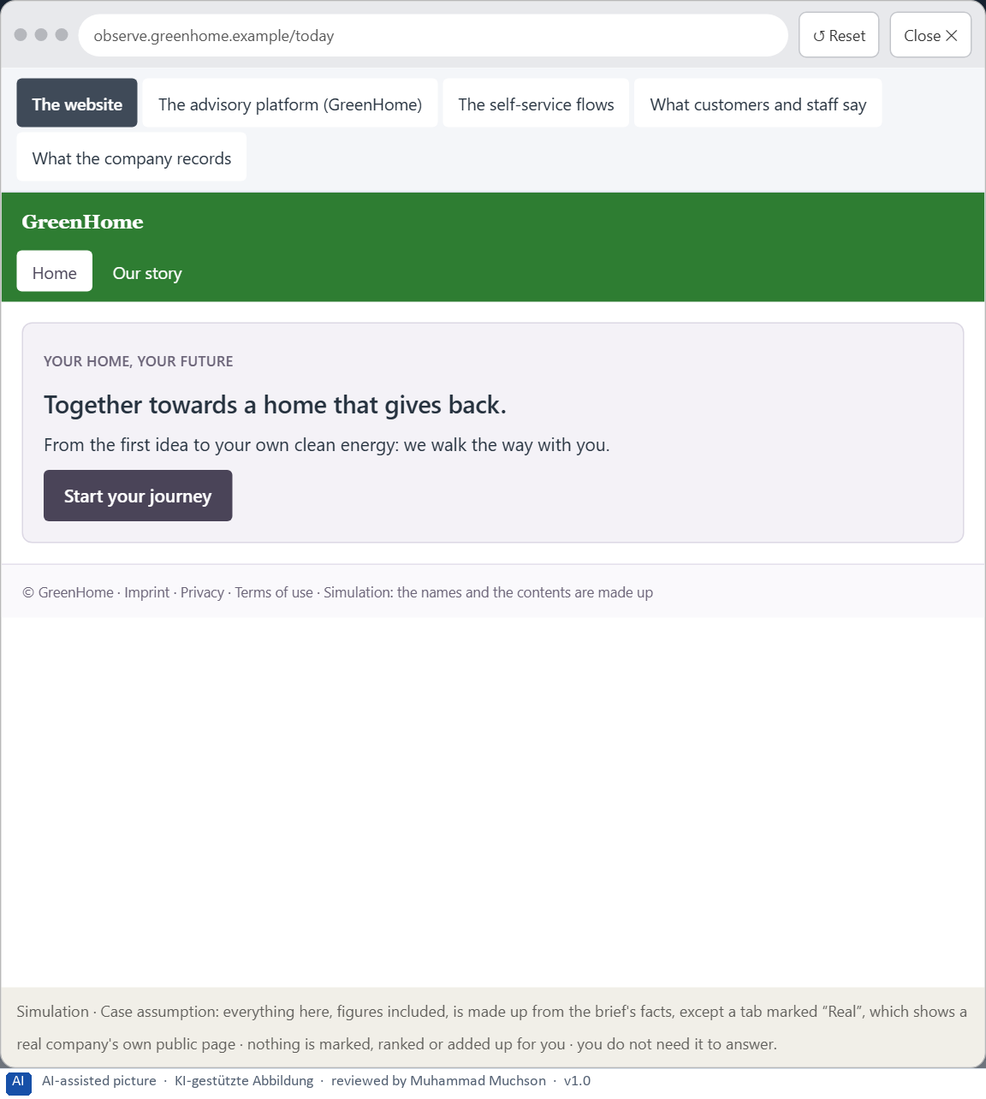
Figure 10 · The platform as it is today, as the lab lets you observe it (1 of 5).
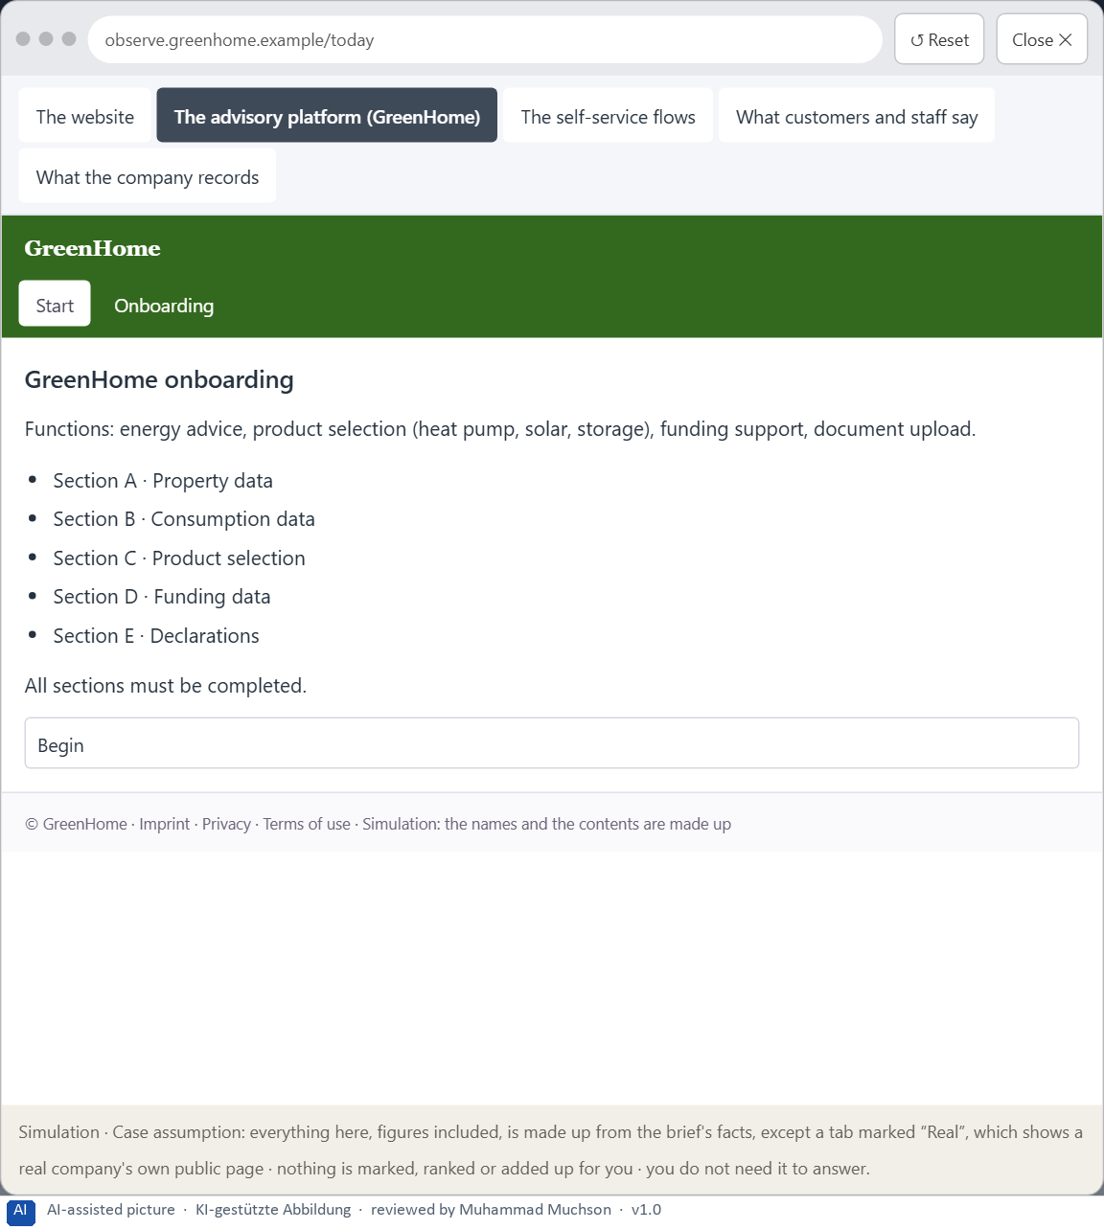
Figure 11 · The platform as it is today, as the lab lets you observe it (2 of 5).
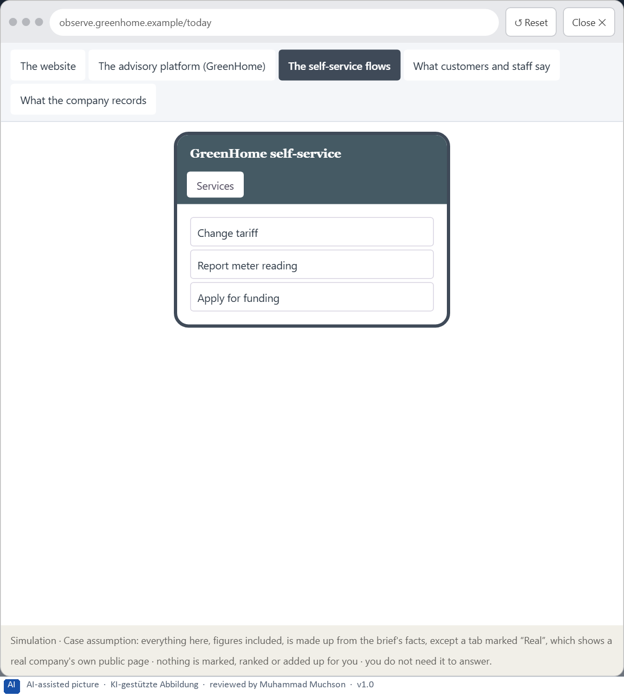
Figure 12 · The platform as it is today, as the lab lets you observe it (3 of 5).
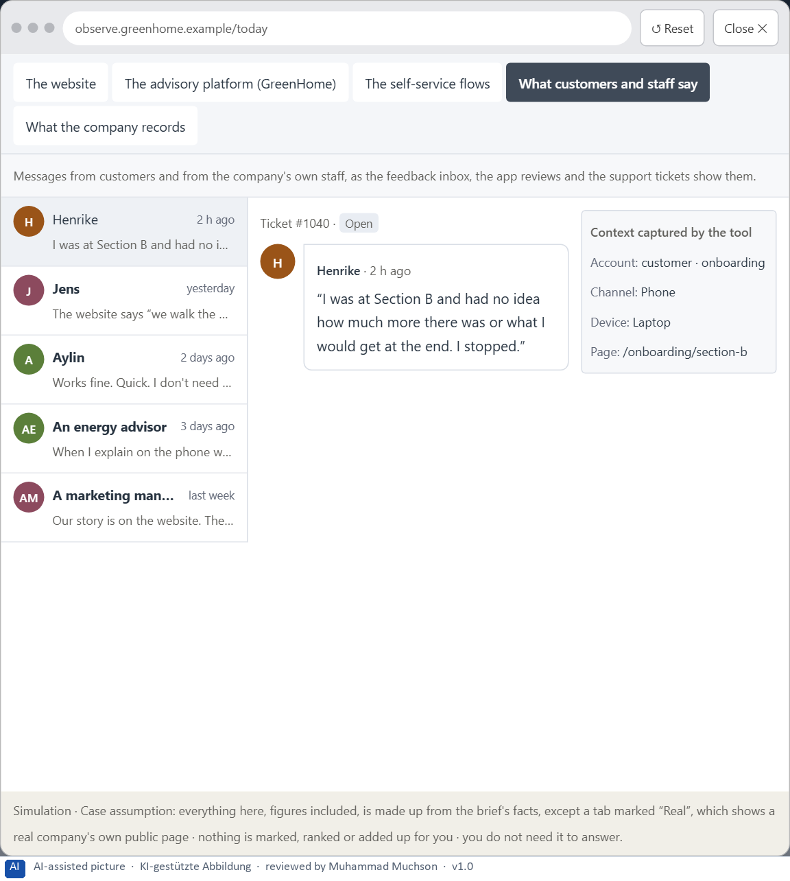
Figure 13 · The platform as it is today, as the lab lets you observe it (4 of 5).
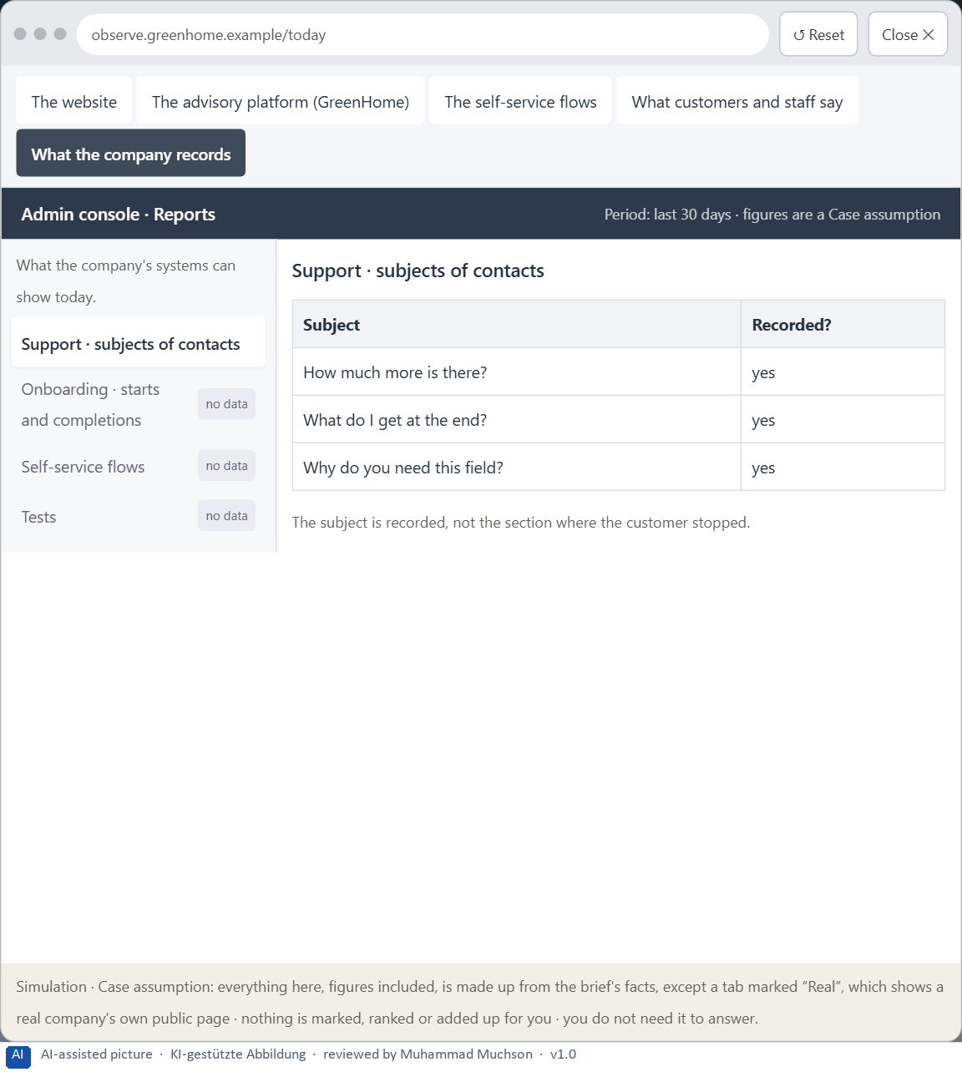
Figure 14 · The platform as it is today, as the lab lets you observe it (5 of 5).
Question 1 of 7 · A guiding vision for narrative UX: which emotional effect and which user journey should be created systematically?
One or two sentences about the journey people should experience in every flow: where it starts, how it carries them and how it ends.
How to build the answer:
- Say what people should know at the start, feel along the way and have at the end.
- Keep it clear enough for specialist content and short enough for people with little time.

Question 2 of 7 · Three strategic guiding decisions on entry, dramaturgical guidance, the experience of progress and narrative relevance
How to build the answer:
- Take your vision and ask which three choices would make it real.
- Write each as “we will …, even though that means …”.
Write them as a list, one decision per line, each with what it gives up.

Question 3 of 7 · A prioritised architecture of measures: which journeys, touchpoints or interactions are improved first, and why?
Put the journeys, touchpoints or interactions in an order and give the reason for the first ones.
How to build the answer:
- List the candidates: the onboarding, the self-service flows, the advisory platform, the website, and the interactions that appear everywhere (entries, transitions, confirmations).
- Put first what most people start and abandon, or what matters most to them.
- Say why the others can wait.

Question 4 of 7 · A risk analysis: which wrong assumptions about user needs, storytelling and seriousness would be especially critical?
Name two or three assumptions about what users need, how storytelling works, or what keeps the company serious, and the harm if each is wrong.
How to build the answer:
- Write down what your concept assumes about user needs.
- Write down what it assumes about storytelling.
- Write down what it assumes about seriousness.

Question 5 of 7 · A governance model: who is responsible for the narrative UX principles, and how are conflicts between clarity, brand and experience quality decided?
Name roles, not people: who owns the narrative UX principles and patterns, the roles of marketing and the specialist department, and how a conflict between clarity, brand and experience quality is decided.
How to build the answer:
- Name who owns the narrative UX principles and the patterns.
- Name the roles of marketing and the specialist department.
- Say how a conflict between clarity, brand and experience quality is decided.

Question 6 of 7 · A decision under uncertainty: make at least one prioritised decision despite patchy data and justify it responsibly
Say what you decide, what you do not know, and why the decision is responsible all the same, for example when you would reverse it.
How to build the answer:
- State the decision in one sentence.
- Name what you do not know.
- Say why it is still responsible: it can be reversed, it can be checked soon, or waiting costs more.

Question 7 of 7 · A management statement: a recommendation to the management with a clear priority and a strategic reason
Four to six sentences: the direction first, then the priority, the reason and what you ask of the management.
How to build the answer:
- Start with the direction in one sentence.
- Name the priority and the reason that carries it.
- Say what you ask of the management and what you will report back.

Use in class: presentation and handout
Mark of use for the worksheet. Presentation is what the trainer shows on screen; Handout is what participants fill in and hand in.
Part of the worksheet | Presentation (shown in the Neuro-UX Lab) | Handout
The case: three platforms on the UX team's desk, and GreenHome | The case read aloud or on screen | The case text
Block 1.1 · Recognise the narrative potential of a digital offer: StartSmart | The task wording at the start of the block (no answers are shown) | Worksheet block with answer boxes (Core)
Block 1.2 · Rate storytelling approaches under conflicting goals: FutureSkills | The task wording at the start of the block (no answers are shown) | Worksheet block with answer boxes (Core)
Block 2.1 · Case study: redesigning the GreenHome onboarding | The task wording at the start of the block (no answers are shown) | Worksheet block with answer boxes (Core)
The situation: the provider behind GreenHome, processes that work and journeys that do not | The case read aloud or on screen | The case text
Block 3.1 · A narrative UX strategy for digital user journeys | The task wording at the start of the block (no answers are shown) | Worksheet block with answer boxes (Core)

Glossary
Every term below is used in this document. Terms stay plain text in the body; this list says what they mean in everyday words.
Term | In plain words | Example | Comes from
Activation | Getting people to act now, often with strong stimuli. It can help for a moment and tire or push people if overdone. | — | Day 7
Case assumption | A fact made up for this exercise to fill a gap in the plan's case. It is marked so you know it is not part of the plan. | — | Day 1
Chief Experience Officer | The manager who is responsible for the experience customers have across all channels, and who decides where the company invests in it. | — | Day 1
Decision architecture | A set of connected decisions that are made on purpose and written down: what effect you want, what comes first, who decides and how conflicts are settled. It replaces many separate fixes. | — | Day 1
Dramaturgy | The order and rhythm of a journey: tension, expectation, sequence, transitions, confirmation and emotional context. | — | Day 8
Experience quality | How using a product feels, on the way and afterwards. It goes beyond usability, which only asks whether people reach their goal. | — | Day 7
Governance | The rules about who may decide what, who is answerable for it and how disagreements are settled. | — | Day 1
Milestone | A visible point on the way that shows a part of the journey is done. | — | Day 8
Narrative guidance | Guiding people through a process as a journey: where they start, where they are going, why it matters, how far they have come and when they are done. | — | Day 8
Onboarding | The first journey with a product, from signing up to being ready to use it. | — | Day 8
Orientation | Knowing where you are, what you can do here and what happens next. | — | Day 1
Stakeholder | A person or department with an interest in a decision, such as marketing, compliance, IT or sales. | — | Day 1
Storytelling in UX | Building a digital journey so it has what a story has: a beginning that shows the goal, a way that shows progress, and an end that feels like an end. | — | Day 8
Touchpoint | Any place where a person meets the company: the website, the customer portal, the app, a chatbot or a phone call. | — | Day 1
Transition | The moment between two steps: what was done, what comes next and why. | — | Day 8
User journey | The whole path a person takes to reach a goal with a product, across steps and touchpoints. | — | Day 8
UX (user experience) | Everything a person goes through when using a product: what they notice, understand, feel and do, from the first look to the last step. The screens are only one part of it. | Finding the booking you want at once and feeling sure it went through is a good UX. | Day 1

The Neuro-UX Lab: where we practise online
In class we use the course website as the place to practise and to learn. Every day has its own address, in the same pattern: the day number is the last part.
What | Address
Neuro-UX Lab (course website) | https://aion-ux-lab.vercel.app/
Day 8 | https://aion-ux-lab.vercel.app/day/8/

On the day page, Route 1 (Levels 1 and 2) and Route 2 (Level 3) can be opened; the cards and the tasks of this document are there too. The pattern is the same up to Day 8, for example https://aion-ux-lab.vercel.app/day/6/.

