AION · UX DEVELOPER · PSYCHOLOGICAL UX DESIGN AND NEURO-UX
DAY 2 · CASE STUDY · LEVEL 2 · 2 UE (UE5–6)
CampusNow: Case study
The day's Level 2 case study with its questions; work on it alone, then compare in your group
AI notice · KI-Hinweis
This document was produced with the help of an AI language model (Claude, Anthropic). The AI drafted the text and tables and built the pictures and working examples of the lab. The content was then read, corrected and approved by the reviewer named below, who is responsible for its accuracy. Every picture carries an AI label on the image. Check figures and sources before you quote them.
KI-Hinweis: Dieses Dokument wurde mit Unterstützung eines KI-Sprachmodells (Claude, Anthropic) erstellt. Texte und Tabellen wurden von der KI entworfen, die Abbildungen sind KI-gestützt erstellt und am Bild gekennzeichnet. Die fachliche Prüfung und Freigabe erfolgte durch die unten genannte Person.

Day | Day 2 · Module 2 (day 1 of 2): Visual perception and user-centred design
Document | Case study (worksheet with answer spaces) for the 2 teaching units UE5–6.
Route and level | Level 2 · Application. Draws on Materi A.
Time | About 90 min (UE5–6), of which about 15–20 min of writing
Neuro-UX Lab (website) | https://aion-ux-lab.vercel.app/day/2/
Case | CampusNow, the day's case study
Version | 1.0 · release date 29.10.2026
Review and approval | Muhammad Muchson, Mentor (subject-matter review and approval)

ABOUT THIS DOCUMENT
In class we also use the Neuro-UX Lab, the course website, as the place to practise and learn. Its address is at the end of this document.
This is the case study of Day 2. Read the case once, look at the picture, and write your answers in the boxes and tables. You can work on paper or type into the document. There are no answer keys in this document; the trainer closes the unit with the model solution.

IN THIS DOCUMENT
Lesson plan: ten teaching units (Ablaufplan)
Case study and transfer project at a glance
Block 2.1 · Case study: reorganising the service portal CampusNow · JUDGED · Core · about 15 min

Day at a glance
Day 2 has ten teaching units (UE). This document is the worksheet; it is used in UE2 to UE6 (Task 1) and UE8 to UE10 (Task 2). The day is built from three documents and the Neuro-UX Lab: Materi (study material), Task (worksheet) and Trainer (coaching, feedback and model solutions), plus the course website.

Lesson plan: ten teaching units (Ablaufplan)
UE | Min | Plan item | What happens | Material | Format
1 | 45 | Knowledge transfer · Level 1 | The trainer presents the cards of Materi A (A1, A2, A3, A4, A5, about 60 min of cards) in the Neuro-UX Lab; participants follow in the handout. | Materi A (Route 1) | Presentation + Handout
2 | 45 | Level 1 · Task 1 | Individual work on Block 1.1 (Core, about 10 min): the first product of the day is read and its effect described. Pairs then compare their results and the trainer collects open questions. | Task 1 · Part 1 · Block 1.1 | Handout (or in the lab)
3 | 45 | Level 1 · Task 2 | Three options are rated on the same criteria and one is chosen under the stated conditions: Block 1.2 (Core, about 8 min). | Task 1 · Part 1 · Block 1.2 | Handout (or in the lab)
4 | 45 | Coaching · transition from Level 1 to Level 2 | Trainer-led. A short talk on the day's coaching focus, then the reflection questions in pairs. The bridge: from describing an effect to a decision you answer for. There is no worksheet block in this unit. | Trainer document, section Coaching | Trainer only
5–6 | 90 | Level 2 · Case study CampusNow (2 UE) incl. model solution | UE5: the trainer presents the case; participants work on Block 2.1 (Core, about 15 min). UE6: groups compare their results and defend them; the trainer closes with the model solution. | Task 1 · Part 2 · Block 2.1  Trainer document, section Case study | Handout; model solution shown after the work
7 | 45 | Level 2 + 3 · Feedback round with a management perspective | Groups present their reasoning, not only their result. The trainer asks the day's Level 3 input questions and leads the discussion. | Trainer document, section Feedback round | Presentation by the groups; Trainer only
8 | 45 | Level 3 · Transfer project, Chief Experience Officer (3 UE: UE8–10) | The trainer presents Materi B (B1, B2, B3; use the "In plain words" and "How to decide" boxes, the rest is handout) and sets the role and the situation. | Materi B (Route 2) | Presentation + Handout
9 | 45 | Level 3 · Transfer project | Individual work or in pairs on Block 3.1 (Core, about 20 min): the strategy memo. | Task 2 · Block 3.1 | Handout (or in the lab)
10 | 45 | Level 3 · Transfer project | Participants present their decision and what they give up, including the one decision made under uncertainty; the trainer debriefs with the model solution. | Task 2 · Block 3.1  Trainer document, section Transfer project | Handout; model solution shown after the work

One UE is counted as 45 minutes here; breaks are not shown. The times are a guide for the trainer. The Core blocks are enough for a complete answer.

Case study and transfer project at a glance
Component | UE | Duration | Participants work in | Model solution in
Level 2 case study (CampusNow) | UE5–6 | 2 UE · 90 min | Task 1 · Part 2 (Block 2.1) | Trainer document, section Case study
Level 3 transfer project (Chief Experience Officer) | UE8–10 | 3 UE · 135 min | Materi B and Task 2 (Block 3.1) | Trainer document, section Transfer project

Part 2 · The case study · Level 2 · Application · Case study (2 UE)
Case study: 2 teaching units (UE5–6)
This part is the day's Level 2 case study. It takes 2 UE (about 90 minutes): UE5 for the briefing and your own work, UE6 for comparing your results with your group and for the trainer's closing. The block below needs about 15 minutes of writing; the rest of the time is discussion.

Block 2.1 · Case study: reorganising the service portal CampusNow · JUDGED · Core · about 15 min
Draws on: A1 · Seeing an interface, and designing from the user's side · A2 · How people scan, select and prioritise · A3 · What guides the eye · A4 · How much at once · A5 · Recognition instead of search, clarity instead of overload, and weighing a measure.
An education organisation runs CampusNow, a digital portal for course booking, certificates, dates and learning materials. All the content is there, but users find many functions only with difficulty. Complaints are rising, abandonment in the booking process is increasing, and mobile use is especially problematic. The observed problems: the start page is overloaded with information, the navigation items are named after the internal organisation, important functions are not visually prioritised, different page types use different structures, the text blocks are long and hard to scan, and users often have to search instead of being guided directly. The conditions: a budget of €150,000, 14 weeks for the implementation, no complete relaunch, first improvements have to be visible quickly, and marketing asks for a modern look, support for fewer questions and IT for standardisation. You work through six steps.
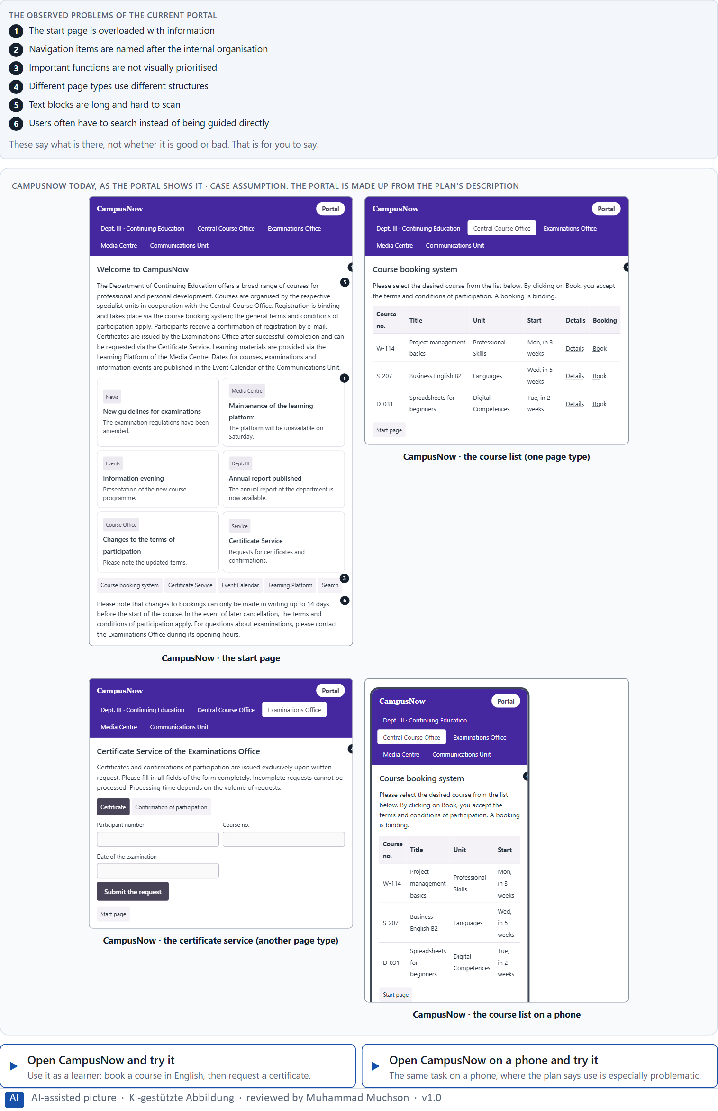
Figure 1 · CampusNow today, as the portal shows it.
Question 1 of 6 · Analyse the central perception and structure problems of the portal
How to build the answer:
- Open CampusNow and book a course as a learner would, once on the desktop and once on the phone.
- Write one problem per line as an effect on the user: what the portal makes hard, not only what is wrong with it.
Write them as a list, one problem per line, each as an effect on the user. At least five.

Question 2 of 6 · Assign the problems to the categories orientation, readability, findability, consistency and cognitive load
Write the problems that belong to each category in a few words. A problem may fit two categories.
How to build the answer:
- Take your problems from question 1.
- Ask which of the five categories each one affects most, and write it there.
Category | The problems in this category
Orientation
Readability
Findability
Consistency
Cognitive load

Question 3 of 6 · Develop 4 prioritised user-centred measures
How to build the answer:
- Turn each group of problems into something you could change within 14 weeks and without a relaunch.
- Put them in order: the measure that helps users most and shows soonest first.
Write them as a numbered list, the first priority first, each with what it changes for users.

Question 4 of 6 · Rate your measures on effect on users, effort, risk and timeliness
Write a few words for each of your four measures that cover all four criteria. Effort means time and people, not money. Many teams rate each Low, Medium or High with a reason.
How to build the answer:
- Take your measures in the order of question 3.
- For each criterion, say how the measure does and why; effort is the time and the people it takes.
- Let the ratings check your order: if a later measure rates better, say why it still comes later, or change the order.
Measure | Effect on users | Effort (time and people) | Risk | Timeliness
Your measure 1
Your measure 2
Your measure 3
Your measure 4

Question 5 of 6 · Make a reasoned prioritisation decision for the first 14 weeks
Say what you do in the first 14 weeks, in which order, and what you leave for later, with the reason.
How to build the answer:
- Use your ratings: what shows quickly and helps most comes first.
- Say what you start now but finish later, and what waits.
- Keep the conditions in mind: no relaunch, first improvements visible quickly, marketing, support and IT.

Question 6 of 6 · Formulate a recommendation to the division management
Three to five sentences: what you recommend, what you do not, and what you expect to change.
How to build the answer:
- Lead with the recommendation.
- Say what you do not prioritise and why.
- Say what you expect to change for users and for the organisation.

Use in class: presentation and handout
Mark of use for the worksheet. Presentation is what the trainer shows on screen; Handout is what participants fill in and hand in.
Part of the worksheet | Presentation (shown in the Neuro-UX Lab) | Handout
Block 2.1 · Case study: reorganising the service portal CampusNow | The task wording at the start of the block (no answers are shown) | Worksheet block with answer boxes (Core)

Glossary
Every term below is used in this document. Terms stay plain text in the body; this list says what they mean in everyday words.
Term | In plain words | Example | Comes from
Case assumption | A fact made up for this exercise to fill a gap in the plan's case. It is marked so you know it is not part of the plan. | — | Day 1
Chief Experience Officer | The manager who is responsible for the experience customers have across all channels, and who decides where the company invests in it. | — | Day 1
Cognitive load | How much a person has to hold in mind and work out at the same time. Every extra signal or choice adds to it; when it is too high, people skip, freeze or leave. | — | Day 1
Consistency | The same thing looks, is named and works the same way everywhere, so what people learn on one page holds on the next. | — | Day 2
Contrast | How much something differs from its surroundings in brightness, colour or size. Strong contrast makes it stand out; too many strong contrasts make everything compete. | — | Day 2
Decision architecture | A set of connected decisions that are made on purpose and written down: what effect you want, what comes first, who decides and how conflicts are settled. It replaces many separate fixes. | — | Day 1
Effort | What a measure takes in time and people: who has to work on it and for how long. On this course effort is never a price. | — | Day 2
Findability | How easily people can find what they are looking for, by browsing the menu or by searching. | — | Day 2
Governance | The rules about who may decide what, who is answerable for it and how disagreements are settled. | — | Day 1
Information architecture | How the content of a website or app is organised, grouped and named, and how people move through it. It is the structure behind the screens. | — | Day 2
Information density | How much a screen shows at once. Too much and everything competes; too little and people have to click a lot to reach anything. | — | Day 2
Orientation | Knowing where you are, what you can do here and what happens next. | — | Day 1
Page type | A kind of page that appears many times, such as a course page, a certificate page or a booking page. Each type should keep the same structure. | — | Day 2
Perception | Taking in what the senses deliver, for example what the eyes see on a screen, before thinking about it. | — | Day 1
Provider-centred design | Designing from the organisation's own point of view: its departments, its terms and what it wants to say. The result is often complete but hard to use. | A menu with one item per department, named as the departments call themselves. | Day 2
Readability | How easily a text can be read and understood: its size, contrast, line length, wording and how it is broken into parts. | — | Day 2
Recognition instead of recall | Showing people the options and the next step so they can recognise them, instead of making them remember or hunt for them. | — | Day 2
Scanning | Looking over a screen quickly and picking out what seems relevant, instead of reading it word by word. Most people scan first. | — | Day 2
Self-service portal | A website where customers do things themselves that once needed a call or a visit, such as reporting damage or downloading a document. | — | Day 1
Stakeholder | A person or department with an interest in a decision, such as marketing, compliance, IT or sales. | — | Day 1
Timeliness | How soon a measure shows its effect for the users. A measure with high timeliness is noticed in days or weeks, not next year. | — | Day 2
Touchpoint | Any place where a person meets the company: the website, the customer portal, the app, a chatbot or a phone call. | — | Day 1
User-centred design | Designing from what the users come to do, how they see and what words they use, and checking the design with them, instead of starting from how the organisation is built. | — | Day 2
UX (user experience) | Everything a person goes through when using a product: what they notice, understand, feel and do, from the first look to the last step. The screens are only one part of it. | Finding the booking you want at once and feeling sure it went through is a good UX. | Day 1
Visual guidance | Using contrast, grouping and structure on purpose so the eye goes first to what matters and then along a clear path. | — | Day 2

The Neuro-UX Lab: where we practise online
In class we use the course website as the place to practise and to learn. Every day has its own address, in the same pattern: the day number is the last part.
What | Address
Neuro-UX Lab (course website) | https://aion-ux-lab.vercel.app/
Day 2 | https://aion-ux-lab.vercel.app/day/2/

On the day page, Route 1 (Levels 1 and 2) and Route 2 (Level 3) can be opened; the cards and the tasks of this document are there too. The pattern is the same up to Day 8, for example https://aion-ux-lab.vercel.app/day/6/.

