AION · UX DEVELOPER · PSYCHOLOGICAL UX DESIGN AND NEURO-UX
DAY 3 · CASE STUDY · LEVEL 2 · 2 UE (UE5–6)
SecureLife: Case study
The day's Level 2 case study with its questions; work on it alone, then compare in your group
AI notice · KI-Hinweis
This document was produced with the help of an AI language model (Claude, Anthropic). The AI drafted the text and tables and built the pictures and working examples of the lab. The content was then read, corrected and approved by the reviewer named below, who is responsible for its accuracy. Every picture carries an AI label on the image. Check figures and sources before you quote them.
KI-Hinweis: Dieses Dokument wurde mit Unterstützung eines KI-Sprachmodells (Claude, Anthropic) erstellt. Texte und Tabellen wurden von der KI entworfen, die Abbildungen sind KI-gestützt erstellt und am Bild gekennzeichnet. Die fachliche Prüfung und Freigabe erfolgte durch die unten genannte Person.

Day | Day 3 · Module 2 (day 2 of 2): Colour, typography and readability
Document | Case study (worksheet with answer spaces) for the 2 teaching units UE5–6.
Route and level | Level 2 · Application. Draws on Materi A.
Time | About 90 min (UE5–6), of which about 15–20 min of writing
Neuro-UX Lab (website) | https://aion-ux-lab.vercel.app/day/3/
Case | SecureLife, the day's case study
Version | 1.0 · release date 29.10.2026
Review and approval | Muhammad Muchson, Mentor (subject-matter review and approval)

ABOUT THIS DOCUMENT
In class we also use the Neuro-UX Lab, the course website, as the place to practise and learn. Its address is at the end of this document.
This is the case study of Day 3. Read the case once, look at the picture, and write your answers in the boxes and tables. You can work on paper or type into the document. There are no answer keys in this document; the trainer closes the unit with the model solution.

IN THIS DOCUMENT
Lesson plan: ten teaching units (Ablaufplan)
Case study and transfer project at a glance
Block 2.1 · Case study: revising the insurance portal SecureLife · JUDGED · Core · about 15 min

Day at a glance
Day 3 has ten teaching units (UE). This document is the worksheet; it is used in UE2 to UE6 (Task 1) and UE8 to UE10 (Task 2). The day is built from three documents and the Neuro-UX Lab: Materi (study material), Task (worksheet) and Trainer (coaching, feedback and model solutions), plus the course website.

Lesson plan: ten teaching units (Ablaufplan)
UE | Min | Plan item | What happens | Material | Format
1 | 45 | Knowledge transfer · Level 1 | The trainer presents the cards of Materi A (A1, A2, A3, A4, A5, about 60 min of cards) in the Neuro-UX Lab; participants follow in the handout. | Materi A (Route 1) | Presentation + Handout
2 | 45 | Level 1 · Task 1 | Individual work on Block 1.1 (Core, about 10 min): the first product of the day is read and its effect described. Pairs then compare their results and the trainer collects open questions. | Task 1 · Part 1 · Block 1.1 | Handout (or in the lab)
3 | 45 | Level 1 · Task 2 | Three options are rated on the same criteria and one is chosen under the stated conditions: Block 1.2 (Core, about 8 min). | Task 1 · Part 1 · Block 1.2 | Handout (or in the lab)
4 | 45 | Coaching · transition from Level 1 to Level 2 | Trainer-led. A short talk on the day's coaching focus, then the reflection questions in pairs. The bridge: from describing an effect to a decision you answer for. There is no worksheet block in this unit. | Trainer document, section Coaching | Trainer only
5–6 | 90 | Level 2 · Case study SecureLife (2 UE) incl. model solution | UE5: the trainer presents the case; participants work on Block 2.1 (Core, about 15 min). UE6: groups compare their results and defend them; the trainer closes with the model solution. | Task 1 · Part 2 · Block 2.1  Trainer document, section Case study | Handout; model solution shown after the work
7 | 45 | Level 2 + 3 · Feedback round with a management perspective | Groups present their reasoning, not only their result. The trainer asks the day's Level 3 input questions and leads the discussion. | Trainer document, section Feedback round | Presentation by the groups; Trainer only
8 | 45 | Level 3 · Transfer project, Chief Experience Officer (3 UE: UE8–10) | The trainer presents Materi B (B1, B2, B3; use the "In plain words" and "How to decide" boxes, the rest is handout) and sets the role and the situation. | Materi B (Route 2) | Presentation + Handout
9 | 45 | Level 3 · Transfer project | Individual work or in pairs on Block 3.1 (Core, about 20 min): the strategy memo. | Task 2 · Block 3.1 | Handout (or in the lab)
10 | 45 | Level 3 · Transfer project | Participants present their decision and what they give up, including the one decision made under uncertainty; the trainer debriefs with the model solution. | Task 2 · Block 3.1  Trainer document, section Transfer project | Handout; model solution shown after the work

One UE is counted as 45 minutes here; breaks are not shown. The times are a guide for the trainer. The Core blocks are enough for a complete answer.

Case study and transfer project at a glance
Component | UE | Duration | Participants work in | Model solution in
Level 2 case study (SecureLife) | UE5–6 | 2 UE · 90 min | Task 1 · Part 2 (Block 2.1) | Trainer document, section Case study
Level 3 transfer project (Chief Experience Officer) | UE8–10 | 3 UE · 135 min | Materi B and Task 2 (Block 3.1) | Trainer document, section Transfer project

Part 2 · The case study · Level 2 · Application · Case study (2 UE)
Case study: 2 teaching units (UE5–6)
This part is the day's Level 2 case study. It takes 2 UE (about 90 minutes): UE5 for the briefing and your own work, UE6 for comparing your results with your group and for the trainer's closing. The block below needs about 15 minutes of writing; the rest of the time is discussion.

Block 2.1 · Case study: revising the insurance portal SecureLife · JUDGED · Core · about 15 min
Draws on: A1 · What colour does · A2 · Decorative against functional colour · A3 · Readable type · A4 · Typographic hierarchy, and colour, type and structure working together · A5 · From colour and type to behaviour, and weighing a measure.
An insurance company runs SecureLife, a digital portal for the contract overview, damage reports and communication with the service. The content is complete, but complaints pile up: users overlook important notes, do not clearly understand status messages and find the interface “exhausting” and “restless”. The observed problems: different blues, greens and reds are used without a clear functional system, buttons and information boxes look too similar, status messages are coded by colour but hardly supported by text, body text is too small and too dense, typographic hierarchies are inconsistent, and important calls to action are lost among other text elements. The conditions: a budget of €130,000, 12 weeks for the implementation, the corporate design is binding in principle but functional adjustments are possible, the portal must be easy to use for different age groups, and a complete relaunch is ruled out. You work through six steps.
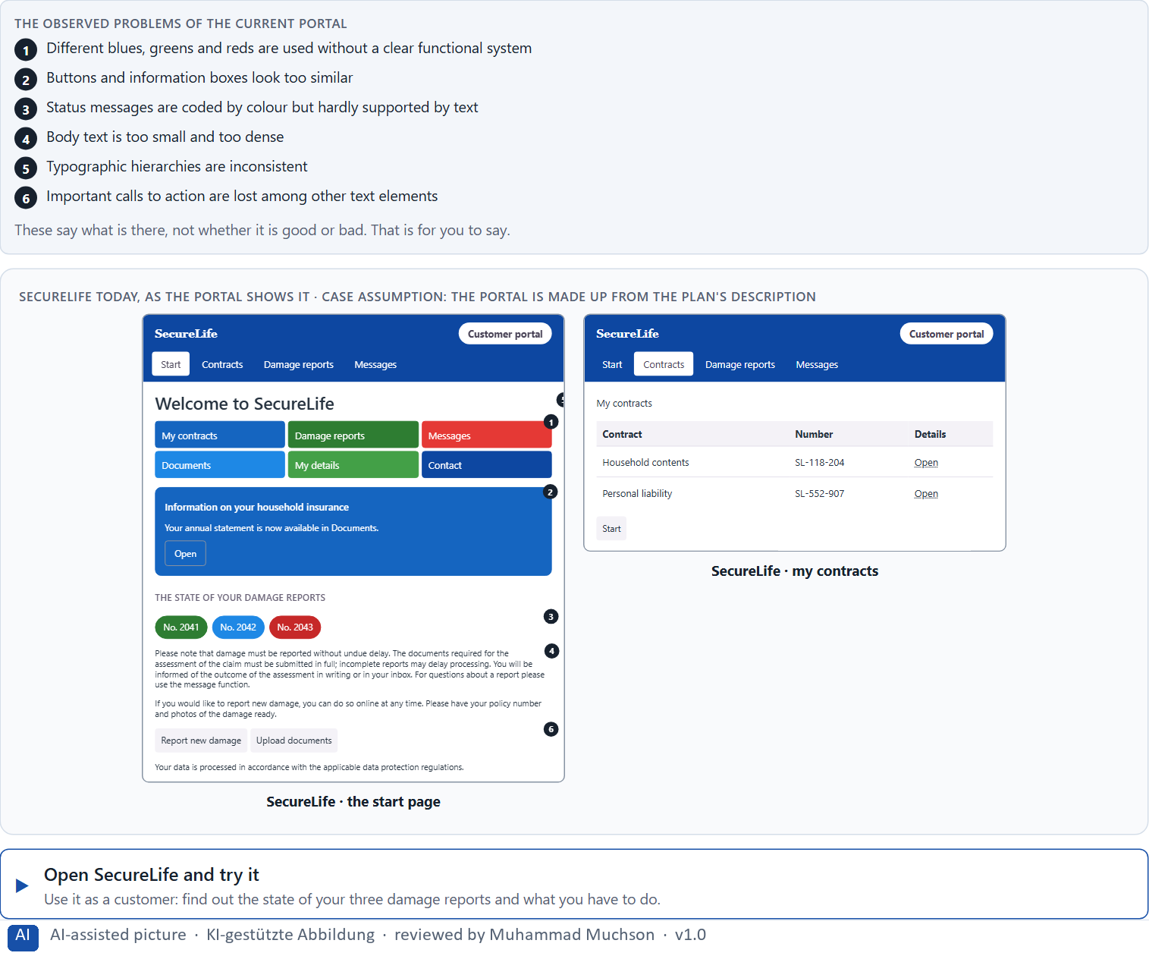
Figure 1 · SecureLife today, as the portal shows it.
Question 1 of 6 · Analyse the central problems in the use of colour and in the typography
How to build the answer:
- Open SecureLife and check the state of a damage report, then report a new one, as a customer would.
- Write one problem per line as an effect on the user: what colour or type makes hard, not only what is wrong with it.
Write them as a list, one problem per line, each as an effect on the user. At least five.

Question 2 of 6 · Assign the problems to the categories readability, orientation, consistency, trust effect and action guidance
Write the problems that belong to each category in a few words. A problem may fit two categories.
How to build the answer:
- Take your problems from question 1.
- Ask which of the five categories each one affects most, and write it there.
Category | The problems in this category
Readability
Orientation
Consistency
Trust effect
Action guidance

Question 3 of 6 · Develop 4 prioritised measures for improvement
How to build the answer:
- Turn each group of problems into something you could change within 12 weeks and within the corporate design.
- Put them in order: what the other measures build on, or what helps users most, first.
Write them as a numbered list, the first priority first, each with what it changes for users.

Question 4 of 6 · Justify your selection using effect on users, feasibility, risk and time pressure
Use all four criteria and say how they support your selection and its order.
How to build the answer:
- Say for your first measures what they change for users and why they are the base for the others.
- Say what is feasible within the corporate design and 12 weeks, and what risk each carries.
- Keep the different age groups in mind.

Question 5 of 6 · Make a prioritisation decision for the first 12 weeks
Say what you do in the first 12 weeks, in which order, and what you leave for later, with the reason.
How to build the answer:
- Say what comes first and why.
- Say what you do in parallel and what waits.
- Keep the corporate design and the age groups in mind.

Question 6 of 6 · Formulate a recommendation to the division management
Three to five sentences: what you recommend, what you prioritise, and what you expect to change.
How to build the answer:
- Lead with the recommendation.
- Name the priorities.
- Say what you expect to change for users and for the company.

Use in class: presentation and handout
Mark of use for the worksheet. Presentation is what the trainer shows on screen; Handout is what participants fill in and hand in.
Part of the worksheet | Presentation (shown in the Neuro-UX Lab) | Handout
Block 2.1 · Case study: revising the insurance portal SecureLife | The task wording at the start of the block (no answers are shown) | Worksheet block with answer boxes (Core)

Glossary
Every term below is used in this document. Terms stay plain text in the body; this list says what they mean in everyday words.
Term | In plain words | Example | Comes from
Body text | The running text of a page, as opposed to headings, labels and buttons. It carries most of the information and must be the easiest to read. | — | Day 3
Brand effect | How a design makes people recognise the company and what they feel about it, such as modern, serious or friendly. | — | Day 3
Call to action | An element that asks people to do something, such as “Report damage” or “Pay now”. It should be the easiest thing on the screen to see and press. | — | Day 3
Case assumption | A fact made up for this exercise to fill a gap in the plan's case. It is marked so you know it is not part of the plan. | — | Day 1
Chief Experience Officer | The manager who is responsible for the experience customers have across all channels, and who decides where the company invests in it. | — | Day 1
Consistency | The same thing looks, is named and works the same way everywhere, so what people learn on one page holds on the next. | — | Day 2
Contrast | How much something differs from its surroundings in brightness, colour or size. Strong contrast makes it stand out; too many strong contrasts make everything compete. | — | Day 2
Corporate design | A company's fixed visual identity: logo, brand colours, typeface and the way they are used. Functional adjustments can often be made within it. | — | Day 3
Decision architecture | A set of connected decisions that are made on purpose and written down: what effect you want, what comes first, who decides and how conflicts are settled. It replaces many separate fixes. | — | Day 1
Design logic | A set of decided rules and shared components, such as which colour means what and which type levels exist, used for every screen so everything stays consistent. | — | Day 3
Functional colour | Colour with a job: it tells people what can be done, what matters most or what state something is in. Each colour keeps one meaning everywhere. | — | Day 3
Governance | The rules about who may decide what, who is answerable for it and how disagreements are settled. | — | Day 1
Orientation | Knowing where you are, what you can do here and what happens next. | — | Day 1
Perception | Taking in what the senses deliver, for example what the eyes see on a screen, before thinking about it. | — | Day 1
Readability | How easily a text can be read and understood: its size, contrast, line length, wording and how it is broken into parts. | — | Day 2
Stakeholder | A person or department with an interest in a decision, such as marketing, compliance, IT or sales. | — | Day 1
Status colour | A colour that shows the state of something, such as sent, waiting or failed. It needs a word or a symbol next to it, because colour alone is missed or misread. | — | Day 3
Touchpoint | Any place where a person meets the company: the website, the customer portal, the app, a chatbot or a phone call. | — | Day 1
Typographic hierarchy | A small, fixed set of text levels, such as page heading, section heading, body text and note, that look clearly different and mean the same on every page. | — | Day 3
Typography | How text is set: which typeface, which size, weight, line spacing and line length, and how the text is broken into levels and parts. | — | Day 3
UX (user experience) | Everything a person goes through when using a product: what they notice, understand, feel and do, from the first look to the last step. The screens are only one part of it. | Finding the booking you want at once and feeling sure it went through is a good UX. | Day 1
Visual hierarchy | An order the eye can follow: the most important thing is clearly the strongest, the rest is quieter. Without it, everything competes equally. | — | Day 1

The Neuro-UX Lab: where we practise online
In class we use the course website as the place to practise and to learn. Every day has its own address, in the same pattern: the day number is the last part.
What | Address
Neuro-UX Lab (course website) | https://aion-ux-lab.vercel.app/
Day 3 | https://aion-ux-lab.vercel.app/day/3/

On the day page, Route 1 (Levels 1 and 2) and Route 2 (Level 3) can be opened; the cards and the tasks of this document are there too. The pattern is the same up to Day 8, for example https://aion-ux-lab.vercel.app/day/6/.

