AION · UX DEVELOPER · PSYCHOLOGICAL UX DESIGN AND NEURO-UX
DAY 5 · CASE STUDY · LEVEL 2 · 2 UE (UE5–6)
MoveEasy: Case study
The day's Level 2 case study with its questions; work on it alone, then compare in your group
AI notice · KI-Hinweis
This document was produced with the help of an AI language model (Claude, Anthropic). The AI drafted the text and tables and built the pictures and working examples of the lab. The content was then read, corrected and approved by the reviewer named below, who is responsible for its accuracy. Every picture carries an AI label on the image. Check figures and sources before you quote them.
KI-Hinweis: Dieses Dokument wurde mit Unterstützung eines KI-Sprachmodells (Claude, Anthropic) erstellt. Texte und Tabellen wurden von der KI entworfen, die Abbildungen sind KI-gestützt erstellt und am Bild gekennzeichnet. Die fachliche Prüfung und Freigabe erfolgte durch die unten genannte Person.

Day | Day 5 · Module 3 (day 2 of 3): Fitts, Hick and Miller in practice
Document | Case study (worksheet with answer spaces) for the 2 teaching units UE5–6.
Route and level | Level 2 · Application. Draws on Materi A.
Time | About 90 min (UE5–6), of which about 15–20 min of writing
Neuro-UX Lab (website) | https://aion-ux-lab.vercel.app/day/5/
Case | MoveEasy, the day's case study
Version | 1.0 · release date 29.10.2026
Review and approval | Muhammad Muchson, Mentor (subject-matter review and approval)

ABOUT THIS DOCUMENT
In class we also use the Neuro-UX Lab, the course website, as the place to practise and learn. Its address is at the end of this document.
This is the case study of Day 5. Read the case once, look at the picture, and write your answers in the boxes and tables. You can work on paper or type into the document. There are no answer keys in this document; the trainer closes the unit with the model solution.

IN THIS DOCUMENT
Lesson plan: ten teaching units (Ablaufplan)
Case study and transfer project at a glance
Block 2.1 · Case study: optimising the booking and management portal MoveEasy · JUDGED · Core · about 15 min

Day at a glance
Day 5 has ten teaching units (UE). This document is the worksheet; it is used in UE2 to UE6 (Task 1) and UE8 to UE10 (Task 2). The day is built from three documents and the Neuro-UX Lab: Materi (study material), Task (worksheet) and Trainer (coaching, feedback and model solutions), plus the course website.

Lesson plan: ten teaching units (Ablaufplan)
UE | Min | Plan item | What happens | Material | Format
1 | 45 | Knowledge transfer · Level 1 | The trainer presents the cards of Materi A (A1, A2, A3, A4, A5, about 60 min of cards) in the Neuro-UX Lab; participants follow in the handout. | Materi A (Route 1) | Presentation + Handout
2 | 45 | Level 1 · Task 1 | Individual work on Block 1.1 (Core, about 10 min): the first product of the day is read and its effect described. Pairs then compare their results and the trainer collects open questions. | Task 1 · Part 1 · Block 1.1 | Handout (or in the lab)
3 | 45 | Level 1 · Task 2 | Three options are rated on the same criteria and one is chosen under the stated conditions: Block 1.2 (Core, about 8 min). | Task 1 · Part 1 · Block 1.2 | Handout (or in the lab)
4 | 45 | Coaching · transition from Level 1 to Level 2 | Trainer-led. A short talk on the day's coaching focus, then the reflection questions in pairs. The bridge: from describing an effect to a decision you answer for. There is no worksheet block in this unit. | Trainer document, section Coaching | Trainer only
5–6 | 90 | Level 2 · Case study MoveEasy (2 UE) incl. model solution | UE5: the trainer presents the case; participants work on Block 2.1 (Core, about 15 min). UE6: groups compare their results and defend them; the trainer closes with the model solution. | Task 1 · Part 2 · Block 2.1  Trainer document, section Case study | Handout; model solution shown after the work
7 | 45 | Level 2 + 3 · Feedback round with a management perspective | Groups present their reasoning, not only their result. The trainer asks the day's Level 3 input questions and leads the discussion. | Trainer document, section Feedback round | Presentation by the groups; Trainer only
8 | 45 | Level 3 · Transfer project, Chief Experience Officer (3 UE: UE8–10) | The trainer presents Materi B (B1, B2, B3; use the "In plain words" and "How to decide" boxes, the rest is handout) and sets the role and the situation. | Materi B (Route 2) | Presentation + Handout
9 | 45 | Level 3 · Transfer project | Individual work or in pairs on Block 3.1 (Core, about 20 min): the strategy memo. | Task 2 · Block 3.1 | Handout (or in the lab)
10 | 45 | Level 3 · Transfer project | Participants present their decision and what they give up, including the one decision made under uncertainty; the trainer debriefs with the model solution. | Task 2 · Block 3.1  Trainer document, section Transfer project | Handout; model solution shown after the work

One UE is counted as 45 minutes here; breaks are not shown. The times are a guide for the trainer. The Core blocks are enough for a complete answer.

Case study and transfer project at a glance
Component | UE | Duration | Participants work in | Model solution in
Level 2 case study (MoveEasy) | UE5–6 | 2 UE · 90 min | Task 1 · Part 2 (Block 2.1) | Trainer document, section Case study
Level 3 transfer project (Chief Experience Officer) | UE8–10 | 3 UE · 135 min | Materi B and Task 2 (Block 3.1) | Trainer document, section Transfer project

Part 2 · The case study · Level 2 · Application · Case study (2 UE)
Case study: 2 teaching units (UE5–6)
This part is the day's Level 2 case study. It takes 2 UE (about 90 minutes): UE5 for the briefing and your own work, UE6 for comparing your results with your group and for the trainer's closing. The block below needs about 15 minutes of writing; the rest of the time is discussion.

Block 2.1 · Case study: optimising the booking and management portal MoveEasy · JUDGED · Core · about 15 min
Draws on: A1 · Fitts's law · A2 · Hick's law · A3 · Miller's rule · A4 · The three laws together · A5 · Less searching, fewer errors, less decision stress, and weighing a measure.
A provider of mobility services runs MoveEasy, a portal where users book trips, manage tickets, change payment data and send support requests. The portal is rich in functions, but use is slow and error-prone; above all on mobile devices, mis-taps and abandoned processes pile up. The observed problems: central booking buttons are small and partly badly placed, too many options at once on the start page raise uncertainty, users have to remember several tariffs and conditions at once, important actions lie in long lists of similar options, process steps offer too many equal choices, and mobile interaction is hard because touch targets are too small. The conditions: a budget of €140,000, 10 weeks for the implementation, mobile use is already above 60 %, a complete relaunch is not possible, marketing wants to keep as many offers visible as possible, and support demands fewer operating errors and questions. You work through six steps.
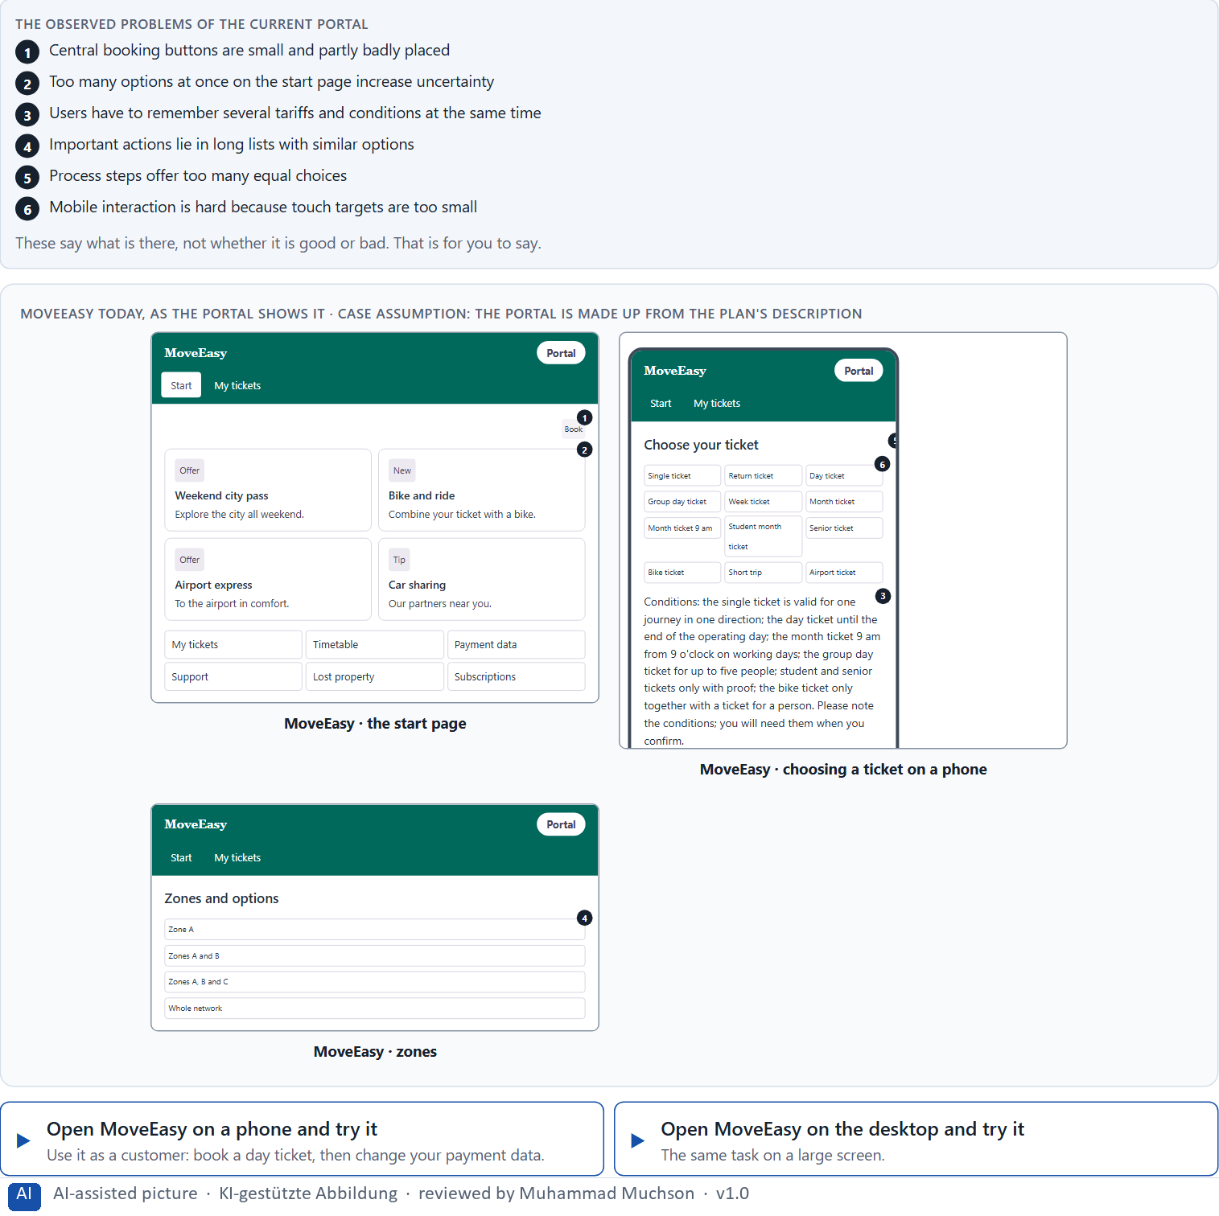
Figure 1 · MoveEasy today, as the portal shows it.
Question 1 of 6 · Analyse the central problems of interaction and decision in the portal
How to build the answer:
- Open MoveEasy on a phone and book a day ticket, then change your payment data, as a customer would.
- Write one problem per line as an effect on the user, and note the law behind it if you see one.
Write them as a list, one problem per line, each as an effect on the user. At least five.

Question 2 of 6 · Assign the problems to the categories reachability, decision effort, memory load, mobile usability and error risk
Write the problems that belong to each category in a few words. A problem may fit two categories.
How to build the answer:
- Take your problems from question 1.
- Ask which of the five categories each one affects most, and write it there.
Category | The problems in this category
Reachability
Decision effort
Memory load
Mobile usability
Error risk

Question 3 of 6 · Develop 4 prioritised measures for improvement
How to build the answer:
- Turn each group of problems into something you could change within 10 weeks and without a relaunch.
- Put them in order: what helps most users soonest, above all on the phone, first.
Write them as a numbered list, the first priority first, each with what it changes for users.

Question 4 of 6 · Justify your selection using effect on users, feasibility, risk and time pressure
Use all four criteria and say how they support your selection and its order.
How to build the answer:
- Say for your first measure what it changes for speed and errors, above all on the phone.
- Say what is feasible without a relaunch, and the risk of each.
- Keep marketing and support in mind, and the 10 weeks.

Question 5 of 6 · Make a prioritisation decision for the first 10 weeks
Say what you do in the first 10 weeks, in which order, and what you leave for later, with the reason.
How to build the answer:
- Say what comes first and why.
- Say what you do in parallel and what waits.
- Say how you deal with marketing's offers.

Question 6 of 6 · Formulate a recommendation to the division management
Three to five sentences: what you recommend, what has priority, and what you expect to change.
How to build the answer:
- Lead with the recommendation.
- Name the priorities.
- Say what you expect to change for users and for the company.

Use in class: presentation and handout
Mark of use for the worksheet. Presentation is what the trainer shows on screen; Handout is what participants fill in and hand in.
Part of the worksheet | Presentation (shown in the Neuro-UX Lab) | Handout
Block 2.1 · Case study: optimising the booking and management portal MoveEasy | The task wording at the start of the block (no answers are shown) | Worksheet block with answer boxes (Core)

Glossary
Every term below is used in this document. Terms stay plain text in the body; this list says what they mean in everyday words.
Term | In plain words | Example | Comes from
Action logic | The order in which a task runs: where it starts, which steps follow, what each step asks and how the person knows they are done. | — | Day 4
Case assumption | A fact made up for this exercise to fill a gap in the plan's case. It is marked so you know it is not part of the plan. | — | Day 1
Chief Experience Officer | The manager who is responsible for the experience customers have across all channels, and who decides where the company invests in it. | — | Day 1
Decision architecture | A set of connected decisions that are made on purpose and written down: what effect you want, what comes first, who decides and how conflicts are settled. It replaces many separate fixes. | — | Day 1
Decision effort | The mental work of comparing options and choosing one. Many equal options raise it. | — | Day 4
Decision stress | The strain people feel when they have to choose between many similar options and fear choosing wrongly. | — | Day 5
Error probability | How likely a person is to make a mistake at a given step. Small targets, many similar options and things to remember all raise it. | — | Day 5
Fitts's law | A target is reached faster and missed less often when it is large and close. Small, distant buttons cost time and cause wrong taps. | — | Day 4
Governance | The rules about who may decide what, who is answerable for it and how disagreements are settled. | — | Day 1
Hick's law | The more equally weighted options people have to choose from, the longer the decision takes. It matters most for unfamiliar options that look alike. | — | Day 4
Interaction standard | A written rule every team follows for how interaction works, such as a minimum target size, one main action per screen or a limit on equal options. | — | Day 5
Memory load | How much a person has to keep in mind while using an interface, such as a number from an earlier screen or the option chosen two steps back. | — | Day 4
Miller's rule | Short-term memory holds only a few things at once, about seven in Miller's old estimate and nearer four in later research. Interfaces should not make people remember what the system knows. | — | Day 4
Mis-tap | A tap that hits the wrong target, often because targets are small or close together. | — | Day 5
Mobile usability | How well a product can be used on a phone: one-handed, on a small screen, often on the move. | — | Day 5
Operating error | A wrong action caused by the interface, such as tapping the wrong button or sending a form twice because nothing confirmed it. | — | Day 4
Orientation | Knowing where you are, what you can do here and what happens next. | — | Day 1
Reachability | How easily a target can be reached and hit: its size, its distance from the hand or pointer, and the space around it. | — | Day 5
Stakeholder | A person or department with an interest in a decision, such as marketing, compliance, IT or sales. | — | Day 1
Touch target | The area of a button or link that reacts to a tap or a click. It can be larger than the visible label; too small, and people miss it. | — | Day 5
UX (user experience) | Everything a person goes through when using a product: what they notice, understand, feel and do, from the first look to the last step. The screens are only one part of it. | Finding the booking you want at once and feeling sure it went through is a good UX. | Day 1
UX law | A well-tested finding about how people perceive, decide or act, used as a rule of thumb in design, such as Hick's law or Fitts's law. It explains why something is hard; it does not replace looking at the users. | — | Day 4

The Neuro-UX Lab: where we practise online
In class we use the course website as the place to practise and to learn. Every day has its own address, in the same pattern: the day number is the last part.
What | Address
Neuro-UX Lab (course website) | https://aion-ux-lab.vercel.app/
Day 5 | https://aion-ux-lab.vercel.app/day/5/

On the day page, Route 1 (Levels 1 and 2) and Route 2 (Level 3) can be opened; the cards and the tasks of this document are there too. The pattern is the same up to Day 8, for example https://aion-ux-lab.vercel.app/day/6/.

