AION · UX DEVELOPER · PSYCHOLOGICAL UX DESIGN AND NEURO-UX
DAY 6 · CASE STUDY · LEVEL 2 · 2 UE (UE5–6)
CitizenFlow: Case study
The day's Level 2 case study with its questions; work on it alone, then compare in your group
AI notice · KI-Hinweis
This document was produced with the help of an AI language model (Claude, Anthropic). The AI drafted the text and tables and built the pictures and working examples of the lab. The content was then read, corrected and approved by the reviewer named below, who is responsible for its accuracy. Every picture carries an AI label on the image. Check figures and sources before you quote them.
KI-Hinweis: Dieses Dokument wurde mit Unterstützung eines KI-Sprachmodells (Claude, Anthropic) erstellt. Texte und Tabellen wurden von der KI entworfen, die Abbildungen sind KI-gestützt erstellt und am Bild gekennzeichnet. Die fachliche Prüfung und Freigabe erfolgte durch die unten genannte Person.

Day | Day 6 · Module 3 (day 3 of 3): Gestalt, hierarchy, progressive disclosure and design systems
Document | Case study (worksheet with answer spaces) for the 2 teaching units UE5–6.
Route and level | Level 2 · Application. Draws on Materi A.
Time | About 90 min (UE5–6), of which about 15–20 min of writing
Neuro-UX Lab (website) | https://aion-ux-lab.vercel.app/day/6/
Case | CitizenFlow, the day's case study
Version | 1.0 · release date 29.10.2026
Review and approval | Muhammad Muchson, Mentor (subject-matter review and approval)

ABOUT THIS DOCUMENT
In class we also use the Neuro-UX Lab, the course website, as the place to practise and learn. Its address is at the end of this document.
This is the case study of Day 6. Read the case once, look at the picture, and write your answers in the boxes and tables. You can work on paper or type into the document. There are no answer keys in this document; the trainer closes the unit with the model solution.

IN THIS DOCUMENT
Lesson plan: ten teaching units (Ablaufplan)
Case study and transfer project at a glance
Block 2.1 · Case study: consolidating the self-service system CitizenFlow · JUDGED · Core · about 15 min

Day at a glance
Day 6 has ten teaching units (UE). This document is the worksheet; it is used in UE2 to UE6 (Task 1) and UE8 to UE10 (Task 2). The day is built from three documents and the Neuro-UX Lab: Materi (study material), Task (worksheet) and Trainer (coaching, feedback and model solutions), plus the course website.

Lesson plan: ten teaching units (Ablaufplan)
UE | Min | Plan item | What happens | Material | Format
1 | 45 | Knowledge transfer · Level 1 | The trainer presents the cards of Materi A (A1, A2, A3, A4, A5, about 60 min of cards) in the Neuro-UX Lab; participants follow in the handout. | Materi A (Route 1) | Presentation + Handout
2 | 45 | Level 1 · Task 1 | Individual work on Block 1.1 (Core, about 10 min): the first product of the day is read and its effect described. Pairs then compare their results and the trainer collects open questions. | Task 1 · Part 1 · Block 1.1 | Handout (or in the lab)
3 | 45 | Level 1 · Task 2 | Three options are rated on the same criteria and one is chosen under the stated conditions: Block 1.2 (Core, about 8 min). | Task 1 · Part 1 · Block 1.2 | Handout (or in the lab)
4 | 45 | Coaching · transition from Level 1 to Level 2 | Trainer-led. A short talk on the day's coaching focus, then the reflection questions in pairs. The bridge: from describing an effect to a decision you answer for. There is no worksheet block in this unit. | Trainer document, section Coaching | Trainer only
5–6 | 90 | Level 2 · Case study CitizenFlow (2 UE) incl. model solution | UE5: the trainer presents the case; participants work on Block 2.1 (Core, about 15 min). UE6: groups compare their results and defend them; the trainer closes with the model solution. | Task 1 · Part 2 · Block 2.1  Trainer document, section Case study | Handout; model solution shown after the work
7 | 45 | Level 2 + 3 · Feedback round with a management perspective | Groups present their reasoning, not only their result. The trainer asks the day's Level 3 input questions and leads the discussion. | Trainer document, section Feedback round | Presentation by the groups; Trainer only
8 | 45 | Level 3 · Transfer project, Chief Experience Officer (3 UE: UE8–10) | The trainer presents Materi B (B1, B2, B3; use the "In plain words" and "How to decide" boxes, the rest is handout) and sets the role and the situation. | Materi B (Route 2) | Presentation + Handout
9 | 45 | Level 3 · Transfer project | Individual work or in pairs on Block 3.1 (Core, about 20 min): the strategy memo. | Task 2 · Block 3.1 | Handout (or in the lab)
10 | 45 | Level 3 · Transfer project | Participants present their decision and what they give up, including the one decision made under uncertainty; the trainer debriefs with the model solution. | Task 2 · Block 3.1  Trainer document, section Transfer project | Handout; model solution shown after the work

One UE is counted as 45 minutes here; breaks are not shown. The times are a guide for the trainer. The Core blocks are enough for a complete answer.

Case study and transfer project at a glance
Component | UE | Duration | Participants work in | Model solution in
Level 2 case study (CitizenFlow) | UE5–6 | 2 UE · 90 min | Task 1 · Part 2 (Block 2.1) | Trainer document, section Case study
Level 3 transfer project (Chief Experience Officer) | UE8–10 | 3 UE · 135 min | Materi B and Task 2 (Block 3.1) | Trainer document, section Transfer project

Part 2 · The case study · Level 2 · Application · Case study (2 UE)
Case study: 2 teaching units (UE5–6)
This part is the day's Level 2 case study. It takes 2 UE (about 90 minutes): UE5 for the briefing and your own work, UE6 for comparing your results with your group and for the trainer's closing. The block below needs about 15 minutes of writing; the rest of the time is discussion.

Block 2.1 · Case study: consolidating the self-service system CitizenFlow · JUDGED · Core · about 15 min
Draws on: A1 · Gestalt laws for navigation · A2 · Visual hierarchy · A3 · Progressive disclosure · A4 · Hierarchy, navigation logic and relief · A5 · From screens to components.
A public service platform gives citizens access to applications, appointment bookings, certificates and status queries. It is extensive in functions, but in many areas it feels inconsistent and overwhelming. Users often lose orientation, abandon applications or contact support although self-service is available. The observed problems: different page types group content differently, primary and secondary actions are not cleanly separated, forms show all fields at once, also optional and context-dependent ones, navigation patterns vary between areas with a similar function, additional information, help and warnings are not cleanly prioritised, and users have to work out themselves which information is relevant and which is only supplementary. The conditions: a budget of €170,000, 14 weeks for the implementation, a complete relaunch is ruled out, several departments have their own requirements, consistency across the service areas is low so far, and usage data is only partly available. You work through six steps.
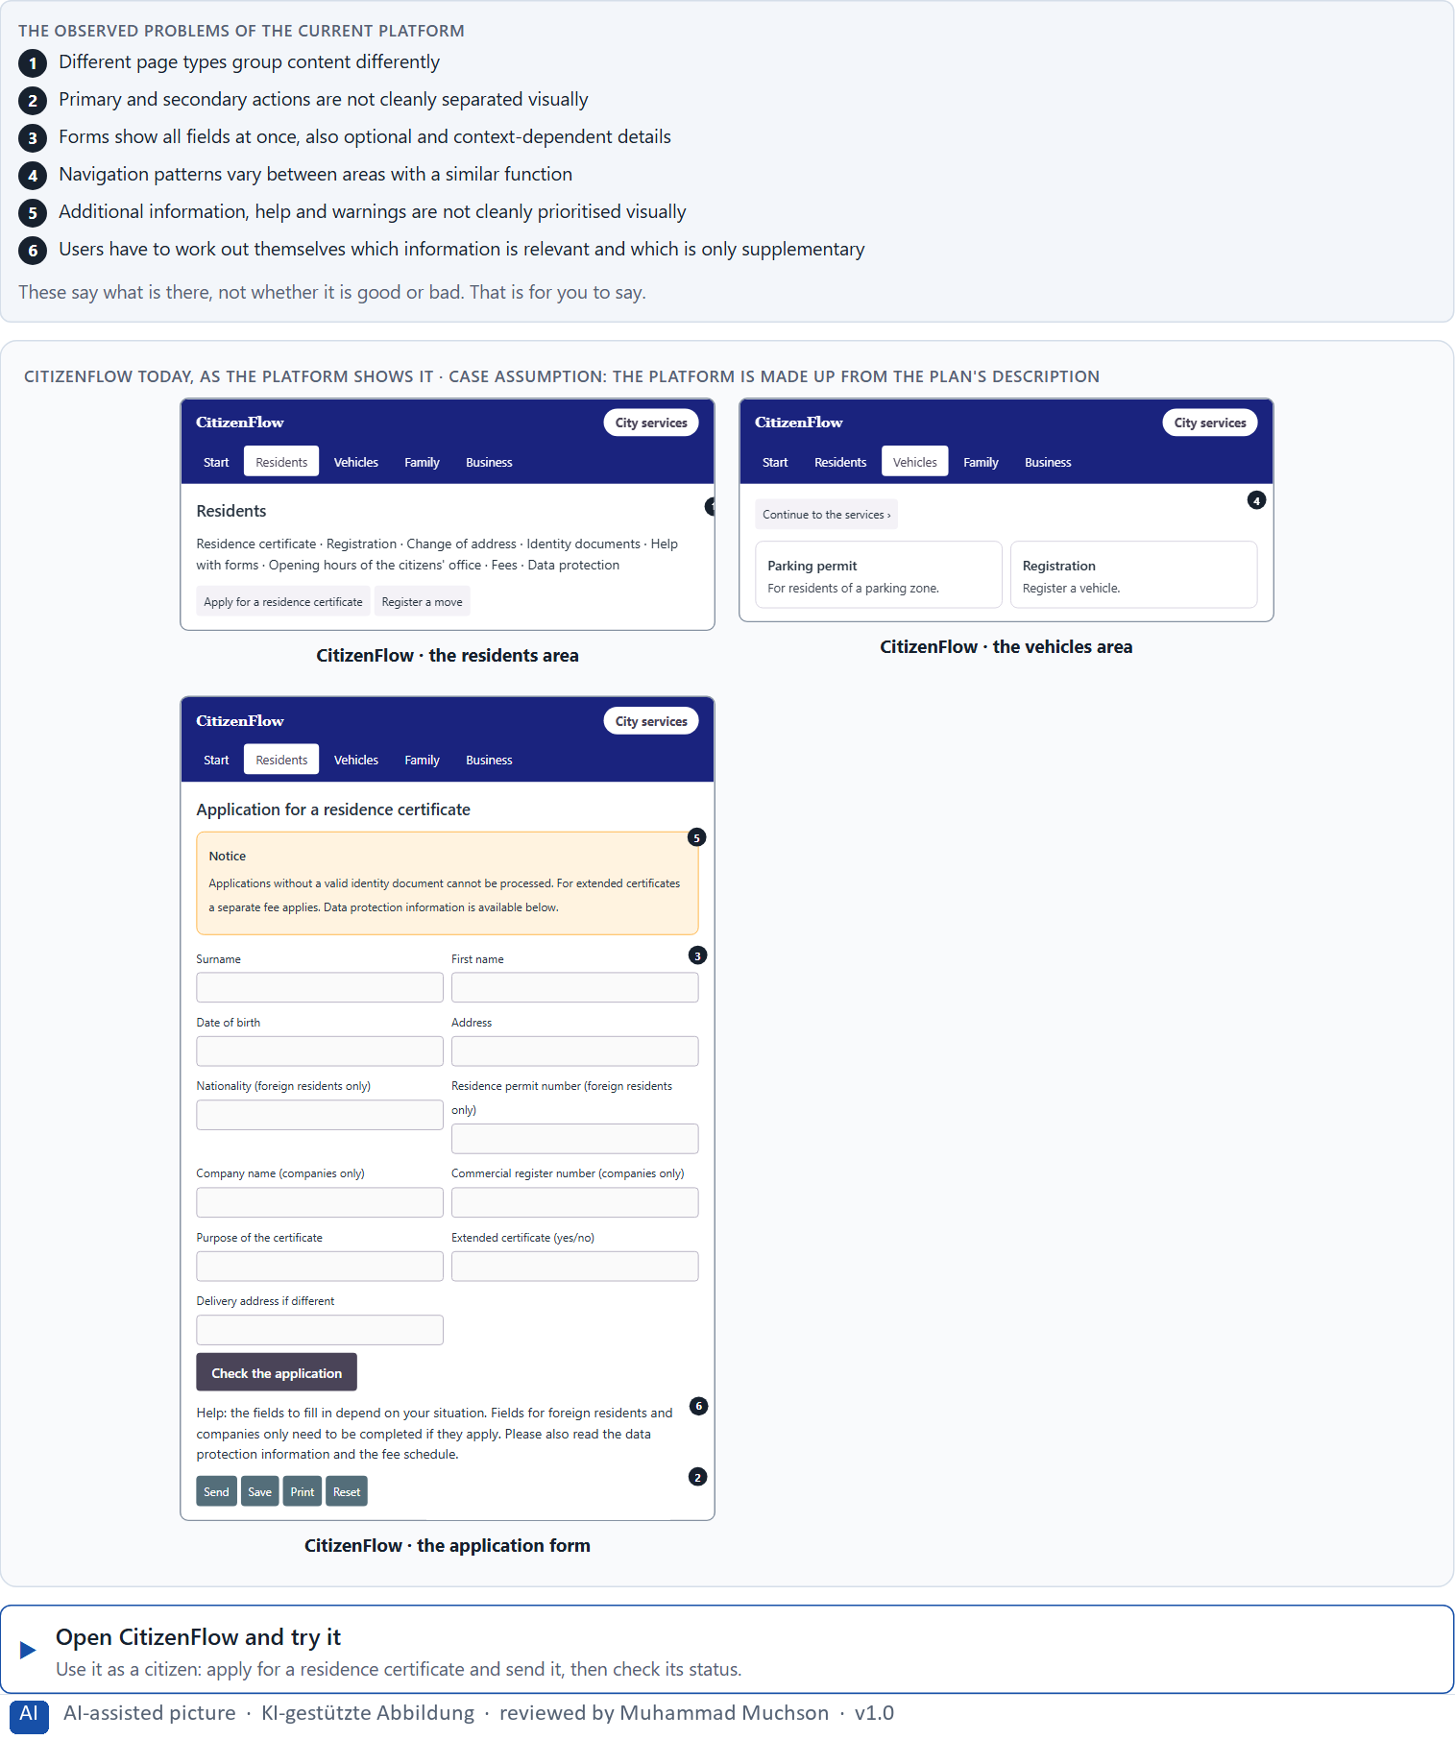
Figure 1 · CitizenFlow today, as the platform shows it.
Question 1 of 6 · Analyse the central problems with regard to Gestalt laws, visual hierarchy and progressive disclosure
How to build the answer:
- Open CitizenFlow and apply for a residence certificate, then book an appointment, as a citizen would.
- Write one problem per line as an effect on the user, and note whether it is about grouping, hierarchy or disclosure.
Write them as a list, one problem per line, each as an effect on the user. At least five.

Question 2 of 6 · Assign the problems to the categories grouping, prioritisation, disclosure of information, consistency and navigation logic
Write the problems that belong to each category in a few words. A problem may fit two categories.
How to build the answer:
- Take your problems from question 1.
- Ask which of the five categories each one affects most, and write it there.
Category | The problems in this category
Grouping
Prioritisation
Disclosure of information
Consistency
Navigation logic

Question 3 of 6 · Develop 4 prioritised measures for improvement
How to build the answer:
- Turn each group of problems into something you could change within 14 weeks and without a relaunch.
- Put them in order, and think about which measure keeps the others in place.
Write them as a numbered list, the first priority first, each with what it changes for users.

Question 4 of 6 · Justify your selection using effect on users, feasibility, risk and time pressure
Use all four criteria and say how they support your selection and its order.
How to build the answer:
- Say for your first measures how they lower overload and improve orientation.
- Say what is feasible without a relaunch and with several departments, and the risk of each.
- Say which measure keeps the others in place over time.

Question 5 of 6 · Make a prioritisation decision for the first 14 weeks
Say what you do in the first 14 weeks, in which order, and what you leave for later, with the reason.
How to build the answer:
- Say what comes first and why.
- Say what you do in parallel and what waits.
- Say how you deal with the departments' own requirements.

Question 6 of 6 · Formulate a recommendation to the division management
Three to five sentences: what you recommend, what has priority, and what you expect to change.
How to build the answer:
- Lead with the recommendation.
- Name the priorities.
- Say what you expect to change for users and for the organisation.

Use in class: presentation and handout
Mark of use for the worksheet. Presentation is what the trainer shows on screen; Handout is what participants fill in and hand in.
Part of the worksheet | Presentation (shown in the Neuro-UX Lab) | Handout
Block 2.1 · Case study: consolidating the self-service system CitizenFlow | The task wording at the start of the block (no answers are shown) | Worksheet block with answer boxes (Core)

Glossary
Every term below is used in this document. Terms stay plain text in the body; this list says what they mean in everyday words.
Term | In plain words | Example | Comes from
Case assumption | A fact made up for this exercise to fill a gap in the plan's case. It is marked so you know it is not part of the plan. | — | Day 1
Chief Experience Officer | The manager who is responsible for the experience customers have across all channels, and who decides where the company invests in it. | — | Day 1
Cognitive load | How much a person has to hold in mind and work out at the same time. Every extra signal or choice adds to it; when it is too high, people skip, freeze or leave. | — | Day 1
Component | A reusable building block of an interface, such as a button, a form field or a status label, built once and used on many screens. | — | Day 6
Consistency | The same thing looks, is named and works the same way everywhere, so what people learn on one page holds on the next. | — | Day 2
Decision architecture | A set of connected decisions that are made on purpose and written down: what effect you want, what comes first, who decides and how conflicts are settled. It replaces many separate fixes. | — | Day 1
Design logic | A set of decided rules and shared components, such as which colour means what and which type levels exist, used for every screen so everything stays consistent. | — | Day 3
Design system | A shared set of principles, components and patterns that every team uses to build its screens, so the product stays consistent and new screens are built faster. | — | Day 6
Error probability | How likely a person is to make a mistake at a given step. Small targets, many similar options and things to remember all raise it. | — | Day 5
Gestalt principles | Rules for how people see parts as a whole, such as proximity (close things belong together) and similarity (alike things belong together). | — | Day 2
Governance | The rules about who may decide what, who is answerable for it and how disagreements are settled. | — | Day 1
Grouping | Showing what belongs together, for example by putting it close together or making it look alike. The eye reads a group as one unit. | — | Day 2
Information density | How much a screen shows at once. Too much and everything competes; too little and people have to click a lot to reach anything. | — | Day 2
Orientation | Knowing where you are, what you can do here and what happens next. | — | Day 1
Page type | A kind of page that appears many times, such as a course page, a certificate page or a booking page. Each type should keep the same structure. | — | Day 2
Predictability | Being able to tell in advance how something will work, because it works like what you have seen before. | — | Day 6
Primary and secondary action | The primary action is the one thing most people should do now and should look strongest; secondary actions are other options and look quieter. | — | Day 6
Problematic hiding | When information people need to decide is buried so deep that they miss it. It looks like simplicity and makes decisions unsafe. | — | Day 6
Progressive disclosure | Showing the few most important things first and the rest one step deeper, on request, so the first screen stays clear. | — | Day 2
Stakeholder | A person or department with an interest in a decision, such as marketing, compliance, IT or sales. | — | Day 1
Status colour | A colour that shows the state of something, such as sent, waiting or failed. It needs a word or a symbol next to it, because colour alone is missed or misread. | — | Day 3
UX (user experience) | Everything a person goes through when using a product: what they notice, understand, feel and do, from the first look to the last step. The screens are only one part of it. | Finding the booking you want at once and feeling sure it went through is a good UX. | Day 1
UX law | A well-tested finding about how people perceive, decide or act, used as a rule of thumb in design, such as Hick's law or Fitts's law. It explains why something is hard; it does not replace looking at the users. | — | Day 4
Visual hierarchy | An order the eye can follow: the most important thing is clearly the strongest, the rest is quieter. Without it, everything competes equally. | — | Day 1

The Neuro-UX Lab: where we practise online
In class we use the course website as the place to practise and to learn. Every day has its own address, in the same pattern: the day number is the last part.
What | Address
Neuro-UX Lab (course website) | https://aion-ux-lab.vercel.app/
Day 6 | https://aion-ux-lab.vercel.app/day/6/

On the day page, Route 1 (Levels 1 and 2) and Route 2 (Level 3) can be opened; the cards and the tasks of this document are there too. The pattern is the same up to Day 8, for example https://aion-ux-lab.vercel.app/day/6/.

