AION · UX DEVELOPER · PSYCHOLOGICAL UX DESIGN AND NEURO-UX
DAY 8 · CASE STUDY · LEVEL 2 · 2 UE (UE5–6)
GreenHome: Case study
The day's Level 2 case study with its questions; work on it alone, then compare in your group
AI notice · KI-Hinweis
This document was produced with the help of an AI language model (Claude, Anthropic). The AI drafted the text and tables and built the pictures and working examples of the lab. The content was then read, corrected and approved by the reviewer named below, who is responsible for its accuracy. Every picture carries an AI label on the image. Check figures and sources before you quote them.
KI-Hinweis: Dieses Dokument wurde mit Unterstützung eines KI-Sprachmodells (Claude, Anthropic) erstellt. Texte und Tabellen wurden von der KI entworfen, die Abbildungen sind KI-gestützt erstellt und am Bild gekennzeichnet. Die fachliche Prüfung und Freigabe erfolgte durch die unten genannte Person.

Day | Day 8 · Module 4 (day 2 of 3): Storytelling in UX/UI design
Document | Case study (worksheet with answer spaces) for the 2 teaching units UE5–6.
Route and level | Level 2 · Application. Draws on Materi A.
Time | About 90 min (UE5–6), of which about 15–20 min of writing
Neuro-UX Lab (website) | https://aion-ux-lab.vercel.app/day/8/
Case | GreenHome, the day's case study
Version | 1.0 · release date 29.10.2026
Review and approval | Muhammad Muchson, Mentor (subject-matter review and approval)

ABOUT THIS DOCUMENT
In class we also use the Neuro-UX Lab, the course website, as the place to practise and learn. Its address is at the end of this document.
This is the case study of Day 8. Read the case once, look at the picture, and write your answers in the boxes and tables. You can work on paper or type into the document. There are no answer keys in this document; the trainer closes the unit with the model solution.

IN THIS DOCUMENT
Lesson plan: ten teaching units (Ablaufplan)
Case study and transfer project at a glance
Block 2.1 · Case study: redesigning the GreenHome onboarding · JUDGED · Core · about 15 min

Day at a glance
Day 8 has ten teaching units (UE). This document is the worksheet; it is used in UE2 to UE6 (Task 1) and UE8 to UE10 (Task 2). The day is built from three documents and the Neuro-UX Lab: Materi (study material), Task (worksheet) and Trainer (coaching, feedback and model solutions), plus the course website.

Lesson plan: ten teaching units (Ablaufplan)
UE | Min | Plan item | What happens | Material | Format
1 | 45 | Knowledge transfer · Level 1 | The trainer presents the cards of Materi A (A1, A2, A3, A4, A5, about 60 min of cards) in the Neuro-UX Lab; participants follow in the handout. | Materi A (Route 1) | Presentation + Handout
2 | 45 | Level 1 · Task 1 | Individual work on Block 1.1 (Core, about 10 min): the first product of the day is read and its effect described. Pairs then compare their results and the trainer collects open questions. | Task 1 · Part 1 · Block 1.1 | Handout (or in the lab)
3 | 45 | Level 1 · Task 2 | Three options are rated on the same criteria and one is chosen under the stated conditions: Block 1.2 (Core, about 8 min). | Task 1 · Part 1 · Block 1.2 | Handout (or in the lab)
4 | 45 | Coaching · transition from Level 1 to Level 2 | Trainer-led. A short talk on the day's coaching focus, then the reflection questions in pairs. The bridge: from describing an effect to a decision you answer for. There is no worksheet block in this unit. | Trainer document, section Coaching | Trainer only
5–6 | 90 | Level 2 · Case study GreenHome (2 UE) incl. model solution | UE5: the trainer presents the case; participants work on Block 2.1 (Core, about 15 min). UE6: groups compare their results and defend them; the trainer closes with the model solution. | Task 1 · Part 2 · Block 2.1  Trainer document, section Case study | Handout; model solution shown after the work
7 | 45 | Level 2 + 3 · Feedback round with a management perspective | Groups present their reasoning, not only their result. The trainer asks the day's Level 3 input questions and leads the discussion. | Trainer document, section Feedback round | Presentation by the groups; Trainer only
8 | 45 | Level 3 · Transfer project, Chief Experience Officer (3 UE: UE8–10) | The trainer presents Materi B (B1, B2, B3; use the "In plain words" and "How to decide" boxes, the rest is handout) and sets the role and the situation. | Materi B (Route 2) | Presentation + Handout
9 | 45 | Level 3 · Transfer project | Individual work or in pairs on Block 3.1 (Core, about 20 min): the strategy memo. | Task 2 · Block 3.1 | Handout (or in the lab)
10 | 45 | Level 3 · Transfer project | Participants present their decision and what they give up, including the one decision made under uncertainty; the trainer debriefs with the model solution. | Task 2 · Block 3.1  Trainer document, section Transfer project | Handout; model solution shown after the work

One UE is counted as 45 minutes here; breaks are not shown. The times are a guide for the trainer. The Core blocks are enough for a complete answer.

Case study and transfer project at a glance
Component | UE | Duration | Participants work in | Model solution in
Level 2 case study (GreenHome) | UE5–6 | 2 UE · 90 min | Task 1 · Part 2 (Block 2.1) | Trainer document, section Case study
Level 3 transfer project (Chief Experience Officer) | UE8–10 | 3 UE · 135 min | Materi B and Task 2 (Block 3.1) | Trainer document, section Transfer project

Part 2 · The case study · Level 2 · Application · Case study (2 UE)
Case study: 2 teaching units (UE5–6)
This part is the day's Level 2 case study. It takes 2 UE (about 90 minutes): UE5 for the briefing and your own work, UE6 for comparing your results with your group and for the trainer's closing. The block below needs about 15 minutes of writing; the rest of the time is discussion.

Block 2.1 · Case study: redesigning the GreenHome onboarding · JUDGED · Core · about 15 min
Draws on: A1 · Why people experience a process as a story · A2 · The elements of narrative guidance · A3 · Telling a story or guiding with one · A4 · Orientation, motivation and memorability, and the risk of overload · A5 · Embedding an action in its context, and weighing a measure.
A company for sustainable energy solutions offers GreenHome, a digital platform for advice, product selection and funding support. The onboarding is functionally complete, but users experience it as sober, long-winded and not very motivating. Many start the process but abandon it before the end. The company wants to make it emotionally more connecting and dramaturgically clearer, without losing specialist clarity. The observed problems: the entry explains functions, but not the personal benefit or the goal for users; the sequence of steps feels administrative rather than developmental; intermediate states and progress are barely visible; help and hints explain but do not motivate; finishing a step does not feel like progress; and the whole feels like a form process rather than an accompanied journey. The conditions: a budget of €155,000, 12 weeks for the implementation, contents and specialist logic must largely be kept, the company wants to look inspiring but serious, user data is only partly available, and a complete relaunch is not possible. You work through six steps.
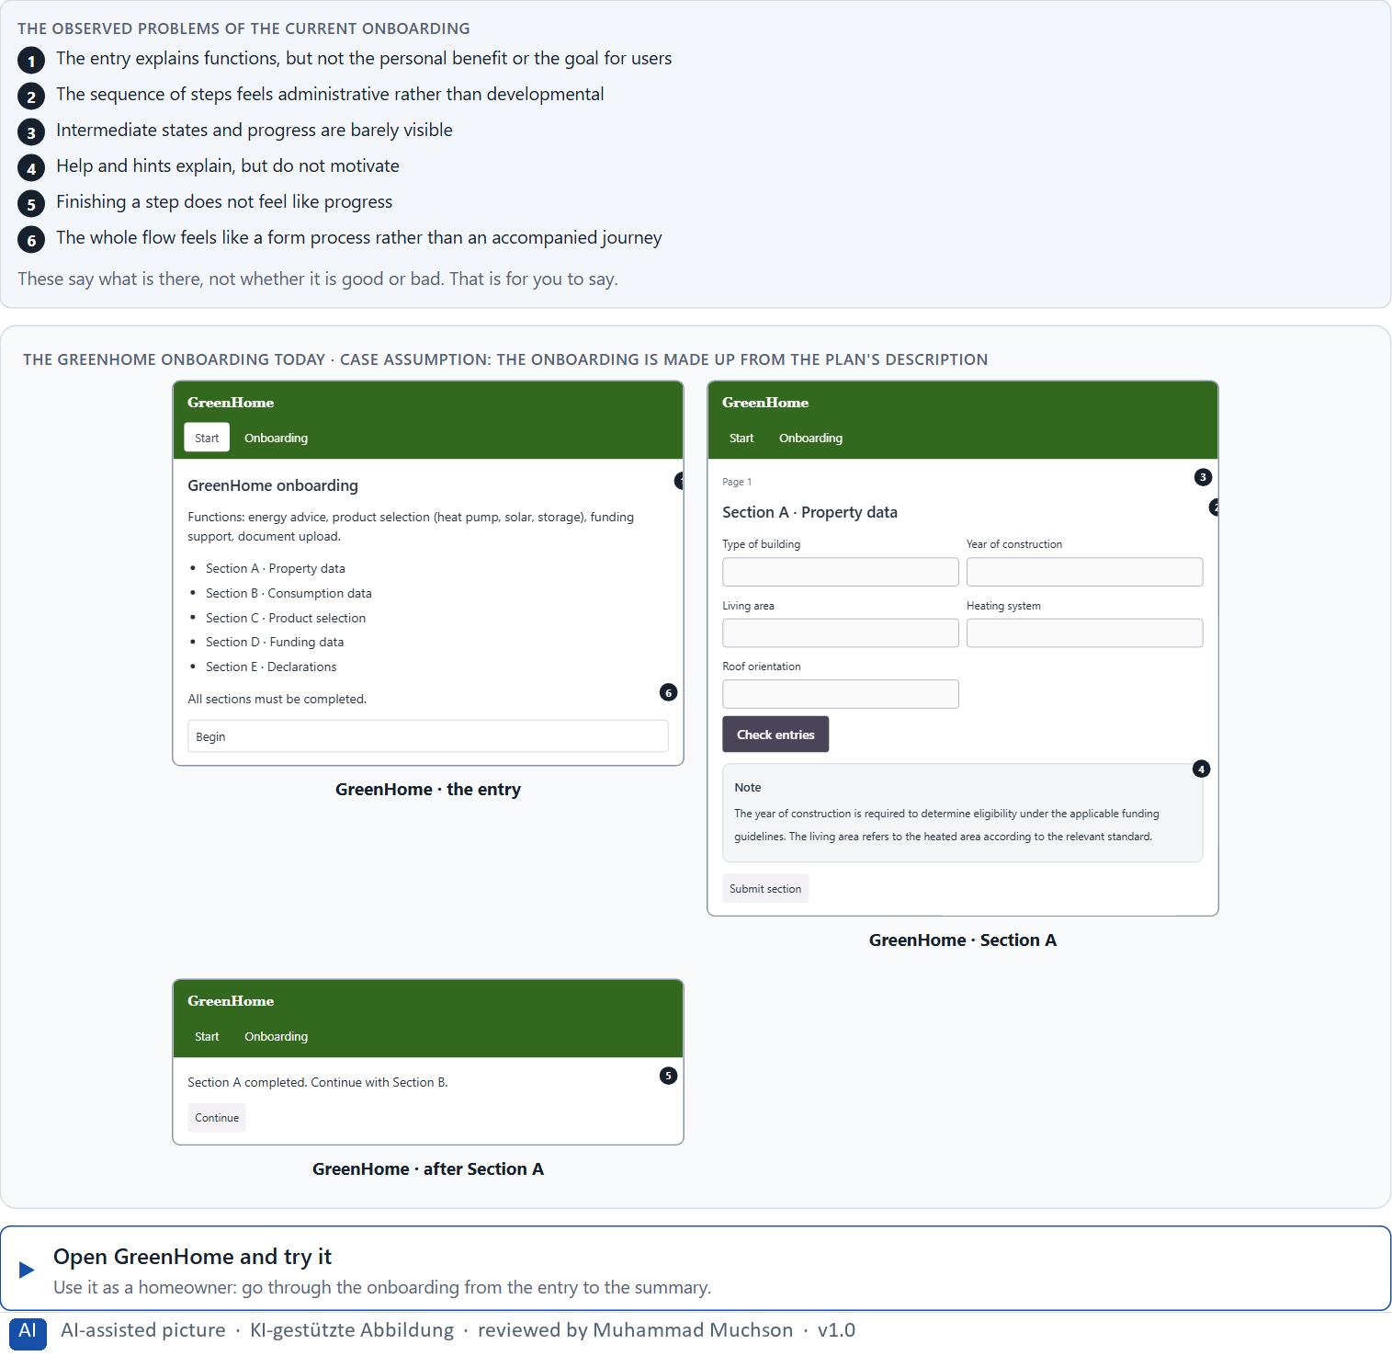
Figure 1 · The GreenHome onboarding today.
Question 1 of 6 · Analyse the central narrative and dramaturgical deficits of the onboarding
How to build the answer:
- Open GreenHome and go through the onboarding as a homeowner would, from the first screen to the summary.
- Write one deficit per line as a missing part of the journey and what it does.
Write them as a list, one deficit per line, each as a missing part of the journey. At least five.

Question 2 of 6 · Assign the problems to the categories entry, relevance, transitions, progress, motivation and completion
Write the problems that belong to each category in a few words. A problem may fit two categories.
How to build the answer:
- Take your problems from question 1.
- Ask which of the six categories each one affects most, and write it there.
Category | The problems in this category
Entry
Relevance
Transitions
Progress
Motivation
Completion

Question 3 of 6 · Develop 4 prioritised measures for improvement
How to build the answer:
- Turn each group of problems into something you could change within 12 weeks, keeping the contents and specialist logic and without a relaunch.
- Put them in order: what gives people a reason to start and to go on first.
Write them as a numbered list, the first priority first, each with what it changes for users.

Question 4 of 6 · Justify your selection using effect on users, feasibility, risk and time pressure
Use all four criteria and say how they support your selection and its order.
How to build the answer:
- Say for your first measures what they change for starting and finishing.
- Say what is feasible while the contents and logic stay, and the risk of each.
- Keep the serious brand and the 12 weeks in mind.

Question 5 of 6 · Make a prioritisation decision for the first 12 weeks
Say what you do in the first 12 weeks, in which order, and what you leave for later, with the reason.
How to build the answer:
- Say what comes first and why.
- Say what you do in parallel and what waits.
- Say how you keep the specialist clarity.

Question 6 of 6 · Formulate a recommendation to the division management
Three to five sentences: what you recommend, what has priority, and what you expect to change.
How to build the answer:
- Lead with the recommendation.
- Name the priorities.
- Say what you expect to change for users and for the company.

Use in class: presentation and handout
Mark of use for the worksheet. Presentation is what the trainer shows on screen; Handout is what participants fill in and hand in.
Part of the worksheet | Presentation (shown in the Neuro-UX Lab) | Handout
Block 2.1 · Case study: redesigning the GreenHome onboarding | The task wording at the start of the block (no answers are shown) | Worksheet block with answer boxes (Core)

Glossary
Every term below is used in this document. Terms stay plain text in the body; this list says what they mean in everyday words.
Term | In plain words | Example | Comes from
Activation | Getting people to act now, often with strong stimuli. It can help for a moment and tire or push people if overdone. | — | Day 7
Case assumption | A fact made up for this exercise to fill a gap in the plan's case. It is marked so you know it is not part of the plan. | — | Day 1
Chief Experience Officer | The manager who is responsible for the experience customers have across all channels, and who decides where the company invests in it. | — | Day 1
Decision architecture | A set of connected decisions that are made on purpose and written down: what effect you want, what comes first, who decides and how conflicts are settled. It replaces many separate fixes. | — | Day 1
Dramaturgy | The order and rhythm of a journey: tension, expectation, sequence, transitions, confirmation and emotional context. | — | Day 8
Experience quality | How using a product feels, on the way and afterwards. It goes beyond usability, which only asks whether people reach their goal. | — | Day 7
Governance | The rules about who may decide what, who is answerable for it and how disagreements are settled. | — | Day 1
Milestone | A visible point on the way that shows a part of the journey is done. | — | Day 8
Narrative guidance | Guiding people through a process as a journey: where they start, where they are going, why it matters, how far they have come and when they are done. | — | Day 8
Onboarding | The first journey with a product, from signing up to being ready to use it. | — | Day 8
Orientation | Knowing where you are, what you can do here and what happens next. | — | Day 1
Stakeholder | A person or department with an interest in a decision, such as marketing, compliance, IT or sales. | — | Day 1
Storytelling in UX | Building a digital journey so it has what a story has: a beginning that shows the goal, a way that shows progress, and an end that feels like an end. | — | Day 8
Touchpoint | Any place where a person meets the company: the website, the customer portal, the app, a chatbot or a phone call. | — | Day 1
Transition | The moment between two steps: what was done, what comes next and why. | — | Day 8
User journey | The whole path a person takes to reach a goal with a product, across steps and touchpoints. | — | Day 8
UX (user experience) | Everything a person goes through when using a product: what they notice, understand, feel and do, from the first look to the last step. The screens are only one part of it. | Finding the booking you want at once and feeling sure it went through is a good UX. | Day 1

The Neuro-UX Lab: where we practise online
In class we use the course website as the place to practise and to learn. Every day has its own address, in the same pattern: the day number is the last part.
What | Address
Neuro-UX Lab (course website) | https://aion-ux-lab.vercel.app/
Day 8 | https://aion-ux-lab.vercel.app/day/8/

On the day page, Route 1 (Levels 1 and 2) and Route 2 (Level 3) can be opened; the cards and the tasks of this document are there too. The pattern is the same up to Day 8, for example https://aion-ux-lab.vercel.app/day/6/.

