AION · UX DEVELOPER · PSYCHOLOGICAL UX DESIGN AND NEURO-UX
DAY 7 · TASK 1 AND TASK 2 · ROUTES 1 AND 2 · LEVELS 1 TO 3
LifeSupport: UX Analysis File and UX Strategy Memo
Describe the effect, choose the measures as a team member, and decide as Chief Experience Officer
AI notice · KI-Hinweis
This document was produced with the help of an AI language model (Claude, Anthropic). The AI drafted the text and tables and built the pictures and working examples of the lab. The content was then read, corrected and approved by the reviewer named below, who is responsible for its accuracy. Every picture carries an AI label on the image. Check figures and sources before you quote them.
KI-Hinweis: Dieses Dokument wurde mit Unterstützung eines KI-Sprachmodells (Claude, Anthropic) erstellt. Texte und Tabellen wurden von der KI entworfen, die Abbildungen sind KI-gestützt erstellt und am Bild gekennzeichnet. Die fachliche Prüfung und Freigabe erfolgte durch die unten genannte Person.

Day | Day 7 · Module 4 (day 1 of 3): Emotional bonding in design
Document | Task (worksheet with answer spaces). Task 1 (UX Analysis File) and Task 2 (UX Strategy Memo).
Route and level | Task 1 = Route 1, Levels 1 and 2 (draws on Materi A). Task 2 = Route 2, Level 3 (draws on Materi B).
Time | Task 1 about 33 min · Task 2 about 20 min
Neuro-UX Lab (website) | https://aion-ux-lab.vercel.app/day/7/
Case | LifeSupport, the day's case study; other products appear as warm-ups
Version | 1.0 · release date 29.10.2026
Review and approval | Muhammad Muchson, Mentor (subject-matter review and approval)

ABOUT THIS DOCUMENT
In class we also use the Neuro-UX Lab, the course website, as the place to practise and learn. Its address is at the end of this document.
This is the worksheet for Day 7. Read the case once, study the evidence printed in this document, and write your answers in the boxes and tables. You can work through it on paper or type into the document. All blocks are Core. There are no answer keys and no scores; the reason you give matters more than the choice.

IN THIS DOCUMENT
Lesson plan: ten teaching units (Ablaufplan)
Case study and transfer project at a glance
The case: three platforms on the UX team's desk, and LifeSupport
Block 1.1 · Analyse the emotional effect of a digital offer from the user's side: WellTrack · JUDGED · Core · about 10 min
Block 1.2 · Rate emotional UX under conflicting goals: CareerPath · JUDGED · Core · about 8 min
Block 2.1 · Case study: realigning the service portal LifeSupport · JUDGED · Core · about 15 min
The situation: the provider behind LifeSupport, functionally solid and emotionally distant
Block 3.1 · An emotionally effective UX strategy for a digital service · JUDGED · Core · about 20 min

Day at a glance
Day 7 has ten teaching units (UE). This document is the worksheet; it is used in UE2 to UE6 (Task 1) and UE8 to UE10 (Task 2). The day is built from three documents and the Neuro-UX Lab: Materi (study material), Task (worksheet) and Trainer (coaching, feedback and model solutions), plus the course website.

Lesson plan: ten teaching units (Ablaufplan)
UE | Min | Plan item | What happens | Material | Format
1 | 45 | Knowledge transfer · Level 1 | The trainer presents the cards of Materi A (A1, A2, A3, A4, A5, about 60 min of cards) in the Neuro-UX Lab; participants follow in the handout. | Materi A (Route 1) | Presentation + Handout
2 | 45 | Level 1 · Task 1 | Individual work on Block 1.1 (Core, about 10 min): the first product of the day is read and its effect described. Pairs then compare their results and the trainer collects open questions. | Task 1 · Part 1 · Block 1.1 | Handout (or in the lab)
3 | 45 | Level 1 · Task 2 | Three options are rated on the same criteria and one is chosen under the stated conditions: Block 1.2 (Core, about 8 min). | Task 1 · Part 1 · Block 1.2 | Handout (or in the lab)
4 | 45 | Coaching · transition from Level 1 to Level 2 | Trainer-led. A short talk on the day's coaching focus, then the reflection questions in pairs. The bridge: from describing an effect to a decision you answer for. There is no worksheet block in this unit. | Trainer document, section Coaching | Trainer only
5–6 | 90 | Level 2 · Case study LifeSupport (2 UE) incl. model solution | UE5: the trainer presents the case; participants work on Block 2.1 (Core, about 15 min). UE6: groups compare their results and defend them; the trainer closes with the model solution. | Task 1 · Part 2 · Block 2.1  Trainer document, section Case study | Handout; model solution shown after the work
7 | 45 | Level 2 + 3 · Feedback round with a management perspective | Groups present their reasoning, not only their result. The trainer asks the day's Level 3 input questions and leads the discussion. | Trainer document, section Feedback round | Presentation by the groups; Trainer only
8 | 45 | Level 3 · Transfer project, Chief Experience Officer (3 UE: UE8–10) | The trainer presents Materi B (B1, B2, B3; use the "In plain words" and "How to decide" boxes, the rest is handout) and sets the role and the situation. | Materi B (Route 2) | Presentation + Handout
9 | 45 | Level 3 · Transfer project | Individual work or in pairs on Block 3.1 (Core, about 20 min): the strategy memo. | Task 2 · Block 3.1 | Handout (or in the lab)
10 | 45 | Level 3 · Transfer project | Participants present their decision and what they give up, including the one decision made under uncertainty; the trainer debriefs with the model solution. | Task 2 · Block 3.1  Trainer document, section Transfer project | Handout; model solution shown after the work

One UE is counted as 45 minutes here; breaks are not shown. The times are a guide for the trainer. The Core blocks are enough for a complete answer.

Case study and transfer project at a glance
Component | UE | Duration | Participants work in | Model solution in
Level 2 case study (LifeSupport) | UE5–6 | 2 UE · 90 min | Task 1 · Part 2 (Block 2.1) | Trainer document, section Case study
Level 3 transfer project (Chief Experience Officer) | UE8–10 | 3 UE · 135 min | Materi B and Task 2 (Block 3.1) | Trainer document, section Transfer project

Which plan item each block answers
UE | Plan item (Strukturplan, Day 7) | Block in this document
UE2 | Level 1, task 1 · Analyse the emotional effect of a digital offer from the user's side: WellTrack | Block 1.1 (Core)
UE3 | Level 1, task 2 · Rate emotional UX under conflicting goals: CareerPath | Block 1.2 (Core)
UE4 | Coaching: from describing to deciding | A classroom talk led by the trainer; not a worksheet block
UE5–6 | Level 2 case study · Case study: realigning the service portal LifeSupport | Block 2.1 (Core)
UE7 | Feedback round with a management perspective | A classroom discussion led by the trainer; not a worksheet block
UE8–10 | Level 3 transfer project · An emotionally effective UX strategy for a digital service | Block 3.1 (Core), in Task 2

Your name
Write your full name here. Use the same name on every Task document this week; it is how your work is matched.

Task 1 · Route 1 · UX Analysis File: name the emotional effect, then decide what to change

The case: three platforms on the UX team's desk, and LifeSupport
Read once · about 3 min
You work in the UX team of a digital agency. This week three products land on your desk. Two are warm-ups: WellTrack, a health platform for prevention, appointments and personal recommendations, and CareerPath, a platform for career development and further training that has three designs for its interface. The main case is LifeSupport, the portal of a health-prevention provider for advice, appointments and documents. It does its job, but users call it impersonal, exhausting and not very supportive, and its use stays below expectations although it offers a lot.
What the plan gives you | How the task runs · three blocks
• Block 1.1: WellTrack, with a correct but cool start page, technical error messages, no positive feedback after successful actions, sober health information that does not build trust, no hints for orientation, safety or relevance, and a professional but unapproachable design  • Block 1.2: three designs for CareerPath; working people from 25 to 60, the wish to look professional and approachable, a limited budget, no tests, 9 weeks to release, the department wants seriousness and marketing more activation  • Block 2.1: LifeSupport, with €145,000 and 12 weeks, no complete relaunch, a brand that must stay serious and become more approachable, partial user data, and a department and marketing with different priorities | • Block 1.1: analyse the emotional effect from the user's side. Describe it spontaneously, name five places where the bond is weakened or built, sort them into six categories, write three effect statements and pick the two biggest emotional weaknesses.  • Block 1.2: rate three designs under conflicting goals. Rate each on five criteria, choose one, name the conflicts between emotion and professional credibility and the remaining risks, and write a recommendation to the project lead.  • Block 2.1: the case study. The central emotional deficits, sorted into five categories, four measures, justified on four criteria, a decision for the first 12 weeks and a recommendation to the division management.

What is known and what is open
In the brief | Clear · Case assumption | Open · on purpose
• WellTrack: correct but cool, technical errors, no positive feedback, sober health information, no orientation or relevance, professional but unapproachable.  • CareerPath: three designs in words; working people from 25 to 60; no tests; 9 weeks; seriousness against activation.  • LifeSupport: distant visual language, technical feedback, critical moments that unsettle, no positive reinforcement, a correct but cold tone; €145,000 and 12 weeks; no relaunch. | • You review WellTrack and CareerPath as an agency would: from their screens, with no access to their data.  • LifeSupport is used most around a check-up: booking it, getting the results, and the documents afterwards.  • LifeSupport's error messages show internal codes, such as “Error 4012: slot unavailable”.  • Support at LifeSupport often hears: “Did my booking work?” and “Is something wrong with my results?” | • How users feel at each step: no data on emotional effect has been collected.  • Which CareerPath design the target group would prefer: there are no tests.  • Why use stays below expectations: the user data is only partial.  • How much of the €145,000 each measure would take: the plan does not say.

As in most projects, not everything is known. Decide anyway, and say what you assume.
Case assumption
The brief says: WellTrack correct but cool, with technical errors, no positive feedback, sober health information, no orientation or relevance, and an unapproachable design; CareerPath's three designs for working people from 25 to 60, a professional yet approachable brand, a limited budget, no tests, 9 weeks, seriousness against activation; LifeSupport impersonal, exhausting and unsupportive, with a distant visual language, technical feedback, unsettling critical moments, no positive reinforcement, a cold tone, €145,000, 12 weeks and no relaunch. Those are the plan's facts and its only figures. Everything else is made up for this exercise: the agency, the pictures, the simulations and the facts marked “Clear”.

Part 1 · Name the emotional effect and weigh designs · Level 1 · Knowledge

Block 1.1 · Analyse the emotional effect of a digital offer from the user's side: WellTrack · JUDGED · Core · about 10 min
Draws on: A1 · Emotions steer behaviour · A2 · Usable is not enough · A3 · Where feelings come from · A4 · Activation, overload and manipulation.
You receive the description of a fictional health platform, WellTrack, for prevention, appointment management and personal recommendations. Open it and use it as someone who has just signed up: book a check-up and read your recommendations. You need no prior knowledge: notice how it makes you feel, not only whether it works. The aim is to recognise emotional effect step by step and to tell it apart from a purely functional judgement.
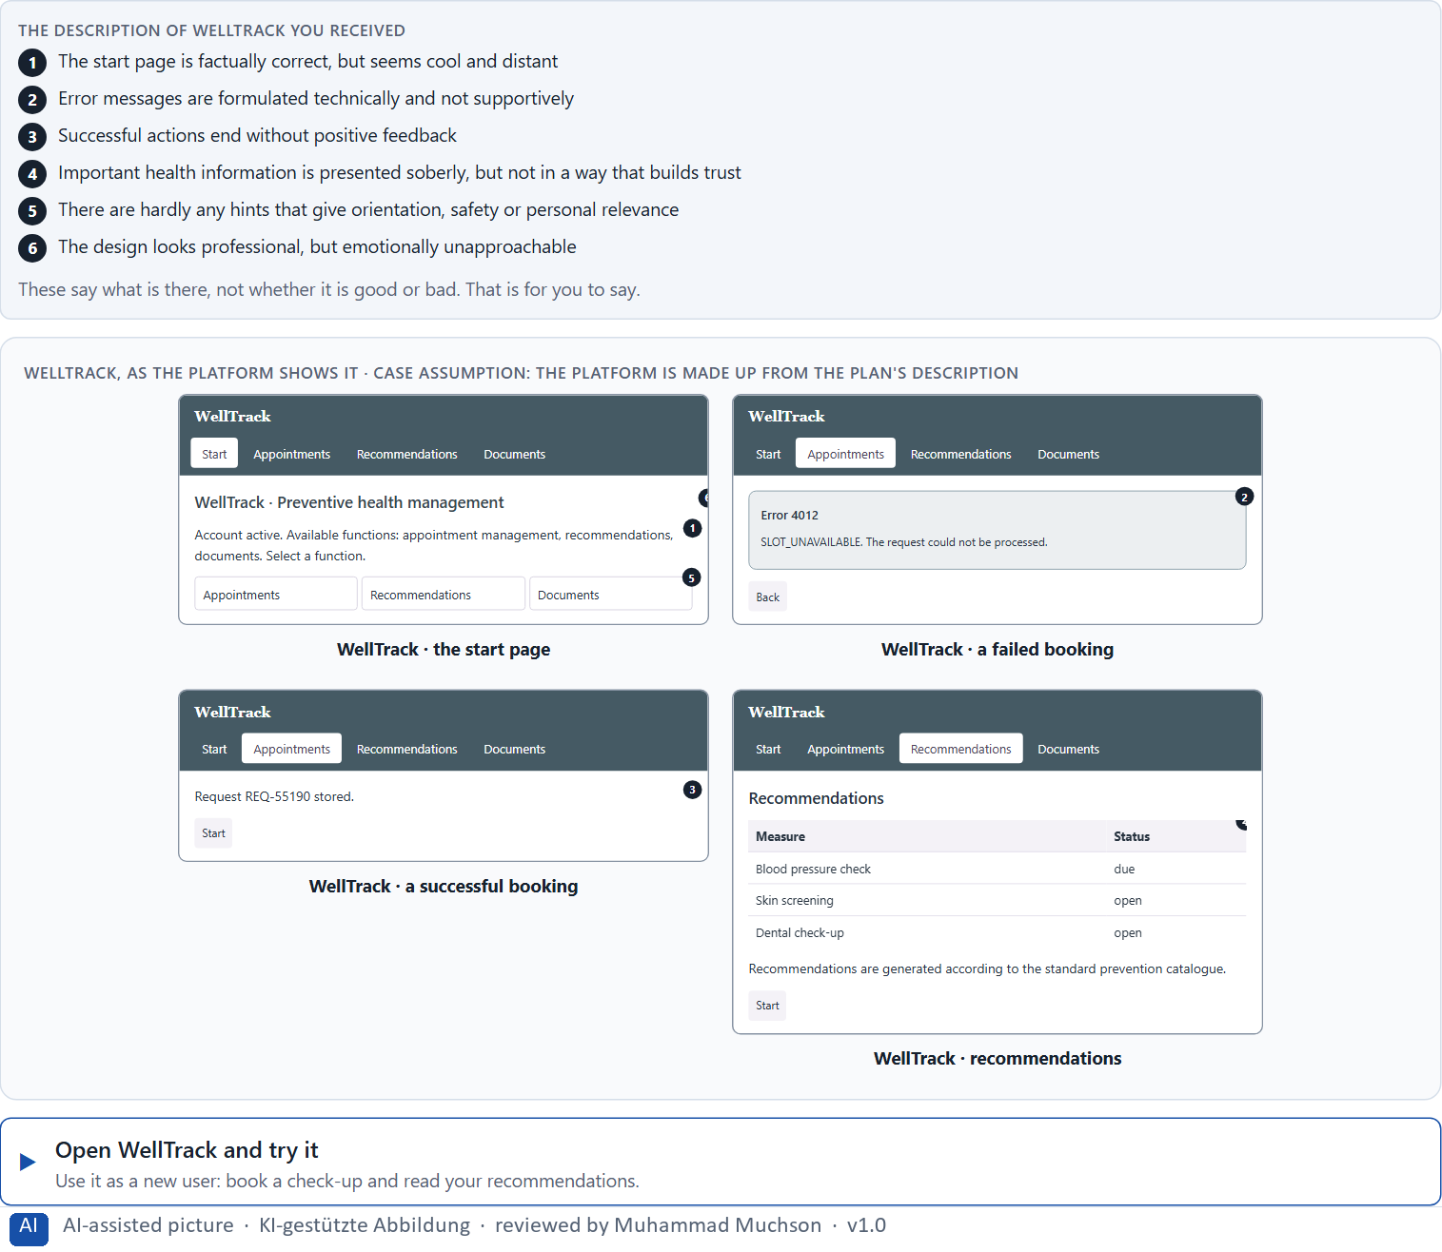
Figure 1 · WellTrack, as the platform shows it.
Question 1 of 5 · Describe spontaneously which emotional effect the offer could have on a first-time user
Two to four sentences: how it feels, where the feeling comes from, and what a first-time user might do.
How to build the answer:
- Open WellTrack, book a check-up and read your recommendations.
- Write how it makes you feel: welcome or distant, safe or unsure, encouraged or left alone.
- Add where the feeling comes from and what you might do next.

Question 2 of 5 · Name at least 5 places where the emotional bond is weakened or built
How to build the answer:
- Go through your visit: the start page, a failed and a successful action, the health information.
- For each place, say whether it weakens or builds the bond, and why.
Write them as a list, one place per line, and say whether it weakens or builds the bond and why.

Question 3 of 5 · Assign the observations to the categories trust, safety, motivation, frustration, closeness and experience quality
Write the observations that belong to each category in a few words. One may fit two categories; put it where its effect is strongest.
How to build the answer:
- Take your places from question 2.
- Ask which feeling each one touches most, and write it there.
- Each of the six is touched by WellTrack.
Category | The observations in this category
Trust
Safety
Motivation
Frustration
Closeness
Experience quality

Question 4 of 5 · Write an effect statement for three points: “For users this could mean that …”
How to build the answer:
- Pick three places from question 2.
- Finish the plan's sentence with what the user would feel, do or fail to do.
Write them as a list, one statement per line, each starting with the observation and ending with what it could mean for users.

Question 5 of 5 · Prioritise the two biggest emotional weaknesses of the offer
How to build the answer:
- Look at your places with one question: which feeling would make a first-time user leave or not come back?
- Pick the two that weigh most and say why.
Write them as a list, the bigger weakness first, each with why it weighs most.

Block 1.2 · Rate emotional UX under conflicting goals: CareerPath · JUDGED · Core · about 8 min
Draws on: A2 · Usable is not enough · A4 · Activation, overload and manipulation · A5 · Trust and perceived competence, and weighing a measure.
CareerPath is a platform for career development and further training. Three designs for its interface are described in words: A) modern, warm and motivating, but with many emotional stimuli and activating messages; B) factual, clear and trustworthy, but not very inspiring or connecting; C) high quality and personal in feel, but in some situations a little unclear in its interaction feedback. The conditions: the target group is working people between 25 and 60, the company wants to look professional and approachable, the budget for a deep revision is limited, there are no user tests yet, the release is in 9 weeks, and the department demands seriousness while marketing demands stronger activation. Decide anyway, and say what you assume.
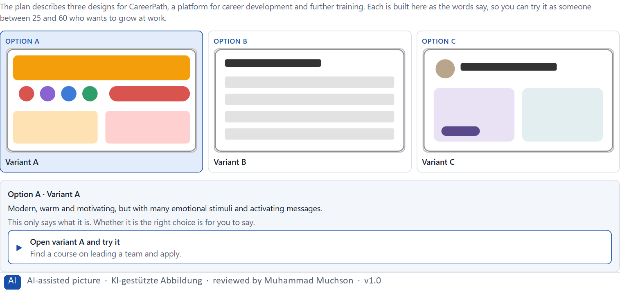
Figure 2 · The product to read, as the lab shows it (careerdesigns).
Question 1 of 5 · Rate each variant on trust, motivation, safety, clarity and experience quality
Write a few sentences for each variant that cover all five criteria. Many teams rate each criterion Low, Medium or High with a reason; you may do that or write it in your own words.
How to build the answer:
- Take one variant at a time and keep the target group in mind: working people from 25 to 60.
- For each criterion, say how the variant does and why.
- Use the same five criteria for every variant, so you can compare them.
Variant | Trust | Motivation | Safety | Clarity | Experience quality
Variant A · warm and motivating, many emotional stimuli
Variant B · factual and trustworthy, not inspiring
Variant C · personal and high quality, feedback sometimes unclear

Question 2 of 5 · Decide which variant is the most viable under the given conditions
Choose one variant, then give your reason below. There is no single right choice; the reason has to rest on the users and the conditions.
How to build the answer:
- Say which condition weighs most for you.
- Say how your choice meets it better than the other two.
Tick one:
☐ Variant A · warm and motivating, many emotional stimuli
☐ Variant B · factual and trustworthy, not inspiring
☐ Variant C · personal and high quality, feedback sometimes unclear
Why this variant, under these conditions?
Give your reason with the conditions: working people from 25 to 60, professional and approachable, a limited budget, no tests, 9 weeks, the department against marketing.
How to build the answer:
- Name the condition that weighs most for you.
- Say how your variant meets it and why the other two meet it less well.
- Say what your choice gives up and how you would deal with its weakness.

Question 3 of 5 · Name the conflicts of goals between emotionalisation and professional credibility
Name at least two conflicts, each as an emotional goal against a goal of credibility.
How to build the answer:
- Look at what activation and warmth would give, and what seriousness and credibility need.
- Write each conflict as “… against …” and say who stands for each side.

Question 4 of 5 · Which risks remain despite your decision?
Name at least one risk that remains and who would feel it.
How to build the answer:
- Think of what your chosen variant is weak at.
- Say who would notice and what would happen.

Question 5 of 5 · Formulate a recommendation to the project management
Two to four sentences: what you recommend, why, and what you will check next.
How to build the answer:
- Lead with the recommendation.
- Give the one reason the project management can follow.
- Say what you will check after the release.

Part 2 · The case study · Level 2 · Application · Case study (2 UE)
Case study: 2 teaching units (UE5–6)
This part is the day's Level 2 case study. It takes 2 UE (about 90 minutes): UE5 for the briefing and your own work, UE6 for comparing your results with your group and for the trainer's closing. The block below needs about 15 minutes of writing; the rest of the time is discussion.

Block 2.1 · Case study: realigning the service portal LifeSupport · JUDGED · Core · about 15 min
Draws on: A1 · Emotions steer behaviour · A2 · Usable is not enough · A3 · Where feelings come from · A4 · Activation, overload and manipulation · A5 · Trust and perceived competence, and weighing a measure.
A provider of health prevention runs LifeSupport, a digital portal for advice, appointment booking and document management. Technically the system does its job, but users perceive it as “impersonal”, “exhausting” and “not very supportive”. Use stays below expectations although the range of functions is large. The observed problems: the visual language is factual but emotionally distant, feedback after actions is technical instead of supportive, critical situations such as error messages create uncertainty instead of orientation, positive experiences are not visibly reinforced, the tone is correct but does not build trust or motivate, and the interaction is functional but does not build a relationship. The conditions: a budget of €145,000, 12 weeks for the implementation, no complete relaunch, the brand should stay serious but become emotionally more approachable, user data is only partly available, and the department and marketing set different priorities. You work through six steps.
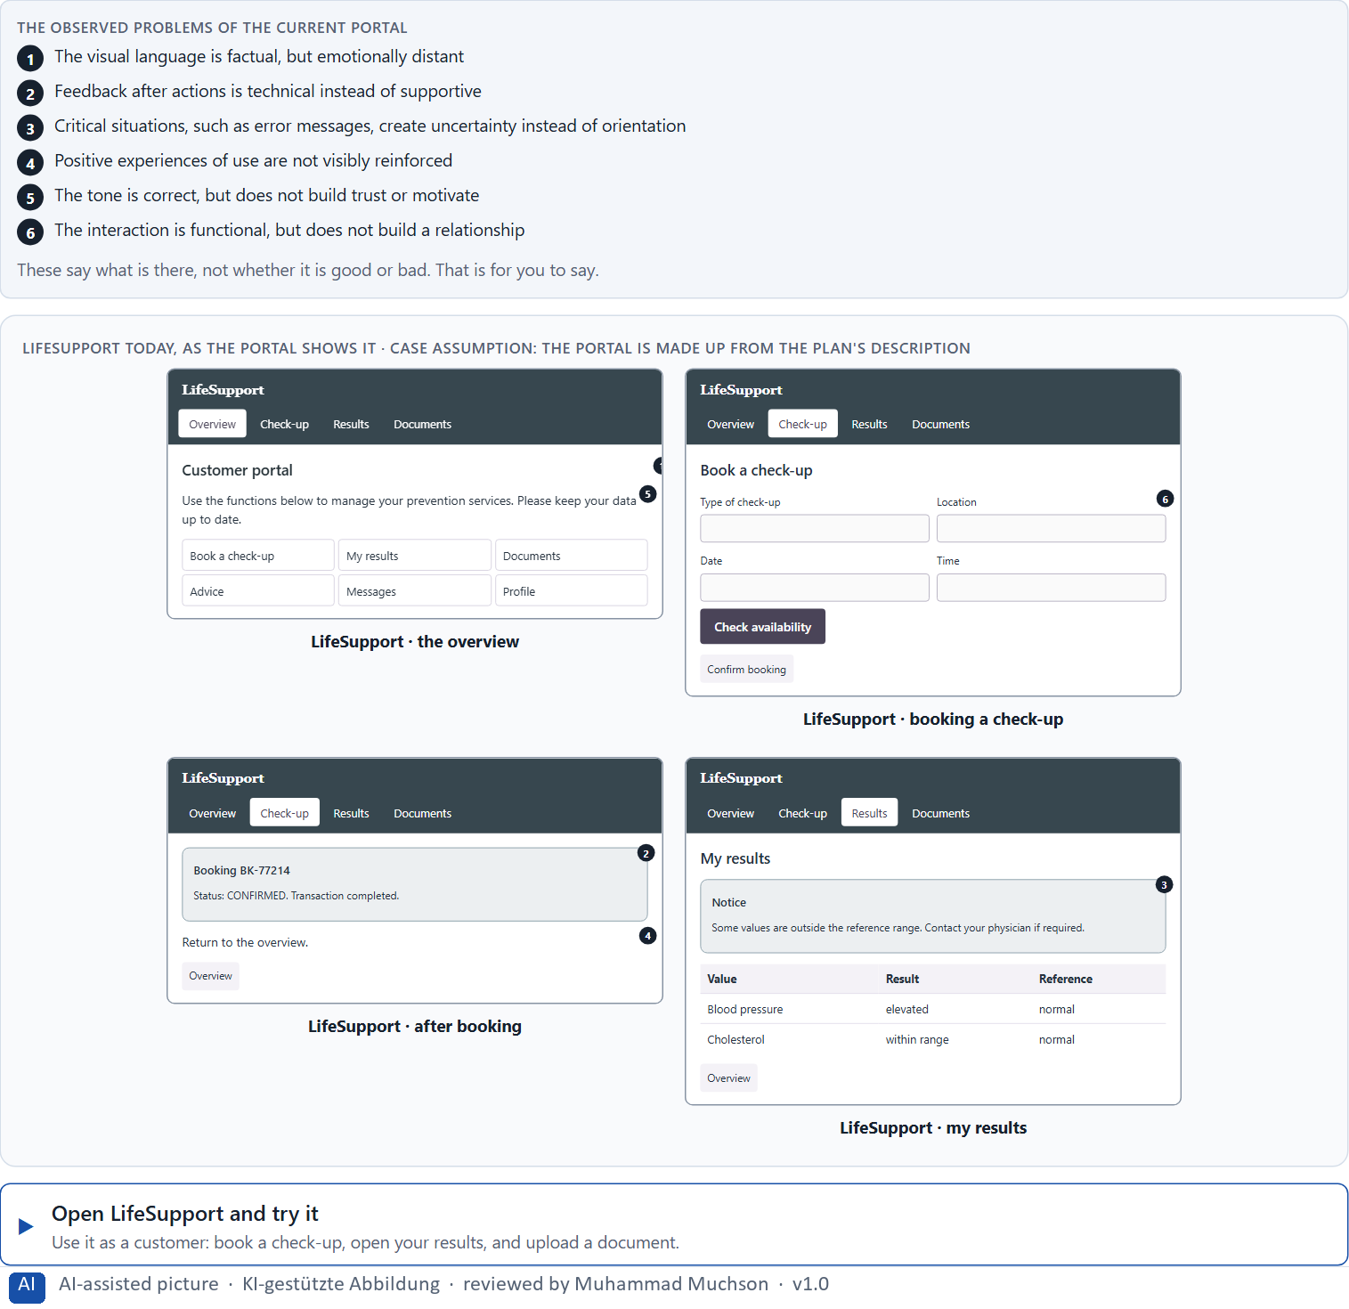
Figure 3 · LifeSupport today, as the portal shows it.
Question 1 of 6 · Analyse the central emotional deficits of the portal
How to build the answer:
- Open LifeSupport, book a check-up, cause an error, and open your results, as a customer would.
- Write one deficit per line as a feeling it creates or fails to create.
Write them as a list, one deficit per line, each as a feeling. At least five.

Question 2 of 6 · Assign the problems to the categories trust, emotional safety, motivation, reducing frustration and experience quality
Write the problems that belong to each category in a few words. A problem may fit two categories.
How to build the answer:
- Take your problems from question 1.
- Ask which of the five categories each one affects most, and write it there.
Category | The problems in this category
Trust
Emotional safety
Motivation
Reducing frustration
Experience quality

Question 3 of 6 · Develop 4 prioritised measures for improvement
How to build the answer:
- Turn each group of problems into something you could change within 12 weeks, without a relaunch and while the brand stays serious.
- Put them in order: what gives safety in the moments that matter most first.
Write them as a numbered list, the first priority first, each with what it changes for users.

Question 4 of 6 · Justify your selection using effect on users, feasibility, risk and time pressure
Use all four criteria and say how they support your selection and its order.
How to build the answer:
- Say for your first measure what it changes in the moments that matter most.
- Say what is feasible without a relaunch and with a serious brand, and the risk of each.
- Keep the department and marketing and the 12 weeks in mind.

Question 5 of 6 · Make a prioritisation decision for the first 12 weeks
Say what you do in the first 12 weeks, in which order, and what you leave for later, with the reason.
How to build the answer:
- Say what comes first and why.
- Say what you do in parallel and what waits.
- Say how you deal with the department and marketing.

Question 6 of 6 · Formulate a recommendation to the division management
Three to five sentences: what you recommend, what has priority, and what you expect to change.
How to build the answer:
- Lead with the recommendation.
- Name the priorities.
- Say what you expect to change for users and for the company.

Task 2 · Route 2 · UX Strategy Memo: decide as Chief Experience Officer

The situation: the provider behind LifeSupport, functionally solid and emotionally distant
Read once · about 2 min
You take the perspective of the Chief Experience Officer of the health-prevention provider that runs LifeSupport. The company has a website, a customer portal and an app. Its digital offers are functionally solid but create little emotional bond: users find them correct, but not supportive, trust-building or motivating. Inside the company, emotion is mostly seen as a question of communication or marketing, not as part of the UX architecture. The management expects a sound strategy for building emotional quality systematically into the digital product experience. You are not to polish single screens but to develop a sound decision architecture for emotional bonding, trust design and experience quality.
The framework | How the task runs · one block
• The budget is limited  • Different stakeholders pursue different goals  • The brand must stay professional  • Not all systems can be adapted at the same time  • Data on emotional effect is only partly available  • First improvements must be visible at short notice  • Wrong decisions can weaken credibility and user acceptance | • Block 3.1 asks seven questions: a guiding vision for emotional UX, three strategic decisions, a prioritised architecture of measures, a risk analysis, a governance model, one decision under uncertainty and a management statement.

What is known and what is open
In the brief | Clear · Case assumption | Open · on purpose
• A website, a customer portal and an app.  • Functionally solid, but correct rather than supportive, trust-building or motivating.  • Inside, emotion counts as a marketing question, not part of the UX architecture.  • The brand must stay professional; first improvements must show soon. | • The company is the health-prevention provider behind LifeSupport in Route 1.  • Marketing writes the website's texts; each product team writes its own messages and error texts in the portal and the app.  • Support records the subject of each contact; the app store reviews are the only written source on how people feel. | • How large the budget is: “limited” is all the plan says.  • How emotional effect could be measured: data is only partly available.  • How users would react to a warmer tone: never tested.

As in most projects, not everything is known. Decide anyway, and say what you assume.
Case assumption
The brief says: a company with a website, a customer portal and an app, functionally solid offers with little emotional bond, users who find them correct but not supportive, trust-building or motivating, emotion seen inside as communication or marketing, a limited budget, different stakeholders, a professional brand, not all systems at once, partial data on emotional effect, first improvements soon, and the warning that wrong decisions can weaken credibility and acceptance. Those are the plan's facts. That the company is the provider of Route 1 and the facts marked “Clear” are made up for this exercise.

The memo is addressed to: The management. Subject: An emotionally effective UX strategy for our digital services.

Part 3 · Level 3 · Management decision · Transfer project (3 UE)
Transfer project: 3 teaching units (UE8–10)
UE8: the trainer presents Materi B and sets the role. UE9: you write the memo. UE10: you present the decision and what you give up; the trainer debriefs.

Block 3.1 · An emotionally effective UX strategy for a digital service · JUDGED · Core · about 20 min
Draws on: B1 · Emotional UX as part of the UX architecture, not a campaign · B2 · Seriousness against closeness · B3 · Who owns emotional UX, and deciding with little data on feelings.
Develop a strategic concept for the provider. Your desk holds what the management, marketing, the department and the data say. Open it, then answer the seven questions; your answers build the memo below.
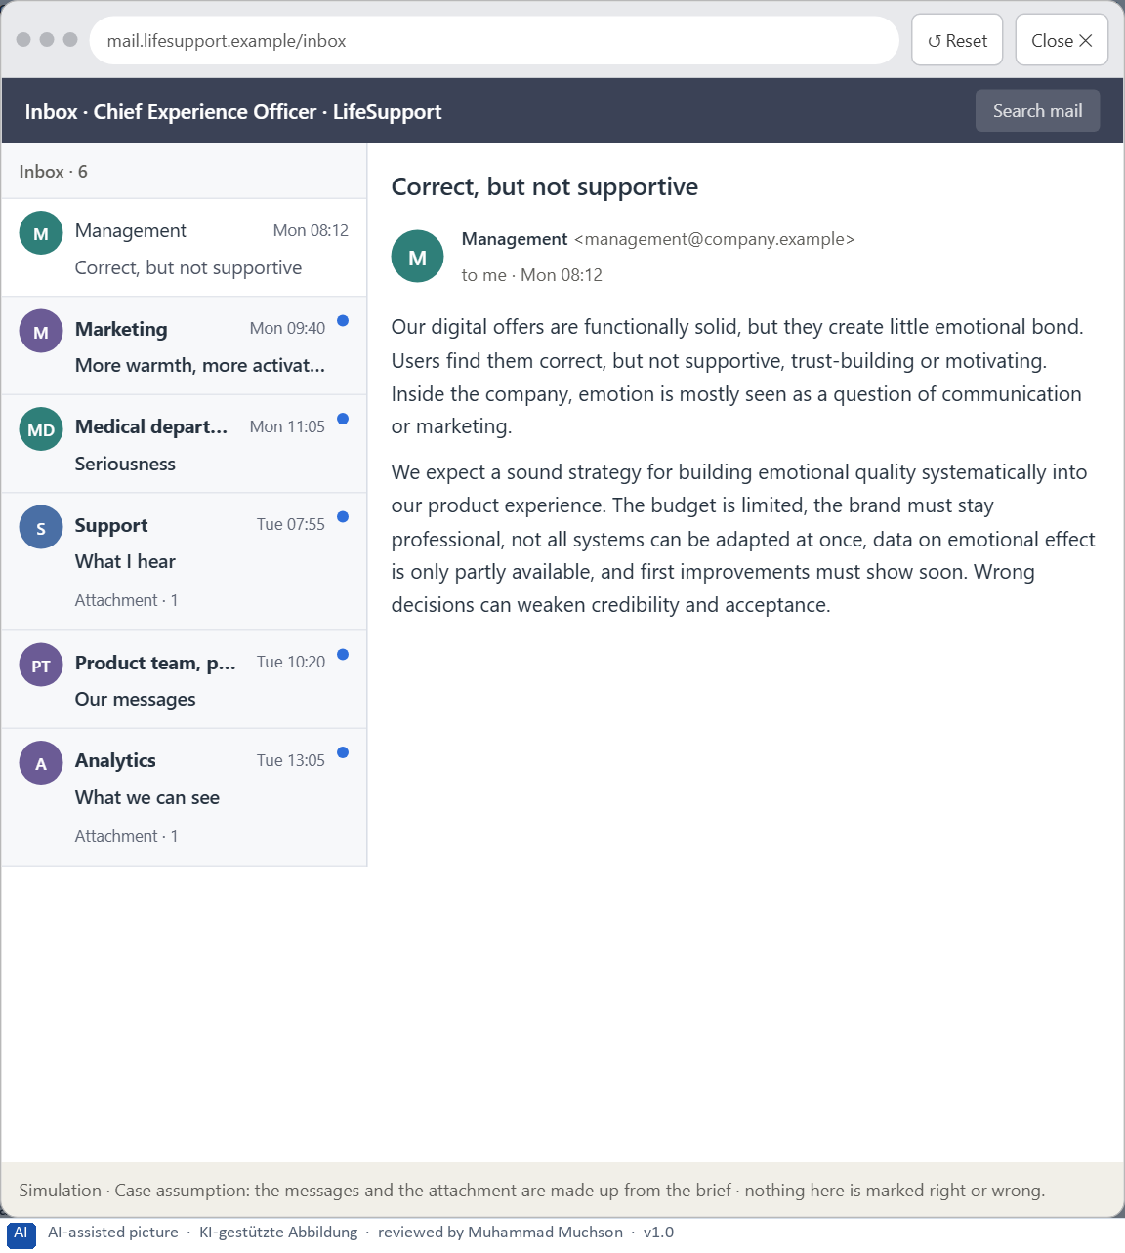
Figure 4 · Your desk: the messages that wait for you, shown in the lab as a mailbox (1 of 6).
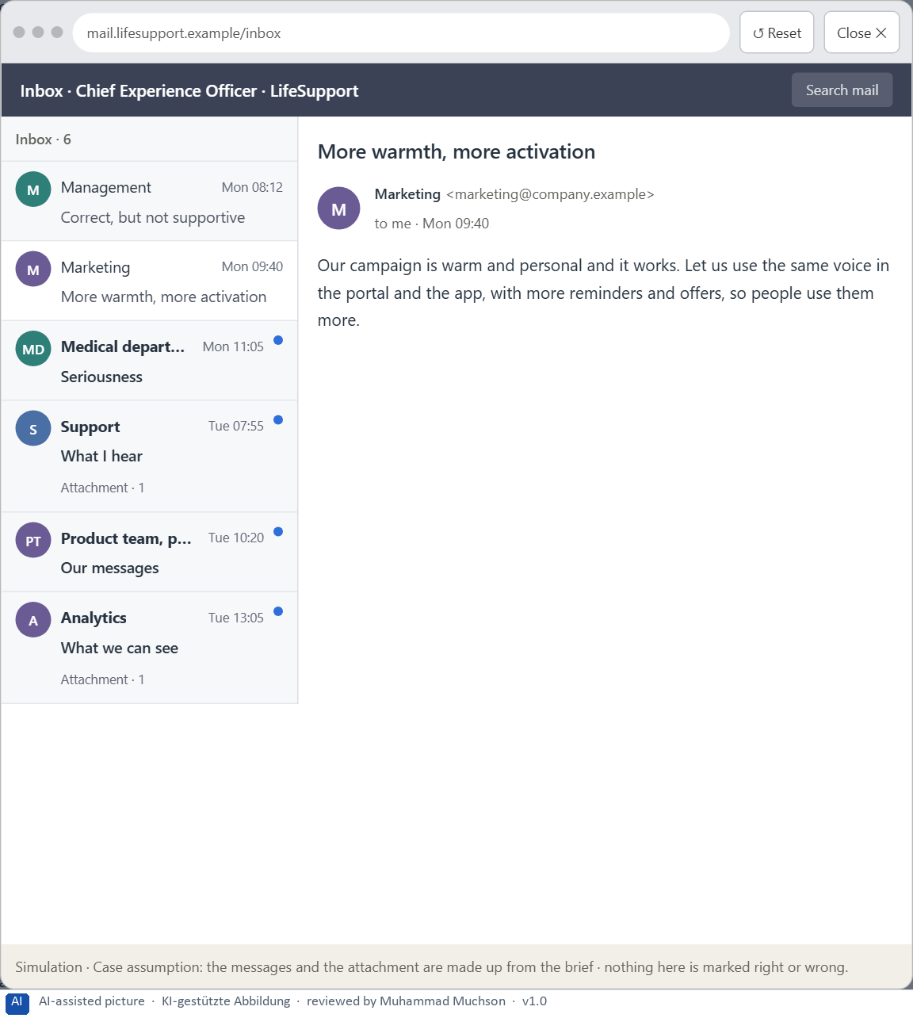
Figure 5 · Your desk: the messages that wait for you, shown in the lab as a mailbox (2 of 6).
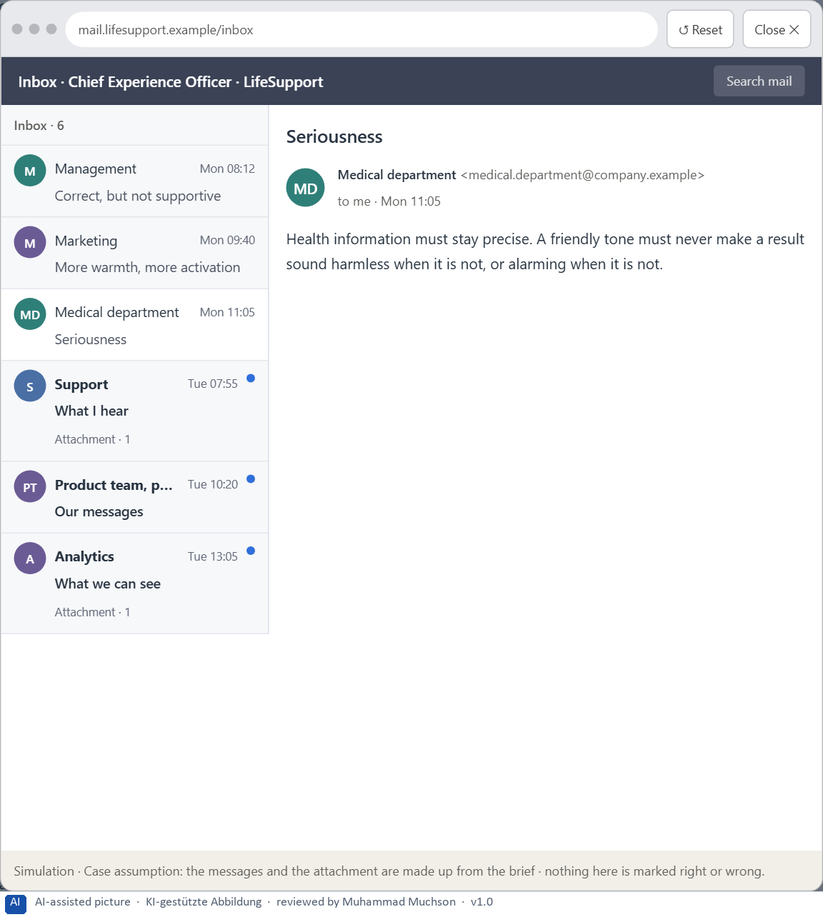
Figure 6 · Your desk: the messages that wait for you, shown in the lab as a mailbox (3 of 6).
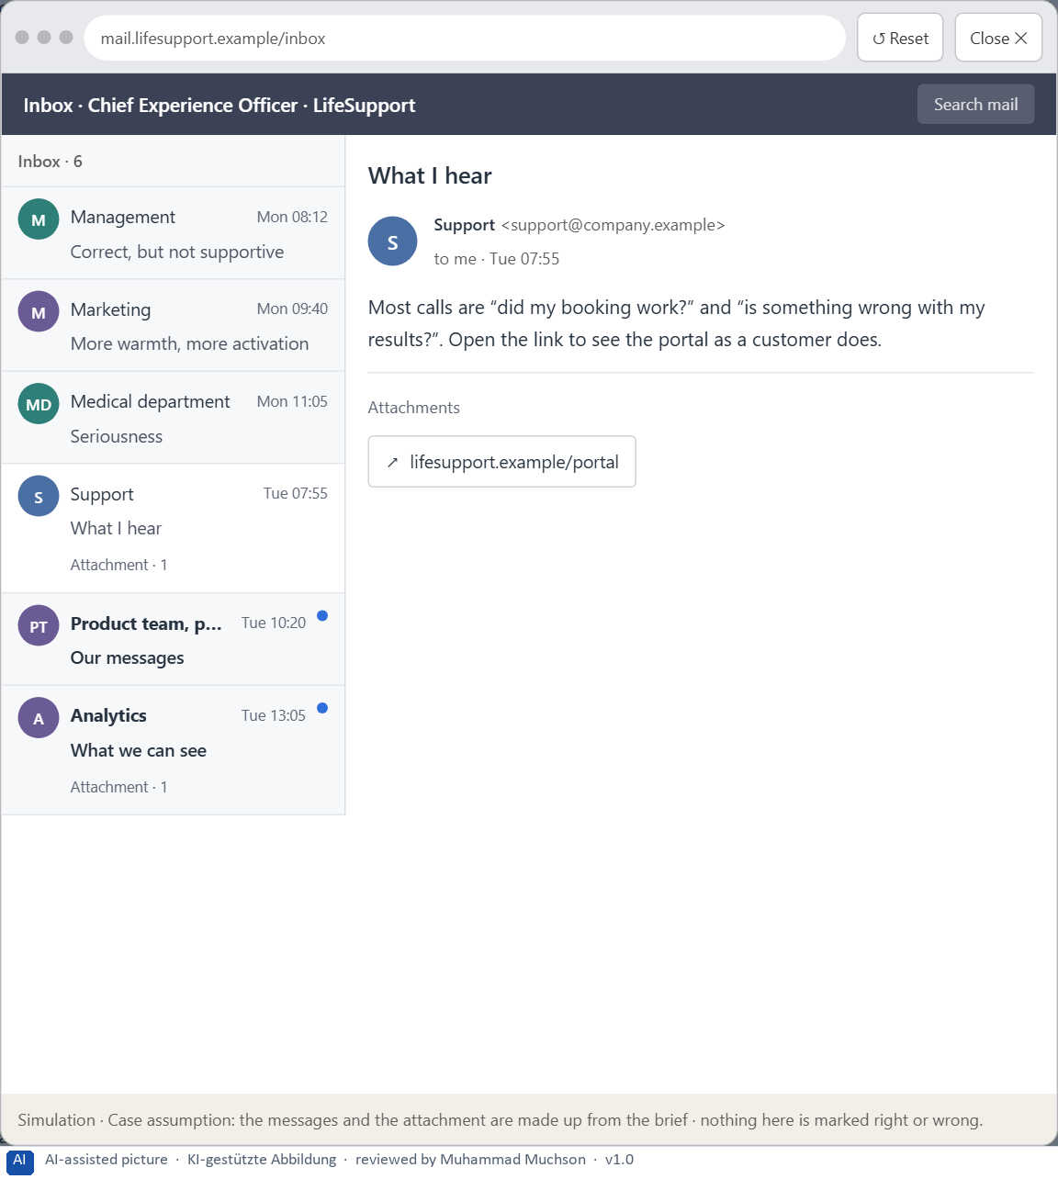
Figure 7 · Your desk: the messages that wait for you, shown in the lab as a mailbox (4 of 6).
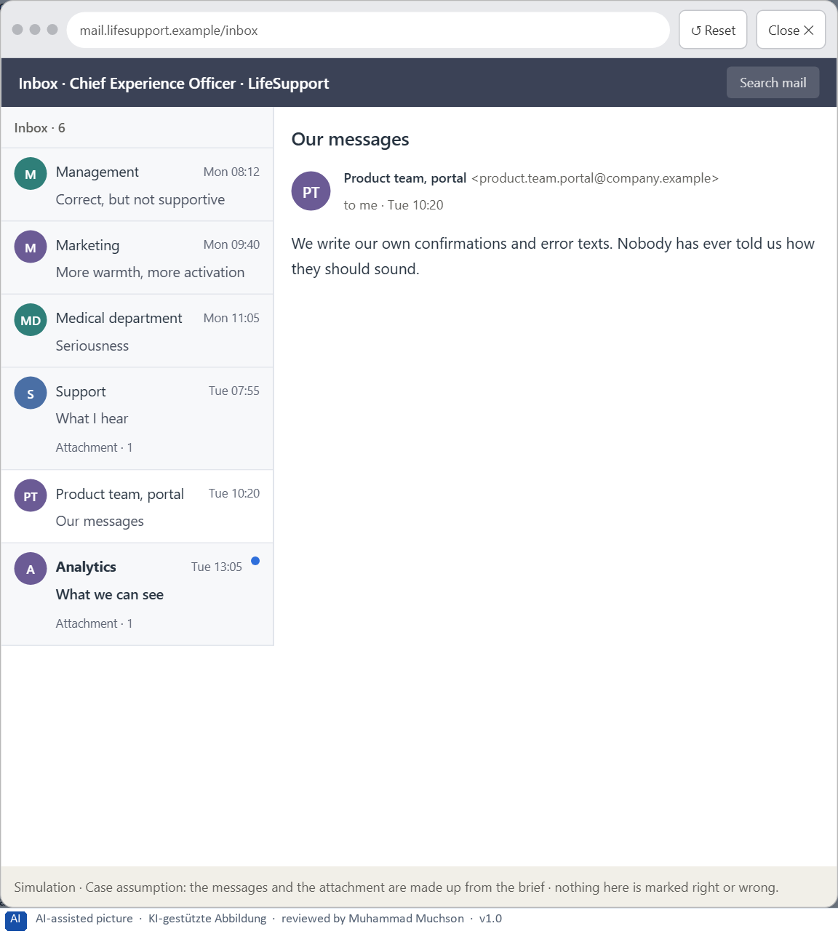
Figure 8 · Your desk: the messages that wait for you, shown in the lab as a mailbox (5 of 6).
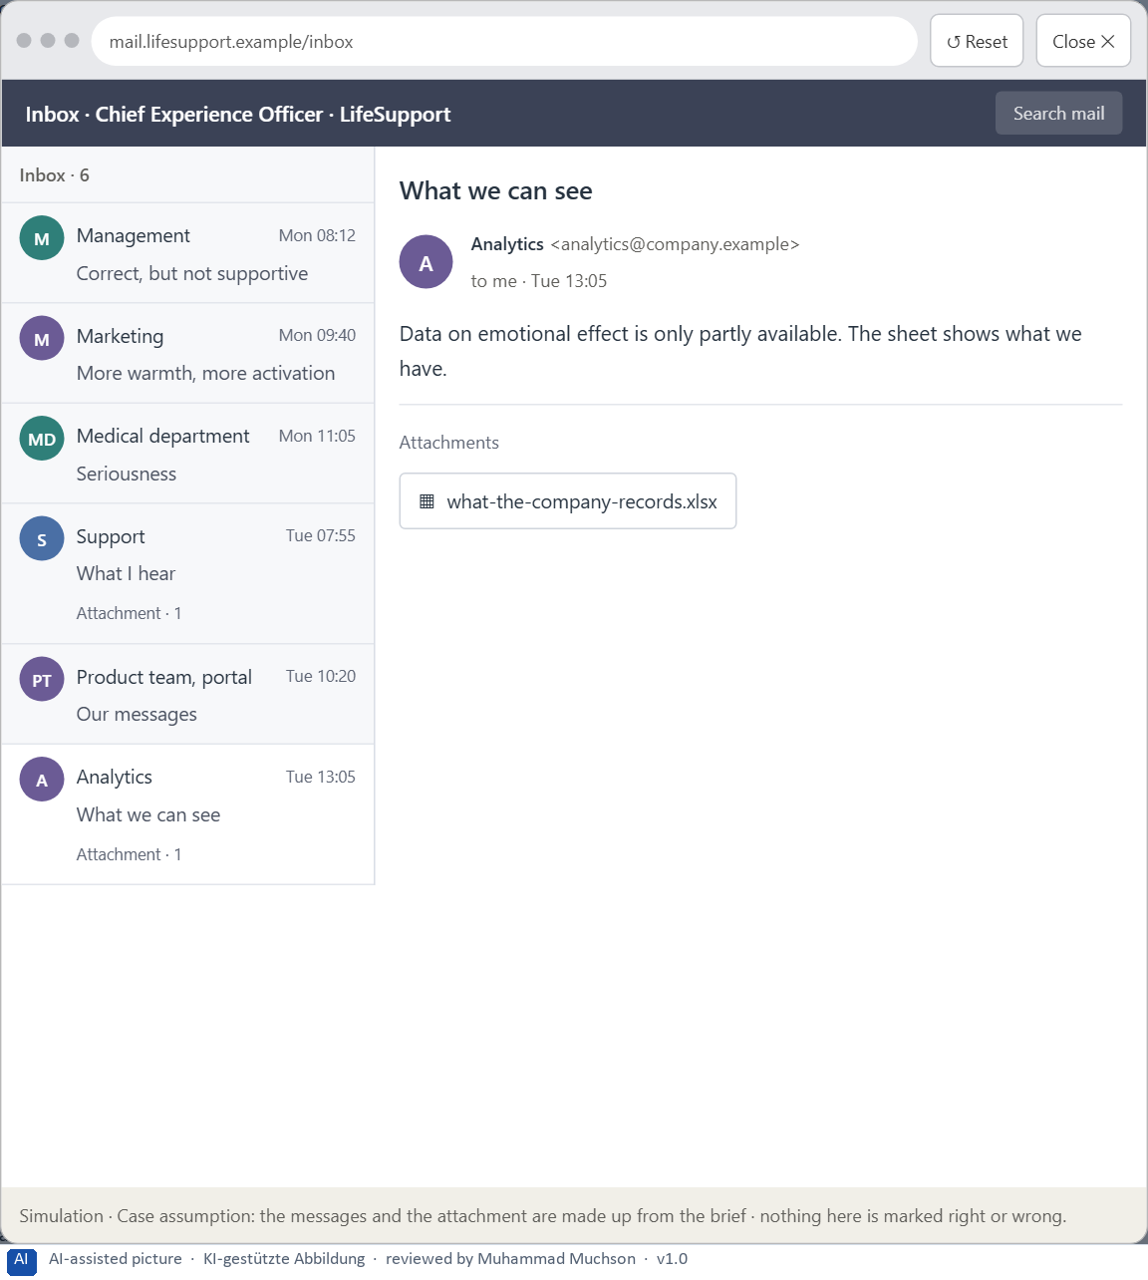
Figure 9 · Your desk: the messages that wait for you, shown in the lab as a mailbox (6 of 6).
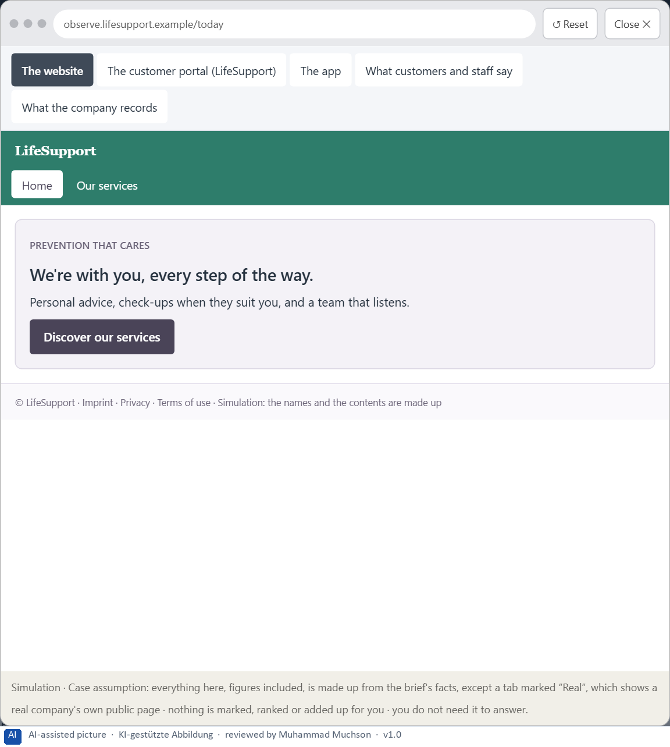
Figure 10 · The platform as it is today, as the lab lets you observe it (1 of 5).
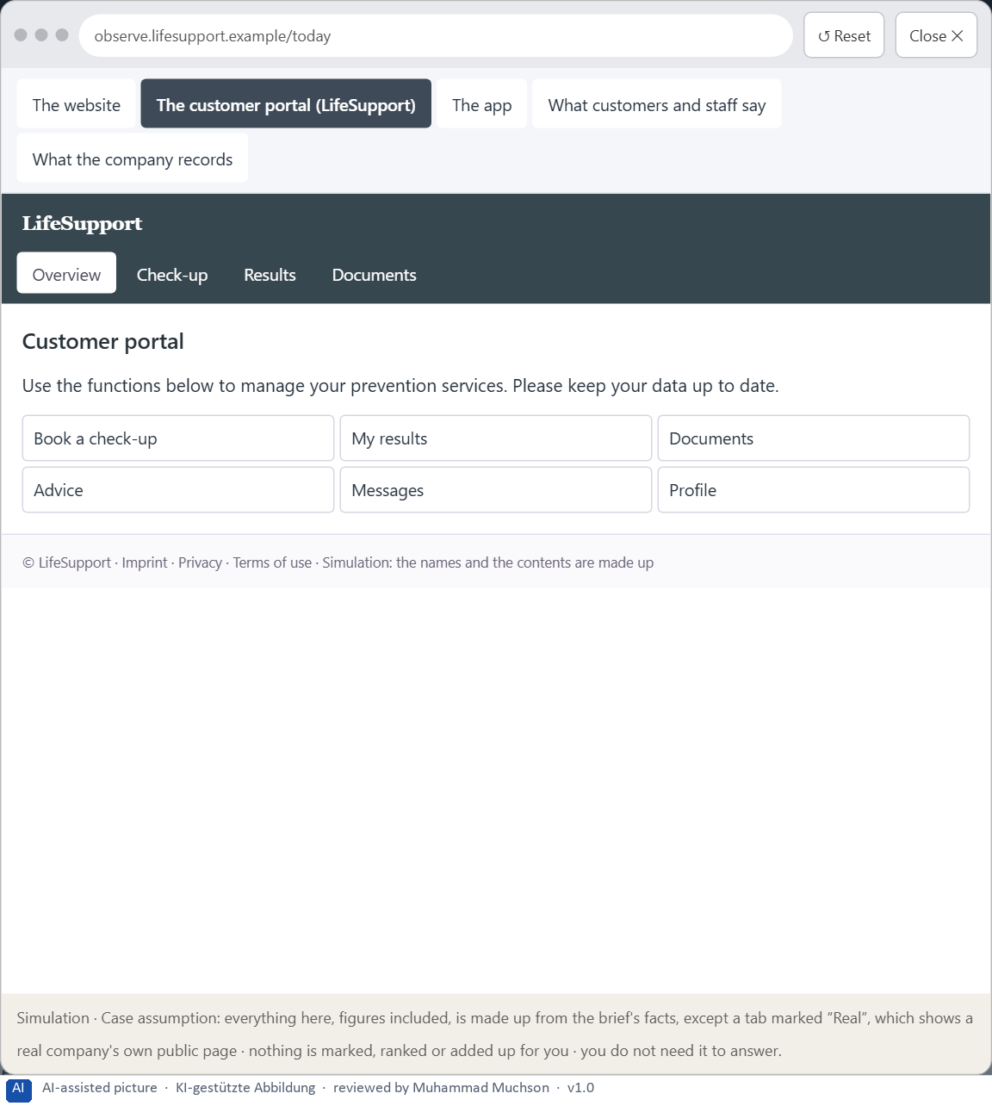
Figure 11 · The platform as it is today, as the lab lets you observe it (2 of 5).
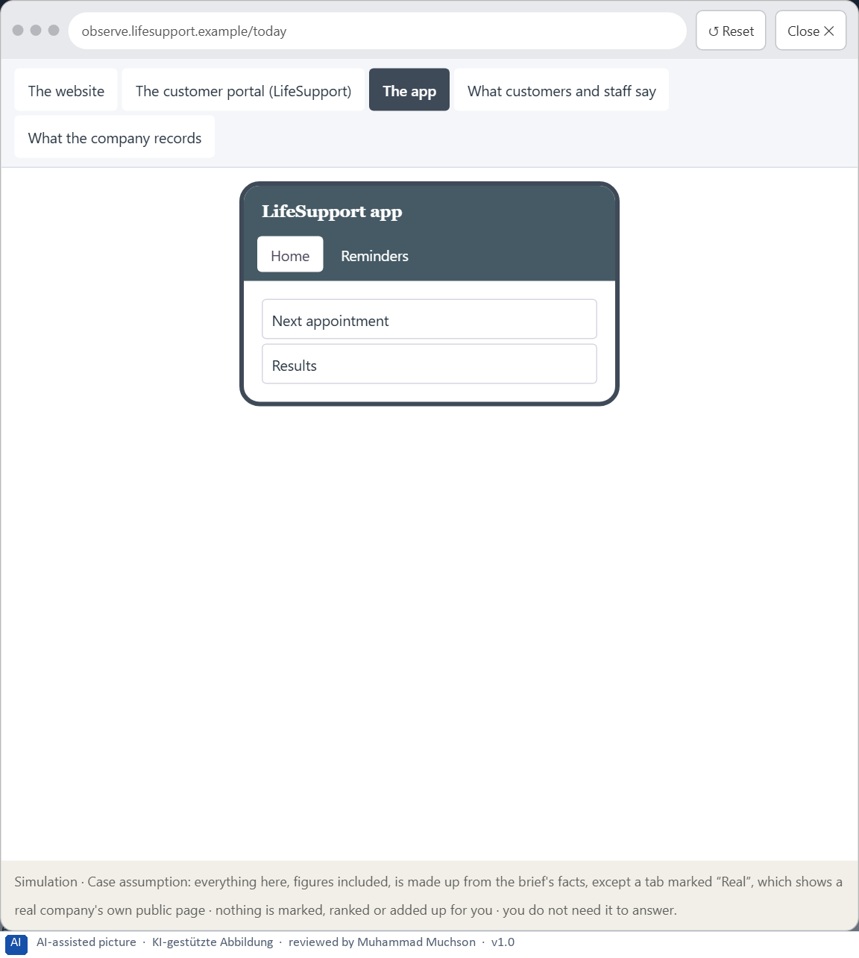
Figure 12 · The platform as it is today, as the lab lets you observe it (3 of 5).
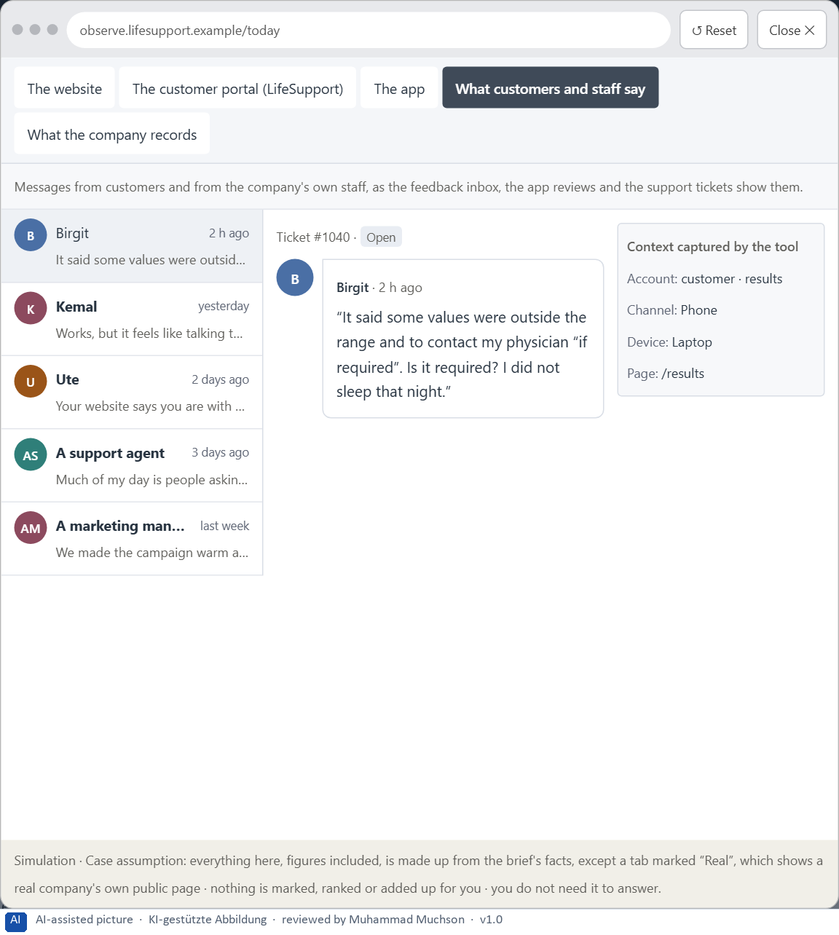
Figure 13 · The platform as it is today, as the lab lets you observe it (4 of 5).
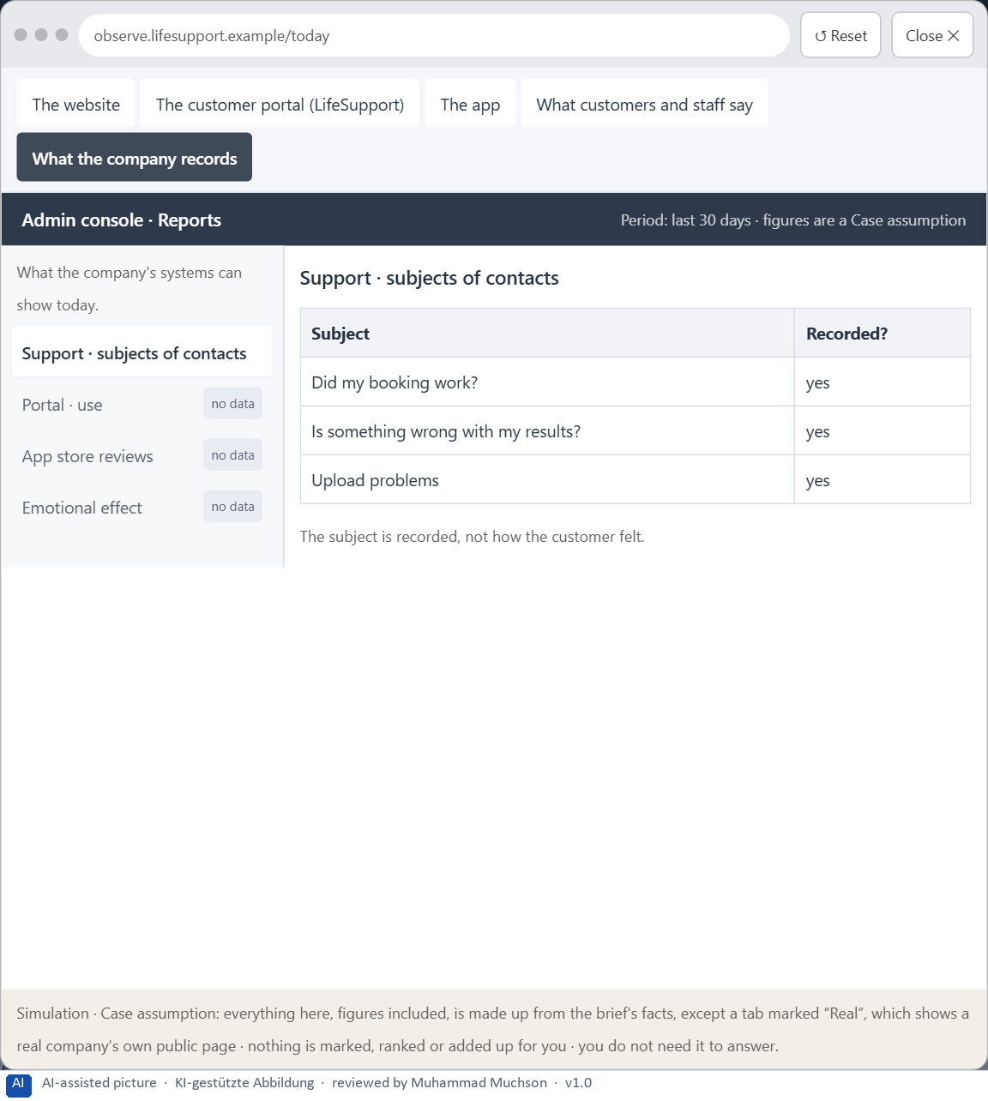
Figure 14 · The platform as it is today, as the lab lets you observe it (5 of 5).
Question 1 of 7 · A guiding vision for emotional UX: which emotional effect and which experience quality should users experience systematically?
One or two sentences about what users should feel in every touchpoint, also when something goes wrong.
How to build the answer:
- Say what users should feel when they come, when they act and when something goes wrong.
- Keep it serious enough for a health brand and warm enough to build a bond.

Question 2 of 7 · Three strategic guiding decisions on trust, emotional safety, motivation and supportive interaction
How to build the answer:
- Take your vision and ask which three choices would make it real.
- Write each as “we will …, even though that means …”.
Write them as a list, one decision per line, each with what it gives up.

Question 3 of 7 · A prioritised architecture of measures: which touchpoints, interactions or communication patterns are improved first, and why?
Put the touchpoints, interactions or patterns in an order and give the reason for the first ones.
How to build the answer:
- List the candidates: the critical moments, the most used flows, the communication patterns (confirmations, errors, reminders) and the touchpoints.
- Put first what affects how people feel at the moments that matter most.
- Say why the others can wait.

Question 4 of 7 · A risk analysis: which wrong assumptions about emotional effect, credibility and user behaviour would be especially critical?
Name two or three assumptions about how emotion works, what keeps credibility, or how users behave, and the harm if each is wrong.
How to build the answer:
- Write down what your concept assumes about emotional effect.
- Write down what it assumes about credibility.
- Write down what it assumes about how users behave.

Question 5 of 7 · A governance model: who is responsible for the emotional UX principles, and how are conflicts between brand, expertise and user effect decided?
Name roles, not people: who owns the emotional UX principles and the tone guide, how a conflict between marketing, the department and the effect on users is decided, and on what basis.
How to build the answer:
- Name who owns the emotional UX principles and the tone guide.
- Name the roles of marketing and the department.
- Say how a conflict between brand, expertise and user effect is decided.

Question 6 of 7 · A decision under uncertainty: make at least one prioritised decision despite patchy data and justify it responsibly
Say what you decide, what you do not know, and why the decision is responsible all the same, for example when you would reverse it.
How to build the answer:
- State the decision in one sentence.
- Name what you do not know.
- Say why it is still responsible: it can be reversed, it can be checked soon, or waiting costs more.

Question 7 of 7 · A management statement: a recommendation to the management with a clear priority and a strategic reason
Four to six sentences: the direction first, then the priority, the reason and what you ask of the management.
How to build the answer:
- Start with the direction in one sentence.
- Name the priority and the reason that carries it.
- Say what you ask of the management and what you will report back.

Use in class: presentation and handout
Mark of use for the worksheet. Presentation is what the trainer shows on screen; Handout is what participants fill in and hand in.
Part of the worksheet | Presentation (shown in the Neuro-UX Lab) | Handout
The case: three platforms on the UX team's desk, and LifeSupport | The case read aloud or on screen | The case text
Block 1.1 · Analyse the emotional effect of a digital offer from the user's side: | The task wording at the start of the block (no answers are shown) | Worksheet block with answer boxes (Core)
Block 1.2 · Rate emotional UX under conflicting goals: CareerPath | The task wording at the start of the block (no answers are shown) | Worksheet block with answer boxes (Core)
Block 2.1 · Case study: realigning the service portal LifeSupport | The task wording at the start of the block (no answers are shown) | Worksheet block with answer boxes (Core)
The situation: the provider behind LifeSupport, functionally solid and emotionally distant | The case read aloud or on screen | The case text
Block 3.1 · An emotionally effective UX strategy for a digital service | The task wording at the start of the block (no answers are shown) | Worksheet block with answer boxes (Core)

Glossary
Every term below is used in this document. Terms stay plain text in the body; this list says what they mean in everyday words.
Term | In plain words | Example | Comes from
Activation | Getting people to act now, often with strong stimuli. It can help for a moment and tire or push people if overdone. | — | Day 7
Case assumption | A fact made up for this exercise to fill a gap in the plan's case. It is marked so you know it is not part of the plan. | — | Day 1
Chief Experience Officer | The manager who is responsible for the experience customers have across all channels, and who decides where the company invests in it. | — | Day 1
Dark pattern | A design that uses emotion against people's own interest, such as false urgency, guilt or hidden costs. | — | Day 7
Decision architecture | A set of connected decisions that are made on purpose and written down: what effect you want, what comes first, who decides and how conflicts are settled. It replaces many separate fixes. | — | Day 1
Emotional bond | The sense, built over time, that a product is on your side. It makes people trust it and come back. | — | Day 7
Emotional safety | Feeling that you know what is happening, that nothing bad will follow from a mistake, and that help is there. | — | Day 7
Experience quality | How using a product feels, on the way and afterwards. It goes beyond usability, which only asks whether people reach their goal. | — | Day 7
Governance | The rules about who may decide what, who is answerable for it and how disagreements are settled. | — | Day 1
Orientation | Knowing where you are, what you can do here and what happens next. | — | Day 1
Perceived competence | How capable a product or company seems to people, judged from small signals such as clear feedback and careful wording. | — | Day 7
Stakeholder | A person or department with an interest in a decision, such as marketing, compliance, IT or sales. | — | Day 1
Tone guide | A short written rule for how a product speaks: which words, how formal, how it sounds when something goes wrong. | — | Day 7
Touchpoint | Any place where a person meets the company: the website, the customer portal, the app, a chatbot or a phone call. | — | Day 1
UX (user experience) | Everything a person goes through when using a product: what they notice, understand, feel and do, from the first look to the last step. The screens are only one part of it. | Finding the booking you want at once and feeling sure it went through is a good UX. | Day 1

The Neuro-UX Lab: where we practise online
In class we use the course website as the place to practise and to learn. Every day has its own address, in the same pattern: the day number is the last part.
What | Address
Neuro-UX Lab (course website) | https://aion-ux-lab.vercel.app/
Day 7 | https://aion-ux-lab.vercel.app/day/7/

On the day page, Route 1 (Levels 1 and 2) and Route 2 (Level 3) can be opened; the cards and the tasks of this document are there too. The pattern is the same up to Day 8, for example https://aion-ux-lab.vercel.app/day/6/.

