AION · UX DEVELOPER · PSYCHOLOGICAL UX DESIGN AND NEURO-UX
DAY 5 · TASK 1 AND TASK 2 · ROUTES 1 AND 2 · LEVELS 1 TO 3
MoveEasy: UX Analysis File and UX Strategy Memo
Describe the effect, choose the measures as a team member, and decide as Chief Experience Officer
AI notice · KI-Hinweis
This document was produced with the help of an AI language model (Claude, Anthropic). The AI drafted the text and tables and built the pictures and working examples of the lab. The content was then read, corrected and approved by the reviewer named below, who is responsible for its accuracy. Every picture carries an AI label on the image. Check figures and sources before you quote them.
KI-Hinweis: Dieses Dokument wurde mit Unterstützung eines KI-Sprachmodells (Claude, Anthropic) erstellt. Texte und Tabellen wurden von der KI entworfen, die Abbildungen sind KI-gestützt erstellt und am Bild gekennzeichnet. Die fachliche Prüfung und Freigabe erfolgte durch die unten genannte Person.

Day | Day 5 · Module 3 (day 2 of 3): Fitts, Hick and Miller in practice
Document | Task (worksheet with answer spaces). Task 1 (UX Analysis File) and Task 2 (UX Strategy Memo).
Route and level | Task 1 = Route 1, Levels 1 and 2 (draws on Materi A). Task 2 = Route 2, Level 3 (draws on Materi B).
Time | Task 1 about 33 min · Task 2 about 20 min
Neuro-UX Lab (website) | https://aion-ux-lab.vercel.app/day/5/
Case | MoveEasy, the day's case study; other products appear as warm-ups
Version | 1.0 · release date 29.10.2026
Review and approval | Muhammad Muchson, Mentor (subject-matter review and approval)

ABOUT THIS DOCUMENT
In class we also use the Neuro-UX Lab, the course website, as the place to practise and learn. Its address is at the end of this document.
This is the worksheet for Day 5. Read the case once, study the evidence printed in this document, and write your answers in the boxes and tables. You can work through it on paper or type into the document. All blocks are Core. There are no answer keys and no scores; the reason you give matters more than the choice.

IN THIS DOCUMENT
Lesson plan: ten teaching units (Ablaufplan)
Case study and transfer project at a glance
The case: three products on the UX team's desk, and MoveEasy
Block 1.1 · Recognise interaction hurdles in a portal: BankDirect · JUDGED · Core · about 10 min
Block 1.2 · Rate navigation and interaction concepts under conflicting goals: AdminFlow · JUDGED · Core · about 8 min
Block 2.1 · Case study: optimising the booking and management portal MoveEasy · JUDGED · Core · about 15 min
The situation: the mobility provider behind MoveEasy, and all its interfaces
Block 3.1 · An interaction strategy for efficient, low-load digital use · JUDGED · Core · about 20 min

Day at a glance
Day 5 has ten teaching units (UE). This document is the worksheet; it is used in UE2 to UE6 (Task 1) and UE8 to UE10 (Task 2). The day is built from three documents and the Neuro-UX Lab: Materi (study material), Task (worksheet) and Trainer (coaching, feedback and model solutions), plus the course website.

Lesson plan: ten teaching units (Ablaufplan)
UE | Min | Plan item | What happens | Material | Format
1 | 45 | Knowledge transfer · Level 1 | The trainer presents the cards of Materi A (A1, A2, A3, A4, A5, about 60 min of cards) in the Neuro-UX Lab; participants follow in the handout. | Materi A (Route 1) | Presentation + Handout
2 | 45 | Level 1 · Task 1 | Individual work on Block 1.1 (Core, about 10 min): the first product of the day is read and its effect described. Pairs then compare their results and the trainer collects open questions. | Task 1 · Part 1 · Block 1.1 | Handout (or in the lab)
3 | 45 | Level 1 · Task 2 | Three options are rated on the same criteria and one is chosen under the stated conditions: Block 1.2 (Core, about 8 min). | Task 1 · Part 1 · Block 1.2 | Handout (or in the lab)
4 | 45 | Coaching · transition from Level 1 to Level 2 | Trainer-led. A short talk on the day's coaching focus, then the reflection questions in pairs. The bridge: from describing an effect to a decision you answer for. There is no worksheet block in this unit. | Trainer document, section Coaching | Trainer only
5–6 | 90 | Level 2 · Case study MoveEasy (2 UE) incl. model solution | UE5: the trainer presents the case; participants work on Block 2.1 (Core, about 15 min). UE6: groups compare their results and defend them; the trainer closes with the model solution. | Task 1 · Part 2 · Block 2.1  Trainer document, section Case study | Handout; model solution shown after the work
7 | 45 | Level 2 + 3 · Feedback round with a management perspective | Groups present their reasoning, not only their result. The trainer asks the day's Level 3 input questions and leads the discussion. | Trainer document, section Feedback round | Presentation by the groups; Trainer only
8 | 45 | Level 3 · Transfer project, Chief Experience Officer (3 UE: UE8–10) | The trainer presents Materi B (B1, B2, B3; use the "In plain words" and "How to decide" boxes, the rest is handout) and sets the role and the situation. | Materi B (Route 2) | Presentation + Handout
9 | 45 | Level 3 · Transfer project | Individual work or in pairs on Block 3.1 (Core, about 20 min): the strategy memo. | Task 2 · Block 3.1 | Handout (or in the lab)
10 | 45 | Level 3 · Transfer project | Participants present their decision and what they give up, including the one decision made under uncertainty; the trainer debriefs with the model solution. | Task 2 · Block 3.1  Trainer document, section Transfer project | Handout; model solution shown after the work

One UE is counted as 45 minutes here; breaks are not shown. The times are a guide for the trainer. The Core blocks are enough for a complete answer.

Case study and transfer project at a glance
Component | UE | Duration | Participants work in | Model solution in
Level 2 case study (MoveEasy) | UE5–6 | 2 UE · 90 min | Task 1 · Part 2 (Block 2.1) | Trainer document, section Case study
Level 3 transfer project (Chief Experience Officer) | UE8–10 | 3 UE · 135 min | Materi B and Task 2 (Block 3.1) | Trainer document, section Transfer project

Which plan item each block answers
UE | Plan item (Strukturplan, Day 5) | Block in this document
UE2 | Level 1, task 1 · Recognise interaction hurdles in a portal: BankDirect | Block 1.1 (Core)
UE3 | Level 1, task 2 · Rate navigation and interaction concepts under conflicting goals: AdminFlow | Block 1.2 (Core)
UE4 | Coaching: from describing to deciding | A classroom talk led by the trainer; not a worksheet block
UE5–6 | Level 2 case study · Case study: optimising the booking and management portal MoveEasy | Block 2.1 (Core)
UE7 | Feedback round with a management perspective | A classroom discussion led by the trainer; not a worksheet block
UE8–10 | Level 3 transfer project · An interaction strategy for efficient, low-load digital use | Block 3.1 (Core), in Task 2

Your name
Write your full name here. Use the same name on every Task document this week; it is how your work is matched.

Task 1 · Route 1 · UX Analysis File: find the law behind each hurdle, then decide what to change

The case: three products on the UX team's desk, and MoveEasy
Read once · about 3 min
You work in the UX team of a digital agency. This week three products land on your desk. Two are warm-ups: BankDirect, a customer portal for transfers, card management and contract services, and AdminFlow, an administration platform that has three variants for its main navigation. The main case is MoveEasy, a mobility provider's portal where users book trips, manage tickets, change payment data and send support requests. It is rich in functions, but using it is slow and error-prone; above all on mobile devices, mis-taps and abandoned processes pile up.
What the plan gives you | How the task runs · three blocks
• Block 1.1: BankDirect, with 14 equal menu options, “start transfer” as a small link at the top right, buttons close together with similar labels, much information in forms, numbers and options to remember, and small central buttons on mobile  • Block 1.2: three navigation variants for AdminFlow; frequent and occasional users, the department wants every function visible, IT wants little rework, mobile use rising strongly, release in 7 weeks, limited test data  • Block 2.1: MoveEasy, with €140,000 and 10 weeks, mobile use already above 60 %, no complete relaunch, marketing that wants many offers visible and support that wants fewer operating errors | • Block 1.1: find the hurdles of interaction. Say where the portal feels slow, unclear or error-prone, assign your observations to the three laws, name five hurdles, write three effect statements and pick the two biggest weaknesses.  • Block 1.2: rate three navigation variants under conflicting goals. Rate each on five criteria, choose one, name the conflicts and the risks you accept, and write a recommendation to the project lead.  • Block 2.1: the case study. The central problems of interaction and decision, sorted into five categories, four measures, justified on four criteria, a decision for the first 10 weeks and a recommendation to the division management.

What is known and what is open
In the brief | Clear · Case assumption | Open · on purpose
• BankDirect: 14 equal menu options, “start transfer” as a small top-right link, similar buttons close together, crowded forms, things to remember, small mobile buttons.  • AdminFlow: three navigation variants in words; frequent and occasional users; 7 weeks; limited test data; mobile use rising.  • MoveEasy: small, badly placed booking buttons, too many options, tariffs to remember, long similar lists, equal choices in each step, small touch targets; €140,000 and 10 weeks; mobile above 60 %. | • You review BankDirect and AdminFlow as an agency would: from their screens, with no access to their data.  • MoveEasy's booking shows all ticket types and their conditions on one screen; the conditions are needed again two steps later.  • MoveEasy's main Book button sits at the top of the phone screen, out of reach of the thumb.  • Support at MoveEasy hears most often: “I booked the wrong ticket” and “I tapped by mistake”. | • How many users there are, and how many book on a phone exactly: the plan says only “above 60 %”.  • Which AdminFlow variant users would cope with best: the test data is limited.  • Where exactly MoveEasy users mis-tap: not recorded for every element.  • How much of the €140,000 each measure would take: the plan does not say.

As in most projects, not everything is known. Decide anyway, and say what you assume.
Case assumption
The brief says: BankDirect with 14 equal options, a small “start transfer” link, similar buttons close together, crowded forms, numbers to remember and small mobile buttons; AdminFlow's three navigation variants for frequent and occasional users, a department against IT, rising mobile use, 7 weeks and limited test data; MoveEasy with small, badly placed buttons, too many options, things to remember, long similar lists, small touch targets, €140,000, 10 weeks, mobile use above 60 % and no relaunch. Those are the plan's facts and its only figures. Everything else is made up for this exercise: the agency, the pictures, the simulations and the facts marked “Clear”.

Part 1 · Find the law behind the hurdles and weigh variants · Level 1 · Knowledge

Block 1.1 · Recognise interaction hurdles in a portal: BankDirect · JUDGED · Core · about 10 min
Draws on: A1 · Fitts's law · A2 · Hick's law · A3 · Miller's rule · A4 · The three laws together.
You receive the description of a fictional customer portal, BankDirect, for transfers, card management and contract services. Open it, on the desktop and on a phone, and try to start a transfer as a customer would. You need no prior knowledge: notice where you are slow, unsure or close to a mistake. The aim is to recognise the three UX laws in concrete problems of use and to describe their effect step by step.
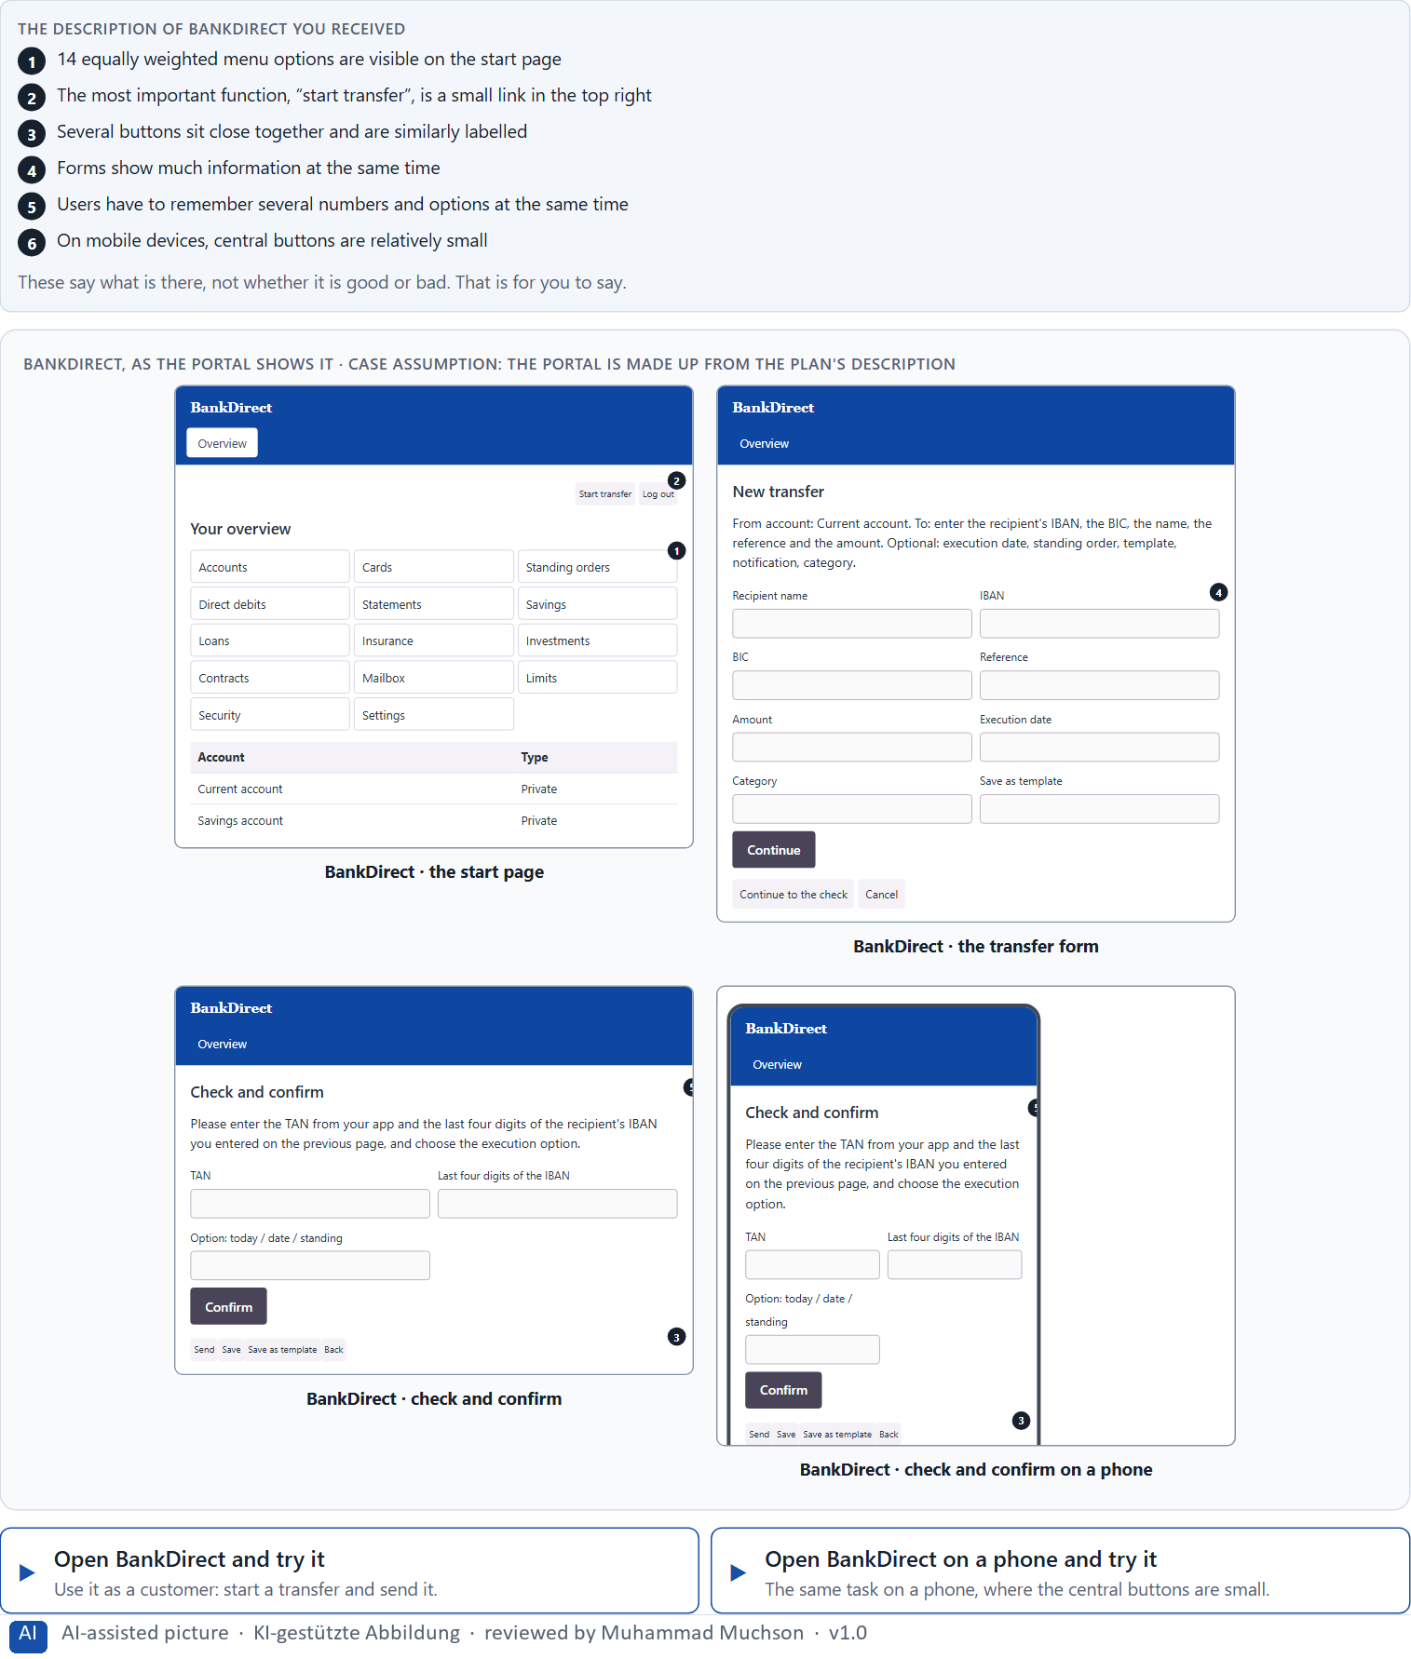
Figure 1 · BankDirect, as the portal shows it.
Question 1 of 5 · Describe which places could feel slow, unclear or error-prone from the user's point of view
Name the places where you were slow, unsure or close to a mistake, and say why.
How to build the answer:
- Open BankDirect and try to start a transfer; then open it on a phone and try again.
- Write down each place where you were slow, unsure or almost tapped the wrong thing.
- For each, say what made it slow, unclear or risky.

Question 2 of 5 · Assign the observations to the three laws Fitts's law, Hick's law and Miller's rule
Write the observations that belong to each law in a few words. One observation may touch two laws; put it where its effect is strongest.
How to build the answer:
- Take your observations from question 1.
- Ask what each one is about: hitting a target, choosing between options, or keeping something in mind.
- Write it under that law.
UX law | The observations for this law
Fitts's law · size, distance, reach
Hick's law · number of choices
Miller's rule · what must be held in mind

Question 3 of 5 · Name at least 5 concrete hurdles of use
How to build the answer:
- Go back through your observations.
- Write each hurdle as something concrete in the portal, and say what it makes the user do or risk.
Write them as a list, one hurdle per line, each concrete, with what it makes the user do or risk.

Question 4 of 5 · Write an effect statement for three points: “For users this could mean that …”
How to build the answer:
- Pick three hurdles from question 3.
- Finish the plan's sentence with what the user would do, risk or fail to do.
Write them as a list, one statement per line, each starting with the hurdle and ending with what it could mean for users.

Question 5 of 5 · Prioritise the two biggest weaknesses with regard to efficiency and error risk
How to build the answer:
- Look at your hurdles with two questions: which one costs the most time, and which one can cause the worst mistake?
- Pick the two that weigh most on efficiency and error risk together, and say why.
Write them as a list, the bigger weakness first, each with why it weighs most on efficiency and error risk.

Block 1.2 · Rate navigation and interaction concepts under conflicting goals: AdminFlow · JUDGED · Core · about 8 min
Draws on: A1 · Fitts's law · A2 · Hick's law · A3 · Miller's rule · A5 · Less searching, fewer errors, less decision stress, and weighing a measure.
AdminFlow is an administration platform. Three variants for its main navigation are described in words: A) all functions visible at a glance, so a high access to functions, but many options at once; B) the central tasks are large and easy to reach, while rare functions lie deeper in submenus; C) a modern, minimalist layout with few visible options, but many steps to the actual action. The conditions: the target group is frequent and occasional users, the department demands that all functions are visible, IT wants to manage with little rework, mobile use is rising strongly, the release is in 7 weeks, and only limited user test data exists. Decide anyway, and say what you assume.
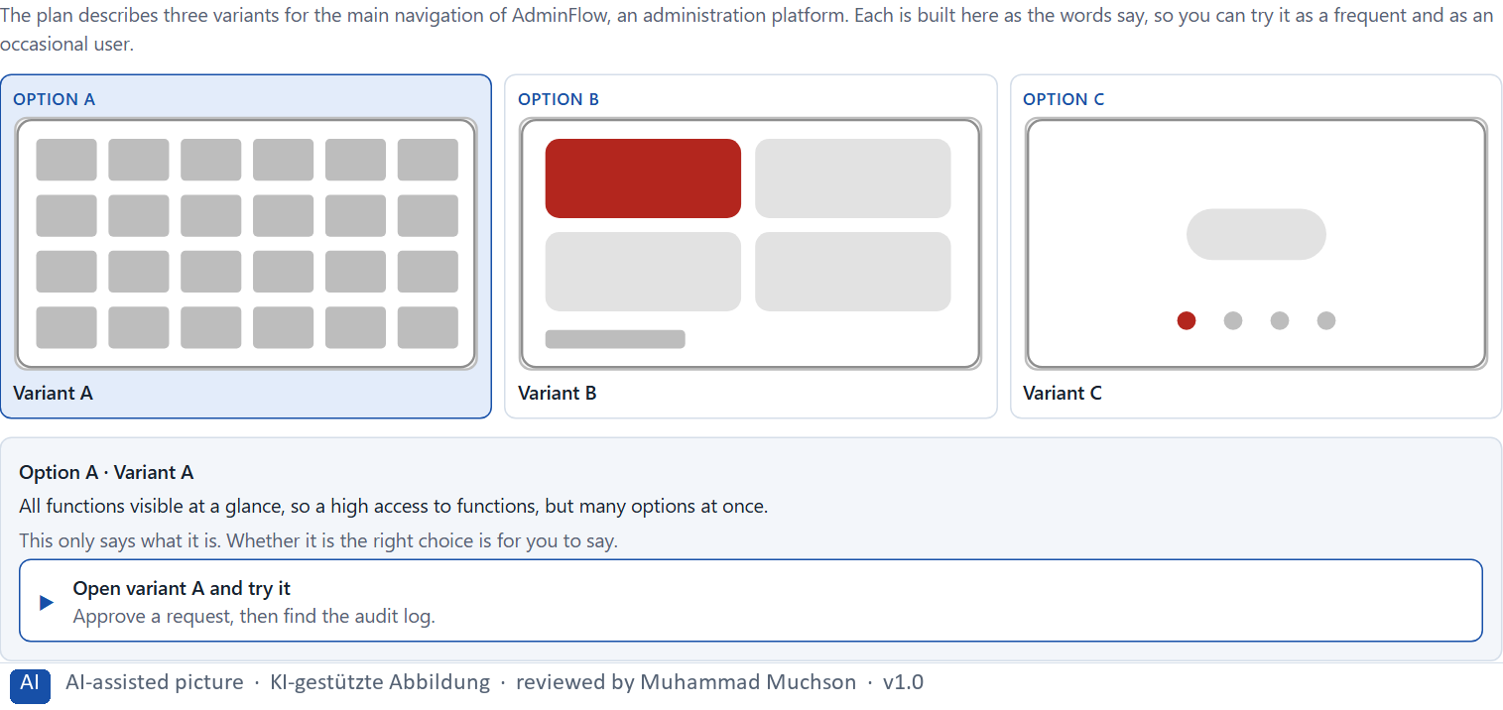
Figure 2 · The product to read, as the lab shows it (adminnav).
Question 1 of 5 · Rate each variant on reachability, decision effort, memory load, efficiency and error risk
Write a few sentences for each variant that cover all five criteria. Many teams rate each criterion Low, Medium or High with a reason; you may do that or write it in your own words.
How to build the answer:
- Take one variant at a time and keep both groups in mind, frequent and occasional users, on the desktop and on a phone.
- For each criterion, say how the variant does and which law explains it.
- Use the same five criteria for every variant, so you can compare them.
Variant | Reachability | Decision effort | Memory load | Efficiency | Error risk
Variant A · all functions visible, many options at once
Variant B · central tasks large, rare ones in submenus
Variant C · minimalist, many steps to the action

Question 2 of 5 · Decide which variant is the most viable under the given conditions
Choose one variant, then give your reason below. There is no single right choice; the reason has to rest on the users and the conditions.
How to build the answer:
- Say which group, which device and which condition weigh most for you.
- Say how your choice meets them better than the other two.
Tick one:
☐ Variant A · all functions visible, many options at once
☐ Variant B · central tasks large, rare ones in submenus
☐ Variant C · minimalist, many steps to the action
Why this variant, under these conditions?
Give your reason with the conditions: frequent and occasional users, the department against IT, rising mobile use, 7 weeks, limited test data.
How to build the answer:
- Name the group, the device and the condition that weigh most for you.
- Say how your variant meets them and why the other two meet them less well.
- Say what your choice gives up.

Question 3 of 5 · Name the conflicts of goals that make your decision difficult
Name at least two conflicts, each as two goals that pull against each other.
How to build the answer:
- Look at who wants what: the department, IT, frequent users, occasional users, mobile users.
- Write each conflict as “… against …” and say who stands for each side.

Question 4 of 5 · Which risks do you knowingly take with your decision?
Name at least one risk you accept and who would feel it.
How to build the answer:
- Think of what your chosen variant is weak at.
- Say who would notice and what would happen.

Question 5 of 5 · Formulate a recommendation to the project management
Two to four sentences: what you recommend, why, and what you will check next.
How to build the answer:
- Lead with the recommendation.
- Give the one reason the project management can follow.
- Say what you will check after the release.

Part 2 · The case study · Level 2 · Application · Case study (2 UE)
Case study: 2 teaching units (UE5–6)
This part is the day's Level 2 case study. It takes 2 UE (about 90 minutes): UE5 for the briefing and your own work, UE6 for comparing your results with your group and for the trainer's closing. The block below needs about 15 minutes of writing; the rest of the time is discussion.

Block 2.1 · Case study: optimising the booking and management portal MoveEasy · JUDGED · Core · about 15 min
Draws on: A1 · Fitts's law · A2 · Hick's law · A3 · Miller's rule · A4 · The three laws together · A5 · Less searching, fewer errors, less decision stress, and weighing a measure.
A provider of mobility services runs MoveEasy, a portal where users book trips, manage tickets, change payment data and send support requests. The portal is rich in functions, but use is slow and error-prone; above all on mobile devices, mis-taps and abandoned processes pile up. The observed problems: central booking buttons are small and partly badly placed, too many options at once on the start page raise uncertainty, users have to remember several tariffs and conditions at once, important actions lie in long lists of similar options, process steps offer too many equal choices, and mobile interaction is hard because touch targets are too small. The conditions: a budget of €140,000, 10 weeks for the implementation, mobile use is already above 60 %, a complete relaunch is not possible, marketing wants to keep as many offers visible as possible, and support demands fewer operating errors and questions. You work through six steps.
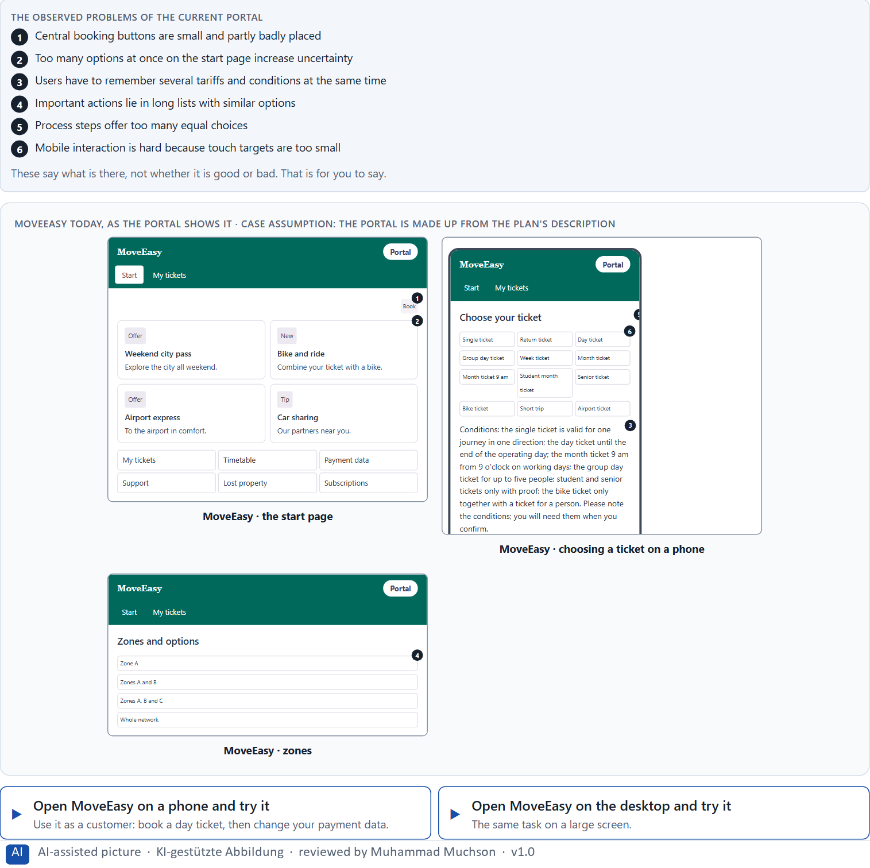
Figure 3 · MoveEasy today, as the portal shows it.
Question 1 of 6 · Analyse the central problems of interaction and decision in the portal
How to build the answer:
- Open MoveEasy on a phone and book a day ticket, then change your payment data, as a customer would.
- Write one problem per line as an effect on the user, and note the law behind it if you see one.
Write them as a list, one problem per line, each as an effect on the user. At least five.

Question 2 of 6 · Assign the problems to the categories reachability, decision effort, memory load, mobile usability and error risk
Write the problems that belong to each category in a few words. A problem may fit two categories.
How to build the answer:
- Take your problems from question 1.
- Ask which of the five categories each one affects most, and write it there.
Category | The problems in this category
Reachability
Decision effort
Memory load
Mobile usability
Error risk

Question 3 of 6 · Develop 4 prioritised measures for improvement
How to build the answer:
- Turn each group of problems into something you could change within 10 weeks and without a relaunch.
- Put them in order: what helps most users soonest, above all on the phone, first.
Write them as a numbered list, the first priority first, each with what it changes for users.

Question 4 of 6 · Justify your selection using effect on users, feasibility, risk and time pressure
Use all four criteria and say how they support your selection and its order.
How to build the answer:
- Say for your first measure what it changes for speed and errors, above all on the phone.
- Say what is feasible without a relaunch, and the risk of each.
- Keep marketing and support in mind, and the 10 weeks.

Question 5 of 6 · Make a prioritisation decision for the first 10 weeks
Say what you do in the first 10 weeks, in which order, and what you leave for later, with the reason.
How to build the answer:
- Say what comes first and why.
- Say what you do in parallel and what waits.
- Say how you deal with marketing's offers.

Question 6 of 6 · Formulate a recommendation to the division management
Three to five sentences: what you recommend, what has priority, and what you expect to change.
How to build the answer:
- Lead with the recommendation.
- Name the priorities.
- Say what you expect to change for users and for the company.

Task 2 · Route 2 · UX Strategy Memo: decide as Chief Experience Officer

The situation: the mobility provider behind MoveEasy, and all its interfaces
Read once · about 2 min
You take the perspective of the Chief Experience Officer of the mobility provider that runs MoveEasy. The company has a customer portal, a service app and an administration interface. Many digital processes work, but they are unnecessarily slow, error-prone and hard to access for first-time users. Inside the company new functions are prioritised, although known problems of reach, choice complexity and information overload remain unsolved. The management demands a sound strategy to improve efficiency, orientation and the quality of interaction. You are not to correct single buttons or menus but to develop a sound decision architecture for navigation, interaction and action logic based on Fitts's law, Hick's law and Miller's rule.
The framework | How the task runs · one block
• The budget is limited  • Mobile use is growing strongly  • Several stakeholders pursue conflicting interests  • Not all systems can be adapted at the same time  • User data is only partly available  • First results must be visible at short notice  • Wrong decisions increase support costs, abandoned processes and frustration | • Block 3.1 asks seven questions: a guiding vision for efficient interaction, three strategic decisions, a prioritised architecture of measures, a risk analysis, a governance model, one decision under uncertainty and a management statement.

What is known and what is open
In the brief | Clear · Case assumption | Open · on purpose
• A customer portal, a service app and an administration interface.  • Processes work, but are slow, error-prone and hard for first-time users.  • New functions are prioritised; known problems of reach, choice and overload stay.  • Mobile use grows strongly; first results must show soon; not all systems at once. | • The company is the mobility provider behind MoveEasy in Route 1.  • Each team builds its buttons, lists and forms its own way; there are no shared interaction standards.  • Support records the subject of each contact; the portal records completed bookings; nobody records mis-taps. | • How large the budget is: “limited” is all the plan says.  • Which interface causes the most errors: the data is only partial.  • How many functions are really used: not measured.

As in most projects, not everything is known. Decide anyway, and say what you assume.
Case assumption
The brief says: a company with a customer portal, a service app and an administration interface, processes that work but are slow, error-prone and hard for first-time users, new functions prioritised over known problems of reach, choice complexity and information overload, a limited budget, strongly growing mobile use, conflicting stakeholders, not all systems at once, partial user data, first results soon, and the warning that wrong decisions increase support costs, abandonment and frustration. Those are the plan's facts. That the company is the mobility provider of Route 1 and the facts marked “Clear” are made up for this exercise.

The memo is addressed to: The management. Subject: An interaction strategy for efficient and low-load digital use.

Part 3 · Level 3 · Management decision · Transfer project (3 UE)
Transfer project: 3 teaching units (UE8–10)
UE8: the trainer presents Materi B and sets the role. UE9: you write the memo. UE10: you present the decision and what you give up; the trainer debriefs.

Block 3.1 · An interaction strategy for efficient, low-load digital use · JUDGED · Core · about 20 min
Draws on: B1 · Interaction as an architecture of effect · B2 · Conflicts of goals · B3 · Who owns the interaction standards, and deciding with incomplete data.
Develop a strategic concept for the mobility provider. Your desk holds what the management, the teams and the data say. Open it, then answer the seven questions; your answers build the memo below.
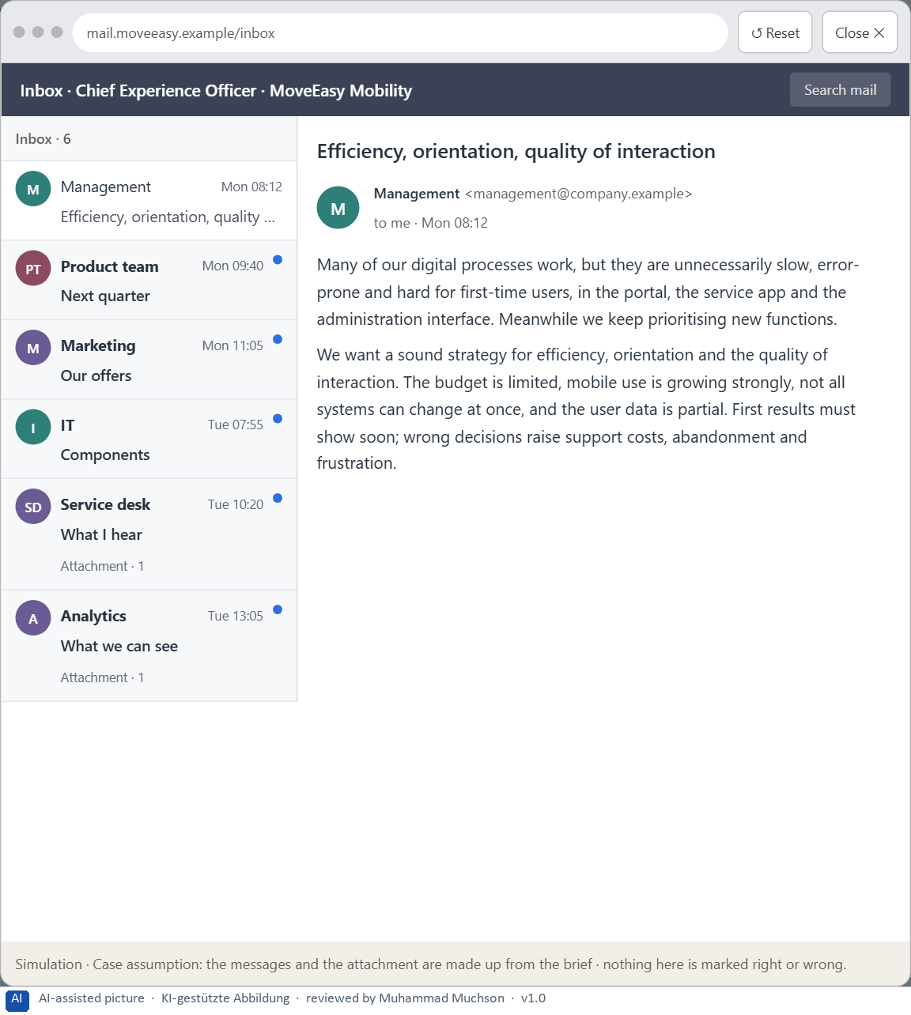
Figure 4 · Your desk: the messages that wait for you, shown in the lab as a mailbox (1 of 6).
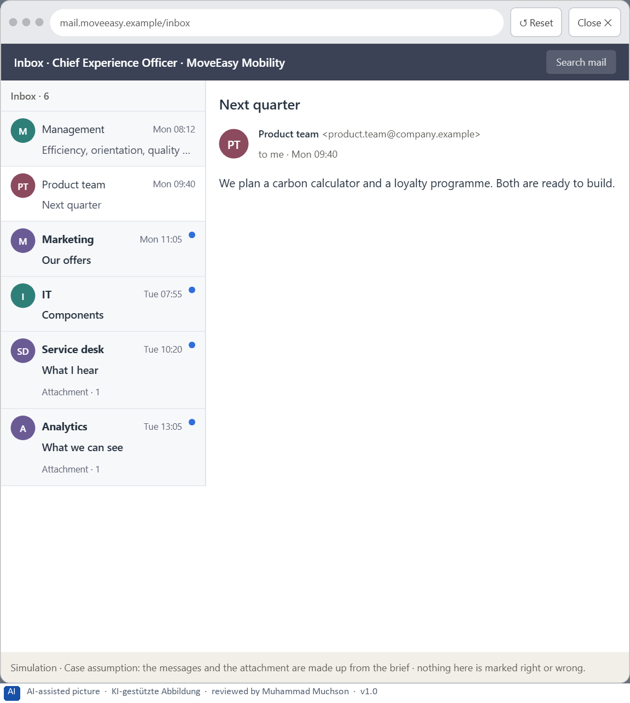
Figure 5 · Your desk: the messages that wait for you, shown in the lab as a mailbox (2 of 6).
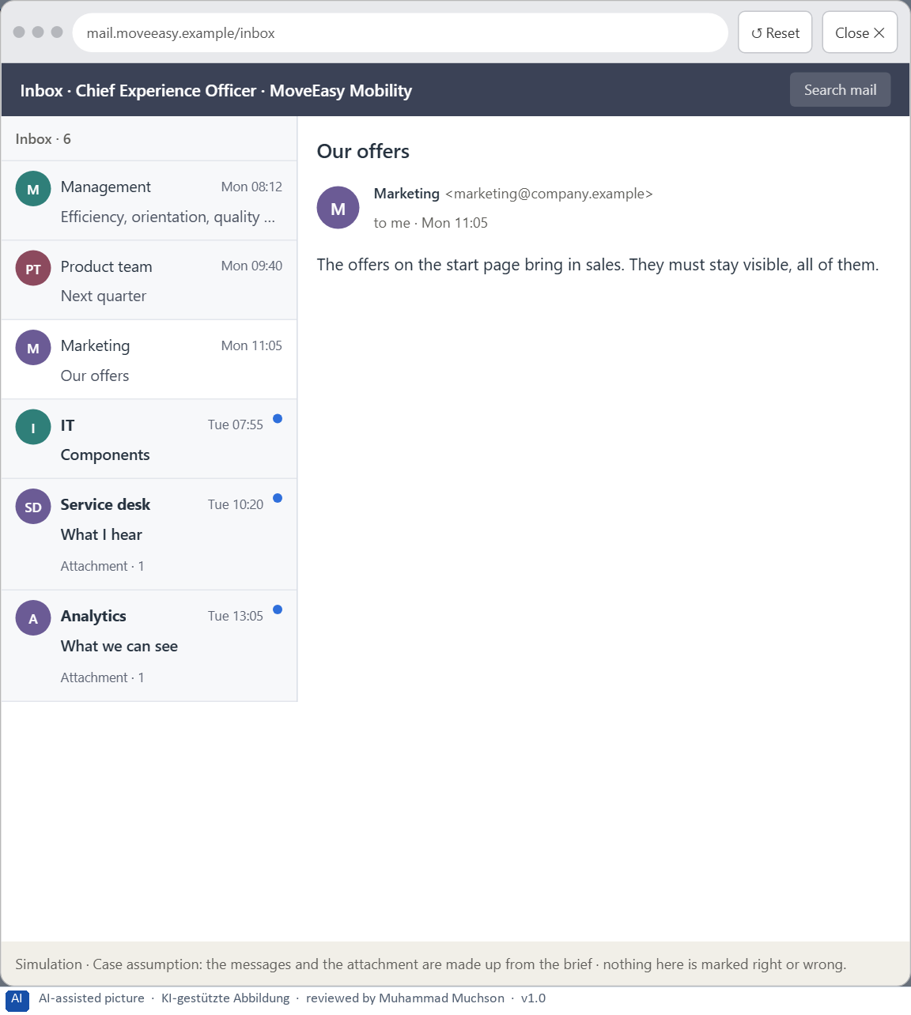
Figure 6 · Your desk: the messages that wait for you, shown in the lab as a mailbox (3 of 6).
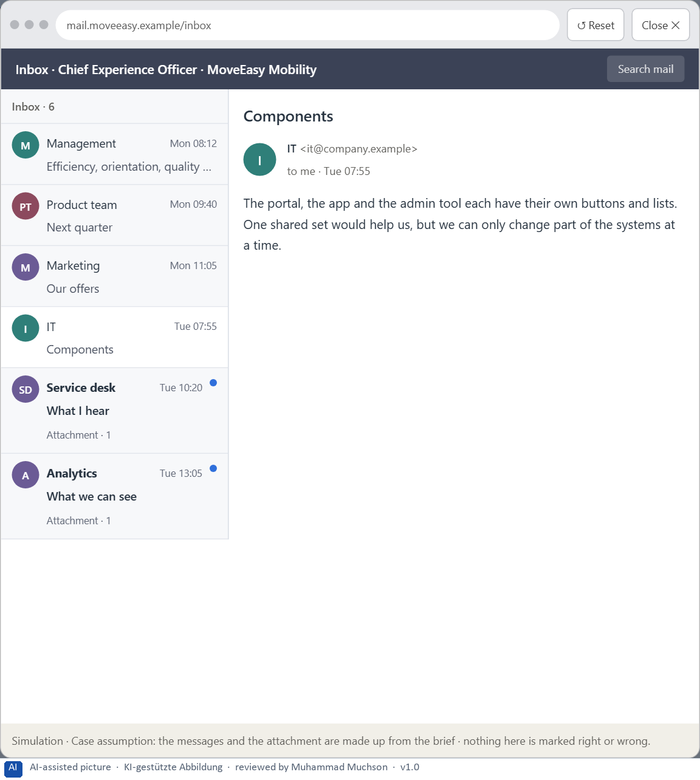
Figure 7 · Your desk: the messages that wait for you, shown in the lab as a mailbox (4 of 6).
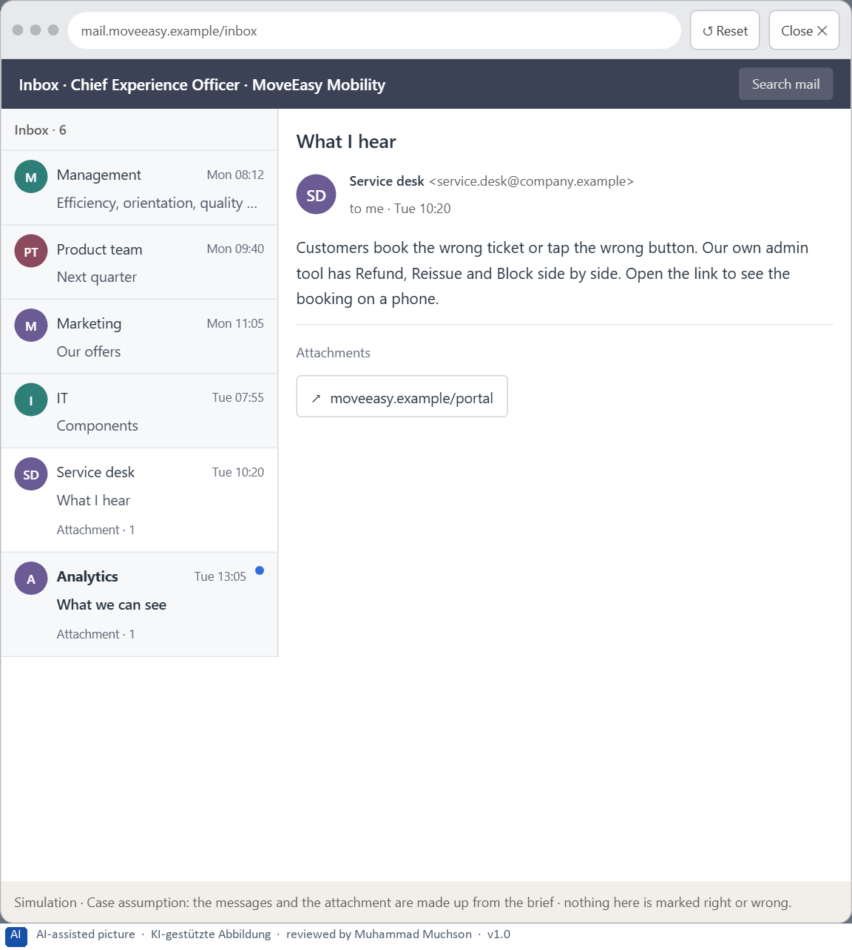
Figure 8 · Your desk: the messages that wait for you, shown in the lab as a mailbox (5 of 6).
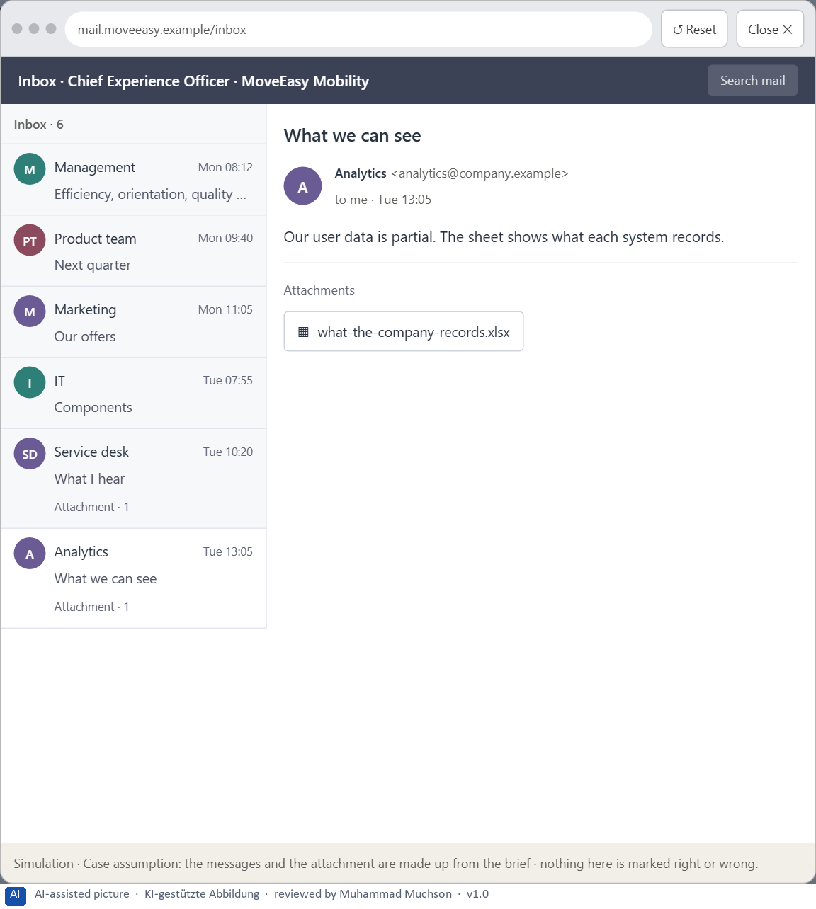
Figure 9 · Your desk: the messages that wait for you, shown in the lab as a mailbox (6 of 6).
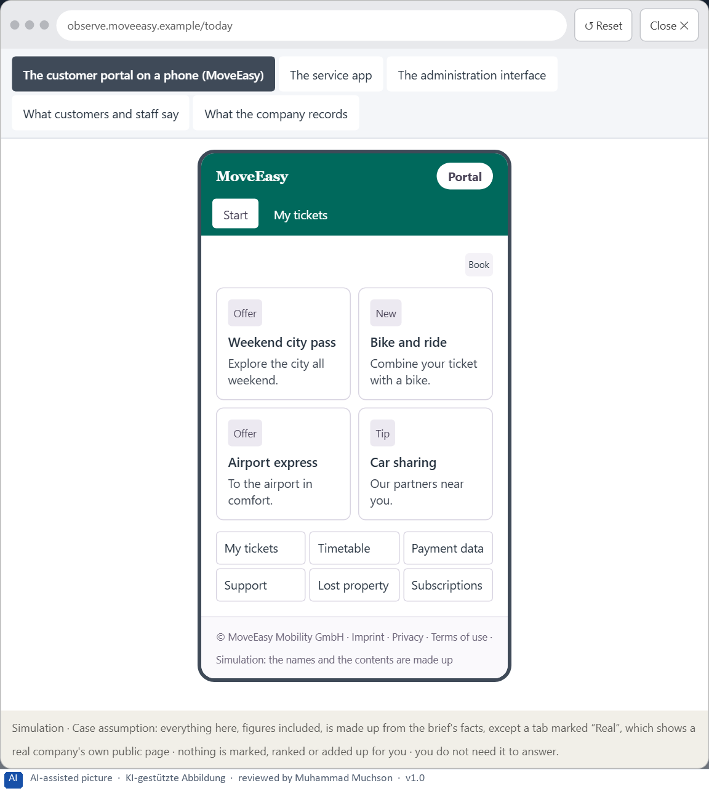
Figure 10 · The platform as it is today, as the lab lets you observe it (1 of 5).
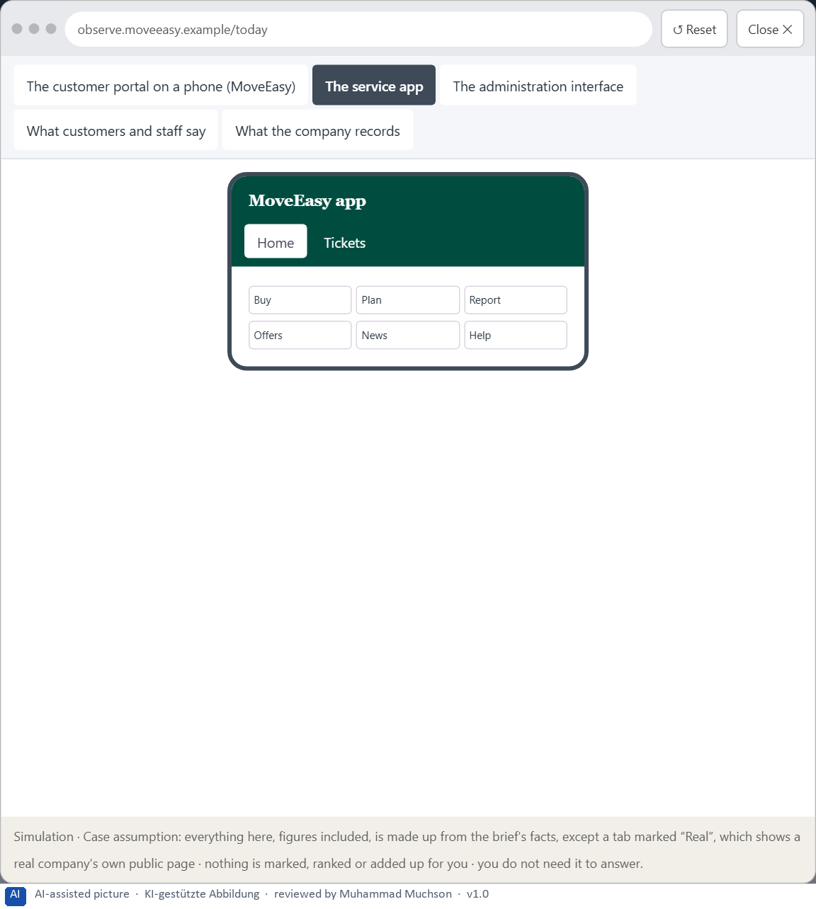
Figure 11 · The platform as it is today, as the lab lets you observe it (2 of 5).
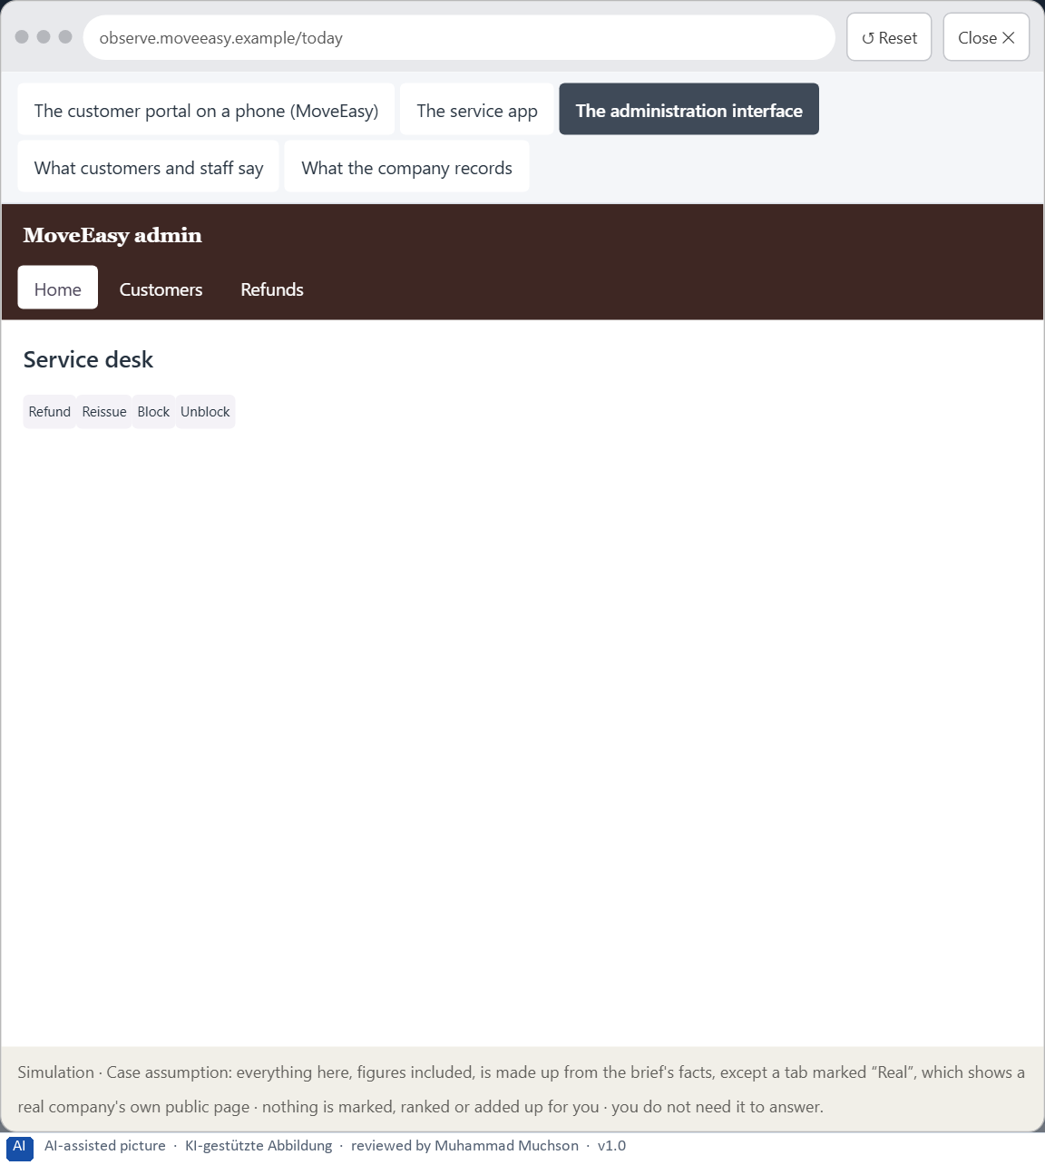
Figure 12 · The platform as it is today, as the lab lets you observe it (3 of 5).
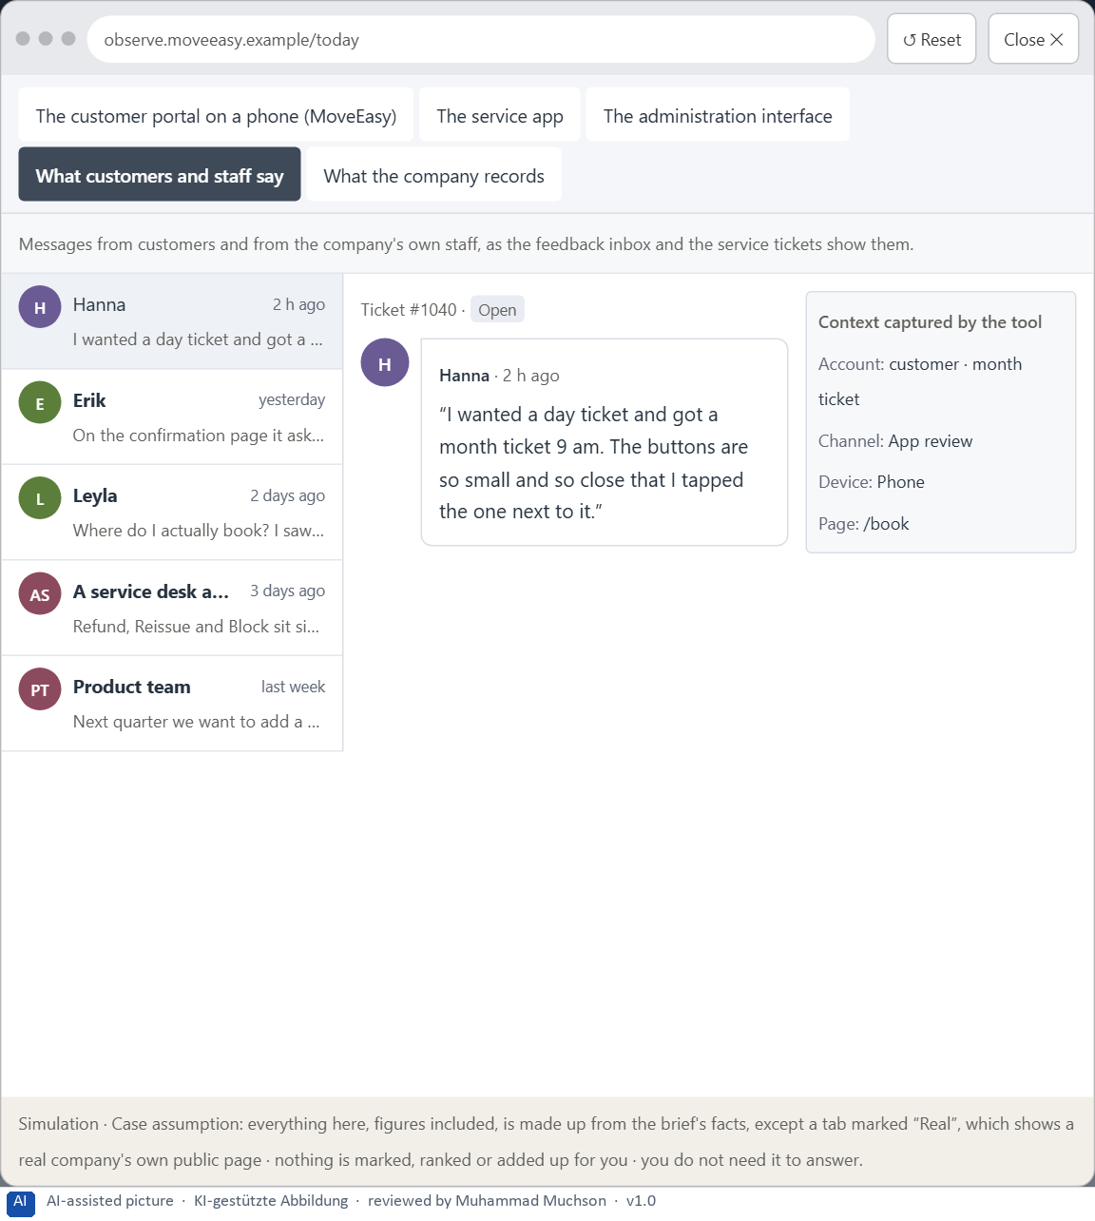
Figure 13 · The platform as it is today, as the lab lets you observe it (4 of 5).
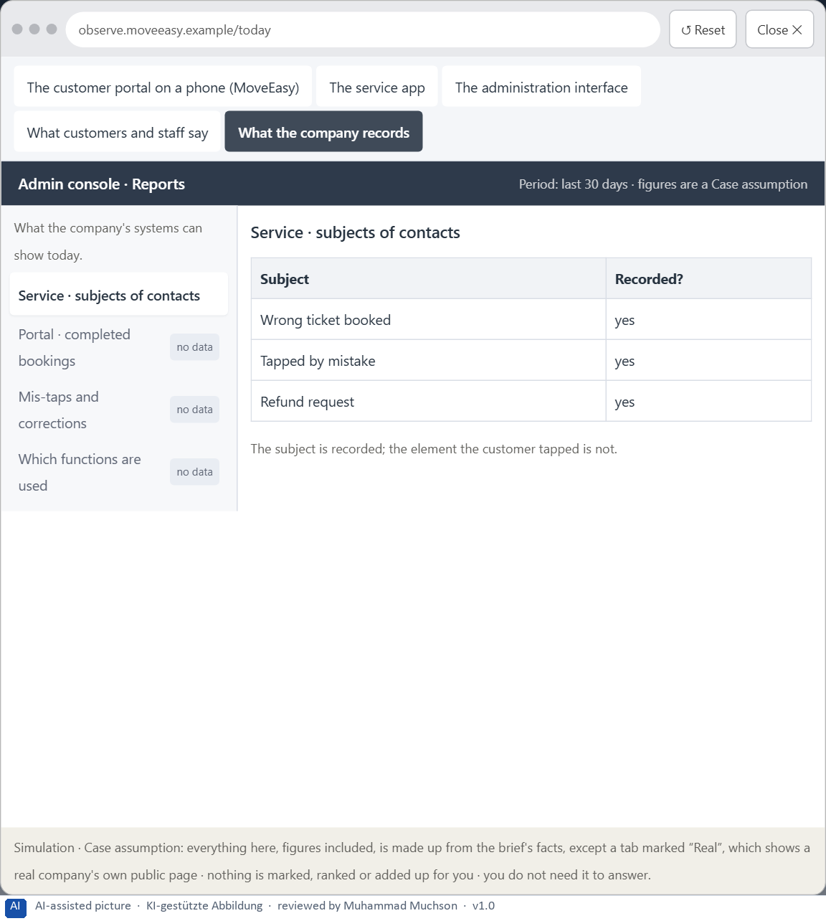
Figure 14 · The platform as it is today, as the lab lets you observe it (5 of 5).
Question 1 of 7 · A guiding vision for efficient interaction: which quality of use and which relief for users should be reached systematically?
One or two sentences about how fast, safe and light interaction should feel, in every interface and on every device.
How to build the answer:
- Say what users should be able to do quickly and safely, also on a phone and the first time.
- Say what they should never have to do: aim, compare too much or remember.

Question 2 of 7 · Three strategic guiding decisions on reachability, reducing choice, structuring information and prioritising main actions
How to build the answer:
- Take your vision and ask which three choices would make it real.
- Write each as “we will …, even though that means …”.
Write them as a list, one decision per line, each with what it gives up.

Question 3 of 7 · A prioritised architecture of measures: which processes, screens or systems are improved first, and why?
Put the processes, screens or systems in an order and give the reason for the first ones.
How to build the answer:
- List the candidates: the most used processes, the interfaces and the shared elements.
- Put first what most users touch and where most errors happen, on the phone.
- Say why the others can wait.

Question 4 of 7 · A risk analysis: which wrong assumptions about user behaviour and the need for functions would be especially critical?
Name two or three assumptions about how users behave or which functions they need, and the harm if each is wrong.
How to build the answer:
- Write down what your concept assumes about users' behaviour.
- Write down what it assumes about which functions are needed.
- For each, say what happens if it is wrong.

Question 5 of 7 · A governance model: who is responsible for the interaction standards, and how are conflicts between feature richness and usability decided?
Name roles, not people: who owns the interaction standards, how a request for more visible functions is decided, and on what basis.
How to build the answer:
- Name who owns the interaction standards across all interfaces.
- Name how a request for more visible functions or a new function is decided.
- Say on what basis the conflict is decided.

Question 6 of 7 · A decision under uncertainty: make at least one prioritised decision despite incomplete data and justify it
Say what you decide, what you do not know, and why the decision is responsible all the same, for example when you would reverse it.
How to build the answer:
- State the decision in one sentence.
- Name what you do not know.
- Say why it is still responsible: it can be reversed, it can be checked soon, or waiting costs more.

Question 7 of 7 · A management statement: a recommendation to the management with a clear priority and a strategic reason
Four to six sentences: the direction first, then the priority, the reason and what you ask of the management.
How to build the answer:
- Start with the direction in one sentence.
- Name the priority and the reason that carries it.
- Say what you ask of the management and what you will report back.

Use in class: presentation and handout
Mark of use for the worksheet. Presentation is what the trainer shows on screen; Handout is what participants fill in and hand in.
Part of the worksheet | Presentation (shown in the Neuro-UX Lab) | Handout
The case: three products on the UX team's desk, and MoveEasy | The case read aloud or on screen | The case text
Block 1.1 · Recognise interaction hurdles in a portal: BankDirect | The task wording at the start of the block (no answers are shown) | Worksheet block with answer boxes (Core)
Block 1.2 · Rate navigation and interaction concepts under conflicting goals: Admi | The task wording at the start of the block (no answers are shown) | Worksheet block with answer boxes (Core)
Block 2.1 · Case study: optimising the booking and management portal MoveEasy | The task wording at the start of the block (no answers are shown) | Worksheet block with answer boxes (Core)
The situation: the mobility provider behind MoveEasy, and all its interfaces | The case read aloud or on screen | The case text
Block 3.1 · An interaction strategy for efficient, low-load digital use | The task wording at the start of the block (no answers are shown) | Worksheet block with answer boxes (Core)

Glossary
Every term below is used in this document. Terms stay plain text in the body; this list says what they mean in everyday words.
Term | In plain words | Example | Comes from
Action logic | The order in which a task runs: where it starts, which steps follow, what each step asks and how the person knows they are done. | — | Day 4
Case assumption | A fact made up for this exercise to fill a gap in the plan's case. It is marked so you know it is not part of the plan. | — | Day 1
Chief Experience Officer | The manager who is responsible for the experience customers have across all channels, and who decides where the company invests in it. | — | Day 1
Decision architecture | A set of connected decisions that are made on purpose and written down: what effect you want, what comes first, who decides and how conflicts are settled. It replaces many separate fixes. | — | Day 1
Decision effort | The mental work of comparing options and choosing one. Many equal options raise it. | — | Day 4
Decision stress | The strain people feel when they have to choose between many similar options and fear choosing wrongly. | — | Day 5
Error probability | How likely a person is to make a mistake at a given step. Small targets, many similar options and things to remember all raise it. | — | Day 5
Fitts's law | A target is reached faster and missed less often when it is large and close. Small, distant buttons cost time and cause wrong taps. | — | Day 4
Governance | The rules about who may decide what, who is answerable for it and how disagreements are settled. | — | Day 1
Hick's law | The more equally weighted options people have to choose from, the longer the decision takes. It matters most for unfamiliar options that look alike. | — | Day 4
Interaction standard | A written rule every team follows for how interaction works, such as a minimum target size, one main action per screen or a limit on equal options. | — | Day 5
Memory load | How much a person has to keep in mind while using an interface, such as a number from an earlier screen or the option chosen two steps back. | — | Day 4
Miller's rule | Short-term memory holds only a few things at once, about seven in Miller's old estimate and nearer four in later research. Interfaces should not make people remember what the system knows. | — | Day 4
Mis-tap | A tap that hits the wrong target, often because targets are small or close together. | — | Day 5
Mobile usability | How well a product can be used on a phone: one-handed, on a small screen, often on the move. | — | Day 5
Operating error | A wrong action caused by the interface, such as tapping the wrong button or sending a form twice because nothing confirmed it. | — | Day 4
Orientation | Knowing where you are, what you can do here and what happens next. | — | Day 1
Reachability | How easily a target can be reached and hit: its size, its distance from the hand or pointer, and the space around it. | — | Day 5
Stakeholder | A person or department with an interest in a decision, such as marketing, compliance, IT or sales. | — | Day 1
Touch target | The area of a button or link that reacts to a tap or a click. It can be larger than the visible label; too small, and people miss it. | — | Day 5
UX (user experience) | Everything a person goes through when using a product: what they notice, understand, feel and do, from the first look to the last step. The screens are only one part of it. | Finding the booking you want at once and feeling sure it went through is a good UX. | Day 1
UX law | A well-tested finding about how people perceive, decide or act, used as a rule of thumb in design, such as Hick's law or Fitts's law. It explains why something is hard; it does not replace looking at the users. | — | Day 4

The Neuro-UX Lab: where we practise online
In class we use the course website as the place to practise and to learn. Every day has its own address, in the same pattern: the day number is the last part.
What | Address
Neuro-UX Lab (course website) | https://aion-ux-lab.vercel.app/
Day 5 | https://aion-ux-lab.vercel.app/day/5/

On the day page, Route 1 (Levels 1 and 2) and Route 2 (Level 3) can be opened; the cards and the tasks of this document are there too. The pattern is the same up to Day 8, for example https://aion-ux-lab.vercel.app/day/6/.

