
UX DEVELOPER · PSYCHOLOGICAL UX DESIGN AND NEURO-UX
DAY 1 · CASE STUDY · LEVEL 2 · 2 UE (UE5–6)
SafeHome Online: Case study
The day's Level 2 case study with its questions; work on it alone, then compare in your group
AI notice · KI-Hinweis
This document was produced with the help of an AI language model (Claude, Anthropic). The AI drafted the text and tables and built the pictures and working examples of the lab. The content was then read, corrected and approved by the reviewer named below, who is responsible for its accuracy. Every picture carries an AI label on the image. Check figures and sources before you quote them.
KI-Hinweis: Dieses Dokument wurde mit Unterstützung eines KI-Sprachmodells (Claude, Anthropic) erstellt. Texte und Tabellen wurden von der KI entworfen, die Abbildungen sind KI-gestützt erstellt und am Bild gekennzeichnet. Die fachliche Prüfung und Freigabe erfolgte durch die unten genannte Person.

Day | Day 1 · Module 1 (day 1 of 1): Psychological UX design and neuro-design
Document | Case study (worksheet with answer spaces) for the 2 teaching units UE5–6.
Route and level | Level 2 · Application. Draws on Materi A.
Time | About 90 min (UE5–6), of which about 15–20 min of writing
Neuro-UX Lab (website) | https://aion-ux-lab.vercel.app/day/1/
Case | SafeHome Online, the day's case study
Version | 1.0 · release date 29.10.2026
Review and approval | Muhammad Muchson, Mentor (subject-matter review and approval)

ABOUT THIS DOCUMENT
In class we also use the Neuro-UX Lab, the course website, as the place to practise and learn. Its address is at the end of this document.
This is the case study of Day 1. Read the case once, look at the picture, and write your answers in the boxes and tables. You can work on paper or type into the document. There are no answer keys in this document; the trainer closes the unit with the model solution.

IN THIS DOCUMENT
Lesson plan: ten teaching units (Ablaufplan)
Case study and transfer project at a glance
Block 2.1 · Case study: redesigning SafeHome Online · JUDGED · Core · about 15 min

Day at a glance
Day 1 has ten teaching units (UE). This document is the worksheet; it is used in UE2 to UE6 (Task 1) and UE8 to UE10 (Task 2). The day is built from three documents and the Neuro-UX Lab: Materi (study material), Task (worksheet) and Trainer (coaching, feedback and model solutions), plus the course website.

Lesson plan: ten teaching units (Ablaufplan)
UE | Min | Plan item | What happens | Material | Format
1 | 45 | Knowledge transfer · Level 1 | The trainer presents the cards of Materi A (A1, A2, A3, A4, A5, about 60 min of cards) in the Neuro-UX Lab; participants follow in the handout. | Materi A (Route 1) | Presentation + Handout
2 | 45 | Level 1 · Task 1 | Individual work on Block 1.1 (Core, about 10 min): the first product of the day is read and its effect described. Pairs then compare their results and the trainer collects open questions. | Task 1 · Part 1 · Block 1.1 | Handout (or in the lab)
3 | 45 | Level 1 · Task 2 | Three options are rated on the same criteria and one is chosen under the stated conditions: Block 1.2 (Core, about 8 min). | Task 1 · Part 1 · Block 1.2 | Handout (or in the lab)
4 | 45 | Coaching · transition from Level 1 to Level 2 | Trainer-led. A short talk on the day's coaching focus, then the reflection questions in pairs. The bridge: from describing an effect to a decision you answer for. There is no worksheet block in this unit. | Trainer document, section Coaching | Trainer only
5–6 | 90 | Level 2 · Case study SafeHome Online (2 UE) incl. model solution | UE5: the trainer presents the case; participants work on Block 2.1 (Core, about 15 min). UE6: groups compare their results and defend them; the trainer closes with the model solution. | Task 1 · Part 2 · Block 2.1  Trainer document, section Case study | Handout; model solution shown after the work
7 | 45 | Level 2 + 3 · Feedback round with a management perspective | Groups present their reasoning, not only their result. The trainer asks the day's Level 3 input questions and leads the discussion. | Trainer document, section Feedback round | Presentation by the groups; Trainer only
8 | 45 | Level 3 · Transfer project, Chief Experience Officer (3 UE: UE8–10) | The trainer presents Materi B (B1, B2, B3; use the "In plain words" and "How to decide" boxes, the rest is handout) and sets the role and the situation. | Materi B (Route 2) | Presentation + Handout
9 | 45 | Level 3 · Transfer project | Individual work or in pairs on Block 3.1 (Core, about 20 min): the strategy memo. | Task 2 · Block 3.1 | Handout (or in the lab)
10 | 45 | Level 3 · Transfer project | Participants present their decision and what they give up, including the one decision made under uncertainty; the trainer debriefs with the model solution. | Task 2 · Block 3.1  Trainer document, section Transfer project | Handout; model solution shown after the work

One UE is counted as 45 minutes here; breaks are not shown. The times are a guide for the trainer. The Core blocks are enough for a complete answer.

Case study and transfer project at a glance
Component | UE | Duration | Participants work in | Model solution in
Level 2 case study (SafeHome Online) | UE5–6 | 2 UE · 90 min | Task 1 · Part 2 (Block 2.1) | Trainer document, section Case study
Level 3 transfer project (Chief Experience Officer) | UE8–10 | 3 UE · 135 min | Materi B and Task 2 (Block 3.1) | Trainer document, section Transfer project

Part 2 · The case study · Level 2 · Application · Case study (2 UE)
Case study: 2 teaching units (UE5–6)
This part is the day's Level 2 case study. It takes 2 UE (about 90 minutes): UE5 for the briefing and your own work, UE6 for comparing your results with your group and for the trainer's closing. The block below needs about 15 minutes of writing; the rest of the time is discussion.

Block 2.1 · Case study: redesigning SafeHome Online · JUDGED · Core · about 15 min
Draws on: A1 · UX, UI and the psychology behind them · A2 · How people see · A3 · Expectations and habits, and three aims of an interface · A4 · Feelings that work before thinking · A5 · Weighing a design measure.
An insurance company runs SafeHome Online, a self-service portal for damage reports, contract overviews and document downloads. It is judged complete in content but has massive usage problems: 46 % of damage reports are abandoned, many customers call the service centre although the functions exist online, users call the portal “complicated”, “cold” and “unsafe”, the specialist departments want to add more notices and safeguards, and the management wants a modern, trustworthy and more efficient customer experience. The current portal: very many blocks of text and legal notices on the entry page, primary actions that are not visually emphasised, no visible progress in the process, warning colours used often, even for neutral information, an upload that is formally correct but worded in an off-putting way, and important actions partly placed below long texts. The conditions: €180,000 and 12 weeks for a first optimisation, the legal notices must stay, IT can only intervene to a limited extent at short notice, and there is no full relaunch, so the measures must be targeted. You carry out a simplified psychological UX analysis in five steps.
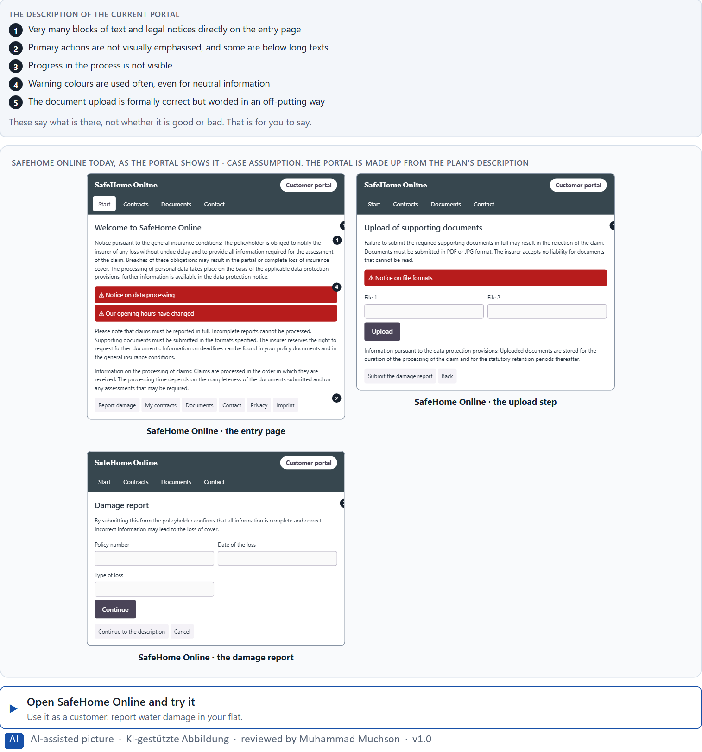
Figure 1 · SafeHome Online today, as the portal shows it.
Question 1 of 5 · Identify at least 5 central effect problems in the current portal
How to build the answer:
- Open SafeHome Online and start a damage report as a customer would.
- Write one problem per line as an effect: what the design does to the customer, not only what is wrong with it.
Write them as a list, one problem per line, each as an effect on the customer.

Question 2 of 5 · Assign the problems to the categories perception, cognitive load, trust, emotional effect and action guidance
Write the problems that belong to each category in a few words. A problem may fit two categories.
How to build the answer:
- Take your five problems from question 1.
- Ask which of the five categories each one affects most, and write it there.
Category | The problems in this category
Perception
Cognitive load
Trust
Emotional effect
Action guidance

Question 3 of 5 · Develop 4 prioritised improvement measures
How to build the answer:
- Turn each group of problems into something you could change within 12 weeks and with little IT capacity.
- Put them in order: the measure that helps customers most within the conditions first.
Write them as a numbered list, the first priority first, each with what it changes for customers.

Question 4 of 5 · Justify your prioritisation using the criteria effect on users, feasibility, risk and time pressure
Use all four criteria and say how they support your order.
How to build the answer:
- Say for your first measure what it changes for customers and why it is feasible with limited IT.
- Say what risk each carries and how the 12 weeks shape the order.
- Keep the legal notices in mind: they stay, but they can be placed and worded differently.

Question 5 of 5 · Formulate a short recommendation to the management
Three to five sentences: what you recommend, what you do not, and what you expect to change.
How to build the answer:
- Lead with the recommendation.
- Give the one reason that will carry the management.
- Say what you expect to change.

Use in class: presentation and handout
Mark of use for the worksheet. Presentation is what the trainer shows on screen; Handout is what participants fill in and hand in.
Part of the worksheet | Presentation (shown in the Neuro-UX Lab) | Handout
Block 2.1 · Case study: redesigning SafeHome Online | The task wording at the start of the block (no answers are shown) | Worksheet block with answer boxes (Core)

Glossary
Every term below is used in this document. Terms stay plain text in the body; this list says what they mean in everyday words.
Term | In plain words | Example | Comes from
Abandonment rate | The share of people who start a process, such as a damage report, and leave before they finish it. | — | Day 1
Attention | The mind's spotlight. Only a small part of a screen is processed at any moment; attention decides which part. | A flashing banner takes attention away from the form you were filling in. | Day 1
Case assumption | A fact made up for this exercise to fill a gap in the plan's case. It is marked so you know it is not part of the plan. | — | Day 1
Chief Experience Officer | The manager who is responsible for the experience customers have across all channels, and who decides where the company invests in it. | — | Day 1
Cognitive load | How much a person has to hold in mind and work out at the same time. Every extra signal or choice adds to it; when it is too high, people skip, freeze or leave. | — | Day 1
Conversion | The share of visitors who do what the company hopes for, such as signing a contract or finishing a request. | — | Day 1
Decision architecture | A set of connected decisions that are made on purpose and written down: what effect you want, what comes first, who decides and how conflicts are settled. It replaces many separate fixes. | — | Day 1
Governance | The rules about who may decide what, who is answerable for it and how disagreements are settled. | — | Day 1
Hypothesis | An assumption you could check later. “This red banner could make users uneasy” is a hypothesis; “this banner is bad” is only an opinion. | — | Day 1
Neuro-UX | Designing an interface with knowledge of how the brain sees, attends, feels and decides, so that the design steers these processes on purpose and responsibly. | — | Day 1
Orientation | Knowing where you are, what you can do here and what happens next. | — | Day 1
Perception | Taking in what the senses deliver, for example what the eyes see on a screen, before thinking about it. | — | Day 1
Primary action | The one thing most people on a screen came to do, such as “Report damage”. It should be the easiest thing to see and press. | — | Day 1
Psychological UX design | Designing with knowledge of how people see, pay attention, feel and decide, and judging a design by what it does to them rather than only by how it looks. | — | Day 1
Self-service portal | A website where customers do things themselves that once needed a call or a visit, such as reporting damage or downloading a document. | — | Day 1
Touchpoint | Any place where a person meets the company: the website, the customer portal, the app, a chatbot or a phone call. | — | Day 1
UI (user interface) | What a person sees and touches on a screen: buttons, colours, text, icons and their layout. It is the surface of the experience. | Changing a button from grey to blue is a UI change. | Day 1
Unconscious design effect | An effect a design has before the person can say why: a screen feels unsafe, rushed or friendly in the first second, and that feeling colours what they do next. | — | Day 1
UX (user experience) | Everything a person goes through when using a product: what they notice, understand, feel and do, from the first look to the last step. The screens are only one part of it. | Finding the booking you want at once and feeling sure it went through is a good UX. | Day 1

The Neuro-UX Lab: where we practise online
In class we use the course website as the place to practise and to learn. Every day has its own address, in the same pattern: the day number is the last part.
What | Address
Neuro-UX Lab (course website) | https://aion-ux-lab.vercel.app/
Day 1 | https://aion-ux-lab.vercel.app/day/1/

On the day page, Route 1 (Levels 1 and 2) and Route 2 (Level 3) can be opened; the cards and the tasks of this document are there too. The pattern is the same up to Day 8, for example https://aion-ux-lab.vercel.app/day/6/.

