
UX DEVELOPER · PSYCHOLOGICAL UX DESIGN AND NEURO-UX
DAY 7 · CASE STUDY · LEVEL 2 · 2 UE (UE5–6)
LifeSupport: Case study
The day's Level 2 case study with its questions; work on it alone, then compare in your group
AI notice · KI-Hinweis
This document was produced with the help of an AI language model (Claude, Anthropic). The AI drafted the text and tables and built the pictures and working examples of the lab. The content was then read, corrected and approved by the reviewer named below, who is responsible for its accuracy. Every picture carries an AI label on the image. Check figures and sources before you quote them.
KI-Hinweis: Dieses Dokument wurde mit Unterstützung eines KI-Sprachmodells (Claude, Anthropic) erstellt. Texte und Tabellen wurden von der KI entworfen, die Abbildungen sind KI-gestützt erstellt und am Bild gekennzeichnet. Die fachliche Prüfung und Freigabe erfolgte durch die unten genannte Person.

Day | Day 7 · Module 4 (day 1 of 3): Emotional bonding in design
Document | Case study (worksheet with answer spaces) for the 2 teaching units UE5–6.
Route and level | Level 2 · Application. Draws on Materi A.
Time | About 90 min (UE5–6), of which about 15–20 min of writing
Neuro-UX Lab (website) | https://aion-ux-lab.vercel.app/day/7/
Case | LifeSupport, the day's case study
Version | 1.0 · release date 29.10.2026
Review and approval | Muhammad Muchson, Mentor (subject-matter review and approval)

ABOUT THIS DOCUMENT
In class we also use the Neuro-UX Lab, the course website, as the place to practise and learn. Its address is at the end of this document.
This is the case study of Day 7. Read the case once, look at the picture, and write your answers in the boxes and tables. You can work on paper or type into the document. There are no answer keys in this document; the trainer closes the unit with the model solution.

IN THIS DOCUMENT
Lesson plan: ten teaching units (Ablaufplan)
Case study and transfer project at a glance
Block 2.1 · Case study: realigning the service portal LifeSupport · JUDGED · Core · about 15 min

Day at a glance
Day 7 has ten teaching units (UE). This document is the worksheet; it is used in UE2 to UE6 (Task 1) and UE8 to UE10 (Task 2). The day is built from three documents and the Neuro-UX Lab: Materi (study material), Task (worksheet) and Trainer (coaching, feedback and model solutions), plus the course website.

Lesson plan: ten teaching units (Ablaufplan)
UE | Min | Plan item | What happens | Material | Format
1 | 45 | Knowledge transfer · Level 1 | The trainer presents the cards of Materi A (A1, A2, A3, A4, A5, about 60 min of cards) in the Neuro-UX Lab; participants follow in the handout. | Materi A (Route 1) | Presentation + Handout
2 | 45 | Level 1 · Task 1 | Individual work on Block 1.1 (Core, about 10 min): the first product of the day is read and its effect described. Pairs then compare their results and the trainer collects open questions. | Task 1 · Part 1 · Block 1.1 | Handout (or in the lab)
3 | 45 | Level 1 · Task 2 | Three options are rated on the same criteria and one is chosen under the stated conditions: Block 1.2 (Core, about 8 min). | Task 1 · Part 1 · Block 1.2 | Handout (or in the lab)
4 | 45 | Coaching · transition from Level 1 to Level 2 | Trainer-led. A short talk on the day's coaching focus, then the reflection questions in pairs. The bridge: from describing an effect to a decision you answer for. There is no worksheet block in this unit. | Trainer document, section Coaching | Trainer only
5–6 | 90 | Level 2 · Case study LifeSupport (2 UE) incl. model solution | UE5: the trainer presents the case; participants work on Block 2.1 (Core, about 15 min). UE6: groups compare their results and defend them; the trainer closes with the model solution. | Task 1 · Part 2 · Block 2.1  Trainer document, section Case study | Handout; model solution shown after the work
7 | 45 | Level 2 + 3 · Feedback round with a management perspective | Groups present their reasoning, not only their result. The trainer asks the day's Level 3 input questions and leads the discussion. | Trainer document, section Feedback round | Presentation by the groups; Trainer only
8 | 45 | Level 3 · Transfer project, Chief Experience Officer (3 UE: UE8–10) | The trainer presents Materi B (B1, B2, B3; use the "In plain words" and "How to decide" boxes, the rest is handout) and sets the role and the situation. | Materi B (Route 2) | Presentation + Handout
9 | 45 | Level 3 · Transfer project | Individual work or in pairs on Block 3.1 (Core, about 20 min): the strategy memo. | Task 2 · Block 3.1 | Handout (or in the lab)
10 | 45 | Level 3 · Transfer project | Participants present their decision and what they give up, including the one decision made under uncertainty; the trainer debriefs with the model solution. | Task 2 · Block 3.1  Trainer document, section Transfer project | Handout; model solution shown after the work

One UE is counted as 45 minutes here; breaks are not shown. The times are a guide for the trainer. The Core blocks are enough for a complete answer.

Case study and transfer project at a glance
Component | UE | Duration | Participants work in | Model solution in
Level 2 case study (LifeSupport) | UE5–6 | 2 UE · 90 min | Task 1 · Part 2 (Block 2.1) | Trainer document, section Case study
Level 3 transfer project (Chief Experience Officer) | UE8–10 | 3 UE · 135 min | Materi B and Task 2 (Block 3.1) | Trainer document, section Transfer project

Part 2 · The case study · Level 2 · Application · Case study (2 UE)
Case study: 2 teaching units (UE5–6)
This part is the day's Level 2 case study. It takes 2 UE (about 90 minutes): UE5 for the briefing and your own work, UE6 for comparing your results with your group and for the trainer's closing. The block below needs about 15 minutes of writing; the rest of the time is discussion.

Block 2.1 · Case study: realigning the service portal LifeSupport · JUDGED · Core · about 15 min
Draws on: A1 · Emotions steer behaviour · A2 · Usable is not enough · A3 · Where feelings come from · A4 · Activation, overload and manipulation · A5 · Trust and perceived competence, and weighing a measure.
A provider of health prevention runs LifeSupport, a digital portal for advice, appointment booking and document management. Technically the system does its job, but users perceive it as “impersonal”, “exhausting” and “not very supportive”. Use stays below expectations although the range of functions is large. The observed problems: the visual language is factual but emotionally distant, feedback after actions is technical instead of supportive, critical situations such as error messages create uncertainty instead of orientation, positive experiences are not visibly reinforced, the tone is correct but does not build trust or motivate, and the interaction is functional but does not build a relationship. The conditions: a budget of €145,000, 12 weeks for the implementation, no complete relaunch, the brand should stay serious but become emotionally more approachable, user data is only partly available, and the department and marketing set different priorities. You work through six steps.
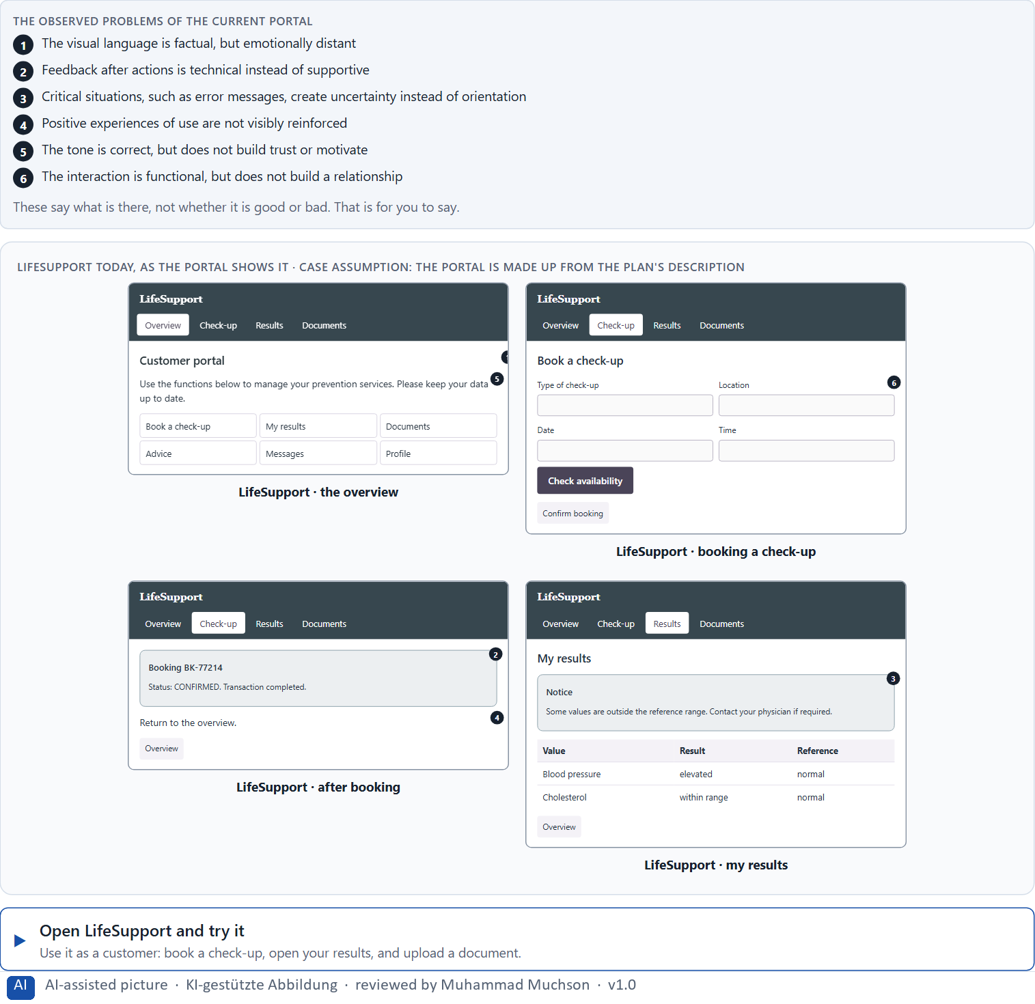
Figure 1 · LifeSupport today, as the portal shows it.
Question 1 of 6 · Analyse the central emotional deficits of the portal
How to build the answer:
- Open LifeSupport, book a check-up, cause an error, and open your results, as a customer would.
- Write one deficit per line as a feeling it creates or fails to create.
Write them as a list, one deficit per line, each as a feeling. At least five.

Question 2 of 6 · Assign the problems to the categories trust, emotional safety, motivation, reducing frustration and experience quality
Write the problems that belong to each category in a few words. A problem may fit two categories.
How to build the answer:
- Take your problems from question 1.
- Ask which of the five categories each one affects most, and write it there.
Category | The problems in this category
Trust
Emotional safety
Motivation
Reducing frustration
Experience quality

Question 3 of 6 · Develop 4 prioritised measures for improvement
How to build the answer:
- Turn each group of problems into something you could change within 12 weeks, without a relaunch and while the brand stays serious.
- Put them in order: what gives safety in the moments that matter most first.
Write them as a numbered list, the first priority first, each with what it changes for users.

Question 4 of 6 · Justify your selection using effect on users, feasibility, risk and time pressure
Use all four criteria and say how they support your selection and its order.
How to build the answer:
- Say for your first measure what it changes in the moments that matter most.
- Say what is feasible without a relaunch and with a serious brand, and the risk of each.
- Keep the department and marketing and the 12 weeks in mind.

Question 5 of 6 · Make a prioritisation decision for the first 12 weeks
Say what you do in the first 12 weeks, in which order, and what you leave for later, with the reason.
How to build the answer:
- Say what comes first and why.
- Say what you do in parallel and what waits.
- Say how you deal with the department and marketing.

Question 6 of 6 · Formulate a recommendation to the division management
Three to five sentences: what you recommend, what has priority, and what you expect to change.
How to build the answer:
- Lead with the recommendation.
- Name the priorities.
- Say what you expect to change for users and for the company.

Use in class: presentation and handout
Mark of use for the worksheet. Presentation is what the trainer shows on screen; Handout is what participants fill in and hand in.
Part of the worksheet | Presentation (shown in the Neuro-UX Lab) | Handout
Block 2.1 · Case study: realigning the service portal LifeSupport | The task wording at the start of the block (no answers are shown) | Worksheet block with answer boxes (Core)

Glossary
Every term below is used in this document. Terms stay plain text in the body; this list says what they mean in everyday words.
Term | In plain words | Example | Comes from
Activation | Getting people to act now, often with strong stimuli. It can help for a moment and tire or push people if overdone. | — | Day 7
Case assumption | A fact made up for this exercise to fill a gap in the plan's case. It is marked so you know it is not part of the plan. | — | Day 1
Chief Experience Officer | The manager who is responsible for the experience customers have across all channels, and who decides where the company invests in it. | — | Day 1
Dark pattern | A design that uses emotion against people's own interest, such as false urgency, guilt or hidden costs. | — | Day 7
Decision architecture | A set of connected decisions that are made on purpose and written down: what effect you want, what comes first, who decides and how conflicts are settled. It replaces many separate fixes. | — | Day 1
Emotional bond | The sense, built over time, that a product is on your side. It makes people trust it and come back. | — | Day 7
Emotional safety | Feeling that you know what is happening, that nothing bad will follow from a mistake, and that help is there. | — | Day 7
Experience quality | How using a product feels, on the way and afterwards. It goes beyond usability, which only asks whether people reach their goal. | — | Day 7
Governance | The rules about who may decide what, who is answerable for it and how disagreements are settled. | — | Day 1
Orientation | Knowing where you are, what you can do here and what happens next. | — | Day 1
Perceived competence | How capable a product or company seems to people, judged from small signals such as clear feedback and careful wording. | — | Day 7
Stakeholder | A person or department with an interest in a decision, such as marketing, compliance, IT or sales. | — | Day 1
Tone guide | A short written rule for how a product speaks: which words, how formal, how it sounds when something goes wrong. | — | Day 7
Touchpoint | Any place where a person meets the company: the website, the customer portal, the app, a chatbot or a phone call. | — | Day 1
UX (user experience) | Everything a person goes through when using a product: what they notice, understand, feel and do, from the first look to the last step. The screens are only one part of it. | Finding the booking you want at once and feeling sure it went through is a good UX. | Day 1

The Neuro-UX Lab: where we practise online
In class we use the course website as the place to practise and to learn. Every day has its own address, in the same pattern: the day number is the last part.
What | Address
Neuro-UX Lab (course website) | https://aion-ux-lab.vercel.app/
Day 7 | https://aion-ux-lab.vercel.app/day/7/

On the day page, Route 1 (Levels 1 and 2) and Route 2 (Level 3) can be opened; the cards and the tasks of this document are there too. The pattern is the same up to Day 8, for example https://aion-ux-lab.vercel.app/day/6/.

