
UX DEVELOPER · PSYCHOLOGICAL UX DESIGN AND NEURO-UX
DAY 10 · TASK 1 AND TASK 2 · ROUTES 1 AND 2 · LEVELS 1 TO 3
CareGuide: UX Analysis File and UX Strategy Memo
Describe the effect, choose the measures as a team member, and decide as Chief Experience Officer
AI notice · KI-Hinweis
This document was produced with the help of an AI language model (Claude, Anthropic). The AI drafted the text and tables and built the pictures and working examples of the lab. The content was then read, corrected and approved by the reviewer named below, who is responsible for its accuracy. Every picture carries an AI label on the image. Check figures and sources before you quote them.
KI-Hinweis: Dieses Dokument wurde mit Unterstützung eines KI-Sprachmodells (Claude, Anthropic) erstellt. Texte und Tabellen wurden von der KI entworfen, die Abbildungen sind KI-gestützt erstellt und am Bild gekennzeichnet. Die fachliche Prüfung und Freigabe erfolgte durch die unten genannte Person.

Day | Day 10 · Module 5 (day 1 of 2): Intelligent interfaces and AI-supported interaction
Document | Task (worksheet with answer spaces). Task 1 (UX Analysis File) and Task 2 (UX Strategy Memo).
Route and level | Task 1 = Route 1, Levels 1 and 2 (draws on Materi A). Task 2 = Route 2, Level 3 (draws on Materi B).
Time | Task 1 about 33 min · Task 2 about 20 min
Neuro-UX Lab (website) | https://aion-ux-lab.vercel.app/day/10/
Case | CareGuide, the day's case study; other products appear as warm-ups
Version | 1.0 · release date 29.10.2026
Review and approval | Muhammad Muchson, Mentor (subject-matter review and approval)

ABOUT THIS DOCUMENT
In class we also use the Neuro-UX Lab, the course website, as the place to practise and learn. Its address is at the end of this document.
This is the worksheet for Day 10. Read the case once, study the evidence printed in this document, and write your answers in the boxes and tables. You can work through it on paper or type into the document. All blocks are Core. There are no answer keys and no scores; the reason you give matters more than the choice.

IN THIS DOCUMENT
Lesson plan: ten teaching units (Ablaufplan)
Case study and transfer project at a glance
The case: two platforms on the UX team's desk, and CareGuide
Block 1.1 · Recognise the potentials and risks of intelligent interaction: SmartAssist · JUDGED · Core · about 10 min
Block 1.2 · Rate adaptive and personalised UX under conflicting goals: CareerNavigator · JUDGED · Core · about 8 min
Block 2.1 · Case study: developing the digital service portal CareGuide · JUDGED · Core · about 15 min
The situation: the provider behind CareGuide, AI pilots that confuse and patronise
Block 3.1 · A strategic UX architecture for intelligent and adaptive interfaces · JUDGED · Core · about 20 min

Day at a glance
Day 10 has ten teaching units (UE). This document is the worksheet; it is used in UE2 to UE6 (Task 1) and UE8 to UE10 (Task 2). The day is built from three documents and the Neuro-UX Lab: Materi (study material), Task (worksheet) and Trainer (coaching, feedback and model solutions), plus the course website.

Lesson plan: ten teaching units (Ablaufplan)
UE | Min | Plan item | What happens | Material | Format
1 | 45 | Knowledge transfer · Level 1 | The trainer presents the cards of Materi A (A1, A2, A3, A4, A5, about 60 min of cards) in the Neuro-UX Lab; participants follow in the handout. | Materi A (Route 1) | Presentation + Handout
2 | 45 | Level 1 · Task 1 | Individual work on Block 1.1 (Core, about 10 min): the first product of the day is read and its effect described. Pairs then compare their results and the trainer collects open questions. | Task 1 · Part 1 · Block 1.1 | Handout (or in the lab)
3 | 45 | Level 1 · Task 2 | Three options are rated on the same criteria and one is chosen under the stated conditions: Block 1.2 (Core, about 8 min). | Task 1 · Part 1 · Block 1.2 | Handout (or in the lab)
4 | 45 | Coaching · transition from Level 1 to Level 2 | Trainer-led. A short talk on the day's coaching focus, then the reflection questions in pairs. The bridge: from describing an effect to a decision you answer for. There is no worksheet block in this unit. | Trainer document, section Coaching | Trainer only
5–6 | 90 | Level 2 · Case study CareGuide (2 UE) incl. model solution | UE5: the trainer presents the case; participants work on Block 2.1 (Core, about 15 min). UE6: groups compare their results and defend them; the trainer closes with the model solution. | Task 1 · Part 2 · Block 2.1  Trainer document, section Case study | Handout; model solution shown after the work
7 | 45 | Level 2 + 3 · Feedback round with a management perspective | Groups present their reasoning, not only their result. The trainer asks the day's Level 3 input questions and leads the discussion. | Trainer document, section Feedback round | Presentation by the groups; Trainer only
8 | 45 | Level 3 · Transfer project, Chief Experience Officer (3 UE: UE8–10) | The trainer presents Materi B (B1, B2, B3; use the "In plain words" and "How to decide" boxes, the rest is handout) and sets the role and the situation. | Materi B (Route 2) | Presentation + Handout
9 | 45 | Level 3 · Transfer project | Individual work or in pairs on Block 3.1 (Core, about 20 min): the strategy memo. | Task 2 · Block 3.1 | Handout (or in the lab)
10 | 45 | Level 3 · Transfer project | Participants present their decision and what they give up, including the one decision made under uncertainty; the trainer debriefs with the model solution. | Task 2 · Block 3.1  Trainer document, section Transfer project | Handout; model solution shown after the work

One UE is counted as 45 minutes here; breaks are not shown. The times are a guide for the trainer. The Core blocks are enough for a complete answer.

Case study and transfer project at a glance
Component | UE | Duration | Participants work in | Model solution in
Level 2 case study (CareGuide) | UE5–6 | 2 UE · 90 min | Task 1 · Part 2 (Block 2.1) | Trainer document, section Case study
Level 3 transfer project (Chief Experience Officer) | UE8–10 | 3 UE · 135 min | Materi B and Task 2 (Block 3.1) | Trainer document, section Transfer project

Which plan item each block answers
UE | Plan item (Strukturplan, Day 10) | Block in this document
UE2 | Level 1, task 1 · Recognise the potentials and risks of intelligent interaction: SmartAssist | Block 1.1 (Core)
UE3 | Level 1, task 2 · Rate adaptive and personalised UX under conflicting goals: CareerNavigator | Block 1.2 (Core)
UE4 | Coaching: from describing to deciding | A classroom talk led by the trainer; not a worksheet block
UE5–6 | Level 2 case study · Case study: developing the digital service portal CareGuide | Block 2.1 (Core)
UE7 | Feedback round with a management perspective | A classroom discussion led by the trainer; not a worksheet block
UE8–10 | Level 3 transfer project · A strategic UX architecture for intelligent and adaptive interfaces | Block 3.1 (Core), in Task 2

Your name
Write your full name here. Use the same name on every Task document this week; it is how your work is matched.

Task 1 · Route 1 · UX Analysis File: find where intelligence helps or confuses, then decide what to change

The case: two platforms on the UX team's desk, and CareGuide
Read once · about 3 min
You work in the UX team of a digital agency. This week three products land on your desk. Two are warm-ups: SmartAssist, a service platform for insurance matters, contract overviews and claims, and CareerNavigator, a platform for professional development with three designs for how it could personalise. The main case is CareGuide, the digital portal of a provider in health and prevention, for information, appointments, documents and individual recommendations. The provider wants it to become more intelligent, so that members find suitable content, next steps and help faster, but it is unsure about trust, comprehensibility and the danger of unsuitable personalisation.
What the plan gives you | How the task runs · three blocks
• Block 1.1: SmartAssist, with recommendations that differ by usage history, an assistant that suggests next steps without always saying why, content that partly fits and partly seems random, automatic help without clear control, simple standard processes and unclear complex ones, and users who cannot tell rules from AI  • Block 1.2: three designs for CareerNavigator; working people with different experience, modern, helpful and trustworthy, a limited budget, release in 12 weeks, partial user data, the department wants service quality and the data protection officers want transparency and control  • Block 2.1: CareGuide, with €180,000 and 14 weeks, no complete relaunch, a trustworthy and supportive brand, heterogeneous data quality, and first results soon | • Block 1.1: find the chances and risks of SmartAssist's intelligent interaction. Describe them, name five places, sort them into six categories, write three effect statements and pick the two biggest chances and risks.  • Block 1.2: rate three personalisation designs under conflicting goals. Rate each on six criteria, choose one, name the conflicts between automation, personalisation and autonomy and the remaining risks, and write a recommendation to the project lead.  • Block 2.1: the case study. The central chances and risks, sorted into six categories, four measures, justified on four criteria, a decision for the first 14 weeks and a recommendation to the division management.

What is known and what is open
In the brief | Clear · Case assumption | Open · on purpose
• SmartAssist: history-based recommendations, unexplained next steps, help without clear control, rules and AI indistinguishable.  • CareerNavigator: three designs in words; mixed experience; partial data; 12 weeks; service quality against transparency and control.  • CareGuide: recommendations that partly fit; no why, no depth, little control; €180,000 and 14 weeks; mixed data quality; no relaunch. | • You review SmartAssist and CareerNavigator as an agency would: from their screens, with no access to their data or their models.  • CareGuide's recommendations come from appointment history, the programmes a member joined and the pages they read; reminders come from fixed rules.  • Members can switch e-mail reminders off; there is no setting for recommendations in the portal itself.  • CareGuide's medical content is reviewed by the provider's doctors; the recommendation logic is built by an external IT partner. | • How often a CareGuide recommendation is wrong: nobody has measured it.  • Which CareerNavigator design users would accept: no tests.  • How much of the €180,000 each measure would take: the plan does not say.  • How members feel about being recommended health content at all: never asked.

As in most projects, not everything is known. Decide anyway, and say what you assume.
Case assumption
The brief says: SmartAssist's history-based recommendations, unexplained next steps, partly fitting content, automatic help without clear control, simple standard processes, unclear complex situations and rules indistinguishable from AI; CareerNavigator's three designs (A strong personalisation with little transparency, B restrained and explainable with high control but less comfort, C adaptive and situational with optional intervention but more effort) for working people with different experience, modern, helpful and trustworthy, a limited budget, 12 weeks, partial data, service quality against transparency and control; CareGuide's partly fitting recommendations, unclear why and how deep, limited control, time saved in simple cases, unclear exceptions, efficiency against data protection, €180,000, 14 weeks, no relaunch, a trustworthy and supportive brand, heterogeneous data, first results soon. Those are the plan's facts and its only figures. Everything else is made up for this exercise: the agency, the pictures, the simulations and the facts marked “Clear”.

Part 1 · Find chances and risks, and weigh personalisation designs · Level 1 · Knowledge

Block 1.1 · Recognise the potentials and risks of intelligent interaction: SmartAssist · JUDGED · Core · about 10 min
Draws on: A1 · Rule-based, adaptive or learning · A2 · How AI guides, recommends and helps · A3 · What intelligent interfaces give, and how they go wrong · A4 · Why, change, undo.
You receive the description of a fictional service platform, SmartAssist, for insurance matters, contract overviews and claims. Open it and use it as a customer: look at your recommendations, follow the assistant's next step, report a simple claim and a complicated one. You need no prior knowledge: notice when the platform seems to know what you need, and when you do not know why it does what it does. The aim is to recognise intelligent interaction patterns systematically and judge them from the user's side.
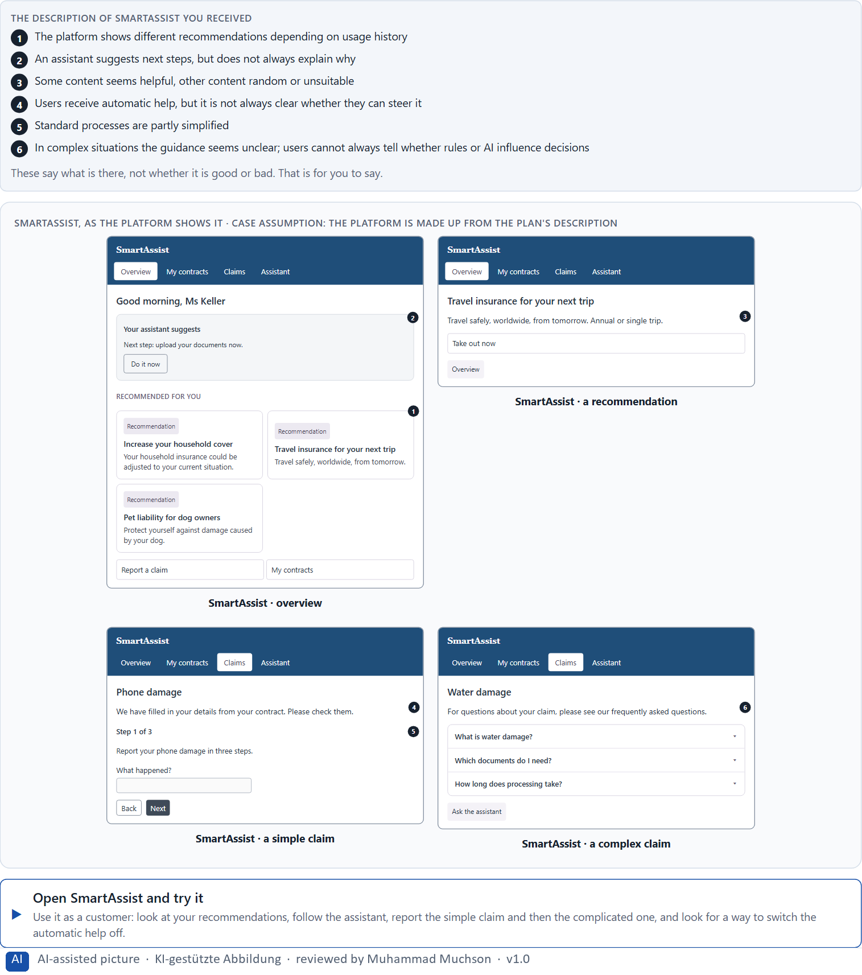
Figure 1 · SmartAssist, as the platform shows it.
Question 1 of 5 · Describe spontaneously which chances and risks the offer could have from the user's point of view
Two to four sentences: where it helps, where it worries or confuses you, and why.
How to build the answer:
- Open SmartAssist, look at the recommendations and follow the assistant's suggestion.
- Report the simple claim and then the complicated one.
- Write where it helped and where you did not know why it acted.

Question 2 of 5 · Name at least 5 places where intelligent interaction seems helpful or problematic
How to build the answer:
- Go through your visit: the recommendations, the assistant, the automatic help, the simple claim, the complicated claim.
- For each place, say whether it helps or causes a problem, and why.
Write them as a list, one place per line, and say whether it helps or causes a problem, and why.

Question 3 of 5 · Assign the observations to the categories relevance, transparency, control, trust, support and misadaptation
Write the observations that belong to each category in a few words. One may fit two; put it where its effect is strongest.
How to build the answer:
- Take your places from question 2.
- Ask which of the six each one affects most, and write it there.
Category | The observations in this category
Relevance
Transparency
Control
Trust
Support
Misadaptation

Question 4 of 5 · Write an effect statement for three points: “For users this could mean that …”
How to build the answer:
- Pick three places from question 2.
- Finish the plan's sentence with what the user would feel, do or fail to do.
Write them as a list, one statement per line, each starting with the observation and ending with what it could mean for users.

Question 5 of 5 · Prioritise the two biggest chances and the two biggest risks of the system
How to build the answer:
- Look at your places with two questions: what helps most customers most, and what could cost most trust?
- Write the two chances first, then the two risks, each with why.
Write four lines: chance 1, chance 2, risk 1, risk 2, each with why it weighs most.

Block 1.2 · Rate adaptive and personalised UX under conflicting goals: CareerNavigator · JUDGED · Core · about 8 min
Draws on: A2 · How AI guides, recommends and helps · A4 · Why, change, undo · A5 · Data, context and situation, and weighing a measure.
CareerNavigator is a platform for professional development and learning recommendations. Three designs for its further development are described in words: A) strong personalisation based on past use and automatic recommendations, but little transparency about the selection criteria; B) restrained personalisation with clear explainability and high user control, but less comfort and less automation; C) adaptive support with situational recommendations and optional ways to intervene, but a higher implementation effort. The conditions: the target group is working people with different levels of experience, the company wants to look modern, helpful and trustworthy, the budget for the technical implementation is limited, the release is in 12 weeks, user data is only partly available, and the department demands high service quality while the data protection officers demand transparency and ways to control. Decide anyway, and say what you assume.
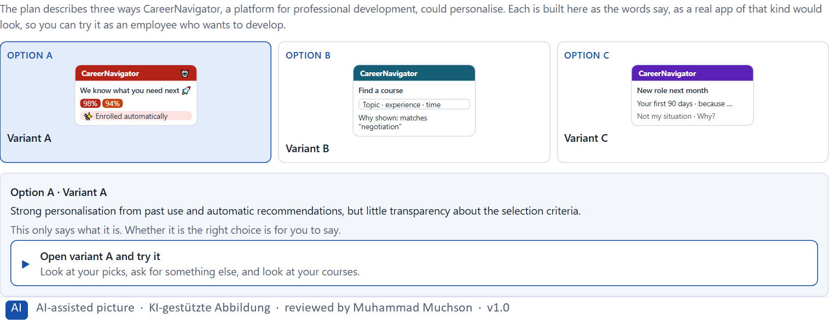
Figure 2 · The product to read, as the lab shows it (designs).
Question 1 of 5 · Rate each variant on relevance, transparency, control, trust, efficiency and user acceptance
Write a few sentences for each variant that cover all six criteria. Many teams rate each criterion Low, Medium or High with a reason; you may do that or write it in your own words.
How to build the answer:
- Take one variant at a time and keep the conditions in mind: partial data, data protection, 12 weeks.
- For each criterion, say how the variant does and why.
- Use the same six criteria for every variant.
Variant | Relevance | Transparency | Control | Trust | Efficiency | User acceptance
Variant A · strong personalisation, little transparency
Variant B · restrained, explainable, high control
Variant C · adaptive, situational, optional intervention

Question 2 of 5 · Decide which variant is the most viable under the given conditions
Choose one variant, then give your reason below. There is no single right choice; the reason has to rest on the users and the conditions.
How to build the answer:
- Say which condition weighs most for you.
- Say how your choice meets it better than the other two.
Tick one:
☐ Variant A · strong personalisation, little transparency
☐ Variant B · restrained, explainable, high control
☐ Variant C · adaptive, situational, optional intervention
Why this variant, under these conditions?
Give your reason with the conditions: working people of different experience, modern, helpful and trustworthy, a limited budget, 12 weeks, partial data, service quality against transparency and control.
How to build the answer:
- Name the condition that weighs most for you.
- Say how your variant meets it and why the other two meet it less well.
- Say what your choice gives up and how you would deal with its weakness.

Question 3 of 5 · Name the conflicts of goals between automation, personalisation and user autonomy
Name at least two conflicts, each as one goal against another, and who stands for each side.
How to build the answer:
- Look at what automation needs (acting for the user), what personalisation needs (data about the user) and what autonomy needs (the user decides).
- Write each conflict as “… against …” and say who stands for each side.

Question 4 of 5 · Which risks remain despite your decision?
Name at least one risk that remains and who would feel it.
How to build the answer:
- Think of what your chosen variant is weak at.
- Say who would notice and what would happen.

Question 5 of 5 · Formulate a recommendation to the project management
Two to four sentences: what you recommend, why, and what you will check next.
How to build the answer:
- Lead with the recommendation.
- Give the one reason the project management can follow.
- Say what you will check after the release.

Part 2 · The case study · Level 2 · Application · Case study (2 UE)
Case study: 2 teaching units (UE5–6)
This part is the day's Level 2 case study. It takes 2 UE (about 90 minutes): UE5 for the briefing and your own work, UE6 for comparing your results with your group and for the trainer's closing. The block below needs about 15 minutes of writing; the rest of the time is discussion.

Block 2.1 · Case study: developing the digital service portal CareGuide · JUDGED · Core · about 15 min
Draws on: A1 · Rule-based, adaptive or learning · A2 · How AI guides, recommends and helps · A3 · What intelligent interfaces give, and how they go wrong · A4 · Why, change, undo · A5 · Data, context and situation, and weighing a measure.
A provider in health and prevention runs CareGuide, a digital portal for information, appointment management, documents and individual recommendations. The company wants to make the portal more intelligent, so that users get suitable content, next steps and relevant help faster. At the same time it is unsure about trust, comprehensibility and the danger of unsuitable personalisation. The observed problems: recommendations seem partly helpful, but partly do not fit the current situation; users do not always understand why certain content is shown; there are no clear hints how strongly the system personalises; the users' ways to intervene are limited or unclear; the platform saves time in simple cases but seems hard to follow in exceptions; and departments see chances for efficiency while data protection warns of opacity and loss of trust. The conditions: a budget of €180,000, 14 weeks for the implementation, no complete relaunch, a brand that must stay trustworthy and supportive, data quality that is partly heterogeneous, and first results that must show soon. You work through six steps.
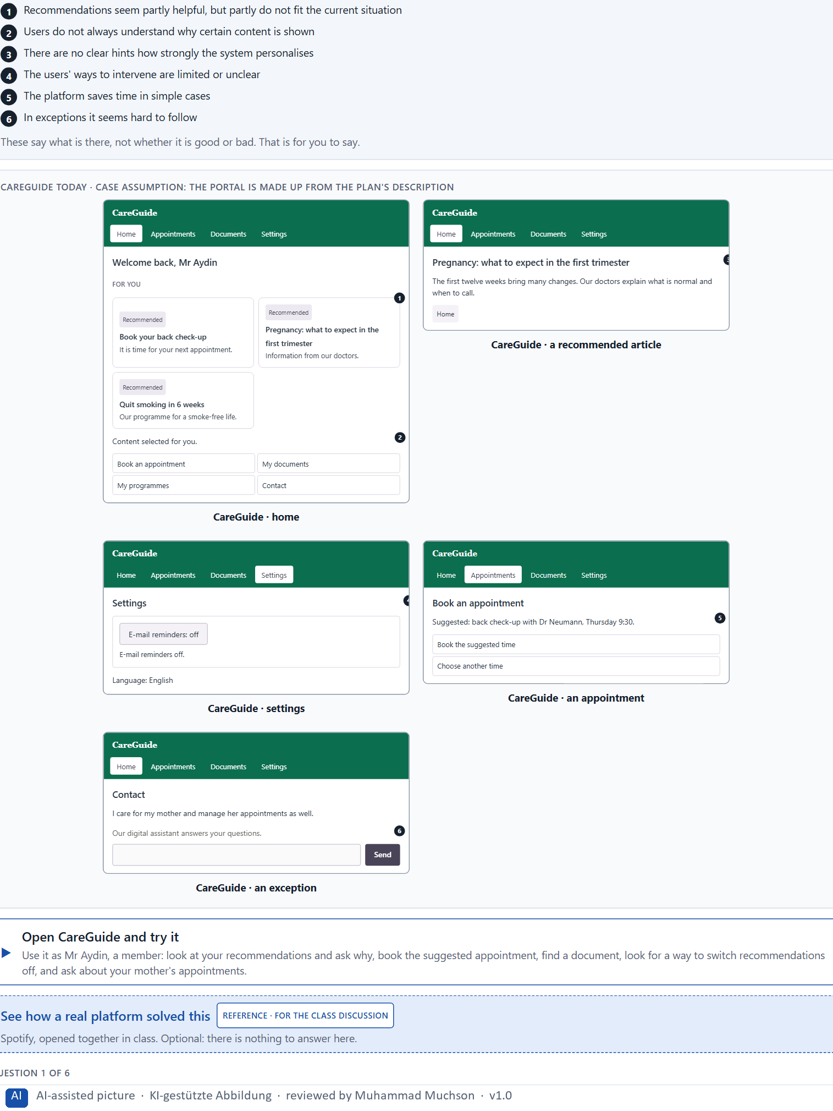
Figure 3 · CareGuide today.
Question 1 of 6 · Analyse the central chances and risks of the intelligent guidance in the portal
How to build the answer:
- Open CareGuide as a member: look at the recommendations, book an appointment, look for a document, and try an exception.
- Write one point per line: a chance or a risk, and what it does.
Write them as a list, one point per line, each as a chance or a risk and what it does. At least five.

Question 2 of 6 · Assign the observations to the categories relevance, transparency, control, trust, efficiency and misadaptation
Write the observations that belong to each category in a few words.
How to build the answer:
- Take your points from question 1.
- Ask which category each affects most, and write it there.
Category | The observations in this category
Relevance
Transparency
Control
Trust
Efficiency
Misadaptation

Question 3 of 6 · Develop 4 prioritised measures for improvement
How to build the answer:
- Turn each group of problems into something you could change within 14 weeks and €180,000, without a relaunch.
- Put them in order: what secures trust and acceptance first.
Write them as a numbered list, the first priority first, each with what it changes for members.

Question 4 of 6 · Justify your selection using effect on users, feasibility, risk and time pressure
Use all four criteria and say how they support your selection and its order.
How to build the answer:
- Say what your first measures change for trust and acceptance.
- Say what is feasible without a relaunch and with mixed data, and the risk of each.
- Keep the 14 weeks and the trustworthy brand in mind.

Question 5 of 6 · Make a prioritisation decision for the first 14 weeks
Say what you do in the first 14 weeks, in which order, and what you leave for later, with the reason.
How to build the answer:
- Say what comes first and why.
- Say what you do in parallel and what waits.
- Say how you keep the brand trustworthy.

Question 6 of 6 · Formulate a recommendation to the division management
Three to five sentences: what you recommend, what has priority, and what you expect to change.
How to build the answer:
- Lead with the recommendation.
- Name the priorities.
- Say what you expect to change.

Task 2 · Route 2 · UX Strategy Memo: decide as Chief Experience Officer

The situation: the provider behind CareGuide, AI pilots that confuse and patronise
Read once · about 2 min
You take the perspective of the Chief Experience Officer of the health and prevention provider that runs CareGuide. The company has a customer portal, an app and a service platform, and plans to make its digital offers more AI-supported and personalised. First pilot functions show potential, but also risks: users do not understand recommendations, partly feel patronised, or get suggestions that do not fit. Inside the company AI is seen mostly as an innovation signal, while questions of trust, steerability and transparency are not yet answered. The management expects a sound strategy for integrating intelligent interfaces responsibly and effectively. You are not to choose single AI features, but to develop a sound decision architecture for adaptive guidance, personalisation and trustworthy interaction.
The framework | How the task runs · one block
• The budget is limited  • Several stakeholders pursue different goals  • The data quality is not consistent throughout  • Trust and the brand must not be weakened  • Not all systems can be adapted at the same time  • First improvements must be visible at short notice  • Wrong decisions can cause damage to the reputation, mis-steering and low acceptance | • Block 3.1 asks seven questions: a guiding vision for intelligent UX, three strategic decisions, a prioritised architecture of measures, a risk analysis, a governance model, one decision under uncertainty and a management statement.

What is known and what is open
In the brief | Clear · Case assumption | Open · on purpose
• A customer portal, an app and a service platform; plans for more AI and personalisation.  • Pilots: recommendations not understood, users feel patronised, unsuitable suggestions.  • Inside, AI is an innovation signal; trust, steerability and transparency are open.  • Trust and brand must hold; first improvements must show soon. | • The company is the health and prevention provider behind CareGuide in Route 1; CareGuide is its customer portal.  • The innovation team wants an AI chat assistant in every channel by next year; the data protection officer wants every recommendation explainable and switchable off.  • The pilots are content recommendations in the app and an appointment suggestion in the portal. | • How large the budget is: “limited” is all the plan says.  • How users react to each pilot: the data is not consistent.  • Whether members want personal health recommendations at all: never asked.

As in most projects, not everything is known. Decide anyway, and say what you assume.
Case assumption
The brief says: a company with a customer portal, an app and a service platform that plans more AI and personalisation, pilots that users do not understand, that patronise or misfit, AI seen inside as an innovation signal, trust, steerability and transparency not yet clarified, a limited budget, several stakeholders, inconsistent data quality, trust and brand that must hold, not all systems at once, first improvements soon, and the warning that wrong decisions can cause reputational damage, mis-steering and low acceptance. Those are the plan's facts. That the company is the provider of Route 1 and the facts marked “Clear” are made up for this exercise.

The memo is addressed to: The management. Subject: A UX architecture for intelligent and adaptive interfaces.

Part 3 · Level 3 · Management decision · Transfer project (3 UE)
Transfer project: 3 teaching units (UE8–10)
UE8: the trainer presents Materi B and sets the role. UE9: you write the memo. UE10: you present the decision and what you give up; the trainer debriefs.

Block 3.1 · A strategic UX architecture for intelligent and adaptive interfaces · JUDGED · Core · about 20 min
Draws on: B1 · Intelligent UX as a decision architecture, not a technology trend · B2 · Personalisation against transparency and trust · B3 · Who answers for an intelligent interface, and deciding with patchy data.
Develop a strategic concept for the provider. Your desk holds what the management, the innovation team, data protection, the doctors, the product team and the data say. Open it, then answer the seven questions; your answers build the memo below.
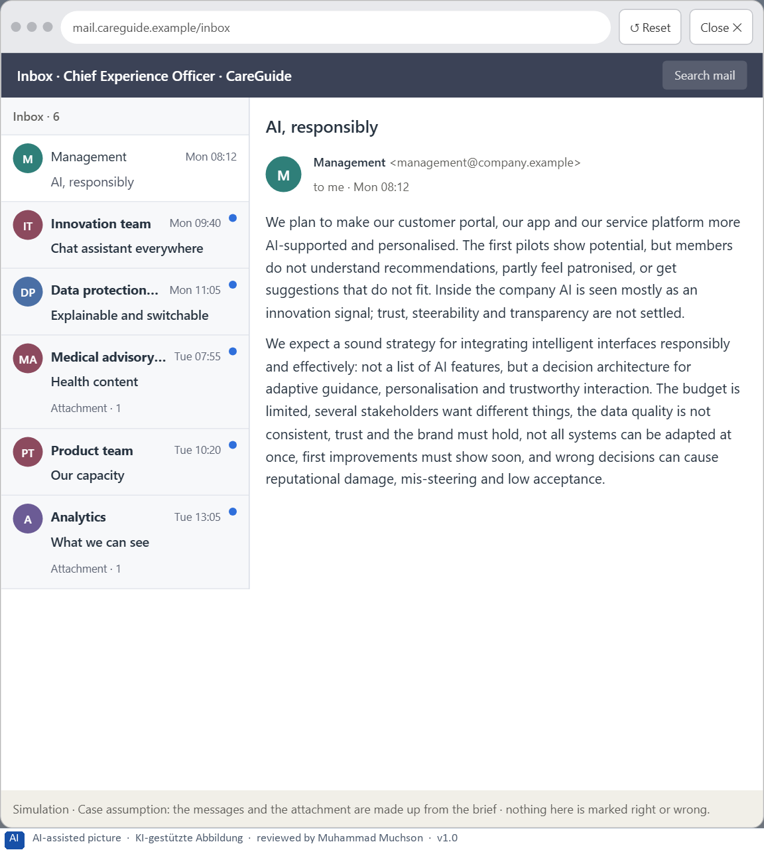
Figure 4 · Your desk: the messages that wait for you, shown in the lab as a mailbox (1 of 6).
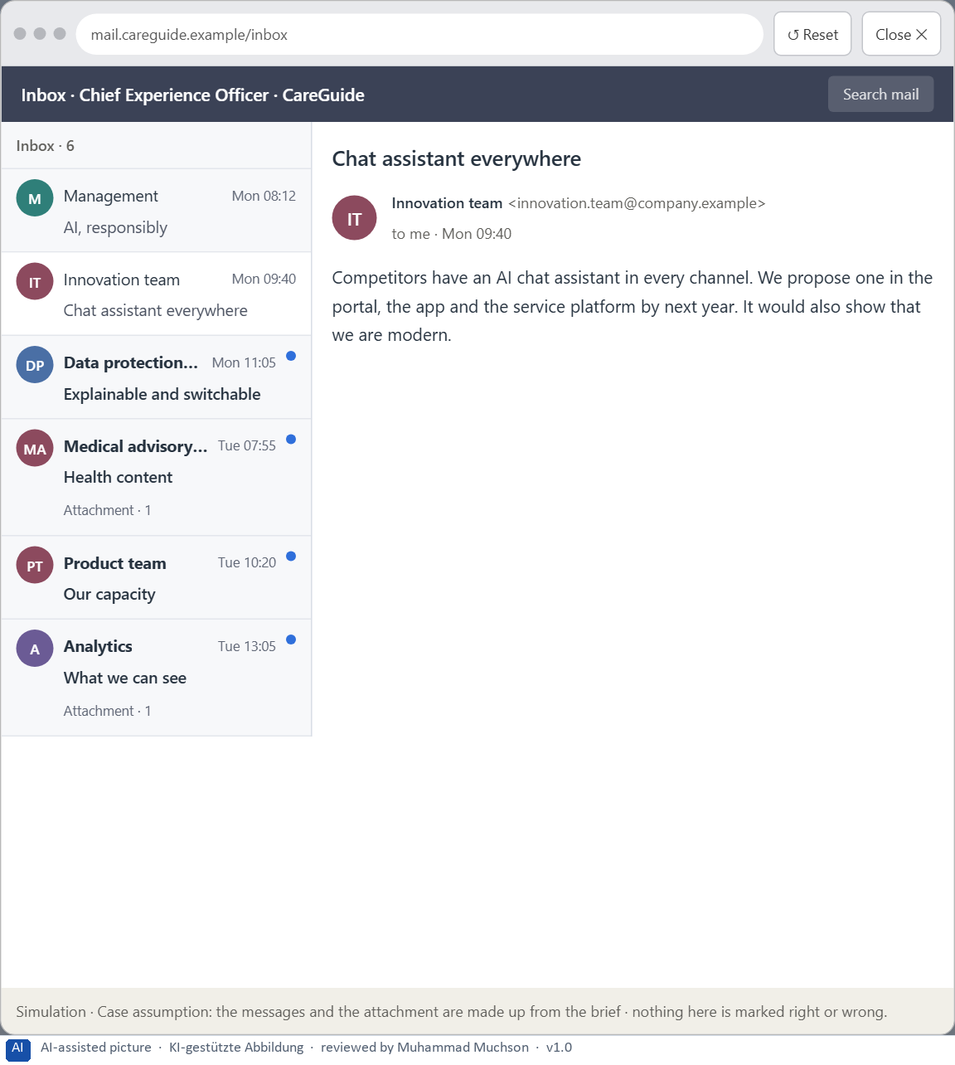
Figure 5 · Your desk: the messages that wait for you, shown in the lab as a mailbox (2 of 6).
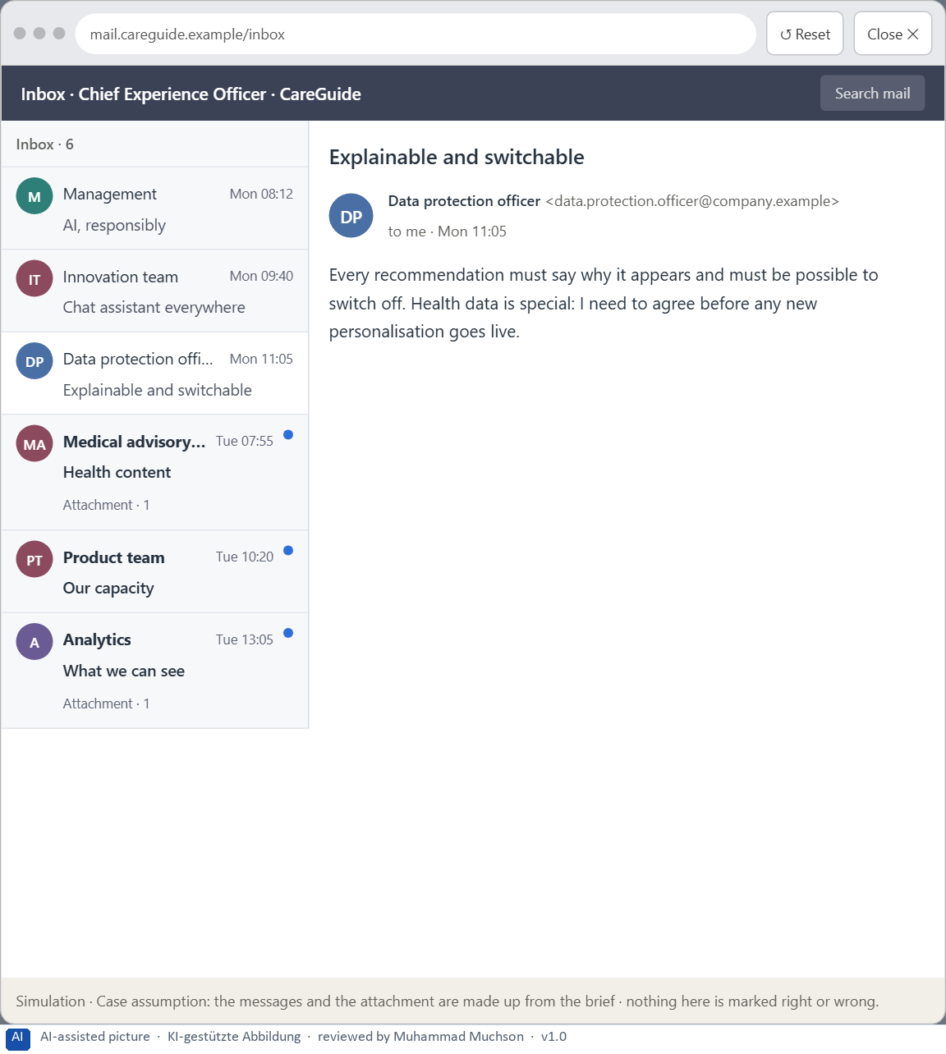
Figure 6 · Your desk: the messages that wait for you, shown in the lab as a mailbox (3 of 6).
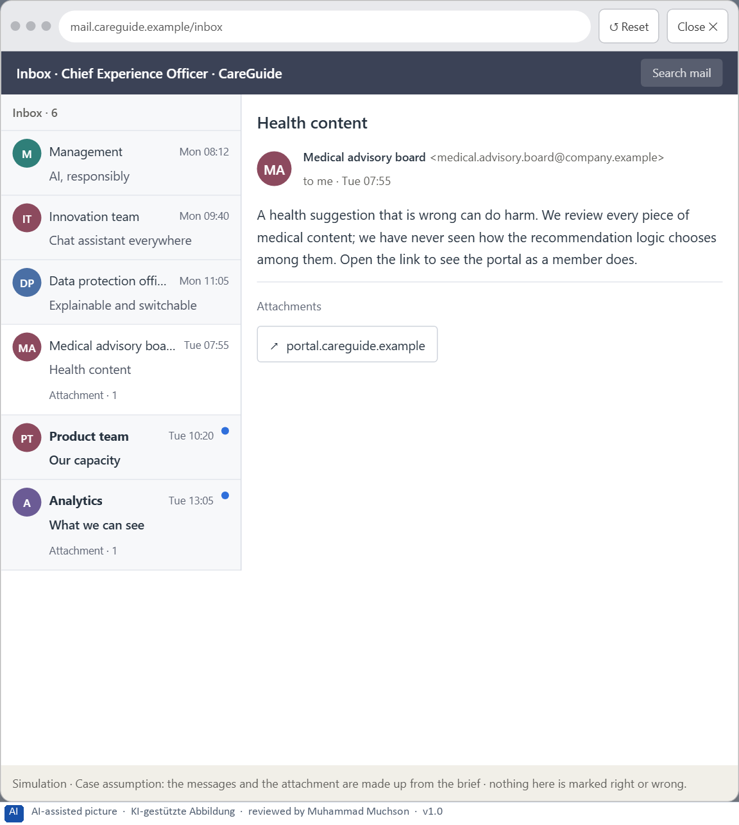
Figure 7 · Your desk: the messages that wait for you, shown in the lab as a mailbox (4 of 6).
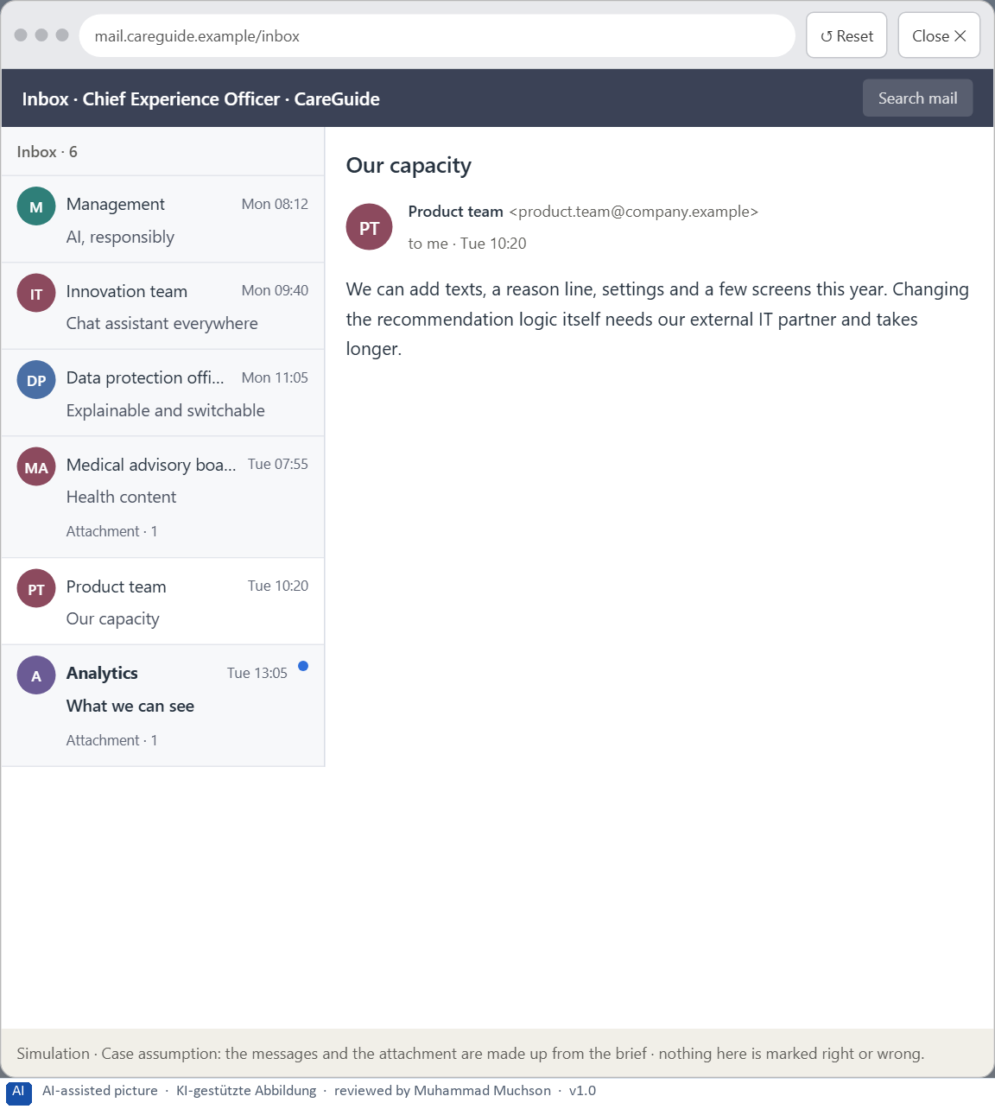
Figure 8 · Your desk: the messages that wait for you, shown in the lab as a mailbox (5 of 6).
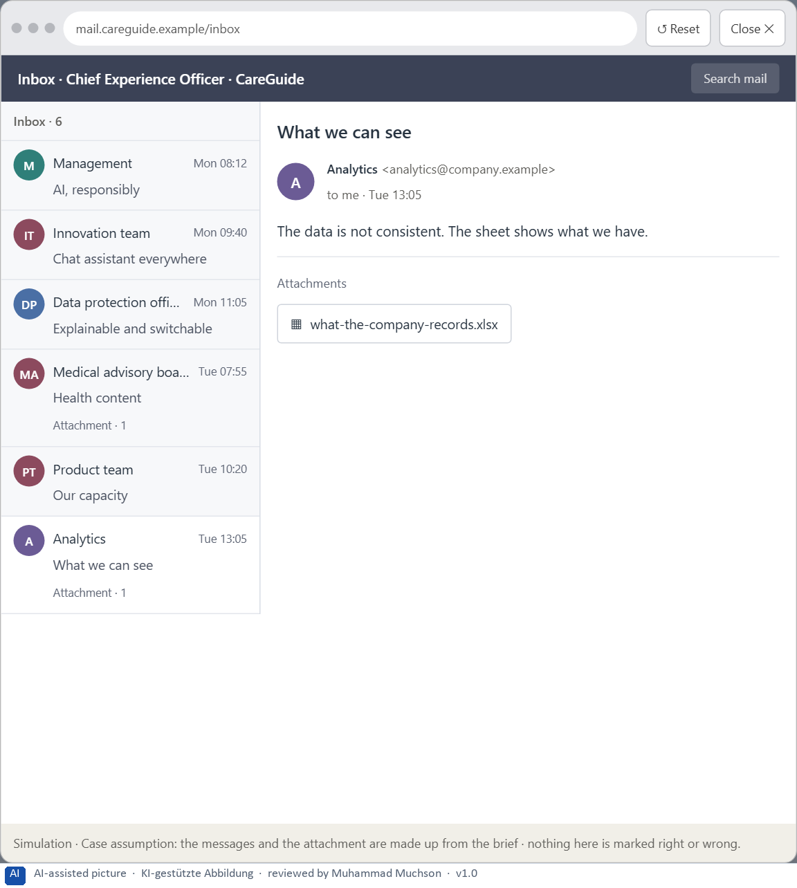
Figure 9 · Your desk: the messages that wait for you, shown in the lab as a mailbox (6 of 6).
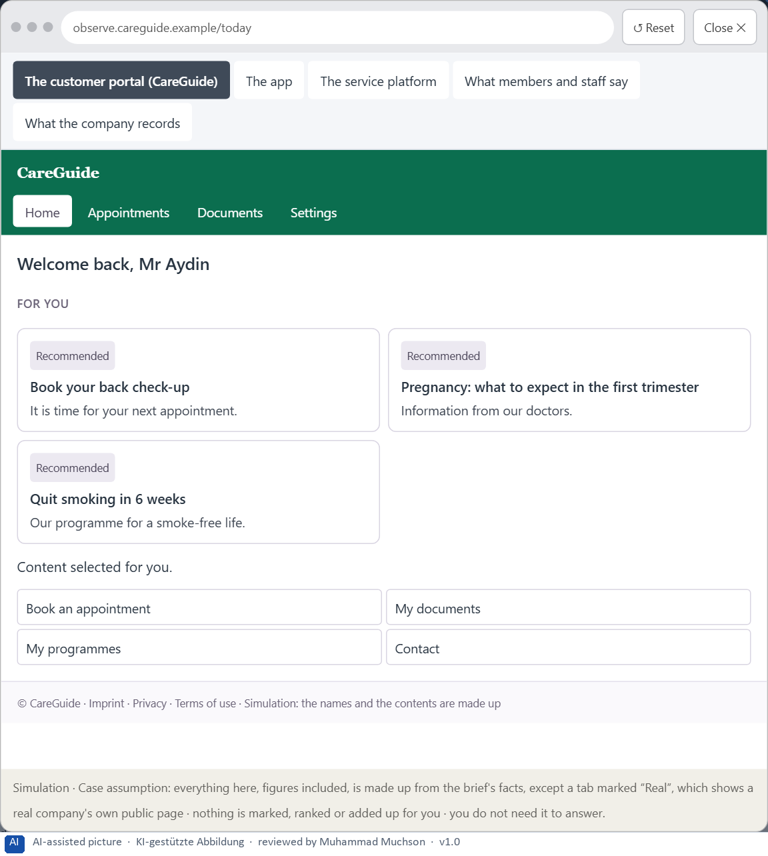
Figure 10 · The platform as it is today, as the lab lets you observe it (1 of 5).
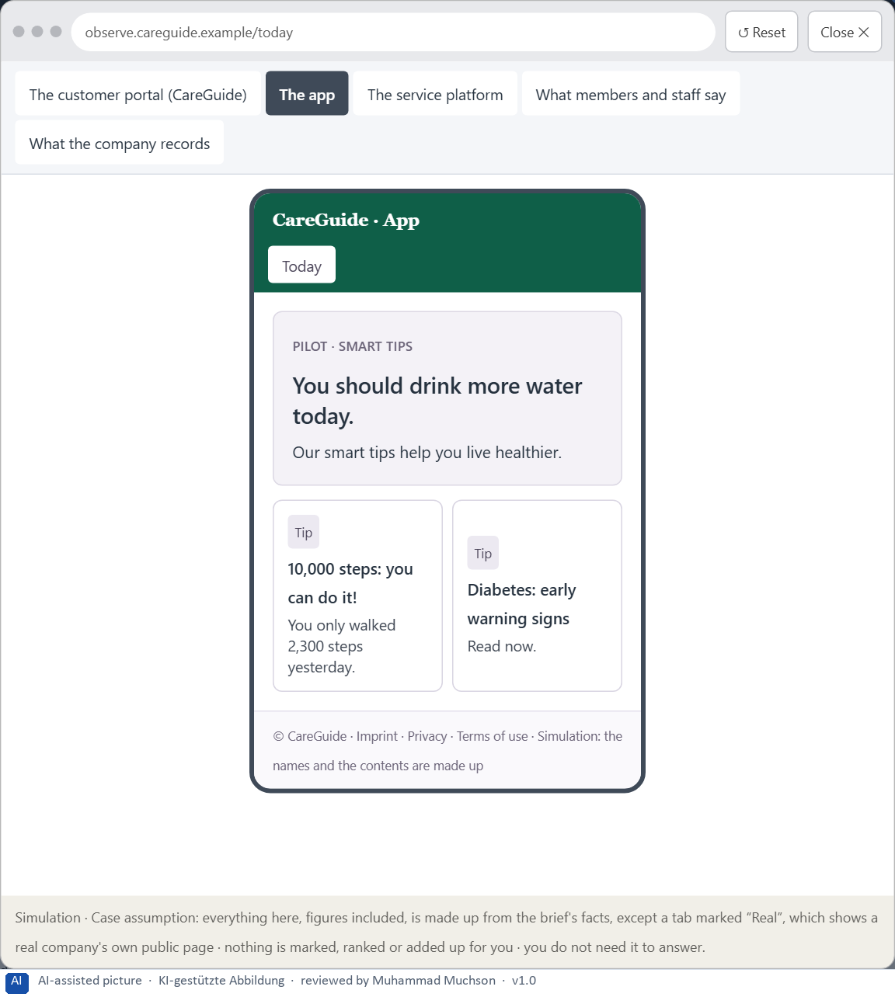
Figure 11 · The platform as it is today, as the lab lets you observe it (2 of 5).
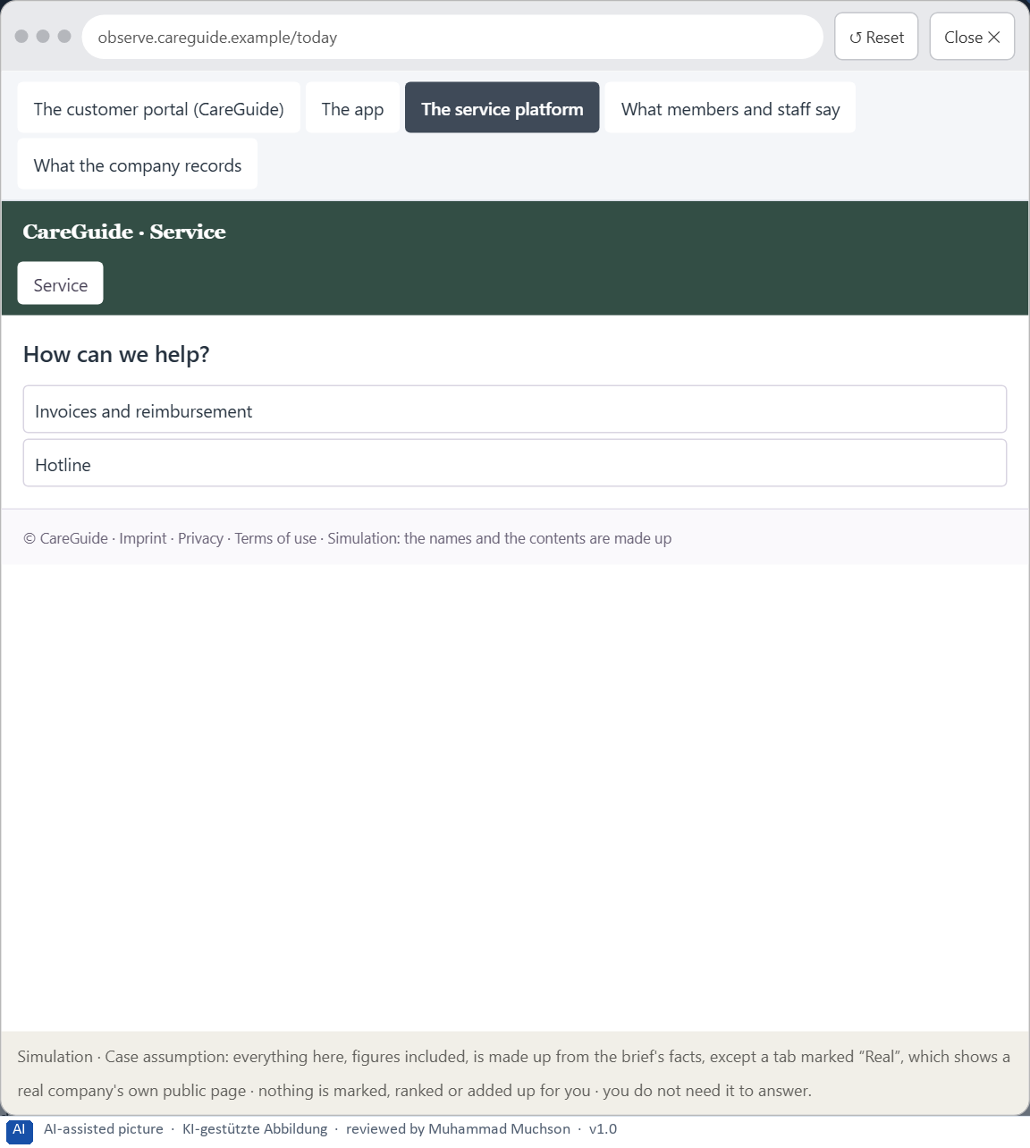
Figure 12 · The platform as it is today, as the lab lets you observe it (3 of 5).
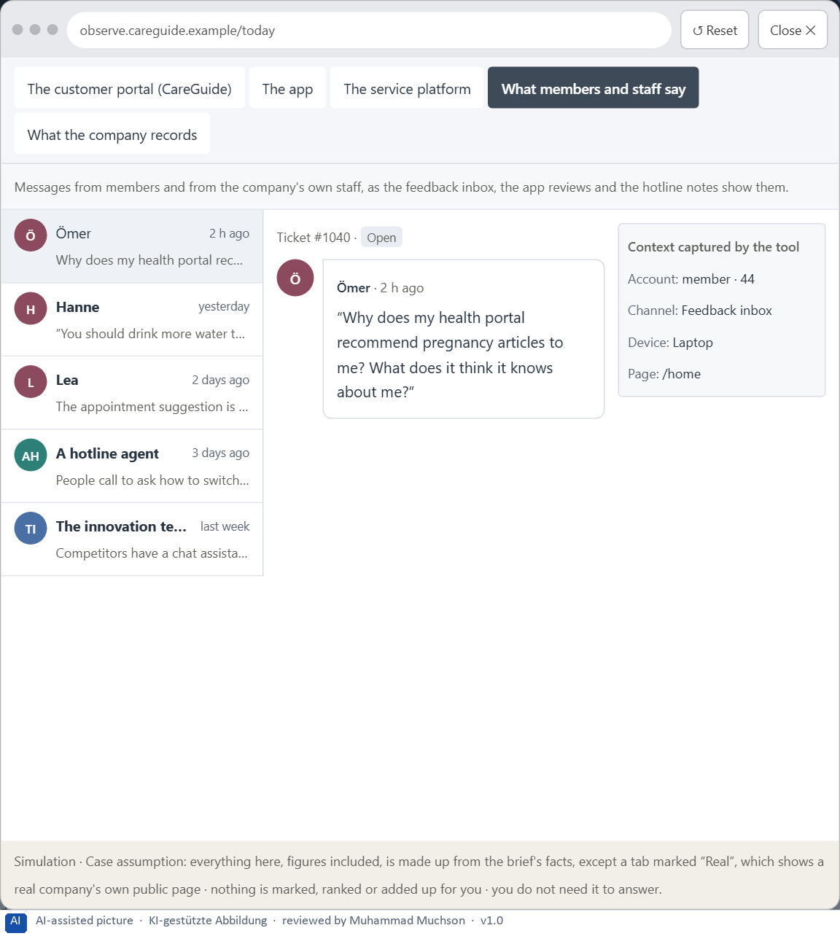
Figure 13 · The platform as it is today, as the lab lets you observe it (4 of 5).
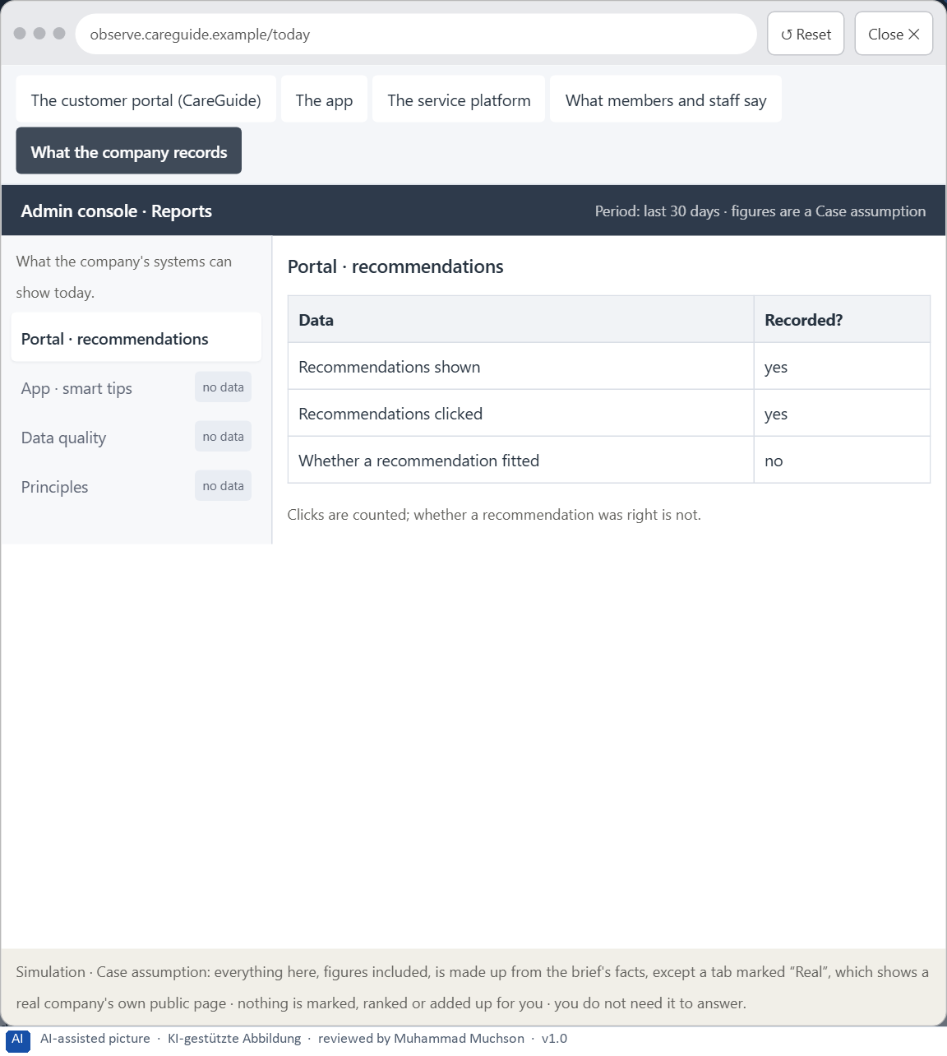
Figure 14 · The platform as it is today, as the lab lets you observe it (5 of 5).
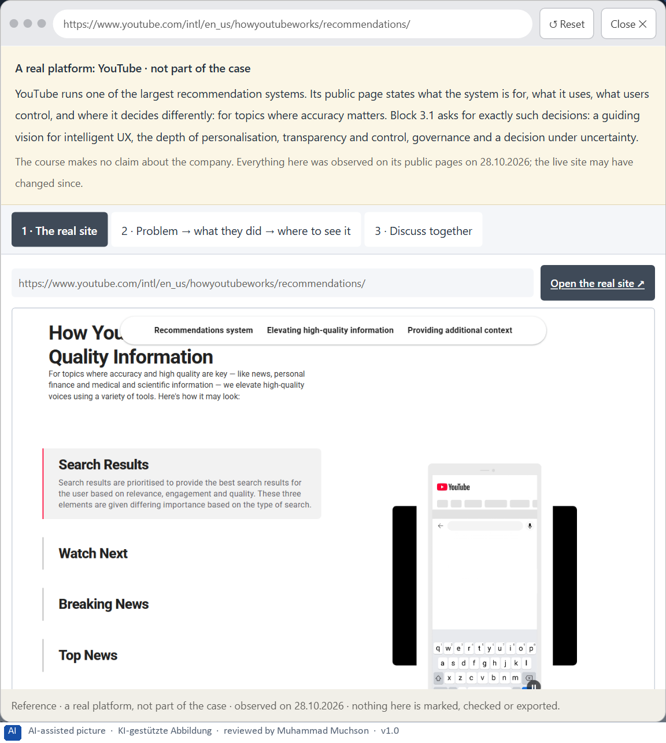
Figure 15 · A real platform that solved this, shown for the class discussion (1 of 3).
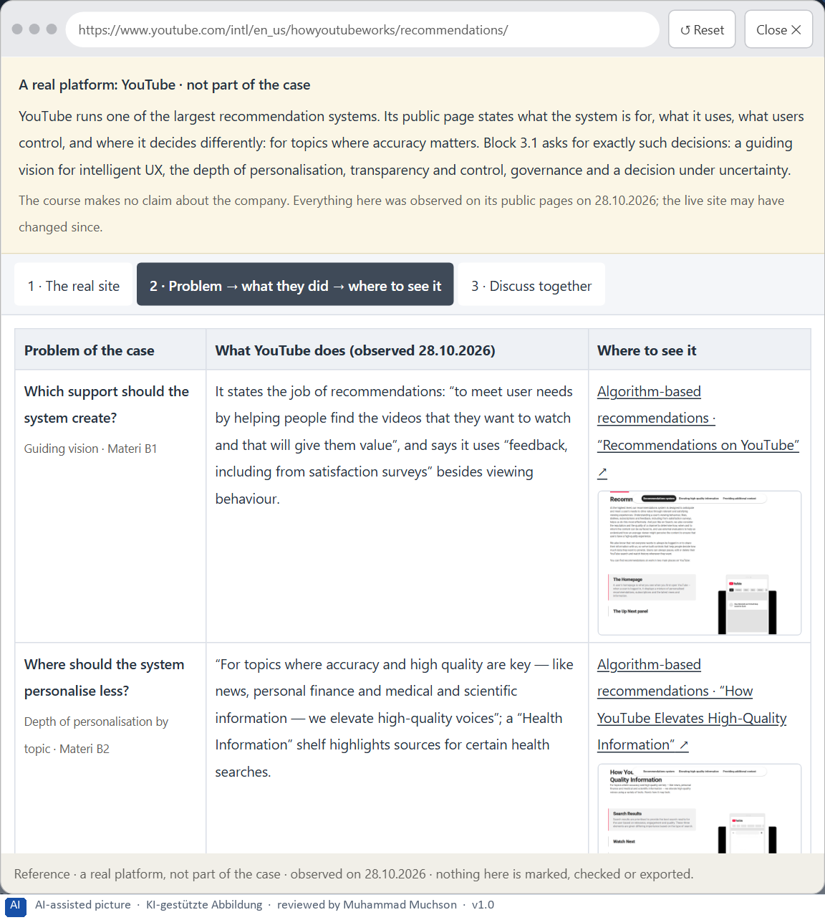
Figure 16 · A real platform that solved this, shown for the class discussion (2 of 3).
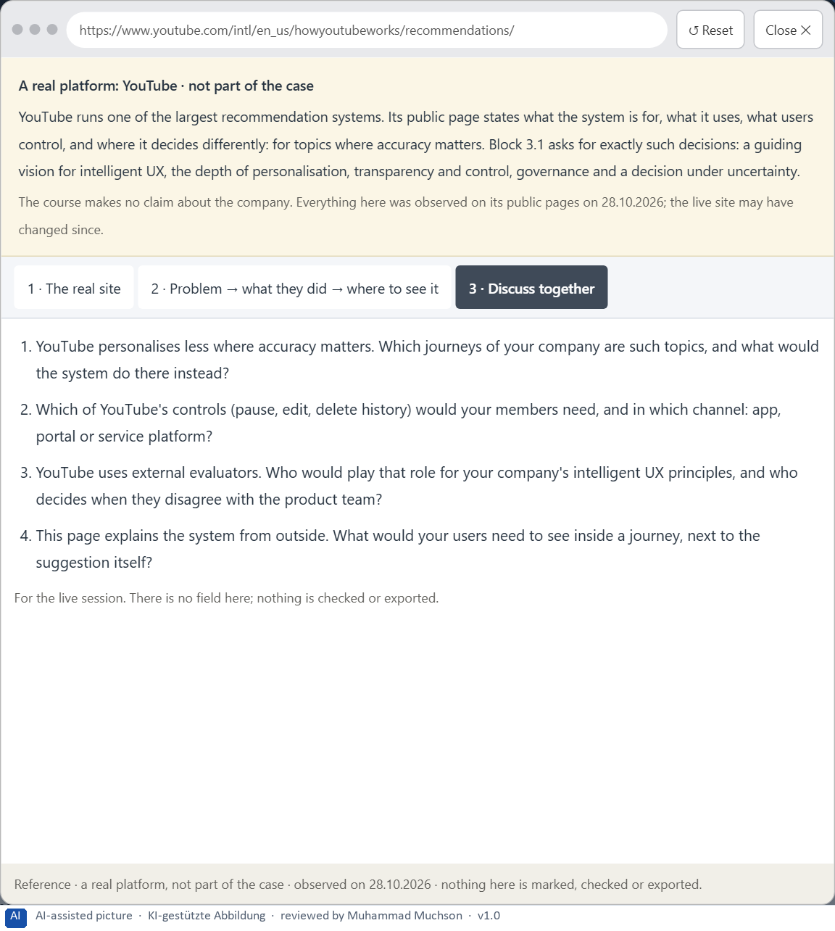
Figure 17 · A real platform that solved this, shown for the class discussion (3 of 3).
Question 1 of 7 · A guiding vision for intelligent UX: which form of support, personalisation and user autonomy should be created systematically?
One or two sentences about the support people get, how personal it is, and what stays their decision.
How to build the answer:
- Say what kind of help members should get from the system.
- Say how personal it may be, and what always remains the member's choice.

Question 2 of 7 · Three strategic guiding decisions on transparency, control, adaptivity, depth of personalisation and trustworthy AI interaction
How to build the answer:
- Take your vision and ask which three choices would make it real.
- Write each as “we will …, even though that means …”.
Write them as a list, one decision per line, each with what it gives up.

Question 3 of 7 · A prioritised architecture of measures: which journeys, functions or touchpoints are extended intelligently first, and why?
Put the journeys, functions or touchpoints in an order and give the reason for the first ones.
How to build the answer:
- List the candidates: appointment suggestions, content recommendations, the chat assistant on the service platform, document search, reminders.
- Put first what is frequent, has good data and low harm if wrong.
- Say why the others wait.

Question 4 of 7 · A risk analysis: which wrong assumptions about user behaviour, data quality and the effect of AI would be especially critical?
Name two or three assumptions and the harm if each is wrong.
How to build the answer:
- Write down what your concept assumes about how members behave.
- Write down what it assumes about the data.
- Write down what it assumes about what AI does.

Question 5 of 7 · A governance model: who is responsible for intelligent UX principles, and how are conflicts between innovation, data protection, trust and economic viability decided?
Name roles, not people: who owns the principles, the roles of data protection, the doctors and the innovation team, and how a conflict is decided.
How to build the answer:
- Name who owns the intelligent UX principles.
- Name the roles of data protection, the doctors and the innovation team.
- Say how a conflict between innovation, data protection, trust and economics is decided.

Question 6 of 7 · A decision under uncertainty: make at least one prioritised decision despite patchy data and justify it responsibly
Say what you decide, what you do not know, and why the decision is responsible all the same, for example when you would reverse it.
How to build the answer:
- State the decision in one sentence.
- Name what you do not know.
- Say why it is still responsible: it can be reversed, it can be checked soon, or waiting costs more.

Question 7 of 7 · A management statement: a recommendation to the management with a clear priority and a strategic reason
Four to six sentences: the direction first, then the priority, the reason and what you ask of the management.
How to build the answer:
- Start with the direction in one sentence.
- Name the priority and the reason that carries it.
- Say what you ask of the management and what you will report back.

Use in class: presentation and handout
Mark of use for the worksheet. Presentation is what the trainer shows on screen; Handout is what participants fill in and hand in.
Part of the worksheet | Presentation (shown in the Neuro-UX Lab) | Handout
The case: two platforms on the UX team's desk, and CareGuide | The case read aloud or on screen | The case text
Block 1.1 · Recognise the potentials and risks of intelligent interaction: SmartAs | The task wording at the start of the block (no answers are shown) | Worksheet block with answer boxes (Core)
Block 1.2 · Rate adaptive and personalised UX under conflicting goals: CareerNavig | The task wording at the start of the block (no answers are shown) | Worksheet block with answer boxes (Core)
Block 2.1 · Case study: developing the digital service portal CareGuide | The task wording at the start of the block (no answers are shown) | Worksheet block with answer boxes (Core)
The situation: the provider behind CareGuide, AI pilots that confuse and patronise | The case read aloud or on screen | The case text
Block 3.1 · A strategic UX architecture for intelligent and adaptive interfaces | The task wording at the start of the block (no answers are shown) | Worksheet block with answer boxes (Core)

Glossary
Every term below is used in this document. Terms stay plain text in the body; this list says what they mean in everyday words.
Term | In plain words | Example | Comes from
Adaptive system | A system that reacts to the situation now (time, place, device, what someone just did) without learning about the person over time. | — | Day 10
Case assumption | A fact made up for this exercise to fill a gap in the plan's case. It is marked so you know it is not part of the plan. | — | Day 1
Chief Experience Officer | The manager who is responsible for the experience customers have across all channels, and who decides where the company invests in it. | — | Day 1
Consistency | The same thing looks, is named and works the same way everywhere, so what people learn on one page holds on the next. | — | Day 2
Decision architecture | A set of connected decisions that are made on purpose and written down: what effect you want, what comes first, who decides and how conflicts are settled. It replaces many separate fixes. | — | Day 1
Explainability | A system can say, in words the person understands, why it suggested or did something. | — | Day 10
Governance | The rules about who may decide what, who is answerable for it and how disagreements are settled. | — | Day 1
Intelligent interface | An interface that supports people in a way that fits their situation: it suggests, adapts or helps, instead of only doing the same thing for everyone. | — | Day 10
Misadaptation | When a system adapts to the wrong situation or the wrong picture of a person, so its help does not fit. | — | Day 10
Personalisation | Changing what someone sees from what is known about them: their history, their preferences, their profile. | — | Day 10
Rule-based system | A system that follows fixed rules written by people: the same input always gives the same output, and the rule can be said in one sentence. | — | Day 10
Stakeholder | A person or department with an interest in a decision, such as marketing, compliance, IT or sales. | — | Day 1
Touchpoint | Any place where a person meets the company: the website, the customer portal, the app, a chatbot or a phone call. | — | Day 1
UX (user experience) | Everything a person goes through when using a product: what they notice, understand, feel and do, from the first look to the last step. The screens are only one part of it. | Finding the booking you want at once and feeling sure it went through is a good UX. | Day 1

The Neuro-UX Lab: where we practise online
In class we use the course website as the place to practise and to learn. Every day has its own address, in the same pattern: the day number is the last part.
What | Address
Neuro-UX Lab (course website) | https://aion-ux-lab.vercel.app/
Day 10 | https://aion-ux-lab.vercel.app/day/10/

On the day page, Route 1 (Levels 1 and 2) and Route 2 (Level 3) can be opened; the cards and the tasks of this document are there too. The pattern is the same up to Day 8, for example https://aion-ux-lab.vercel.app/day/6/.

