
UX DEVELOPER · PSYCHOLOGICAL UX DESIGN AND NEURO-UX
DAY 11 · CASE STUDY · LEVEL 2 · 2 UE (UE5–6)
CityHelp Voice: Case study
The day's Level 2 case study with its questions; work on it alone, then compare in your group
AI notice · KI-Hinweis
This document was produced with the help of an AI language model (Claude, Anthropic). The AI drafted the text and tables and built the pictures and working examples of the lab. The content was then read, corrected and approved by the reviewer named below, who is responsible for its accuracy. Every picture carries an AI label on the image. Check figures and sources before you quote them.
KI-Hinweis: Dieses Dokument wurde mit Unterstützung eines KI-Sprachmodells (Claude, Anthropic) erstellt. Texte und Tabellen wurden von der KI entworfen, die Abbildungen sind KI-gestützt erstellt und am Bild gekennzeichnet. Die fachliche Prüfung und Freigabe erfolgte durch die unten genannte Person.

Day | Day 11 · Module 5 (day 2 of 2): Voice interfaces, neuro-design and testing AI interfaces
Document | Case study (worksheet with answer spaces) for the 2 teaching units UE5–6.
Route and level | Level 2 · Application. Draws on Materi A.
Time | About 90 min (UE5–6), of which about 15–20 min of writing
Neuro-UX Lab (website) | https://aion-ux-lab.vercel.app/day/11/
Case | CityHelp Voice, the day's case study
Version | 1.0 · release date 29.10.2026
Review and approval | Muhammad Muchson, Mentor (subject-matter review and approval)

ABOUT THIS DOCUMENT
In class we also use the Neuro-UX Lab, the course website, as the place to practise and learn. Its address is at the end of this document.
This is the case study of Day 11. Read the case once, look at the picture, and write your answers in the boxes and tables. You can work on paper or type into the document. There are no answer keys in this document; the trainer closes the unit with the model solution.

IN THIS DOCUMENT
Lesson plan: ten teaching units (Ablaufplan)
Case study and transfer project at a glance
Block 2.1 · Case study: developing the voice service assistant CityHelp Voice · JUDGED · Core · about 15 min

Day at a glance
Day 11 has ten teaching units (UE). This document is the worksheet; it is used in UE2 to UE6 (Task 1) and UE8 to UE10 (Task 2). The day is built from three documents and the Neuro-UX Lab: Materi (study material), Task (worksheet) and Trainer (coaching, feedback and model solutions), plus the course website.

Lesson plan: ten teaching units (Ablaufplan)
UE | Min | Plan item | What happens | Material | Format
1 | 45 | Knowledge transfer · Level 1 | The trainer presents the cards of Materi A (A1, A2, A3, A4, A5, about 60 min of cards) in the Neuro-UX Lab; participants follow in the handout. | Materi A (Route 1) | Presentation + Handout
2 | 45 | Level 1 · Task 1 | Individual work on Block 1.1 (Core, about 10 min): the first product of the day is read and its effect described. Pairs then compare their results and the trainer collects open questions. | Task 1 · Part 1 · Block 1.1 | Handout (or in the lab)
3 | 45 | Level 1 · Task 2 | Three options are rated on the same criteria and one is chosen under the stated conditions: Block 1.2 (Core, about 8 min). | Task 1 · Part 1 · Block 1.2 | Handout (or in the lab)
4 | 45 | Coaching · transition from Level 1 to Level 2 | Trainer-led. A short talk on the day's coaching focus, then the reflection questions in pairs. The bridge: from describing an effect to a decision you answer for. There is no worksheet block in this unit. | Trainer document, section Coaching | Trainer only
5–6 | 90 | Level 2 · Case study CityHelp Voice (2 UE) incl. model solution | UE5: the trainer presents the case; participants work on Block 2.1 (Core, about 15 min). UE6: groups compare their results and defend them; the trainer closes with the model solution. | Task 1 · Part 2 · Block 2.1  Trainer document, section Case study | Handout; model solution shown after the work
7 | 45 | Level 2 + 3 · Feedback round with a management perspective | Groups present their reasoning, not only their result. The trainer asks the day's Level 3 input questions and leads the discussion. | Trainer document, section Feedback round | Presentation by the groups; Trainer only
8 | 45 | Level 3 · Transfer project, Chief Experience Officer (3 UE: UE8–10) | The trainer presents Materi B (B1, B2, B3; use the "In plain words" and "How to decide" boxes, the rest is handout) and sets the role and the situation. | Materi B (Route 2) | Presentation + Handout
9 | 45 | Level 3 · Transfer project | Individual work or in pairs on Block 3.1 (Core, about 20 min): the strategy memo. | Task 2 · Block 3.1 | Handout (or in the lab)
10 | 45 | Level 3 · Transfer project | Participants present their decision and what they give up, including the one decision made under uncertainty; the trainer debriefs with the model solution. | Task 2 · Block 3.1  Trainer document, section Transfer project | Handout; model solution shown after the work

One UE is counted as 45 minutes here; breaks are not shown. The times are a guide for the trainer. The Core blocks are enough for a complete answer.

Case study and transfer project at a glance
Component | UE | Duration | Participants work in | Model solution in
Level 2 case study (CityHelp Voice) | UE5–6 | 2 UE · 90 min | Task 1 · Part 2 (Block 2.1) | Trainer document, section Case study
Level 3 transfer project (Chief Experience Officer) | UE8–10 | 3 UE · 135 min | Materi B and Task 2 (Block 3.1) | Trainer document, section Transfer project

Part 2 · The case study · Level 2 · Application · Case study (2 UE)
Case study: 2 teaching units (UE5–6)
This part is the day's Level 2 case study. It takes 2 UE (about 90 minutes): UE5 for the briefing and your own work, UE6 for comparing your results with your group and for the trainer's closing. The block below needs about 15 minutes of writing; the rest of the time is discussion.

Block 2.1 · Case study: developing the voice service assistant CityHelp Voice · JUDGED · Core · about 15 min
Draws on: A1 · Screen, chat or voice · A2 · A good voice dialogue · A3 · Neuro-design · A4 · Prototyping and testing an AI interface · A5 · Where voice belongs, and weighing a measure.
A municipal service platform wants to introduce a voice assistant, CityHelp Voice, for appointments, status queries and simple citizen requests. The aim is to lower barriers to use, improve reachability and relieve service processes. At the same time there is uncertainty about comprehensibility, error-proneness, acceptance and the quality of AI-supported answers. The observed problems: first prototypes understand simple requests well but fail on ambiguous ones; users often do not know which inputs are possible or sensible; errors are reported technically instead of helpfully; the combination of voice and AI seems efficient in some situations and hard to control in others; test runs show acceptance for simple tasks but distrust for more sensitive requests; and the departments see relief, while data protection and citizen service warn of reputational risks. The conditions: a budget of €190,000, 14 weeks for the implementation, no full multichannel solution at once, a system that people who are not at home with technology can follow, limited data from earlier tests, and first results that must show soon. You work through six steps.
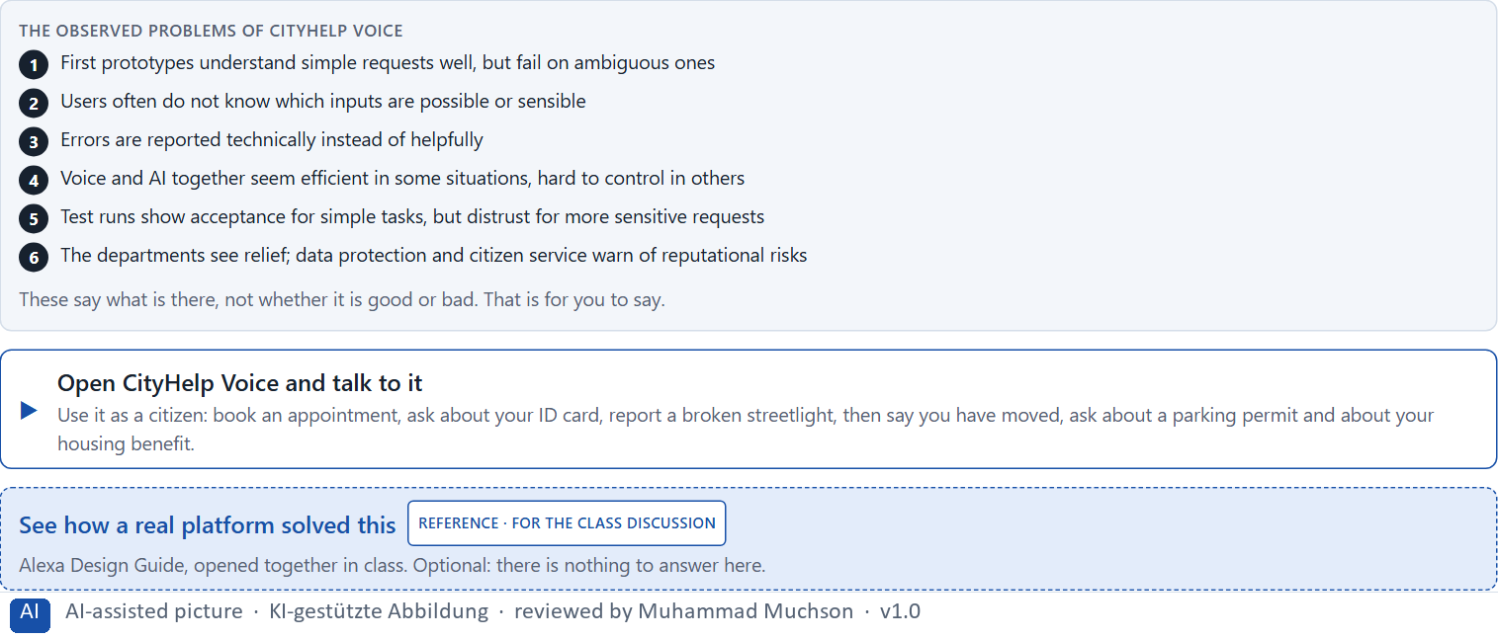
Figure 1 · The product to read, as the lab shows it (cityhelp).
Question 1 of 6 · Analyse the central chances and risks of the voice assistant
How to build the answer:
- Talk to CityHelp Voice as a citizen: book an appointment, ask about an application, report a streetlight, then try something ambiguous and something sensitive.
- Write one point per line: a chance or a risk, and what it does.
Write them as a list, one point per line, each as a chance or a risk and what it does. At least five.

Question 2 of 6 · Assign the observations to the categories comprehensibility, error robustness, control, trust, relief and acceptance
Write the observations that belong to each category in a few words.
How to build the answer:
- Take your points from question 1.
- Ask which category each affects most, and write it there.
Category | The observations in this category
Comprehensibility
Error robustness
Control
Trust
Relief
Acceptance

Question 3 of 6 · Develop 4 prioritised measures for improvement
How to build the answer:
- Turn each group of problems into something you could change within 14 weeks and €190,000, without a full multichannel solution.
- Put them in order: what secures comprehensibility and trust first.
Write them as a numbered list, the first priority first, each with what it changes for citizens.

Question 4 of 6 · Justify your selection using effect on users, feasibility, risk and time pressure
Use all four criteria and say how they support your selection and its order.
How to build the answer:
- Say what your first measures change for comprehensibility and trust.
- Say what is feasible in 14 weeks with limited test data, and the risk of each.
- Keep the less tech-savvy users and the first visible results in mind.

Question 5 of 6 · Make a prioritisation decision for the first 14 weeks
Say what you do in the first 14 weeks, in which order, and what you leave for later, with the reason.
How to build the answer:
- Say what comes first and why.
- Say what you do in parallel and what waits.
- Say how you keep citizens' trust.

Question 6 of 6 · Formulate a recommendation to the division management
Three to five sentences: what you recommend, what has priority, and what you expect to change.
How to build the answer:
- Lead with the recommendation.
- Name the priorities.
- Say what you expect to change.

Use in class: presentation and handout
Mark of use for the worksheet. Presentation is what the trainer shows on screen; Handout is what participants fill in and hand in.
Part of the worksheet | Presentation (shown in the Neuro-UX Lab) | Handout
Block 2.1 · Case study: developing the voice service assistant CityHelp Voice | The task wording at the start of the block (no answers are shown) | Worksheet block with answer boxes (Core)

Glossary
Every term below is used in this document. Terms stay plain text in the body; this list says what they mean in everyday words.
Term | In plain words | Example | Comes from
Case assumption | A fact made up for this exercise to fill a gap in the plan's case. It is marked so you know it is not part of the plan. | — | Day 1
Chief Experience Officer | The manager who is responsible for the experience customers have across all channels, and who decides where the company invests in it. | — | Day 1
Decision architecture | A set of connected decisions that are made on purpose and written down: what effect you want, what comes first, who decides and how conflicts are settled. It replaces many separate fixes. | — | Day 1
Dialogue logic | The order of turns in a voice conversation: who speaks when, one question at a time, and what happens after each answer. | — | Day 11
Error handling | What an assistant does when it does not understand: a good one asks a better question or hands over to a person instead of repeating itself. | — | Day 11
Governance | The rules about who may decide what, who is answerable for it and how disagreements are settled. | — | Day 1
Intelligent interface | An interface that supports people in a way that fits their situation: it suggests, adapts or helps, instead of only doing the same thing for everyone. | — | Day 10
Neuro-UX | Designing an interface with knowledge of how the brain sees, attends, feels and decides, so that the design steers these processes on purpose and responsibly. | — | Day 1
Predictability | Being able to tell in advance how something will work, because it works like what you have seen before. | — | Day 6
Reachability | How easily a target can be reached and hit: its size, its distance from the hand or pointer, and the space around it. | — | Day 5
Stakeholder | A person or department with an interest in a decision, such as marketing, compliance, IT or sales. | — | Day 1
Touchpoint | Any place where a person meets the company: the website, the customer portal, the app, a chatbot or a phone call. | — | Day 1
UX (user experience) | Everything a person goes through when using a product: what they notice, understand, feel and do, from the first look to the last step. The screens are only one part of it. | Finding the booking you want at once and feeling sure it went through is a good UX. | Day 1
Voice user interface | An interface people use by speaking and listening; it has no screen to show what it understood, so it has to say it back. | — | Day 10

The Neuro-UX Lab: where we practise online
In class we use the course website as the place to practise and to learn. Every day has its own address, in the same pattern: the day number is the last part.
What | Address
Neuro-UX Lab (course website) | https://aion-ux-lab.vercel.app/
Day 11 | https://aion-ux-lab.vercel.app/day/11/

On the day page, Route 1 (Levels 1 and 2) and Route 2 (Level 3) can be opened; the cards and the tasks of this document are there too. The pattern is the same up to Day 8, for example https://aion-ux-lab.vercel.app/day/6/.

