
UX DEVELOPER · PSYCHOLOGICAL UX DESIGN AND NEURO-UX
DAY 12 · CASE STUDY · LEVEL 2 · 2 UE (UE5–6)
CitizenConnect: Case study
The day's Level 2 case study with its questions; work on it alone, then compare in your group
AI notice · KI-Hinweis
This document was produced with the help of an AI language model (Claude, Anthropic). The AI drafted the text and tables and built the pictures and working examples of the lab. The content was then read, corrected and approved by the reviewer named below, who is responsible for its accuracy. Every picture carries an AI label on the image. Check figures and sources before you quote them.
KI-Hinweis: Dieses Dokument wurde mit Unterstützung eines KI-Sprachmodells (Claude, Anthropic) erstellt. Texte und Tabellen wurden von der KI entworfen, die Abbildungen sind KI-gestützt erstellt und am Bild gekennzeichnet. Die fachliche Prüfung und Freigabe erfolgte durch die unten genannte Person.

Day | Day 12 · Module 6 (day 1 of 2): Accessibility, standards and neurodiversity
Document | Case study (worksheet with answer spaces) for the 2 teaching units UE5–6.
Route and level | Level 2 · Application. Draws on Materi A.
Time | About 90 min (UE5–6), of which about 15–20 min of writing
Neuro-UX Lab (website) | https://aion-ux-lab.vercel.app/day/12/
Case | CitizenConnect, the day's case study
Version | 1.0 · release date 29.10.2026
Review and approval | Muhammad Muchson, Mentor (subject-matter review and approval)

ABOUT THIS DOCUMENT
In class we also use the Neuro-UX Lab, the course website, as the place to practise and learn. Its address is at the end of this document.
This is the case study of Day 12. Read the case once, look at the picture, and write your answers in the boxes and tables. You can work on paper or type into the document. There are no answer keys in this document; the trainer closes the unit with the model solution.

IN THIS DOCUMENT
Lesson plan: ten teaching units (Ablaufplan)
Case study and transfer project at a glance
Block 2.1 · Case study: making the portal CitizenConnect more accessible · JUDGED · Core · about 15 min

Day at a glance
Day 12 has ten teaching units (UE). This document is the worksheet; it is used in UE2 to UE6 (Task 1) and UE8 to UE10 (Task 2). The day is built from three documents and the Neuro-UX Lab: Materi (study material), Task (worksheet) and Trainer (coaching, feedback and model solutions), plus the course website.

Lesson plan: ten teaching units (Ablaufplan)
UE | Min | Plan item | What happens | Material | Format
1 | 45 | Knowledge transfer · Level 1 | The trainer presents the cards of Materi A (A1, A2, A3, A4, A5, about 60 min of cards) in the Neuro-UX Lab; participants follow in the handout. | Materi A (Route 1) | Presentation + Handout
2 | 45 | Level 1 · Task 1 | Individual work on Block 1.1 (Core, about 10 min): the first product of the day is read and its effect described. Pairs then compare their results and the trainer collects open questions. | Task 1 · Part 1 · Block 1.1 | Handout (or in the lab)
3 | 45 | Level 1 · Task 2 | Three options are rated on the same criteria and one is chosen under the stated conditions: Block 1.2 (Core, about 8 min). | Task 1 · Part 1 · Block 1.2 | Handout (or in the lab)
4 | 45 | Coaching · transition from Level 1 to Level 2 | Trainer-led. A short talk on the day's coaching focus, then the reflection questions in pairs. The bridge: from describing an effect to a decision you answer for. There is no worksheet block in this unit. | Trainer document, section Coaching | Trainer only
5–6 | 90 | Level 2 · Case study CitizenConnect (2 UE) incl. model solution | UE5: the trainer presents the case; participants work on Block 2.1 (Core, about 15 min). UE6: groups compare their results and defend them; the trainer closes with the model solution. | Task 1 · Part 2 · Block 2.1  Trainer document, section Case study | Handout; model solution shown after the work
7 | 45 | Level 2 + 3 · Feedback round with a management perspective | Groups present their reasoning, not only their result. The trainer asks the day's Level 3 input questions and leads the discussion. | Trainer document, section Feedback round | Presentation by the groups; Trainer only
8 | 45 | Level 3 · Transfer project, Chief Experience Officer (3 UE: UE8–10) | The trainer presents Materi B (B1, B2, B3; use the "In plain words" and "How to decide" boxes, the rest is handout) and sets the role and the situation. | Materi B (Route 2) | Presentation + Handout
9 | 45 | Level 3 · Transfer project | Individual work or in pairs on Block 3.1 (Core, about 20 min): the strategy memo. | Task 2 · Block 3.1 | Handout (or in the lab)
10 | 45 | Level 3 · Transfer project | Participants present their decision and what they give up, including the one decision made under uncertainty; the trainer debriefs with the model solution. | Task 2 · Block 3.1  Trainer document, section Transfer project | Handout; model solution shown after the work

One UE is counted as 45 minutes here; breaks are not shown. The times are a guide for the trainer. The Core blocks are enough for a complete answer.

Case study and transfer project at a glance
Component | UE | Duration | Participants work in | Model solution in
Level 2 case study (CitizenConnect) | UE5–6 | 2 UE · 90 min | Task 1 · Part 2 (Block 2.1) | Trainer document, section Case study
Level 3 transfer project (Chief Experience Officer) | UE8–10 | 3 UE · 135 min | Materi B and Task 2 (Block 3.1) | Trainer document, section Transfer project

Part 2 · The case study · Level 2 · Application · Case study (2 UE)
Case study: 2 teaching units (UE5–6)
This part is the day's Level 2 case study. It takes 2 UE (about 90 minutes): UE5 for the briefing and your own work, UE6 for comparing your results with your group and for the trainer's closing. The block below needs about 15 minutes of writing; the rest of the time is discussion.

Block 2.1 · Case study: making the portal CitizenConnect more accessible · JUDGED · Core · about 15 min
Draws on: A1 · Accessibility, usability and inclusive design · A2 · Barriers in perception · A3 · Barriers in interaction · A4 · Barriers in language and structure · A5 · Standards, law and risk.
A municipal service platform offers information, appointment bookings and application processes digitally. It is heavily used, but complaints about poor legibility, unclear navigation and poor operability with assistive technologies keep coming. The organisation wants to make the portal more accessible and inclusive without a complete relaunch. The observed problems: weak contrast makes central information hard to read; forms are not cleanly structured and contain unclear error messages; keyboard operation is patchy; important hints are differentiated visually but not in words; content is partly complicated; and different page types are not built consistently. The conditions: a budget of €160,000, 14 weeks for the implementation, no complete relaunch, legal requirements that must be considered first, several departments that supply content, and first improvements that must show soon. You work through six steps.
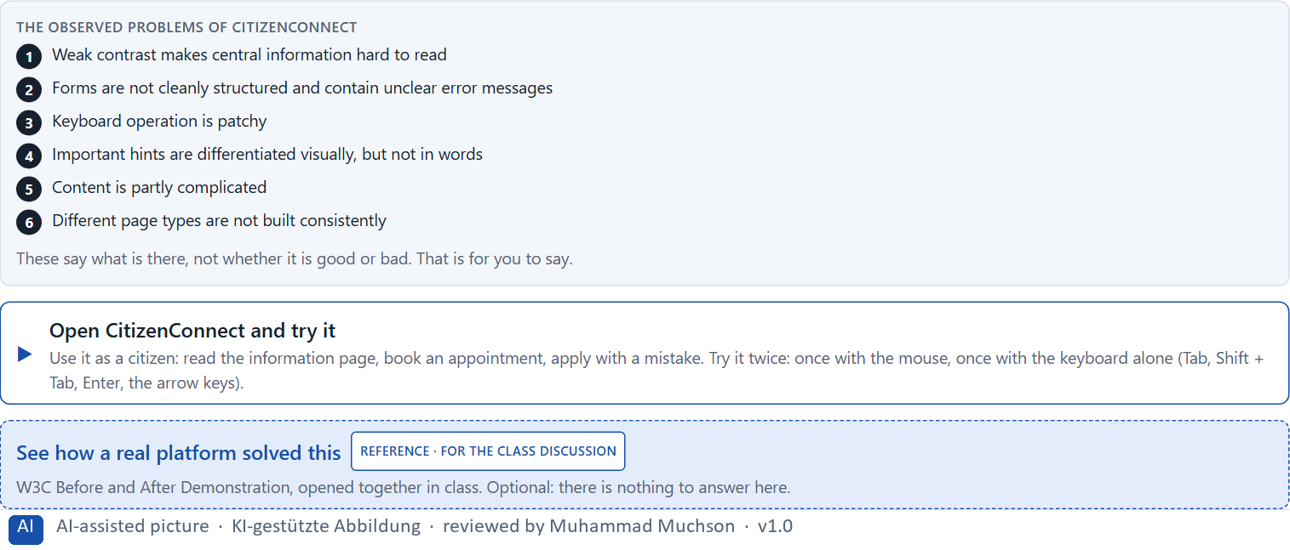
Figure 1 · The product to read, as the lab shows it (citizenconnect).
Question 1 of 6 · Analyse the central barriers and gaps in inclusion of the portal
How to build the answer:
- Open CitizenConnect as a citizen: read an information page, book an appointment, fill in an application with a mistake, then try it all with the keyboard alone.
- Write one barrier per line, and what it does.
Write them as a list, one barrier per line, each with what it does. At least five.

Question 2 of 6 · Assign the problems to the categories perceivability, operability, comprehensibility, error tolerance and consistency
Write the problems that belong to each category in a few words.
How to build the answer:
- Take your barriers from question 1.
- Ask which category each affects most, and write it there.
Category | The problems in this category
Perceivability
Operability
Comprehensibility
Error tolerance
Consistency

Question 3 of 6 · Develop 4 prioritised measures for improvement
How to build the answer:
- Turn each group of problems into something you could change within 14 weeks and €160,000, without a relaunch.
- Put them in order: what reduces exclusion first.
Write them as a numbered list, the first priority first, each with what it changes for citizens.

Question 4 of 6 · Justify your selection using effect on users, legal certainty, feasibility, risk and time pressure
Use all five criteria and say how they support your selection and its order.
How to build the answer:
- Say what your first measures change for exclusion.
- Say how they serve legal certainty, and what is feasible without a relaunch.
- Keep the 14 weeks and the several departments in mind.

Question 5 of 6 · Make a prioritisation decision for the first 14 weeks
Say what you do in the first 14 weeks, in which order, and what you leave for later, with the reason.
How to build the answer:
- Say what comes first and why.
- Say what you do in parallel and what waits.
- Say how you make the first improvements visible.

Question 6 of 6 · Formulate a recommendation to the division management
Three to five sentences: what you recommend, what has priority, and what you expect to change.
How to build the answer:
- Lead with the recommendation.
- Name the priorities.
- Say what you expect to change.

Use in class: presentation and handout
Mark of use for the worksheet. Presentation is what the trainer shows on screen; Handout is what participants fill in and hand in.
Part of the worksheet | Presentation (shown in the Neuro-UX Lab) | Handout
Block 2.1 · Case study: making the portal CitizenConnect more accessible | The task wording at the start of the block (no answers are shown) | Worksheet block with answer boxes (Core)

Glossary
Every term below is used in this document. Terms stay plain text in the body; this list says what they mean in everyday words.
Term | In plain words | Example | Comes from
Accessibility | Designing so that everyone can use a product, also people who see less well, see colours differently, or use a keyboard or a screen reader. | — | Day 3
Assistive technology | Tools people use to operate digital products, such as a screen reader that reads the screen aloud, a magnifier, a switch or voice control. | — | Day 12
Brand effect | How a design makes people recognise the company and what they feel about it, such as modern, serious or friendly. | — | Day 3
Case assumption | A fact made up for this exercise to fill a gap in the plan's case. It is marked so you know it is not part of the plan. | — | Day 1
Chief Experience Officer | The manager who is responsible for the experience customers have across all channels, and who decides where the company invests in it. | — | Day 1
Component | A reusable building block of an interface, such as a button, a form field or a status label, built once and used on many screens. | — | Day 6
Consistency | The same thing looks, is named and works the same way everywhere, so what people learn on one page holds on the next. | — | Day 2
Contrast | How much something differs from its surroundings in brightness, colour or size. Strong contrast makes it stand out; too many strong contrasts make everything compete. | — | Day 2
Decision architecture | A set of connected decisions that are made on purpose and written down: what effect you want, what comes first, who decides and how conflicts are settled. It replaces many separate fixes. | — | Day 1
Governance | The rules about who may decide what, who is answerable for it and how disagreements are settled. | — | Day 1
Inclusive design | Designing with the full range of people from the start, including permanent, temporary and situational limits and different minds. | — | Day 12
Keyboard operability | Everything can be reached and used with the keyboard alone (Tab, Enter, the arrow keys), which many assistive technologies rely on. | — | Day 12
Legibility | How easily single letters and words can be told apart. Thin, decorative or very small type is less legible. | — | Day 3
Page type | A kind of page that appears many times, such as a course page, a certificate page or a booking page. Each type should keep the same structure. | — | Day 2
Perception | Taking in what the senses deliver, for example what the eyes see on a screen, before thinking about it. | — | Day 1
Stakeholder | A person or department with an interest in a decision, such as marketing, compliance, IT or sales. | — | Day 1
UX (user experience) | Everything a person goes through when using a product: what they notice, understand, feel and do, from the first look to the last step. The screens are only one part of it. | Finding the booking you want at once and feeling sure it went through is a good UX. | Day 1
WCAG | The Web Content Accessibility Guidelines: the international standard for accessible web content, with levels A, AA and AAA; AA is the usual target. | — | Day 12

The Neuro-UX Lab: where we practise online
In class we use the course website as the place to practise and to learn. Every day has its own address, in the same pattern: the day number is the last part.
What | Address
Neuro-UX Lab (course website) | https://aion-ux-lab.vercel.app/
Day 12 | https://aion-ux-lab.vercel.app/day/12/

On the day page, Route 1 (Levels 1 and 2) and Route 2 (Level 3) can be opened; the cards and the tasks of this document are there too. The pattern is the same up to Day 8, for example https://aion-ux-lab.vercel.app/day/6/.

