
UX DEVELOPER · PSYCHOLOGICAL UX DESIGN AND NEURO-UX
DAY 14 · CASE STUDY · LEVEL 2 · 2 UE (UE5–6)
IndustryXR: Case study
The day's Level 2 case study with its questions; work on it alone, then compare in your group
AI notice · KI-Hinweis
This document was produced with the help of an AI language model (Claude, Anthropic). The AI drafted the text and tables and built the pictures and working examples of the lab. The content was then read, corrected and approved by the reviewer named below, who is responsible for its accuracy. Every picture carries an AI label on the image. Check figures and sources before you quote them.
KI-Hinweis: Dieses Dokument wurde mit Unterstützung eines KI-Sprachmodells (Claude, Anthropic) erstellt. Texte und Tabellen wurden von der KI entworfen, die Abbildungen sind KI-gestützt erstellt und am Bild gekennzeichnet. Die fachliche Prüfung und Freigabe erfolgte durch die unten genannte Person.

Day | Day 14 · Module 7 (day 1 of 3): Immersive technologies and neuroscientific UX basics
Document | Case study (worksheet with answer spaces) for the 2 teaching units UE5–6.
Route and level | Level 2 · Application. Draws on Materi A.
Time | About 90 min (UE5–6), of which about 15–20 min of writing
Neuro-UX Lab (website) | https://aion-ux-lab.vercel.app/day/14/
Case | IndustryXR, the day's case study
Version | 1.0 · release date 29.10.2026
Review and approval | Muhammad Muchson, Mentor (subject-matter review and approval)

ABOUT THIS DOCUMENT
In class we also use the Neuro-UX Lab, the course website, as the place to practise and learn. Its address is at the end of this document.
This is the case study of Day 14. Read the case once, look at the picture, and write your answers in the boxes and tables. You can work on paper or type into the document. There are no answer keys in this document; the trainer closes the unit with the model solution.

IN THIS DOCUMENT
Lesson plan: ten teaching units (Ablaufplan)
Case study and transfer project at a glance
Block 2.1 · Case study: a future strategy for the training and service offer IndustryXR · JUDGED · Core · about 15 min

Day at a glance
Day 14 has ten teaching units (UE). This document is the worksheet; it is used in UE2 to UE6 (Task 1) and UE8 to UE10 (Task 2). The day is built from three documents and the Neuro-UX Lab: Materi (study material), Task (worksheet) and Trainer (coaching, feedback and model solutions), plus the course website.

Lesson plan: ten teaching units (Ablaufplan)
UE | Min | Plan item | What happens | Material | Format
1 | 45 | Knowledge transfer · Level 1 | The trainer presents the cards of Materi A (A1, A2, A3, A4, A5, about 60 min of cards) in the Neuro-UX Lab; participants follow in the handout. | Materi A (Route 1) | Presentation + Handout
2 | 45 | Level 1 · Task 1 | Individual work on Block 1.1 (Core, about 10 min): the first product of the day is read and its effect described. Pairs then compare their results and the trainer collects open questions. | Task 1 · Part 1 · Block 1.1 | Handout (or in the lab)
3 | 45 | Level 1 · Task 2 | Three options are rated on the same criteria and one is chosen under the stated conditions: Block 1.2 (Core, about 8 min). | Task 1 · Part 1 · Block 1.2 | Handout (or in the lab)
4 | 45 | Coaching · transition from Level 1 to Level 2 | Trainer-led. A short talk on the day's coaching focus, then the reflection questions in pairs. The bridge: from describing an effect to a decision you answer for. There is no worksheet block in this unit. | Trainer document, section Coaching | Trainer only
5–6 | 90 | Level 2 · Case study IndustryXR (2 UE) incl. model solution | UE5: the trainer presents the case; participants work on Block 2.1 (Core, about 15 min). UE6: groups compare their results and defend them; the trainer closes with the model solution. | Task 1 · Part 2 · Block 2.1  Trainer document, section Case study | Handout; model solution shown after the work
7 | 45 | Level 2 + 3 · Feedback round with a management perspective | Groups present their reasoning, not only their result. The trainer asks the day's Level 3 input questions and leads the discussion. | Trainer document, section Feedback round | Presentation by the groups; Trainer only
8 | 45 | Level 3 · Transfer project, Chief Experience Officer (3 UE: UE8–10) | The trainer presents Materi B (B1, B2, B3; use the "In plain words" and "How to decide" boxes, the rest is handout) and sets the role and the situation. | Materi B (Route 2) | Presentation + Handout
9 | 45 | Level 3 · Transfer project | Individual work or in pairs on Block 3.1 (Core, about 20 min): the strategy memo. | Task 2 · Block 3.1 | Handout (or in the lab)
10 | 45 | Level 3 · Transfer project | Participants present their decision and what they give up, including the one decision made under uncertainty; the trainer debriefs with the model solution. | Task 2 · Block 3.1  Trainer document, section Transfer project | Handout; model solution shown after the work

One UE is counted as 45 minutes here; breaks are not shown. The times are a guide for the trainer. The Core blocks are enough for a complete answer.

Case study and transfer project at a glance
Component | UE | Duration | Participants work in | Model solution in
Level 2 case study (IndustryXR) | UE5–6 | 2 UE · 90 min | Task 1 · Part 2 (Block 2.1) | Trainer document, section Case study
Level 3 transfer project (Chief Experience Officer) | UE8–10 | 3 UE · 135 min | Materi B and Task 2 (Block 3.1) | Trainer document, section Transfer project

Part 2 · The case study · Level 2 · Application · Case study (2 UE)
Case study: 2 teaching units (UE5–6)
This part is the day's Level 2 case study. It takes 2 UE (about 90 minutes): UE5 for the briefing and your own work, UE6 for comparing your results with your group and for the trainer's closing. The block below needs about 15 minutes of writing; the rest of the time is discussion.

Block 2.1 · Case study: a future strategy for the training and service offer IndustryXR · JUDGED · Core · about 15 min
Draws on: A1 · From screen to space · A2 · Presence, attention and load · A3 · Intensify or overwhelm · A4 · Fascination or impact · A5 · Ethics and responsibility, and weighing a measure.
An industrial company plans to develop its training, maintenance and support processes with immersive technologies. AR instructions, VR training environments and neuroscience-informed UX concepts for better attention steering are being discussed. Inside there is enthusiasm for the technology, but robust experience of acceptance, economic viability and fit with existing processes is missing. The observed problems: it is unclear which use cases really offer immersive value; single pilot ideas are technically exciting but hardly prioritised by effect and benefit; stakeholders pursue divergent goals between innovation, safety, efficiency and cost control; usage risks such as overload, technical failures and acceptance problems have not been assessed enough; the link between technical fascination and strategic relevance is unclear; and there is no robust roadmap for introduction, testing and scaling. The conditions: a budget of €220,000 for the first phase, 16 weeks for piloting and decision preparation, full technological integration not possible in the short term, several business units that want to take part, hardly any data from real user tests, and first visible innovation steps the management wants to see soon. You work through six steps.
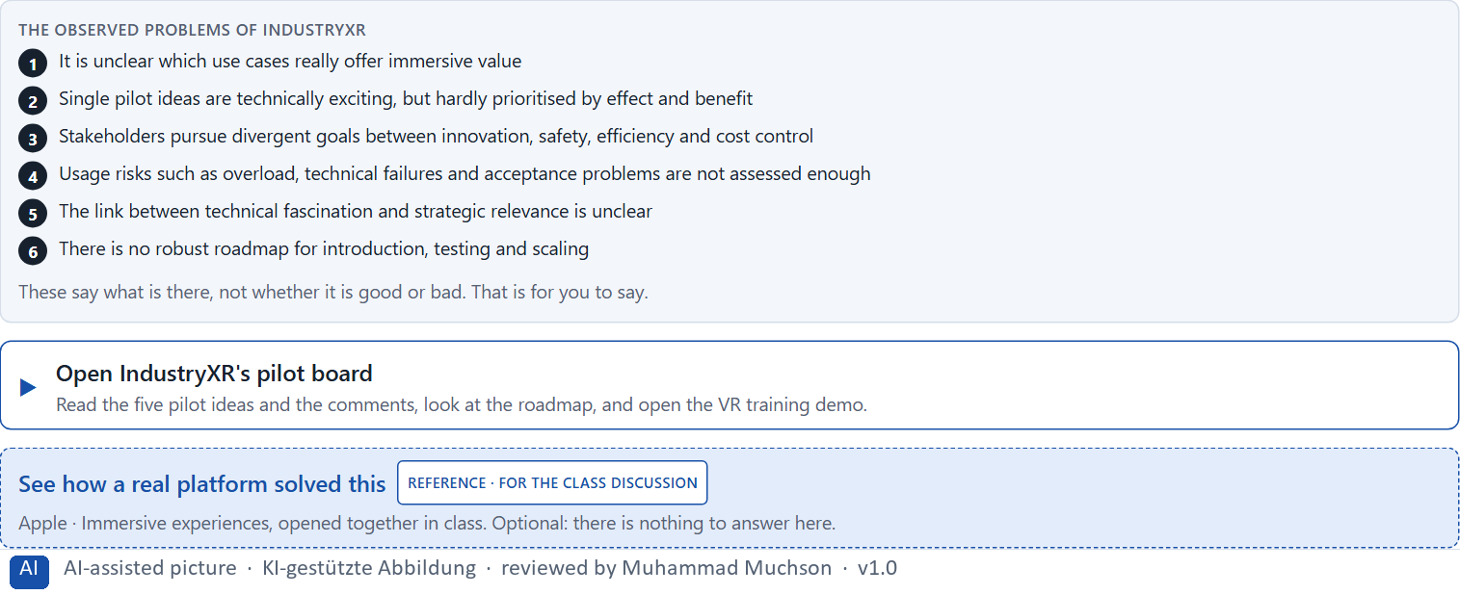
Figure 1 · The product to read, as the lab shows it (industryxr).
Question 1 of 6 · Analyse the central chances and risks of the planned immersive development
How to build the answer:
- Open IndustryXR's pilot board and the VR training demo; read what each business unit wants.
- Write one point per line: a chance or a risk, and what it does.
Write them as a list, one point per line, each as a chance or a risk and what it does. At least five.

Question 2 of 6 · Assign the observations to the categories user value, maturity, acceptance, overload, economic viability and scalability
Write the observations that belong to each category in a few words.
How to build the answer:
- Take your points from question 1.
- Ask which category each affects most, and write it there.
Category | The observations in this category
User value
Maturity
Acceptance
Overload
Economic viability
Scalability

Question 3 of 6 · Develop 4 prioritised measures for a responsible pilot strategy
How to build the answer:
- Turn each group of problems into something you could do within 16 weeks and €220,000, without full integration.
- Put them in order: what reduces investment and reputational risk first.
Write them as a numbered list, the first priority first, each with what it changes.

Question 4 of 6 · Justify your selection using effect on users, feasibility, risk, time pressure and investment security
Use all five criteria and say how they support your selection and its order.
How to build the answer:
- Say what your first measures change for investment and reputational risk.
- Say what is feasible in 16 weeks and what makes the investment safer.
- Keep the several business units and the visible steps wanted soon in mind.

Question 5 of 6 · Make a prioritisation decision for the first 16 weeks
Say what you do in the first 16 weeks, in which order, and what you leave for later, with the reason.
How to build the answer:
- Say what comes first and why.
- Say what you do in parallel and what waits.
- Say what the management will see at the end.

Question 6 of 6 · Formulate a recommendation to the division management
Three to five sentences: what you recommend, what has priority, and what you expect to change.
How to build the answer:
- Lead with the recommendation.
- Name the priorities.
- Say what you expect to change.

Use in class: presentation and handout
Mark of use for the worksheet. Presentation is what the trainer shows on screen; Handout is what participants fill in and hand in.
Part of the worksheet | Presentation (shown in the Neuro-UX Lab) | Handout
Block 2.1 · Case study: a future strategy for the training and service offer Indus | The task wording at the start of the block (no answers are shown) | Worksheet block with answer boxes (Core)

Glossary
Every term below is used in this document. Terms stay plain text in the body; this list says what they mean in everyday words.
Term | In plain words | Example | Comes from
Attention | The mind's spotlight. Only a small part of a screen is processed at any moment; attention decides which part. | A flashing banner takes attention away from the form you were filling in. | Day 1
Case assumption | A fact made up for this exercise to fill a gap in the plan's case. It is marked so you know it is not part of the plan. | — | Day 1
Chief Experience Officer | The manager who is responsible for the experience customers have across all channels, and who decides where the company invests in it. | — | Day 1
Component | A reusable building block of an interface, such as a button, a form field or a status label, built once and used on many screens. | — | Day 6
Decision architecture | A set of connected decisions that are made on purpose and written down: what effect you want, what comes first, who decides and how conflicts are settled. It replaces many separate fixes. | — | Day 1
Governance | The rules about who may decide what, who is answerable for it and how disagreements are settled. | — | Day 1
Immersion | How much a technology surrounds the senses and shuts out the real surroundings; more immersion can mean more presence, and more load. | — | Day 14
Maturity | How far a technology is from an idea to reliable use: does it work, in the real environment, for real users, at scale? | — | Day 14
Orientation | Knowing where you are, what you can do here and what happens next. | — | Day 1
Presence | The feeling of really being in a place that is digital or partly digital. | — | Day 14
Stakeholder | A person or department with an interest in a decision, such as marketing, compliance, IT or sales. | — | Day 1
Touchpoint | Any place where a person meets the company: the website, the customer portal, the app, a chatbot or a phone call. | — | Day 1
UX (user experience) | Everything a person goes through when using a product: what they notice, understand, feel and do, from the first look to the last step. The screens are only one part of it. | Finding the booking you want at once and feeling sure it went through is a good UX. | Day 1

The Neuro-UX Lab: where we practise online
In class we use the course website as the place to practise and to learn. Every day has its own address, in the same pattern: the day number is the last part.
What | Address
Neuro-UX Lab (course website) | https://aion-ux-lab.vercel.app/
Day 14 | https://aion-ux-lab.vercel.app/day/14/

On the day page, Route 1 (Levels 1 and 2) and Route 2 (Level 3) can be opened; the cards and the tasks of this document are there too. The pattern is the same up to Day 8, for example https://aion-ux-lab.vercel.app/day/6/.

