二代网络通信采用UDP协议，端口6000，命令为字符串形式,编码格式为UTF-8,具体如下：
数据回传格式：（测试完成后返回总的测试结果）
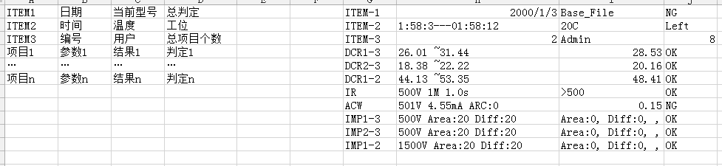
例如：
(ITEM-1)(2000/01/03)(Base_File)(NG)(ITEM-2)(1:58:3---01:58:12)(--C)(Left)(ITEM-3)(2)(Admin)(11)(DCR1-3)(26.01 ~31.44 )(28.53)(OK)(DCR2-3)(18.38 ~22.22 )(20.16)(OK)(DCR1-2)(44.13 ~53.35 )(48.41)(OK)(DCR1-3)(26.01 ~31.44 )(28.56)(OK)(IR)(500V 1M 1.0s)(>500)(OK)(ACW)(501V 4.55mA ARC:0)(0.00)(NG)(IMP1-3)(500V Area:20 Diff:20)( Area:0, Diff:0, , )(OK)(IMP2-3)(500V Area:20 Diff:20)( Area:0, Diff:0, , )(IMP1-2)(1500V Area:20 Diff:20)( Area:0, Diff:0, , )(OK)(PWR123)(I:3.200A P:3000.0W CU:600V)(0.000 ,0.0 ,0.2 )(OK)(PWR124)(I:5.00A P:3000.0W CU:600V)(0.000 ,0.0 ,0.0 )(OK)(PWR125)(I:5.00A P:3000.0W CU:600V)(0.000 ,0.0 ,0.0 )(OK)

项目名称对照：
DCR-直流电阻
MAG-反嵌
IR-绝缘
ACHV-交流耐压
SURGE-匝间
PWR-空载
Turn-转向
BLOCK-堵转
LVS-低压启动
INDL-电感

