Cardano HFT Platform — Technical Architecture
Table of Contents
Cardano HFT Platform — Technical Architecture 1
1) Vision & Purpose 1
2) Architectural Overview 1
A. Frontend Layer (React + TypeScript + Vite) 1
B. Application & API Layer (Node.js + Express + TypeScript) 2
C. Data + Blockchain Layer 2
3) Technologies Used in the Solution 3
4) Core Principles 4
5) Key Components 4
6) Data Flow (End-to-End) 4
7) API Families 5
8) Data Models 6
PoolToken 6
TradeOrder 6
Strategy (In-Memory) 7
9) Security 7
11) Roadmap 7
11) Mockup Screens 7

1) Vision & Purpose
Enable automated, strategy-based trading on Cardano DEXs with secure wallet management, real-time token discovery, and non-custodial execution. Outcome: production-ready platform bridging traditional HFT with Cardano DeFi.

2) Architectural Overview
A hybrid three-tier system built for scalability, security, and real-time performance:

A. Frontend Layer (React + TypeScript + Vite)
- Framework: React 18 with TypeScript for type safety
- Build Tool: Vite for fast development and optimized production builds
- State Management: Redux Toolkit for global state (wallet, tokens, strategies)
- UI Components:
  - Custom-designed components with Tailwind CSS
  - Sonner for toast notifications
  - Dark mode support
- Wallet Integration:
  - Mesh SDK (CIP-30) for browser wallet connections (Nami, Eternl, Flint)
  - Cardano wallet adapter for multi-wallet support
- Routing: React Router for SPA navigation

B. Application & API Layer (Node.js + Express + TypeScript)
- Runtime: Node.js with Express.js REST API
- Architecture: Service-oriented design with clear separation of concerns
- Core Services:
  - Strategy Manager Service: Orchestrates trading strategies lifecycle
  - Trading Bot Service: Monitors prices and executes orders
  - Wallet Service: Manages encrypted wallet storage and transactions
  - Price Oracle Service: Fetches live prices from Minswap pools
- API Endpoints: RESTful JSON under /api for wallets, tokens, strategies, orders
- Security: AES-256-GCM encryption for seed phrases, environment-based secrets

C. Data + Blockchain Layer
- Database: MySQL with Sequelize ORM for structured data
  - Tables: Wallets, Tokens (Pools), Trade Orders, Strategies
- Blockchain Integration:
  - Cardano Network: Preprod Testnet (production-ready for Mainnet)
  - Node Provider: Blockfrost API for blockchain queries
  - DEX: Minswap V2 pools for token swaps
  - Transaction Builder: Lucid-Cardano for building/signing transactions
  - SDK: Minswap SDK for pool calculations and swap execution

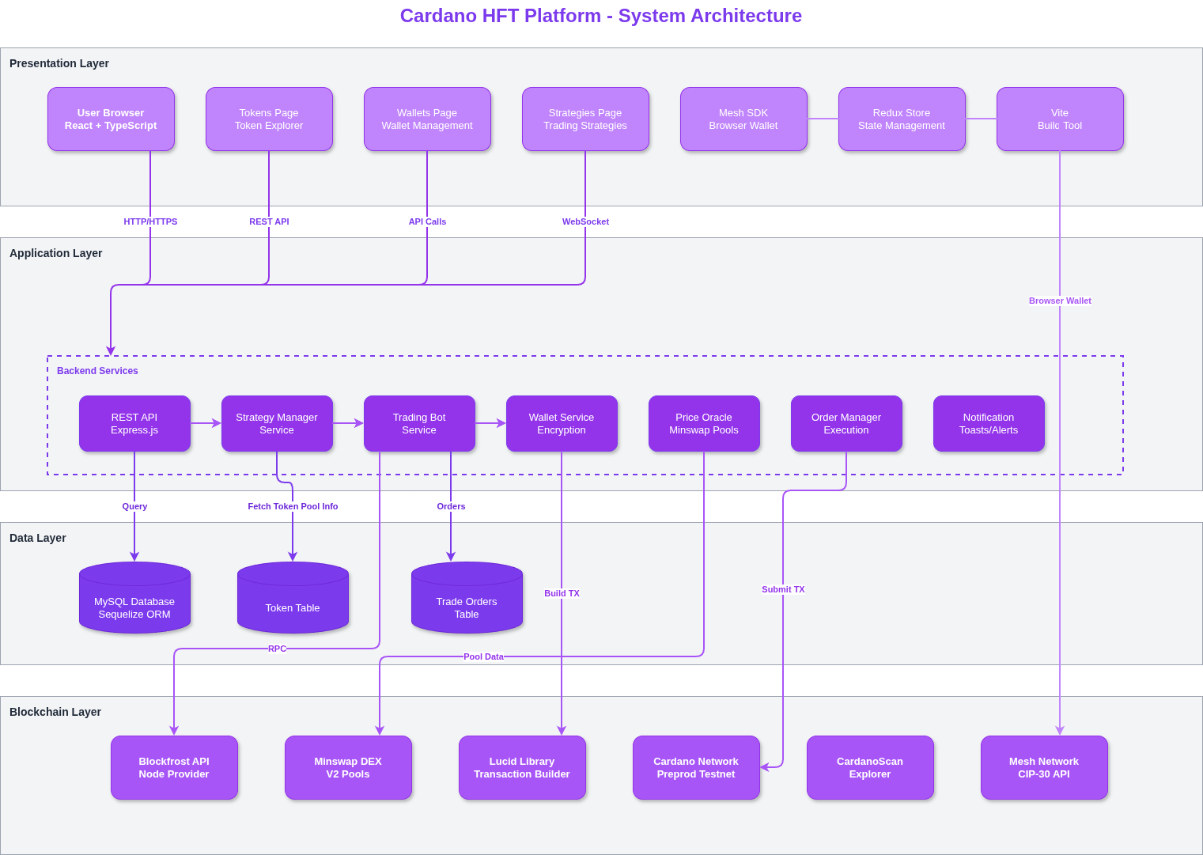

3) Technologies Used in the Solution
Category | Technology | Purpose
Frontend | React + TypeScript | Type-safe UI development with component reusability
Build Tool | Vite | Fast HMR and optimized production builds
State Management | Redux Toolkit | Centralized state for wallet, tokens, and strategies
Styling | Tailwind CSS | Utility-first CSS for rapid UI development
Backend | Node.js + Express | Scalable REST API with TypeScript
Database | MySQL + Sequelize | Relational database with ORM for structured queries
Blockchain | Cardano (Preprod/Mainnet) | Layer-1 blockchain for transaction settlement
APIs & Integrations | Lucid + Blockfrost APIs | Blockchain interaction and node queries
DEX Integration | Minswap V2 SDK | Pool data fetching and swap execution
Wallet Integration | Mesh SDK (CIP-30) | Browser wallet connections (Nami, Eternl, Flint)
Encryption | AES-256-GCM (Node crypto) | Secure seed phrase storage
Payments | ADA (Lovelace) | Native Cardano token for gas and liquidity
Math Library | Big.js | Precise decimal arithmetic for token amounts
Key Differentiators:
- React for frontend ensures high performance and developer productivity
- Python (FastAPI) is NOT used; Node.js + Express provides unified JavaScript/TypeScript stack
- Lucid + Blockfrost APIs enable direct blockchain interaction without custom node infrastructure
- AES-256-GCM encryption secures wallet seed phrases at rest

4) Core Principles
Principle | Rationale
Hybrid Off/On-Chain | Strategy logic off-chain for speed; execution on-chain for immutability
Wallet-as-Identity | CIP-30 wallets replace auth; signatures authorize actions
Non-Custodial | Backend wallets encrypted; private keys never exposed to frontend
Real-Time | Bot checks prices (10s), UI updates (5s)
Auditability | Every order has DB record + on-chain txHash

5) Key Components
Frontend: Tokens (search 100+ pools), Wallets (create/import/fund/delete), Strategies (price-target with start/stop/delete controls).
Backend Services: Strategy Manager (30s execution loop), Trading Bot (10s order polling + Lucid swaps), Wallet Service (BIP39 + encryption), Price Oracle (Minswap pool data).

6) Data Flow (End-to-End)
- Connect browser wallet (Mesh SDK) → store address
- Create backend wallet → encrypt mnemonic → save file
- Fund via browser wallet → Lucid transaction
- Browse tokens → MySQL pools via /api/tokens
- Create strategy → POST /api/strategy/price-target
- Execute loop: Strategy Manager → Trading Bot → Lucid swap → Cardano
- Monitor frontend polls /api/strategy/live (5s)
- Controls: Stop/Start/Delete via API
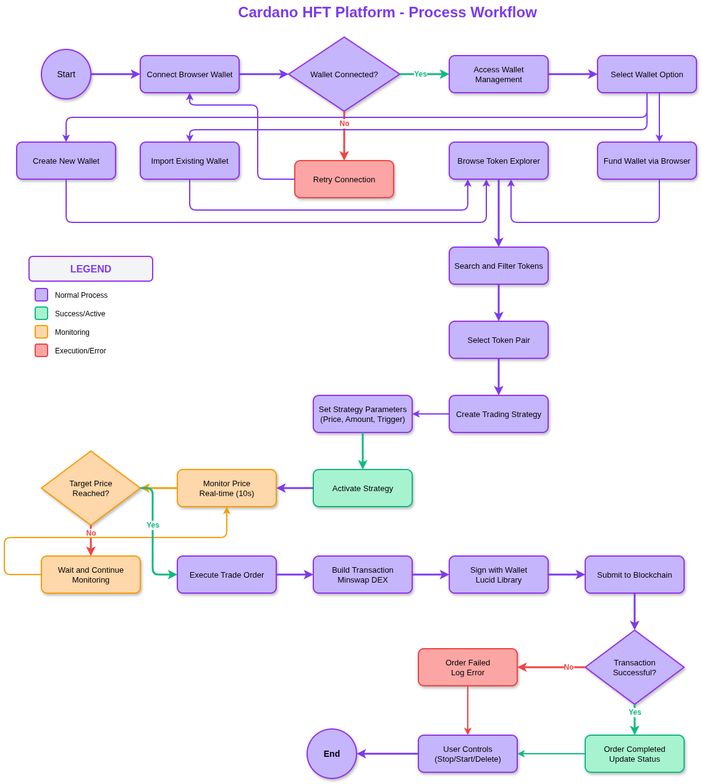

7) API Families
Wallets: /api/wallet (create, add, list, balance, remove)
Tokens: /api/tokens (list, search, refresh)
Strategies: /api/strategy (price-target, live, stop, start, delete)
Orders: /api/orders (list, details)

8) Data Models

PoolToken
Field | Type | Description
id | number (PK) | Auto-increment ID
policyId | string | Cardano policy ID
assetName | string | Token asset name
symbol | string | Token symbol (e.g., MIN)
name | string | Full token name
decimals | number | Token decimals
assetA | string | Pool asset A identifier
assetB | string | Pool asset B identifier
reserveA | string | Reserve amount for asset A
reserveB | string | Reserve amount for asset B
totalLiquidity | string | Total pool liquidity
createdAt | Date | Timestamp

TradeOrder
Field | Type | Description
id | string (PK) | UUID
walletAddress | string (FK) | Reference to Wallet
tradingPair | string | e.g., MIN-ADA
baseToken | string | Policy ID + asset name
quoteToken | string | Quote token (ADA)
isBuy | boolean | Buy or Sell order
amount | number | Order amount in tokens
targetPrice | number | Trigger price in ADA
currentPrice | number | Current market price
triggerAbove | boolean | Trigger above or below target
status | enum | pending, executing, completed, failed
txHash | string | Cardano transaction hash
executedPrice | number | Actual execution price
executedAt | Date | Execution timestamp
errorMessage | string | Error details if failed
createdAt | Date | Order creation timestamp

Strategy (In-Memory)
Field | Type | Description
id | string | UUID
name | string | Strategy name
walletAddress | string | Backend wallet address
tradingPair | string | e.g., MIN-ADA
baseToken | string | Policy ID + asset name
quoteToken | string | Quote token (ADA)
isActive | boolean | Strategy active status
targetPrice | number | Price trigger in ADA
orderAmount | number | Order size in tokens
side | enum | BUY or SELL
triggerType | enum | ABOVE or BELOW
executeOnce | boolean | One-time or recurring

9) Security
AES-256-GCM for seed phrases, non-custodial design, txHash for auditability, encrypted wallet files, no logs of seeds.

11) Roadmap
Grid trading and DCA strategies.
Multi-DEX aggregation.
WebSocket real-time feeds for sub-second updates.
Portfolio analytics with P&L tracking.
API access for algorithmic traders.
Mainnet deployment with institutional security.

11) Mockup Screens

