## **Project 2 – VS CODE**

# 

### **Introduction**

Microsoft developed the free and open-source code editor known as Visual Studio Code, which is abbreviated as VS Code. It is made to be lightweight, easy to use, and highly customizable. It also has a lot of features, making it a popular choice for developers of all skill levels.

VS Code is a source-code editor made by Microsoft with the Electron Framework, for Windows, Linux and macOS.

VS Code is available for Windows, macOS, and Linux and supports numerous programming languages, such as Python, Java, JavaScript, TypeScript, and C#, among others. Debugging tools, extensions, and a plethora of keyboard shortcuts are included, as well as built-in support for Git and other version control systems.

The extensibility of VS Code is a key feature. The editor can be customized to meet the needs of developers by installing extensions that add new features like support for additional programming languages or tools. The Versus Code Commercial center offers many augmentations created by both Microsoft and the local area.

The integrated terminal in VS Code is another well-liked feature. It lets developers run code and execute commands right from the editor. This can assist in streamlining processes and increasing productivity.

In general, VS Code is a powerful and adaptable code editor that is well-liked by developers for its adaptability, user-friendliness, and extensive feature set. It is a great option for developers who want a code editor that can be tailored to their specific requirements due to its emphasis on customization and extensibility.

**Project Summary**

|  |  |
| --- | --- |
| Website | <https://code.visualstudio.com/> |
| Organization/Foundation Name | Microsoft |
| License | MIT License |
| Open/Proprietary | Open Source |
| Source Path(if open source) | <https://github.com/microsoft/vscode> |
| Brief Description | Visual Studio Code is a lightweight but powerful source code editor which runs on your desktop and is available for Windows, macOS and Linux. It comes with built-in support for JavaScript, TypeScript and Node.js and has a rich ecosystem of extensions for other languages and runtimes (such as C++, C#, Java, Python, PHP, Go, .NET). |
| Documentation | <https://code.visualstudio.com/docs> |

#### **Project Details**

#### Key Features

#### Here are some of the key features of Visual Studio Code:

1. **Multi-platform support**: VS Code is available on Windows, macOS, and Linux, allowing developers to use it on their preferred platform.
2. **Code editing**: VS Code provides a powerful and versatile code editor that supports a wide range of programming languages, including Python, Java, JavaScript, TypeScript, C#, and many others.
3. **IntelliSense**: VS Code provides intelligent code completion, code navigation, and syntax highlighting, helping developers write code more quickly and accurately.
4. **Debugging**: VS Code provides built-in debugging support for many languages, allowing developers to debug their code directly within the editor.
5. **Git integration**: VS Code provides built-in Git integration, allowing developers to manage their code repositories directly within the editor.
6. **Extensions**: VS Code supports a wide range of extensions that can be used to add new features and customize the editor to meet specific needs.
7. **Integrated terminal**: VS Code provides an integrated terminal, allowing developers to execute commands and run code directly from within the editor.
8. **Live Share**: VS Code provides a Live Share feature that allows developers to collaborate in real-time on the same codebase, even if they are using different platforms or programming languages.
9. **Task automation**: VS Code provides a built-in task runner that allows developers to automate repetitive tasks, such as building or deploying their code.

Overall, the key features of VS Code make it a powerful and versatile code editor that is popular among developers for its flexibility, ease of use, and wide range of capabilities. Its focus on customization and extensibility make it an excellent choice for developers who want a code editor that can be tailored to their specific needs.

#### Architecture

Visual Studio Code (VS Code) is built on top of the Electron framework, which allows developers to create desktop applications using web technologies such as HTML, CSS, and JavaScript. Here is a high-level overview of the architecture of VS Code:

1. **Electron**: As mentioned, VS Code is built on the Electron framework, which provides the underlying architecture for the editor.
2. **Main process**: The main process is the heart of VS Code's architecture, responsible for managing the overall state of the application and providing core functionality such as file I/O, launching extensions, and managing the windowing system.
3. **Renderer process**: The renderer process is responsible for rendering the user interface of VS Code. It uses HTML, CSS, and JavaScript to display the editor, and communicates with the main process to access system resources and perform actions.
4. **Extensions**: Extensions are a key part of VS Code's architecture, allowing developers to add new functionality to the editor. Extensions run in separate processes, which communicate with the main process and renderer process to access resources and perform actions.
5. **Language servers**: VS Code uses language servers to provide language-specific features such as code completion, syntax highlighting, and debugging. Language servers run in separate processes, communicating with the main process and renderer process to provide these features.
6. **Debug adapter**: VS Code uses debug adapters to provide debugging functionality for various programming languages. Debug adapters communicate with the main process to manage the debug session and with language servers to provide language-specific debugging features.

Overall, the architecture of VS Code is designed to be modular and flexible, allowing developers to add new functionality and support for different programming languages through extensions and language servers. The use of Electron provides a powerful foundation for building a desktop application with web technologies, while the main and renderer processes provide a stable and efficient platform for managing the editor's state and user interface.

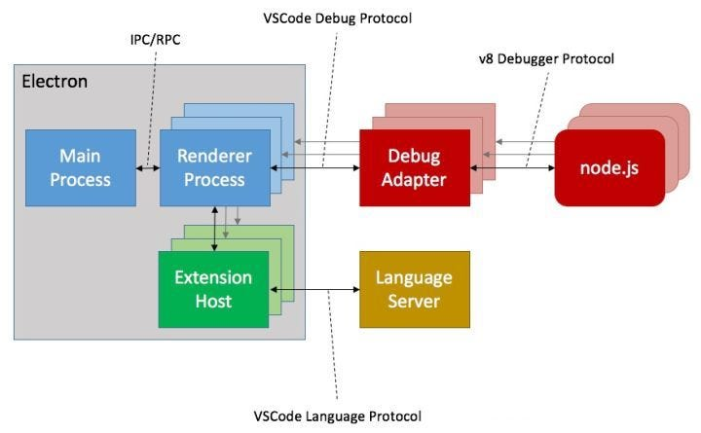

#### Current Usage

Visual Studio Code is a streamlined code editor with support for development operations like debugging, task running, and version control. It aims to provide just the tools a developer needs for a quick code-build-debug cycle and leaves more complex workflows to fuller featured IDEs, such as Visual Studio IDE.

VS Code is known for its versatility, as it can support many programming languages and has a large extension marketplace that allows users to customize their editor with various plugins and tools. It also has features such as IntelliSense, which provides code suggestions and auto-completion, as well as debugging and version control capabilities.

Overall, VS Code is a widely used tool in the development community and is favoured for its flexibility and user-friendly interface.

We have data on 18,229 companies that use Visual Studio Code.

#### Technical Details

VS Code is known for its scalability and performance, and it was made to be a lightweight and fast code editor. The editor itself runs on the client side, and the language services, like IntelliSense, run on the server side, thanks to its client-server architecture. This architecture helps keep the editor responsive even when working with large files or complex projects by allowing for the effective use of system resources.

Through the use of extensions, which can provide additional functionality and enhance performance for specific use cases, VS Code's performance and scalability can also be improved. For instance, extensions like Prettier can automatically format code, and extensions like ESLint can give real-time feedback on the quality of the code.

Although VS Code's overall performance and scalability may be affected by a variety of factors, such as the project's size and complexity and available system resources, it is generally regarded as a performant and scalable code editor.

Here are some more technical details about VS Code:

1. **Language**: VS Code is primarily built using TypeScript, a superset of JavaScript that adds optional static typing and other features.
2. **Architecture**: VS Code follows a client-server architecture, where the editor itself runs on the client side and the language services, such as IntelliSense, run on the server side. This architecture allows for efficient use of system resources and helps to keep the editor responsive even when working with large files or complex projects.
3. **Extension Marketplace**: VS Code has a large and active extension marketplace with thousands of extensions available for download. Extensions can provide additional functionality, such as language support, code formatting, and debugging tools.

Overall, VS Code is a highly configurable and customizable code editor with many powerful features that can help developers work more efficiently.

#### Any other information

Here are some extra important information about VS Code:

**Cross-platform Support**: VS Code is a cross-platform editor that works on Windows, macOS, and Linux. This allows developers to use the same editor across different operating systems and helps to ensure consistency and portability of their development environments.

**Accessibility**: VS Code is designed to be accessible to all users, including those with disabilities. It includes features such as screen reader support, high contrast themes, and keyboard navigation options to make the editor more accessible and user-friendly.

**Open Source**: VS Code is an open-source project, which means that the source code is freely available for developers to view, modify, and contribute to. This allows the community to contribute to the development of the editor and helps to ensure that it remains a free and open tool for all users.

**Community**: VS Code has a large and active community of developers who contribute to the project by creating extensions, providing support, and sharing knowledge through forums, blogs, and other resources. The community helps to ensure that VS Code remains a vibrant and growing tool that can meet the evolving needs of developers.

**Remote Development**: VS Code includes features for remote development, which allows developers to connect to remote servers, containers, or virtual machines and edit code as if they were working locally. This can be useful for teams that need to collaborate on code or for developers who need to work on different environments.

Overall, VS Code is a powerful, versatile, and user-friendly code editor that is supported by a large and active community. Its cross-platform support, accessibility, open-source nature, and remote development capabilities make it a popular tool for developers around the world.

### Project References

website: <https://code.visualstudio.com/>

Documentation: <https://code.visualstudio.com/docs>

Github: <https://github.com/microsoft/vscode>

Community Forum: <https://marketplace.visualstudio.com/items?itemName=alperg.slack-vscode>