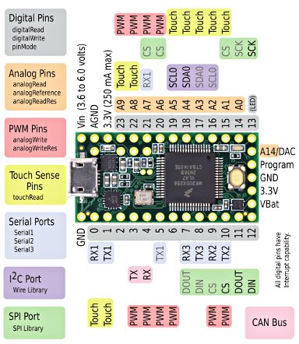

Pinouts (Teensy 3.2)
Teensy 3.2 & 3.1 have exactly the same pinout. Teensy 3.2 provides more power on its 3.3V pin, and accepts a wider voltage input range. If used within Teensy 3.1 limits, Teensy 3.2 and 3.1 are interchangeable.
Both 3.2 and 3.1 are meant to be a drop-in replacement for Teensy 3.0. Only 1 pin has different functionality. The reset pin was replaced by A14/DAC, which you can use for true analog output, or as another analog input.
Pins 3 and 4 gained CAN bus functions.
Pins 6, 9, 15, and 20-21 can still have SPI chip select capability, but the labels were removed to simplify the pinout card. Currently no libraries use the native chip selects. However, a new SPIFIFO library is in development.

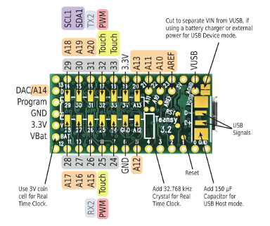
On the back side, 2 pins gained new PWM functionality and 6 pins have new analog input capability. A second I2C port is also added.

