1 - Overview of Text Editors in Linux

2 - Creating Files Without Using an Editor

3 - nano and gedit

4 – nano

5 – gedit

1 - Overview of Text Editors in Linux
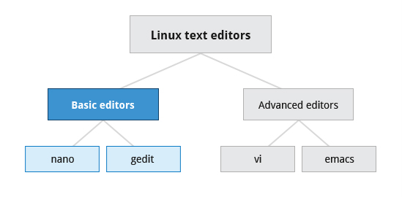

At some point you will need to manually edit text files. You might be composing an email off-line, writing a script to be used for bash or other command interpreters, altering a system or application configuration file, or developing source code for a programming language such as C or Java.
Linux Administrators quite often sidestep the text editors, by using graphical utilities for creating and modifying system configuration files. However, this can be far more laborious than directly using a text editor. Note that word processing applications such as Notepad or the applications that are part of office suites are not really basic text editors because they add a lot of extra (usually invisible) formatting information that will probably render system administration configuration files unusable for their intended purpose. So using text editors really is essential in Linux.
By now you have certainly realized Linux is packed with choices; when it comes to text editors, there are many choices ranging from quite simple to very complex, including:
- nano
- gedit
- vi
- emacs
In this section, we will learn about nano and gedit; editors which are relatively simple and easy
to learn. Before we start, let's take a look at some cases where an editor is not needed.
2 - Creating Files Without Using an Editor
Sometimes you may want to create a short file and don't want to bother invoking a full text editor. In addition, doing so can be quite useful when used from within scripts, even when creating longer files. You'll no doubt find yourself using this method when you start on the later chapters that cover bash scripting!
If you want to create a file without using an editor there are two standard ways to create one from the command line and fill it with content.
The first is to use echo repeatedly:
$ echo line one > myfile
$ echo line two >> myfile
$ echo line three >> myfile
Earlier we learned that a single greater-than sign (>) will send the output of a command to a file. Two greater-than signs (>>) will append new output to an existing file.
The second way is to use cat combined with redirection:
$ cat << EOF > myfile
> line one
> line two
> line three
> EOF
$
Both the above techniques produce a file with the following lines in it:
line one
line two
line three
and are extremely useful when employed by scripts.
3 - nano and gedit
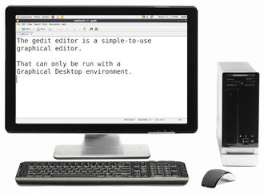

There are some text editors that are pretty obvious; they require no particular experience to learn and are actually quite capable if not robust. One particularly easy one to use is the text-terminal based editor nano. Just invoke nano by giving a file name as an argument. All the help you need is displayed at the bottom of the screen, and you should be able to proceed without any problem.
As a graphical editor, gedit is part of the GNOME desktop system (kwrite is associated with KDE). The gedit and kwrite editors are very easy to use and are extremely capable. They are also very configurable. They look a lot like Notepad in Windows. Other variants such as kedit and kate are also supported by KDE.

4 - nano
nano is easy to use, and requires very little effort to learn. To open a file in nano, type nano <filename> and press Enter. If the file doesn't exist, it will be created.
nano provides a two line “shortcut bar” at the bottom of the screen that lists the available commands. Some of these commands are:
- CTRL-G: Display the help screen
- CTRL-O: Write to a file
- CTRL-X: Exit a file
- CTRL-R: Insert contents from another file to the current buffer
- CTRL-C: Cancels previous commands
5 - gedit
gedit (pronounced 'g-edit') is a simple-to-use graphical editor that can only be run within a Graphical Desktop environment. It is visually quite similar to the Notepad text editor in Windows, but is actually far more capable and very configurable and has a wealth of plugins available to extend its capabilities further.
To open a new file in gedit, find the program in your desktop's menu system, or from the command line type gedit <filename>. If the file doesn't exist it will be created.
Using gedit is pretty straight-forward and doesn't require much training. Its interface is composed of quite familiar elements.

