Ch11
S1
1 - User Accounts
The Linux kernel allows properly authenticated users to access files and applications. While each user is identified by a unique integer (the user id or UID), a separate database associates a username with each UID. Upon account creation, new user information is added to the user database and the user's home directory must be created and populated with some essential files. Command line programs such as useradd and userdel as well as GUI tools are used for creating and removing accounts.
For each user, the following seven fields are maintained in the /etc/passwd file:
Field Name | Details | Remarks
Username | User login name | Should be between 1 and 32 characters long
Password | User password (or the character x if the password is stored in the /etc/shadow file) in encrypted format | Is never shown in Linux when it is being typed; this stops prying eyes
User ID (UID) | Every user must have a user id (UID) | - UID 0 is reserved for root user  - UID's ranging from 1-99 are reserved for other predefined accounts  - UID's ranging from 100-999 are reserved for system accounts and groups (except for RHEL, which reserves only up to 499)  - Normal users have UID's of 1000 or greater, except on RHEL where they start at 500
Group ID (GID) | The primary Group ID (GID); Group Identification Number stored in the /etc/group file | Will be covered in detail in the chapter on Processes
User Info | This field is optional and allows insertion of extra information about the user such as their name | For example: Rufus T. Firefly
Home Directory | The absolute path location of user's home directory | For example: /home/rtfirefly
Shell | The absolute location of a user's default shell | For example: /bin/bash

2 - Types of Accounts
By default, Linux distinguishes between several account types in order to isolate processes and workloads. Linux has four types of accounts:
- root
- System
- Normal
- Network
For a safe working environment, it is advised to grant the minimum privileges possible and necessary to accounts, and remove inactive accounts. The last utility, which shows the last time each user logged into the system, can be used to help identify potentially inactive accounts which are candidates for system removal.
Keep in mind that practices you use on multi-user business systems are more strict than practices you can use on personal desktop systems that only affect the casual user. This is especially true with security. We hope to show you practices applicable to enterprise servers that you can use on all systems, but understand that you may choose to relax these rules on your own personal system.
3 - Understanding the root Account
root is the most privileged account on a Linux/UNIX system. This account has the ability to carry out all facets of system administration, including adding accounts, changing user passwords, examining log files, installing software, etc. Utmost care must be taken when using this account. It has no security restrictions imposed upon it.
When you are signed in as, or acting as root, the shell prompt displays '#' (if you are using bash and you haven’t customized the prompt as we discuss elsewhere in this course). This convention is intended to serve as a warning to you of the absolute power of this account.
S2
1 - Operations that Require root Privileges
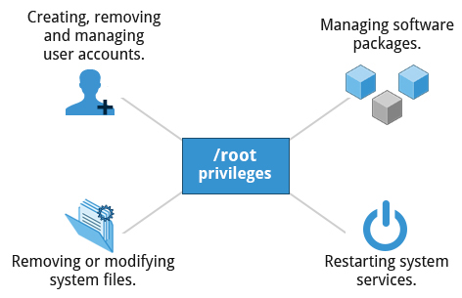

root privileges are required to perform operations such as:
- Creating, removing and managing user accounts.
- Managing software packages.
- Removing or modifying system files.
- Restarting system services.
Regular account users of Linux distributions may be allowed to install software packages, update some settings, and apply various kinds of changes to the system. However, root privilege is required for performing administration tasks such as restarting services, manually installing packages and managing parts of the filesystem that are outside the normal user’s directories.
2 - Creating a New User in Linux
To create a new user account:
- At the command prompt, as root type useradd <username> and press the ENTER key.
- To set the initial password, type passwd <username> and press the ENTER key. The New password: prompt is displayed.
- Enter the password and press the ENTER key.
To confirm the password, the prompt Retype new password: is displayed.
- Enter the password again and press the ENTER key.
The message passwd: all authentication tokens updated successfully. is displayed.
3 - Operations That Do Not Require root Privileges
A regular account user can perform some operations requiring special permissions; however, the system configuration must allow such abilities to be exercised.
SUID (Set owner User ID upon execution—similar to the Windows "run as" feature) is a special kind of file permission given to a file. SUID provides temporary permissions to a user to run a program with the permissions of the file owner (which may be root) instead of the permissions held by the user.
The table provides examples of operations which do not require root privileges:
Operations that do not require Root privilege | Examples of this operation
Running a network client | Sharing a file over the network
Using devices such as printers | Printing over the network
Operations on files that the user has proper permissions to access | Accessing files that you have access to or sharing data over the network
Running SUID-root applications | Executing programs such as passwd.

S3
1 - Comparing sudo and su
In Linux you can use either su or sudo to temporarily grant root access to a normal user; these methods are actually quite different. Listed below are the differences between the two commands.
su | sudo
When elevating privilege, you need to enter the root password. Giving the root password to a normal user should never, ever be done. | When elevating privilege, you need to enter the user’s password and not the root password.
Once a user elevates to the root account using su, the user can do anything that the root user can do for as long as the user wants, without being asked again for a password. | Offers more features and is considered more secure and more configurable. Exactly what the user is allowed to do can be precisely controlled and limited. By default the user will either always have to keep giving their password to do further operations with sudo, or can avoid doing so for a configurable time interval.
The command has limited logging features. | The command has detailed logging features.
2 - sudo Features
sudo has the ability to keep track of unsuccessful attempts at gaining root access. Users' authorization for using sudo is based on configuration information stored in the /etc/sudoers file and in the /etc/sudoers.d directory.
A message such as the following would appear in a system log file (usually /var/log/secure) when trying to execute sudo bash without successfully authenticating the user:
authentication failure; logname=op uid=0 euid=0 tty=/dev/pts/6 ruser=op rhost= user=op
conversation failed
auth could not identify password for [op]
op : 1 incorrect password attempt ;
TTY=pts/6 ; PWD=/var/log ; USER=root ; COMMAND=/bin/bash

3 - The sudoers File
Whenever sudo is invoked, a trigger will look at /etc/sudoers and the files in /etc/sudoers.d to determine if the user has the right to use sudo and what the scope of their privilege is. Unknown user requests and requests to do operations not allowed to the user even with sudo are reported. You can edit the sudoers file by using visudo, which ensures that only one person is editing the file at a time, has the proper permissions, and refuses to write out the file and exit if there is an error in the changes made.
The basic structure of an entry is:
who where = (as_whom) what
The file has a lot of documentation in it about how to customize. Most Linux distributions now prefer you add a file in the directory /etc/sudoers.d with a name the same as the user. This file contains the individual user's sudo configuration, and one should leave the master configuration file untouched except for changes that affect all users.
4 - Command Logging
By default, sudo commands and any failures are logged in /var/log/auth.log under the Debian distribution family, and in /var/log/messages or /var/log/secure on other systems. This is an important safeguard to allow for tracking and accountability of sudo use. A typical entry of the message contains:
- Calling username
- Terminal info
- Working directory
- User account invoked
- Command with arguments
Running a command such as sudo whoami results in a log file entry such as:
Dec 8 14:20:47 server1 sudo: op : TTY=pts/6 PWD=/var/log USER=root COMMAND=/usr/bin/whoami
5 - Process Isolation
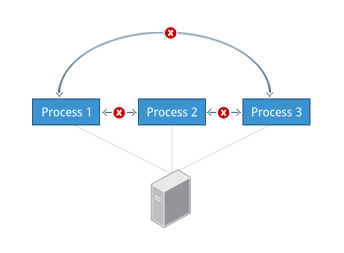

Linux is considered to be more secure than many other operating systems because processes are naturally isolated from each other. One process normally cannot access the resources of another process, even when that process is running with the same user privileges. Linux thus makes it difficult (though certainly not impossible) for viruses and security exploits to access and attack random resources on a system.
Additional security mechanisms that have been recently introduced in order to make risks even smaller are:
- Control Groups (cgroups): Allows system administrators to group processes and associate finite resources to each cgroup.
- Linux Containers (LXC): Makes it possible to run multiple isolated Linux systems (containers) on a single system by relying on cgroups.
- Virtualization: Hardware is emulated in such a way that not only processes can be isolated, but entire systems are run simultaneously as isolated and insulated guests (virtual machines) on one physical host.

6 - Hardware Device Access
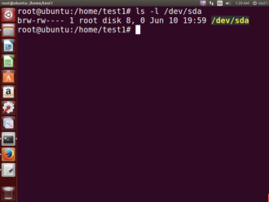
Linux limits user access to non-networking hardware devices in a manner that is extremely similar to regular file access. Applications interact by engaging the filesystem layer (which is independent of the actual device or hardware the file resides on). This layer will then opens a device special file (often called a device node) under the /dev directory that corresponds to the device being accessed. Each device special file has standard owner, group and world permission fields. Security is naturally enforced just as it is when standard files are accessed.
Hard disks, for example, are represented as /dev/sd*. While a root user can read and write to the disk in a raw fashion (for example, by doing something like:
$ echo hello world > /dev/sda1
the standard permissions as shown in the figure make it impossible for regular users to do so. Writing to a device in this fashion can easily obliterate the filesystem stored on it in a way that cannot be repaired without great effort, if at all. The normal reading and writing of files on the hard disk by applications is done at a higher level through the filesystem, and never through direct access to the device node.
7 - Keeping Current
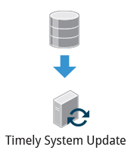

When security problems in either the Linux kernel or applications and libraries are discovered, Linux distributions have a good record of reacting quickly and pushing out fixes to all systems by updating their software repositories and sending notifications to update immediately. The same thing is true with bug fixes and performance improvements that are not security related.
However, it is well known that many systems do not get updated frequently enough and problems which have already been cured are allowed to remain on computers for a long time; this is particularly true with proprietary operating systems where users are either uninformed or distrustful of the vendor's patching policy as sometimes updates can cause new problems and break existing operations. Many of the most successful attack vectors come from exploiting security holes for which fixes are already known but not universally deployed.
So the best practice is to take advantage of your Linux distribution's mechanism for automatic updates and never postpone them. It is extremely rare that such an update will cause new problems.

