1 - Introduction to Networking
A network is a group of computers and computing devices connected together through communication channels, such as cables or wireless media. The computers connected over a network may be located in the same geographical area or spread across the world.
A network is used to:
- Allow the connected devices to communicate with each other.
- Enable multiple users to share devices over the network, such as printers and scanners.
- Share and manage information across computers easily.
Most organizations have both an internal network and an Internet connection for users to communicate with machines and people outside the organization. The Internet is the largest network in the world and is often called "the network of networks".
2 - IP Addresses
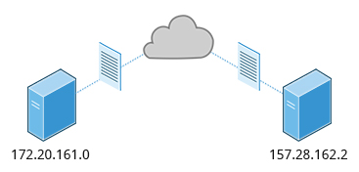

Devices attached to a network must have at least one unique network address identifier known as the IP (Internet Protocol) address. The address is essential for routing packets of information through the network.
Exchanging information across the network requires using streams of bite-sized packets, each of which contains a piece of the information going from one machine to another. These packets contain data buffers together with headers which contain information about where the packet is going to and coming from, and where it fits in the sequence of packets that constitute the stream. Networking protocols and software are rather complicated due to the diversity of machines and operating systems they must deal with, as well as the fact that even very old standards must be supported.
3 - IPv4 and IPv6
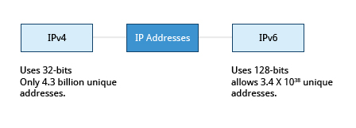
There are two different types of IP addresses available: IPv4 (version 4) and IPv6 (version 6). IPv4 is older and by far the more widely used, while IPv6 is newer and is designed to get past the limitations of the older standard and furnish many more possible addresses.
IPv4 uses 32-bits for addresses; there are only 4.3 billion unique addresses available. Furthermore, many addresses are allotted and reserved but not actually used. IPv4 is becoming inadequate because the number of devices available on the global network has significantly increased over the past years.
IPv6 uses 128-bits for addresses; this allows for 3.4 X 1038 unique addresses. If you have a larger network of computers and want to add more, you may want to move to IPv6, because it provides more unique addresses. However, it is difficult to move to IPv6 as the two protocols do not inter-operate. Due to this, migrating equipment and addresses to IPv6 requires significant effort and hasn't been as fast as was originally intended.

4 - Decoding IPv4 Addresses
A 32-bit IPv4 address is divided into four 8-bit sections called octets.
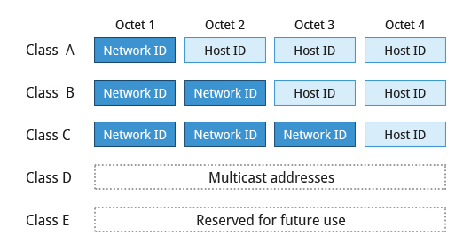
Example:
IP address → 172 . 16 . 31 . 46
Bit format → 10101100.00010000.00011111.00101110

Network addresses are divided into five classes: A, B, C, D, and E. Classes A, B, and C are classified into two parts: Network addresses (Net ID) and Host address (Host ID). The Net ID is used to identify the network, while the Host ID is used to identify a host in the network. Class D is used for special multicast applications (information is broadcast to multiple computers simultaneously) and Class E is reserved for future use. In this section you will learn about classes A, B, and C.
5 - Class A Network Addresses
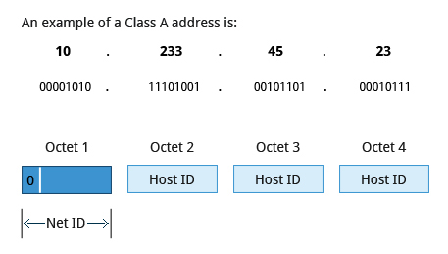
Class A addresses use the first octet of an IP address as their Net ID and use the other three octets as the Host ID. The first bit of the first octet is always set to zero. So you can use only 7-bits for unique network numbers. As a result, there are a maximum of 126 Class A networks available (the addresses 0000000 and 1111111 are reserved). Not surprisingly, this was only feasible when there were very few unique networks with large numbers of hosts. As the use of the Internet expanded, Classes B and C were added in order to accomodate the growing demand for independent networks.
Each Class A network can have up to 16.7 million unique hosts on its network. The range of host address is from 1.0.0.0 to 127.255.255.255.
Note: The value of an octet, or 8-bits, can range from 0 to 255.
6 - Class B Network Addresses
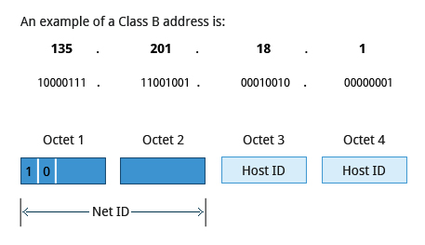

Class B addresses use the first two octets of the IP address as their Net ID and the last two octets as the Host ID. The first two bits of the first octet are always set to binary 10, so there are a maximum of 16,384 (14-bits) Class B networks. The first octet of a Class B address has values from 128 to 191. The introduction of Class B networks expanded the number of networks but it soon became clear that a further level would be needed.
Each Class B network can support a maximum of 65,536 unique hosts on its network. The range of host address is from 128.0.0.0 to 191.255.255.255.

7 - Class C Network Addresses
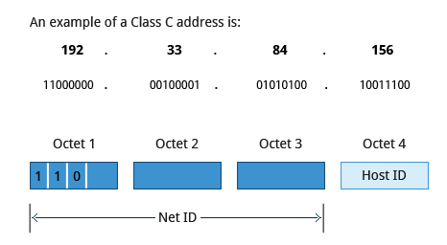

Class C addresses use the first three octets of the IP address as their Net ID and the last octet as their Host ID. The first three bits of the first octet are set to binary 110, so almost 2.1 million (21-bits) Class C networks are available. The first octet of a Class C address has values from 192 to 223. These are most common for smaller networks which don't have many unique hosts.
Each Class C network can support up to 256 (8-bits) unique hosts. The range of host address is from 192.0.0.0 to 223.255.255.255.

8 - IP Address Allocation
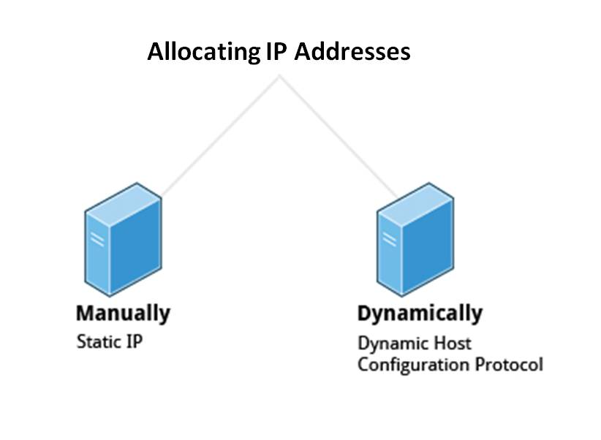

Typically, a range of IP addresses are requested from your Internet Service Provider (ISP) by your organization's network administrator. Often your choice of which class of IP address you are given depends on the size of your network and expected growth needs.
You can assign IP addresses to computers over a network manually or dynamically. When you assign IP addresses manually, you add static (never changing) addresses to the network. When you assign IP addresses dynamically (they can change every time you reboot or even more often), the Dynamic Host Configuration Protocol (DHCP) is used to assign IP addresses.

9 - Manually Allocating an IP Address
Before an IP address can be allocated manually, one must identify the size of the network by determining the host range; this determines which network class (A, B, or C) can be used. The ipcalc program can be used to ascertain (établir) the host range.
Note: The version of ipcalc supplied in the Fedora family of distributions does not behave as described below, it is really a different program.
Assume that you have a Class C network. The first three octets of the IP address are 192.168.0. As it uses 3 octets (i.e. 24 bits) for the network mask, the shorthand (sténo) for this type of address is 192.168.0.0/24. To determine the host range of the address you can use for this new host, at the command prompt, type: ipcalc 192.168.0.0/24 and press Enter.
From the result, you can check the HostMin and HostMax values to manually assign a static address available from 1 to 254 (192.168.0.1 to 192.168.0.254).
10 - Name Resolution
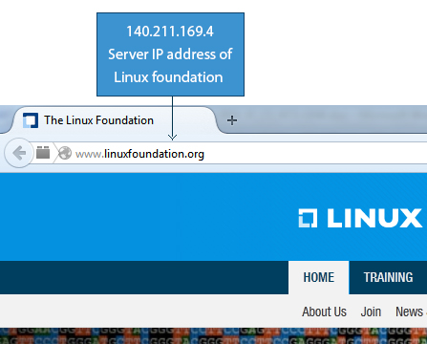

Name Resolution is used to convert numerical IP address values into a human-readable format known as the hostname. For example, 140.211.169.4 is the numerical IP address that refers to the linuxfoundation.org hostname. Hostnames are easier to remember.
Given an IP address, you can obtain its corresponding hostname. Accessing the machine over the network becomes easier when you can type the hostname instead of the IP address.
You can view your system’s hostname simply by typing hostname with no argument.
Note: If you give an argument, the system will try to change its hostname to match it, however, only root users can do that.
The special hostname localhost is associated with the IP address 127.0.0.1, and describes the machine you are currently on (which normally has additional network-related IP addresses).
Note: The next two screens cover the demonstration and Try-It-Yourself activity. You can view a demonstration and practice the procedure through the Try-It-Yourself activity.

11 - Using Domain Name System (DNS) and Name Resolution Tools
Domain Name System (DNS) translates Internet domain and host names to IP addresses.
Click below to view a demonstration on how to use DNS and name resolution tools.
To view the video in High Definition mode, click HD in the video panel.
Let's get started on using the DNS and name resolution tools such as nslookup, whois, and dig.
- To use DNS and name resolution tools:
- 1. Open the command prompt.
- 2. To display the contents of /etc/hosts file, type cat /etc/hosts and press Enter.
- 3. The contents of /etc/hosts file are displayed :
regis@regis-System-Product-Name:~$ cat /etc/hosts
127.0.0.1 localhost
127.0.1.1 regis-System-Product-Name

# The following lines are desirable for IPv6 capable hosts
::1 ip6-localhost ip6-loopback
fe00::0 ip6-localnet
ff00::0 ip6-mcastprefix
ff02::1 ip6-allnodes
ff02::2 ip6-allrouters
- 4. To display the contents of /etc/resolv.conf, type cat /etc/resolv.conf and press Enter.
- 5. The contents of /etc/resolv.conf are displayed :
regis@regis-System-Product-Name:~$ cat /etc/resolv.conf
# Dynamic resolv.conf(5) file for glibc resolver(3) generated by resolvconf(8)
# DO NOT EDIT THIS FILE BY HAND -- YOUR CHANGES WILL BE OVERWRITTEN
nameserver 127.0.1.1
- 6. To look up hostnames using DNS, type host linuxfoundation.org and press Enter.
- 7. The IP address of the specified hostname is displayed :
regis@regis-System-Product-Name:~$ host linuxfoundation.org
linuxfoundation.org has address 140.211.169.4
linuxfoundation.org mail is handled by 5 ALT1.ASPMX.L.GOOGLE.COM.
linuxfoundation.org mail is handled by 5 ALT2.ASPMX.L.GOOGLE.COM.
linuxfoundation.org mail is handled by 10 ASPMX2.GOOGLEMAIL.COM.
linuxfoundation.org mail is handled by 10 ASPMX3.GOOGLEMAIL.COM.
linuxfoundation.org mail is handled by 1 ASPMX.L.GOOGLE.COM.

- 8. To look up name servers interactively, type nslookup linuxfoundation.org and press Enter.
- 9. The IP address of the domain name is displayed :
regis@regis-System-Product-Name:~$ nslookup linuxfoundation.org
Server: 127.0.1.1
Address: 127.0.1.1#53
Non-authoritative answer:
Name: linuxfoundation.org
Address: 140.211.169.4
- 10. To look up domain name information from nameserver, type dig linuxfoundation.org and press Enter.
- 11. The domain name information is displayed :
regis@regis-System-Product-Name:~$ dig linuxfoundation.org

; <<>> DiG 9.9.5-3ubuntu0.4-Ubuntu <<>> linuxfoundation.org
;; global options: +cmd
;; Got answer:
;; ->>HEADER<<- opcode: QUERY, status: NOERROR, id: 54907
;; flags: qr rd ra; QUERY: 1, ANSWER: 1, AUTHORITY: 2, ADDITIONAL: 1

;; OPT PSEUDOSECTION:
; EDNS: version: 0, flags:; udp: 4096
;; QUESTION SECTION:
;linuxfoundation.org. IN A

;; ANSregis@regis-System-Product-Name:~$ dig linuxfoundation.org

; <<>> DiG 9.9.5-3ubuntu0.4-Ubuntu <<>> linuxfoundation.org
;; global options: +cmd
;; Got answer:
;; ->>HEADER<<- opcode: QUERY, status: NOERROR, id: 54907
;; flags: qr rd ra; QUERY: 1, ANSWER: 1, AUTHORITY: 2, ADDITIONAL: 1

;; OPT PSEUDOSECTION:
; EDNS: version: 0, flags:; udp: 4096
;; QUESTION SECTION:
;linuxfoundation.org. IN A

;; ANSWER SECTION:
linuxfoundation.org. 10459 IN A 140.211.169.4

;; AUTHORITY SECTION:
linuxfoundation.org. 12504 IN NS ns2.linux-foundation.org.
linuxfoundation.org. 12504 IN NS ns1.linux-foundation.org.

;; Query time: 36 msec
;; SERVER: 127.0.1.1#53(127.0.1.1)
;; WHEN: Tue Sep 29 10:50:46 CEST 2015
;; MSG SIZE rcvd: 117

12 - Try-It-Yourself: Using Domain Name System (DNS) and Name Resolution Tools
To practice, click the link provided below.
Using Domain Name System (DNS) and Name Resolution Tools
13 - Network Interfaces
Network interfaces are a connection channel between a device and a network. Physically, network interfaces can proceed through a network interface card (NIC) or can be more abstractly implemented as software. You can have multiple network interfaces operating at once. Specific interfaces can be brought up (activated) or brought down (de-activated) at any time.
A list of currently active network interfaces is reported by the ifconfig utility which you may have to run as the superuser, or at least, give the full path, i.e., /sbin/ifconfig, on some distributions.
regis@regis-System-Product-Name:~$ /sbin/ifconfig
eth0 Link encap:Ethernet HWaddr 00:24:8c:3d:52:a0
inet addr:192.168.0.10 Bcast:192.168.0.255 Mask:255.255.255.0
inet6 addr: fe80::224:8cff:fe3d:52a0/64 Scope:Link
UP BROADCAST RUNNING MULTICAST MTU:1500 Metric:1
RX packets:4796 errors:0 dropped:0 overruns:0 frame:0
TX packets:4911 errors:0 dropped:0 overruns:0 carrier:1
collisions:0 txqueuelen:1000
RX bytes:2830730 (2.8 MB) TX bytes:965232 (965.2 KB)

lo Link encap:Local Loopback
inet addr:127.0.0.1 Mask:255.0.0.0
inet6 addr: ::1/128 Scope:Host
UP LOOPBACK RUNNING MTU:65536 Metric:1
RX packets:799 errors:0 dropped:0 overruns:0 frame:0
TX packets:799 errors:0 dropped:0 overruns:0 carrier:0
collisions:0 txqueuelen:0
RX bytes:98246 (98.2 KB) TX bytes:98246 (98.2 KB)

14 - Network Configuration Files
Network configuration files are essential to ensure that interfaces function correctly.
For Debian family configuration, the basic network configuration file is /etc/network/interfaces. You can type /etc/init.d/networking start to start the networking configuration.
regis@regis-System-Product-Name:~$ /etc/init.d/networking start
regis@regis-System-Product-Name:~$ cat /etc/network/interfaces
# interfaces(5) file used by ifup(8) and ifdown(8)
auto lo
iface lo inet loopback
15 - Network Configuration Commands
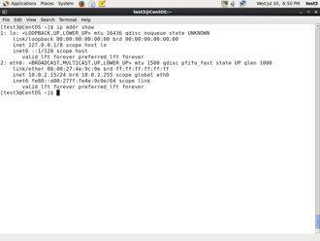
To view the IP address: /sbin/ip addr show
$
regis@regis-System-Product-Name:~$ /sbin/ip addr show
1: lo: <LOOPBACK,UP,LOWER_UP> mtu 65536 qdisc noqueue state UNKNOWN group default
link/loopback 00:00:00:00:00:00 brd 00:00:00:00:00:00
inet 127.0.0.1/8 scope host lo
valid_lft forever preferred_lft forever
inet6 ::1/128 scope host
valid_lft forever preferred_lft forever
2: eth0: <BROADCAST,MULTICAST,UP,LOWER_UP> mtu 1500 qdisc pfifo_fast state UP group default qlen 1000
link/ether 00:24:8c:3d:52:a0 brd ff:ff:ff:ff:ff:ff
inet 192.168.0.10/24 brd 192.168.0.255 scope global eth0
valid_lft forever preferred_lft forever
inet6 fe80::224:8cff:fe3d:52a0/64 scope link
valid_lft forever preferred_lft forever
3: wlan0: <BROADCAST,MULTICAST> mtu 1500 qdisc noop state DOWN group default qlen 1000
link/ether 00:22:b0:75:15:18 brd ff:ff:ff:ff:ff:ff
To view the routing information:
$ /sbin/ip route show
regis@regis-System-Product-Name:~$ /sbin/ip route show
default via 192.168.0.254 dev eth0 proto static
192.168.0.0/24 dev eth0 proto kernel scope link src 192.168.0.10 metric 1
ip is a very powerful program that can do many things. Older (and more specific) utilities such as ifconfig and route are often used to accomplish similar tasks. A look at the relevant man pages can tell you much more about these utilities.
16 - ping
ping is used to check whether or not a machine attached to the network can receive and send data; i.e., it confirms that the remote host is online and is responding.
To check the status of the remote host, at the command prompt, type ping <hostname>.
ping is frequently used for network testing and management; however, its usage can increase network load unacceptably. Hence, you can abort the execution of ping by typing CTRL-C, or by using the -c option, which limits the number of packets that ping will send before it quits. When execution stops, a summary is displayed.
regis@regis-System-Product-Name:~$ ping 78.248.92.111
PING 78.248.92.111 (78.248.92.111) 56(84) bytes of data.
64 bytes from 78.248.92.111: icmp_seq=1 ttl=64 time=4.38 ms
64 bytes from 78.248.92.111: icmp_seq=2 ttl=64 time=0.643 ms
64 bytes from 78.248.92.111: icmp_seq=3 ttl=64 time=0.649 ms
64 bytes from 78.248.92.111: icmp_seq=4 ttl=64 time=0.703 ms
64 bytes from 78.248.92.111: icmp_seq=5 ttl=64 time=0.646 ms
64 bytes from 78.248.92.111: icmp_seq=6 ttl=64 time=0.641 ms
^C
--- 78.248.92.111 ping statistics ---
6 packets transmitted, 6 received, 0% packet loss, time 4999ms
rtt min/avg/max/mdev = 0.641/1.278/4.389/1.391 ms

17 - route
A network requires the connection of many nodes. Data moves from source to destination by passing through a series of routers and potentially across multiple networks. Servers maintain routing tables containing the addresses of each node in the network. The IP Routing protocols enable routers to build up a forwarding table that correlates final destinations with the next hop addresses.
route is used to view or change the IP routing table. You may want to change the IP routing table to add, delete or modify specific (static ) routes to specific hosts or networks. The table explains some commands that can be used to manage IP routing.
Task | Command
Show current routing table | $ route –n
Add static route | $ route add -net address
Delete static route | $ route del -net address
regis@regis-System-Product-Name:~$ route -n
Kernel IP routing table
Destination Gateway Genmask Flags Metric Ref Use Iface
0.0.0.0 192.168.0.254 0.0.0.0 UG 0 0 0 eth0
192.168.0.0 0.0.0.0 255.255.255.0 U 1 0 0 eth0
18 - traceroute
traceroute is used to inspect the route which the data packet takes to reach the destination host which makes it quite useful for troubleshooting network delays and errors. By using traceroute you can isolate connectivity issues between hops, which helps resolve them faster.
To print the route taken by the packet to reach the network host, at the command prompt, type traceroute <domain>.
traceroute to google.com (216.58.211.110), 30 hops max, 60 byte packets
1 192.168.0.254 (192.168.0.254) 1.210 ms 1.641 ms 2.047 ms
2 78.248.92.254 (78.248.92.254) 27.964 ms 28.294 ms 28.519 ms
3 213.228.39.62 (213.228.39.62) 29.860 ms 30.090 ms 30.960 ms
4 nantes-crs8-1-be1101.intf.routers.proxad.net (212.27.57.34) 35.376 ms 35.628 ms 35.851 ms
5 p11-crs16-1-be1105.intf.routers.proxad.net (194.149.161.153) 43.673 ms 44.278 ms 44.500 ms
6 cbv-crs8-1.intf.routers.proxad.net (78.254.249.102) 44.828 ms 34.499 ms 34.410 ms
7 72.14.211.26 (72.14.211.26) 34.010 ms 35.732 ms 35.957 ms
8 72.14.239.145 (72.14.239.145) 44.215 ms 44.569 ms 38.941 ms
9 72.14.233.83 (72.14.233.83) 38.594 ms 40.856 ms 41.077 ms
10 par03s15-in-f14.1e100.net (216.58.211.110) 40.567 ms 42.077 ms 41.834 ms
Click the image to view an enlarged version.
Note: The next screen covers the Try-It-Yourself activity through which you can practice the procedure.
19 - Try-It-Yourself: Using ping, route, and traceroute Commands
To practice, click the link provided below.
Using ping, route, and traceroute Commands
20 - More Networking Tools
Now, let’s learn about some additional networking tools. Networking tools are very useful for monitoring and debugging network problems, such as network connectivity and network traffic.
Networking Tools | Description
ethtool | Queries network interfaces and can also set various parameters such as the speed.
netstat | Displays all active connections and routing tables. Useful for monitoring performance and troubleshooting.
nmap | Scans open ports on a network. Important for security analysis
tcpdump | Dumps network traffic for analysis.
iptraf | Monitors network traffic in text mode.
Note: The next two screens cover the demonstration and Try-It-Yourself activity. You can view a demonstration and practice the procedure through the Try-It-Yourself activity.

21 - Using More Networking Tools
Click below to view a demonstration on how to use more networking tools.
To view the video in High Definition mode, click HD in the video panel.
Let’s get started on using More Networking Tools.
- To use more networking tools:
- 1. Open the command prompt.
- 2. To query network interface connected to eth0, type sudo ethtool eth0 and press Enter.
regis@regis-System-Product-Name:~$ sudo ethtool eth0
[sudo] password for regis:
Settings for eth0:
Supported ports: [ TP ]
Supported link modes: 10baseT/Half 10baseT/Full
100baseT/Half 100baseT/Full
1000baseT/Full
Supported pause frame use: No
Supports auto-negotiation: Yes
Advertised link modes: 1000baseT/Full
Advertised pause frame use: No
Advertised auto-negotiation: Yes
Speed: 100Mb/s
Duplex: Full
Port: Twisted Pair
PHYAD: 0
Transceiver: internal
Auto-negotiation: on
MDI-X: Unknown
Supports Wake-on: pg
Wake-on: g
Current message level: 0x00000000 (0)

Link detected: yes
- 3. To display all active connections and routing tables, type netstat -r and press Enter.
- All active connections and routing tables are displayed :
regis@regis-System-Product-Name:~$ type netstat -r
netstat is /bin/netstat
bash: type: -r: not found

- 4. To scans open ports on a network, type sudo nmap -sP 10.0.2.15/24 and press Enter.
- The open ports on a network are displayed :
regis@regis-System-Product-Name:~$ type sudo nmap -sP 10.0.2.15/24
sudo is hashed (/usr/bin/sudo)
bash: type: nmap: not found
bash: type: -sP: not found
bash: type: 10.0.2.15/24: not found

22 - Try-It-Yourself: Using Network Tools
To practice, click the link provided below.
Using Network Tools

23 - Check Your Understanding
Which command is used to view a system’s hostname?

hostname - correct

24 - Check Your Understanding
Which command checks whether a host is online?
ping <span style="font-family: 'Courier New'; color: #3366ff;">ping</span> - correct route traceroute netstat

