1 - FTP (File Transfer Protocol)
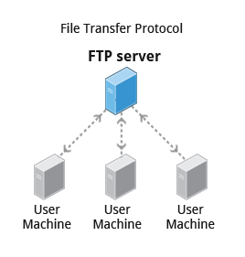

When you are connected to a network, you may need to transfer files from one machine to another. File Transfer Protocol (FTP) is a well-known and popular method for transferring files between computers using the Internet. This method is built on a client-server model. FTP can be used within a browser or with standalone client programs.
2 - FTP Clients
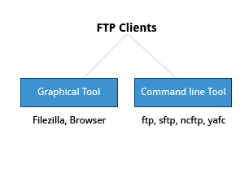
FTP clients enable you to transfer files with remote computers using the FTP protocol. These clients can be either graphical or command line tools. Filezilla, for example, allows use of the drag-and-drop approach to transfer files between hosts. All web browsers support FTP, all you have to do is give a URL like : ftp://ftp.kernel.org where the usual http:// becomes ftp://.
Some command line FTP clients are:
- ftp
- sftp
- ncftp
- yafc (Yet Another FTP Client)
sftp is a very secure mode of connection, which uses the Secure Shell (ssh) protocol, which we will discuss shortly. sftp encrypts its data and thus sensitive information is transmitted more securely. However, it does not work with so-called anonymous FTP (guest user credentials). Both ncftp and yafc are also powerful FTP clients which work on a wide variety of operating systems including Windows and Linux.
Note: The next two screens cover the demonstration and Try-It-Yourself activity. You can view a demonstration and practice the procedure through the Try-It-Yourself activity.

3 -
- Let's get started on connecting to an FTP server using command line ftp client.
- To connect to an FTP server using the command line ftp client:
- 1. In the command prompt, type ftp aristotle.learningmate.com and press Enter.
- ftp application will ask for credentials
- 2. Enter the name of the authenticated user and press enter
- 3. When prompted, do enter the password and press Enter
- The ftp prompt on the screen shows that the ftp application is connected to aristotle.learningmate.com to perform ftp operations.
- 4. To view the list of files and folders in the remote site, type ls and press Enter.
- A list of files is displayed.
- 5. To retrieve file1.txt, type get file1.txt and press Enter.
- The specified file is received from the FTP server.
- 6. To quit the ftp application, type Quit and press Enter.
- You will be disconnected from the FTP server.

4 - SSH: Executing Commands Remotely
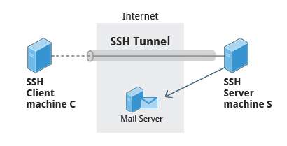

Secure Shell (SSH) is a cryptographic network protocol used for secure data communication. It is also used for remote services and other secure services between two devices on the network and is very useful for administering systems which are not easily available to physically work on but to which you have remote access.
To run my_command on a remote system via SSH, at the command prompt, type, ssh <remotesystem> my_command and press Enter. ssh then prompts you for the remote password. You can also configure ssh to securely allow your remote access without typing a password each time.
5 - Copying Files Securely with scp
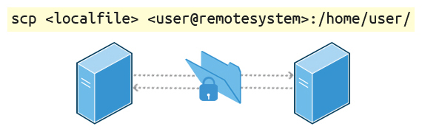

We can also move files securely using Secure Copy (scp) between two networked hosts. scp uses the SSH protocol for transferring data.
To copy a local file to a remote system, at the command prompt, type scp <localfile> <user@remotesystem>:/home/user/ and press Enter.
You will receive a prompt for the remote password. You can also configure scp so that it does not prompt for a password for each transfer.

