Chapter 3 – section 2 -
The Boot Process
Have you ever wondered what happens in the background from the time you press the Power button until the Linux login prompt appears?
The Linux boot process is the procedure for initializing the system. It consists of everything that happens from when the computer power is first switched on until the user interface is fully operational.
Once you start using Linux, you will find that having a good understanding of the steps in the boot process will help you with troubleshooting problems as well as with tailoring the computer's performance to your needs.
Click the image to view an enlarged version.

BIOS - The First Step
Starting an x86-based Linux system involves a number of steps. When the computer is powered on, the Basic Input/Output System (BIOS) initializes the hardware, including the screen and keyboard, and tests the main memory. This process is also called POST (Power On Self Test).
The BIOS software is stored on a ROM chip on the motherboard. After this, the remainder of the boot process is completely controlled by the operating system.
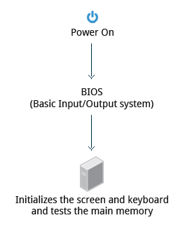

Master Boot Records (MBR) and Boot Loader
Once the POST is completed, the system control passes from the BIOS to the boot loader. The boot loader is usually stored on one of the hard disks in the system, either in the boot sector (for traditional BIOS/MBR systems) or the EFI partition (for more recent (Unified) Extensible Firmware Interface or EFI/UEFI systems). Up to this stage, the machine does not access any mass storage media. Thereafter, information on the date, time, and the most important peripherals are loaded from the CMOS values (after a technology used for the battery-powered memory store - which allows the system to keep track of the date and time even when it is powered off).
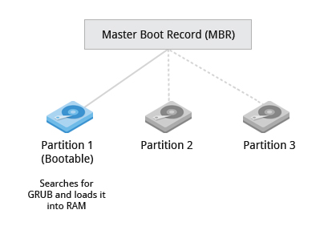

A number of boot loaders exist for Linux; the most common ones are GRUB (for GRand Unified Boot loader) and ISOLINUX (for booting from removable media). Most Linux boot loaders can present a user interface for choosing alternative options for booting Linux, and even other operating systems that might be installed. When booting Linux, the boot loader is responsible for loading the kernel image and the initial RAM disk (which contains some critical files and device drivers needed to start the system) into memory.
Boot Loader in Action
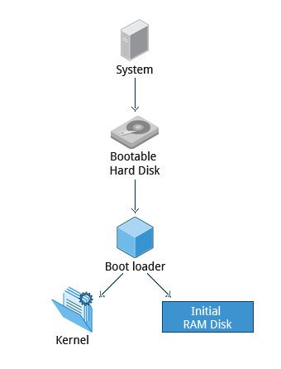

The boot loader has two distinct stages:
First Stage:
For systems using the BIOS/MBR method, the boot loader resides at the first sector of the hard disk also known as the Master Boot Record (MBR). The size of the MBR is just 512 bytes. In this stage, the boot loader examines the partition table and finds a bootable partition. Once it finds a bootable partition, it then searches for the second stage boot loader e.g, GRUB, and loads it into RAM (Random Access Memory).
For systems using the EFI/UEFI method, UEFI firmware reads its Boot Manager data to determine which UEFI application is to be launched and from where (i.e., from which disk and partition the EFI partition can be found). The firmware then launches the UEFI application, for example, GRUB, as defined in the boot entry in the firmware's boot manager. This procedure is more complicated but more versatile than the older MBR methods.
Second Stage:
The second stage boot loader resides under /boot. A splash screen is displayed which allows us to choose which Operating System (OS) to boot. After choosing the OS, the boot loader loads the kernel of the selected operating system into RAM and passes control to it.
The boot loader loads the selected kernel image (in the case of Linux) and passes control to it. Kernels are almost always compressed, so its first job is to uncompress itself. After this, it will check and analyze the system hardware and initialize any hardware device drivers built into the kernel.

The Linux Kernel
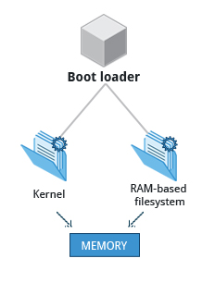

The boot loader loads both the kernel and an initial RAM–based file system (initramfs) into memory so it can be used directly by the kernel.
When the kernel is loaded in RAM, it immediately initializes and configures the computer’s memory and also configures all the hardware attached to the system. This includes all processors, I/O subsystems, storage devices, etc. The kernel also loads some necessary user space applications.
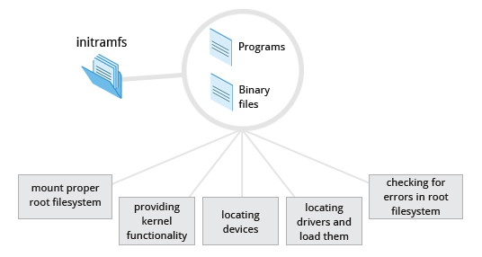
The Initial RAM Disk

The initramfs filesystem image contains programs and binary files that perform all actions needed to mount the proper root filesystem, like providing kernel functionality for the needed filesystem and device drivers for mass storage controllers with a facility called udev (for User Device) which is responsible for figuring out which devices are present, locating the drivers they need to operate properly, and loading them. After the root filesystem has been found, it is checked for errors and mounted.
The mount program instructs the operating system that a filesystem is ready for use, and associates it with a particular point in the overall hierarchy of the filesystem (the mount point). If this is successful, the initramfs is cleared from RAM and the init program on the root filesystem (/sbin/init) is executed.
init handles the mounting and pivoting over to the final real root filesystem. If special hardware drivers are needed before the mass storage can be accessed, they must be in the initramfs image.
/sbin/init and Services
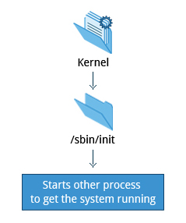
Once the kernel has set up all its hardware and mounted the root filesystem, the kernel runs the /sbin/init program. This then becomes the initial process, which then starts other processes to get the system running. Most other processes on the system trace their origin ultimately to init; the exceptions are kernel processes, started by the kernel directly for managing internal operating system details.
Traditionally, this process startup was done using conventions that date back to System V UNIX, with the system passing through a sequence of runlevels containing collections of scripts that start and stop services. Each runlevel supports a different mode of running the system. Within each runlevel, individual services can be set to run, or to be shut down if running. Newer distributions are moving away from the System V standard, but usually support the System V conventions for compatibility purposes.
Besides starting the system, init is responsible for keeping the system running and for shutting it down cleanly. It acts as the "manager of last resort" for all non-kernel processes, cleaning up after them when necessary, and restarts user login services as needed when users log in and out.

Text-Mode Login
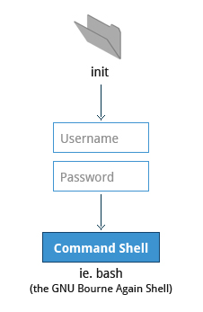
Near the end of the boot process, init starts a number of text-mode login prompts (done by a program called getty). These enable you to type your username, followed by your password, and to eventually get a command shell.
Usually, the default command shell is bash (the GNU Bourne Again Shell), but there are a number of other advanced command shells available. The shell prints a text prompt, indicating it is ready to accept commands; after the user types the command and presses Enter, the command is executed, and another prompt is displayed after the command is done.
As you'll learn in the chapter 'Command Line Operations', the terminals which run the command shells can be accessed using the ALT key plus a function key. Most distributions start six text terminals and one graphics terminal starting with F1 or F2. If the graphical environment is also started, switching to a text console requires pressing CTRL-ALT + the appropriate function key (with F7 or F1 being the GUI). As you'll see shortly, you may need to run the startx command in order to start or restart your graphical desktop after you have been in pure text mode.
X Window System
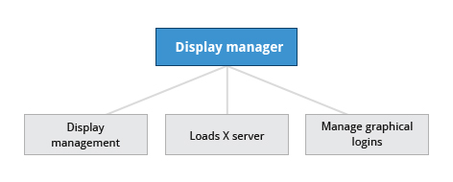
Generally, in a Linux desktop system, the X Window System is loaded as the final step in the boot process.
A service called the display manager keeps track of the displays being provided, and loads the X server (so-called because it provides graphical services to applications, sometimes called X clients). The display manager also handles graphical logins, and starts the appropriate desktop environment after a user logs in.

More About the X Window System
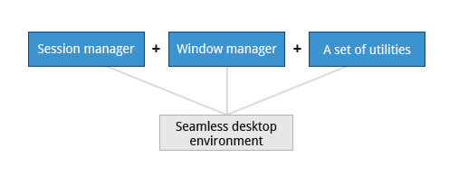

A desktop environment consists of a session manager, which starts and maintains the components of the graphical session, and the window manager, which controls the placement and movement of windows, window title-bars, and controls.
Although these can be mixed, generally a set of utilities, session manager, and window manager are used together as a unit, and together provide a seamless desktop environment.
If the display manager is not started by default in the default runlevel, you can start X a different way, after logging on to a text-mode console, by running startx from the command line.

