Chapter 3 – section 3 – Linux distribution installation
Choosing a Linux Distribution
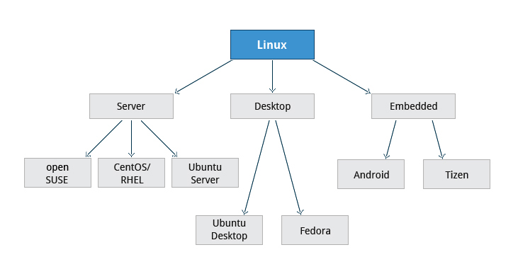
Your family is planning to buy its first car. What are the factors you need to consider while purchasing a car? Your planning depends a lot on your requirements. For instance, your budget, available finances, size of the car, type of engine, after-sales services, etc.
Similarly, determining which distribution to deploy also requires some planning. The figure shows some but not all choices, as there are other choices for distributions and standard embedded Linux systems are mostly neither Android or Tizen, but are slimmed down standard distributions.

Questions to Ask When Choosing a Linux Distribution

Some questions worth thinking about before deciding on a distribution include:
- What is the main function of the system? (server or desktop)
- What types of packages are important to the organization? For example, web server, word processing, etc.
- How much hard disk space is available? For example, when installing Linux on an embedded device, there will be space limitations.
- How often are packages updated?
- How long is the support cycle for each release? For example, LTS releases have long term support.
- Do you need kernel customization from the vendor?
- What hardware are you running the Linux distribution on? For example, X86, ARM, PPC, etc.
- Do you need long-term stability or short-term experimental software?

Linux Installation: Planning
A partition layout needs to be decided at the time of installation because Linux systems handle partitions by mounting them at specific points in the filesystem. You can always modify the design later, but it always easier to try and get it right to begin with.
Nearly all installers provide a reasonable filesystem layout by default, with either all space dedicated to normal files on one big partition and a smaller swap partitition, or with separate partitions for some space-sensitive areas like /home and /var. You may need to override the defaults and do something different if you have special needs, or if you want to use more than one disk.
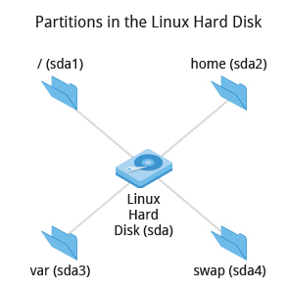

More About Planning in Linux Installation
All installations include the bare minimum software for running a Linux distribution.
Most installers also provide options for adding categories of software. Common applications (such as the Firefox web browser and LibreOffice office suite), developer tools (like the vi and emacs text editors which we will explore later in this course), and other popular services, (such as the Apache web server tools or MySQL database) are usually included. In addition, a desktop environment is installed by default.
All installers secure the system being installed as part of the installation. Usually, this consists of setting the password for the superuser (root) and setting up an initial user. In some cases (such as Ubuntu), only an initial user is set up; direct root login is disabled and root access requires logging
in first as a normal user and then using sudo as we will describe later. Some distributions will also install more advanced security frameworks, such as SELinux or AppArmor.
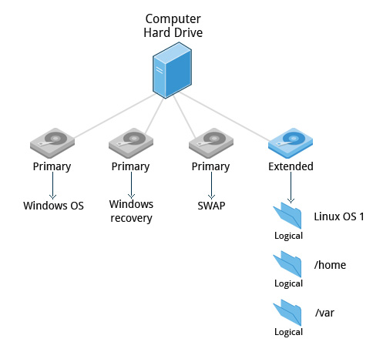
Linux Installation: Install Source
Like other operating systems, Linux distributions are provided on optical media such as CDs or DVDs. USB media is also a popular option. Most Linux distributions support booting a small image and downloading the rest of the system over the network; these small images are usable on media or as network boot images, making it possible to install without any local media at all.
Many installers can do an installation completely automatically, using a configuration file to specify installation options. This file is called a Kickstart file for Fedora-based systems, an AutoYAST profile for SUSE-based systems, and a preseed file for the Debian-based systems.
Each distribution provides its own documentation and tools for creating and managing these files.
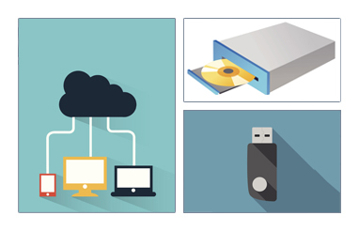

Linux Installation: The Process
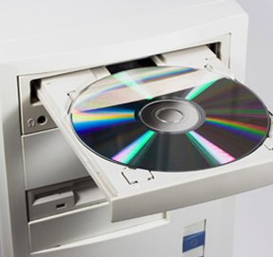
The actual installation process is pretty similar for all distributions.
After booting from the installation media, the installer starts and asks questions about how the system should be set up. (These questions are skipped if an automatic installation file is provided.) Then, the installation is performed.
Finally, the computer reboots into the newly-installed system. On some distributions, additional questions are asked after the system reboots.
Most installers have the option of downloading and installing updates as part of the installation process; this requires Internet access. Otherwise, the system uses its normal update mechanism to retrieve those updates after the installation is done.
Note: The next few screens demonstrate the Installation process in each of the three Linux distribution families we cover in this course. You can view a demonstration for the distribution type of your choice.
Linux Installation: The Warning

IMPORTANT!
The demonstrations show how to install Linux directly on your machine, erasing everything that was there. While the demonstrations will not alter your computer, following these procedures in real life will erase all current data. The Linux Foundation has a document available here that describes alternate methods of installing Linux without over-writing existing data that you may want to consult if you need to preserve the information on your hard disk.
These alternate methods are:
- Re-partitioning your hard disk to free up enough room to permit dual boot (side-by-side) installation of Linux along with your present operating system.
- Using a host machine hypervisor program (such as VMWare's products or Oracle Virtual Box) to install a client Linux Virtual Machine.
- Booting off of and using a Live CD or USB stick and not writing to the hard disk at all.
The first method is sometimes complicated and should be done when your confidence is high and you understand the steps involved. The second and third methods are quite safe and make it difficult to damage your system.
To install Ubuntu, a member of the Debian Family Version of Linux, you need to insert the Ubuntu Installation CD/DVD or connect the Ubuntu Installation USB to the system. Start the machine and boot from the CD or the USB, whichever you are using.
- 1. On the left side, select English and click Install Ubuntu.
- This shows whether the machine is connected to the Internet, and also the space available on the drive. Additionally, you can also select download updates while installing if required.
- 2. Click Continue.
- 3. Select Erase disk and install Ubuntu and click Install Now.
- Note that this option deletes the current partitions in the disk and creates its own default partitions.
- If you want to create a custom layout, click Something else, then click New Partition table which will delete all previous partitions including the data present in them.
- 4. Select the required time zone and click Continue.
- 5. Select the appropriate language from the Keyboard layout and click Continue.
- 6. Enter the user details with password.
- 7. Select Require my password to log in and click Continue to begin the installation.
- Note that the installation process will carry on until the operating system is successfully installed.
- 8. After the installation is complete, click Restart Now to restart the system.
- Note that the installation is complete once the system restarts.

