Documentation :
- We could spend weeks if not months teaching you how Linux works.
- That would be akin to giving you a fish to eat.
- Instead we want to teach to how to fish, so that you can learn to feed yourself.
- Linux has a wealth of documentation describing various commands and how different options affect the operations of those commands.
- As you learn new commands and their options in this course, always be aware that there is so much more to learn from the documentation.
- Let’s get started!
Learning Objectives
By the end of this chapter, you should be able to:
- Use different sources of documentation.
- Use the man pages.
- Access the GNU info system.
- Use the help command and --help option.
- Use other documentation sources.

Introduction to Linux Documentation Sources
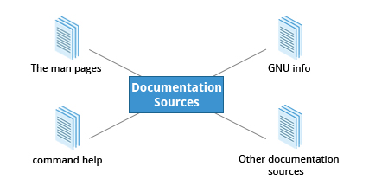
Whether you are an inexperienced user or a veteran, you won’t always know how to use various Linux programs and utilities, or what to type at the command line. You will need to consult the help documentation regularly. Because Linux-based systems draw from a large variety of sources, there are numerous reservoirs of documentation and ways of getting help. Distributors consolidate this material and present it in a comprehensive and easy-to-use manner.
Important Linux documentation sources include:
- The man pages (short for manual pages)
- GNU Info
- The help command and --help option
- Other Documentation Sources, e.g. https://www.gentoo.org/doc/en/
The man pages

The man pages are the most often-used source of Linux documentation. They provide in-depth documentation about many programs and utilities as well as other topics, including configuration files, system calls, library routines, and the kernel.
Typing man with a topic name as an argument retrieves the information stored in the topic's man pages. Some Linux distributions require every installed program to have a corresponding man page, which explains the depth of coverage. (Note: man is actually an abbreviation for manual.) The man pages structure were first introduced in the early UNIX versions of the early 1970s.
The man pages are often converted to:
- Web pages
- Published books
- Graphical help
- Other formats
man
The man program searches, formats, and displays the information contained in the man pages. Because many topics have a lot of information, output is piped through a terminal pager program such as less to be viewed one page at a time; at the same time the information is formatted for a good visual display.
When no options are given, by default one sees only the dedicated page specifically about the topic. You can broaden this to view all man pages containing a string in their name by using the -f option. You can also view all man pages that discuss a specified subject (even if the specified subject is not present in the name) by using the –k option.
man –f generates the same result as typing whatis.
man –k generates the same result as typing apropos.
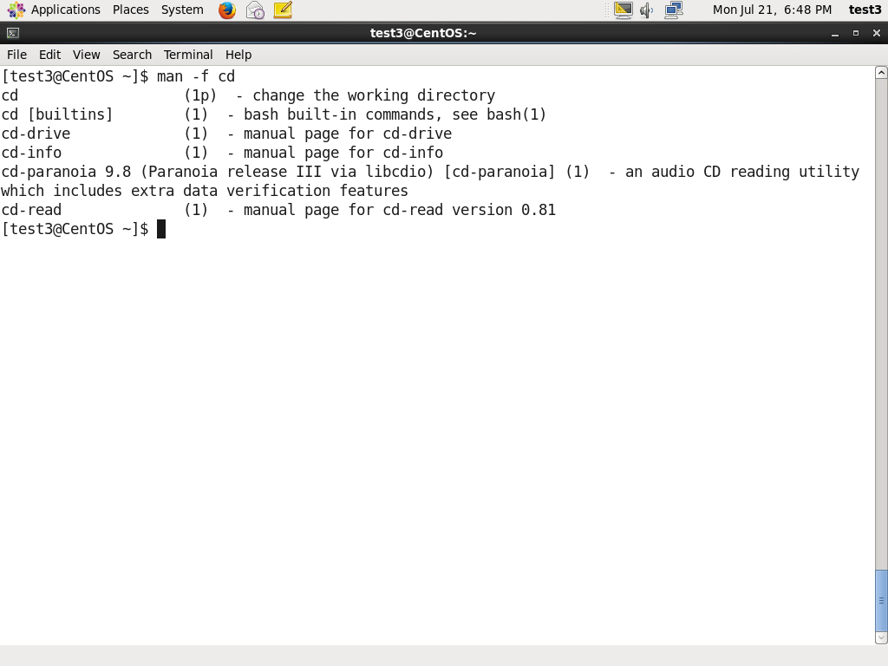
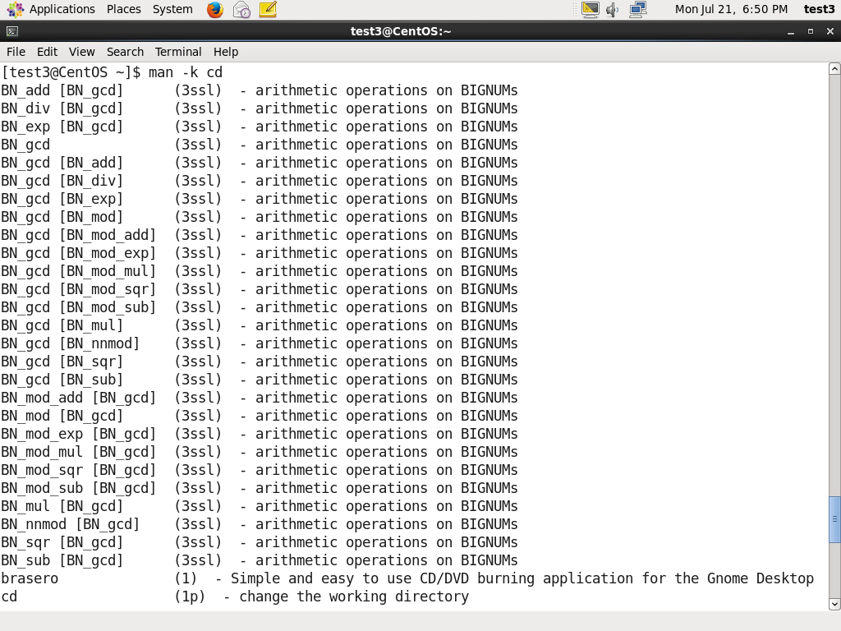
Manual Chapters
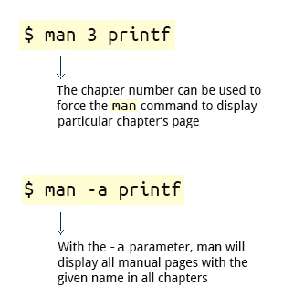
The man pages are divided into nine numbered chapters (1 through 9). Sometimes, a letter is appended to the chapter number to identify a specific topic. For example, many pages describing part of the X Window API are in chapter 3X.
The chapter number can be used to force man to display the page from a particular chapter; it is common to have multiple pages across multiple chapters with the same name, especially for names of library functions or system calls.
With the -a parameter, man will display all pages with the given name in all chapters, one after the other.
$ man 3 printf
$ man -a printf
GNU Info System

The next source of Linux documentation is the GNU Info System.
This is the GNU project's standard documentation format (info) which it prefers as an alternative to man. The info system is more free-form and supports linked sub-sections.
Functionally, the GNU Info System resembles man in many ways. However, topics are connected using links (even though its design predates the World Wide Web). Information can be viewed through either a command line interface, a graphical help utility, printed or viewed online.
Command Line Info Browser
Typing info with no arguments in a terminal window displays an index of available topics. You can browse through the topic list using the regular movement keys: arrows, Page Up, and Page Down.
You can view help for a particular topic by typing info <topic name>. The system then searches for the topic in all available info files.
Some useful keys are: q to quit, h for help, and Enter to select a menu item.
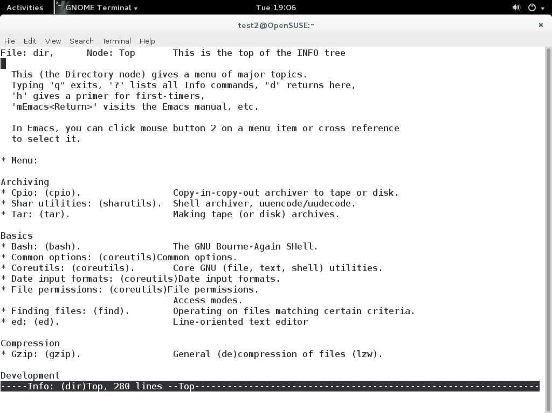
info Page Structure
The topic which you view in the info page is called a node.
Nodes are similar to sections and subsections in written documentation. You can move between nodes or view each node sequentially. Each node may contain menus and linked subtopics, or items.
Items can be compared to Internet hyperlinks. They are identified by an asterisk (*) at the beginning of the item name. Named items (outside a menu) are identified with double-colons (::) at the end of the item name. Items can refer to other nodes within the file or to other files. The table lists the basic keystrokes for moving between nodes.
Key Key Function n Go to the next node p Go to the previous node u Move one node up in the index | FunctionKey Function n Go to the next node p Go to the previous node u Move one node up in the index
Introduction to the help Option
The third source of Linux documentation is use of the help option.
Most commands have an available short description which can be viewed using the --help or the -h option along with the command or application. For example, to learn more about the man command, you can run the following command:
$ man --help
The --help option is useful as a quick reference and it displays information faster than the man or info pages.
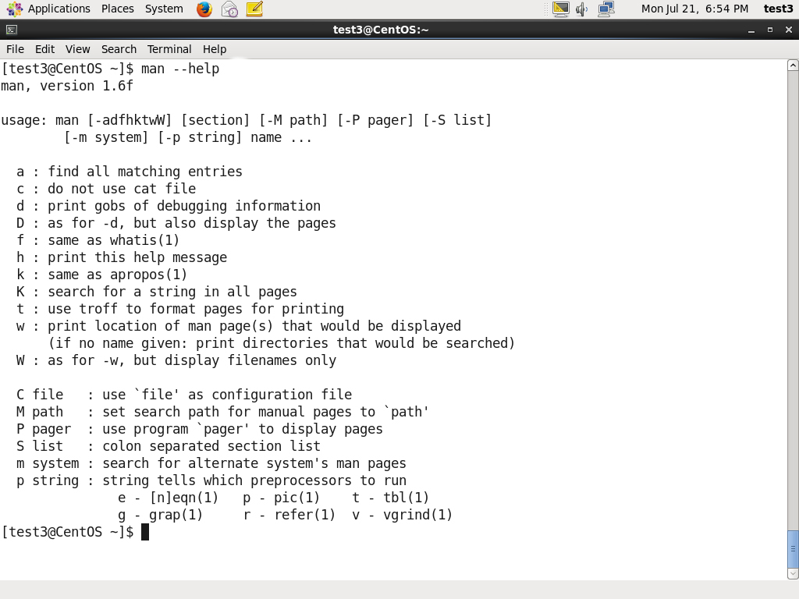
About the help Command

Some popular commands (such as echo) when run in a bash command shell silently run their own built-in versions of system programs or utilities, because it is more efficient to do so. (We will discuss command shells in great detail later.) To view a synopsis of these built-in commands, you can simply type help.
For these built-in commands, help performs the same basic function as the -h and --help arguments (which we will discuss shortly) perform for stand-alone programs.
The next screen covers a demonstration on how to use man, info and the help option.
To view a list of available manual pages for passwd:
- 1. On the command prompt, type the man dash -f passwd command.
- 2. Press Enter.
- To get the manual page for the passwd configuration file:
- 1. On the command prompt, type the man 5 passwd command.
- 2. Press Enter.
- 3. Hit SPACE to navigate to the next screen. You can also use specific keys to navigate between nodes.
- 4. Press Q to return to the command prompt
- To get the manual page for the passwd command:
- 1. On the command prompt, type the man 1 passwd command.
- 2. Press Enter.
- 3. Hit SPACE to navigate to the next screen. You can also use specific keys to navigate between nodes.
- 4. Press Q to return to the command prompt
- To get help with the passwd command using the info command:
- 5. On the command prompt, type the info passwd command.
- 6. Press Enter
- 7. Hit SPACE to navigate to the next screen. You can also use specific keys to navigate between nodes.
- 8. Press Q to return to the command prompt
- To get a quick list of available options with the cat command using the help option:
- 9. On the command prompt, type the cat --help command.
- 10. Press Enter.

