Ch14 – print
S1 – Configuration
1 - Introduction to Printing
To manage printers and print directly from a computer or across a networked environment, you need to know how to configure and install a printer. Printing itself requires software that converts information from the application you are using to a language your printer can understand. The Linux standard for printing software is the Common UNIX Printing System (CUPS).
2 - CUPS Overview

CUPS is the software that is used behind the scenes to print from applications like a web browser or LibreOffice. It converts page descriptions produced by your application (put a paragraph here, draw a line there, and so forth) and then sends the information to the printer. It acts as a print server for local as well as network printers.
Printers manufactured by different companies may use their own particular print languages and formats. CUPS uses a modular printing system which accommodates a wide variety of printers and also processes various data formats. This makes the printing process simpler; you can concentrate more on printing and less on how to print.
Generally, the only time you should need to configure your printer is when you use it for the first time. In fact, CUPS often figures things out on its own by detecting and configuring any printers it locates.
3 - How Does CUPS Work?
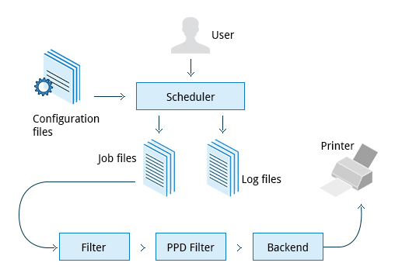

CUPS carries out the printing process with the help of its various components:
- Configuration Files
- Scheduler
- Job Files
- Log Files
- Filter
- Printer Drivers
- Backend
You will learn about each of these components in detail in the next few screens.

4 - Scheduler
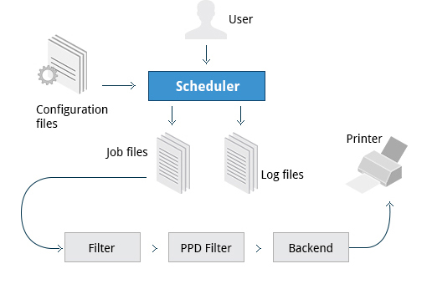

CUPS is designed around a print scheduler that manages print jobs, handles administrative commands, allows users to query the printer status, and manages the flow of data through all CUPS components.
As you'll see shortly, CUPS has a browser-based interface which allows you to view and manipulate the order and status of pending print jobs.
5 - Configuration Files
The print scheduler reads server settings from several configuration files, the two most important of which are cupsd.conf and printers.conf. These and all other CUPS related configuration files are stored under the /etc/cups/ directory.
cupsd.conf is where most system-wide settings are located; it does not contain any printer-specific details. Most of the settings available in this file relate to network security, i.e. which systems can access CUPS network capabilities, how printers are advertised on the local network, what management features are offered, and so on.
printers.conf is where you will find the printer-specific settings. For every printer connected to the system, a corresponding section describes the printer’s status and capabilities. This file is generated only after adding a printer to the system and should not be modified by hand.
You can view the full list of configuration files by typing: ls -l /etc/cups/
regis@regis-System-Product-Name:~$ ls -l /etc/cups/
total 60
-rw------- 1 root lp 108 avril 24 2014 classes.conf
-rw-r--r-- 1 root root 2812 avril 8 2014 cups-browsed.conf
-rw-r--r-- 1 root root 4500 avril 17 2014 cupsd.conf
-rw-r--r-- 1 root root 2970 avril 10 2014 cups-files.conf
drwxr-xr-x 2 root root 4096 avril 10 2014 interfaces
drwxr-xr-x 2 root lp 4096 avril 24 2014 ppd
-rw------- 1 root lp 541 sept. 24 10:43 printers.conf
-rw------- 1 root lp 541 juil. 10 17:42 printers.conf.O
-rw-r--r-- 1 root root 240 avril 17 2014 raw.convs
-rw-r--r-- 1 root root 211 avril 17 2014 raw.types
-rw-r--r-- 1 root root 160 avril 10 2014 snmp.conf
drwx------ 2 root lp 4096 avril 17 2014 ssl
-rw-r----- 1 root lp 91 août 16 09:11 subscriptions.conf
-rw-r----- 1 root lp 241 août 13 22:15 subscriptions.conf.O

6 - Job Files
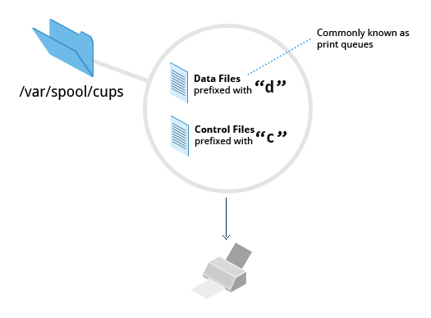
CUPS stores print requests as files under the /var/spool/cups directory (these can actually be accessed before a document is sent to a printer). Data files are prefixed with the letter d while control files are prefixed with the letter c. After a printer successfully handles a job, data files are automatically removed. These data files belong to what is commonly known as the print queue.
7 - Log Files
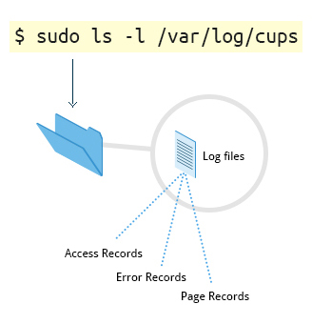

Log files are placed in /var/log/cups and are used by the scheduler to record activities that have taken place. These files include access, error, and page records.
To view what log files exist, type:
sudo ls -l /var/log/cups
(Note on some distributions permissions are set such that you don't need the sudo.) You can view the log files with the usual tools.

8 - Filters, Printer Drivers, and Backends
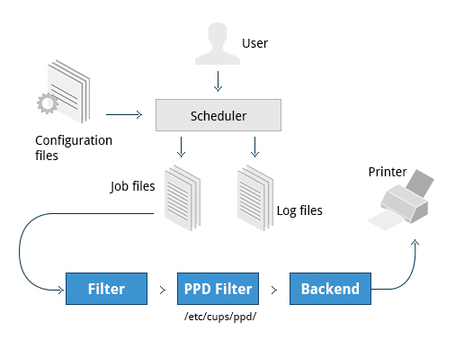
CUPS uses filters to convert job file formats to printable formats. Printer drivers contain descriptions for currently connected and configured printers, and are usually stored under /etc/cups/ppd/. The print data is then sent to the printer through a filter and via a backend that helps to locate devices connected to the system.
So In short, when you execute a print command, the scheduler validates the command and processes the print job creating job files according to the settings specified in configuration files. Simultaneously, the scheduler records activities in the log files. Job files are processed with the help of the filter, printer driver, and backend, and then sent to the printer.
9 - Installing CUPS
Due to printing being a relatively important and fundamental feature of any Linux distribution, most Linux systems come with CUPS preinstalled. In some cases, especially for Linux server setups, CUPS may have been left uninstalled. This may be fixed by installing the corresponding package manually. To install CUPS, please ensure that your system is connected to the Internet.
10 - Managing CUPS
After installing CUPS, you'll need to start and manage the CUPS daemon so that CUPS is ready for configuring a printer. Managing the CUPS daemon is simple; all management features are wrapped around the cups init script, which can be easily started, stopped, and restarted.
11 - Configuring a Printer from the GUI
Each Linux distribution has a GUI application that lets you add, remove, and configure local or remote printers. Using this application, you can easily set up the system to use both local and network printers. The following screens show how to find and use the appropriate application in each of the distribution families covered in this course.
When configuring a printer, make sure the device is currently turned on and connected to the system; if so it should show up in the printer selection menu. If the printer is not visible, you may want to troubleshoot using tools that will determine if the printer is connected. For common USB printers, for example, the lsusb utility will show a line for the printer. Some printer manufacturers also require some extra software to be installed in order to make the printer visible to CUPS, however, due to the standardization these days, this is rarely required.

12 - Adding Printers from the CUPS Web Interface
A fact that few people know is that CUPS also comes with its own web server, which makes a configuration interface available via a set of CGI scripts.
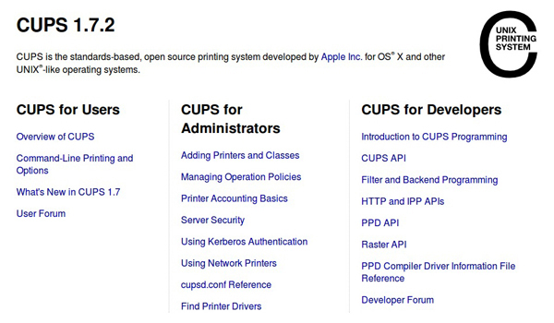

This web interface allows you to:
  - Add and remove local/remote printers
  - Configure printers:
– Local/remote printers
– Share a printer as a CUPS server
  - Control print jobs: – Monitor jobs
– Show completed or pending jobs
– Cancel or move jobs
The CUPS web interface is available on your browser at: http://localhost:631
Some pages require a username and password to perform certain actions, for example to add a printer. For most Linux distributions, you must use the root password to add, modify, or delete printers or classes.

