Ch15 – Bash shell scripting
S1 – Features and capabilities
1 - Introduction to Scripts
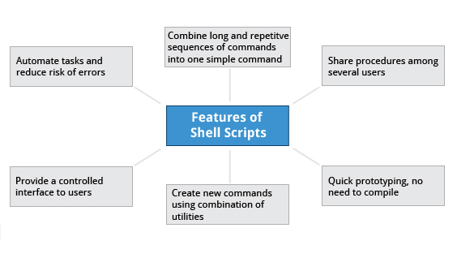

Suppose you want to look up a filename, check if the associated file exists, and then respond accordingly, displaying a message confirming or not confirming the file's existence. If you only need to do it once, you can just type a sequence of commands at a terminal. However, if you need to do this multiple times, automation is the way to go. In order to automate sets of commands you’ll need to learn how to write shell scripts, the most common of which are used with bash. The graphic illustrates several of the benefits of deploying scripts.
2 - Introduction to Shell Scripts
Remember from our earlier discussion, a shell is a command line interpreter which provides the user interface for terminal windows. It can also be used to run scripts, even in non-interactive sessions without a terminal window, as if the commands were being directly typed in. For example typing: find . -name "*.c" -ls at the command line accomplishes the same thing as executing a script file containing the lines:
#!/bin/bash
find . -name "*.c" -ls
The #!/bin/bash in the first line should be recognized by anyone who has developed any kind of script in UNIX environments. The first line of the script, that starts with #!, contains the full path of the command interpreter (in this case /bin/bash) that is to be used on the file. As we will see on the next screen, you have a few choices depending upon which scripting language you use.

3 - Command Shell Choices
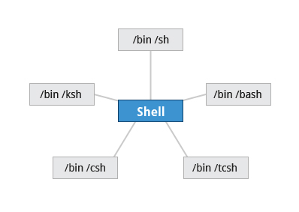

The command interpreter is tasked with executing statements that follow it in the script. Commonly used interpreters include: /usr/bin/perl, /bin/bash, /bin/csh, /usr/bin/python and /bin/sh.
Typing a long sequence of commands at a terminal window can be complicated, time consuming, and error prone. By deploying shell scripts, using the command-line becomes an efficient and quick way to launch complex sequences of steps. The fact that shell scripts are saved in a file also makes it easy to use them to create new script variations and share standard procedures with several users.
Linux provides a wide choice of shells; exactly what is available on the system is listed in /etc/shells. Typical choices are:
/bin/sh
/bin/bash
/bin/tcsh
/bin/csh
/bin/ksh
Most Linux users use the default bash shell, but those with long UNIX backgrounds with other shells may want to override the default.
Click the link to download UNIX Shell.pdf to read more about the UNIX Shell.
4 - bash Scripts
Let's write a simple bash script that displays a two-line message on the screen. Either type
$ cat > exscript.sh
#!/bin/bash
echo "HELLO"
echo "WORLD"
and press ENTER and CTRL-D to save the file, or just create exscript.sh in your favorite text editor. Then, type chmod +x exscript.sh to make the file executable. (The chmod +x command makes the file executable for all users.) You can then run it by simply typing ./exscript.sh or by doing:
$ bash exscript.sh
HELLO
WORLD
regis@regis-System-Product-Name:~$ cat > exscript.sh
#!/bin/bash
echo "HELLO"
echo "WORLD"
regis@regis-System-Product-Name:~$ chmod +x exscript.sh
regis@regis-System-Product-Name:~$ bash exscript.sh
HELLO
WORLD
Note if you use the second form, you don't have to make the file executable.
5 - Interactive Example Using bash Scripts
Now, let's see how to create a more interactive example using a bash script. The user will be prompted to enter a value, which is then displayed on the screen. The value is stored in a temporary variable, sname. We can reference the value of a shell variable by using a $ in front of the variable name, such as $sname. To create this script, you need to create a file named ioscript.sh in your favorite editor with the following content:
#!/bin/bash
# Interactive reading of variables
echo "ENTER YOUR NAME"
read sname
# Display of variable values
echo $sname
Once again, make it executable by doing chmod +x ioscript.sh.
In the above example, when the script ./ioscript.sh is executed, the user will receive a prompt ENTER YOUR NAME. The user then needs to enter a value and press the Enter key. The value will then be printed out.
regis@regis-System-Product-Name:~$ cat > ioscript.sh
#!/bin/bash
# Interactive reading of variables
echo "ENTER YOUR NAME"
read sname
# Display of variable values
echo $sname
regis@regis-System-Product-Name:~$ chmod +x ioscript.sh
regis@regis-System-Product-Name:~$ bash ioscript.sh
ENTER YOUR NAME
Régis LERUSTE
Régis LERUSTE
Additional note: The hash-tag/pound-sign/number-sign (#) is used to start comments in the script and can be placed anywhere in the line (the rest of the line is considered a comment).

6 - Return Values


All shell scripts generate a return value upon finishing execution; the value can be set with the exit statement. Return values permit a process to monitor the exit state of another process often in a parent-child relationship. This helps to determine how this process terminated and take any appropriate steps necessary, contingent on success or failure.
7 - Viewing Return Values
As a script executes, one can check for a specific value or condition and return success or failure as the result. By convention, success is returned as 0, and failure is returned as a non-zero value. An easy way to demonstrate success and failure completion is to execute ls on a file that exists and one that doesn't, as shown in the following example, where the return value is stored in the environment variable represented by $?:
$ ls /etc/passwd
/etc/ passwd
$ echo $?
0
In this example, the system is able to locate the file /etc/passwd and returns a value of 0 to indicate success; the return value is always stored in the $? environment variable. Applications often translate these return values into meaningful messages easily understood by the user.
S2 – Syntax
1 - Basic Syntax and Special Characters
Scripts require you to follow a standard language syntax. Rules delineate how to define variables and how to construct and format allowed statements, etc. The table lists some special character usages within bash scripts:
Character | Description
# | Used to add a comment, except when used as \#, or as #! when starting a script
\ | Used at the end of a line to indicate continuation on to the next line
; | Used to interpret what follows as a new command
$ | Indicates what follows is a variable
Note that when # is inserted at the beginning of a line of commentary, the whole line is ignored.
# This line will not get executed.

2 - Splitting Long Commands Over Multiple Lines
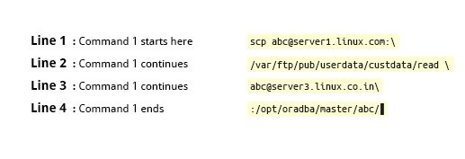

Users sometimes need to combine several commands and statements and even conditionally execute them based on the behaviour of operators used in between them. This method is called chaining of commands.
The concatenation operator (\) is used to concatenate large commands over several lines in the shell.
For example, you want to copy the file /var/ftp/pub/userdata/custdata/read from server1.linux.com to the /opt/oradba/master/abc directory on server3.linux.co.in. To perform this action, you can write the command using the \ operator as:
scp abc@server1.linux.com:\
/var/ftp/pub/userdata/custdata/read \
abc@server3.linux.co.in:\
/opt/oradba/master/abc/
The command is divided into multiple lines to make it look readable and easier to understand. The \ operator at the end of each line combines the commands from multiple lines and executes it as one single command.
3 - Putting Multiple Commands on a Single Line
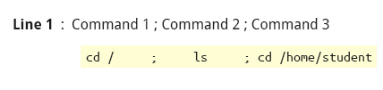

Sometimes you may want to group multiple commands on a single line. The ; (semicolon) character is used to separate these commands and execute them sequentially as if they had been typed on separate lines.
The three commands in the following example will all execute even if the ones preceding them fail:
$ make ; make install ; make clean
However, you may want to abort subsequent commands if one fails. You can do this using the && (and) operator as in:
$ make && make install && make clean
If the first command fails the second one will never be executed. A final refinement is to use the || (or) operator as in:
$ cat file1 || cat file2 || cat file3
In this case, you proceed until something succeeds and then you stop executing any further steps.
4 - Functions
A function is a code block that implements a set of operations. Functions are useful for executing procedures multiple times perhaps with varying input variables. Functions are also often called subroutines. Using functions in scripts requires two steps:
1. Declaring a function
2. Calling a function
The function declaration requires a name which is used to invoke it. The proper syntax is:
function_name () {
command...
}
For example, the following function is named display:
display () {
echo "This is a sample function"
}
The function can be as long as desired and have many statements. Once defined, the function can be called later as many times as necessary. In the full example shown in the figure, we are also showing an often-used refinement: how to pass an argument to the function. The first argument can be referred to as $1, the second as $2, etc.

5 - Built-in Shell Commands
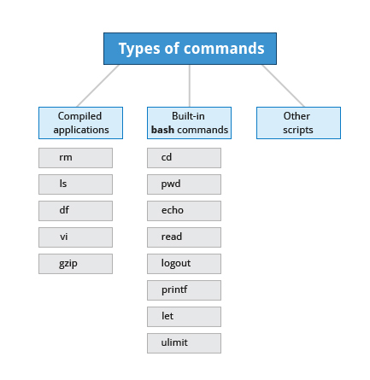

Shell scripts are used to execute sequences of commands and other types of statements. Commands can be divided into the following categories:
- Compiled applications
- Built-in bash commands
- Other scripts
Compiled applications are binary executable files that you can find on the filesystem. The shell script always has access to compiled applications such as rm, ls, df, vi, and gzip.
bash has many built-in commands which can only be used to display the output within a terminal shell or shell script. Sometimes these commands have the same name as executable programs on the system, such as echo which can lead to subtle problems. bash built-in commands include and cd, pwd, echo, read, logout, printf, let, and ulimit.
A complete list of bash built-in commands can be found in the bash man page, or by simply typing help.
6 - Command Substitution
At times, you may need to substitute the result of a command as a portion of another command. It can be done in two ways:
- By enclosing the inner command with backticks (`)
- By enclosing the inner command in $( )
No matter the method, the innermost command will be executed in a newly launched shell environment, and the standard output of the shell will be inserted where the command substitution was done.
Virtually any command can be executed this way. Both of these methods enable command substitution; however, the $( ) method allows command nesting. New scripts should always use this more modern method. For example:
$ cd /lib/modules/$(uname -r)/
In the above example,
the output of the command "uname –r" becomes the argument for the cd command.
Note: uname command prints system information with -r option we get the kernel release:
3.13.0-62-generic.

7 - Environment Variables
Almost all scripts use variables containing a value, which can be used anywhere in the script.
These variables can either be user or system defined. Many applications use such environment variables (covered in the "User Environment" chapter) for supplying inputs, validation, and controlling behaviour.
Some examples of standard environment variables are HOME, PATH, and HOST. When referenced, environment variables must be prefixed with the $ symbol as in $HOME. You can view and set the value of environment variables. For example, the following command displays the value stored in the PATH variable:
$ echo $PATH
However, no prefix is required when setting or modifying the variable value. For example, the following command sets the value of the MYCOLOR variable to blue:
$ MYCOLOR=blue
You can get a list of environment variables with the env, set, or printenv commands.
8 - Exporting Variables
By default, the variables created within a script are available only to the subsequent steps of that script. Any child processes (sub-shells) do not have automatic access to the values of these variables. To make them available to child processes, they must be promoted to environment variables using the export statement as in:
export VAR=value
or
VAR=value ; export VAR
While child processes are allowed to modify the value of exported variables, the parent will not see any changes; exported variables are not shared, but only copied.

9 - Script Parameters
Users often need to pass parameter values to a script, such as a filename, date, etc. Scripts will take different paths or arrive at different values according to the parameters (command arguments) that are passed to them. These values can be text or numbers as in:
$ ./script.sh /tmp
$ ./script.sh 100 200
Within a script, the parameter or an argument is represented with a $ and a number. The table lists some of these parameters.
Parameter | Meaning
$0 | Script name
$1 | First parameter
$2, $3, etc. | Second, third parameter, etc.
$* | All parameters
$# | Number of arguments

10 - Using Script Parameters
Using your favorite text editor, create a new script file named script3.sh with the following contents:
#!/bin/bash
echo "The name of this program is: $0"
echo "The first argument passed from the command line is: $1"
echo "The second argument passed from the command line is: $2"
echo "The third argument passed from the command line is: $3"
echo "All of the arguments passed from the command line are : $*"
echo
echo "All done with $0"
Make the script executable with chmod +x. Run the script giving it three arguments as in: script3.sh one two three, and the script is processed as follows:
$0 prints the script name: script3.sh
$1 prints the first parameter: one
$2 prints the second parameter: two
$3 prints the third parameter: three
$* prints all parameters: one two three
The final statement becomes: All done with script3.sh

11 - Output Redirection
Most operating systems accept input from the keyboard and display the output on the terminal. However, in shell scripting you can send the output to a file. The process of diverting the output to a file is called output redirection.
The > character is used to write output to a file. For example, the following command sends the output of free to the file /tmp/free.out:
$ free > /tmp/free.out
To check the contents of the /tmp/free.out file, at the command prompt type cat /tmp/free.out.
Two > characters (>>) will append output to a file if it exists, and act just like > if the file does not already exist.
12 - Input Redirection

Just as the output can be redirected to a file, the input of a command can be read from a file. The process of reading input from a file is called input redirection and uses the < character. If you create a file called script8.sh with the following contents:
#!/bin/bash
echo “Line count”
wc -l < /temp/free.out
and then execute it with chmod +x script8.sh ; ./script8.sh, it will count the number of lines from the /temp/free.out file and display the results.
S3 – Constructs
1 - The if Statement
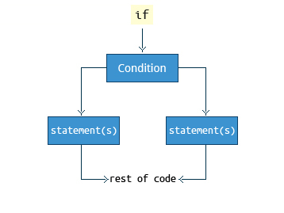

Conditional decision making using an if statement, is a basic construct that any useful programming or scripting language must have.
When an if statement is used, the ensuing actions depend on the evaluation of specified conditions such as:
- Numerical or string comparisons
- Return value of a command (0 for success)
- File existence or permissions
In compact form, the syntax of an if statement is:
if TEST-COMMANDS; then CONSEQUENT-COMMANDS; fi
A more general definition is:
if condition
then
statements
else
statements
fi
2 – if statements
Objective of the script: To accept a file name from command prompt and display its existence
Steps:
- Accept the command line argument and store in 'file1'
- Check for its existence and found true
Display the “File exist”
- Else
Display the “File doesn't exist”
Le script is as follow:

#!/bin/bash
file=$1 #La commande file (determine file type) est affectée par le nom du fichier (1er argument $1)
if [ -f $file ] #[-f namefile] l'option -f associée au nom du fichier permet de rechercher si le fichier existe ou pas
then
echo -e “The $file exist” #-e enable interpretation of backslash escapes
else
echo -e “The $file does not exist”
fi

Pour rendre le fichier exécutable :

chmod +x if-demo.sh

Pour exécuter le script :

bash if-demo.sh test1
The file test1 exist

bash if-demo.sh test10
The file test10 does not exist

3 – Nested if statement in bash shell sript
Script file name: vsc1.sh
Objective of the script: To accept 2 numbers, 1 operator (+, -, x) and display the calculated based operator.

Steps:
- Display a message to enter first number
- Read the firt number
- Display a message to enter second number
- Read the second number
- Display a message to enter the option for the operation
- Read the option number-sign
- if operator is 1
Display the sum of the 2 numbers
- else if operator is 2
Display the difference of the 2 numbers
- else if operator is 3
Display the product of the 2 numbers
- else
Display invalid input

Les variables :
- inp1 first number
- inp2 second number
- Operator: 1 +, 2 -, 3 x → -n → $oper

Le script :

#! /bin/bash
echo "Enter firt number"
read inp1
echo "Enter second number"
read inp2
echo "Enter the option for the operation"
echo "1 for addition"
echo "2 for difference"
echo "3 for product"
echo -n "Choose one of them : "
read oper
if [ $oper -eq 1 ]
then
echo "Addition result " $(($inp1 + $inp2))
else
if [ $oper -eq 2 ]
then
echo "Subtraction result " $(($inp1 - $inp2))
else
if [ $oper -eq 3 ]
then
echo "Multiplication result " $(($inp1 * $inp2))
else
echo "Invalid input"
fi
fi
fi

Essai du script :

regis@regis-System-Product-Name:/media/regis/Données/SCAO/LINUX$ bash vsc1.sh
Enter firt number
12
Enter second number
12
Enter the option for the operation
1 for addition
2 for difference
3 for product
Choose one of them : 3
Multiplication result 144

4 - Using the if Statement
The following if statement checks for the /etc/passwd file, and if the file is found it displays the message
/etc/passwd exists.:
if [ -f /etc/passwd ]
then
echo "/etc/passwd exists."
fi
Notice the use of the square brackets ([]) to delineate the test condition. There are many other kinds of tests you can perform, such as checking whether two numbers are equal to, greater than, or less than each other and make a decision accordingly; we will discuss these other tests.
In modern scripts you may see doubled brackets as in[[ -f /etc/passwd ]]. This is not an error. It is never wrong to do so and it avoids some subtle problems such as referring to an empty environment variable without surrounding it in double quotes; we won't talk about this here.
5 - Testing for Files
You can use the if statement to test for file attributes such as:
- File or directory existence
- Read or write permission
- Executable permission
For example, in the following example:
if [ -f /etc/passwd ] ; then
ACTION
fi
the if statement checks if the file /etc/passwd is a regular file.
Note the very common practice of putting “; then” on the same line as the if statement.
bash provides a set of file conditionals, that can used with the if statement, including:

Condition | Meaning
-e file | Check if the file exists.
-d file | Check if the file is a directory.
-f file | Check if the file is a regular file (i.e., not a symbolic link, device node, directory, etc.)
-s file | Check if the file is of non-zero size.
-g file | Check if the file has sgid set.
-u file | Check if the file has suid set.
-r file | Check if the file is readable.
-w file | Check if the file is writable.
-x file | Check if the file is executable.
You can view the full list of file conditions using the command man 1 test.
6 - Example of Testing of Strings
You can use the if statement to compare strings using the operator == (two equal signs). The syntax is as follows:
if [ string1 == string2 ] ; then
ACTION
fi
Let’s now consider an example of testing strings.
In the example illustrated here, the if statement is used to compare the input provided by the user and accordingly display the result.

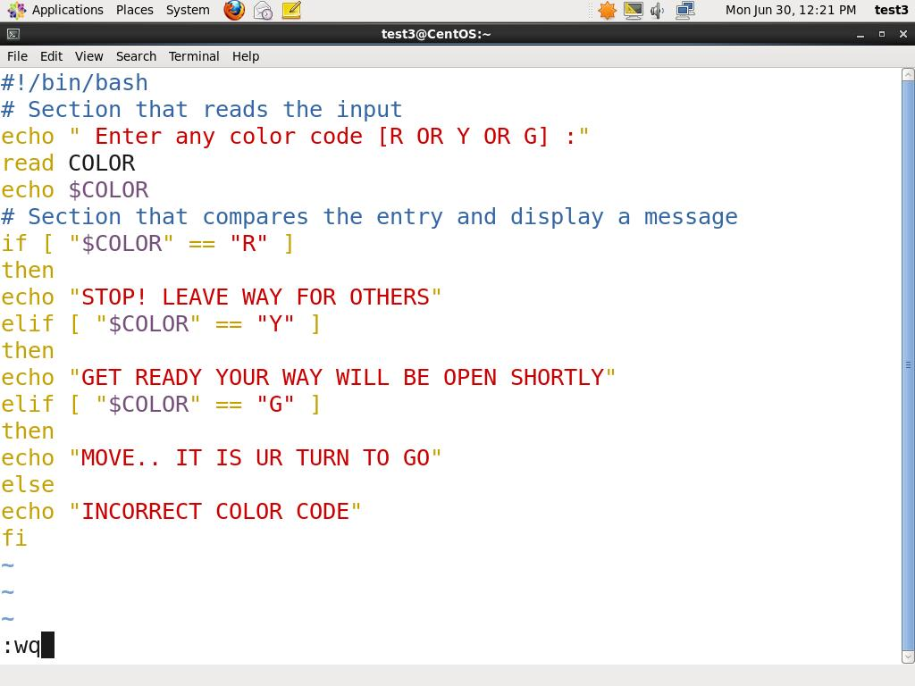
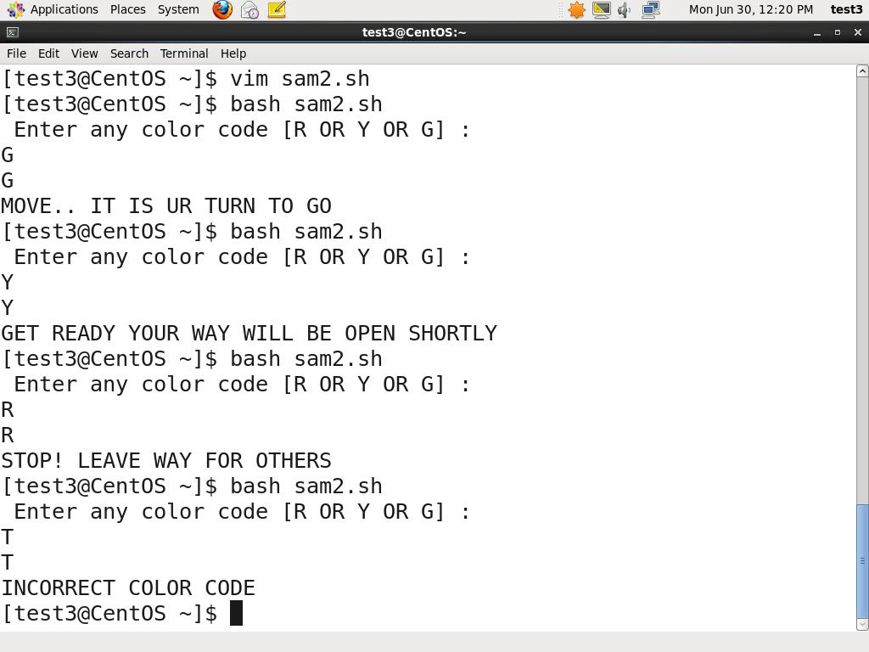
7 - Numerical Tests
You can use specially defined operators with the if statement to compare numbers. The various operators that are available are listed in the table.
Operator | Meaning
-eq | Equal to
-ne | Not equal to
-gt | Greater than
-lt | Less than
-ge | Greater than or equal to
-le | Less than or equal to
The syntax for comparing numbers is as follows:
exp1 -op exp2
8 - Example of Testing for Numbers
Let us now consider an example of comparing numbers using the various operators:
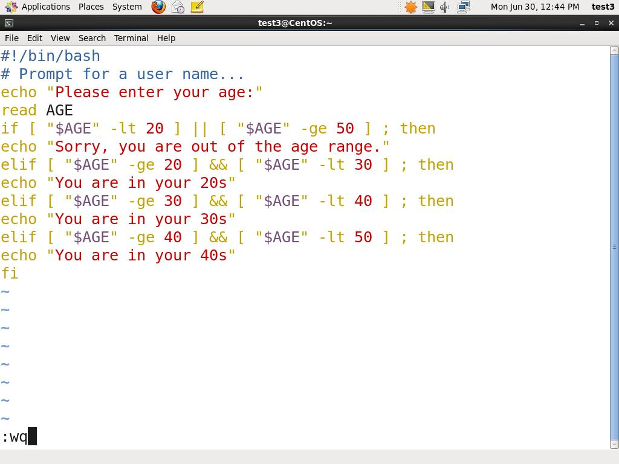
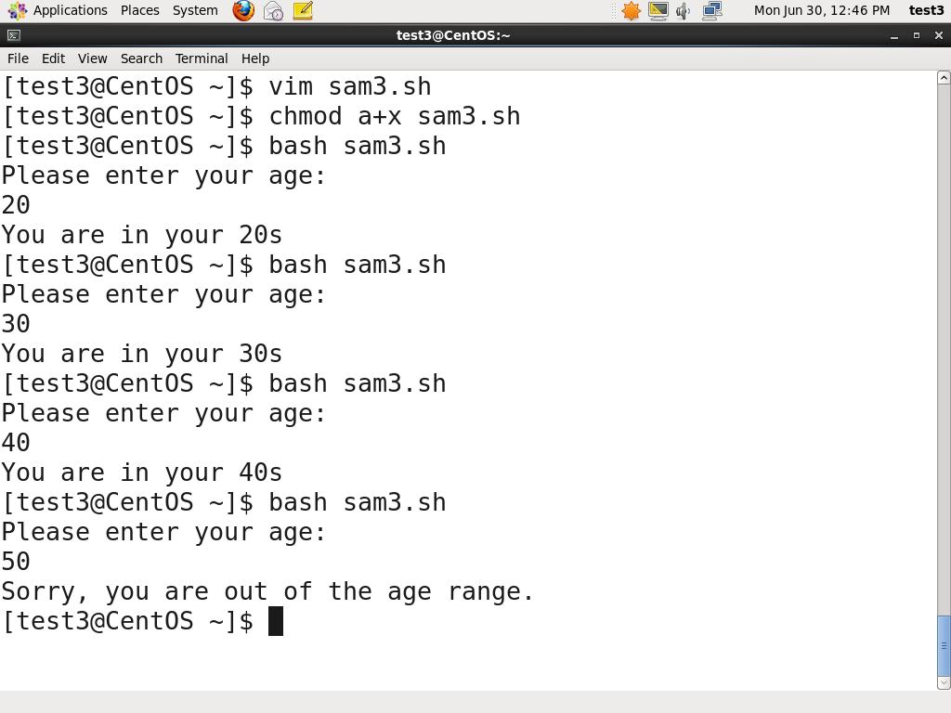
8 - Arithmetic Expressions

Arithmetic expressions can be evaluated in the following three ways (spaces are important!):
- Using the expr utility: expr is a standard but somewhat deprecated program. The syntax is as follows:
expr 8 + 8
echo $(expr 8 + 8)
- Using the $((...)) syntax: This is the built-in shell format. The syntax is as follows:
echo $((x+1))
- Using the built-in shell command let. The syntax is as follows:
let x=( 1 + 2 ); echo $x
In modern shell scripts the use of expr is better replaced with var=$((...))
