Introduction

Suppose you have been assigned to a project building a product for a Linux platform. Project requirements include making sure the project works properly on the most widely used Linux distributions. To accomplish this you need to learn about the different components, services and configurations associated with each distribution. We're about to look at how you'd go about doing exactly that.
Linux Distributions
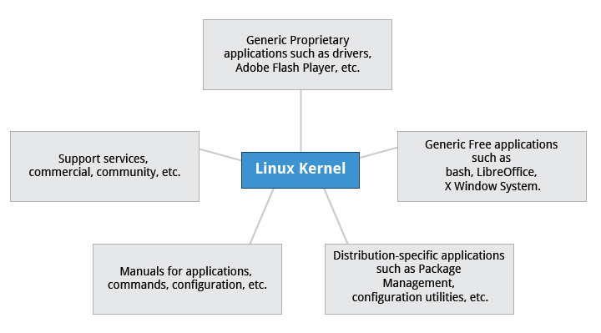
So, what is a Linux distribution and how does it relate to the Linux kernel?
As illustrated above, the Linux kernel is the core of a computer operating system. A full Linux distribution consists of the kernel plus a number of other software tools for file-related operations, user management, and software package management. Each of these tools provides a small part of the complete system. Each tool is often its own separate project, with its own developers working to perfect that piece of the system.

More about Linux Distributions
As mentioned earlier, the current Linux kernel, along with past Linux kernels (as well as earlier release versions) can be found at the www.kernel.org web site. The various Linux distributions may be based on different kernel versions. For example, the very popular RHEL 6 distribution is based on the 2.6.32 version of the Linux kernel, which is rather old but extremely stable. Other distributions may move more quickly in adopting the latest kernel releases. It is important to note that the kernel is not an all or nothing proposition, for example, RHEL 6 has incorporated many of the more recent kernel improvements into their version of 2.6.32.

Services Associated with Distributions
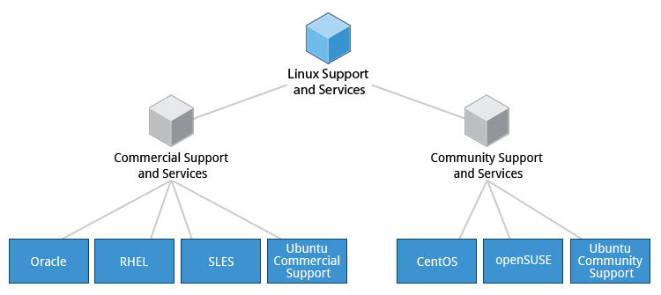
A vast variety of Linux distributions cater to different audiences and organizations depending on their specific needs. Large commercial organizations tend to favor the commercially supported distributions from Red Hat, SUSE and Canonical (Ubuntu).
CentOS is a popular free alternative to Red Hat Enterprise Linux (RHEL). Ubuntu and Fedora are popular in the educational realm. Scientific Linux is favored by the scientific research community for its compatibility with scientific and mathematical software packages. Both CentOS and Scientific Linux are binary-compatible with RHEL; i.e., binary software packages in most cases will install properly across the distributions.
Many commercial distributors, including Red Hat, Ubuntu, SUSE, and Oracle, provide long term

Summary (1 of 2)

You have completed this chapter. Let’s summarize the key concepts covered.
  - Linux borrows heavily from the UNIX operating system, with which its creators were well versed.
  - Linux accesses many features and services through files and file-like objects.
  - Linux is a fully multitasking, multiuser operating system, with built-in networking and service processes known as daemons.
- Linux is developed by a loose confederation of developers from all over the world, collaborating over the Internet, with Linus Torvalds at the head. Technical skill and a desire to contribute are the only qualifications for participating.
Summary (2 of 2)
- The Linux community is a far reaching ecosystem of developers, vendors, and users that supports and advances the Linux operating system.
- Some of the common terms used in Linux are: Kernel, Distribution, Boot loader, Service, Filesystem, X Window system, desktop environment, and command line.
- A full Linux distribution consists of the kernel plus a number of other software tools for file-related operations, user management, and software package management.

