Chapter 4 - Graphical Interface

Introduction – Learning objectives
For new users in any operating system, the place to start is the graphical user interface.
- And, in this session, we will talk about the basics from log in to log out and shut down.
- Before we go to the many settings you have to customize the look and feel, to your needs.
- Let’s go!
Learning Objectives
By the end of this chapter, you should be able to:
- Manage graphical interface sessions.
- Perform basic operations using the graphical interface.
- Change the graphical desktop to suit your needs.
Section 1 – Session management
- Introduction
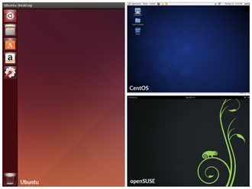
You can use either a Command Line Interface (CLI) or a Graphical User Interface (GUI) when using Linux. To work at the CLI, you have to remember which programs and commands are used to perform tasks, and how to quickly and accurately obtain more information about their use and options. On the other hand, using the GUI is often quick and easy. It allows you to interact with your system through graphical icons and screens. For repetitive tasks the CLI is often more efficient, while the GUI is easier to navigate if you don't remember all the details or do something only rarely.
In this section you will learn how to manage sessions using the GUI for the three Linux distribution families that we explicitly cover in this course: CentOS (Fedora family), openSUSE (SUSE family) and Ubuntu (Debian family). As you'll see shortly, openSUSE uses KDE instead of GNOME as the default desktop manager. However, since in many cases we use just a single distro for illustration, we've used GNOME for the openSUSE visuals throughout this course. If you are using KDE your experience will vary somewhat from what is shown.

GNOME Desktop Environment



GNOME is a popular desktop environment with an easy to use graphical user interface. It is bundled (empaqueter) as the default desktop environment for many distributions including Red Hat Enterprise Linux, Fedora, CentOS, SUSE Linux Enterprise, and Debian. GNOME has menu-based navigation and is sometimes an easy transition for at least some Windows users. However, as you'll see, the look and feel can be quite different across distributions, even if they are all using GNOME.
Another common desktop environment very important in the history of Linux and also widely used is KDE, which is used by default in openSUSE.
Other alternatives for a desktop environment include Unity (from Ubuntu, based on GNOME), Xfce, and LXDE. Most desktop environments follow a similar structure to GNOME.
GUI Startup
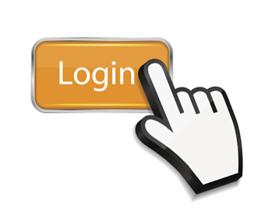
When you install a desktop environment, the X display manager starts at the end of the boot process. This X display manager is responsible for starting the graphics system, logging in the user, and starting the user’s desktop environment. You can often select from a choice of desktop environments when logging in to the system.
The default display manager for GNOME is called gdm. Other popular display managers include lightdm (used on Ubuntu) and kdm (associated with KDE).
Logging In and Out
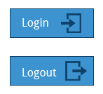
The next few screens cover the demonstrations and Try-It-Yourself activities of a member of each of the three Linux distribution families we cover in this course. You can view a demonstration for the distribution type of your choice and practice the procedure through the relevant Try-It-Yourself activity.
To log on to the system, perform the following steps:
- 1. Click the desired user. In this case it is test1.
- 2. Enter the password for user test1 and press Enter.
- The Ubuntu desktop is displayed.
- Note that the session will load the default or the previous session’s choice of desktop environment.
- To log off of the system, perform the following steps:
- 1. On the Ubuntu desktop screen, click the power icon in the top-right corner.
- 2. Click Log Out.
- 3. Click Log Out in the confirmation box.

Shutting Down and Restarting

Besides normal daily starting and stopping of the computer, a system restart may be required as part of certain major system updates, generally only those involving installing a new Linux kernel.
The init process is responsible for implementing both restarts and shut downs. On systems using System V init, run level 0 is usually used for shutting down, and run level 6 is used to reboot the system. (We will discuss system run levels later.)
Next we will discuss how to shut down and restart the system in the three different reference distributions.
Shutting Down and Restarting in Ubuntu
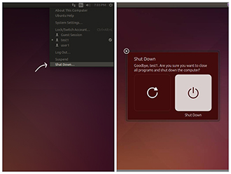
To shut down the computer in Ubuntu, perform the following steps:
- On the Ubuntu desktop screen, click the power icon on the upper-right corner of the screen.
- Click Shut Down...
The Restart and Shutdown icons are displayed.
- Click the shut down icon on the right to shutdown the system and click the restart icon on the left to restart the system.
Note: Generally the shut down option is in an obvious location on the desktop. On many laptops and desktops, you can press the on/off button on the computer to display the shut down box.
Suspending
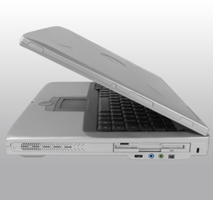
Most modern computers support suspend mode or sleep mode when you stop using your computer for a short while. Suspend mode saves the current system state and allows you to resume your session more quickly while remaining on but using very little power. It works by keeping your system’s applications, desktop, and so on in system RAM, but turning off all of the other hardware. The suspend mode bypasses the time for a full system start-up and continues to use minimal power.
Default Directories
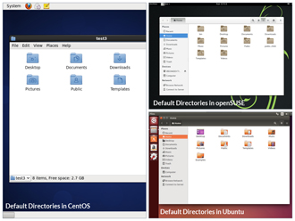
Every user with an account on the system will have a home directory, usually created under /home and named the same as the username (such as /home/student). By default, files the user saves will be placed in a directory tree starting there. Account creation, whether during system installation or at a later time when a new user is added, also induces default directories to be created under the user's home directory, such as Documents, Desktop, and Downloads.
On the next few screens, you will learn more about the default directories in CentOS, openSUSE, and Ubuntu.
Section 2 – Basic Operations
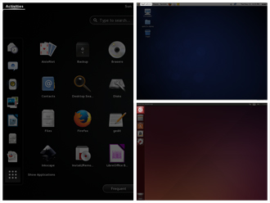
Even experienced users can forget the precise command that launches an application, or exactly what options and arguments it requires. Fortunately, Linux allows you to quickly open applications using the graphical interface.
Applications are found at different places in Linux (and within GNOME):
- In CentOS, applications can be opened from the Applications menu in the upper-left corner of the screen.
- In openSUSE, applications can be opened from the Activities menu in the upper-left corner of the screen.
- In Ubuntu, applications can be opened from the Dash button in the upper-left corner of the screen.
- For KDE, and other environments, applications can be opened from the button in the lower-left corner.

Submenus
Submenus for different types of applications include:
- Accessories
- Games
- Graphics
- Internet
- Office
- Sound and Video
- System Tools
On the following screens you will learn how to perform basic operations in Linux using the Graphical Interface.
Locating Applications
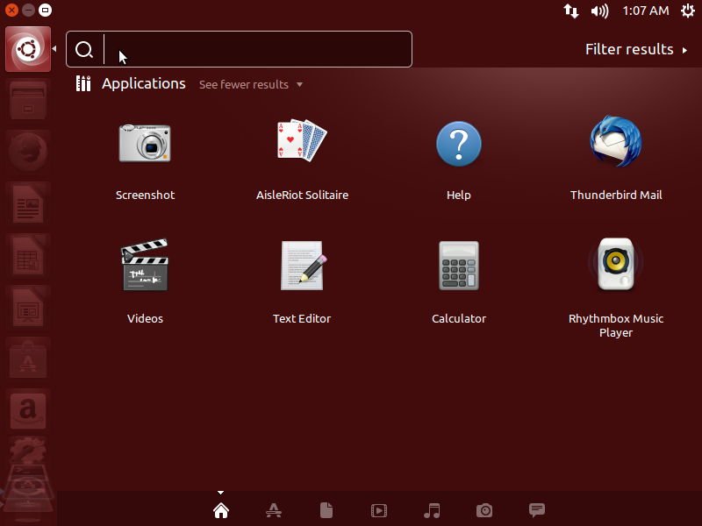
Unlike other operating systems, the initial install of Linux usually comes with a wide range of applications and software archives that contain thousands of programs that enable you to accomplish a wide variety of tasks with your computer. For most key tasks a default application is usually already installed. However, you can always install more applications and try different options.
For example, Firefox is popular as the default browser in many Linux distributions, while Epiphany, Konqueror, and Chromium (the open-source base for Google Chrome) are usually available for install from software repositories. Proprietary web browsers, such as Opera and Chrome are also available.
Locating applications from the GNOME and KDE menus is easy as they are neatly organized in functional submenus.
Default Applications
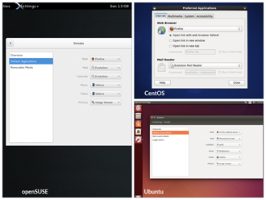
Multiple applications are available to accomplish various tasks and to open a file of a given type. For example, you can click on a web address while reading an email and launch a browser such as Firefox or Chrome.
The file managing program can be used to set the default application to be used for any particular file type.
Default Directories
Every user with an account on the system will have a home directory, usually created under /home and named the same as the username (such as /home/student). By default, files the user saves will be placed in a directory tree starting there. Account creation, whether during system installation or at a later time when a new user is added, also induces default directories to be created under the user's home directory, such as Documents, Desktop, and Downloads.
On the next few screens, you will learn more about the default directories in CentOS, openSUSE, and Ubuntu.
Default Directories in Ubuntu
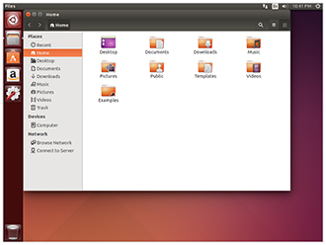
To access your home directory from the graphical user interface in GNOME on Ubuntu, click the File Cabinet icon on the left of the screen.
The File Manager (Files in the case of Ubuntu) will open a window with your Home directory displayed. The left panel of the File Manager window holds a list of commonly used directories, such as Computer, Home, Desktop, Documents, Downloads, and Trash.
You can also click the magnifying glass icon on the top-right of the File Manager window to search for files or directories that exist inside your home directory.
Viewing Files
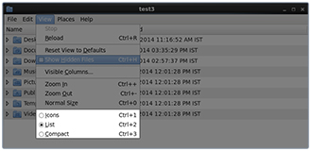
Nautilus (the name of the File Manager or file browser) allows you to view files and directories in several different formats.
To view files in the Icons, List, or Compact formats, click the View drop-down and select your view, or press CTRL-1 , CTRL-2 and CTRL-3 respectively.
In addition you can also arrange the files and directories by Name, Size, Type, or Modification Date for further sorting. To do so, click View and select Arrange Items.
More About Viewing Files
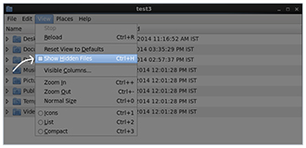
Another useful option is to show hidden files (sometimes imprecisely called system files), which are usually configuration files that are hidden by default and whose name starts with a dot. To show hidden files, click View and select Show Hidden Files or press CTRL- H.
The file browser provides multiple ways to customize your window view to facilitate easy drag and drop file operations. You can also alter the size of the icons by selecting Zoom In and Zoom Out under the View menu.
Searching for Files

Nautilus includes a great search tool inside the file browser window.
- Click Search in the toolbar (to bring up a text box).
- Enter the keyword in the text box.
Nautilus will perform a recursive search from the current directory for any file or directory which contains a part of this keyword.
- To open Nautilus from the command line, simply type nautilus
- To open Nautilus in graphical mode, Press ALT-F2 and search for Nautilus. Click the icon that appears.
Note: Both the above methods, will open the graphical interface for the program.
The shortcut key to get to the search text box is CTRL-F. You can exit the search text box view by clicking the Search button again.
Another quick way to access a specific directory is to press CTRL-L, which will give you a Location text box to type in a path to a directory.
More About Searching for Files
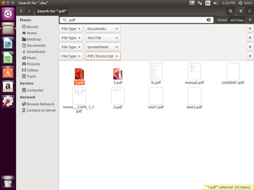
Nautilus allows you to refine your search beyond the initial keyword by providing drop-down menus to further filter the search.
- Based on Location or File Type, select additional criteria from the drop-down.
- To regenerate the search, click the Reload button.
- To add multiple search criteria, click the + button and select additional search criteria.
For example, if you want to find a PDF file containing the word Linux in your home directory, navigate to your home directory and search for the word “Linux” . You should see that the default search criterion limits the search to your home directory already. To finish the job, click the + button to add another search criterion, select File Type for the type of criterion, and select PDF under the File Type drop-down.
Editing a File
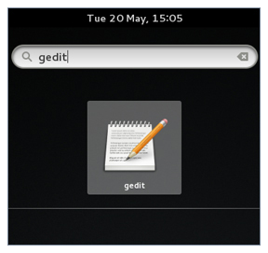
Editing any text file through the graphical interface is easy in the GNOME desktop environment. Simply double-click the file on the desktop or in the Nautilus file browser window to open the file with the default text editor.
The default text editor in GNOME is gedit. It is simple yet powerful, ideal for editing documents, making quick notes, and programming. Although gedit is designed as a general purpose text editor, it offers additional features for spell checking, highlighting, file listings, and statistics.
You'll learn much more about using text editors in a later chapter.
Removing a File

Deleting a file in Nautilus will automatically move the deleted files to the .local/share/Trash/files/ directory (a trash can of sorts) under the user's HOME directory. There are several ways to delete files and directories using Nautilus.
- Select all the files and directories that you want to delete.
- Press Delete (in Unity/KDE) or CTRL-Delete (in GNOME) on your keyboard. Or, Right-click the file.
- Select Move to Trash. Or, Highlight the file.
- Click Edit and Move to Trash through the graphical interface.
More About Removing a File
To permanently delete a file:
- On the left panel inside a Nautilus file browser window, right-click on the Trash directory.
- Select Empty Trash.
Alternatively, select the file or directory you want to permanently delete and press Shift-Delete.
As a precaution, you should never delete your home directory as doing so will most likely erase all your GNOME configuration files and possibly prevent you from logging in. Many personal system and program configurations are stored under your home directory.
Note: The next few screens cover the demonstrations and Try-It-Yourself activities of a member of each of the three Linux distribution families we cover in this course. You can view a demonstration for the distribution type of your choice and practice the procedure through the relevant Try-It-Yourself activity.
Locating and Setting Default Applications, and Exploring Filesystems in Ubuntu
Click below to view demonstrations of Locating and Setting Default Applications, and Exploring Filesystems in Ubuntu.
To view the video in High Definition mode, click HD in the video panel.

Let's see how to locate the Firefox application in Ubuntu.
- 1. In the upper-left panel, click the Ubuntu icon.
- 2. Click the Firefox Web Browser icon from Applications.
- If you have many applications, type Firefox in the Search box to get the Firefox icon.
- 3. Close Firefox by clicking Close in the upper-left corner of the Firefox window.
- Let’s now see how to set Firefox as a default web browser in Ubuntu.
- 1. In the left panel, click the System Settings icon.
- 2. In the System Settings window, select Details.
- 3. In the Details window, click Default Applications.
- 4. In the Web Drop-Down, select the Firefox Web Browser.
- Next, let's explore the home directory using File Manager. We will view files in list mode, create a new empty document, save it, and remove it.
- 1. In the left panel, click the File Manager icon.
- This will, by default, open your Home directory.
- 2. In the File Manager window, click the List icon.
- 3. Double-click the Documents directory to open it.
- 4. To view the menu, right-click anywhere on the white space in the Documents window.
- 5. In the New Document submenu, select Empty Document to create a blank document.
- 7. Rename that document from Untitled Document to Test.
- 8. Double-click the Test file to open it in gedit.
- 9. Type your name in it. Click the Save button from the toolbar.
- 10. To close the file, click the Close button in the upper-left corner of the gedit application window.
- 11. Right-click the Test document.
- 12. Click Move to Trash to remove the file.
Section 3 - Graphical Desktop
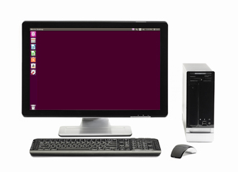
Each Linux distribution comes with its own set of desktop backgrounds. You can change the default by choosing a new wallpaper or selecting a custom picture to be set as the desktop background. If you do not want to use an image as the background, you can select a color to be displayed on the desktop instead.
In addition, you can also change the desktop theme, which changes the look and feel of the Linux system. The theme also defines the appearance of application windows.
In this section, you will learn how to change the desktop background and theme.
Desktop Background
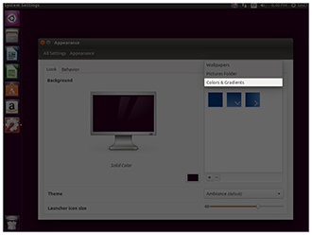
If you do not like any of the installed wallpapers, you can use different shades of color as the background using the Colors and Gradients drop-down in the Appearance window.
There are three types of color: solid, horizontal gradient, and vertical gradient. Click the box at the bottom and pick the effect between solid and the two gradients. In addition, you can also install packages that contain wallpapers by searching for packages using “wallpaper” as a keyword.
Note: The next few screens cover the demonstrations and Try-It-Yourself activities of a member of each of the three Linux distribution families we cover in this course. You can view a demonstration for the distribution type of your choice and practice the procedure through the relevant Try-It-Yourself activity.
Changing the Desktop Background in Ubuntu
Click below to view a demonstration on how to change the desktop background in Ubuntu.
To view the video in High Definition mode, click HD in the video panel.
1. Right-click anywhere on the Ubuntu desktop.
- 2. Click Change Desktop Background.
- The Appearance window is displayed.
- 3. Select any picture from the Wallpapers panel inside the Appearance window.
- Note that if you want your picture as the wallpaper, click the + sign below the wallpapers. You can use the picture from the default wallpapers available. After you select picture preview, the wallpaper is changed automatically.
- Note that in the same window you can also change the current Theme.
Changing the Theme
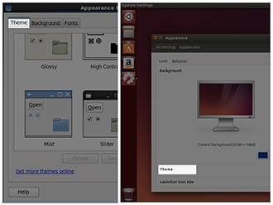
The visual appearances of applications (the buttons, scroll bars, widgets, and other graphical components) are controlled by a theme. GNOME comes with a set of different themes which can change the way your applications look.
The exact method for changing your theme will depend on your distribution. For example, for Ubuntu you can right-click anywhere on the desktop and select a different theme from the Theme drop-down. For CentOS you have to click on System → Preferences → Appearance.
More About Changing the Theme
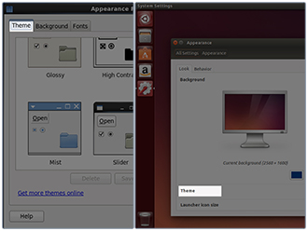
There are other options to get additional themes beyond the default selection. You can download and install themes from http://art.gnome.org/themes/
In CentOS, you can change themes from System → Preferences → Appearance
In Ubuntu, you can change themes from System Settings → Appearance
In openSUSE to change themes you will need to install the gnome-tweak-tool program.
Summary (1 of 3)
You have completed this chapter. Let's summarize the key concepts covered:
- GNOME is a popular desktop environment and graphical user interface that runs on top of the Linux operating system.
- The default display manager for GNOME is called gdm.
- The gdm display manager presents the user with the login screen which prompts for the login username and password.
- Logging out through the desktop environment kills all processes in your current X session and returns to the display manager login screen.
Summary (2 of 3)
  - Linux enables users to switch between logged in sessions.
  - Suspending puts the computer into sleep mode.
  - For each key task, there is generally a default application installed.
  - Every user created in the system will have a home directory.
  - The Places menu contains entries that allow you to access different parts of the computer and the network.
Summary (3 of 3)
- Nautilus gives three formats to view files.
- Most text editors are located in the Accessories submenu.
- Each Linux distribution comes with its own set of desktop backgrounds.
- GNOME comes with a set of different themes which can change the way your applications look.

