Chapter 5 – System configuration from the graphical interface
Learning Objectives
By the end of this chapter, you should be able to:
- Apply system, display, and date and time settings using the System Settings panel.
- Track the network settings and manage connections using Network Manager in Linux.
- Install and update software in Linux from a graphical interface.
Note that we will revisit all these tasks later when we discuss how to accomplish them from the command line interface.
Section 1 – System Display Date and Time settings
System Settings
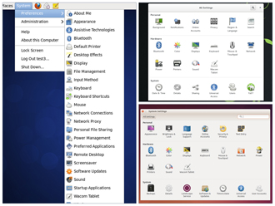
The System Settings panel allows you to control most of the basic configuration options and desktop settings such as specifying the screen resolution, managing network connections, or changing the date and time of the system.
As we mentioned in Chapter 4, we use the GNOME Desktop Manager for the visuals in this course as it is the default for CentOS and Ubuntu and readily available on openSUSE (for which the default is the KDE Desktop Manager).
The procedure to access System Settings varies according to distribution:
- CentOS: click System → Preferences.
- openSUSE: click Activities, type Settings in the Search box.
- Ubuntu: they are located in the panel on the left of the screen.
Display Settings
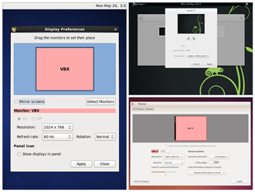
The Displays panel under System Settings (or Display and Monitor panel under Configure Desktop) contains the most common settings for changing the desktop appearance. These settings function independently of the specific display drivers you are running.
If your system uses a proprietary driver such as those from nVidia or AMD, you will probably have a configuration program for that driver that is not included in System Settings. This program may give more configuration options, but may also be more complicated, and might require sysadmin (root) access. If possible, you should configure the settings in the Displays panel rather than the proprietary configuration program.
The X server, which actually provides the GUI, uses the /etc/X11/xorg.conf file as its configuration file if it exists. In modern Linux distributions, this file is usually present only in unusual circumstances, such as when certain less common graphic drivers are in use. Changing this configuration file directly is usually for more advanced users.
Setting Resolution and Configuring Multiple Screens
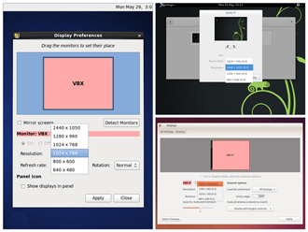
While your system will usually figure out the best resolution for your screen automatically, it may get this wrong in some cases, or you might want to change the resolution to meet your needs.
You can accomplish this using the Displays panel. The switch to the new resolution will be effective when you click Apply, and then confirm that the resolution is working. In case the selected resolution fails to work or you are just not happy with the appearance, the system will switch back to the original resolution after a short timeout.
In most cases the configuration for multiple displays is set up automatically as one big screen spanning all monitors, using a reasonable guess for screen layout. If the screen layout is not as desired, a check box can turn on mirrored mode, where the same display is seen on all monitors.
The next few screens contain demonstrations for the three Linux distributions that we reference in this course.
Date and Time Settings
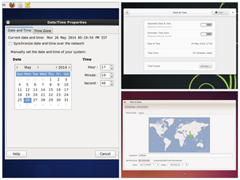
Linux always uses Coordinated Universal Time (UTC) for its own internal time-keeping. Displayed or stored time values rely on the system time zone setting to get the proper time. UTC is similar to, but more accurate than, Greenwich Mean Time (GMT).
The Date and Time Settings window can be accessed from the System Settings window. Alternatively, you can right-click Date and Time on the top panel to access the Date and Time Settings window.
Network Time Protocol

The Network Time Protocol (NTP) is the most popular and reliable protocol for setting the local time via Internet servers. Most Linux distributions include a working NTP setup which refers to specific time servers run by the distribution. This means that no setup, beyond "on or off", is required for network time synchronization. If desired, more detailed configuration is possible by editing the standard NTP configuration file (/etc/ntp.conf) for Linux NTP utilities.

Section 2 – Network manager
Network Configuration
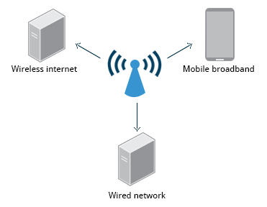
All Linux distributions have network configuration files, but file formats and locations can differ from one distribution to another. Hand editing of these files can handle quite complicated setups, but is not very dynamic or easy to learn and use. The Network Manager utility was developed to make things easier and more uniform across distributions. It can list all available networks (both wired and wireless), allow the choice of a wired, wireless or mobile broadband network, handle passwords, and set up Virtual Private Networks (VPNs). Except for unusual situations, it’s generally best to let the Network Manager establish your connections and keep track of your settings.
In this section, you will learn how to manage network connections, including wired and wireless connections, and mobile broadband and VPN connections.
Mobile Broadband and VPN Connections
You can set up a mobile broadband connection with Network Manager, which will launch a wizard to set up the connection details for each connection.
Once the configuration is done, the network is configured automatically each time the broadband network is attached.
Network Manager can also manage your VPN connections.
It supports many VPN technologies, such as native IPSec, Cisco OpenConnect (via either the Cisco client or a native open-source client), Microsoft PPTP, and OpenVPN.
You might get support for VPN as a separate package from your distributor. You need to install this package if your preferred VPN is not supported.
Section 3 – Installing and Updating Software

Each package in a Linux distribution provides one piece of the system, such as the Linux kernel, the C compiler, the shared software code for interacting with USB devices, or the Firefox web browser.
Packages often depend on each other; for example, because Firefox can communicate using SSL/TLS, it will depend on a package which provides the ability to encrypt and decrypt SSL and TLS communication, and will not install unless that package is also installed at the same time.
One utility handles the low-level details of unpacking a package and putting the pieces in the right places. Most of the time, you will be working with a higher-level utility which knows how to download packages from the Internet and can manage dependencies and groups for you.
In this section, you will learn how to install and update software in Linux using the Debian and RPM systems (which is used by both Fedora and SUSE family systems).
Debian Family System
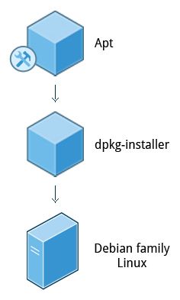
Let’s look at Package Management in the Debian Family System.
dpkg is the underlying package manager for these systems; it can install, remove, and build packages. Unlike higher-level package management systems, it does not automatically download and install packages and satisfy their dependencies.
For Debian-based systems, the higher-level package management system is the apt (Advanced Package Tool) system of utilities. Generally, while each distribution within the Debian family uses apt, it creates its own user interface on top of it (for example, apt-get, aptitude, synaptic, Ubuntu Software Center, Update Manager, etc). Although apt repositories are generally compatible with each other, the software they contain generally isn’t. Therefore, most apt repositories target a particular distribution (like Ubuntu), and often software distributors ship with multiple repositories to support multiple distributions. The demonstration using the Ubuntu Software Center is shown later in this section.

