Create a SharePoint List :   
  
List Name : Comments

Column Name : ItemID : Single Line of text

Column Name : Comments : Multiline of text.

Add a column “Benefit” in the InnovationCampaign Sharepoint list and also in the archive one. Comment column can be deleted. No longer required.

Open the flow :

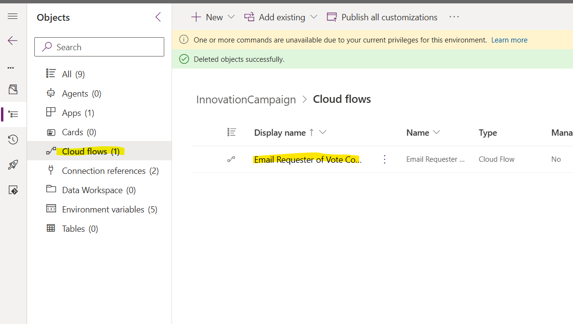

Edit it

Change the recurrence time as per your convenience .

