# Utilizing the serial communication

Serial communication in such fields like telecommunication and computer science, is the process of sending data one unit per a time over a communication channel, bus or cable. In embedded systems, the AVR microcontrollers, serial communication also founded in UART to send digital signal from the microcontroller to a PC or otherwise, depends on what is our target. UART is a Universal Asynchronous Receiver/Transmitter. Transmitter (TX) is a device which sends data and Receiver (RX) gets the data from the transmitter. Transmitter and Receiver have flags to detect errors while transmission or receiving the frame, the same we can see in Network, for example in TCP/IP protocols, where each frame with our data transfers to the another device and in the frame there is also information about the state of connection, is there errors or loss and etc. If yes, send again, else, everything is good, wait a new packet with a frame.

# Programming the transmission speed

There are two different ways to set the necessary speed to the microcontroller, the first one is to calculate which value we should set to the UBRRnL and/or if we need UBRRnH. Or another way is to use the already calculated values from the “Boud Rate settings” Figure. We just need to know the frequency of our device, for example 16MHertz and what kind of speed (symbols per second or frames per second) we need.

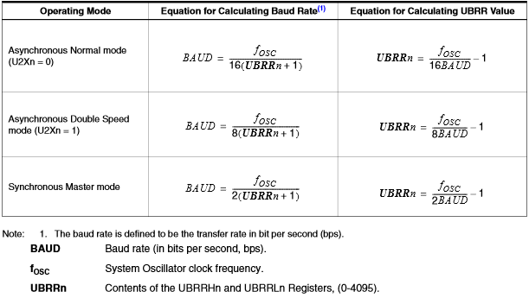

Figure 1. Boud Rate calculations

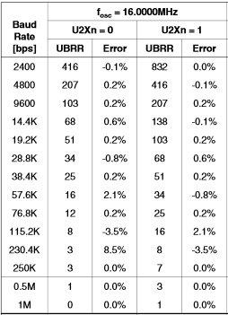

Figure 2. Boud Rate settings

For example, if we want to set our microcontroller speed equal to 9600 we can write this three lines:

$$case 9600:$$

$$UBRR0L = 103; // speed 9600 BD$$

$$UBRR0H = 0;$$

If we want to set 2400, we have to write:

$$case 2400:$$

$$UBRR0L = 160; // speed 2400 BD$$

$$UBRR0H = 1; // = 256 +$$

For starting communication between transmitter and receiver, we have to set necessary flags to zero, set the Stop bit, Parity bit and Data Bits Format. Then enable transmitter and receiver:

$$UCSR0B = ( 1 << TXEN0) | ( 1 << RXEN0); // enable transmitter and receiver$$

# The inspection of the data transmission

The session between Transmitter and Receiver happens by sending frames one by one (frame – is a little piece of data). When the first portion taken, then sent and gotten by Receiver, UART starts new session with the same algorithms.

The Transmitter has two very important flags that indicate its state: USART Data Register Empty (UDREn) and Transmit Complete (TXCn). The Data Register Empty checks if the transmit buffer is ready to receive new data (empty or cleared), this bit sets and UCSRnA Register bit to zero. Then we enable Data Register Empty Interrupt Enable (UDRIEn) bit in UCSRnB, after that which will be executed. The Transmit Complete (TXCn) Flag bit is one, when entire frame in the Transmit Shift Register has been shifted out and there are no data in the buffer. The TXCn Flag bit is automatically cleared when transmit complete interrupt executed.

The Receiver has only one flag that indicated the Receiver state – the Receiver Complete (RXCn) Flag checks if there are unread data in the receiver buffer or not. If it exists – flag is one, and zero if the receiver buffer is empty. When the RXCn is set, there will be the Receive Complete Interrupt Enable (RXCIEn) in UCSRnB is set, the USART Receive Complete interrupt will be executed.

Errors checks on the USART Receiver, there are three Error Flags: Frame Error (FEn), Data OverRun (DORn) and Parity Error (UPEn). All can be accessed by reading UCSRnA. All the flags located in the receive buffer together with the frame, which they indicate the error status. All flags must be set to zero when the UCSRnA is written for upward compatibility of future USART implementations. None of the Error Flags can generate interrupts.

The Frame Error (FEn) Flag indicates the state of the first stop bit of the next readable frame stored in the receive buffer. The FEn Flag is zero when the stop bit was correctly read (as one), and else if it was incorrect (zero). This flag can be used for detecting out-of-sync conditions, detecting break conditions and protocol handling. The FEn Flag is not affected by the setting of the USBSn bit in UCSRnC since the Receiver ignores all, except for the first, stop bits.

The Data OverRun (DORn) Flag indicates data loss due to a receiver buffer full condition. A Data OverRun occurs when the receive buffer is full (two characters), it is a new character waiting in the Receive Shift Register, and a new start bit is detected. If the DORn Flag is set there was one or more serial frame lost between the frame last read from UDRn, and the next frame read from UDRn. For compatibility with future devices, always write this bit to zero when writing to UCSRnA. The DORn Flag is cleared when the frame received was successfully moved from the Shift Register to the receive buffer.

The Parity Error (UPEn) Flag indicates that the next frame in the receive buffer had a Parity Error when received. If Parity Check is not enabled the UPEn bit will always be read zero. For compatibility with future devices, always set this bit to zero when writing to UCSRnA.