NVIDIA NemoClaw and the OpenClaw Strategy: Transforming Enterprise AI

Executive Summary
At the NVIDIA GTC 2026 conference, CEO Jensen Huang declared that "every software company in the world needs to have an OpenClaw strategy" [1]. This statement frames OpenClaw not just as another tool, but as one of the most significant open-source releases in the history of computing, comparable to the impact of Linux, Kubernetes, and HTML. To address the inherent security risks of autonomous agentic systems, NVIDIA introduced NemoClaw—a reference platform and open-source stack designed to make OpenClaw enterprise-ready with built-in security, privacy, and policy enforcement [2].

1. Understanding the Core Frameworks
To appreciate the transformation, it is essential to distinguish between the community-driven OpenClaw and NVIDIA's enterprise-grade NemoClaw.

OpenClaw: The Agentic Foundation
OpenClaw is an open-source, self-hosted gateway and framework for building autonomous AI agents (often referred to as "claws") [3]. It acts as a bridge between various communication channels (WhatsApp, Telegram, Discord, iMessage) and powerful AI models [3].

- Agentic Autonomy: Unlike traditional chatbots, "claws" can plan tasks, execute code, and operate persistently over long periods [2].
- Multi-Channel: A single gateway allows users to interact with their personal or corporate AI agents from any messaging platform [3].
- Self-Hosted: Organizations maintain control over their data by running the gateway on their own infrastructure [3].

NemoClaw: The Enterprise Reference Platform
NemoClaw is NVIDIA’s contribution to the OpenClaw ecosystem. It is a reference stack that packages OpenClaw with specialized NVIDIA technologies to ensure safety and performance in corporate environments [2].

- One-Command Setup: Enterprises can deploy a secure environment using a single command: openshell sandbox create --remote spark --from openclaw [2].
- Optimized for Hardware: NemoClaw is designed to run on NVIDIA DGX Spark (a compact "desktop data center") and DGX Station, as well as local RTX-powered PCs [2] [4].
- NVIDIA Nemotron Models: It utilizes open-source models like Nemotron, which are optimized for agentic reasoning and tool use [2].

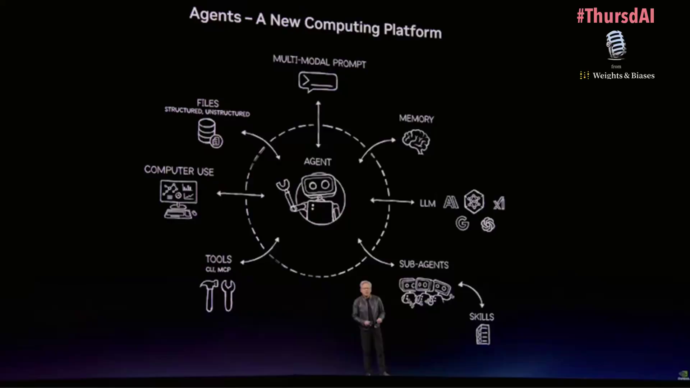
Figure 1: Agents - A New Computing Platform, illustrating the core components of an agentic system.

2. The "OpenShell" Security Revolution
The most critical component of NemoClaw is NVIDIA OpenShell, an open-source runtime that provides the "security baked in" mentioned by Jensen Huang [1].

The "Browser Tab" Security Model
Traditional AI guardrails live inside the agent's prompt, which can be bypassed via prompt injection. OpenShell moves the control point outside the agent. It treats an AI agent like a browser tab [2]:

- Isolated Sandboxes: Every agent runs in its own isolated execution environment. If an agent is compromised or makes an error, it cannot affect the host system [2].
- Out-of-Process Enforcement: Constraints are enforced at the runtime level, meaning the agent cannot override them regardless of its instructions [2].

Key Safety Features
Feature | Description
Network Boundaries | Restricts where an agent can communicate, preventing data exfiltration to unauthorized external servers [2].
Policy Engine | Evaluates every action (file access, process spawning, API calls) against corporate policies before execution. It ensures an agent can install a verified skill but cannot execute an unreviewed binary [2].
Privacy Router | Automatically keeps sensitive context on-device using local open models and routes to frontier models like Claude and GPT only when policy allows [2].
Audit Trails | Maintains a full log of every "allow" and "deny" decision, providing a transparent record for compliance [2].

3. Transformation in the IT Enterprise
The shift from SaaS (Software as a Service) to GaaS (agentic as a Service) marks a fundamental change in how IT departments operate [1].

From Tools to Agents
In the "Old IT" model, software companies created tools that humans used to save files and perform tasks. In the "Post-OpenClaw" era:

- Every SaaS becomes GaaS: Software will no longer just be a UI; it will be an agentic service that proactively completes workflows [1].
- Self-Evolving Systems: Agents can now "learn" new skills at runtime. OpenShell allows agents to propose policy updates when they hit roadblocks, which human administrators can then approve [2].

Deployment Scenarios
- Desktop Supercomputing: Using the DGX Spark, developers can run a "data center in a box" under their desk, providing enough local compute to run complex agentic workflows without cloud latency or privacy risks [4].
- Hybrid Workflows: The Privacy Router allows companies to use the best of both worlds—local security for sensitive data and cloud-scale intelligence for general reasoning [2].

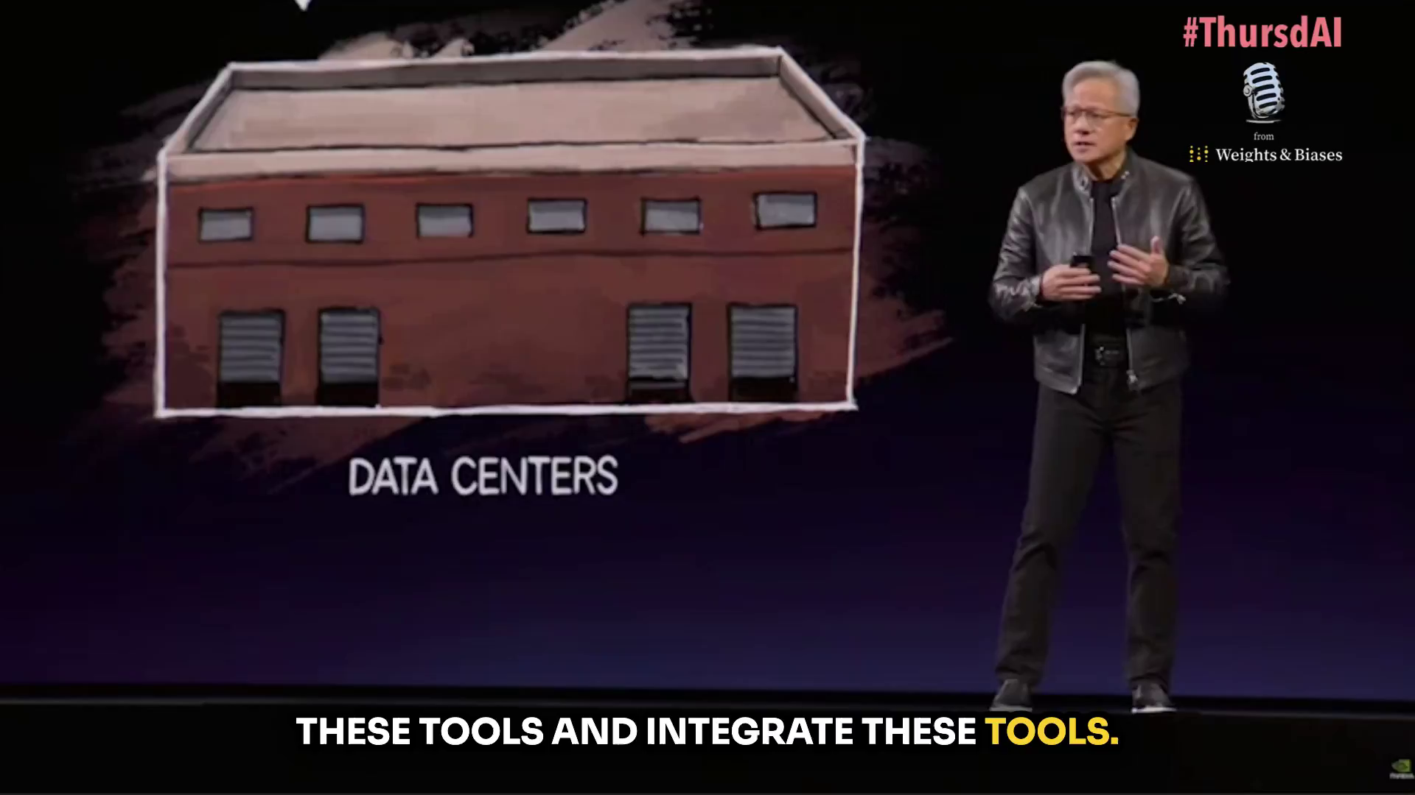
Figure 2: Representation of traditional data centers.

4. Challenges and Limitations of Implementing NVIDIA NemoClaw in Enterprise IT
While NVIDIA NemoClaw and the OpenShell runtime provide a critical security layer for autonomous agents, organizations face several technical, operational, and strategic challenges when integrating these technologies into existing IT infrastructures.

Technical and Performance Overhead
The "security-first" architecture of NemoClaw introduces inherent technical trade-offs that can impact user experience and system efficiency.

- Sandbox Latency: OpenShell's "browser tab" model relies on out-of-process policy enforcement and isolated sandboxing [2]. Every action—from file access to network requests—must be verified by the runtime, which can introduce perceptible latency in agentic workflows compared to native, unshielded execution.
- Resource Intensity: Running high-performance agents locally requires significant compute power. While NemoClaw is optimized for NVIDIA DGX Spark and RTX GPUs, scaling these agents across an entire workforce can lead to high memory and power consumption on endpoint devices [2] [6].
- Integration Complexity: Existing IT stacks are often not designed for "always-on" autonomous processes. Retrofitting legacy systems to communicate securely with OpenShell-protected agents requires complex API mapping and potentially significant changes to internal network architecture [7].

Operational and Governance Hurdles
The transition from traditional software to autonomous agents (GaaS) creates a "governance gap" that IT departments must bridge.

- Policy Management Fatigue: NemoClaw's policy engine requires granular oversight. As agents "self-evolve" and propose new skills, human administrators may face "approval fatigue," either becoming a bottleneck to productivity or reflexively approving risks to maintain workflow speed [2].
- Shadow AI and Fragmentation: Despite the availability of NemoClaw, employees may continue to deploy unmanaged OpenClaw instances directly onto corporate machines via simple CLI commands [8]. This creates a fragmented environment where "Shadow AI" agents operate outside of IT visibility and the OpenShell security umbrella.
- Skill Supply Chain Risks: NemoClaw still interacts with the broader OpenClaw ecosystem, including marketplaces like ClawHub. Even with OpenShell's sandboxing, the sheer volume of malicious or poorly coded skills (over 900 identified in early 2026) creates a constant threat surface that requires continuous monitoring [8].

Financial and Strategic Limitations
Implementing the full NemoClaw reference stack involves significant investment and strategic alignment.

- Hardware Lock-in: To achieve the performance and security levels promised by Jensen Huang, organizations are often pushed toward proprietary NVIDIA hardware like the DGX Spark ($4,000+ mini-PC) or DGX Station [9]. This can lead to high capital expenditure (CapEx) and vendor lock-in.
- Skill Gap: Managing agentic systems, policy engines, and privacy routers requires a new set of skills that many IT teams currently lack. The cost of upskilling or hiring specialized "Agentic Ops" talent is a major barrier to entry.
- Non-Human Identity Management: NemoClaw agents create persistent, non-human identities that often fall outside traditional Identity and Access Management (IAM) and MFA controls [8]. Integrating these "claws" into existing zero-trust frameworks is a significant architectural challenge.

Summary of Challenges
Category | Primary Challenge | Impact on Enterprise
Technical | Sandbox Latency & Resource Load | Reduced agent responsiveness and high endpoint power/memory usage.
Operational | Policy Approval Fatigue | Potential for human error or bottlenecks in autonomous workflows.
Security | Shadow AI & Supply Chain | Unmanaged agents and malicious skills bypassing corporate governance.
Financial | Hardware & Talent Costs | Significant upfront investment in NVIDIA hardware and specialized staff.

5. Comparative Analysis: NVIDIA NemoClaw vs. Open-Source AI Agent Platforms
NVIDIA NemoClaw represents a shift toward "Enterprise Agentic AI," but it competes in a crowded ecosystem of open-source frameworks. This section compares NemoClaw with other major platforms like AutoGPT, Microsoft AutoGen, and LangChain, focusing on their respective challenges and limitations.

Architectural Comparison
Feature | NVIDIA NemoClaw | AutoGPT | Microsoft AutoGen | LangChain
Primary Focus | Security & Policy Enforcement | Autonomous Task Execution | Multi-Agent Orchestration | Modular Agent Components
Isolation Model | Hardware-Optimized Sandbox (OpenShell) | Docker (optional), Local Execution | Docker-based Sandboxing | Developer-defined
Security Control | Out-of-Process (External) | In-Process (Internal) | Component-level (Internal) | In-Process (Internal)
Enterprise Readiness | High (Reference Stack) | Low (Experimental) | Medium (Research-focused) | High (Developer-heavy)
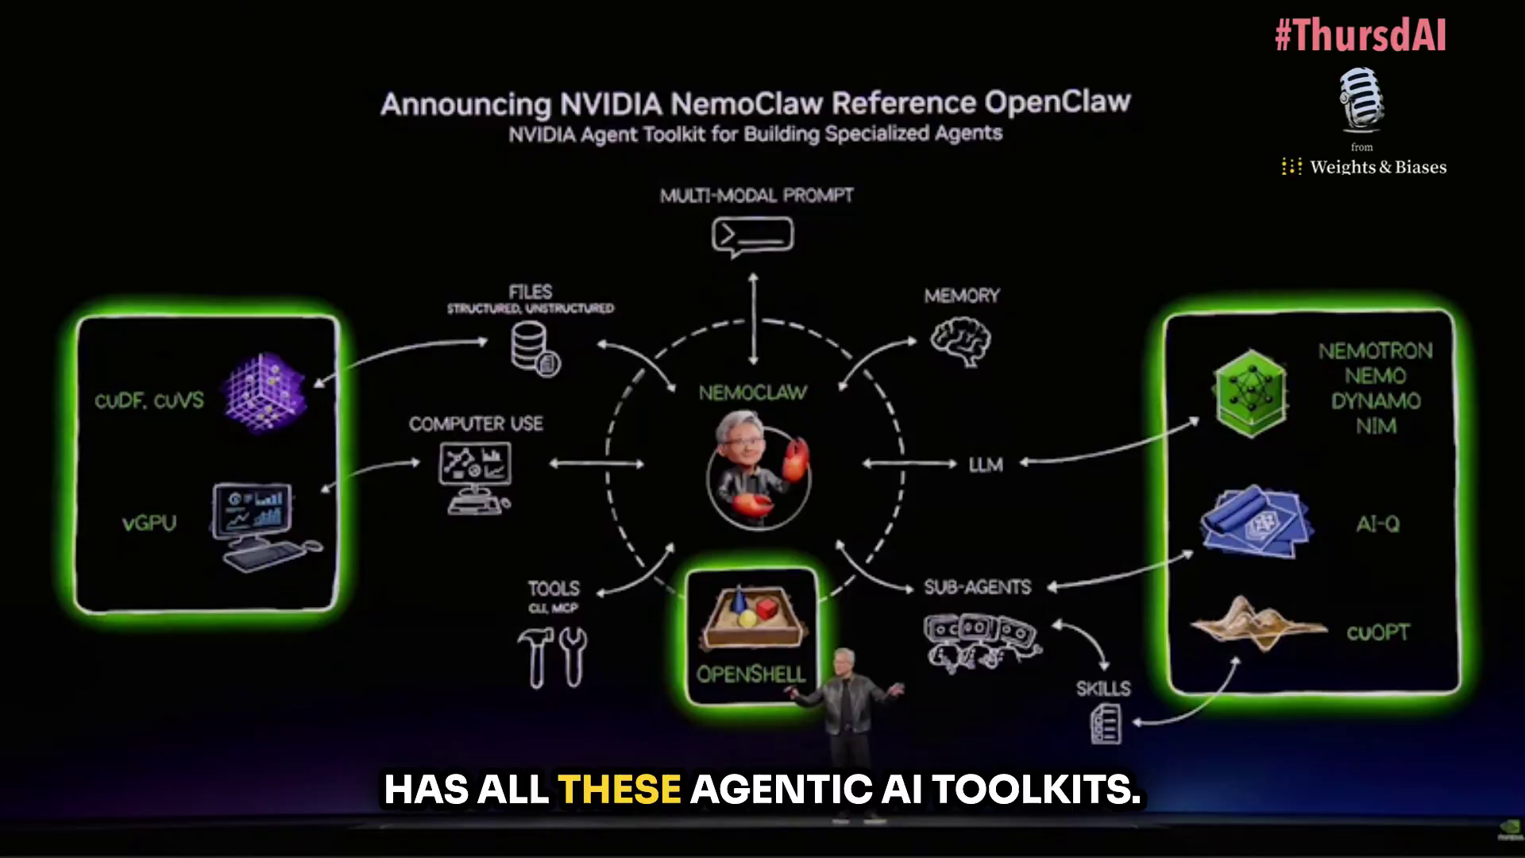
Figure 3: NVIDIA NemoClaw Reference OpenClaw architecture, highlighting OpenShell and Nemotron integration.

Key Challenges: NemoClaw vs. The Ecosystem

Security and Trust (The "Control Point" Debate)
- NemoClaw's Advantage: NemoClaw's OpenShell runtime moves the control point outside the agent process [2]. This prevents "prompt injection" from overriding security rules, a vulnerability that plagues AutoGPT and LangChain, where guardrails often live within the same process as the agent [10].
- The Challenge: While NemoClaw secures the runtime, it still relies on the OpenClaw community for "skills." This unvetted supply chain remains a risk, with hundreds of malicious skills already identified on marketplaces like ClawHub [11].

Operational Complexity vs. Developer Flexibility
- AutoGen & LangChain: These platforms offer extreme flexibility. Developers can build highly customized multi-agent conversations (AutoGen) or complex RAG pipelines (LangChain) [12]. However, this leads to "architecture fragmentation"—15 different teams building 15 different ways [13].
- NemoClaw: It prioritizes a standardized "reference stack." The challenge is operational fatigue; administrators must manage granular policies and approve "self-evolving" skill requests, which can become a bottleneck compared to the "wild west" freedom of AutoGPT [2].

Production Scaling and Compliance
- The "Compliance Gap": Most open-source frameworks (AutoGPT, AutoGen) lack built-in SOC 2, GDPR, or ISO certifications [13]. They require significant engineering to become "production-ready."
- NemoClaw's Approach: It provides the infrastructure for compliance (audit trails, privacy routers), but organizations still face the hardware lock-in challenge. To get the full safety benefits, organizations are often tethered to NVIDIA's proprietary hardware like the DGX Spark [6].

Comparative Limitations Summary

AutoGPT & OpenClaw (Community Version)
- Limitations: High risk of system compromise; lack of governance; inconsistent execution; high token costs due to infinite loops [10].
- Target: Individual power users and experimental prototyping.

Microsoft AutoGen
- Limitations: Requires deep AI engineering expertise; no native authentication or RBAC; limited pre-built business integrations [12] [13].
- Target: Research and complex multi-agent system prototyping.

NVIDIA NemoClaw
- Limitations: Hardware dependency (NVIDIA GPUs/DGX); policy management overhead; potential performance latency from sandboxing; nascent ecosystem compared to LangChain [2] [6].
- Target: Enterprise-grade, secure autonomous workforce deployment.

Conclusion
NemoClaw's primary differentiator is its hardware-integrated security model, which addresses the "trust gap" that prevents platforms like AutoGPT from entering the enterprise. However, it trades the "developer-first" flexibility of LangChain and AutoGen for a "security-first" architecture that requires more rigorous operational oversight and specific hardware investments.

References
[1] Jensen Huang at NVIDIA GTC 2026. (Video Transcription: /home/ubuntu/upload/nemoclaw_converted_20260316_201136_transcription_20260316_201149.txt)
[2] Run Autonomous, Self-Evolving Agents More Safely with NVIDIA OpenShell. (NVIDIA Technical Blog:https://developer.nvidia.com/blog/run-autonomous-self-evolving-agents-more-safely-with-nvidia-openshell/)
[3] OpenClaw Documentation. (OpenClaw:https://docs.openclaw.ai/)
[4] NVIDIA DGX Spark: AI Supercomputer on Your Desk. (NVIDIA:https://www.nvidia.com/en-us/products/workstations/dgx-spark/)
[5] Nvidia GTC 2026: CEO Jensen Huang keynote. (CNBC:https://www.cnbc.com/2026/03/16/nvidia-gtc-2026-ceo-jensen-huang-keynote-blackwell-vera-rubin.html)
[6] NVIDIA Announces NemoClaw for the OpenClaw Community. (NVIDIA News:http://nvidianews.nvidia.com/news/nvidia-announces-nemoclaw)
[7] Nvidia GTC 2026: CEO Jensen Huang keynote. (CNBC:https://www.cnbc.com/2026/03/16/nvidia-gtc-2026-ceo-jensen-huang-keynote-blackwell-vera-rubin.html)
[8] Why You Should Uninstall OpenClaw AI Immediately: A Security Warning. (Immersive Labs:https://www.immersivelabs.com/resources/c7-blog/openclaw-what-you-need-to-know-before-it-claws-its-way-into-your-organization)
[9] Nvidia Opens Orders for DGX Station, Ready to Run Giant AI Models. (PCMag:https://www.pcmag.com/news/nvidia-opens-dgx-station-orders-introduces-nemoclaw-gtc)
[10] AutoGPT for Development: The Good, The Bad, and The Ethical Implications. (Medium:https://medium.com/@genengineerAI/autogpt-for-development-the-good-the-bad-and-the-ethical-implications-13f6a538d026)
[11] OpenClaw's 230 Malicious Skills: What Agentic AI Supply Chain Crisis Reveals. (AuthMind:https://www.authmind.com/blogs/openclaw-malicious-skills-agentic-ai-supply-chain)
[12] OpenClaw vs AutoGen: Open-Source AI Agent Frameworks Compared (2026). (Nexus:https://agent.nexus/blog/openclaw-vs-autogen)
[13] Side-by-Side Comparison of Open-Source Frameworks. (Nexus:https://agent.nexus/blog/openclaw-vs-autogen)

