# Lab9a Notes

## UML Diagram

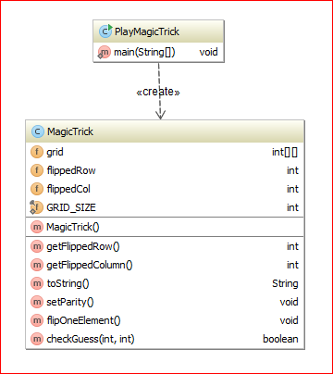

**Assumes the same number of rows and columns**

## Example for GRID_SIZE set to 6:

1. **MagicTrick constructor**:
   1. creates GRID_SIZE by GRID_SIZE array **this.grid**

|  |  |  |  |  |  |
| --- | --- | --- | --- | --- | --- |
| 0 | 0 | 0 | 0 | 0 | 0 |
| 0 | 0 | 0 | 0 | 0 | 0 |
| 0 | 0 | 0 | 0 | 0 | 0 |
| 0 | 0 | 0 | 0 | 0 | 0 |
| 0 | 0 | 0 | 0 | 0 | 0 |
| 0 | 0 | 0 | 0 | 0 | 0 |

* 1. initializes all elements except in the last row and the last column to randomly generated either 0 or 1

|  |  |  |  |  |  |
| --- | --- | --- | --- | --- | --- |
| 1 | 0 | 0 | 0 | 0 | 0 |
| 0 | 0 | 1 | 1 | 0 | 0 |
| 1 | 1 | 1 | 1 | 1 | 0 |
| 0 | 1 | 0 | 0 | 1 | 0 |
| 0 | 1 | 0 | 1 | 0 | 0 |
| 0 | 0 | 0 | 0 | 0 | 0 |

* 1. calls setParity method

1. **setParity method**:
   1. first, fills the last column with either 0 or 1, so the sums of each row are even:

|  |  |  |  |  |  |
| --- | --- | --- | --- | --- | --- |
| 1 | 0 | 0 | 0 | 0 | 1 |
| 0 | 0 | 1 | 1 | 0 | 0 |
| 1 | 1 | 1 | 1 | 1 | 1 |
| 0 | 1 | 0 | 0 | 1 | 0 |
| 0 | 1 | 0 | 1 | 0 | 0 |
| 0 | 1 | 0 | 1 | 0 | 0 |

* 1. next, fills the last row with either 0 or 1, so the sums of each column are even

|  |  |  |  |  |  |
| --- | --- | --- | --- | --- | --- |
| 1 | 0 | 0 | 0 | 0 | 1 |
| 0 | 0 | 1 | 1 | 0 | 0 |
| 1 | 1 | 1 | 1 | 1 | 1 |
| 0 | 1 | 0 | 0 | 1 | 0 |
| 0 | 1 | 0 | 1 | 0 | 0 |
| 0 | 1 | 0 | 1 | 0 | 0 |

1. **flipOneElement method** – randomly generates values for **this.flippedRow** and **this.flippedCol** and flips the value of the element indexed by this values (0 to 1; 1 to 0)