Lab11b Notes:
- Implement a service class that calculates statistics based on data in a file. The text file contains grades represented by integer values, one per line.
  - The constructor takes a Scanner object as the parameter (please note that the Scanner object is created by the client and should be used by the constructor to read for the text file). The constructor creates ArrayList<Integer> called grades and fills it with grades read from the given text file. If a value that is not an integer is encountered, an InputMismatchException is thrown, so the constructor must handle it: prints a message to the console, skips that value, and continues processing the remaining lines.
    - for the reading from a text file you should be able to reuse some code from the example 11.13.
  - The class has also methods that return the grade average, the pass rate, the highest grade, and a method that returns all grades as an array of letter grades.
  - toString method simply returns the number of grades
  - saveGradesInFile method writes this.grades as an object into savedGrades.dat file (see example 11.16)
  - displaySavedGrades method reads the ArrayList object from the savedGrades.dat file, saves it into a temp variable, and displays the content to the console (see example 11.17)
- The sample input files grades1.txt and grades2.txt are included. See sample run provided below.
- The FileStatisticsClient.java is provided and fully implemented. Please analyze the code carefully. Please notice how the client takes care of possible IOException for reading from the text file
- The letter grade is calculated based on the following grade scale:
  - A 90% - 100%
  - B 80% - 89%
  - C 70% - 79%
  - D 60% - 69%
  - F 0% - 59%
- Start with creating FileStatistics class and declaring skeleton methods as per UML diagram provided below:

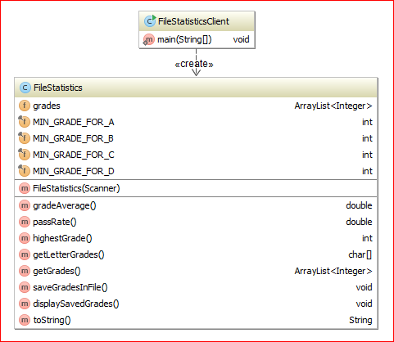

Sample run of the program:

Enter the name of the file containing grades (i.e. grades1.txt)
grades1
Enter the name of the file containing grades (i.e. grades1.txt)
grades1.txt
Looking for C:\IDEA_Workspace\Lab11b\grades1.txt
Found the file, it was last modified on Mon Apr 27 08:00:05 PST 2015
---> In the constructor: reading data from the input file
100
20
99
48
59
67
79
The input line "aabcccdefghijk" does not contain integer - ignoring
89
94
The input line "lmnopqrs" does not contain integer - ignoring
71
The input line "tuvwxzzzzz" does not contain integer - ignoring
82
93
64
95
---> In the constructor: 14 grades read in.

***** Grade statistics: *****
There are 14 grades.

The grade average is 75.71

The highest grade is 100.00

The pass rate is 79%

The letter grades are:
100 --> A
20 --> F
99 --> A
48 --> F
59 --> F
67 --> D
79 --> C
89 --> B
94 --> A
71 --> C
82 --> B
93 --> A
64 --> D
95 --> A

Saved grades in "savedGrades.dat" file.
The saved grades are: [100, 20, 99, 48, 59, 67, 79, 89, 94, 71, 82, 93, 64, 95]
End of the file "savedGrades.dat" reached

Would you like to analyze data from another file? (yes/no)
yes
Enter the name of the file containing grades (i.e. grades1.txt)
grades2.txt
Looking for C:\IDEA_Workspace\Lab11b\grades2.txt
Found the file, it was last modified on Mon Apr 27 08:00:18 PST 2015
---> In the constructor: reading data from the input file
The input line "12abc" does not contain integer - ignoring
78
20
33
78
59
67
79
89
94
The input line "xyz" does not contain integer - ignoring
77
82
93
99
95
The input line "seventySix" does not contain integer - ignoring
---> In the constructor: 14 grades read in.

***** Grade statistics: *****
There are 14 grades.

The grade average is 74.50

The highest grade is 99.00

The pass rate is 79%

The letter grades are:
78 --> C
20 --> F
33 --> F
78 --> C
59 --> F
67 --> D
79 --> C
89 --> B
94 --> A
77 --> C
82 --> B
93 --> A
99 --> A
95 --> A

Saved grades in "savedGrades.dat" file.
The saved grades are: [78, 20, 33, 78, 59, 67, 79, 89, 94, 77, 82, 93, 99, 95]
End of the file "savedGrades.dat" reached

Would you like to analyze data from another file? (yes/no)
no

Process finished with exit code 0

