2015



Benjamin Johnson

Now is with



Han Pen

Now is pursuing graduate studies at NAU. His research interests are the intersection of predictive modeling and adaptive communications.



Abdulmajid Alhawsawi

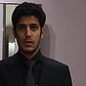

Alhmed Altamimi



Xinghao Qi



Yulan Westerveld

2016

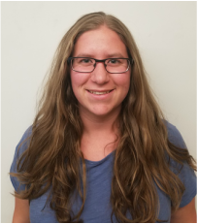

Alyssa Thomson

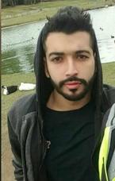

Hashem Aldashti



Omar Marshad



Tyler Mullholand

2016



I am Huiwen Chu. I am pursuing BS degree in Electrical Engineering at Northern Arizona University. Interested in robotic system, sensor and communication system, skilled in 3D-modeling.

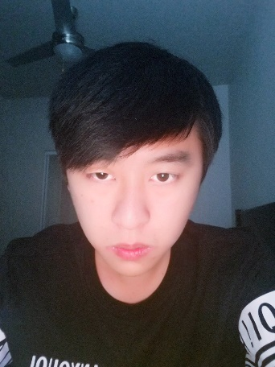

I am Qiyuan Huang. I am interested in Artificial Intelligence, and my hobby is cooking.

.

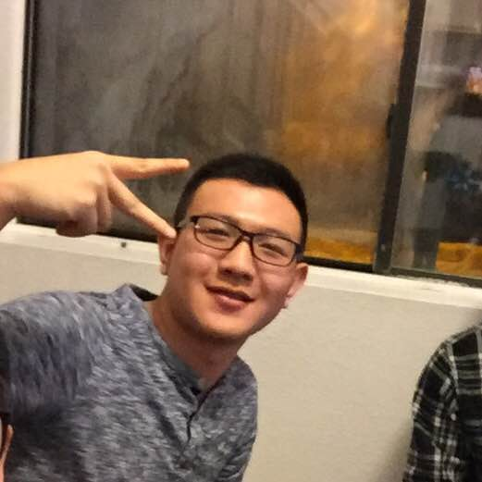

Yazhou Li:

I am Electrical Engineering student Yazhou Li. I was born in China. My only hobby is playing basketball and I am good at it. I am very interested in any Robot Project. My career goal is that to be a good Electrical Engineer. For now, I hope I can take master or PHD degree after graduated from NAU.



My name is Sixian Zhang. I am interested in FPGA, computer vision, and computer graphic area. In this project, I am interested in motion capture technology used by the controller. I want to work in video game industry in the future. My hobby is hiking.



Matthew Burns

I am matthew burns. My expertise is Web content management through web-front layout and back-end design. My recent research interest is Cybersecurity. I also spend time playing guitar, reading and hiking.



Tanner Brelje

I am a BS student in the department of computer science at Northern Arizona University. My expertise include web-development and project management. my personal favorites include

Legend of Zelda: BOTW, MGSV: The Phantom Pain, and Paper Mario TTYD.



Josh Gutman

I am a BS student in the department of computer science. My research interest is bioinformatics. I am familiar with BLAST, NASP. I am interested in developing high performance parallel computing solutions using Slrum.

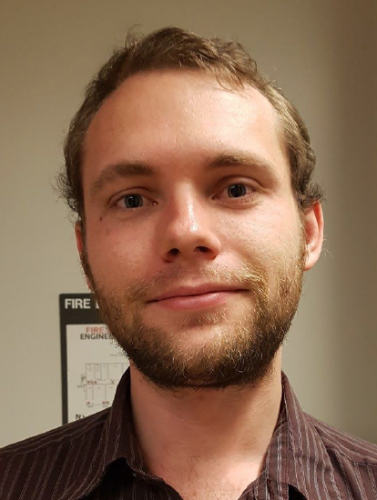

Charles Chatwin

Skills: Website development, computer programming

.