Modernizing Enterprise Middleware
A Domain- and Cloud-Centric Approach to Integration on Azure
Date: January 19, 2026

Table of Contents
Table of Contents 2
Executive Summary 3
Key Findings 3
Recommendations 4
1. The State of Enterprise Middleware: The Hidden Dependency 4
2. Why Replacement Fails: Applications vs. Middleware 5
3. AIS Modernization Framework: The Four Shifts 5
4. Azure-Native Target Architecture 6
5. Operating Model and Governance 7
6. Evolutionary Modernization Patterns 7
7. Crawl–Walk–Run Roadmap 7
Crawl: Establish Clarity, Confidence, and a Safe Starting Point 8
Walk: Expand Capability and Shared Ownership 8
Run: Absorb Capabilities and Retire Legacy Platforms 8
8. Business Outcomes and Metrics 9
9. Risks and Mitigations 9
10. Key Questions for Leaders 9
Conclusion 9

Executive Summary
Enterprise middleware has become one of the most pervasive yet least visible sources of operational risk, technical debt, and architectural drag within large organizations.
Platforms such as BizTalk, MuleSoft, TIBCO, and WebSphere were originally deployed to simplify connectivity and enforce reliability across heterogeneous systems. Over time, however, these platforms have evolved into deeply embedded integration hubs whose cost structures, skill dependencies, and architectural constraints no longer align with modern cloud-native strategies.
Today, CIOs and technology leaders face mounting urgency to address this growing liability. End-of-life timelines for legacy platforms, rising licensing and infrastructure costs, shrinking talent pools, and increasing pressure to support event-driven, API-first architectures have converged into a strategic inflection point. Organizations can no longer treat middleware modernization as a technical upgrade; it has become a foundational requirement for digital agility and business resilience.
The core challenge is not identifying a drop-in replacement—none exists. Instead, enterprises must answer a more consequential question: How do we evolve integration from a centralized, platform-centric construct into a distributed, cloud-native capability without disrupting mission-critical business operations? The most successful organizations reframe modernization as an architectural, operational, and organizational transformation—not a tooling decision.
AIS’s point of view is that responsible modernization requires four coordinated shifts: (1) from platform-centric to business-centric integration, (2) from manual discovery to AI-augmented understanding, (3) from configuration-heavy platforms to agentic engineering, and (4) from centralized ownership to governed distributed execution.
Enterprises that adopt this approach realize meaningful business outcomes: reduced licensing and platform overhead, improved alignment with Azure-native architectures, accelerated delivery of integration changes, increased observability and resilience, and a more sustainable integration operating model that endures beyond any single technology platform. Most importantly, integration shifts from being a constraint to becoming an enabler of continuous business innovation.
“Middleware modernization is not a tooling decision—it is an operating model decision.”

Key Findings
- Legacy middleware now represents disproportionate operational risk relative to the business value it delivers.
- No commercial broker provides a 1:1 replacement for entrenched platforms; modernization is an architectural and operating-model change.
- AI-augmented discovery accelerates understanding of hidden business rules and integration dependencies without replacing human judgment.
- A domain and cloud-centric approach aligns integration to business capabilities while leveraging Azure-native services for resilience and speed.

Recommendations
- Frame modernization around business capabilities and bounded contexts—not platform parity or feature-for-feature replacement.
- Use AI-assisted analysis to surface implicit logic in orchestrations, mappings, and runtime behavior before moving workloads.
- Adopt an evolutionary approach (parallel run, selective routing, feature flags) to preserve SLAs while shifting traffic incrementally.
- Distribute ownership to domain teams under strong guardrails from a central integration enablement function.

1. The State of Enterprise Middleware: The Hidden Dependency
Enterprise middleware platforms were introduced to tame point-to-point chaos, enforce reliability, and abstract heterogeneity across core systems. Over time, these platforms became central integration hubs—useful but opaque—encoding critical business logic in orchestrations, mappings, and operational conventions.
As licensing and infrastructure costs rise and specialized skills grow scarce, these hubs have drifted out of alignment with modern, cloud-native architectures. The result: high fixed costs, vendor and skills lock-in, and friction that constrains transformation speed.
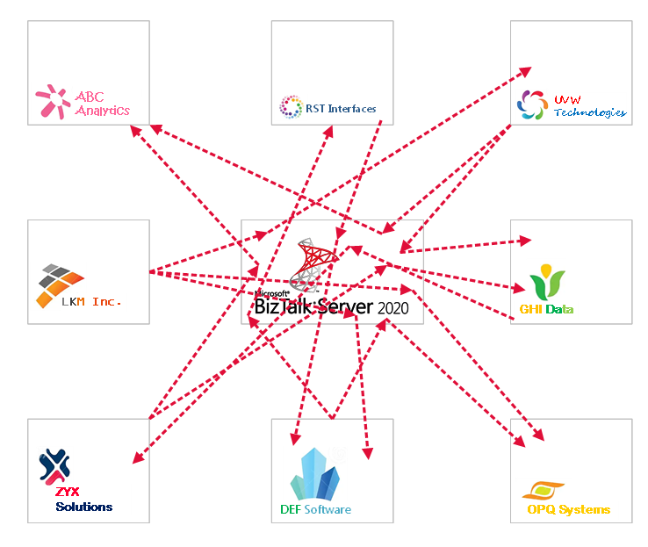
Figure 1 Traditional Middleware

2. Why Replacement Fails: Applications vs. Middleware
Middleware modernization is categorically different from application migration. Applications are bounded to a product or capability; middleware spans many business processes with near-zero downtime expectations and strict transactional guarantees.
Dimension | Application Modernization | Middleware / Integration Modernization
Business Impact | Scoped impact; failures often contained. | Enterprise-wide blast radius; disruptions cross processes.
Logic Visibility | Business logic explicit in code and requirements. | Logic implicit in mappings, orchestrations, and runtime behavior.
Operational Constraints | Planned downtime and phased releases are often acceptable. | Near-zero downtime with strict SLAs and transactional consistency.
Migration Approach | Lift, replatform, or refactor paths are well understood. | No direct replacement; requires incremental extraction and parallel run.
Ownership Model | Clear product-team ownership with modern skills. | Centralized ownership and specialized skills; modernization redistributes responsibility.
Cost Structure | Costs scale with usage/value. | High fixed licensing and platform costs decoupled from delivered value.

3. AIS Modernization Framework: The Four Shifts
AIS’s position is that successful middleware modernization requires four coordinated shifts that connect strategy, architecture, engineering, and operating model.
From platform-centric to business-centric integration - Align integration boundaries to business capabilities and bounded contexts. Separate business semantics from technical plumbing and make integration a first-class part of the application fabric.
From manual discovery to AI-augmented understanding - Use AI to extract message semantics, transactional boundaries, and dependencies from code, configurations, tests, documentation, and runtime behavior—validated by human-led domain modeling (e.g., Event Storming).
From configuration-heavy platforms to agentic engineering - Use an integration starter kit and guardrails to generate and assemble integrations rapidly in the same languages, pipelines, and tooling as the rest of the platform (e.g., C# workflows as Azure Functions or containers).
From centralized ownership to governed distributed execution - Shift responsibility to domain product teams for mappings and logic while centralizing shared services, governance, patterns, and standards to reduce cognitive load and risk.
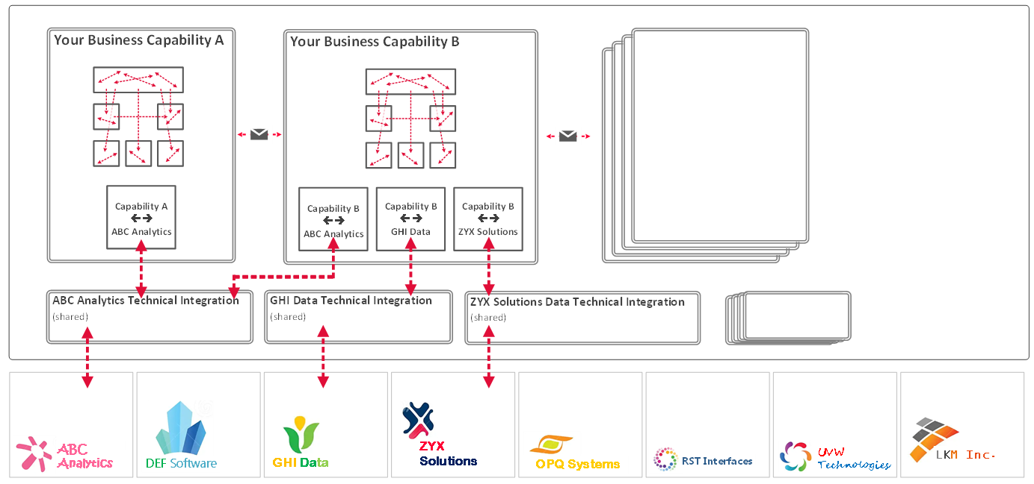
Figure 2 Distributed Integration Responsibility with Governance

4. Azure-Native Target Architecture
Rather than recreating a monolithic broker, assemble capabilities from Azure-native services as composable building blocks. Treat integration as part of the application fabric, not a bolt-on platform.
Reference components include: Event-driven messaging with Azure Service Bus and Event Grid; API-first design via Azure API Management; execution via Azure Functions or containers; enterprise observability and security; and data movement/enrichment via Azure data and AI services.
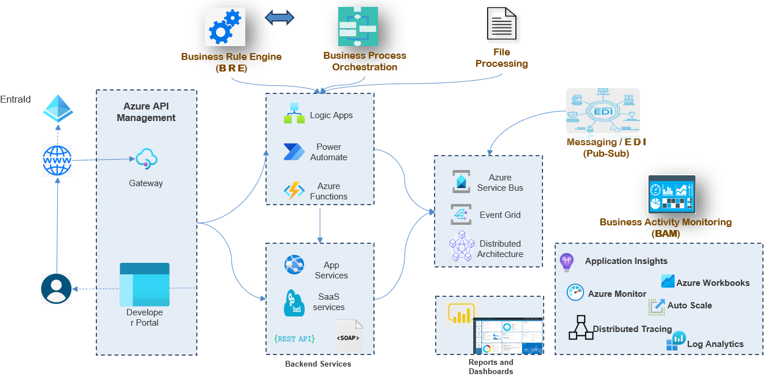
Figure 3 Target Azure Architeture

5. Operating Model and Governance
Successful modernization is as much organizational as it is technical. Establish a central modernization enablement team to provide templates, guardrails, shared services, and governance while enabling distributed delivery by domain teams.
Expose operations, testing, and support teams to new patterns and observability models early to reduce fear and improve reliability. Build alignment across engineering, operations, and leadership around the “why” and the “how.”

6. Evolutionary Modernization Patterns
- Parallel run and controlled cutover to protect SLAs and data consistency.
- Feature flags and selective routing to shift traffic incrementally.
- Incremental extraction of integration capabilities to reduce risk.
- Per-integration disaster recovery and resiliency strategies tailored to criticality.

7. Crawl–Walk–Run Roadmap
See Figure 5 (Appendix): Crawl–Walk–Run progression (scope, guardrails, outcomes per phase).
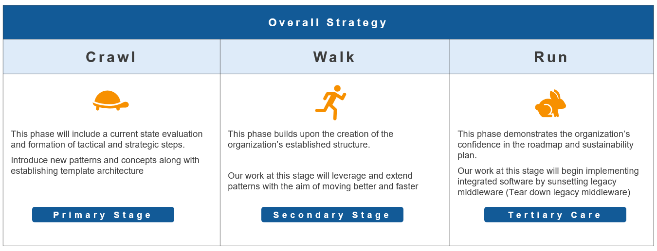
Figure 4 Crawl, Walk, Run Strategy

Crawl: Establish Clarity, Confidence, and a Safe Starting Point
- AI-powered discovery of integration behavior, business rules, and dependencies; validate through human-led domain modeling.
- Introduce destination architecture foundations in a controlled manner; start with low-risk capabilities (e.g., translation, notifications, simple workflows).
- Enablement for operations/testing with new observability models; make change visible, measurable, and reversible.
- Consensus building across engineering, operations, and leadership around the direction, tradeoffs, and long-term vision.

Walk: Expand Capability and Shared Ownership
- Introduce richer patterns: pub/sub, longer-running workflows (saga patterns), file processing, cross-system orchestration.
- Achieve operational maturity with retries, asynchronous behavior, and real-world incident response.
- Broaden participation: product teams contribute domain logic; central teams focus on shared services and standards.
- Coexist with legacy middleware; route traffic incrementally; manage risk via parallel operation and controlled rollout.

Run: Absorb Capabilities and Retire Legacy Platforms
- Incrementally decommission legacy capabilities as they are absorbed into the cloud-native architecture.
- Retire unused integrations identified during discovery; reduce licensing and infrastructure overhead.
- Operate integration as part of the common platform fabric with shared pipelines, security, and observability.
- Institutionalize a sustainable operating model: distributed ownership under governance; reusable patterns and templates reduce risk and cognitive load.

8. Business Outcomes and Metrics
Expected outcomes include lower platform and licensing costs; improved architectural alignment; faster delivery; higher resilience; and a sustainable operating model that survives platform transitions.
Illustrative metrics: time-to-change for integrations; percentage of traffic on modern architecture; cost-to-serve per message; incident MTTR for integration faults; test automation coverage for integration workflows.

9. Risks and Mitigations
Risk | Mitigation
Under-scoped discovery | Combine AI-assisted analysis with facilitated domain modeling sessions; require human validation for critical flows.
Big-bang cutover pressure | Enforce parallel run, feature flags, and controlled routing; mandate exit criteria per integration.
Skill gaps in product teams | Provide an integration starter kit, patterns, and hands-on enablement; embed platform engineers temporarily.
Fragmented governance | Define clear ownership boundaries, SLAs, and guardrails; centralize shared observability and security.
Figure 5 Risks and Mitigations

10. Key Questions for Leaders
- How much of our middleware cost is tied to platform overhead versus delivered value?
- Are our integrations aligned to business capabilities—or to historical technical decisions?
- Can our teams evolve integrations at the pace the business requires?
- What would change if integration were part of our application fabric instead of a separate platform?

Conclusion
Middleware modernization is not a platform swap; it is the reclamation of integration as a strategic capability aligned with the business, engineered with modern tools, and operated as part of the enterprise cloud foundation. By applying AIS’s four shifts and executing through a Crawl–Walk–Run roadmap, enterprises can reduce cost and risk while turning integration into an enduring enabler of continuous innovation.

