Shri Sanjanaa.S.E.

Student,

Kumaraguru College of Technology

February 8, 2023

**Plaricks (Plastic-bricks)**

**Problem Statement:**

Since the construction industry is the largest user of coal (used to fire the bricks) in the country and a significant cause of air pollution, it also leads to the loss of fertile topsoil.

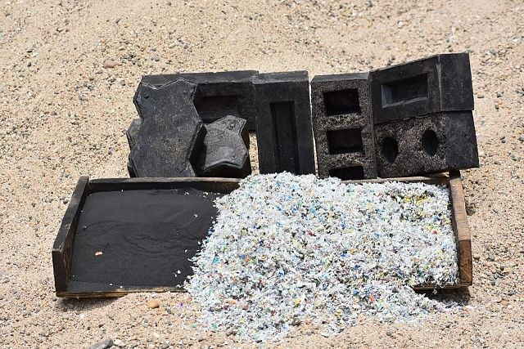

**Solution:**

Therefore, to solve this pertinent problem, creating bricks made from foundry dust and waste plastic would be an ingenious solution.

To solve this environmental issue, we devised the concept of making bricks without using any water. Also, more water is saved during the construction process, as the walls built with these bricks do not need to be cured with water. Also, the best part of this idea is that while 70 percent of the total sand can be reused, the other 30 percent, in the form of foundry dust, is too fine to be used again.   
Also, with enhanced technology, we can evolve this idea into making interlocking bricks, which essentially work like Lego blocks. Foundry dust, which consists of silica, clay, and carbon is a significant waste for the foundry industry; it is also difficult to dispose of as the particles are extremely light and can remain suspended in the air, causing pollution. Also, the manufacturing process releases zero emissions into the environment, and the bricks are ready for use after being rested for 30 minutes.