**DAY: 5 LAB PROGRAMS**

1. **GIVEN AN BIN ARRAY AND AN INTEGR K RETURN TRUE IF ALL ONES ARE ATLEAST K PLACESAWAY FROM EACH OTHER OTHERWISE RETURN FALSE.**

def bin(arr,k):

index=None

for i, num in enumerate(arr):

if num == 1:

if index is not None and i- index < k:

return False

index=i

return True

arr=[1,0,0,1,0,0,0,1]

k=4

print(bin(arr,k))

TIME COMPLEXITY: O(n)

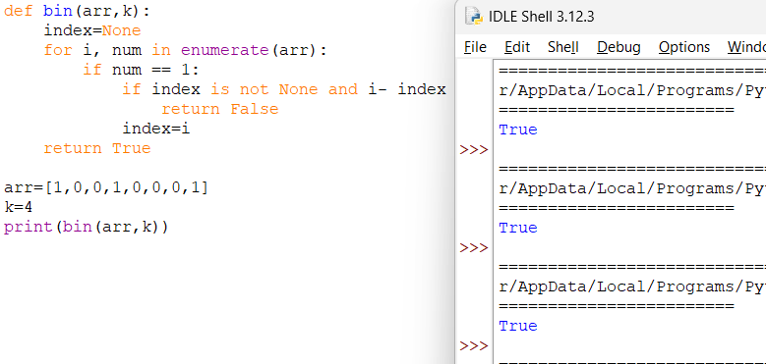

**2. Longest Continuous Subarray With Absolute Diff Less Than or Equal to Limit**

**Given an array of integers nums and an integer limit, return the size of the longest non-empty subarray such that the absolute difference between any two elements of this subarray is less than or equal to limit.**

**Example 1:**

**Input: nums = [8,2,4,7], limit = 4**

**Output: 2**

**Explanation: All subarrays are:**

**[8] with maximum absolute diff |8-8| = 0 <= 4.**

**[8,2] with maximum absolute diff |8-2| = 6 > 4.**

**[8,2,4] with maximum absolute diff |8-2| = 6 > 4.**

**[8,2,4,7] with maximum absolute diff |8-2| = 6 > 4.**

**[2] with maximum absolute diff |2-2| = 0 <= 4.**

**[2,4] with maximum absolute diff |2-4| = 2 <= 4.**

**[2,4,7] with maximum absolute diff |2-7| = 5 > 4.**

**[4] with maximum absolute diff |4-4| = 0 <= 4.**

**[4,7] with maximum absolute diff |4-7| = 3 <= 4.**

**[7] with maximum absolute diff |7-7| = 0 <= 4.**

**Therefore, the size of the longest subarray is 2.**

**Example 2:**

**Input: nums = [10,1,2,4,7,2], limit = 5**

**Output: 4**

**Explanation: The subarray [2,4,7,2] is the longest since the maximum absolute diff is |2-7| = 5 <= 5.**

**Example 3:**

**Input: nums = [4,2,2,2,4,4,2,2], limit = 0**

**Output: 3**

**Constraints:**

**● 1 <= nums.length <= 105**

**● 1 <= nums[i] <= 109**

**● 0 <= limit <= 109**

def subarray(arr,limit):

left=0

minvalue=float('inf')

maxvalue=float('-inf')

maxlength=0

for right,num in enumerate(arr):

minvalue=min(minvalue,num)

maxvalue=max(maxvalue,num)

while maxvalue-minvalue > limit:

minvalue=min(arr[left:right+1])

maxvalue=max(arr[left:right+1])

left+=1

maxlength=max(maxlength,right-left+1)

return maxlength

arr=[8,2,4,7]

limit=6

print(subarray(arr,limit))

TIME COMPLEXITY: O(n^2)

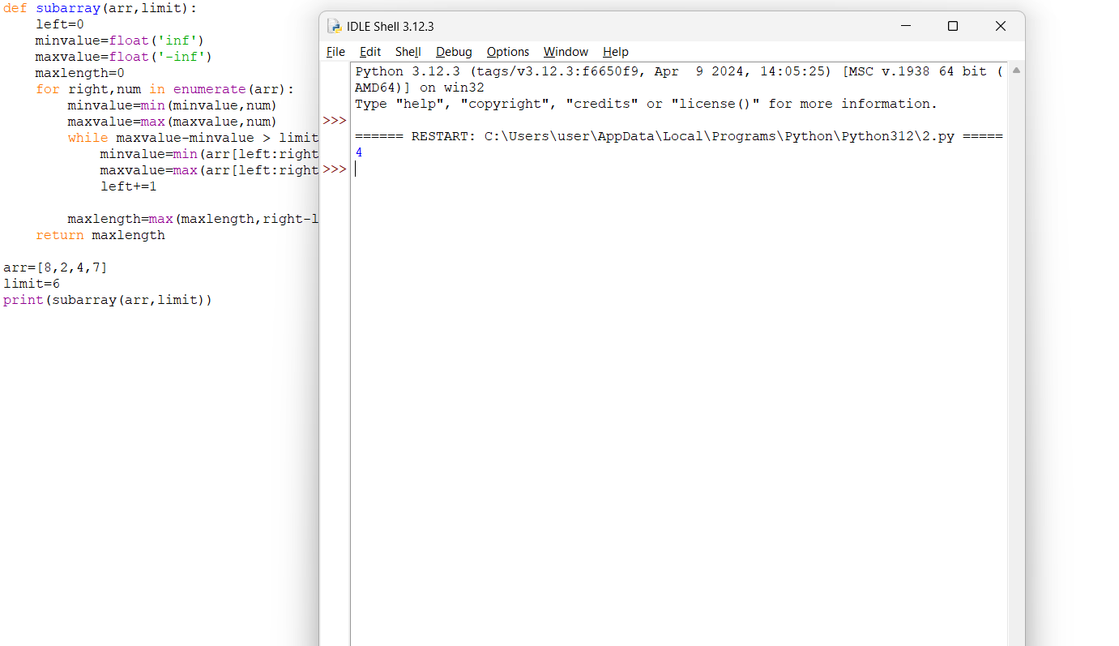

**3. Find the Kth Smallest Sum of a Matrix With Sorted Rows**

**You are given an m x n matrix mat that has its rows sorted in non-decreasing order and an integer k.**

**You are allowed to choose exactly one element from each row to form an array.**

**Return the kth smallest array sum among all possible arrays.**

**Example 1:**

**Input: mat = [[1,3,11],[2,4,6]], k = 5**

**Output: 7**

**Explanation: Choosing one element from each row, the first k smallest sum are:**

**[1,2], [1,4], [3,2], [3,4], [1,6]. Where the 5th sum is 7.**

**Example 2:**

**Input: mat = [[1,3,11],[2,4,6]], k = 9**

**Output: 17**

**Example 3:**

**Input: mat = [[1,10,10],[1,4,5],[2,3,6]], k = 7**

**Output: 9**

**Explanation: Choosing one element from each row, the first k smallest sum are:**

**[1,1,2], [1,1,3], [1,4,2], [1,4,3], [1,1,6], [1,5,2], [1,5,3]. Where the 7th sum is 9.**

**Constraints:**

**● m == mat.length**

**● n == mat.length[i]**

**● 1 <= m, n <= 40**

**● 1 <= mat[i][j] <= 5000**

**● 1 <= k <= min(200, nm)**

**● mat[i] is a non-decreasing array.**

def kthsmallestsum(mat,k):

def counting(target):

count=0

for row in mat:

col=len(row)-1

while col>=0 and row[col]>target:

col-=1

count+=col+1

return count

left=mat[0][0]

right=mat[-1][-1]*len(mat[0])

while(left<right):

mid=left+(right-left)//2

if counting(mid)<k:

left=mid+1

else:

right=mid

return left

mat=[[1,2,11],[2,4,6]]

k=9

print(kthsmallestsum(mat,k))

TIME COMPLEXITY: O(log n * m * log n).

Top of Form

Bottom of Form

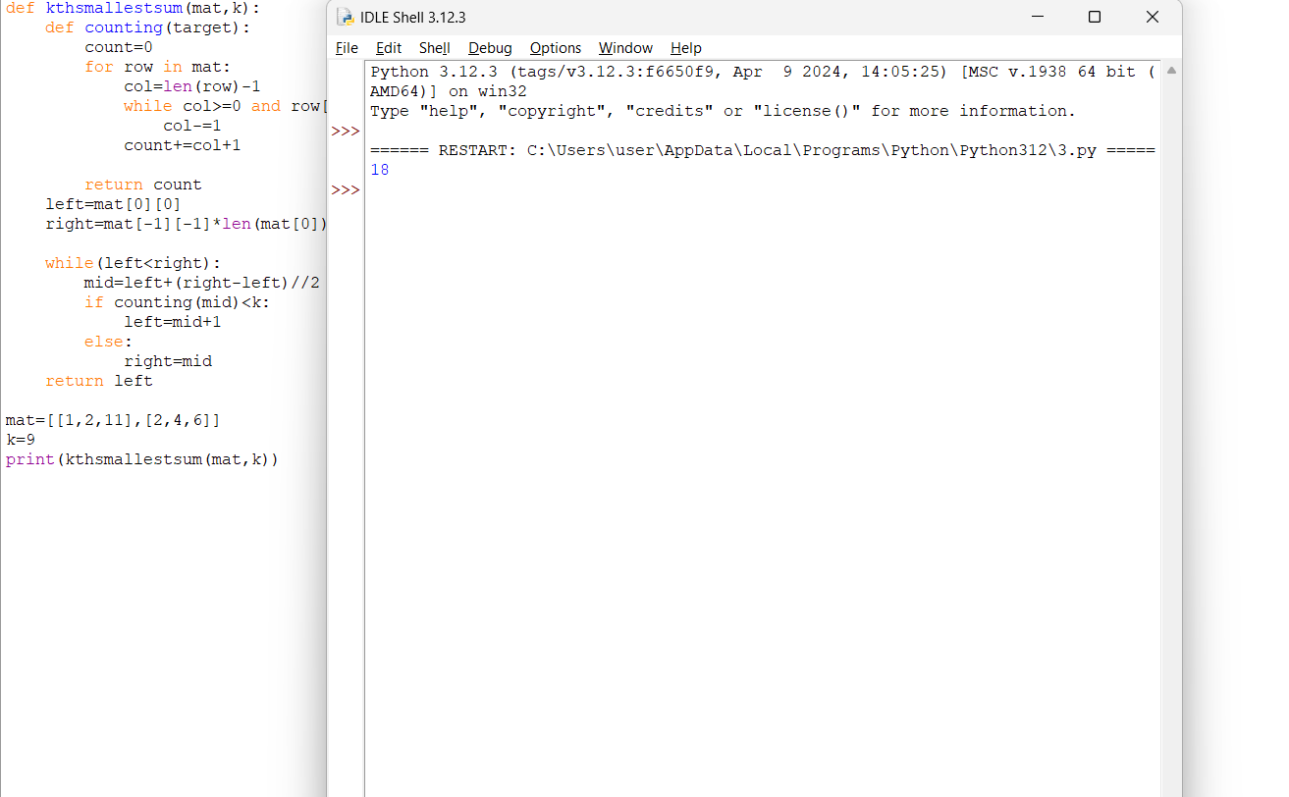

**4. Count Triplets That Can Form Two Arrays of Equal XOR**

**Given an array of integers arr.**

**We want to select three indices i, j and k where (0 <= i < j <= k < arr.length).**

**Let's define a and b as follows:**

**● a = arr[i] ^ arr[i + 1] ^ ... ^ arr[j - 1]**

**● b = arr[j] ^ arr[j + 1] ^ ... ^ arr[k]**

**Note that ^ denotes the bitwise-xor operation.**

**Return the number of triplets (i, j and k) Where a == b.**

**Example 1:**

**Input: arr = [2,3,1,6,7]**

**Output: 4**

**Explanation: The triplets are (0,1,2), (0,2,2), (2,3,4) and (2,4,4)**

**Example 2:**

**Input: arr = [1,1,1,1,1]**

**Output: 10**

**Constraints:**

**● 1 <= arr.length <= 300**

**● 1 <= arr[i] <= 108**

def countTriplets(arr):

n = len(arr)

count = 0

xor = 0

xor_counts = {0: 1}

for j in range(n):

xor ^= arr[j]

count += xor_counts.get(xor, 0) * j - (j * (j - 1)) // 2

xor_counts[xor] = xor_counts.get(xor, 0) + 1

return count

arr = [1, 1, 1, 1, 1]

print(countTriplets(arr))

TIME COMPLEXITY: O(n)

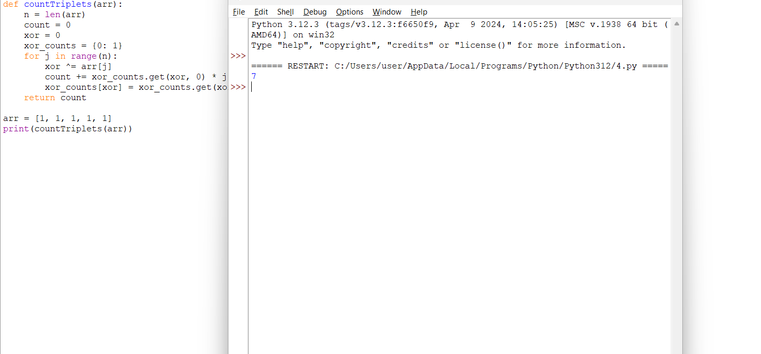

**5.Minimum Time to Collect All Apples in a Tree**

**Given an undirected tree consisting of n vertices numbered from 0 to n-1, which has some apples in their vertices. You spend 1 second to walk over one edge of the tree. Return the minimum time in seconds you have to spend to collect all apples in the tree, starting at vertex 0 and coming back to this vertex.**

**The edges of the undirected tree are given in the array edges, where edges[i] = [ai, bi] means that exists an edge connecting the vertices ai and bi. Additionally, there is a boolean array hasApple, where hasApple[i] = true means that vertex i has an apple; otherwise, it does not have any apple.**

**Example 1:**

**Input: n = 7, edges = [[0,1],[0,2],[1,4],[1,5],[2,3],[2,6]], hasApple = [false,false,true,false,true,true,false]**

**Output: 8**

**Explanation: The figure above represents the given tree where red vertices have an apple. One optimal path to collect all apples is shown by the green arrows.**

**Example 2:**

**Input: n = 7, edges = [[0,1],[0,2],[1,4],[1,5],[2,3],[2,6]], hasApple = [false,false,true,false,false,true,false]**

**Output: 6**

**Explanation: The figure above represents the given tree where red vertices have an apple. One optimal path to collect all apples is shown by the green arrows.**

**Example 3:**

**Input: n = 7, edges = [[0,1],[0,2],[1,4],[1,5],[2,3],[2,6]], hasApple = [false,false,false,false,false,false,false]**

**Output: 0**

**Constraints:**

**● 1 <= n <= 105**

**● edges.length == n - 1**

**● edges[i].length == 2**

**● 0 <= ai < bi <= n - 1**

**● fromi < toi**

**● hasApple.length == n**

def minTimeToCollectApples(n, edges, hasApple):

graph = {i: [] for i in range(n)}

for edge in edges:

graph[edge[0]].append(edge[1])

graph[edge[1]].append(edge[0])

def dfs(node, parent):

total_time = 0

for neighbor in graph[node]:

if neighbor != parent:

time_to_neighbor = dfs(neighbor, node)

if time_to_neighbor > 0 or hasApple[neighbor]:

total_time += time_to_neighbor + 2

return total_time if total_time > 0 or hasApple[node] or node != 0 else 0

return dfs(0, -1)

n = 7

edges = [[0,1],[0,2],[1,4],[1,5],[2,3],[2,6]]

hasApple = [False, False, True, False, True, True, False]

print(minTimeToCollectApples(n, edges, hasApple))

TIME COMPLEXITY: O(n+m)

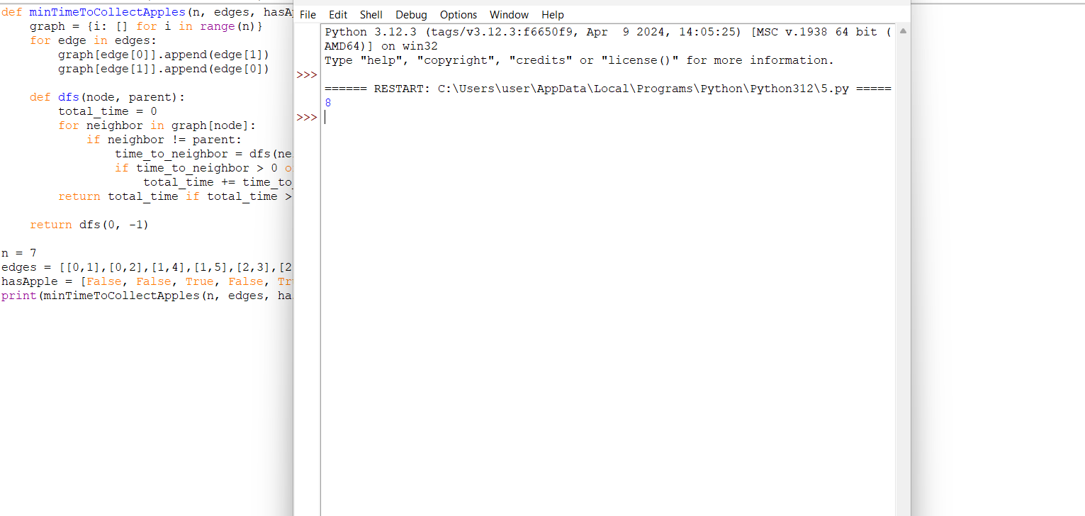

**6. Number of Ways of Cutting a Pizza**

**Given a rectangular pizza represented as a rows x cols matrix containing the following characters: 'A' (an apple) and '.' (empty cell) and given the integer k. You have to cut the pizza into k pieces using k-1 cuts.**

**For each cut you choose the direction: vertical or horizontal, then you choose a cut position at the cell boundary and cut the pizza into two pieces. If you cut the pizza vertically, give the left part of the pizza to a person. If you cut the pizza horizontally, give the upper part of the pizza to a person. Give the last piece of pizza to the last person.**

**Return the number of ways of cutting the pizza such that each piece contains at least one apple. Since the answer can be a huge number, return this modulo 10^9 + 7.**

**Example 1:**

**Input: pizza = ["A..","AAA","..."], k = 3**

**Output: 3**

**Explanation: The figure above shows the three ways to cut the pizza. Note that pieces must contain at least one apple.**

**Example 2:**

**Input: pizza = ["A..","AA.","..."], k = 3**

**Output: 1**

**Example 3:**

**Input: pizza = ["A..","A..","..."], k = 1**

**Output: 1**

**Constraints:**

**● 1 <= rows, cols <= 50**

**● rows == pizza.length**

**● cols == pizza[i].length**

**● 1 <= k <= 10**

**● pizza consists of characters 'A' and '.' only.**

def waysToCutPizza(pizza, k):

MOD = 10**9 + 7

rows, cols = len(pizza), len(pizza[0])

dp = [[[0] * k for _ in range(cols)] for _ in range(rows)]

for i in range(rows - 1, -1, -1):

for j in range(cols - 1, -1, -1):

dp[i][j][0] = 1 if 'A' in pizza[i][j:] else 0

for s in range(1, k):

for x in range(i, rows - 1):

if 'A' in pizza[i][j:]:

dp[i][j][s] += dp[x + 1][j][s - 1]

dp[i][j][s] %= MOD

for y in range(j, cols - 1):

if 'A' in [pizza[x][j] for x in range(i, rows)]:

dp[i][j][s] += dp[i][y + 1][s - 1]

dp[i][j][s] %= MOD

return dp[0][0][k - 1]

print(waysToCutPizza(["A..","AAA","..."], 3))

