10/08/2024 JAVA-CSA0893

1] Write a java program to create class smartphone with instance brand model provide public getter and setter method to access and modify the variable add a method called increase that takes an integer value and increases the storage of that value.

public class Smartphone {

private String brand;

private String model;

private int storage;

public Smartphone(String brand, String model, int storage) {

this.brand = brand;

this.model = model;

this.storage = storage;

}

public String getBrand() {

return brand;

}

public void setBrand(String brand) {

this.brand = brand;

}

public String getModel() {

return model;

}

public void setModel(String model) {

this.model = model;

}

public int getStorage() {

return storage;

}

public void setStorage(int storage) {

this.storage = storage;

}

public void increaseStorage(int amount) {

this.storage += amount;

}

public static void main(String[] args) {

Smartphone myPhone = new Smartphone("Apple", "iPhone 12", 64);

System.out.println("Brand: " + myPhone.getBrand());

System.out.println("Model: " + myPhone.getModel());

System.out.println("Storage: " + myPhone.getStorage() + "GB");

myPhone.increaseStorage(128);

System.out.println("Updated Storage: " + myPhone.getStorage() + "GB");

}

}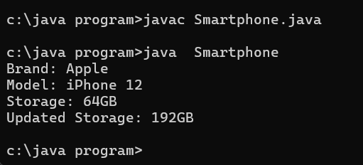

Output:

c:\java programs>javac Smartphone.java

c:\java programs>java Smartphone

Brand: Apple

Model: iPhone 12

Storage: 64GB

Updated Storage: 192GB

c:\java programs>zz