7/26/2023

Ali Houssein Issa

Exams scheduling

MANAGEMENT System

Table of Contents

Table of Figures: 2

Abstract 3

Vision 4

Phases of the project 5

Key Features 7

Requirement 8

Project description 8

Requirements 9

Admin 9

Use case 10

Login-Register Use Case 10

Admin Use Case 11

Design 12

Data Modeling 12

Context data model 12

Key-base data model 13

Fully attributed data model 13

DFD Diagrams 14

Context Diagram 14

Level zero DFD Diagram 15

Level 2 DFD Diagram 16

Conclusion 19

# Table of Figures:

Figure 1-Login UseCase 10

Figure 2_Admin UseCase 11

Figure 3-Context Data Model 12

Figure 4-Key-base Data Model 13

Figure 5-Fully Attributed Data Model 13

Figure 6-Context Diagram 14

Figure 7-Level-0- DFD Diagram 15

Figure 8-Level-1-DFD Diagram 16

Figure 9-User DFD Diagram 16

Figure 10-User DFD Diagram 17

Figure 11-User DFD Diagram 18

Figure 12-User DFD Diagram 18

# Abstract

The Exam Scheduling Management System is a comprehensive and efficient solution designed to address the challenges faced in organizing and managing exam schedules. This system offers a streamlined approach to scheduling exams, reducing complexities and optimizing communication between educational institutions and students.

With the increasing number of students taking exams annually, the traditional manual methods of scheduling have become cumbersome and time-consuming. The Exam Scheduling Management System seeks to alleviate these issues by providing a user-friendly platform for effective coordination and communication.

Through this system, educational institutions can effortlessly organize exam schedules, allocate resources, and allocate invigilators without any hassle. Students, on the other hand, benefit from easy access to their exam schedules and can seamlessly plan their preparation.

The key features of the Exam Scheduling Management System include real-time updates on exam dates and venues, automated conflict resolution for overlapping exams, and personalized notifications for students and invigilators. Additionally, the system offers data analytics and insights to educational institutions for further improvement in scheduling and resource allocation.

By implementing this system, institutions can optimize their exam management processes, leading to enhanced efficiency, reduced administrative burden, and improved overall communication with students. The Exam Scheduling Management System is poised to revolutionize exam administration, making it a valuable asset for educational institutions seeking to enhance their examination processes.

# Vision

Before the examination period, the university prepares a schedule for administrating the exams and each campus distributes the sections of each course in the available auditoriums. The student’s task is to check in which auditorium and on which seat color he is. Schedules are posted on boards at the entrance of each building on the campus. For unrevealed reasons, the posted schedules show the course name and section without the instructor’s name. In general, students don’t memorize their sections.

During exams, student attendance is an essential process taken by all universities. Until these days, and in the era of technology, attendance is still taken in a way that requires the proctor to check the IDs of all students and take their signature using a paper sheet, and as a final step, the names of absent students are spelled loudly to assure their absence. On another hand, in important events, students are encouraged to attend and benefit from the events, therefore the university is willing to record the attendance of the students and give benefits to them for attending such events, which is currently done manually.

Many students enter the wrong auditorium and start solving their exams until the proctor notices the happened misconception, takes the student’s exam, and guides him to the right room to start a new one. This procedure wastes, in addition to an exam copy, a lot of the student’s exam time and stresses the students which may affect badly their performance in the exam. This also wastes the time of the proctor during the process of taking attendance using a paper sheet and checking the id of each student. Not only in the examination period but also in events, the university is facing a problem where important events usually have poor attendance rates.

We propose a system that aims to solve these problems where it can take the attendance of the students in the exams and guide them to the right room on one hand, and track their attendance in events in another hand.

## Phases of the project

Hypothetically, this project will pass through the following phases:

1. Engineering phase
2. Development phase
3. implementation phase
4. Testing phase
5. Deployment in the headquarter of the association.
6. Deployment in a community (all association sections)
7. Launch it as a service for different users

Based on these phases the project will decompose onto two stages.

The team working on this project will be limited to the first four phases 1, 2, 3 and 4.

Through these four first phases, we will pass through the following:

1. Engineering phase: it will include research, conceptualization, feasibility assessment, establishing design requirements, preliminary design, detailed design, and production planning and tool design.
2. Development phase: where we study the process of scoping, planning, staffing, organizing, directing, and controlling the development of the system at a minimum cost within a specified period.
3. Implementation phase: involves putting the project plan into action. The project takes shape during this phase. This phase involves the construction of the actual project result. Programmers are occupied with encoding, designers are involved in developing graphic material, and contractors are building.
4. Testing phase: is where we focus on investigation and discovery. During this phase, developers find out whether the code and programming work according to customer requirements, and we use the results to reduce the number of errors within the software program.

Following this last phase, the project can pass to another level and be deployed for production with multiple options and scenarios, and now we can start with the second stage.

Below we list the most important phases in this stage:

1. Develop additional documents for the needed material like computers, and servers for the management of the data in the state administration after deployed in one state.
2. Helps the sections of the association to set strategies on how these sections can collaborate which each other and exchange data.1
3. Propose a plan to transform this idea and project into a business/service (includes software, materials, suppliers....)

## Key Features

Some of the features that the software will provide are:

* Our application is based on both software and hardware. The hardware needed is a barcode reader at the entrance of each auditorium. The reader is driven by a tablet used for displaying info and communicating with the database.
* The software is a web application with a university-side running on the tablets and a server-side managing students’ access to auditoriums. Recorded attendance and needed data are stored in a database.
* Students receive their seat number, color and room through emails containing their own barcode.
* After scanning the barcode, a message is sent into your account that is found in the Web application

The admin can insert student by adding an excel file that contain (student name, majors, and the courses)

# Requirement

## Project description

ESMS is tailored to meet the specific needs of educational institutions, providing a user-friendly interface for scheduling exams, allocating resources, and managing invigilators seamlessly. By automating the scheduling process, the system eliminates the hassles of manual coordination, reducing administrative burden, and optimizing communication.

## Requirements

### Admin

* The Admin shall be able to login.
* The Admin shall be able to create User.
* The Admin shall be able to update user
* The Admin shall be able to create role
* The Admin shall be able to update role
* The Admin shall be able to create period
* The Admin shall be able to update period
* The Admin shall be able to create Room
* The Admin shall be able to update room
* The Admin shall be able to create Day
* The Admin shall be able to update Day
* The Admin shall be able to create course
* The Admin shall be able to update course
* The Admin shall be able to add students to course
* The Admin shall be able to check all the students
* The Admin shall be able to create schedule
* The Admin shall be able to edit profile
* The Admin shall be able to Reset password
* The Admin shall be able to check time conflict of the courses
* The Admin shall be able to check student conflict

## Use case

### Login-Register Use Case

This use case represents the process of login and registration.

The Admin should first send a request to register in the app, after accepted this request the Admin has the ability to login and benefits from the functionalities exciting in the app.

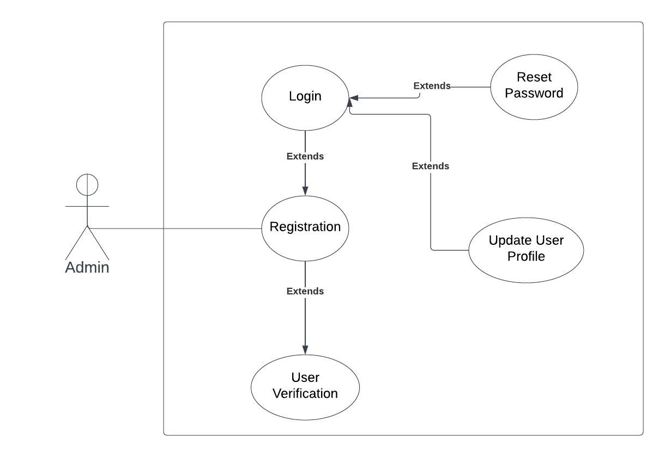

Figure -Login UseCase

### Admin Use Case

This use case represents the process and functionalities in the admin section.

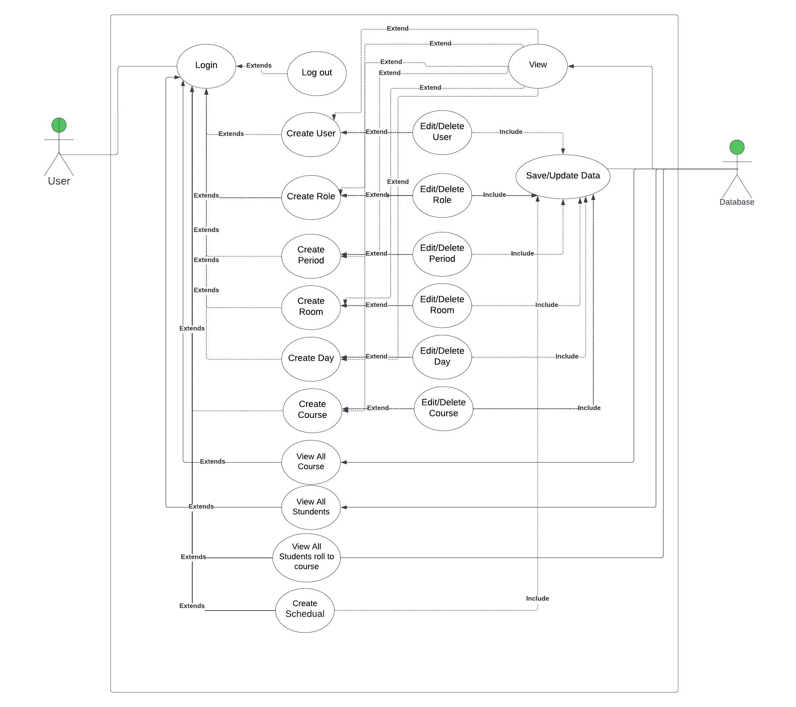

Figure _Admin UseCase

# Design

## Data Modeling

### Context data model

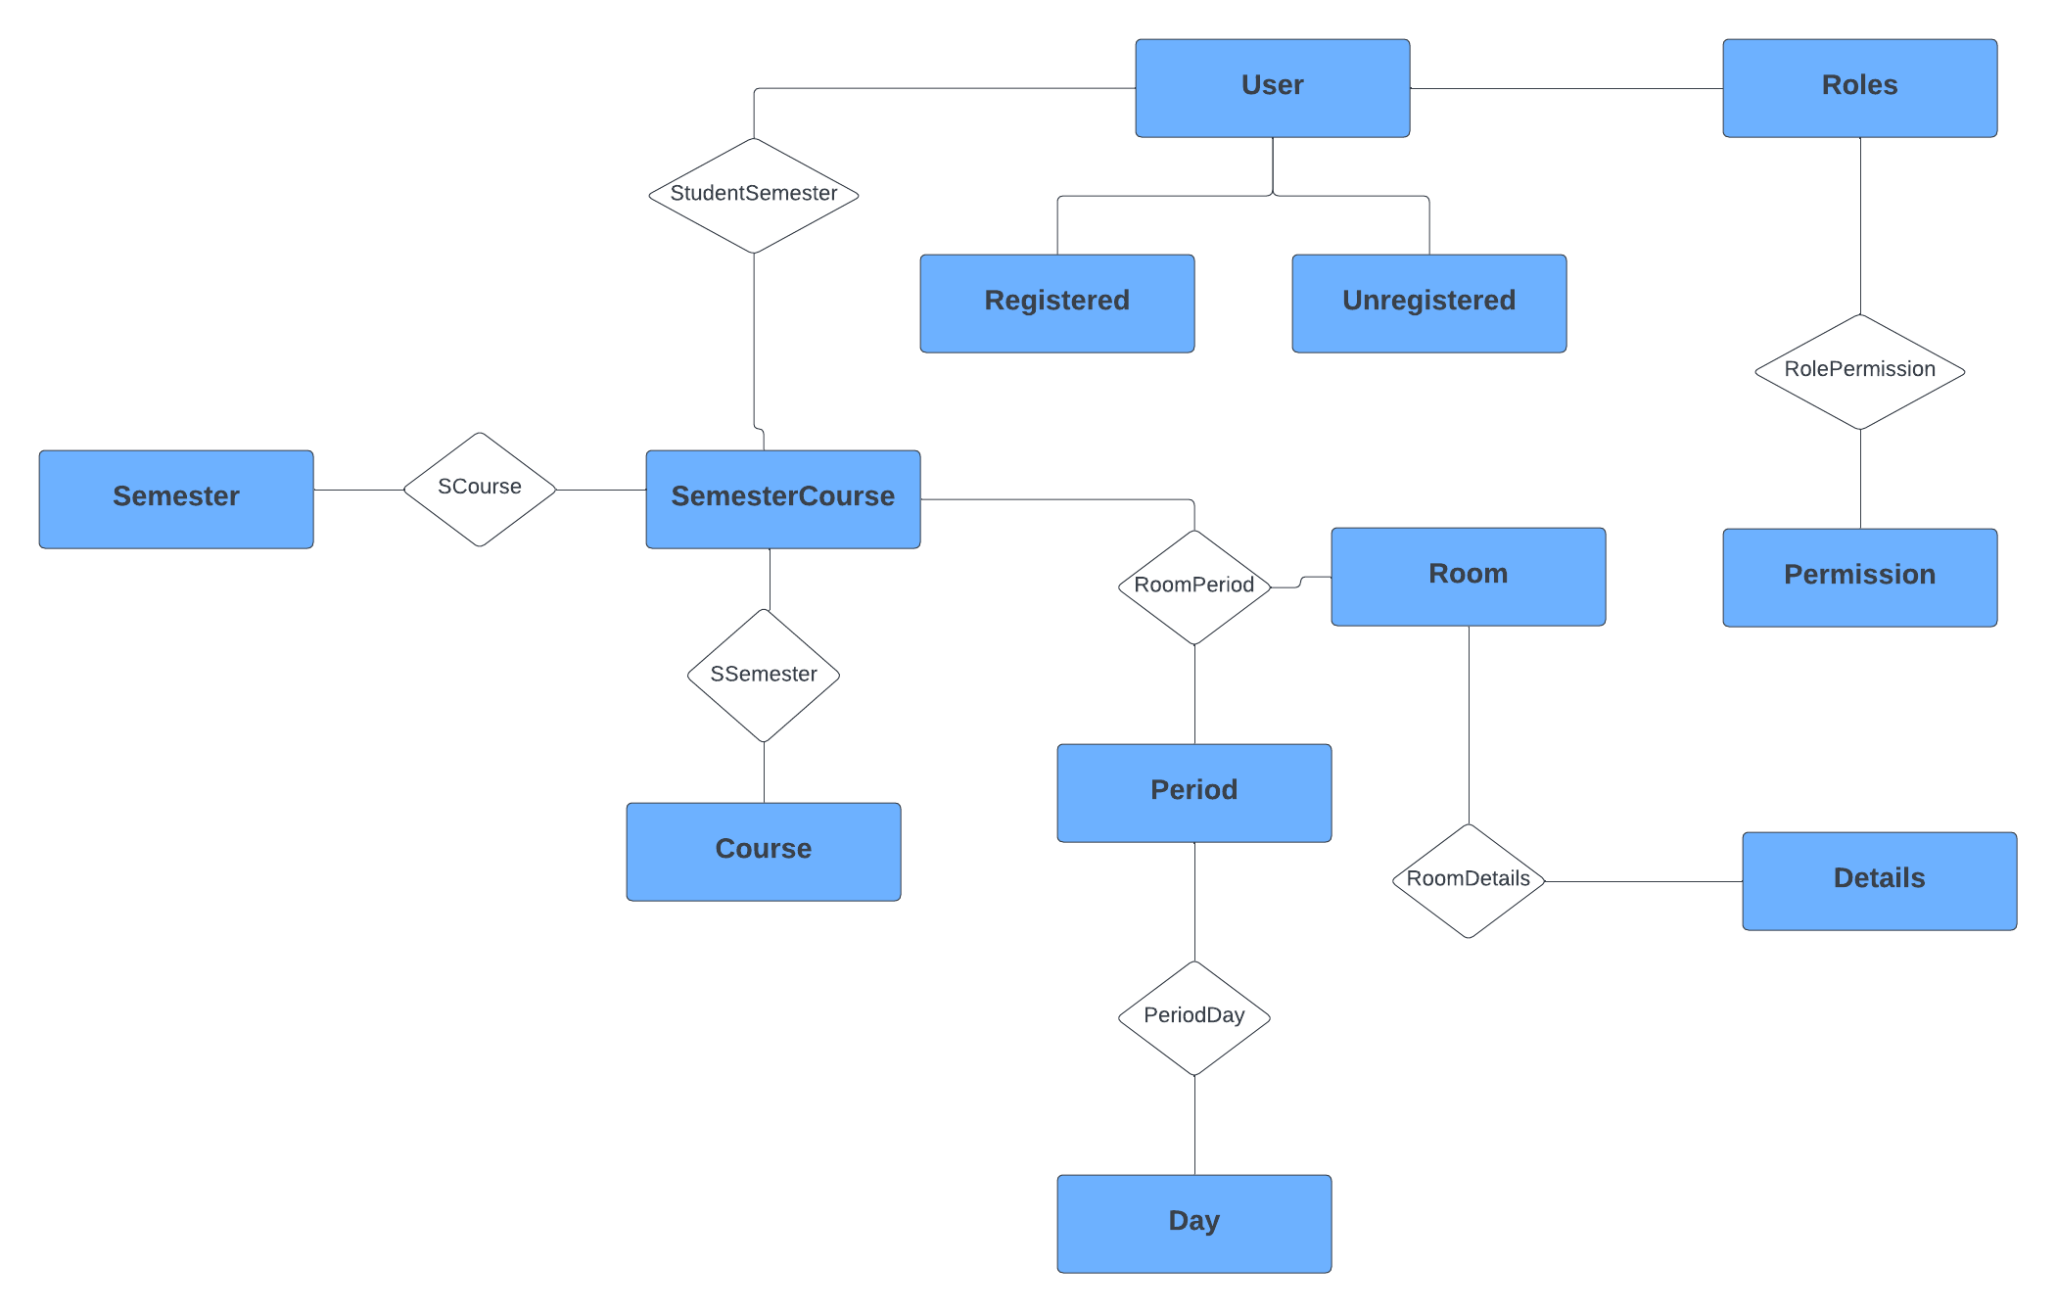

Figure -Context Data Model

### Key-base data model

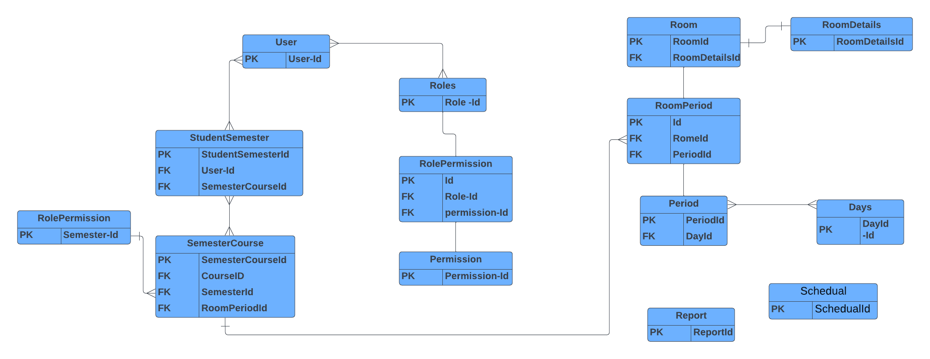

Figure -Key-base Data Model

### Fully attributed data model

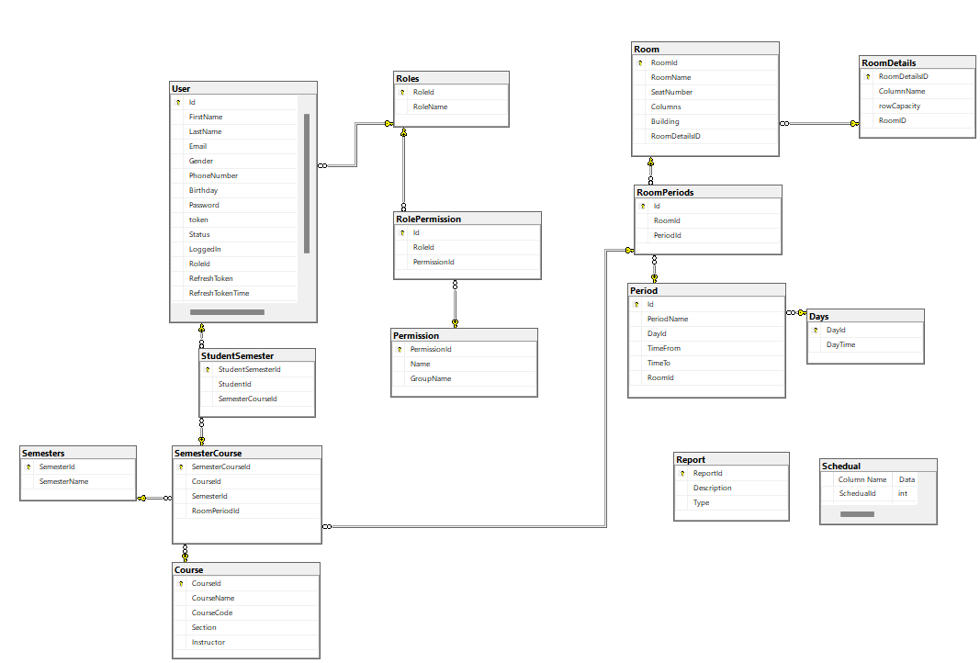

Figure -Fully Attributed Data Model

## 

## DFD Diagrams

### Context Diagram

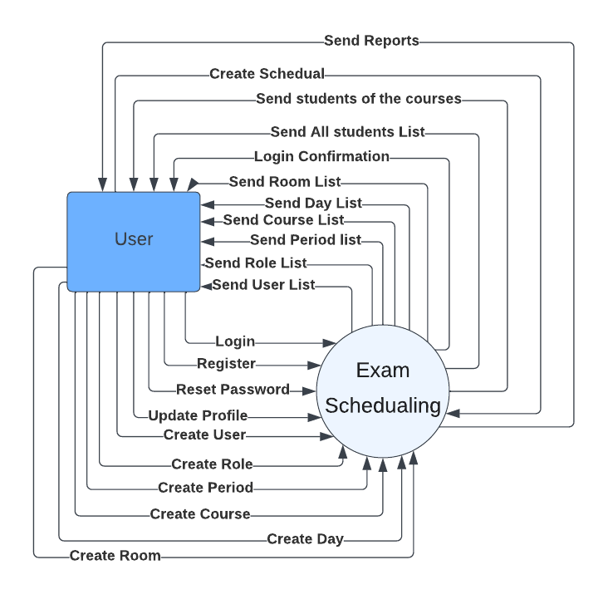

Figure -Context Diagram

Level zero DFD Diagram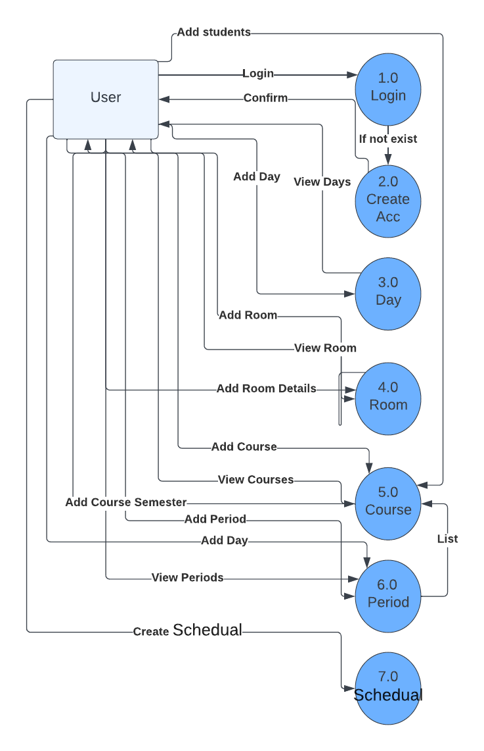

Figure -Level-0- DFD Diagram

### Level 2 DFD Diagram

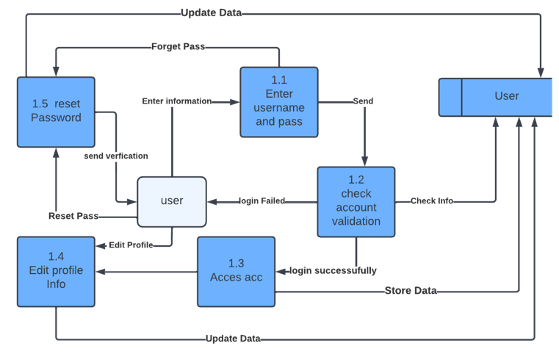

Figure -Level-1-DFD Diagram

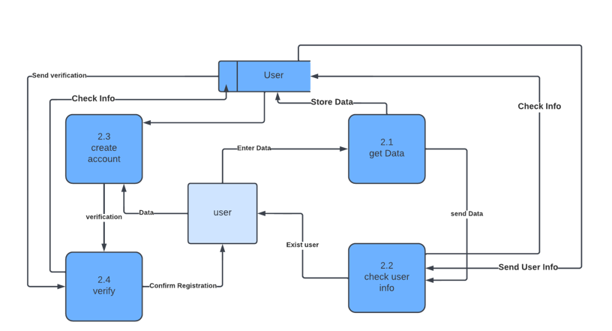

Figure -User DFD Diagram

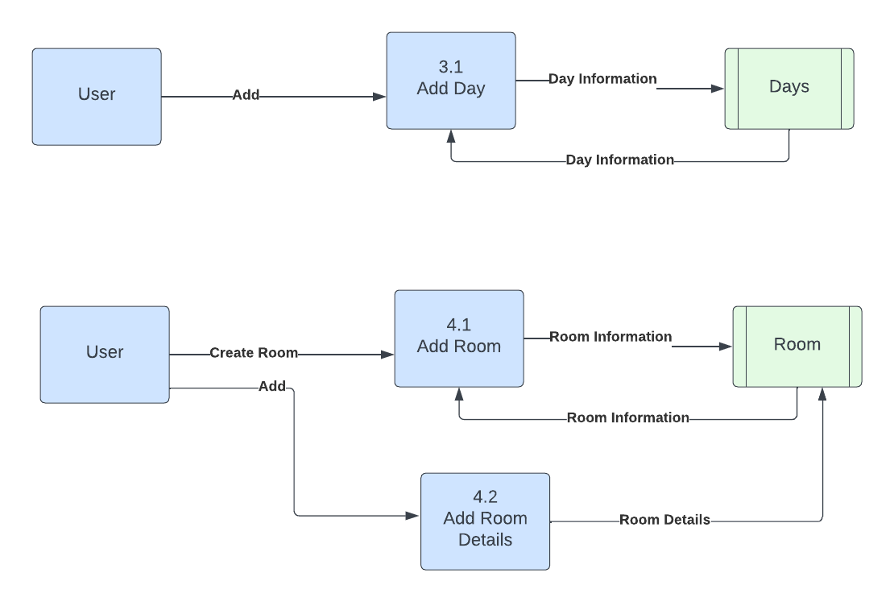

Figure -User DFD Diagram

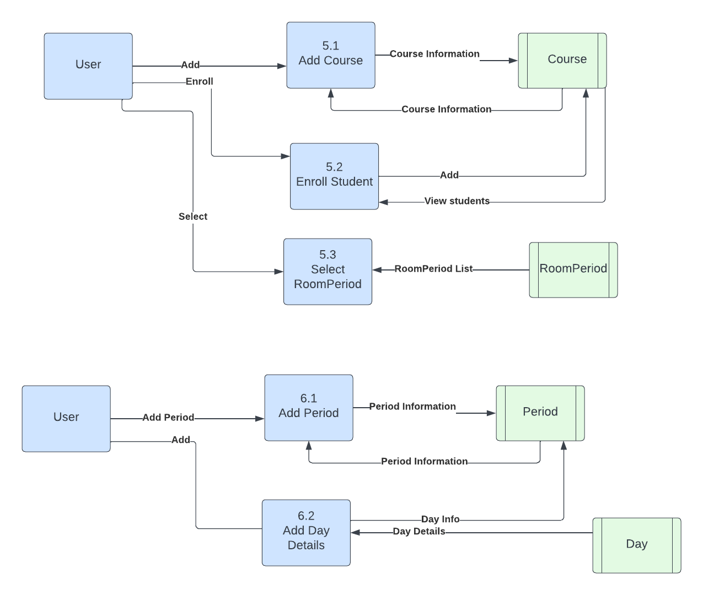

Figure -User DFD Diagram

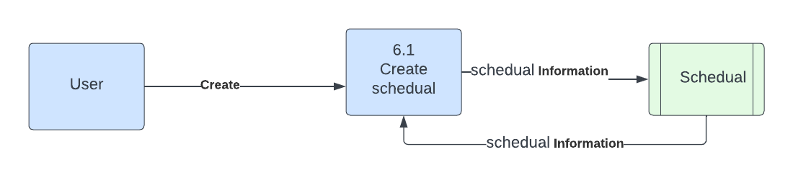

Figure -User DFD Diagram

# Conclusion

The Exam Scheduling Management System (ESMS) is a revolutionary solution that redefines the way educational institutions conduct and manage their exam schedules. By addressing the challenges associated with traditional manual methods, ESMS significantly enhances the efficiency, accuracy, and communication within the exam scheduling process. ESMS empowers educational institutions with a user-friendly platform to seamlessly organize and allocate exams, resources, and invigilators. The system's automated conflict resolution capabilities ensure a fair distribution of exams and reduce unnecessary stress for students. Real-time updates and personalized notifications enable students to access their exam schedules conveniently, empowering them to plan and prepare effectively. Through data analytics and insights, institutions can make informed decisions, optimizing resource allocation and refining their exam management procedures. This contributes to a more conducive learning environment and overall academic excellence. ESMS represents a paradigm shift in exam scheduling management, saving valuable time and effort for both educational institutions and students. By streamlining processes, reducing administrative burdens, and fostering effective communication, the system paves the way for a smoother and more efficient examination experience. In this rapidly evolving educational landscape, adopting ESMS is not just a recommendation; it is a necessity for institutions seeking to stay competitive, enhance student satisfaction, and deliver the best possible educational experience. As we embrace the future of education, the Exam Scheduling Management System stands as an invaluable ally in the pursuit of excellence, ensuring that the journey of learning remains focused, organized, and successful for all stakeholders involved.