

**A PROJECT BASED REPORT**

**ON**

**“DATA SCIENCE ASSISTING CRISIS MANAGEMENT”**

SUBMITTED TO THE

SAVITRIBAI PHULE PUNE UNIVERSITY

IN PARTIAL FULFILLMENT FOR THE AWARD OF THE DEGREE OF

BACHELOR OF ENGINEERING

IN

INFORMATION TECHNOLOGY

COMPOSED BY

**TITHI CHOUDHARY - 71815697J**

**SHREYA KHEDEKAR - 71815362G**

**MUSKAN SHAIKH - 71815614F**

**RICHA SIRWANI - 71815650B**

UNDER THE GUIDANCE OF

**DR. M.A. THALOR**

DEPARTMENT OF INFORMATION TECHNOLOGY

ALL INDIA SHRI SHIVAJI MEMORIAL SOCIETY’S

INSTITUTE OF INFORMATION TECHNOLOGY

PUNE - 411001

**2020 - 2021**



Department of Information Technology Engineering



**CERTIFICATE**

This is to certify that the project based report entitled **“Data Science Assisting Crisis Management”** being submitted by **Group I** is a record of bonafide work carried out by them under the supervision and guidance of **Dr. M.A. Thalor** in fulfillment of the requirement for **BE (Information Technology Engineering) – 2015 course** of Savitribai Phule Pune University, Pune in the academic year 2020-2021.

Date:

Place:

Dr. M.A. Thalor Dr. M.A. Thalor

Guide Head of the Department



This project-based report has been examined by us as per the Savitribai Phule Pune University, Pune, requirements at AISSMS Institute of Information Technology on “ANALYSING MACRO-ENVIRONMENTAL FACTORS, HENCE PROVIDING FUTURE ESTIMATES UNDER DIFFERENT DOMAINS – DATA INTELLIGENTLY”.

(Name & Signature) (Name & Signature)

Internal Examiner External Examiner

I

**ACKNOWLEDGEMENT**

We would like to express my sincere gratitude and deep regards to my guide Dr. M.A. Thalor for providing her invaluable guidance, comments and suggestions throughout the course of the project. We would like to thank her for constantly motivating us to work harder, that will help us in the journey of our future aspirations on which we are about to embark on.

Also, we would like to thank the faculty of the Information Technology Department for their assistance and providing valuable information in their respective fields. We are grateful for their cooperation during the period of the assignment.

Group I

BE IT

AISSMS IOIT, Pune.

II

**ABSTRACT**

Since the time of evolution, no matter how much the human race advances in relative fields, natural calamities or disastrous emergencies still creates a drastic impact in our lives. In such circumstances, the state of affairs needs to be handled efficiently. This management should not only cover the nation-wide extremities, but also look into the livelihood of its people. A large amount of jobs, whether in primary, secondary or tertiary sectors get affected equally. There are countries of the world where the use of evolving technology is not a part of the management system. Thus, by introducing state of the art technologies, a major relief can be provided to various wage-earners. Through this project, we aim to build an application, that can analyze the current scenario in times of need, for instance the ongoing Covid-19 spread. We try to make a forecast based on the past data available, to see the outspread intensity in coming next few days. Based on the investigation, we plan on providing future estimates in different working domains, that will ultimately help them in their steady income, erstwhile assisting them in their overall growth during such hardships. We try to take inferences from much older cases like that in the case of Spanish Influenza, how were the conditions then and how the various domains of work were affected. Through this, we will be able to dispense better solutions in the form of graphical representation, that will help the user to know by what estimates his/her domain will be affected, and based on the conclusion drawn, the user can implement several methods of conceal.

III

**Contents**

Certificate I

Acknowledgement II

Abstract III

List of Figures IV

List of Tables V

List of Graphs VI

List of Abbreviations

|  |  |  |  |  |  |  |  |  |  |  |  |  |  |  |  |  |  |  |  |  |  |  |  |  |  |  |  |  |  |  |  |  |  |  |  |  |  |  |  |  |  |  |  |  |  |  |  |  |  |  |  |  |  |  |  |  |  |  |  |  |  |  |  |  |  |  |  |  |  |  |  |
| --- | --- | --- | --- | --- | --- | --- | --- | --- | --- | --- | --- | --- | --- | --- | --- | --- | --- | --- | --- | --- | --- | --- | --- | --- | --- | --- | --- | --- | --- | --- | --- | --- | --- | --- | --- | --- | --- | --- | --- | --- | --- | --- | --- | --- | --- | --- | --- | --- | --- | --- | --- | --- | --- | --- | --- | --- | --- | --- | --- | --- | --- | --- | --- | --- | --- | --- | --- | --- | --- | --- | --- |
| |  |  |  |  | | --- | --- | --- | --- | | **Sr.** | | **Chapter** | **Page No** | | **1.** |  | **Introduction** |  | |  | 1.1 | Project Introduction |  | |  | 1.2 | Motivation behind Project |  | |  | 1.3 | Objective of the work |  | | **2.** |  | **Literature Survey**  Literature Survey (Tabulated Form) |  | | **3.** |  | **Problem Statement/Definition** |  | | **4.** |  | **Project Requirement Specification** |  | | **5.** |  | **Systems Proposed Architecture** |  | | **6.** | 6.1  6.2 | **High Level Design of the Project**  Use-Case Diagram  Activity Diagram |  | | **7.** | 7.1  7.2 | **System Implementation**  Methodology – for selection of favorable algorithm  Algorithms  7.2.1. AutoRegressive Integrated Moving Average  7.2.2. Long-Short Term Memory  7.2.3. Extreme Gradient Boost (XGBOOST)  with Multioutput Regressor  7.2.4. Polynomial Neural Network |  | | **8.** |  | **GUI/Working Modules/Experimental Results** |  | | **9.** |  | **Project Plan** |  | | **10.** |  | **Conclusion** |  | | **11.** |  | **Bibliography in IEEE format** |  | |  |  |  |  | |  |  | **Appendices**   1. **Plagiarism Report of Paper and Project Report** 2. **Base Papers** 3. **Tools Used** 4. **Papers Published/Certificates** |  | |  |  |  |
|  |  |  |  |
|  |  |  |  |
|  |  |  |  |
|  |  |  |  |
|  |  |  |  |

**LIST OF FIGURES**

**Sr. No. Figure Name Page No.**

5.1 Systems Proposed Architecture 9

5.2 System Flow Architecture 10

6.1 Use-Case Diagram 11

6.2 Activity Diagram 12

7.1 Groupings Under GROOMS 15

9.1 Project Plan – Gantt Chart 20

IV

**LIST OF TABLES**

**Sr. No. Table Name Page No.**

1 Literature Survey

V

**LIST OF GRAPHS**

**Sr. No. Graphs Page No.**

VI

**LIST OF ABBREVIATIONS**

**Sr. No. Abbreviations Page No.**

1 Machine Learning – ML

2 Group of Optimized and Multi-source Selection – GROOMS

3 AutoRegressive Integrated Moving Average – ARIMA

4 Long-Short Term Memory – LSTM

5 Extreme Gradient Boost – XGBOOST

6 Polynomial Neural Network – PNN

VII

**CHAPTER 1**

**INTRODUCTION TO DATA SCIENCE ASSISTING CRISIS MANAGEMENT**

* 1. **Introduction to Project**

In circumstances where drastic emergent situation arises, it becomes difficult for the locality of the people to sustain their source of income, while working in varied domains. It creates impacts on not only small-scaled but also large-scaled industries in general, as being currently experienced in the Corona virus outbreak.

Our goal is to develop a state-of-the-art system to decrease the negative effect of the situation, by introducing the user of the application to info-graphic details according to the sector of work the user is a part of. The system will keep updating the current status of the situation, in our case the COVID-19 spread, while also giving user an opportunity to know the conditions for the next few days as required. In addition to the past datasets of covid, the inferences and patterns of effect on various domains of society will be calculated from some other old case studies, like in our case by making use of Spanish Influenza outbreak of 1918.

The process, combined with time-series methodologies of prediction and dynamic flow of data by automated machine learning will lead to optimized and accurate outputs; which will be in benefit during times of crisis.

* 1. **Motivation behind project topic**

In times when uncertainties play a major role in governing the lives of people, not knowing how the situation may transpire ahead, by what margin their work may get affected, a solution is required that can help the earners keep their income steady.

Although many predictive models are present in the scenario for forecasting the effects of the pandemic, our purpose is that while predicting the cause, we would be able to provide insights to the user for betterment of their domain.



* 1. **Aim and Objective(s) of the work**

1. Aim – The project aims to implement a system, that analyses the present scenario and forecasts the current pandemic circumstances, while providing insights to the application users of their respective domains.
2. Objective – In the proposed system, the objective is to design a structure to be Data Intelligent, i.e. based on the dynamic flow of data, predictions are being made precisely, and by the usage of info-graphics concept, the system is made interactive for the users to understand the effect of the pandemic on their domain, thus helping them to make positively calculated decisions.



**CHAPTER 2**

**LITERATURE SURVEY**

In this section, by using Table 2.1 we analyze the papers based on their description of methods and solutions being used which we can implement to solve the problem statement. Through this comparison via advantages and disadvantages, we can make an accurate judgement of what will fetch us the desired results.

**Table 2.1:** Literature Survey



|  |  |  |  |  |
| --- | --- | --- | --- | --- |
| **Sr. No.** | **Author(s)** | **Names of Paper** | **Advantages** | **Disadvantages** |
| 1. | Shinde, G. R., Kalamkar, A. B., Mahalle, P. N., Dey, N., Chaki, J., & Hassanien, A. E. | Forecasting Models for Coronavirus Disease (COVID-19): A Survey of the State-of-the-Art.  [1]. | Discussing various methods available for forecasting the spread of Corona Virus, majorly focusing in the areas of Mathematical Models as well as Machine Learning Models and hence providing solutions from recommendation systems. | However, forecasting is possible using these methods, there may be varied differences in output, based on the incubation period, unaccounted numbers of positive patients and there may also be lack of consistent update in the data. |
| 2. | Simon James Fong, Gloria Li, Nilanjan Dey, Rubén González Crespo, Enrique Herrera-Viedma. | Finding an Accurate Early Forecasting Model from Small Dataset: A Case of 2019-nCoV Novel Coronavirus Outbreak  [2]. | Implementing GROOMS (Group of Optimized and Multisource Selection) method , wherein we accept group of 5 data analytics models pertaining to construct forecast model. | The method of selection for the most suitable algorithm is preferable, but further in-depth investigation may be required for PNN model as there may be underlying factors of error in it, that may come up in later stages. |
| 3. | Kane, M. J., Price, N., Scotch, M., & Rabinowitz, P. | Comparison of ARIMA and Random Forest time series models for prediction of avian influenza H5N1 outbreaks  [3]. | Applying the methods of ARIMA (AutoRegressive Integrated Moving Average) and Random Forest to define which algorithm provides the best Result. | Although Random Forest is being focused in this section, we need to look at the fact that Random Forest algorithm mainly works on majority voting system; and hence the high frequency noises are also being recorded in the prediction values. |
| 4. | Azad, S., Poonia, N. | Short-term forecasts of COVID-19 spread across Indian states until 1 May 2020  [4]. | Making use of ARIMA algorithm to remove high frequency noises present in the data, simultaneously detecting local trends in it for accurate forecasting. Also including Holt’s method of squared mean transformation to stabilize variance in the dataset. | There are high chances of negative values also being predicted in the result which can be normalized by squared mean transformation. |
| 5. | Chimmula, V. K. R., & Zhang, L. | Time series forecasting of COVID-19 transmission in Canada using LSTM networks  [5]. | Use of LSTM (Long-Short Term Memory) for prediction, which produces sequence of output at the end of the complete processing. | Since LSTM focuses on memorizing the parameters of each block, this algorithm requires a large amount of resources as well as time to get trained and become ready for real-world applications. |
| 6. | Yoshiro Suzuki, Ayaka Suzuki, Shun Nakamura, Toshiko Ishikawa, Akira Kinoshita | ML model estimating number of COVID-19 infection cases over coming 24 days in every province of South Korea (XGBoost and MultiOutputRegressor)  [6]. | To carry out XGBOOST (Extreme Gradient Boost) in combination with MultiOutputRegressor, which in turn will provide multiple objectives for output variable. | If any errors are to occur, or the model is bound to fail at some point, it is indicated by the XGBOOST at very late stages of implementation. |
| 7. | Sujath, R., Chatterjee, J. M., & Hassanien, A. E. | A machine learning forecasting model for COVID-19 pandemic in India  [7]. | Performing linear regression, Multilayer perceptron and Vector autoregression method for desired results on the COVID-19 | Among the three concepts of ML, the best results are provided by MLP, as the output of previous nodes are fed as input to next set of nodes, that will reduce the amount of error in every proceedings. |
| 8. | Pai, C., Bhaskar, A., & Rawoot, V. | Investigating the dynamics of COVID-19 pandemic in India under lockdown  [8]. | Discusses challenges for all the countries to come up with effective public health and administrative strategies to battle against COVID-19 and sustain their economies. | Explains use of SIR model by Kermack and McKendrick for understanding the rates of increase or decrease in any kind of infectious disease occurring among the mass. |
| 9. | Ray, D., Salvatore, M., Bhattacharyya, R., Wang, L., Du, J., Mohammed, S., Mukherjee, B. | Predictions, role of interventions and effects of a historic national lockdown in India’s response to the COVID-19 pandemic: data science call to arms  [9]. | Analyzing the effect of historic lockdown, as well as concluding whether the period of lockdown should be extended or not. | It is concluded that even if the intervals of lockdown are changed and the process of unlock starts, there still needs to be restrictions implemented on socialistic and economic factors. |
| 10. | Singh RK, Rani M, Bhagavathula AS, Sah R, Rodriguez-Morales AJ, Kalita H, Nanda C, Sharma S, Sharma YD, Rabaan AA, Rahmani J, Kumar P. | Prediction of the COVID-19 Pandemic for the Top 15 Affected Countries: Advanced Autoregressive Integrated Moving Average (ARIMA) Model  [10]. | Predictive analysis of 15 countries on COVID-19, using advanced ARIMA model. | By making use of advanced ARIMA, an introduction to the concept of AIK (Akaike’s Information Criterion) is added, which is useful for selecting predictors for regression. |



**CHAPTER 3**

**PROBLEM STATEMENT/DEFINITON**

The ideology of this project is to analyze various macro factors that affects the economy when emergent situation arises unexpectedly in the vicinity. Thus, by various classifications and automated theories, we can easily conjugate the reasons of loss of income in varied sectors of work, hence providing future estimates and solutions respectively.

Some of the pre-requisite keywords for the problem at hand are as follows,

1. Data Mining
2. Data Analytics
3. Data Visualization and Decision Making
4. Automated Machine Learning
5. Forecasting/Prediction



**CHAPTER 4**

**PROJECT REQUIREMENT SPECIFICATION**

In this section, we define the project requirement specifications, as well as the specs required by the actors of the project.

**Project Specifications:**

* Data Mining
* Data Analytics powered with AutoML,etc.
* Data Visualization
* A combination of Prediction,Decision Making,Business Intelligence
* A server side program in PYTHON with functions to operate the inflow of data at runtime and functions that deploy Api’s to the client side.

**User Requirements Specifications:**

* Chrome, Mozilla

**Amin Requirements Specifications:**

* Software Requirements-

1. Visualization Tool – Tableau
2. Python 3

* Hardware Requirements-

Operating System (Windows/Linux)



**CHAPTER 5**

**SYSTEMS PROPOSED ARCHITECTURE**

In the following representation in Fig. 5.1, structure of the system implementation of the project is explained via the diagram.













































Fig. 5.1. Systems Proposed Architecture



In the Fig. 5.2, a brief step by step system architecture flow of the project is given via the work-flow representation.



Fig. 5.2. Systems Architecture Flow



**CHAPTER 6**

**HIGH LEVEL DESIGN OF THE PROJECT**

This section summarizes the unified modeling concepts of the application being developed, i.e. representing the system visually along with its main actors, roles, actions being performed, classes defined; in order to better understand, alter or document the information related to the system.

**Design Classifications of the system:**

* 1. **Use-Case Diagram**

In Fig. 6.1, a simple representation of a user’s interaction with the application is represented. Added actors such as Application Administrator helps in management of the application overall.

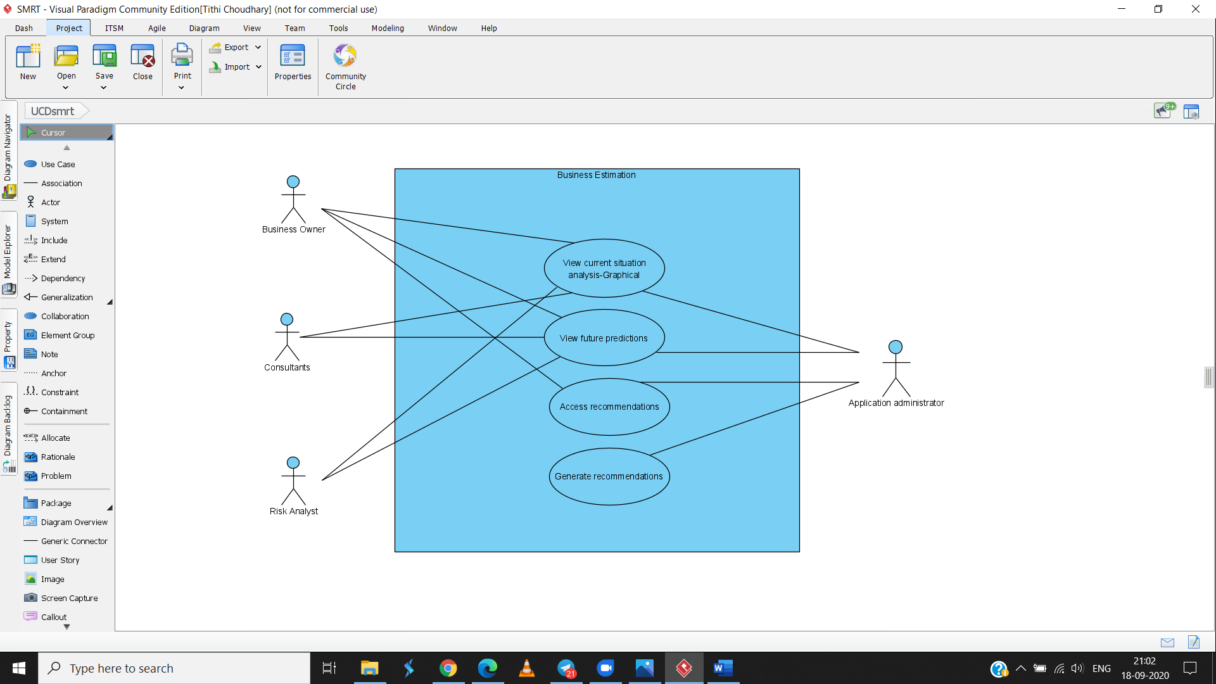

Fig. 6.1. Use-Case Diagram



* 1. **Activity Diagram**

Fig. 6.2 represents the activity diagram, that basically depicts the behavior of the system. Through this representation we can look into the start till the end application, while in between viewing the various decision paths being estimated.

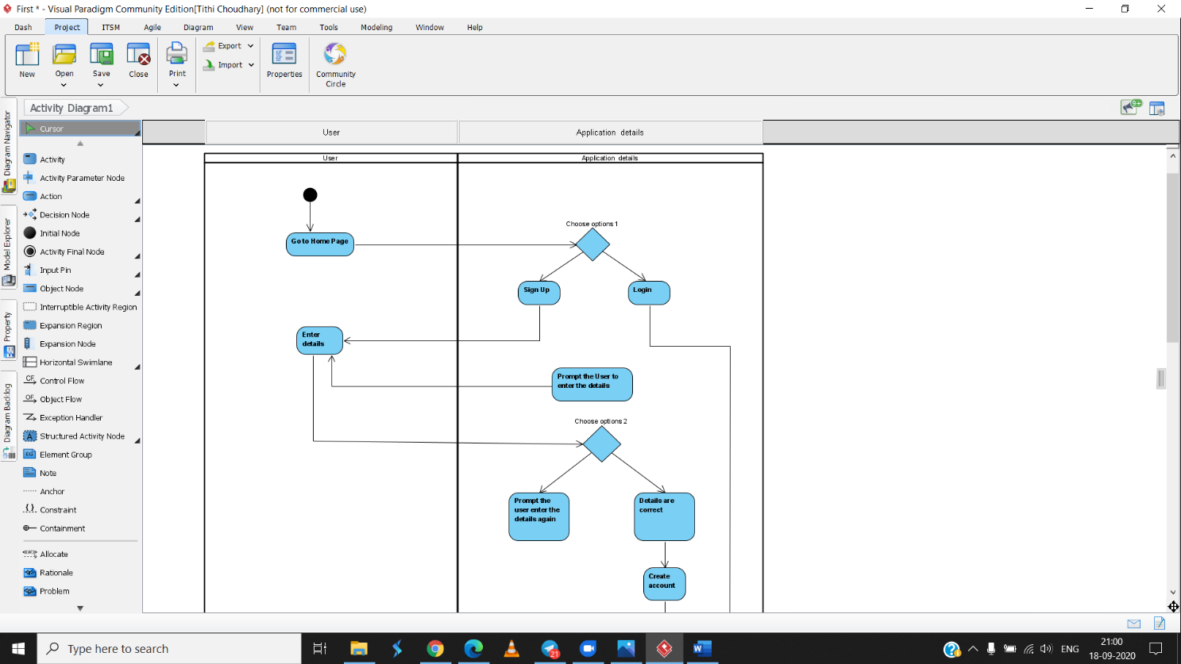

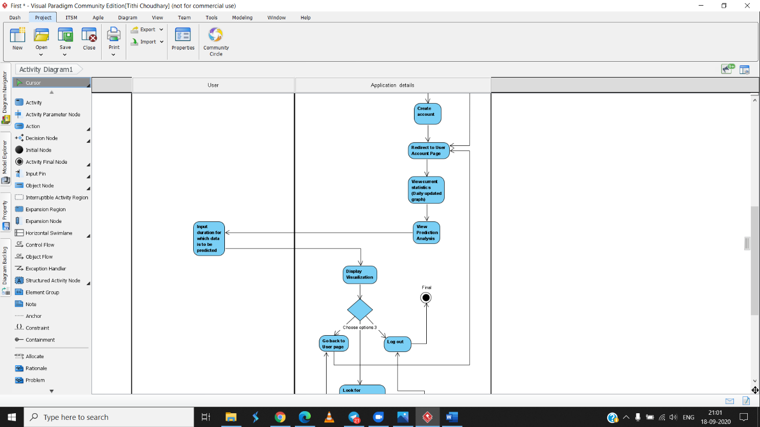



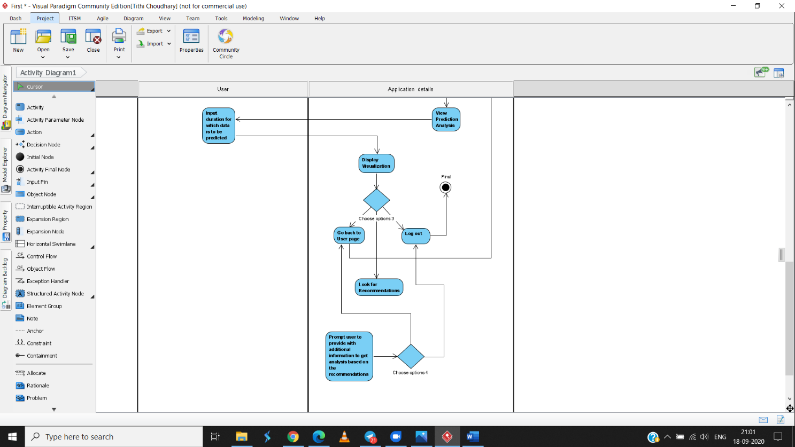

Fig. 6.2. Activity Diagram



**CHAPTER 7**

**SYSTEM IMPLEMENTATION**

The following section gives a detailed insight intomethod of development and procedures, algorithms, methodologies and various other aspects that will be brought in use for the working problem case. The goal is to do a thorough analysis for the implication of best fit models and algorithms that will make the system effective.

Before the process of selection of algorithms for the proposed work, we need to focus on data at first. Since there may be large variability in the datasets, containing high anomaly values and other white noises; it becomes necessary to clean and normalize the data for standard results. Since our suggested system may require data from various sources with dynamicity, the origin of the sources may be very different from each other. Thus, data cleaning becomes an integral part of the process.

We plan on using past datasets of economic conditions during pandemics such as the case in Spanish Influenza of 1918. Based on the patterns being instigated through the data, and based on the present-day forecasting of corona virus spread, the plan of action is to give a summarized detail of what may come forward in the sector the user works in.

* 1. **Methodology – for selection of favorable algorithm**

In the current case-scenario, a very less amount of data is available. Due to this severely fast developing epidemic conditions, our model needs to be working among high uncertainties. Thus, in order to select the most appropriate and accurate algorithm, we will be making use of an extensive selection method, named as Group of Optimized and Multisource Selection, abbreviated as GROOMS. This method is specifically designed in order to achieve highest rates of prediction with limited resource. This design is being used for group forecasting, by making use of algorithms, some of which are capable of taking multiple sources of input.

After comparison among various optimized methods, the one that produces highest prediction accuracy and lower Root mean squared error (RMSE) will be implemented for defining the forecast on rate of growth/decline in spread of the virus. In the main, we take five groups of data analytics that are in relevance to constructing a forecast model.

A brief explanation of types of group of algorithms being used for favorable algorithm prediction is represented below in Fig. 7.1.





Fig. 7.1. Grouping under GROOMS.

* 1. **Algorithms**

Following are some of the algorithms to be implemented for model selection as mentioned above in the GROOMS methodology.

* + 1. ***AutoRegressive Integrated Moving Average (ARIMA)***

An autoregressive integrated moving average model is a type of time-series forecasting method, that measures the solidity of one dependent variable with respect to other changing variables in relation. When dealing with real-time data, most of them are not represented in a stationary form as they are successively update in certain time frames. Thus, such models are required to have dth difference of the time-series to be calculated in order to form stationary data for that time stamp.

* + 1. ***Long-Short Term Memory (LSTM)***

LSTM’s are a special case of RNN, that are capable of learning long-term dependencies. This algorithm is especially designed to avoid the long-term reliance, because remembering information for larger proportions is their default behavior. In one block of LSTM cell, three types of gates are represented: input gate, that manages the flow of data into the cell, forget gate, that specifies the extent for which the value may remain inside the cell and output gate, that governs the fact that how much of the value inside cell is to be computed for output activation.



* + 1. ***Extreme Gradient Boost (XGBoost) with Multioutput Regressor***

XGBOOST is an ensemble technique. Sometimes based on one model, it is not enough to conclude our findings. Thus, this model implies the power of multiple learners. In addition to this, Multioutput Regressor functionality can be introduced, so as to achieve multiple real-valued output/target variables. The output can be of binary form, which makes it fall under multi-label classification; whereas discreet valued outputs are defined as multi-dimensional classification

* + 1. ***Polynomial Neural Network (PNN)***

Polynomial Neural Network (PNN) is a model based on Group Method of Data Handling (GMDH) principle that focuses on making the structure fully automatic, whilst optimizing parameters. Hence, based on the complexity of model development, PNN iteratively expands the formation, until it is observed that no more expansion is required in the system based on the performance improvement. A PNN is simply a polynomial equation whose coefficients and their powers are modelled as weights and neurons.



**CHAPTER 8**

**GUI/WORKING MODULES/EXPERIMENTAL RESULTS**

In the following section, we travers through the User Interface Development of the application. These are currently the structured pages that will be an integral part of the system. Each page represents the modules of the project, that will be in later stages combined with the backend projections.



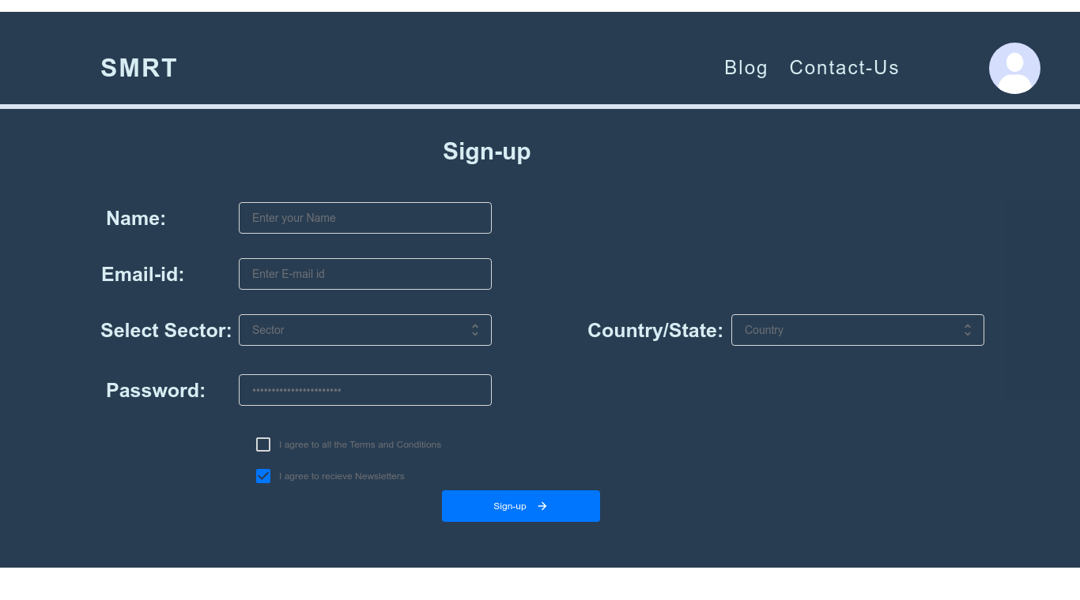



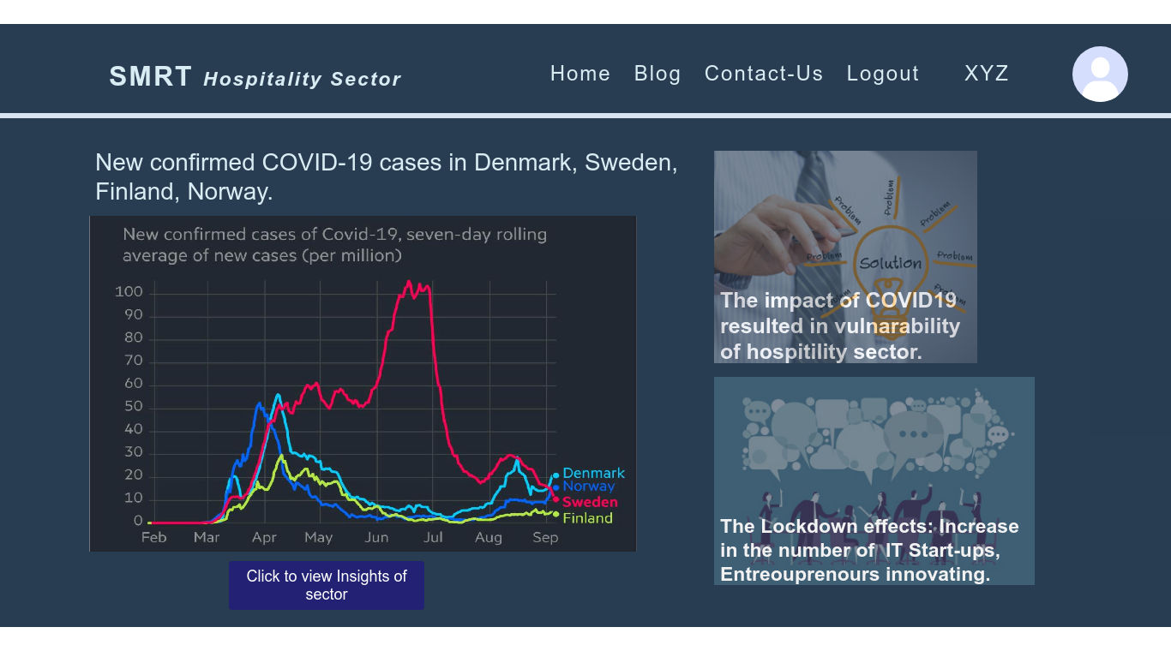

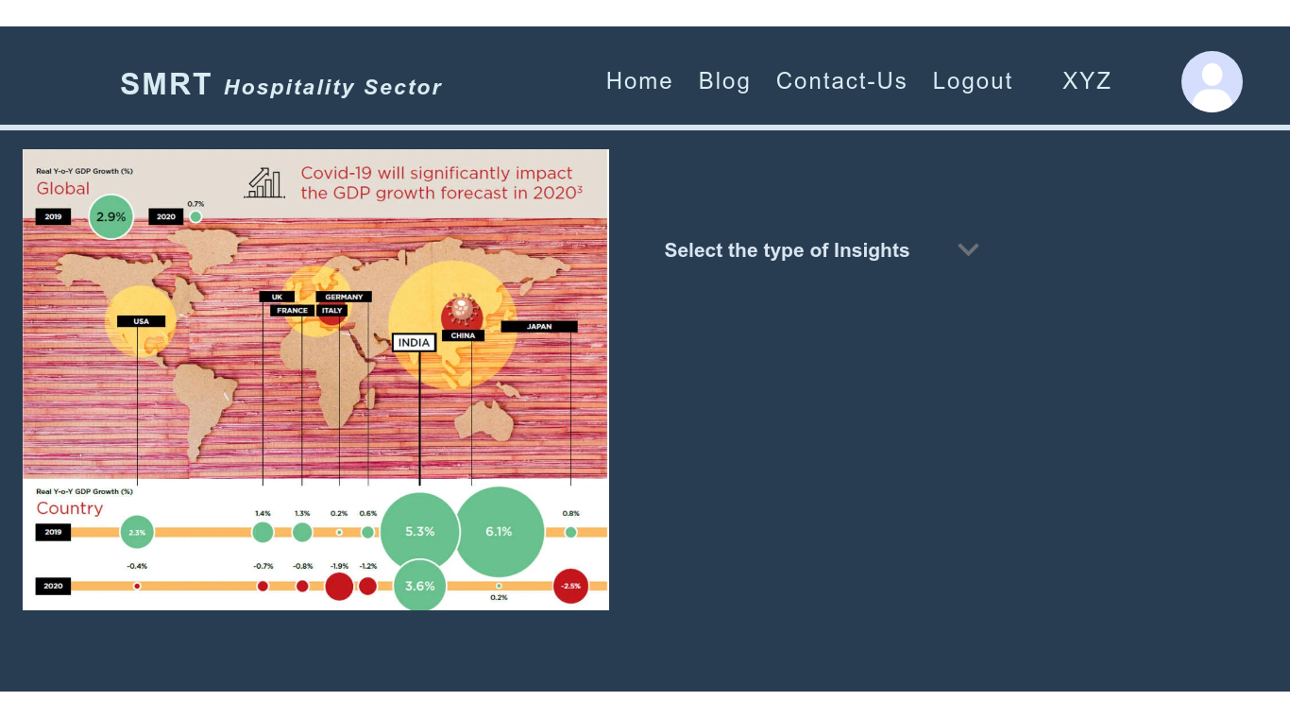



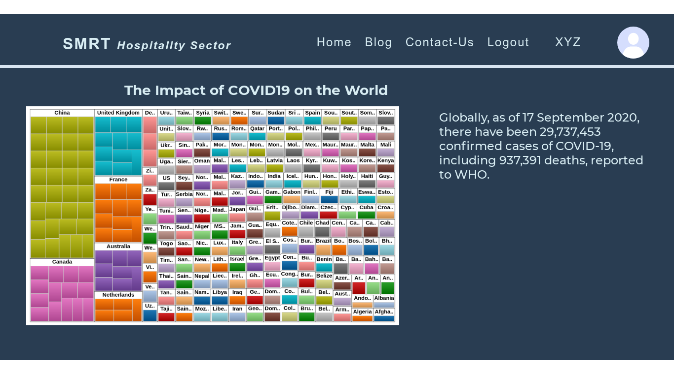

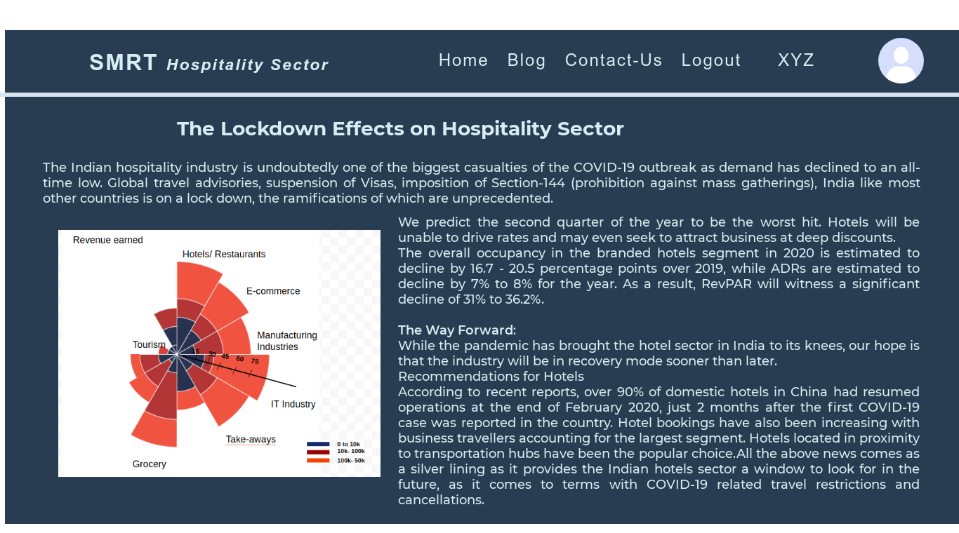



**CHAPTER 9**

**PROJECT PLAN**

Herein, we manage the time line of the project completion stages, by tabulating our work progress. Based on the Gantt Chart representation in Fig. 9.1, we can analyze that by when will we be able to execute the various stages of the system, as well as provide deliverables respectively.

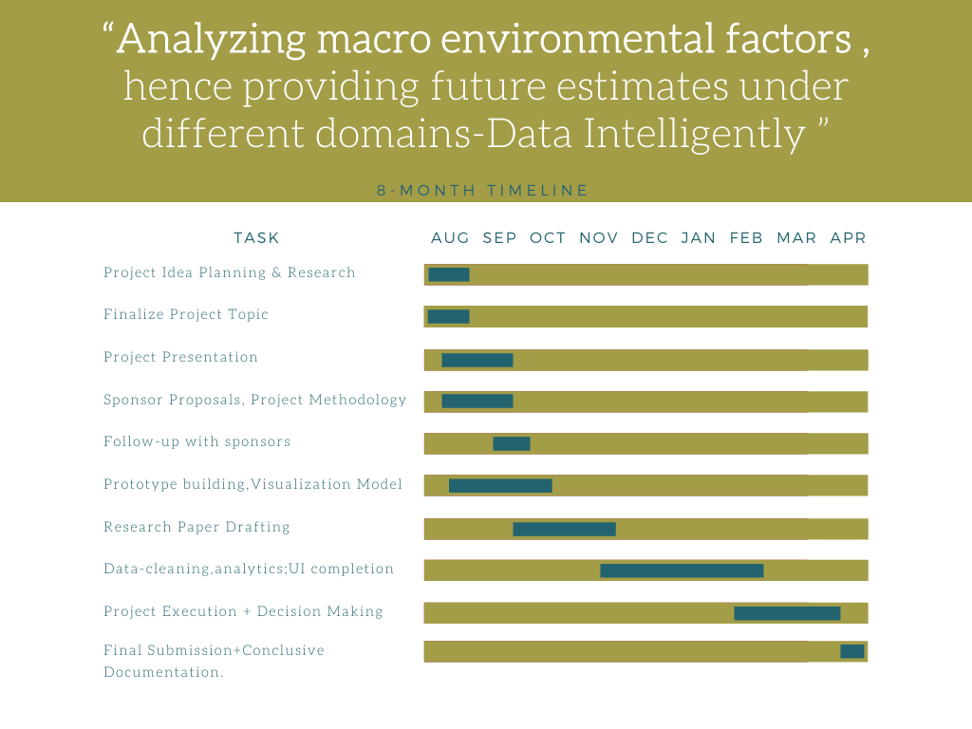

Fig. 9.1. Project Plan – Gantt Chart.

**CONCLUSION**

Through this report, we can conclude that the end product is a web-based application designed for users of various working domains for their stability of livelihoods, during uncertain situations of emergencies. The purpose of this project is to ease the lives of people who may be direct or indirect earners of an institution. Through methods of data analytics for prediction and other complex algorithms of development, decisions are being made to execute steps that can help the users exercise the correct measures during times of national pandemics. The user can understand the conditions of their respective sectors via user-friendly interfacing of the application and visual info-graphics of the output. The backend concludes the predictive analysis, pattern recognition in the acceleration/deceleration of the economic conditions of various working domains, as well as data visualization aspects of the system.

It is important to note that although various predictive analysis have been made in past few months on the pandemic situation, we take one step ahead in the field, to try the model at a large scale for efficient crisis management. This method, as a scope of future improvement can be useful for various other national emergencies in future.



**BIBLIOGRAPHY**

1. *“Forecasting Models for Coronavirus Disease (COVID-19): A Survey of the State-of-the-Art.”* Shinde, G. R., Kalamkar, A. B., Mahalle, P. N., Dey, N., Chaki, J., & Hassanien, A. E. (2020). SN Computer Science [1].
2. *“Finding an Accurate Early Forecasting Model from Small Dataset: A Case of 2019-nCoV Novel Coronavirus Outbreak”* Simon James Fong1, Gloria Li2 , Nilanjan Dey3 , Rubén González Crespo4 , Enrique Herrera-Viedma5 [2].
3. *“Comparison of ARIMA and Random Forest time series models for prediction of avian influenza H5N1 outbreaks.”* Kane, M. J., Price, N., Scotch, M., & Rabinowitz, P. (2014). BMC Bioinformatics [3].
4. *“Short-term forecasts of COVID-19 spread across Indian states until 1 May 2020”* Azad, S.; Poonia, N.*Preprints* 2020 [4].
5. *“Time Series Forecasting of COVID-19 transmission in Canada Using LSTM Networks.”* Chaos, Solitons & Fractals, 109864 [5].
6. *“Machine learning model estimating number of COVID-19 infection cases over coming 24 days in every province of South Korea (XGBoost and MultiOutputRegressor)”* Authors: Yoshiro Suzuki* 1 , Ayaka Suzuki* 2 , Shun Nakamura, Toshiko Ishikawa, Akira Kinoshita [6].
7. *“A machine learning forecasting model for COVID-19 pandemic in India.”* Stochastic Environmental Research and Risk Assessment. Sujath, R., Chatterjee, J. M., & Hassanien, A. E. (2020) [7].
8. *“Investigating the dynamics of COVID-19 pandemic in India under lockdown.”* Pai, C., Bhaskar, A., & Rawoot, V. (2020). Chaos, Solitons & Fractals, 138, 109988 [8].
9. *“Predictions, Role of Interventions and Effects of a Historic National Lockdown in India’s Response to the the COVID-19 Pandemic: Data Science Call to Arms.”* Ray, D., Salvatore, M., Bhattacharyya, R., Wang, L., Du, J., Mohammed, S., … Mukherjee, B. (2020), *Harvard Data Science Review* [9].
10. *“Prediction of the COVID-19 Pandemic for the Top 15 Affected Countries: Advanced Autoregressive Integrated Moving Average (ARIMA) Model. ”* Singh RK, Rani M, Bhagavathula AS, Sah R, Rodriguez-Morales AJ, Kalita H, Nanda C, Sharma S, Sharma YD, Rabaan AA, Rahmani J, Kumar P. JMIR Public Health Surveill 2020;6(2):e19115 [10].
11. “The lockdown effect: A counterfactual for Sweden” - Benjamin Born, Alexander M. Dietrich, Gernot J. Müller
12. “Visual Cues: Practical Data Visualization” - Peter R. Keller, Mary M. Keller, Scott Markel, A. John Mallinckrodt, and Susan McKay
13. Polynomial Neural Network - <https://scialert.net/fulltext/?doi=jai.2011.89.99>
14. A Gentle Introduction to XGBoost for Applied Machine Learning - <https://machinelearningmastery.com/gentle-introduction-xgboost-applied-machine-learning/>
15. Essentials of Deep Learning : Introduction to Long Short Term Memory - <https://www.analyticsvidhya.com/blog/2017/12/fundamentals-of-deep-learning-introduction-to-lstm/>



1. Autoregressive Integrated Moving Average (ARIMA) - <https://www.investopedia.com/terms/a/autoregressive-integrated-moving-average-arima.asp>
2. 5 Machine Learning Techniques for Sales Forecasting - <https://towardsdatascience.com/5-machine-learning-techniques-for-sales-forecasting-598e4984b109>



REVIEW-1 EVALUATION SHEET

(Attach original Copy)

Published paper in UGC Journal