Adobe Premiere Beginner Training Guide
  - A practical, step-by-step guide for students learning video editing

1. Introduction
Adobe Premiere is a professional video-editing application used to organize clips, build stories, improve sound and picture quality, and deliver finished videos. This guide introduces a simple workflow that beginners can repeat for class projects, social-media videos, interviews, presentations, and short films.

Learning objectives
By the end of this guide, students should be able to:
- Create and organize a Premiere project.
- Explain the basic stages of editing.
- Import and manage video, audio, and image files.
- Build and clean a rough cut.
- Finish a sequence with titles, audio adjustments, and basic color correction.
- Export a reliable MP4 file and check its quality.
Recommended practice project: Create a 60–90 second video using at least five video clips, one music track, one title, and one closing screen.

2. Course Outline
- Understand the editing workflow and interface.
- Set up a project and import media.
- Review clips and choose the best moments.
- Assemble and clean a rough cut.
- Create the final footage with sound, titles, transitions, and color.
- Export an MP4 and perform quality checks.
- Complete the quiz and final checklist.

3. Editing Concepts

The basic workflow
- Plan: Decide the purpose, audience, length, and message.
- Organize: Import files and arrange them in clearly named bins.
- Rough cut: Place the strongest clips in story order.
- Fine cut: Improve timing, continuity, sound, titles, and visuals.
- Export: Create the delivery file and review it outside Premiere.

Essential terms
- Project: The Premiere file that stores editing decisions and links to media.
- Sequence: The timeline where clips are arranged.
- Clip: A video, audio, or image item used in a sequence.
- Timeline: The editing area where time runs from left to right.
- Track: A horizontal video or audio layer in the timeline.
- In point and Out point: The selected start and end of a clip.
- Cut: The point where one shot ends and another begins.
- Transition: A visual or audio change between clips.
- Frame rate: The number of frames shown each second, such as 24, 25, or 30 fps.
- Resolution: The frame dimensions, such as 1920 × 1080.
Example: For a short campus video, begin with a wide establishing shot, follow with medium shots of activities, add close-ups for detail, and finish with a clear closing title.

4. Importing Videos and Organizing Media

Before opening Premiere
- Create one main folder for the project.
- Add subfolders named Video, Audio, Images, Graphics, Project Files, and Exports.
- Copy all source files into these folders before editing.
- Use clear file names, such as Interview_A_Take_01 or Campus_Wide_02.

Create and save the project
- Open Premiere and create a new project.
- Give the project a meaningful name and save it inside Project Files.
- Save immediately, then save regularly while working.

Import media
- Use the Media Browser or the Import workspace to locate the project folder.
- Select the required videos, audio files, and images.
- Import them into the Project panel.
- Create bins that match the folders on the computer.
- Open several clips in the Source Monitor and check picture, sound, orientation, and frame rate.
Best practice: Do not rename, move, or delete source files after importing them. Premiere links to their saved locations.
Example: Place interview clips in an Interviews bin, supporting shots in a B-roll bin, and music in an Audio bin.

5. Building and Cleaning the Rough Cut

Build the first version
- Create a sequence that matches the main footage settings.
- Review each clip and mark useful sections with In and Out points.
- Add selected clips to the timeline in story order.
- Focus first on meaning and structure, not effects.
- Keep an alternate sequence before making major changes.

Clean the cut
- Trim unwanted starts, endings, pauses, mistakes, and repeated ideas.
- Remove flash frames, accidental gaps, and clips with no purpose.
- Use Ripple Edit where appropriate so later clips close the gap.
- Check that cuts feel clear and natural.
- Listen for sudden changes in volume or distracting background noise.
- Use B-roll to cover a visible jump cut when it supports the story.

Simple decision test
For every shot, ask: Does it add information, emotion, context, or rhythm? If it adds none of these, shorten it or remove it.
Example: In an interview, remove a long pause between two sentences. If the speaker’s movement jumps, place a relevant close-up over the cut while keeping the interview audio continuous.

6. Creating the Final Footage

Refine the edit
- Watch the complete sequence without stopping and note confusing or slow sections.
- Adjust shot length and order to improve pace.
- Use transitions only when they communicate a change in time, place, or idea. A straight cut should be the default.
- Add opening, name, information, and closing titles where needed.
- Keep titles brief, readable, and inside safe margins.

Improve audio
- Balance dialogue so speech remains clear and consistent.
- Lower music under speech and use short fades at its beginning and end.
- Remove or reduce obvious noise when possible without making voices sound unnatural.
- Monitor the sequence with headphones and speakers.

Improve the picture
- Correct exposure and white balance before applying a creative look.
- Match neighboring shots so brightness and color do not change unexpectedly.
- Check that horizontal lines are level and important subjects are framed clearly.
- Use effects sparingly; every effect should support the message.

Final timeline review
Zoom into the timeline and scan from beginning to end for empty gaps, disabled clips, missing media warnings, abrupt audio edits, spelling errors, and unfinished graphics. Save a clearly named final sequence, such as ProjectName_Final_v01.

7. Export to MP4: Best Practices
- Select the final sequence and place the playhead at the beginning.
- Open the Export workspace.
- Choose H.264 as the format. This normally creates an .mp4 file.
- Start with a preset that matches the sequence and intended destination.
- Confirm the output name and save location in the Exports folder.
- Check that both Video and Audio are enabled.
- Confirm the frame size and frame rate match the intended delivery settings.
- For a standard Full HD project, use 1920 × 1080 and keep the source frame rate unless the assignment requires something different.
- Use a suitable bitrate: higher values usually improve quality but create larger files. For many 1080p class projects, a moderate target is a practical starting point.
- Choose a high-quality audio setting, commonly AAC at 48 kHz.
- Set the Source Range correctly so only the intended program is exported.
- Export, then play the entire MP4 outside Premiere.

Quality-control checks
- The file opens and plays from beginning to end.
- Picture and sound remain synchronized.
- No frames are missing, frozen, stretched, or unexpectedly black.
- Dialogue is clear and music does not overpower it.
- Titles are readable and correctly spelled.
- The file name, duration, resolution, and destination are correct.
Naming example: StudentName_ProjectTitle_Final_1080p.mp4
Important: Keep the Premiere project and original media after export. The MP4 is a delivery file, not an editable project backup.

8. Illustrated Step-by-Step Premiere Examples
The following guided examples use simplified interface illustrations. Button positions and labels may vary slightly by Premiere version and workspace layout.

Example 1: Import and Organize Media
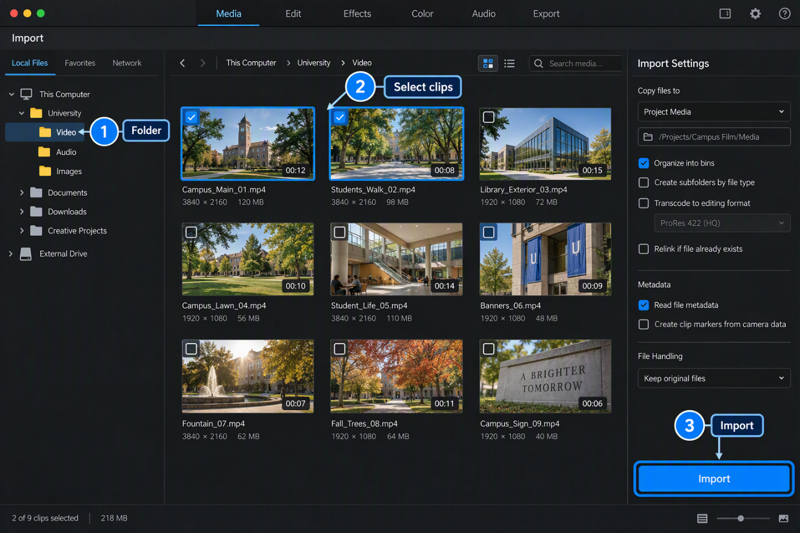
Illustration 1. Choose the project folder, select the required clips, and import them into organized bins.
- Open the Import workspace and browse to the project’s Video folder.
- Select the clips needed for the lesson.
- Check the destination and organization options.
- Select Import, then confirm that the clips appear in the Project panel.
Student task: Import three campus clips and place them in a bin named B-roll.

Example 2: Build and Clean a Rough Cut
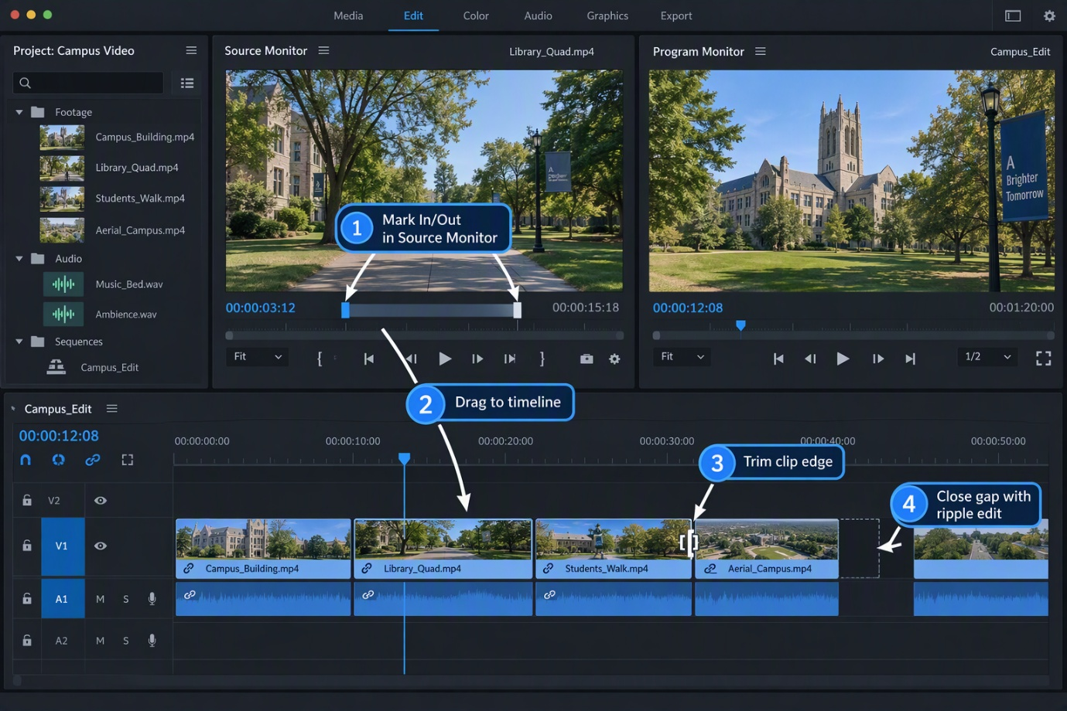
Illustration 2. Select the useful part of a source clip, add it to the timeline, trim its edge, and close unwanted gaps.
- Double-click a clip to open it in the Source Monitor.
- Mark an In point before the useful action and an Out point after it.
- Drag the selected section to the V1 track; linked sound appears on A1.
- Drag a clip edge to remove an unwanted start or ending.
- Use a ripple edit or ripple delete to close a gap without leaving empty space.
- Play across every cut and check that the story remains clear.
Student task: Assemble four shots into a 20-second sequence with no empty gaps.

Example 3: Add Titles, Balance Audio, and Correct Color
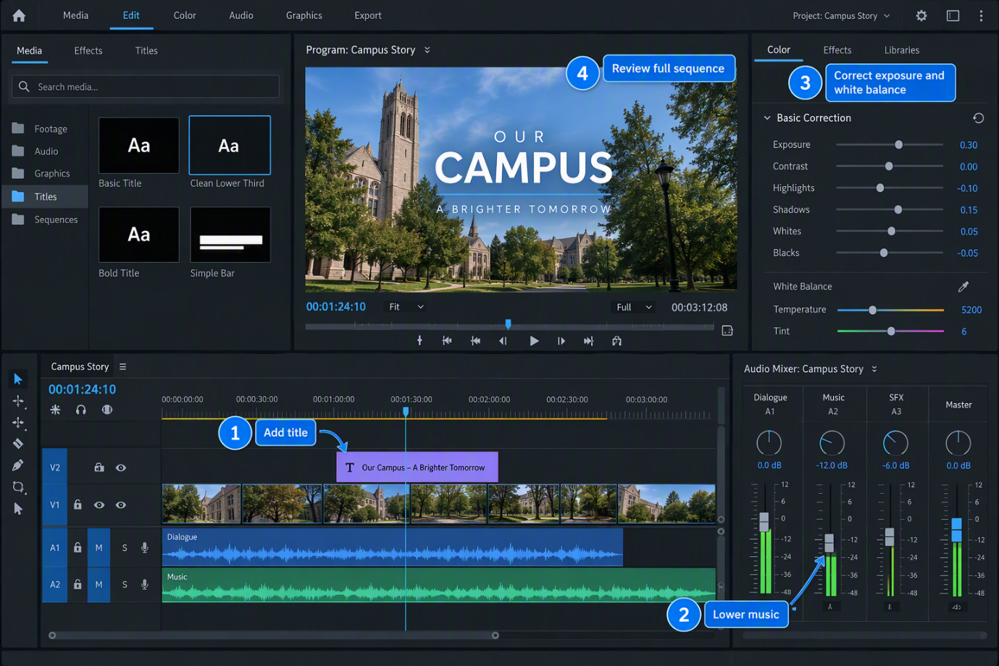
Illustration 3. Add a title on a higher video track, keep music below dialogue, make basic picture corrections, and review the full sequence.
- Add a simple title above the video on V2 and keep it on screen long enough to read.
- Place dialogue on A1 and music on A2 so each can be adjusted separately.
- Lower the music while speech is present; use headphones to check clarity.
- Correct exposure and white balance before adding a creative look.
- Watch the complete sequence and check titles, picture consistency, and audio transitions.
Student task: Add a five-second opening title, reduce the music under dialogue, and match the brightness of two neighboring shots.

Example 4: Export a Full HD MP4
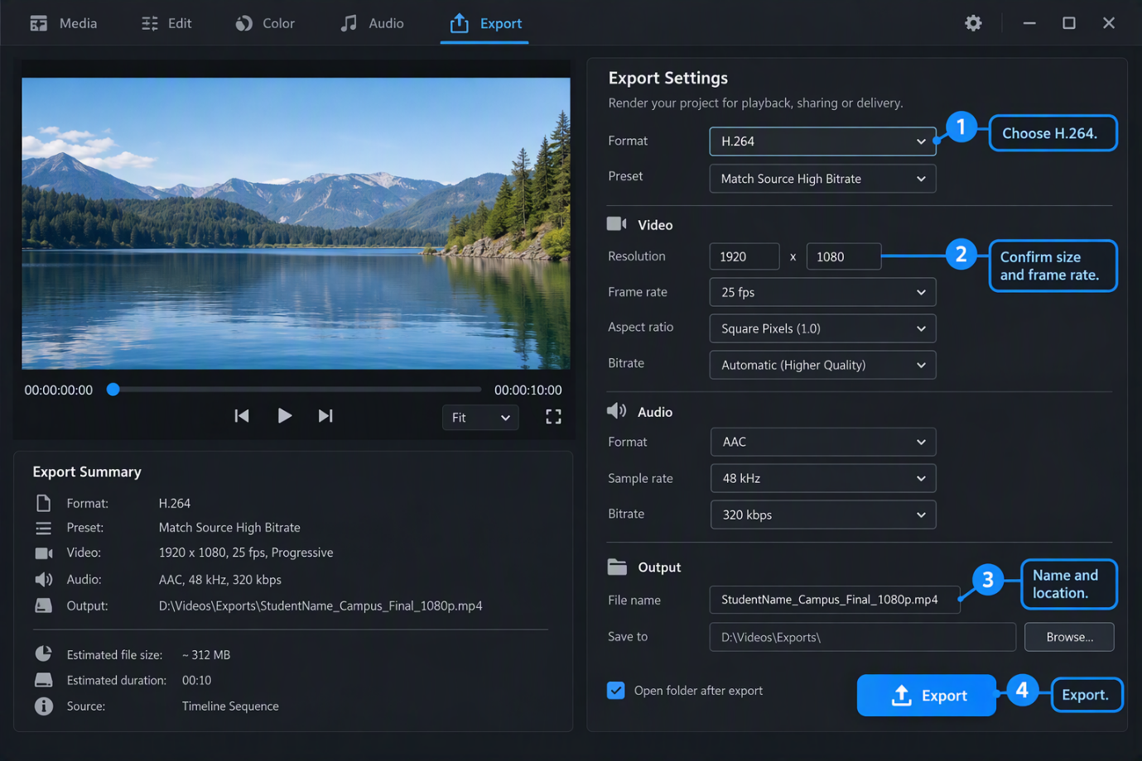
Illustration 4. Choose H.264, confirm the delivery settings, name the file clearly, and export the MP4.
- Open the Export workspace with the final sequence active.
- Choose H.264 and begin with a preset that matches the source.
- Confirm the required resolution and frame rate; the example uses 1920 × 1080 at 25 fps.
- Confirm that audio is enabled and uses AAC at 48 kHz.
- Enter a clear file name and choose the Exports folder.
- Select Export, then play the finished MP4 outside Premiere from beginning to end.
Student task: Export the practice sequence as StudentName_Campus_Final_1080p.mp4 and complete the quality-control checklist.

9. Suggested Training Schedule
Five-session beginner plan
Session | Topics | Practice task
1 | Interface, workflow, projects, sequences, and basic terms | Create a project and identify the main panels.
2 | Folder setup, importing, bins, Source Monitor, In and Out points | Import and organize all practice media.
3 | Timeline tools, story order, trimming, ripple edits, and B-roll | Build a 60–90 second rough cut.
4 | Fine cut, audio balance, titles, transitions, and basic color correction | Produce a polished final sequence.
5 | H.264 export, MP4 settings, quality control, and review | Export, test, and submit the final MP4.

10. Beginner Quiz
- What is the difference between a project and a sequence?
- Why should source media be organized before editing begins?
- What do In and Out points control?
- What is the main purpose of a rough cut?
- When is a straight cut usually better than a transition?
- Why might an editor place B-roll over an interview cut?
- Which export format commonly creates an MP4 file?
- Name three items to check after exporting.

Answer key
- A project stores editing information and media links; a sequence is the timeline where clips are arranged.
- Organization makes files easier to find and reduces broken links and mistakes.
- They define the selected beginning and end of a clip.
- It establishes the story, structure, and main timing before detailed finishing.
- When no special change in time, place, or idea needs to be shown.
- To add useful visual information or hide a visible jump cut while preserving the audio.
- H.264.
- Any three: complete playback, synchronization, picture quality, audio clarity, correct titles, correct duration, correct resolution, file name, or save location.

11. Final Checklist

Project and media
- All media is stored inside the main project folder.
- Bins and files have clear names.
- The project and final sequence are saved with version numbers.
- No media is offline or missing.

Edit and presentation
- The opening communicates the topic quickly.
- The story order is clear and the pace is appropriate.
- Unwanted pauses, mistakes, gaps, and repeated shots are removed.
- Transitions and effects are limited and purposeful.
- Titles are readable, consistent, and correctly spelled.
- Color and brightness are reasonably consistent between shots.

Audio
- Dialogue is clear and consistent.
- Music sits below speech and fades naturally.
- No sudden clicks, silent gaps, distortion, or distracting noise remains.

Export and submission
- Format is H.264 and the output file is MP4.
- Resolution, frame rate, source range, video, and audio settings are correct.
- The export uses the required file name and save location.
- The exported file has been watched from beginning to end outside Premiere.
- The Premiere project, original media, and exported MP4 are backed up.

Useful follow-up prompts
- Create a one-page outline from this guide.
- Add one classroom example to each section.
- Simplify this guide for younger or first-time learners.
- Turn this guide into a detailed training schedule with lesson timings.
- Create another quiz with multiple-choice questions and a separate answer key.

