

Data: November 22, 2015 # TX-098

SLOT PERFORATION PROGRAM

Well 199JTM1093W | API-4210333969 (vertical, injector) | ?

MAXXWELL PRODUCTION
Oil and gas well slotting perforation professional service

Business ID: NV20141386654
FEIN #: 35-2509442

Address: 848 N. Rainbow Blvd, 5353
Las Vegas, NV
United States
89107-1103

Toll free: 1.800.696.5721
Tel: 716.359.2559
702.932.1905
647.291.8707
306.700.3446

Email: info@maxxwell.net
info@maxxwell.us
info@maxxwell.ca
maxxwell@rogers.com

Internet: www.maxxwell.us
www.maxxwell.ca
www.maxxwell.net
www.oil-production.com

Submitted by:
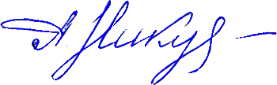

Anatoli Nikouline, CEO, C.E.T. OACETT, A.Sc.T. SASTT, SPE, UIA
/Oil and gas well slotting perforation professional service engineer/

Maxxwell Production appreciates the opportunity to present this proposal and looks forward to being of service to you.

Well 199JTM1093W | API-4210333969 (vertical, injector) | ?

TABLE OF CONTENTS

Description |  |  |  |  | Page
Design and Logging |  |  | . . . . . . . . . . . . . . . . . . . . . . . . . . . . . . . . . . . . . . . . . . |  | 3
 | Original design of the well 199JTM1093W |  | . . . . . . . . . . . . . . . . . . . . . . . . . . . . . . . . . . . . . . . . . . |  | 3
Summary geophysical express analysis |  |  | . . . . . . . . . . . . . . . . . . . . . . . . . . . . . . . . . . . . . . . . . . |  | 4
 | Perspective Intervals |  | . . . . . . . . . . . . . . . . . . . . . . . . . . . . . . . . . . . . . . . . . . |  | 4
 | Selection of intervals |  | . . . . . . . . . . . . . . . . . . . . . . . . . . . . . . . . . . . . . . . . . . |  | 4
 | Recommended intervals |  | . . . . . . . . . . . . . . . . . . . . . . . . . . . . . . . . . . . . . . . . . . |  | 5
Initial Data |  |  | . . . . . . . . . . . . . . . . . . . . . . . . . . . . . . . . . . . . . . . . . . |  | 5
 | Initial data |  | . . . . . . . . . . . . . . . . . . . . . . . . . . . . . . . . . . . . . . . . . . |  | 6
 | Selected intervals for cutting |  | . . . . . . . . . . . . . . . . . . . . . . . . . . . . . . . . . . . . . . . . . . |  | 6
Results of calculation of technological parameters HSP |  |  | . . . . . . . . . . . . . . . . . . . . . . . . . . . . . . . . . . . . . . . . . . |  | 7
 | Results of calculation of technological parameters |  | . . . . . . . . . . . . . . . . . . . . . . . . . . . . . . . . . . . . . . . . . . |  | 7
Technical Parameters (nozzles, erosion, rate, connection) |  |  | . . . . . . . . . . . . . . . . . . . . . . . . . . . . . . . . . . . . . . . . . . |  | 8
 | Connection |  | . . . . . . . . . . . . . . . . . . . . . . . . . . . . . . . . . . . . . . . . . . |  | 9
 | Flow Control valve |  | . . . . . . . . . . . . . . . . . . . . . . . . . . . . . . . . . . . . . . . . . . |  | 10
 | Pressure-Temperature-Cutting speed dependence |  | . . . . . . . . . . . . . . . . . . . . . . . . . . . . . . . . . . . . . . . . . . |  | 10
 | Tool 1 |  | . . . . . . . . . . . . . . . . . . . . . . . . . . . . . . . . . . . . . . . . . . |  | 11
 | Tool 2 |  |  |  | 12
 | Surface equipment scheme |  | . . . . . . . . . . . . . . . . . . . . . . . . . . . . . . . . . . . . . . . . . . |  | 13
 | Slotting perforation process graph |  | . . . . . . . . . . . . . . . . . . . . . . . . . . . . . . . . . . . . . . . . . . |  | 14
Slotting Perforation Program |  |  | . . . . . . . . . . . . . . . . . . . . . . . . . . . . . . . . . . . . . . . . . . |  | 15
 | Preparation for slot perforation process |  | . . . . . . . . . . . . . . . . . . . . . . . . . . . . . . . . . . . . . . . . . . |  | 16
 | Slot Perforation Process |  | . . . . . . . . . . . . . . . . . . . . . . . . . . . . . . . . . . . . . . . . . . |  | 17
 | Start |  | . . . . . . . . . . . . . . . . . . . . . . . . . . . . . . . . . . . . . . . . . . |  | 18
 | Slot perforation schedule |  | . . . . . . . . . . . . . . . . . . . . . . . . . . . . . . . . . . . . . . . . . . |  | 19
 | HSP |  | . . . . . . . . . . . . . . . . . . . . . . . . . . . . . . . . . . . . . . . . . . |  | 21
Safety and operational requirements |  |  | . . . . . . . . . . . . . . . . . . . . . . . . . . . . . . . . . . . . . . . . . . |  | 22
 | Emergency medical response procedure |  | . . . . . . . . . . . . . . . . . . . . . . . . . . . . . . . . . . . . . . . . . . |  | 24
 | Fire emergency procedure |  | . . . . . . . . . . . . . . . . . . . . . . . . . . . . . . . . . . . . . . . . . . |  | 25
 | Spill or release procedure |  | . . . . . . . . . . . . . . . . . . . . . . . . . . . . . . . . . . . . . . . . . . |  | 25
 | H2S emergency procedure |  | . . . . . . . . . . . . . . . . . . . . . . . . . . . . . . . . . . . . . . . . . . |  | 25
 | Emergency response for storm |  | . . . . . . . . . . . . . . . . . . . . . . . . . . . . . . . . . . . . . . . . . . |  | 26
 | Response to a bomb threat |  | . . . . . . . . . . . . . . . . . . . . . . . . . . . . . . . . . . . . . . . . . . |  | 27
 | Emergency medical information forms |  | . . . . . . . . . . . . . . . . . . . . . . . . . . . . . . . . . . . . . . . . . . |  | 28
Well 199JTM1093W |  | API-4210333969 (vertical, injector) |  | ?

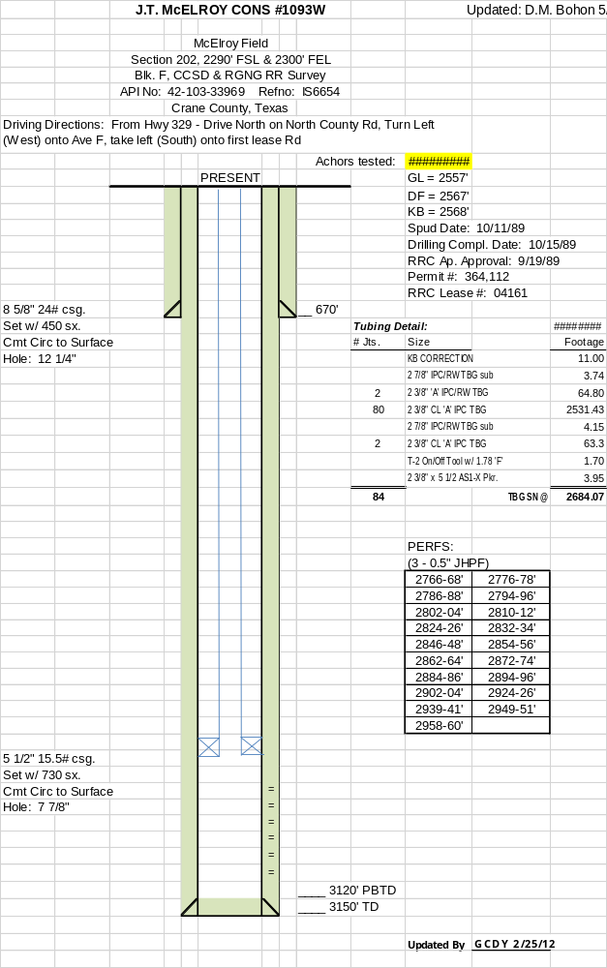
Well 199JTM1093W | API-4210333969 (vertical, injector) | ?

SUMMARY GEOPHYSICAL EXPRESS ANALYSIS

Background:
casing diameter (OD) | depth (ft.)
8-5/8” | 670
5-1/2” | 2684
7-7/8” | 3120
Perforated intervals: | 2776-78'
2766-68' | 2794-96'
2786-88' | 2810-12'
2802-04' | 2832-34'
2824-26' | 2854-56'
2846-48' | 2872-74'
2862-64' | 2894-96'
2884-86' | 2924-26'
2902-04' | 2949-51'
2939-41' | 2958-60'

Initial data:
● | well design
● | log
● | correlation
Results:
● | Layers-collectors highlights in the following intervals (Picture 1, 2)

# | top (ft.) | foot (ft.) | thickness (ft.) | note
1 | 2761 | 2793 | 32 | Layer E
2 | 2798 | 2802 | 4 | Layer E
3 | 2813 | 2820 | 7 | Layer E
4 | 2826 | 2830 | 4 | Layer D5
5 | 2834 | 2839 | 5 | Layer D5
6 | 2843 | 2854 | 11 | Layer D5
7 | 2861 | 2869 | 8 | Layer D5
8 | 2875 | 2910 | 35 | Layer D5
Sum |  |  | 106

● | Main injector interval 2890-2956’

Well 199JTM1093W | API-4210333969 (vertical, injector) | ?

Well 199JTM1093W | API-4210333969 (vertical, injector) | ?

● | Recommended intervals:

# | top (ft.) | foot (ft.) | thickness (ft.) | note
1 | 2761 | 2793 | 32 | Layer E
2 | 2798 | 2802 | 4 | Layer E
3 | 2813 | 2820 | 7 | Layer E
4 | 2843 | 2854 | 11 | Layer D5
5 | 2861 | 2869 | 8 | Layer D5
6 | 2875 | 2910 | 35 | Layer D5
Sum |  |  | 97

RECOMMENDED INTERVALS

# | top (ft.) |  |  | foot (ft.)
1 | 2848.0 |  |  | 2849.5
2 | 2846.0 |  |  | 2847.5
3 | 2844.0 |  |  | 2845.5
4 | 2791.0 |  |  | 2792.0
5 | 2789.0 |  |  | 2790.5
6 | 2787.0 |  |  | 2788.5
7 | 2779.0 |  |  | 2780.0
8 | 2777.0 |  |  | 2778.5
9 | 2775.0 |  |  | 2776.5
Sum |  |  | 12.5

INITIAL DATA

TD | 3150’
PBTD | 3120’
Treatment intervals: | 2844-2850’
Treatment intervals: | 2787-2792’
Treatment intervals: | 2775-2780’
OD Casing | 5.5”
Casing weight (lb. /ft.) | 15.5
Brand | J-55
ID Casing | 4.95”
Drift Casing | 4.85”
OD Tubing | 2.875”
ID Tubing | 2.0”
Drift Tubing-2 | 2.0”
OD Drill Bit | 7.87”
Bottom hole temp | 90⁰F / 32.2⁰C
Casing Collars

SELECTED INTERVALS FOR CUTTING

interval | lifting | depth | lifting | depth | process | depth | cutting | between | between
9 |  |  | ● lifting 2’ | ● 2775.0’ | ● start | 2775.0’ | ↓
9 |  |  | ↑ |  | ● length | 1.5’ | ↓
9 |  |  | ↑ |  | ● finish | 2776.5’ | ↓ | ↓
 |  |  | ↑ |  |  |  |  | 0.5’
8 |  |  | ● lifting 2’ | ● 2777.0’ | ● start | 2777.0’ | ↓ | ↑
8 |  |  | ↑ |  | ● length | 1.5’ | ↓
8 |  |  | ↑ |  | ● finish | 2778.5’ | ↓ | ↓
 |  |  | ↑ |  |  |  |  | 0.5’
7 |  |  | lifting 8’ | ● 2779,0’ | ● start | 2779.0’ | ↓ | ↑
7 |  |  | ↑ |  | ● length | 1.0’ | ↓
7 |  |  | ↑ |  | ● finish | 2780.0’ | ↓ | ↓
 |  |  | ↑ |  |  |  |  | 7’
6 |  |  | ● lifting 2’ | ● 2787.0’ | ● start | 2787.0’ | ↓ | ↑
6 |  |  | ↑ |  | ● length | 1.5’ | ↓
6 |  |  | ↑ |  | ● finish | 2788.5’ | ↓ | ↓
 |  |  | ↑ |  |  |  |  | 0.5’
5 |  |  | ● lifting 2’ | ● 2789.0’ | ● start | 2789.0’ | ↓ | ↑
5 |  |  | ↑ |  | ● length | 1.5’ | ↓
5 |  |  | ↑ |  | ● finish | 2790.5’ | ↓ | ↓
 |  |  | ↑ |  |  |  |  | 0.5’
4 |  |  | lifting 53’ | ● 2791.0’ | ● start | 2791.0’ | ↓ | ↑
4 |  |  | ↑ |  | ● length | 1.0’ | ↓
4 |  |  | ↑ |  | ● finish | 2792.0’ | ↓ | ↓
 |  |  | ↑ |  |  |  |  | 52’
3 |  |  | ● lifting 2’ | ● 2844.0’ | ● start | 2844.0’ | ↓ | ↑
3 |  |  | ↑ |  | ● length | 1.5’ | ↓
3 |  |  | ↑ |  | ● finish | 2845.5’ | ↓ | ↓
 |  |  | ↑ |  |  |  |  | 0.5’
2 |  |  | ● lifting 2’ | ● 2846.0’ | ● start | 2846.0’ | ↓ | ↑
2 |  |  | ↑ |  | ● length | 1.5’ | ↓
2 |  |  | ↑ |  | ● finish | 2847.5’ | ↓ | ↓
 |  |  | ↑ |  |  |  |  | 0.5’
1 |  |  | installation | ● 2848.0’ | ● start | 2848.0’ | ↓ | ↑
1 |  |  |  |  | ● length | 1.5’ | ↓
1 |  |  |  |  | ● finish | 2849.5’ | ↓

Well 199JTM1093W | API-4210333969 (vertical, injector) | ?

RESULTS OF CALCULATION OF TECHNOLOGICAL PARAMETERS FOR HSP

Casing area volume (inside) TD = 3150.0’ | 3150.0 gal / 75.0 bbl
Tubing area volume on the lowest position = 2775.0’ | 483.0 gal / 11.5 bbl
Tubing area volume on the highest position = 2849.5’ | 495.6 gal / 11.8 bbl
Average Volume (Well) TD = 3150.0’ | 3150.0 gal / 75.0 bbl
All Volume (Surface + Well) | 7660.8 gal / 182.4 bbl
Pump performers (Start) | 5.45 bbl./min
Pump performers (Finish) | 10.0 bbl./min
Water tank (surface) | 4510.8 gal / 107.4 bbl
Working pressure | 5000-5500 psi
Cutting (slotting) speed | 0.18 / 0.20 in / min (corrected during the operation)
Full length of the equipment (before tubing) | Tool: 11.2’, Pipe Joint: 6’, Marker: 4.1’, Total: 21.3’
Marker length | 4.1’
One section of tubing length | 31.5’
Installation of the first (initial) cutting interval | 2848’ (2846.36’) (Elongation 0.59-0.68 inches)
Shale shaker (on top of cuttings tank) | 1
Low pressure tubing plus connections | 98.4 ft
Standard BOP equipment | Frac valve + 8 stripper rubbers for frac valve
1 high-pressure (triplex) pump | 1
1 blender | 1
High pressure iron tubing & reverse flow manifold | 98.4 ft including connections
Frac van | 1
Non-soapy brine from nearby well | 3847.2 gal / 91.6 bbl
Friction reducer additive for | 65.6 ft or 3 water
Abrasive quartz sand (abrasive grit*) 10/35 or 20/40 | 38 tons (4 nozzles)
The distance between cuts (slots) | 0.5’
Time to reach the sand to the nozzles |  | ~ 2.5 min
Time to reach the sand to the surface |  | ~ 11-15 min
Pressure loss in tubing |  | ~ 42 / 34 psi
Pressure drop across the nozzles |  | ~ 500 psi
Friction coefficient |  | ~ 1.5
Pup joints |  | 2’ + 5’

# | Cutting interval | Action
* Initial position for the first cutting interval with taking into account the tubing’s elongation is 2847.36’
1 | 2848.0’-2849.5 (1.5’) | Lift up to 2’
2 | 2846.0’-2847.5 (1.5’) | Lift up to 2’
3 | 2844.0’-2845.5 (1.5’) | Lift up to 53’
4 | 2791.0’-2792.0 (1.0’) | Lift up to 2’
5 | 2789.0’-2790.5 (1.5’) | Lift up to 2’
6 | 2787.0’-2788.5 (1.5’) | Lift up to 8’
7 | 2779.0’-2780.5 (1.0’) | Lift up to 2’
8 | 2777.0’-2778.5 (1.5’) | Lift up to 2’
9 | 2775.0’-2776.5 (1.5’) | Lift up to surface
* The intervals must be adjusted to bypass couplings of casing after correlation logging

Well 199JTM1093W | API-4210333969 (vertical, injector) | ?

TECHNICAL PARAMETERS

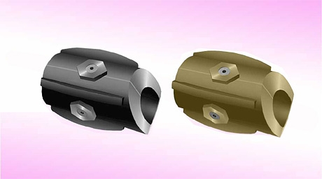 | 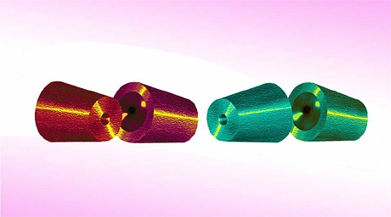

APPROXIMATE NOZZLES DIAMETERS (INITIAL AND FINAL)

 | Initial diameter |  | Final diameter
Number of nozzles | 1 nozzle | all nozzles | 1 nozzle | all nozzles
2 | 5.1 mm (0.2 inches) | 10.2 mm (0.4 inches) | 8.9 mm (0.35 inches) | 17.8 mm (0.7 inches)
4 | 5.1 mm (0.2 inches) | 20.4 mm (0.8 inches) | 8.9 mm (0.35 inches) | 35.6 mm (1.4 inches)

APPROXIMATE EROSION OF NOZZLES BY CUTTING INTERVALS

2 NOZZLES

Start | End of 1 interval | End of 2 interval | End of 3 interval | End of 4 interval | End of 5 interval
10.2 mm | 11.8 mm | 13.2 mm | 14.8 mm | 16.2 mm | 17.8 mm
0.4 inches | 0.46 inches | 0.52 inches | 0.58 inches | 0.64 inches | 0.7 inches

4 NOZZLES

Start | End of 1 interval | End of 2 interval | End of 3 interval | End of 4 interval | End of 5 interval
20.4 mm | 23.6 mm | 26.4 mm | 29.6 mm | 32.4 mm | 35.6 mm
0.8 inches | 0.93 inches | 0.26 inches | 1.04 inches | 1.28 inches | 1.4 inches

APPROXIMATE PUMP RATE BY CUTTING INTERVALS

2 NOZZLES

Start | End of 1 interval | End of 2 interval | End of 3 interval | End of 4 interval | End of 5 interval
0.38 m³/min | 0.45 m³/min | 0.54 m³/min | 0.63 m³/min | 0.72 m³/min | 0.81 m³/min
3.25 bbl./min | 3.85 bbl./min | 4.45 bbl./min | 5.05 bbl./min | 5.65 bbl./min | 6.25 bbl./min

4 NOZZLES

Start | End of 1 interval | End of 2 interval | End of 3 interval | End of 4 interval | End of 5 interval
0.65 m³/min | 0.76 m³/min | 0.87 m³/min | 0.97 m³/min | 1.08 m³/min | 1.19 m³/min
5.45 bbl./min | 6.35 bbl./min | 7.33 bbl./min | 8.17 bbl./min | 9.09 bbl./min | 10.0 bbl./min

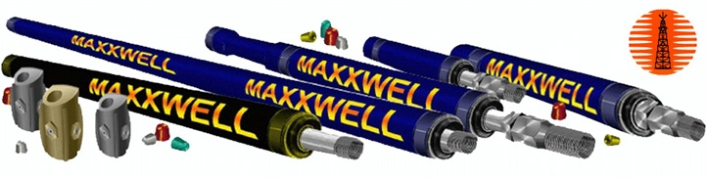
CONNECTION TOOL/EQUIPMENT’S ADAPTER WITH TUBING
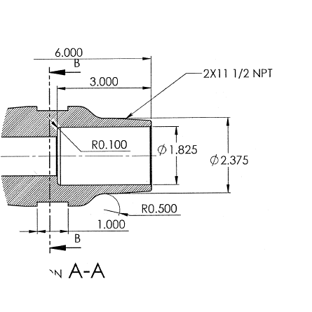

Well 199JTM1093W | API-4210333969 (vertical, injector) | ?

Well 199JTM1093W | API-4210333969 (vertical, injector) | ?

FLOW CONTROL VALVE

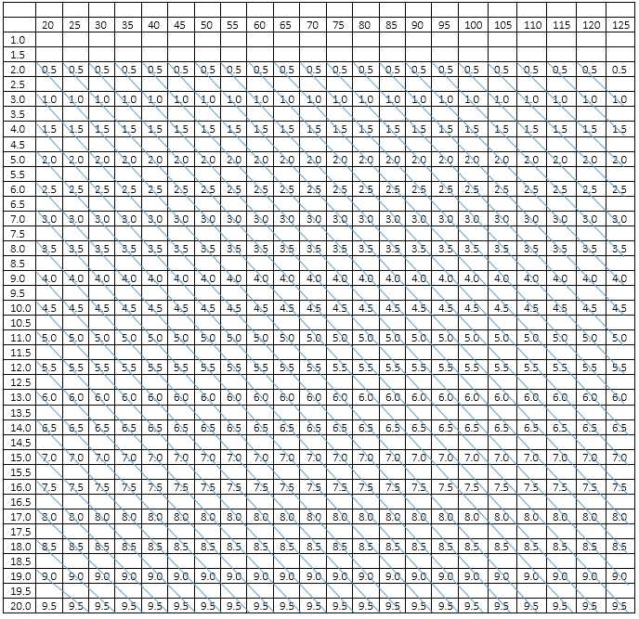

Well 199JTM1093W | API-4210333969 (vertical, injector) | ?

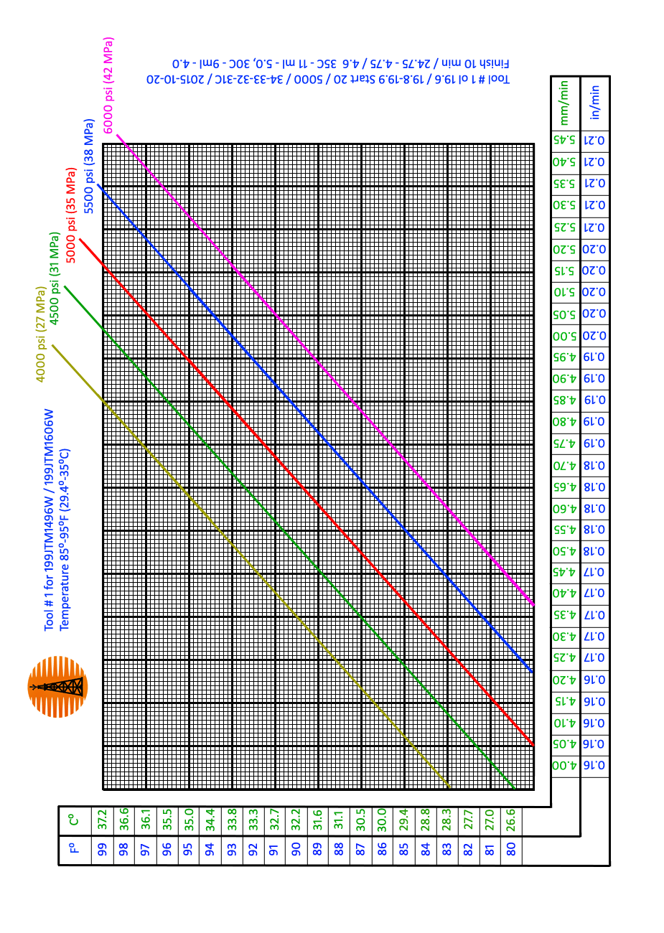
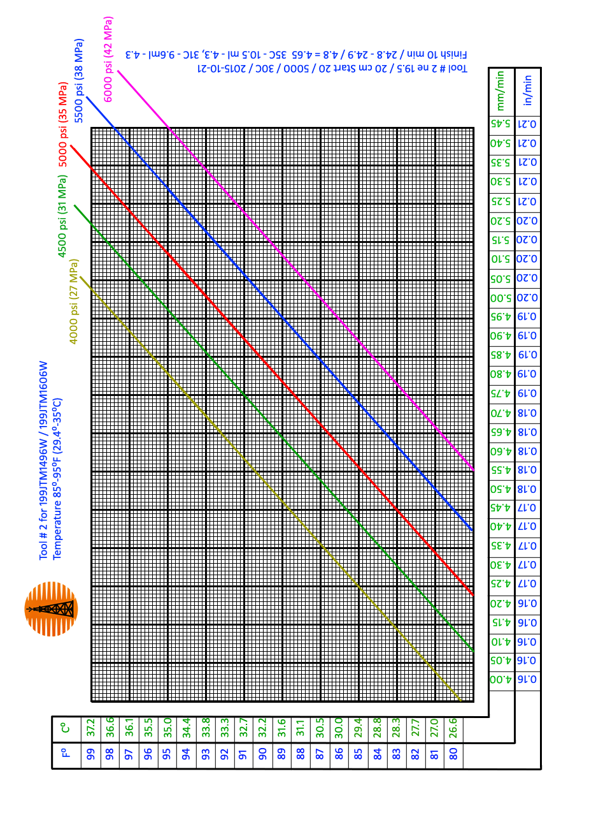
SURFACE EQUIPMENT

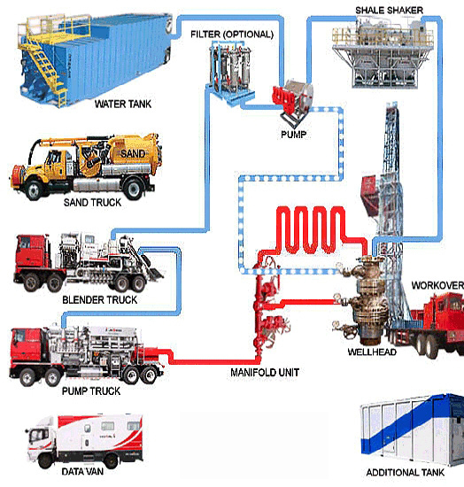

Well 199JTM1093W | API-4210333969 (vertical, injector) | ?

SLOTTING PERFORATION PROCESS EXAMPLE

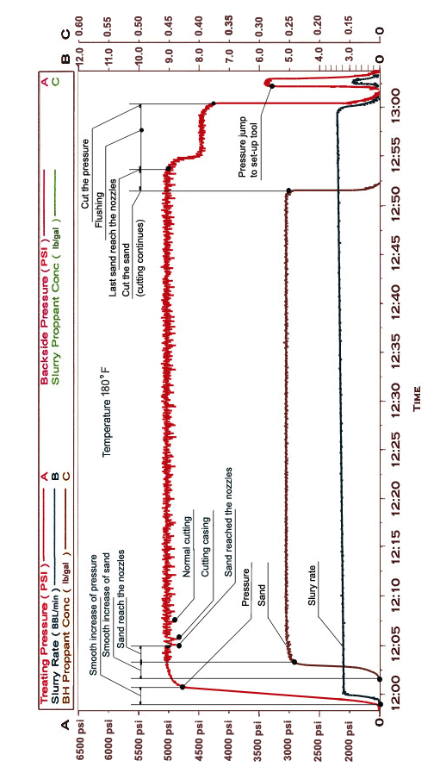

Well 199JTM1093W | API-4210333969 (vertical, injector) | ?

GENERAL SLOTTING PROGRAM DETAILS

1. Have site cleaned up and prepared for operations. Notify Operator at least 24 hours before starting operations.

2. Notify the SIR and the land owner at least 24 hours before commencing well site operations. When notifying these contacts, inform them of the intended operations, the start and the expected duration of time. Record the names and the times of the notifications on the first day’s report. Ensure all residents within a 1 mile radius of the well receive the notification letter & note this on the first daily report. Spot water tank. Before moving be sure to open tank and take pictures of the amount of sand in the tank.
3. Move-in and rig-up mobile service rig, specifications complete with pump, clean rig tank, and BOP system. Conduct detailed CAODC Service Rig Inspection and report any equipment/safety deficiencies, inoperable service rig components or negative pressure test results before proceeding. Install and pull test rig anchors to service rig manufacturers specifications (if required). Perform a surface casing vent flow test and report the vent status.

4. Hold a safety and procedural meeting with all onsite personnel.

5. Remove the wellhead top section and install and pressure test the BOP to 200 psi and 2000 psi for 10 minutes each.

6. Set up surface flow lines to be able to reverse flow casing and tubing (manifold for casing/tubing reverse flow). Have tanker truck bring water into the storage tank. Record well pressure before taking off gauge. Bleed off any pressure (< 100 psi). ND tree & NU Frac Valve (if necessary). Pressure test Frac Valve. Kill well.

7. Pressure test tubing with pump in the hole. If tubing does not pressure test call magnascope to scan tubing.

8. If needed, pump hot formation water down backside of the tubing and establish circulation down the backside and up the tubing and up over the rods. Unseat the pump and pull pump and rods to surface. Inspect the rods on the site to see if any need replacing. If the pump needs to be replaced or refurbished, hot shot for service.

9. Confirm is an anchor downhole, if so unseat anchor and pull tubing. Inspect tubing on lease to identify any pieces that need replacing.

10. Pressure test the blind rams, HCR and manifold to a low test and a high test for duration of 15 minutes and record in tour sheet.

11. Pressure test the pipe rams and annular preventer to a low test and a high test for a duration of 15 minutes each. Test kelly cock, stabbing valve and motor kills. Ensure that all BOP control equipment tests positive prior to drill out and all motor kills are working properly.

12. Have directional company ready to install directional motor to the end of the drill pipe with a 0.5° knuckle so that the well can be drilled deeper. Also install an MWD tool to track the bit. If a depth of 1196 m tvd is reached before the target, stop drilling and consult Admiralty representative.

13. Have rentals delivered: Power Swivel, Drill Pipe, Drill Pipe Elevator, Cross-over to tubing and tuning pieces, Centrifuge, Command Center, 3 x Light Plant, Reamer, 2 x open tanks, Trash Pump, Genset and Shale Shaker.

14. Have Geological Services on-site to collect cuttings.

15. Run in hole with directional equipment.

Well 199JTM1093W | API-4210333969 (vertical, injector) | ?

16. Take and record a survey.

17. Pressure test the Maxxwell slotting tool on surface so that it is ready to be installed. While is being tested, the mixing skid, twin pumper and nitrogen unit should arrive and be setting up high pressure iron and sand mixer with ~ 50 T of 20/40 abrasive quartz sand. Once the tool is positioned, hook-up all iron and pressure test. The slotting intervals and ideal cutting parameters can be seen below.

18. Run the Maxxwell slotting tool down to the first (deepest, further away) slot (be sure to account for elongation).

19. The Formation water on-site.

20. A filtration and settling area will be set-up on site so that all of the cuttings can be separated once each slot has been cut, the cuttings will be collected in a pail and the slot interval will be marked. Then the volume excavated from each slot can be calculated to determine the dimensions of each slot interval. While we are slotting the sand, cutting fluid, excavated reservoir pieces and nitrogen will be flowing up the back side of the tubing. The fluid will flow over the Shale Shaker first to remove the large pieces of material and then into a settling tank where the nitrogen bubbles can settle out and the larger pieces of material will settle out. The fluid will then be sucked out of the settling tank with a Trash Pump and into the Centrifuge to take out the smaller material from the slotting fluid. From there the fluid will go into the rig tank and water tank to be treated with KCl and Biotide (swelling clays and micro-organisms) before being pulled into the mixer and pushed back downhole with sand.

PREPARATIONS FOR SLOT PERFORATION PROCESS

Stage | Description | Time
1 | Prepare site. Inspection driveways, territory clean-up, coating gravel (if necessary)
2 | Equip site with safety requirements, electricity and lighting, toilet, sitting area
3 | Organization site, garbage collection and disposal, reservoir for rock and sand
4 | Spot rig and installation
5 | Pump-Jack disassembly. Lift service tubing and downhole equipment
6 | Headwell with BOP installation
 | * wellhead and surface piping, (BOP equipment) frac valve + stripper robbers for frac valve
7 | Spot operation tubing (tubing trailer)
8 | Spot cutting tank (with shaker for reset the waste abrasive quartz sand)
9 | Spot water storage tank (fill brine water storage tank). Well should be filled with water.
10 | Surface piping. Set up surface flow lines to be able to reverse flow csg/tbg
11 | Well inspection / preparation. Pass with scraper / caliber ID=4.9”
12 | Slot perforation tool/equipment assembly
13
14 | HSP tool/equipment + additional pipe joints + non-magnetic marker + tubing connection
 | * additional pipe joints (~ 3 x 6”) are selected depending on the maximum allowable lift the high pressure line when changing sections tubing during the cutting process
 | * non-magnetic marker (~ 4 - 5”’) it must be visible during logging
15 | Measure the length of the tool/equipment assembly to the nozzles
16 | Pull down the tool/equipment on the tubing into the well to the desired depth
17 | Wireline service. Correlation log (backsight logging)
18 | Correction the downhole tool/equipment based on the obtained log
19 | Stop. Leave it in this position until the HSP process, not to move the tubing
20 | Spot frac service (pump service) with frac-van (monitoring centre)
21 | Install high pressure line and Manifold block (to be able to reverse flow csg/tbg)
 | * (optional) desired intermediate pump (to be able in emergency situation to reverse flow csg/tbg
22 | Abrasive quartz sand in the special track
23 | Blender/mixer for controlled and uniform supply of sand
24 | Spot additional nitrogen/chemical treatment service
25 | Safety meeting (s)
26 | Pump pressure and high pressure line test (before wellhead)
27 | (optional) Tubing pressure test:
 | disconnect high pressure line from wellhead
 | drop downhole cermet 1.5” ball
 | connect high pressure line with wellhead
 | supply pressure ~ 7000 psi for 1 min. If tubing keeps the pressure, cut the pressure
 | switch Manifold block on the reverse flushing
 | by reverse flushing wash out the cermet 1.5” ball on the surface
28 | Disconnect high pressure line from wellhead and drop downhole valve metal 1.0” ball
 | (optional) Procedures 27, 28 may skip if the tubing is new, all connections are good tight, and all pipes are clean. In this case the valve metal 1.0” ball can be put into the HSP tool/equipment before pull down into the well to the desired depth (paragraph 16)

SLOT PERFORATION PROCESS

Stage | Description | Time
● | Lower and lift the tool with caution to prevent possible jamming (especially in the horizontal section).
● | Installation of the first (initial) cutting interval taking into account the elongation of tubing.
● | The system and tubing must be absolutely clean (without residual of proppant which is used in hydraulic fracturing), otherwise such foreign bodies will get stuck in the nozzles.
● | The speed of movement of the cutting nozzles along the wellbore depends on the temperature and pressure (graph is attached). The actual temperature is determined in the process of slotting perforation. Depending on the temperature optimal cutting modes are chosen (pressure and sand concentration). Initial pressure parameters - 4500 psi, sand concentration - 0.21 lb/gal.
● | The initial pressure supply should be smooth (approximately during a minute). Hydraulic impacts (caused by the rapid increase in pressure, initial overpressure, jumps pressure) on the tool not allowed. When the pressure is established, it is possible to supply the abrasive sand.
● | Pressure drop below 800 psi leads to set up the tool (perforator is set to the starting position). Set up time is 4 sec. The maximum pressure on the tool may not exceed 6200 psi.
● | The initial abrasive sand supply should be smooth (approximately during a minute). Feed sand with packs, irregular supply of abrasive sand, over sand, jumping concentration of abrasive sand unacceptable and leads to failure of the nozzles.
● | Incorrect supply of pressure and abrasive sand reduces working time of nozzles to one or two cutting intervals.
● | If it is impossible to establish normal operation (conditions) for slotting perforation process - stop the process.
● | (Graph of slotting perforation process is attached). Immediately after the filling of abrasive sand the cutting does not occur. Time to reach the abrasive sand to nozzles is approximately 4-5 min (depending on slurry rate). During the slotting perforation process the pressure and concentration curves (on the monitor) must be sufficiently straight, without jumps. Pressure curve should be a “small teeth of saw”. The process should not be interrupted during cutting through the whole interval.
● | Emergency stop pressure must immediately provide additional circulation of the working fluid to prevent the filling tool with the sand and rock, because it could lead to the loss of the well.
● | Time of working process is determined according to the speed-temperature graph (temperature graph is attached). It is required take into account the time for flushing.
● | Full stroke of working stock in the tool is 1.64 inches including the time to reach the sand to nozzles and flushing after slotting perforation process.
● | Under the normal operating conditions (supply the pressure and sand concentration) the slurry rate and erosion of nozzles (at 4 nozzles) should have approximately the following parameters:

Start | End of 1 interval | End of 2 interval | End of 3 interval | End of 4 interval | End of 5 interval
0.65 m³/min | 0.76 m³/min | 0.87 m³/min | 0.97 m³/min | 1.08 m³/min | 1.19 m³/min
5.45 bbl./min | 6.35 bbl./min | 7.33 bbl./min | 8.17 bbl./min | 9.09 bbl./min | 10.0 bbl./min

Start |  | End of 1 interval | End of 2 interval | End of 3 interval | End of 4 interval | End of 5 interval
20.4 mm |  | 23.6 mm | 26.4 mm | 29.6 mm | 32.4 mm | 35.6 mm
0.8 inches |  | 0.93 inches | 0.26 inches | 1.04 inches | 1.28 inches | 1.4 inches
Stage | Description |  |  |  |  |  | Time
● | An excessively high or over limit slurry rate at high pressure should serve as grounds for lifting the tool on the surface for replace the nozzles.
● | At the termination supply of abrasive sand, the cutting process continues until the last batch of sand will reach the nozzles (approximately 4-5 min, depending on slurry rate).
● | At the end of the operation there needs to be done flushing during 10-15 min. Sand and rock reaches the surface during approximately 20-25 min. During flushing the pressure may be reduced up to 4000-4500 psi).
● | (Optional) After cut the pressure it is recommended make the jump of pressure (as shown on the slotting graph) up to 3500 psi for greater certainty that perforator took the starting position and is ready for cutting of the next interval.
Stage | Description |  |  |  |  |  | Time
START
1 | Slowly raise the pressure up to 4500 psi (without hydraulic shocks).
2 | After two or three minutes of normal operation (rate 5.45 bbl. /min) begin to gradually apply the sand. The concentration not more than 0.21 lb/gal.
3 | After 4 minutes, the sand reaches the nozzles. Follow the graph, the pressure and the concentration of sand. Working conditions: Pressure ~ 5000 psi, Concentration ~ 0.25-0.28 lb/gal.
● | Measure the temperature in the cutting tank. Compare with the speed graph. Specifies the time for cutting the interval.
● | After 20 minutes, in the cutting (shaker) tank should be a rock.
4 | At the end of the cutting interval stop the flow of sand, but cutting continues for 4 minutes more.
● | (Optional) After passing through the nozzles pure water waiting 5 minutes with the same pressure, then make the leap by the pressure 5000 psi→900 psi→5000 psi (to nozzle were in the middle of the interval) and flushing for 15 minutes.
● | (Optional) For ensure that the perforator with nozzles got to the starting position can again raise pressure up to 3000 psi and stop.
5 | After cut pressure and pull the tool in the next interval.

POSSIBLE VIOLATIONS OF HSP TECHNOLOGICAL PROCESS

● The presence in the pumping system, manifold block or in the high pressure line a residual of proppant (fracturing sand).
● The presence in the tubing, drilling pipes or in the coiled tubing a residual of rock, mud, clay, foreign particles, etc.
● Inability to gradually raise the pressure pump, inability of pump to keep the pressure on the same position, pressure jumps, stop the pump, the inability to create a back flushing.
● Inability to continuously supply of abrasive quartz sand, sand feed by batches, inability to supply the sand concentration at the same position, excess concentrations of sand, concentration jumps.

SLOT PERFORATION SCHEDULE

# | Interval | Slots | Skip | Process | Time
* Initial position for the first cutting interval with taking into account the tubing’s elongation is 2847.36’
1 | 2848.0’-2849.5’ | <1.5’> |  | Cutting 1 interval | 1 hour 40 min
 |  |  |  | Flushing | 15 min
 |  |  |  | Lift up to 2’ | 10 min
 |  |  | >0.5’<
2 | 2846.0’-2847.5’ | <1.5’> |  | Cutting 2 interval | 1 hour 40 min
 |  |  |  | Flushing | 15 min
 |  |  |  | Lift up to 2’ | 10 min
 |  |  | >0.5’<
3 | 2844.0’-2845.5’ | <1.5’> |  | Cutting 3 interval | 1 hour 40 min
 |  |  |  | Flushing | 15 min
 |  |  |  | Lift up to 53’ | 10 min
 |  |  | >52’<
4 | 2791.0’-2792.0’ | <1.0’> |  | Cutting 4 interval | 1 hour 5 min
 |  |  |  | Flushing | 15 min
 |  |  |  | Lift up to 2’ | 10 min
 |  |  | >0.5’<
5 | 2789.0’-2790.5’ | <1.5’> |  | Cutting 5 interval | 1 hour 40 min
 |  |  |  | Flushing | 15 min
 |  |  |  | Lift up to 2’ | 10 min
 |  |  | >0.5’<
6 | 2787.0’-2788.5’ | <1.5’> |  | Cutting 6 interval | 1 hour 5 min
 |  |  |  | Flushing | 15 min
 |  |  |  | Lift up to 8’ | 10 min
 |  |  | >7.0’<
7 | 2779.0’-2780.0’ | <1.0’> |  | Cutting 7 interval | 1 hour 40 min
 |  |  |  | Flushing | 15 min
 |  |  | >0.5’< | Lift up to 2’ | 10 min
8 | 2777.0’-2778.5’ | <1.5’> |  | Cutting 8 interval | 1 hour 40 min
 |  |  |  | Flushing | 15 min
 |  |  | >0.5’< | Lift up to 2’ | 10 min
9 | 2775.0’-2776.5’ | <1.5’> |  | Cutting 9 interval | 1 hour 40 min
 |  |  |  | Flushing | 15 min
 |  |  |  |  | 10 min
10 | 2720.0’ |  |  | Flushing | 40-45 min
 |  |  |  | Lift up the tool | 50 min
cutting: |  |  |  |  | 12 hours 10 min
flushing: |  |  |  |  | 3 hours 00 min
lifting: |  |  |  |  | 2 hours 20 min
 |  |  |  | Total Time: | 17 hours 30 min

Well 199JTM1093W | API-4210333969 (vertical, injector) | ?

Well 199JTM1093W | API-4210333969 (vertical, injector) | ?

HSP

interval | lifting | depth | lifting | depth | process | depth | cutting | between | between
9 |  |  | ● lifting 2’ | ● 2775.0’ | ● start | 2775.0’ | ↓
9 |  |  | ↑ |  | ● length | 1.5’ | ↓
9 |  |  | ↑ |  | ● finish | 2776.5’ | ↓ | ↓
 |  |  | ↑ |  |  |  |  | 0.5’
8 |  |  | ● lifting 2’ | ● 2777.0’ | ● start | 2777.0’ | ↓ | ↑
8 |  |  | ↑ |  | ● length | 1.5’ | ↓
8 |  |  | ↑ |  | ● finish | 2778.5’ | ↓ | ↓
 |  |  | ↑ |  |  |  |  | 0.5’
7 |  |  | lifting 8’ | ● 2779,0’ | ● start | 2779.0’ | ↓ | ↑
7 |  |  | ↑ |  | ● length | 1.0’ | ↓
7 |  |  | ↑ |  | ● finish | 2780.0’ | ↓ | ↓
 |  |  | ↑ |  |  |  |  | 7’
6 |  |  | ● lifting 2’ | ● 2787.0’ | ● start | 2787.0’ | ↓ | ↑
6 |  |  | ↑ |  | ● length | 1.5’ | ↓
6 |  |  | ↑ |  | ● finish | 2788.5’ | ↓ | ↓
 |  |  | ↑ |  |  |  |  | 0.5’
5 |  |  | ● lifting 2’ | ● 2789.0’ | ● start | 2789.0’ | ↓ | ↑
5 |  |  | ↑ |  | ● length | 1.5’ | ↓
5 |  |  | ↑ |  | ● finish | 2790.5’ | ↓ | ↓
 |  |  | ↑ |  |  |  |  | 0.5’
4 |  |  | lifting 53’ | ● 2791.0’ | ● start | 2791.0’ | ↓ | ↑
4 |  |  | ↑ |  | ● length | 1.0’ | ↓
4 |  |  | ↑ |  | ● finish | 2792.0’ | ↓ | ↓
 |  |  | ↑ |  |  |  |  | 52’
3 |  |  | ● lifting 2’ | ● 2844.0’ | ● start | 2844.0’ | ↓ | ↑
3 |  |  | ↑ |  | ● length | 1.5’ | ↓
3 |  |  | ↑ |  | ● finish | 2845.5’ | ↓ | ↓
 |  |  | ↑ |  |  |  |  | 0.5’
2 |  |  | ● lifting 2’ | ● 2846.0’ | ● start | 2846.0’ | ↓ | ↑
2 |  |  | ↑ |  | ● length | 1.5’ | ↓
2 |  |  | ↑ |  | ● finish | 2847.5’ | ↓ | ↓
 |  |  | ↑ |  |  |  |  | 0.5’
1 |  |  | installation | ● 2848.0’ | ● start | 2848.0’ | ↓ | ↑
1 |  |  |  |  | ● length | 1.5’ | ↓
1 |  |  |  |  | ● finish | 2849.5’ | ↓

SAFETY AND OPERATIONAL REQUIREMENTS

It is expected the field operations representatives will use their judgment and knowledge in executing the program and supervising the operations to ensure that all work is conducted in a safe manner that results in the greatest degree of protection possible for the on-site personnel, the public and the environment. The program is a guide and cannot replace good judgment on the wellsite.

Safety and Operational requirements are encourages and stresses the importance of safety in all aspects of its operations and therefore expects contractors and wellsite supervisors to adhere to recommended safe industry practices and Occupational Health and Safety regulations. All work must be conducted in compliance with the following:

● SIR Regulations
● Occupational Health and Safety Regulations
● Applicable ARP’s
● Safety Specifications
● Safety Meetings

● Regular safety meetings are to be held and documented by the wellsite supervisor responsible for coordinating the activities of contractors. These meetings are held at the beginning of each day, prior to each high-pressure operation or stimulation and more frequently as conditions warrant.

● Meetings will be held with all involved personnel to ensure that each individual is familiar with the overall objectives, their specific duties, pressure limitations, and emergency and safety procedures.

● These meetings are to be documented on the Daily Tour Sheets.

Notifications

● Provide 24 hour notification of flaring operations and any pending operations if applicable to the SER area office. Record SIR contact, dates, and times on the Daily Morning Report. When notifying via the Digital Data Submission system note the electronic confirmation number on the morning report.

● Notify appropriate PFRA office in areas that fall under their direction.

● Venting and flaring notifications must be done 24 hours prior to commencement of flaring. Residents within 1.5 km radius (sweet) or 3 km radius (sour) of the well must be notified if the flaring or cleanup operation is to exceed 4 hours duration and/or the 24 hour flare volume is to exceed 30E3m³ (1 mile for H2S<1% & 2 miles for H2S>1%. Refer to SIR Guidelines, to ensure that all flaring notification requirements have been met.

● The SIR has adopted a policy that places responsibilities of resident notification with the operating oil company (contract field supervisor) and failure to comply with this policy could result in a total shutdown of operations. It is therefore extremely important for the wellsite supervisor to establish communications with any residents in the vicinity of the well who may be affected by the following operations and keep them informed of any activity that is deemed to be disruptive to their daily routine - e.g. Acidizing, Fracturing, testing, perforating, etc.

● Ensure the operators field superintendent is contacted prior to moving on equipment.

● Rig Inspection and BOP Drills

● Rig inspections are to be done on the first well for a new contractor and every two weeks after. BOP drills are to be done on every well and at least once every seven calendar days and recorded in the Daily Tour Sheet.

● BOP drills should be done more often to bring crew training up to an acceptable level if required.

● The BOP drill form is to be filled out and noted on the Daily Tour Sheet.

● A Walk around Rig Inspection is to be conducted at the beginning of each day and recorded in the Daily Tour Sheet.
Emergency Response Plan - Schedule A

● The supervisor and rig manager should be familiar with the Emergency Response Plan.

● Ensure that on all wells with site specific Emergency Response Plans (ERP), crew members are briefed and trained about their respective duties when an ERP goes into effect.

● Ensure that the Emergency Response Plan Contact list is filled out and posted.

Ground Disturbance

● All ground disturbance must follow all applicable regulations.

● Rig anchors should never be installed without a line locate pull test to 20000 lbs.

● All ground disturbance greater than 1 foot, within 16 feet of ANY underground facility, anode bed, pipeline/riser or electrical cable must be exposed via Hydrovac or Hand exposing. This is critical before cutting and capping well bores.

● The use of mechanical equipment (backhoe) within 2 feet of exposed or buried pipelines or electrical cables is not allowed.

● All operations are to remain on operators right of way (see survey plan). If in doubt check concerning re-staking the lease and road.

Pressure Testing

● Prior to the installation of BOP’s, unless the well has not been completed, conduct a stump test of the BOP equipment, safety valve, pump manifold and lines to a low of 200 psi and a high of either; 2000 psi, the pressure rating of the production casing flange or the formation pressure, whichever is the greater.

● Upon installation of the BOP’s ensure that the ring groove connection is pressure tested as above and that all BOP components are function tested as per regulations. • Prior to starting other operations, such as Fracture, acidizing, wireline operations, etc., ensure that all equipment that has potential to be exposed to well pressure or that is used to control well pressure is pressure tested as above and/or in accordance with the contractor’s specifications.

● All pressure tests are to be recorded in the Daily Tour Sheet as per regulations.

Vent Flow Test

● Conduct a bubble test on the surface casing vent to check for flow. Fill out a Surface Casing Vent Flow / Gas Migration sheet and e-mail with the first morning report.

EMERGENCY RESPONSE PLAN

The Emergency Response Plan must contains telephone numbers of provincial regulatory agencies, emergency response agencies, company personnel, and on-site personnel who may need to be contacted in the event of an emergency. It also contains the legal site description and simple directions for the most efficient way.

Following are the procedures to be followed in the event of an emergency. It is the responsibility of every worker on site to familiarize themselves with these procedures and know their role within each one. It is the responsibility of the site consultant/operator to delegate these roles, and ensure that workers have an opportunity to practice them.

The goal is a safe and healthy worksite from start to finish. Should an emergency arise, a quick, well prepared response will give us our best chance for a positive outcome. Emergencies that could arise at this site are:

● Incidents which result in or could result in serious injury or loss of life; (Medical Emergency)
● Well blow-out or other emergencies related to drilling & field operations;
● H2S release;
● Major fire;
● Spill of a product or chemical which may be hazardous to health and/or property/environment;
● Acts of God such as a blizzard; and
● Bomb Threat.

EMERGENCY MEDICAL RESPONSE PROCEDURE

1 | Assess the situation – is it safe to approach the victim? Note the time of incident.
2 | First person on the scene contact or direct someone to contact site supervisor and emergency medical services.
 | - Provide information about location of incident
 | - Provide information on nature of injuries
 | - Stay on the line with emergency services until they decide to end the call
3 | Perform critical interventions ( i.e. CPR/control massive hemorrhage)
4 | Treat injuries to the best that training and available equipment allows
5 | Do not leave the patient until another person with more advanced training arrives to take over.
6 | Stand-by and be prepared to assist as necessary.
7 | If patient can be moved (no suspected neck or spine injury) begin moving to more advanced medical aid only if necessary. Transport to hospital requires driver and attendant. Stay in contact with ambulance and transport patient until transfer can be made with ambulance.
8 | If suspected neck or spine injury, move only if leaving patient would put them in greater danger (fire, chemical spill, etc.). Make every attempt to keep the head and neck as stable as possible.
9 | If patient cannot be moved, wait for ambulance to arrive, keeping patient as comfortable as possible.
10 | Monitor and record vital signs (including the time when the vital signs are taken) every five to ten minutes;
The on-site supervisor or a designate is responsible for all notifications. Under no circumstances should anyone notify or talk to either next-of-kin or the media in the event of an injury or accident.

FIRE EMERGENCY PROCEDURE

1 | Immediately shut off power, engines, and any fuel sources if safe to do so.
2 | Move fuel sources away from fire if safe to do so
3 | Have all non-essential personnel evacuate to muster point and assign someone to do a head count.
4 | If the fire is controllable, use extinguisher to fight fire - if not call fire department and clear the area. Ensure the proper extinguisher is used depending on the fire.
5 | Make notifications as per notification flow chart.
The on-site supervisor or a designate is responsible for all notifications. Under no circumstances should anyone notify or talk to either next-of-kin or the media in the event of an accident or injury.

SPILL OR RELEASE PROCEDURE

1 | Identify product.
2 | Clear area and make any local notifications if necessary to protect public health.
3 | Make sure to get proper PPE. Check MSDS.
4 | Control product flow.
5 | Attempt to contain product. Divert from water courses if possible.
6 | Lay out absorbent material.
7 | Make notifications according to flow chart.
The on-site supervisor or a designate is responsible for all notifications. Under no circumstances should anyone notify or talk to either next-of-kin or the media in the event of an accident or injury.

H2S EMERGENCY PROCEDURE

In the event of an H2S release, it is imperative that the following seven step response strategy is followed in order. Remember, Hydrogen Sulphide can render you unconscious with one breath. The first step is always to get yourself to safety.
Seven Step Response Strategy:
1 | Evacuate - Immediately move upwind (check on-site wind sock) if release is downwind of you or move crosswind if release is upwind of you. If possible, move to higher ground as H2S is heavier than air.
2 | Assess - Do a head count and look for other hazards.
3 | Alarm - Call for help by whatever means available ex. horn, radio, whistle, etc. Call or have someone call fire dept.
4 | Protect - Must use an SCBA if a rescue is to be attempted. If no SCBA is available, do not attempt rescue - wait for fire dept.
5 | Rescue - If SCBA is available, put on and retrieve victim. Move to a safe area.
6 | Revive - Apply CPR if necessary.
7 | Medical Aid - Arrange for transport of victim to nearest medical facility.
The on-site supervisor or a designate is responsible for all notifications. Under no circumstances should anyone notify or talk to either next-of-kin or the media.

EMERGENCY RESPONSE FOR STORM

1 | During working hours the site supervisor is to monitor weather both visually and by radio or highway hotline.
2 | If a weather warning is issued, the site supervisor must determine if the threat is imminent and decide on a course of action which may include: shutting down the site, securing equipment and structures that may be affected, or sending workers home in advance of storm if safe to do so.
3 | If weather conditions do not permit travel, workers should go to wait out the storm. The site supervisor should gather any emergency equipment that may be needed.
4 | Site supervisor or designate conduct a visual inspection of site to confirm all people have evacuated to safe area. Once all people are gathered, perform a head count and verify with signing sheet.
5 | Site supervisor to advise Management of the situation, giving details of location, number of workers kept on site, and readiness for the storm. If possible, supervisor should periodically re-establish contact to keep management informed of conditions.
6 | Once storm has passed, supervisor must assess site for any damage and determine the next course of action.
7 | Workers are not to leave the site until the supervisor authorizes that it is safe to do so, based on most current weather broadcast. If possible recommend that workers travel in groups of at least 2 vehicles. If their vehicles do not have survival gear, they should be supplied with whatever is available from the site (to be returned later). They should also have a cell phone with them.
8 | If stranded in vehicle, Do Not Leave The Vehicle. Stay in vehicle and wait for someone to come to you. Conserve fuel by only starting vehicle periodically.

RESPONSE TO A BOMB THREAT

1 | Threat received by telephone:
 | Respond as follows:
 | A. Do not put caller on hold. Listen to them and do not interrupt.
 | B. Remain as calm as you can.
 | C. Note the time and write it down.
 | D. Notify the supervisor/consultant if possible while you are on the phone.
 | E. Stall any way you can. Ask questions such as:
 | - Where is the bomb?
 | - When will it go off?
 | - What kind of bomb is it?
 | - How do you know so much about the bomb?
 | - Why are you doing this?
 | - Did you put it there?
 | - What is your name?
 | F. As you are talking make written notes on such things as:
 | - Male of female?
 | - Accent? Mannerisms?
 | - Approx. age?
 | - Background noise, if any o Etc.
2 | When you hang up, if you haven’t yet notified the supervisor/consultant do so now.
3 | Supervisor/consultant is to call R.C.M.P. Person who took the call should remain close as R.C.M.P. may want to talk to them.
4 | Supervisor/consultant to decide whether or not to evacuate the site.

MEDICAL INFORMATION FORM

Name: | Age:
Known Allergies:
Known Medical Conditions:
Relevant Medical History:
Currently on the
Following Medications:
Emergency Contact:

EMERGENCY DRILL EVALUATION FORM
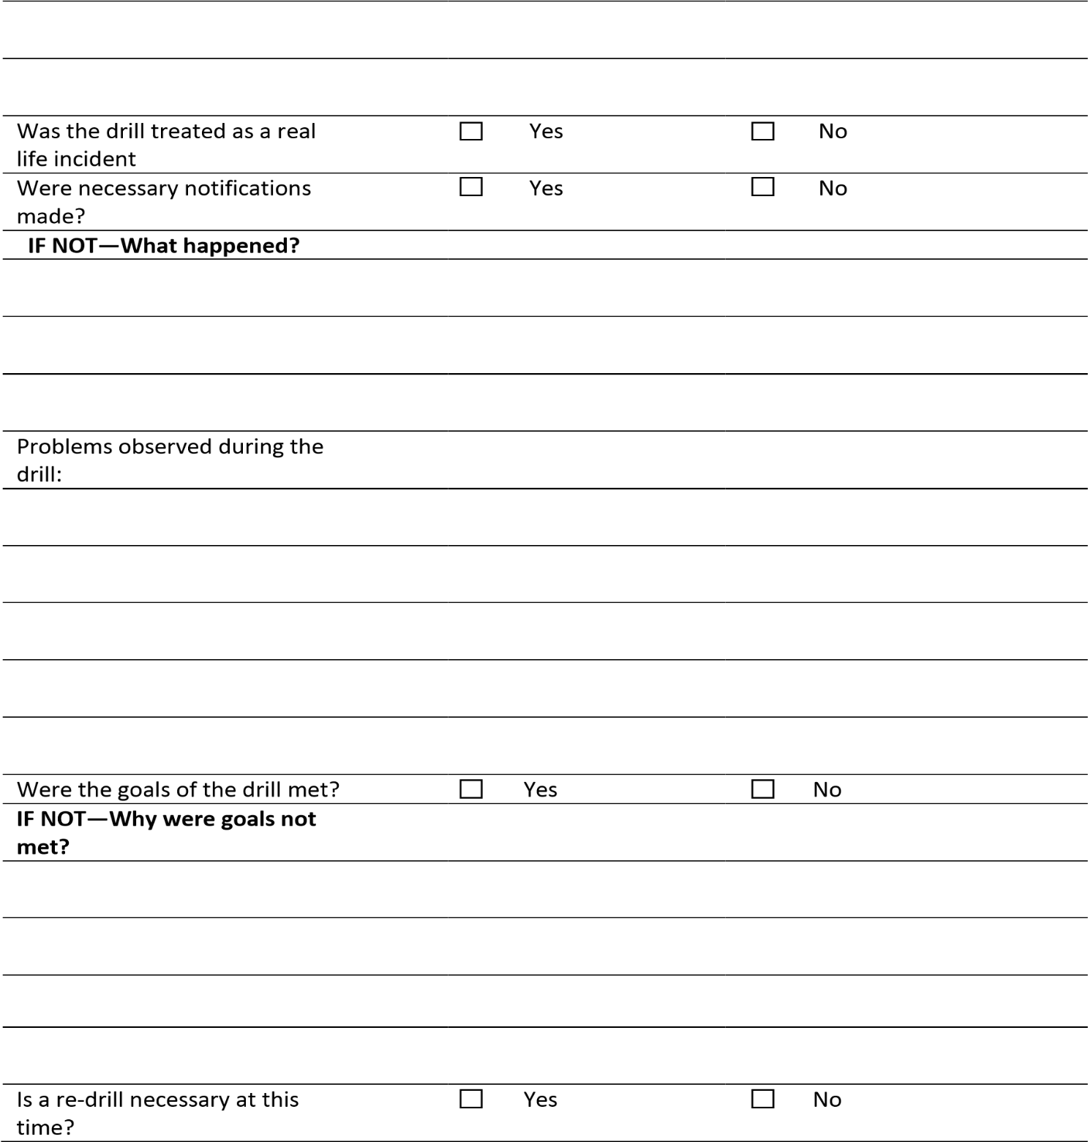
Date/Time of Drill: | Location
Drill Scenario Summary:

Corrective Actions and Recommendations | Assigned to: | Date  Completed:

Location of proposed practice drill:
Type of drill (circle all that apply): | Medical | Site Evacuation | Fire
 | Natural Disaster | Haz Mat | Confined Space
 | Rescue | Blow-Out | Other (specify)
Details of drill scenario:
Safety or Environmental Concerns about this scenario?
How have concerns been addressed?
Who are the intended victims of this drill (if any)?
What equipment will be needed?
What are the goals of the drill?
What Emergency Response Agencies will be involved?
Have Emergency Response Agencies, adjacent facilities and surrounding community been notified of drill in advance?
Media involved/notified?
Manager Comments:
EMERGENCY DRILL PLANNING FORM
Date/Time of proposed practice drill

