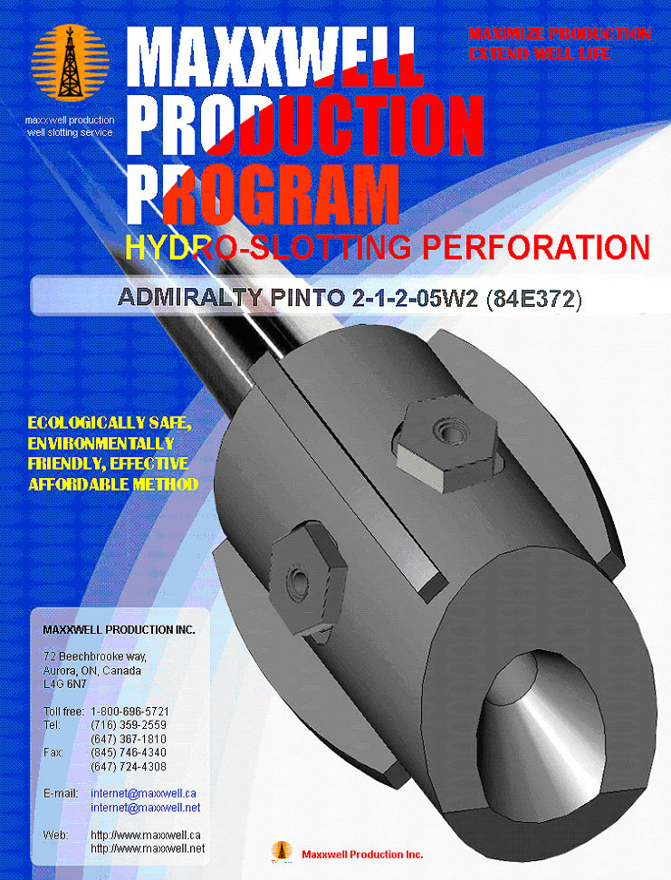
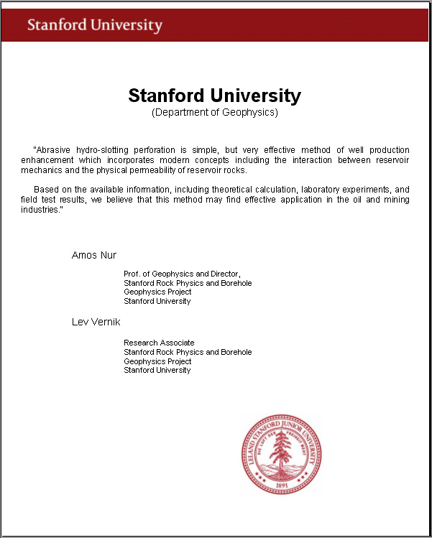

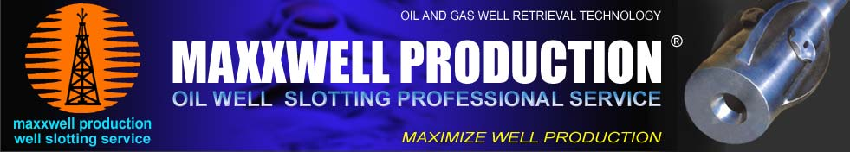

December 11, 2013 # SK-003

SLOT DISCHARGE OF PRODUCTIVE LAYER
WITH HYDRO-SLOTTING PERFORATION

OIL WELL ADMIRALTY PINTO 02-01-002-05W2 (84E372)

MIDALE / FROBISHER FORMATION

Date: December 11, 2013

By: Anatoli Nikouline C.E.T.
Hydro-slotting perforation technology engineer
Maxxwell Production Inc.
72 Beechbrooke way,
Aurora, Ontario, Canada
L4G 6N7

For: Quinton Hardage, P. Eng.
President & Chief Executive Officer
Admiralty Oils Ltd.
# 210-226 20th Street East,
Saskatoon, Saskatchewan, Canada
S7K 0A6

This Program has been furnished by Maxxwell Production Inc. (MPI) to Admiralty Oils Ltd. (AOL) under the terms of Exclusive Agreement dated January 21, 2013 and Confidentiality and Non-Disclosure Agreement dated January 16, 2013. This Program, including all materials and conclusions contained herein, is confidential for use by MPI and AOL in development and implementation of the Program. Being pursuant to the terms and conditions of the above Agreements and governed by the terms of these agreements.

OIL WELL ADMIRALTY PINTO 02-01-002-05W2 (84E372)

WELL DATA

Company | Admiralty
Well | Admiralty Pinto 02-01-002-05W2
Field | Pinto
Province/County | Saskatchewan
Country/State | Canada
Location | 101/02-01-002-05W2/00
LSD | 02
SEC | 01
TWP | 002
RGE | 05W2
Licence Number | 84E372
Coordinates well (Latitude) | 49.08944 deg N
Coordinates well (Longitude) | 102.55220 deg W
TVD | 1651 m
Plug | 1600 m
OD casing | 114.3 mm (4.5”)
ID casing | 103.89 mm (4.09”)
Bit Size | 200.00 mm
Hole Fluid Type | GEL CHEMICAL
Density/Viscosity | 1130.0 kg/m (106.00 sec/L)
PH/Fluid Loss | 9.00 (7,50 ml/ 30 min)
Rm @ Measured Temp | 0.90 @ 20.0 ohm-m
Rmf @ Measured Temp | 0.70 @ 16.0 ohm-m
Rmc @ Measured Temp | 0.30 @ 18.0 ohm-m
Rm @ BHT | 0.81 @ 24.0 ohm-m
Max Recorded Temp | 60ºC (layer level)

Total intervals : | 11.8 m
Treatment interval | 1586.2 - 1597.5 m
Working time : | 30 hours
Total depth | 1651 m (1600 m - plug)
OD casing (9.50 lb/ft) | 114.3 mm (4.5 “)
ID casing (9.50 lb/ft) | 103.89 mm (4.09”)
ID drift (9.50 lb/ft) | 100 mm (or less)
Sump to the bottom | 2.0 m (!) Attention
Volume of fluid in the well (including tubing) | 15.10 m³
Water storage tank volume | 31.0 m³
Cuttings tank volume | 20.0 m³
Required temperature of the working fluid | 30ºC
Density | 20 - 40 kg/m³ (corrected during the operation)
With using 2 nozzles:
Amount of abrasive quartz sand 10/35 (optional 20/40) | 27 tons
Pump performers (slurry rate) | 0.3 - 1.7 m³/min
Working pressure | 27.5 - 41.5 MPa (corrected during the operation)
With using 4 nozzles:
Amount of abrasive quartz sand 10/35 (optional 20/40) | 54 tons
Pump performers (slurry rate) | 0.6 - 1.94 m³/min
Working pressure | 27.5 - 41.5 MPa (corrected during the operation)

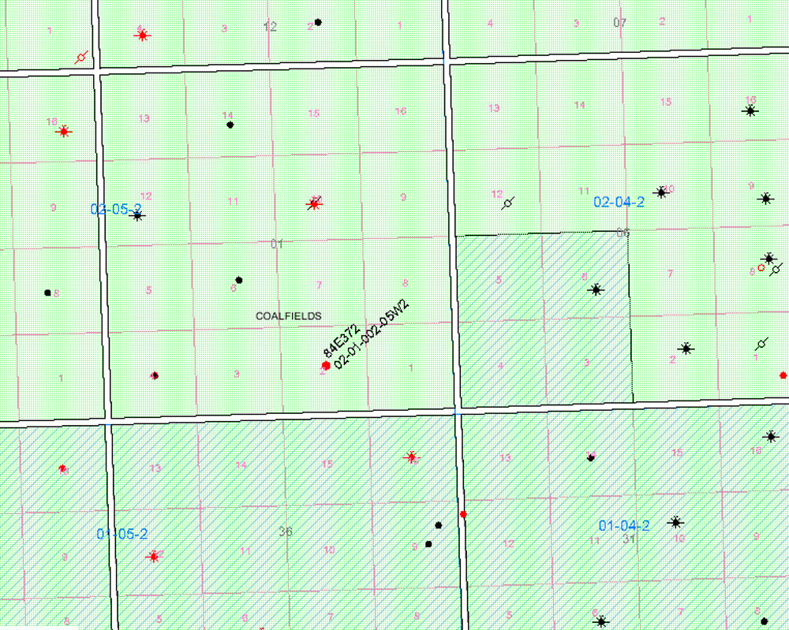

OPENING FORMATION

Midale /Frobisher | 1586.2-1598.0 m

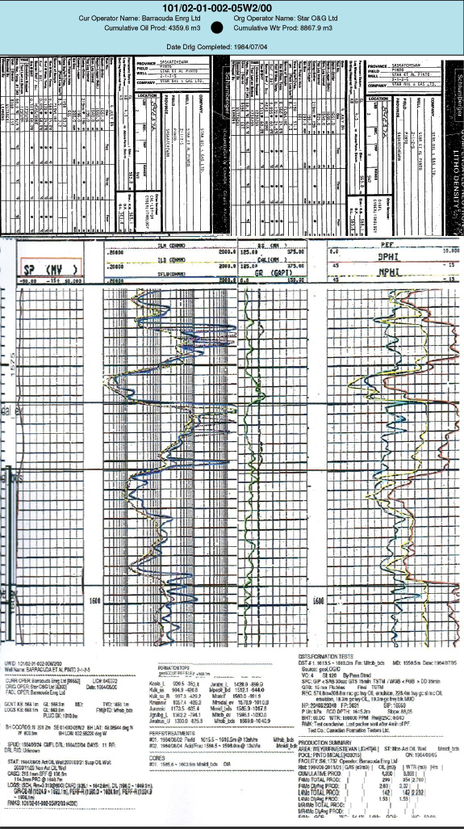

Summary analysis of geological & geophysical data of the well 02-01-002-05W2.
Background:

Logging of the well 02-01-002-05W2, core analysis data in the range 1585,5-1603,5 meters, test results, analysis of oil.

On the basis of the submissions formation Midale (1578,8-1598,0 m) is represented well-grained calcareous sandstone areas, there are vertical cracks, areas of clay material to include in the bottom and top pack clay rocks.

When testing the interval 1586-1598 m (05.08.1998) flowed oil and water (oil 4,8-27,0 m³ water 0,218,3 m³).

According to the GIS the reservoir sandstones in the interval lies 1586,2-1598,0 m (oil 11.8 m), and the porosity is divided into three layers (reference is made to the depth of the GIS method CC):

1. 1586.2 -1589.8 m - Oil - 3,6 m from the core formation porosity 12.6% (14 Arr.), Permeability 0.328 and (14 Arr.), Coefficient of residual water saturation 55.9% (13 Arr. ). GIS layer has a porosity of 15%, resistance 1.5 ohms;

2. 1589,8-1595,2 m - Oil - 5,4 m, formation porosity from cores 8% (21 Arr.), Permeability 0.432 and (21 Arr.), Coefficient of residual water 37.5% (21 Arr.). GIS layer has a porosity of 7%, the resistance of 9 ohms;

3. 1595,2-1598,0 m - Oil - 2, 8 m, the porosity of the reservoir from the core 10% (7 Arr.) 0.54 and permeability (7 Arr.), Coefficient of residual water 24.9% (5 Arr.). GIS layer has a porosity of 12%, resistance 2 ohms;

It should be noted, that the high value of the residual water, determined from core samples are overstated. Investigation of residual water by centrifugation for an indirect estimation of water saturation of the collector. Getting joint tributaries (Oil and water), in our opinion, due to the presence of water in the reservoir connected. According to the GIS water-oil contact in the hole is not opened.

Based on the above information, for slotted perforations in the well 02-01-002-05W2 recommended interval 1586,2-1598,0 m.

As the reservoirs may be considered interval 1619.0-1621.0 m, 1625.0-1626.0 m and 1627.0-1628.0 m on GIS data porous intervals (15%, 10%, 10% respectively), the receptivity from 2 to 5 ohms, but not characterized as a collector of FP methods.

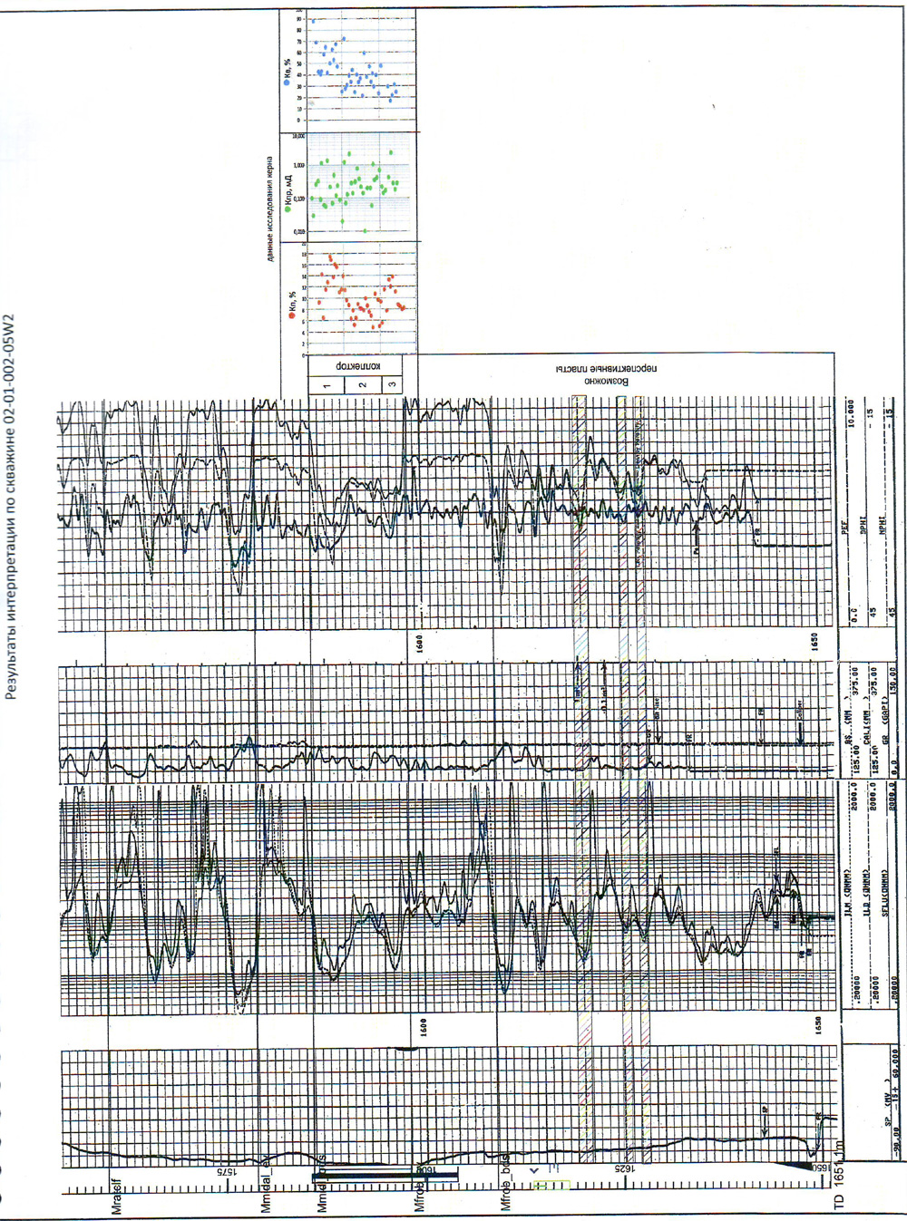
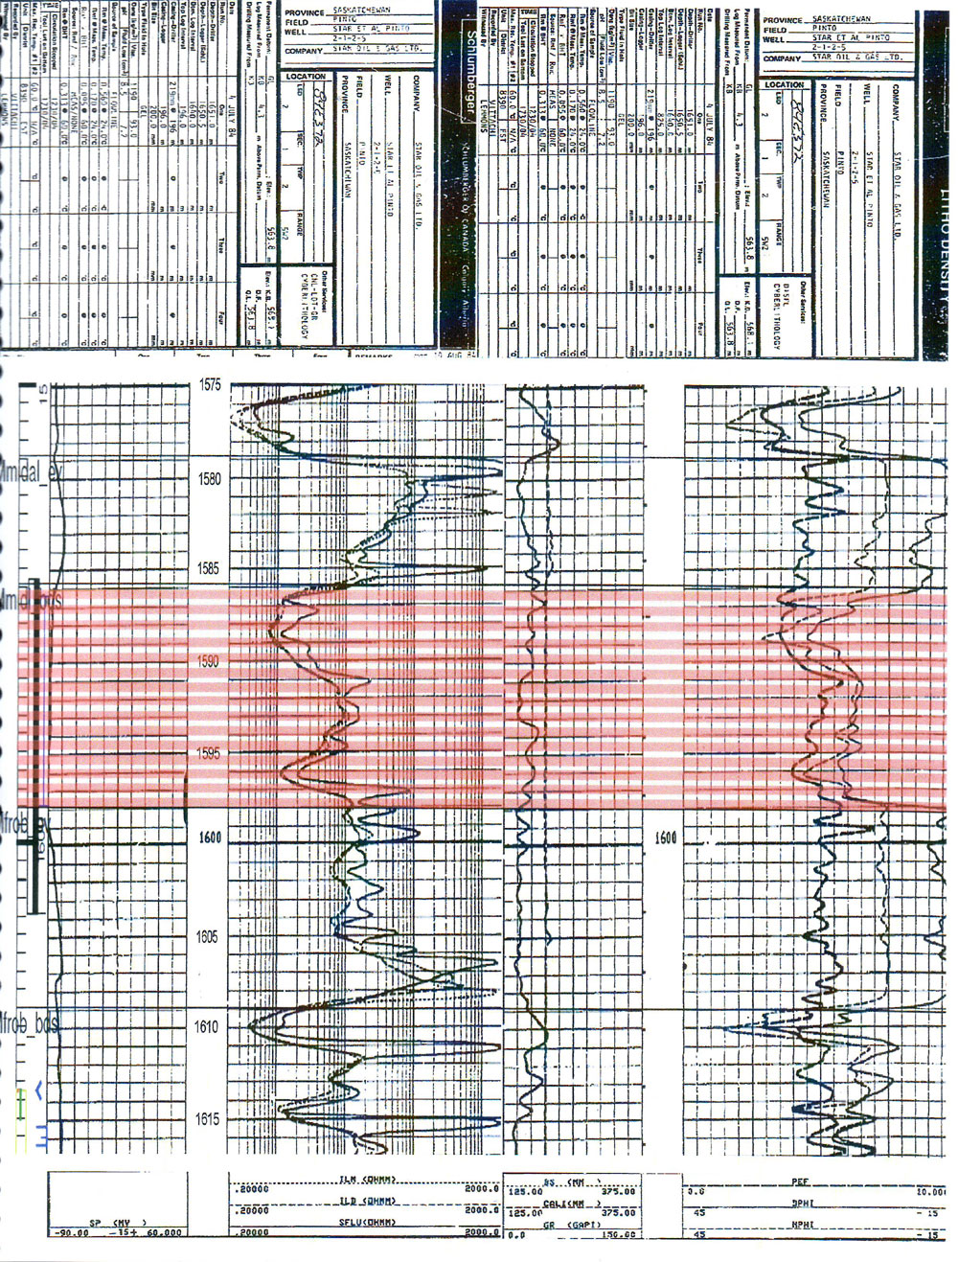
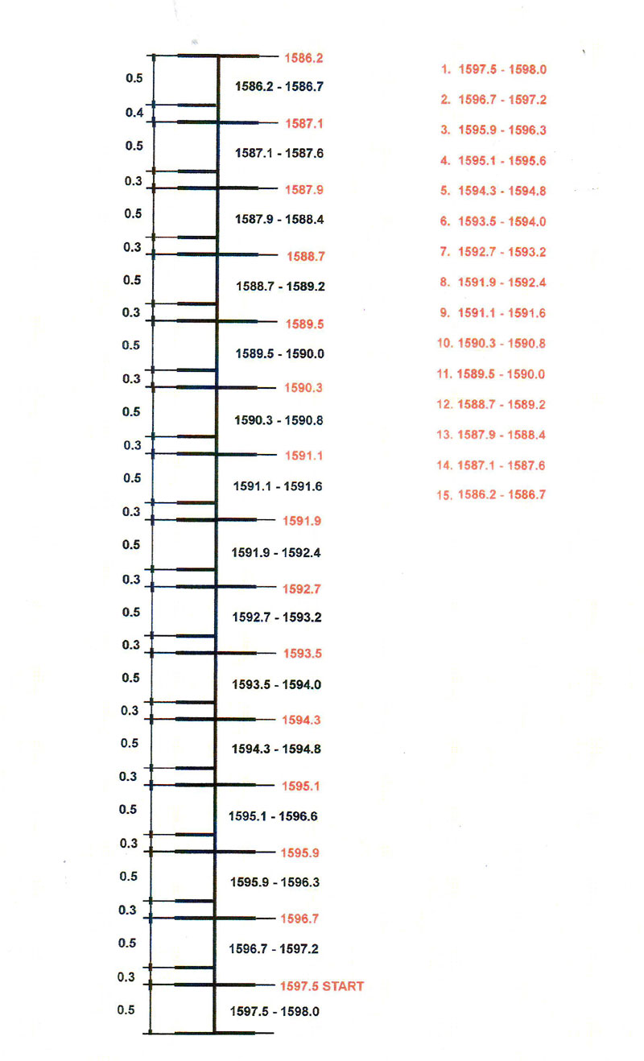

CUTTING INTERVALS

Primary zone (1586.7 - 1598.0 m)
(Practically continuous slot, with distances between cuts 0.5 + 0.2 m)

Interval 1 | 1597.5 - 1598.0 m
Interval 2 | 1596.5 - 1597.0 m
Interval 3 | 1595.5 - 1596.0 m
Interval 4 | 1594.5 - 1595.0 m
Interval 5 | 1593.5 - 1594.0 m
Interval 6 | 1592.5 - 1594.0 m
Interval 7 | 1591.5 - 1593.0 m
Interval 8 | 1590.5 - 1592.0 m
Interval 9 | 1589.5 - 1590.0 m
Interval 10 | 1588.5 - 1589.0 m
Interval 11 | 1587.5 - 1588.0 m
Interval 12 | 1587.5 - 1587.0 m
Interval 13 | 1586.5 - 1586.7 m
Total intervals : | 6.2 m
Total time : | ~ 30 hours

STATISTICS

initial level | 1597.5 m
final level | 1586.2 m
total distance | 11.8 m
continuous slot | 6.2 m
continuous surface drainage | ~ 35.0 m² (2 nozzles) ~ 70.0 m² (4 nozzles)

APPROXIMATE SETTINGS

Abrasive quartz sand (~ 10/35) optional (~20/40)
2 nozzles | 30.0 tons
4 nozzles | 60.0 tons
Net cutting time
cutting speed 3.0 mm/min | ~ 34 hours 30 min
cutting speed 3.5 mm/min | ~ 29 hours 30 min
cutting speed 4.0 mm/min | ~ 25 hours 45 min
cutting speed 4.5 mm/min | ~ 23 hours 00 min
cutting speed 5.0 mm/min | ~ 20 hours 30 min
cutting speed 5.5 mm/min | ~ 18 hours 45 min
Pumping settings (with 2 nozzles)
start slurry rate | ~ 0.3 m³/min
final slurry rate | ~ 0.7 m³/min
working pressure | ~ 27.5 - 41.5 MPa
Pumping settings (with 4 nozzles)
start slurry rate | ~ 0.6 m³/min
final slurry rate | ~ 1.94 m³/min
working pressure | ~ 27.5 - 41.5 MPa

ENTERING VALUES FOR THE CALCULATION OF HYDRO-SLOTTING PERFORATION

OD Casing | 114.3 mm (4.5”)
ID Casing | 103.89 mm (4.09”)
Drift Casing | ~ 100.0 mm
OD Tubing | 60.33 mm
ID Tubing | 50.67 mm
Drift Tubing | 48.28 mm
OD Drill Bit | 200.0 mm
Cement weight | 1400 kg/m
Cement used | SpectraCem NP + 0.9% FL-5 + 0.8% LCB-1000
Total Well Depth | 1584.0 m
Formation | Midale / Frobisher formations
Treatment interval | 1586.2-1598.0 m
Continuous interval | 6  .2 m
Open hole used | 200.0 mm
Mud weight used | 1100 to 1300 kg/m³
Bottom hole temp | 60ºC
Casing Collars | -
Fluid salinity | 46000 ppm
RESULTS

Casing area volume (inside) 1600.0 m | 33.85 m³
Tubing area volume on 1586.2 m | 4.53 m³
Tubing area volume on 1598.0 m | 4.57 m³
Tubing area volume (inside) 1586.2 m | 3.20 m³
Tubing area volume (inside) 1598.0 m | 3.22 m³
Fluid Volume (Well) for 1586.2 m | 15.08 m³
Fluid Volume (Well) for 1598.0 m | 15.07 m³
Average Volume (Well) 1592.1 m | 15.08 m³
Pump performers | 0.3-0.7 m³/min (2 nozzles) 0.6 - 1.94 m³/min (4 nozzles)
Working pressure | 27.5 - 41.5 MPa
Equipment speed | 4.0 - 4.5 - 5.0 (corrected during the operation)
Full length of the equipment (before tubing) | 3.4 m
Marker length | 1.25 m
Installation of the first interval | 1597.5 m (With elongation=35 cm= 1562.5 m)
Elongation of tubing (~ 30 MPa) | 350 mm
Time to reach the sand to nozzles | 6 min 30 sec
Time to reach the sand to surface | 18 min 00 sec
Pressure loss in tubing | 2.0 MPa
Pressure drop across the nozzles | 35.3 MPa
Friction coefficient | 1.5
Pup joints | 0.6 m + 1.5 m
Volume of working fluid in the surface system | 30 m³
Water storage tank volume approximately (minimum) | 20 m³
Cutting tank volume approximately (minimum) | 20 m³
Shale shaker (on top of cuttings tank) | 1 pump (500-600 l/min)
Low pressure tubing plus connections | 30 m (98.4 ft)
Standard BOP equipment | Frac valve + 8 stripper rubbers for frac valve
1 high-pressure (triplex) pump | minimum 35 MPa & 1 m³/min
1 blender | 25-50 kg/ m³
High pressure iron tubing & reverse flow manifold | 30 m (98.4 ft) including connections
Frac van | 1
Friction reducer additive for | 20 m (65.6 ft) or 3 water
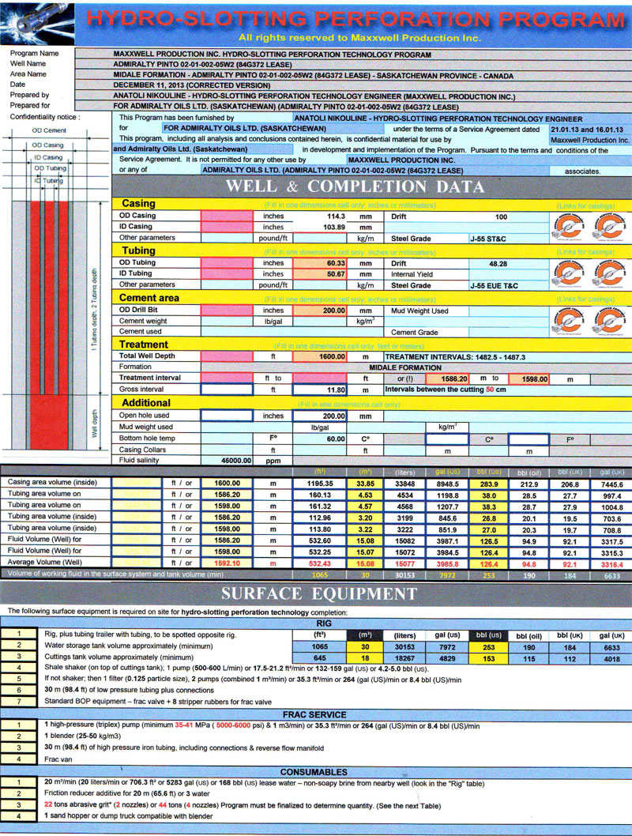
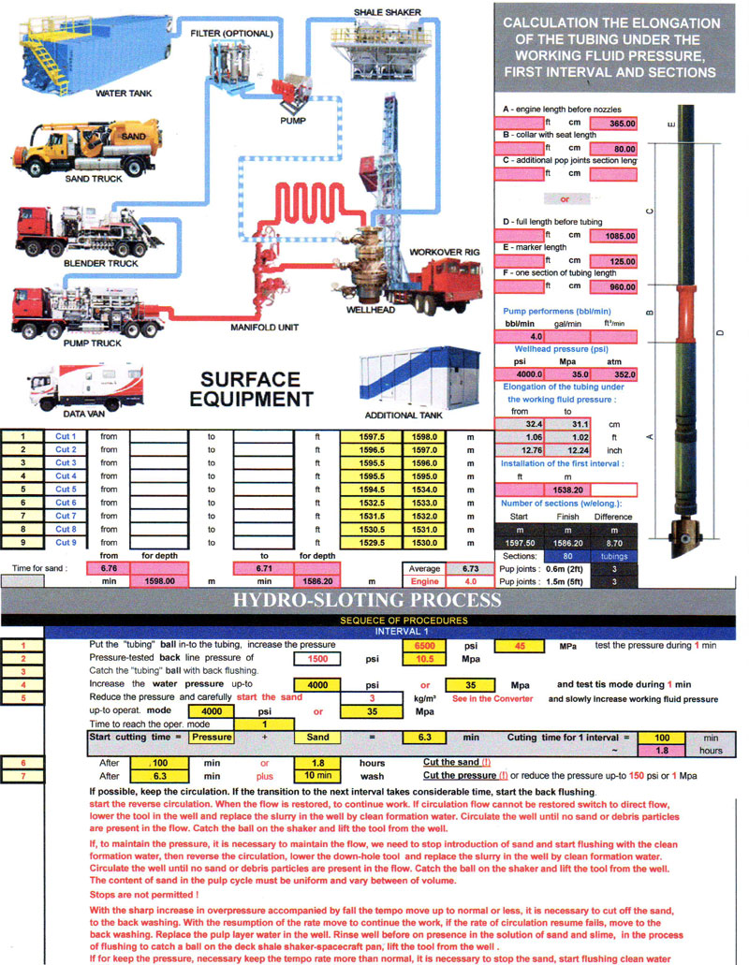

PREPARATION FOR HYDRO-SLOTTING PERFORATION

PREPARATION

a. Prepare site. MIRU. Spot rig, spot tubing trailer opposite rig if derrick cannot stand up tubing, cuttings tank, water storage tank, other equipment according to Surface Equipment schematic. Set up surface flow lines to be able to reverse flow csg/tbg (Manifold for csg/tbg reverse flow). Vacuum trucks bring _ m³ (total: in the tank and in the well) brine and fill water storage tank. Record well pressure before taking off gauge. Bleed off any pressure (< 0.7 MPa). ND tree & NU Frac Valve. Pressure test Frac Valve. Kill well.

► During the process of hydro-slotting perforation it is recommended heating the water in the system (possibly steam generator). The temperature inside the well is 57ºC. For prevent the cooling of the temperature during the process the water gets into the well from the surface, recommended heating water on the surface before the temperature of the working fluid in the pipes 30ºC.

► Measure the length of the equipment assembly. During the lowering of equipment into the well to measure sections of tubing. Lower equipment to the well so that the perforator’s nozzle at a depth ~ 1597.0 m.

b. (Stage 1 in the Tab) Make up and tally hydro-slotting equipment downhole assembly (equipment + transition adapter + test sub (marker) (~ 1 x 1.25 m) + pup joints (~ 2 x 2 m, 1 x 1 m). RIH with equipment and PU (~ 1 m) tubing from trailer & drift & tally in hole. RIH with pup joints (~ 2 x 2 m, 1 x 1 m).

c. (Stage 2 in the Tab) Optional RU wireline loggers. RIH with 125.0 mm gauge ring. If casing is new and no deformation is expected, and no fill is expected, well ID does not need to be.

a. Warm up. RU frac equipment (pumps, blender, hopper, high-pressure lines, manifold, frac van). RU sand truck and conveyor belt to blender. Record water temperature and viscosity. Record SI pressure of tbg/csg. Test stripper rubber. Test surface lines.

► During the process of hydro-slotting perforation it is recommended heating the water in the system (possibly steam generator). The temperature inside the well is 60ºC. For prevent the cooling of the temperature during the process the water gets into the well from the surface, recommended heating water on the surface before the temperature of the working fluid in the pipes 30ºC.

b. Conduct operational and safety meeting with all personnel on location, detailing all procedures and pressure limitations.

► Hydro-slotting operations. Refer to hydro-slotting procedures (next section). Program will be comprised of _ stages and include the following vertical intervals, in order of excavation (from deepest to shallowest) (to be varied to avoid casing collars).

► Abrasive quartz sand (abrasive grit*) 36 tons -2 nozzles, 70 tons-4 nozzles (abrasive quartz sand 1.5 - 3.0mm size of grains) ~ 10/35, (optional ~20/40).
► During the process can be adjusted the final intervals (depth).
► Take into consideration the elongation of tubing ~ 350 mm.
► The content of sand in the pulp cycle must be uniform and vary between 5% - 7% of volume.
► If the pressure increase over 41.5 MPa , accompanied by drop the tempo of pumping down, it is necessary to stop supply the sand, and turn reverse flushing.
► If the rate resumption - continue the process.
► If the circulation rate fails, turn reverse flushing.
► If the operating pressure drop below 10 Mpa the equipment automatic charging to its original start position (interval).

► Lowering up the tool
► Cutting process
DAY 1

CORRELATION

stage | operation (procedure) | the depth (level) | distance | approximate time
1 | Lowering the tool for 1 interval | ~ 1597.0 m | (Elongation 35 cm) | ~ 2 hour 00 min
2 | Correlation log |  |  | ~ 1 hour 25 min
3 | Correction the installation | 1597.5 m | (1562.5 m) | ~ 0 hour 05 min

TIME : ~ 3 hour 30 min

TUBING TESTING

stage | operation (procedure) | the depth (level) | distance | approximate time
4 | Drop the testing ball |  |  | ~ 0 hour 15 min
5 | Tubing pressure testing | (within 1 min) |  | ~ 0 hour 05 min
6 | Reverse flushing |  |  | ~ 0 hour 20 min
7 | Catching the testing ball | (within 10 min) |  | ~ 0 hour 05 min
8 | Drop the valve (cutting) ball |  |  | ~ 0 hour 15 min

TIME : ~ 1 hour 00 min

HYDRO-SLOTTING PERFORATION PROCESS

stage | operation (procedure) | the depth (level) | distance | approximate time
9 | Cutting 1 interval (cutting down) | 1597.5 ► 1598.0 m | 0.5 m | ~ 1 hour 50 min
10 | Direct flushing |  |  | ~ 0 hour 20 min
11 | Lifting UP the tool for the 2 interval | 1597.5 ► 1596.5 m | 1.0 m | ~ 0 hour 05 min
12 | Cutting 2 interval (cutting down) | 1596.5 ► 1597.0 m | 0.5 m | ~ 1 hour 50 min
13 | Direct flushing |  |  | ~ 0 hour 20 min
14 | Lifting UP the tool for the 3 interval | 1596.5 ► 1595.5 m | 1.0 m | ~ 0 hour 05 min
15 | Cutting 3 interval (cutting down) | 1595.5 ► 1596.0 m | 0.5 m | ~ 1 hour 50 min
16 | Direct flushing |  |  | ~ 0 hour 20 min
17 | Lifting UP the tool for the 4 interval | 1595.5 ► 1594.5 m | 1.0 m | ~ 0 hour 10 min
18 | Cutting 4 interval (cutting down) | 1594.5 ► 1595.0 m | 0.5 m | ~ 1 hour 50 min
19 | Direct flushing with lowering the tool | 1594.5 ► 1598.0 m | 3.5 m | ~ 0 hour 50 min

TIME : ~ 9 hour 30 min

TOTAL TIME FOR THIS DAY : ~ 14 hour 00 min

► Lowering up the tool
► Cutting process

DAY 2

TOOL REPLACEMENT

stage | operation (procedure) | the depth (level) | distance | approximate time
20 | Lifting UP the tool on the surface with marks on the tubing |  |  | ~ 1 hour 35 min
21 | Inspection the tool, replacement nozzles, perforator or tool |  |  | ~ 0 hour 10 min
22 | Lowering the tool for 5 interval | ~ 1593.5 m | (Elongation 35 cm) | ~ 2 hour 00 min
24 | Drop the valve (cutting) ball |  |  | ~ 0 hour 15 min

TIME : ~ 4 hour 00 min

HYDRO-SLOTTING PERFORATION PROCESS

stage | operation (procedure) | the depth (level) | distance | approximate time
25 | Cutting 5 interval (cutting down) | 1593.5 ► 1594.0 m | 0.5 m | ~ 1 hour 50 min
26 | Direct flushing |  |  | ~ 0 hour 20 min
27 | Lifting UP the tool for the 6 interval | 1593.5 ► 1592.5 m | 1.0 m | ~ 0 hour 05 min
28 | Cutting 6 interval (cutting down) | 1592.5 ► 1593.0 m | 0.5 m | ~ 1 hour 50 min
29 | Direct flushing |  |  | ~ 0 hour 20 min
30 | Lifting UP the tool for the 7 interval | 1592.5 ► 1591.5 m | 1.0 m | ~ 0 hour 05 min
31 | Cutting 7 interval (cutting down) | 1591.5 ► 1592.0 m | 0.5 m | ~ 1 hour 50 min
32 | Direct flushing |  |  | ~ 0 hour 20 min
33 | Lifting UP the tool for the 8 interval | 1591.5 ► 1590.5 m | 1.0 m | ~ 0 hour 10 min
34 | Cutting 8 interval (cutting down) | 1590.5 ► 1591.0 m | 0.5 m | ~ 1 hour 50 min
35 | Direct flushing with lowering the tool | 1590.5 ► 1598.0 m | 5.5 m | ~ 0 hour 50 min

TIME : ~ 9 hour 30 min

TOTAL TIME FOR THIS DAY : ~ 13 hour 30 min

► Lowering up the tool
► Cutting process
DAY 3

TOOL REPLACEMENT

stage | operation (procedure) | the depth (level) | distance | approximate time
36 | Lifting UP the tool on the surface with marks on the tubing |  |  | ~ 1 hour 35 min
37 | Inspection the tool, replacement nozzles, perforator or tool |  |  | ~ 0 hour 10 min
38 | Lowering the tool for 9 interval | ~ 1589.5 m | (Elongation 35 cm) | ~ 2 hour 00 min
39 | Drop the valve (cutting) ball |  |  | ~ 0 hour 15 min

TIME : ~ 4 hour 00 min

HYDRO-SLOTTING PERFORATION PROCESS

stage | operation (procedure) | the depth (level) | distance | approximate time
40 | Cutting 1 interval (cutting down) | 1589.5 ► 1590.0 m | 0.5 m | ~ 1 hour 50 min
41 | Direct flushing |  |  | ~ 0 hour 20 min
42 | Lifting UP the tool for the 2 interval | 1589.5 ► 1588.5 m | 1.0 m | ~ 0 hour 05 min
43 | Cutting 2 interval (cutting down) | 1588.5 ► 1589.0 m | 0.5 m | ~ 1 hour 50 min
44 | Direct flushing |  |  | ~ 0 hour 20 min
45 | Lifting UP the tool for the 3 interval | 1588.5 ► 1587.5 m | 1.0 m | ~ 0 hour 05 min
46 | Cutting 3 interval (cutting down) | 1587.5 ► 1588.0 m | 0.5 m | ~ 1 hour 50 min
47 | Direct flushing |  |  | ~ 0 hour 20 min
48 | Lifting UP the tool for the 4 interval | 1587.5 ► 1586.5 m | 1.0 m | ~ 0 hour 10 min
49 | Cutting 4 interval (cutting down) | 1586.5 ► 1586.7 m | 0.2 m | ~ 0 hour 50 min
50 | Direct flushing with lowering the tool | 1586.5 ► 1598.0 m | 11.5 m | ~ 0 hour 50 min

TIME : ~ 8 hour 30 min

LIFTING THE TOOL UP ON THE SURFACE

stage | operation (procedure) | the depth (level) | distance | approximate time
51 | Lifting UP the tool on the surface |  |  | ~ 1 hour 30 min

TIME : ~ 1 hour 30 min

TOTAL TIME FOR THIS DAY : ~ 14 hour 00 min

15

14

13

12

11

10

9

8

7

6
LOSS PRESSURE WORKING PRESSURE WELLHEAD PRESSURE

POSSIBLE CHEMICAL TREATMENT

Continue completion, possible chemical treatment, and test well.
The approximate composition:

Acid: 15% HCl
Surface-active substances: 0.3%-0.5% (water-repellent agent for for debit wells)
Corrosion inhibitor: 0.5%
Stabilizer: 0.1%
Moderator of the reaction rate: 0.1% (in US three ready types).

Solution volume is calculated from the drainage radius equal 5 feet from the wellbore.

