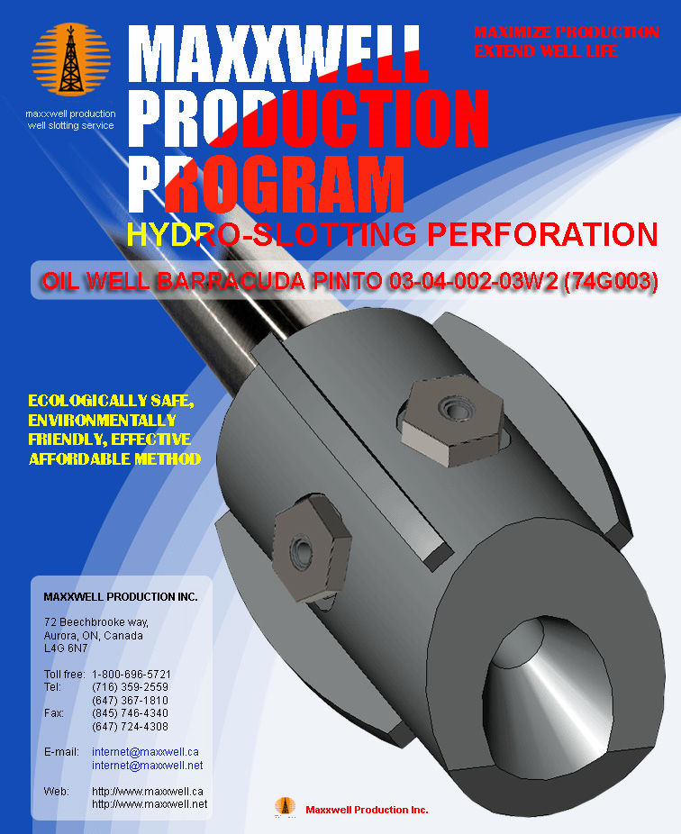
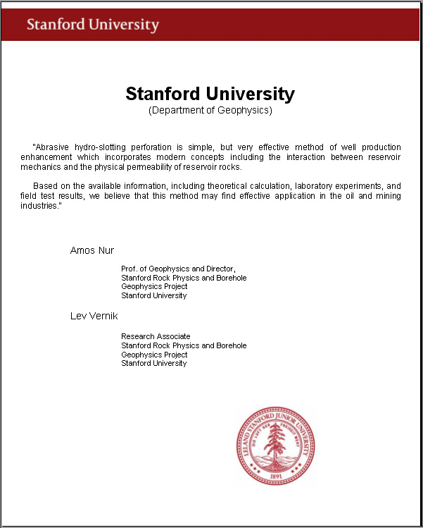

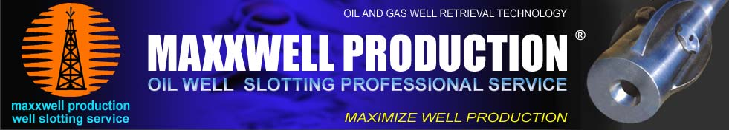

December 10, 2013 # SK-003

SLOT DISCHARGE OF PRODUCTIVE LAYER
WITH HYDRO-SLOTTING PERFORATION

OIL WELL BARRACUDA PINTO 03-04-002-03W2 (74G003)

MIDALE / FROBISHER FORMATION

Date: December 10, 2013

By: Anatoli Nikouline C.E.T.
Hydro-slotting perforation technology engineer
Maxxwell Production Inc.
72 Beechbrooke way,
Aurora, Ontario, Canada
L4G 6N7

For: Quinton Hardage, P. Eng.
President & Chief Executive Officer
Admiralty Oils Ltd.
# 210-226 20th Street East,
Saskatoon, Saskatchewan, Canada
S7K 0A6

This Program has been furnished by Maxxwell Production Inc. (MPI) to Admiralty Oils Ltd. (AOL) under the terms of Exclusive Agreement dated January 21, 2013 and Confidentiality and Non-Disclosure Agreement dated January 16, 2013. This Program, including all materials and conclusions contained herein, is confidential for use by MPI and AOL in development and implementation of the Program. Being pursuant to the terms and conditions of the above Agreements and governed by the terms of these agreements.

OIL WELL BARRACUDA PINTO 03-04-002-03W2 (74G003)

Present a comparative analysis of the well prepared on the basis of information provided by the Customer (AOL) :

(http://www.wellslotting.com/318606249670643186062/496706431860624967064/030400203W2.htm)

1. Map 1 of 03-04-002-03W2 (74G003)
2. Map 2 of 03-04-002-03W2 (74G003)
3. Map 3 of 03-04-002-03W2 (74G003)
4. Map 4 of 03-04-002-03W2 (74G003)
5. Chemical and Geological report (Water Analysis) from 26/07/85
6. Well Ticket from 11/06/13
7. Log of the well 03-04-002-03W2 (74G003)
8. Production History from 10/1974 - 05/2013
9. Well Completion Data from 07/20/75
10. Well side and access road of the well 03-04-002-03W2
11. Pressure Test from 07/21/74
12. Application for MPR-Oil well 03-04-002-03W2
13. Drill Tests from 12/07/74
14. Geological data sheet from 11/26/74
15. Oil well report from 4/2/75
16. Well activity report from 11/01/2005
17. Well Bulletin for 03-04-002-03W2
18. Licence to drill a well

WELL DATA

Company | Admiralty
Well | Barracuda Pinto 03-04-002-03W2
Field | Pinto
Province/County | Saskatchewan
Country/State | Canada
Location | 101/03-04-002-03W2/00
LSD | 03
SEC | 04
TWP | 002
RGE | 03W21
Service | HBC
Licence Number | 74G003
Permanent Datum | GL
Coordinates well (Latitude) | 49.08955 deg N
Coordinates well (Longitude) | 102.35603 deg W
TVD | 1584 m (5200 ft)
FM@TD | 1584 m (5200 ft)
OD casing | 114.3 mm (4.5”)
ID casing | 103.89 mm (4.09”)
Bit Size | 200.00 mm
Hole Fluid Type | GEL CHEMICAL
Density/Viscosity | 1130.0 kg/m (106.00 sec/L)
PH/Fluid Loss | 9.00 (7,50 ml/ 30 min)
Sample Source | FLOW LINE
Rm @ Measured Temp | 0.90 @ 20.0 ohm-m
Rmf @ Measured Temp | 0.70 @ 16.0 ohm-m
Rmc @ Measured Temp | 0.30 @ 18.0 ohm-m
Source Rmf/Rmc | PRESS
Rm @ BHT | 0.81 @ 24.0 ohm-m
Time Since Circulation | 3
Max Recorded Temp | 57ºC (layer level)
Equipment/Base | 13052(MDH)
Casing area volume | 33.51 m³
Fluid volume | 14.99 m³

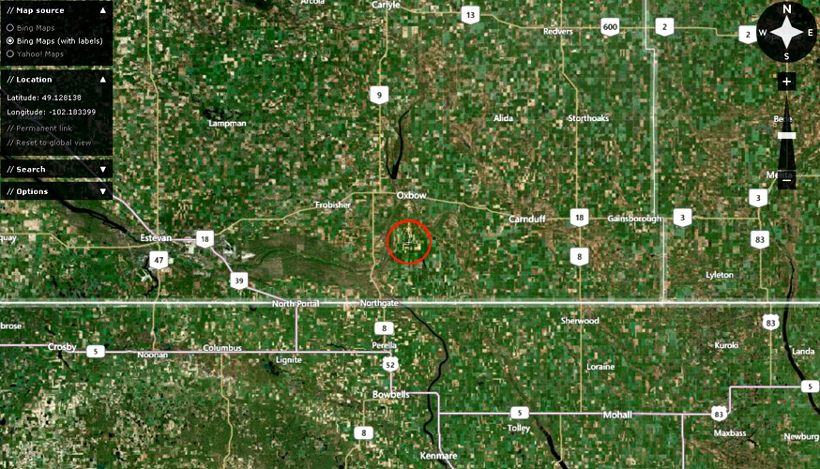

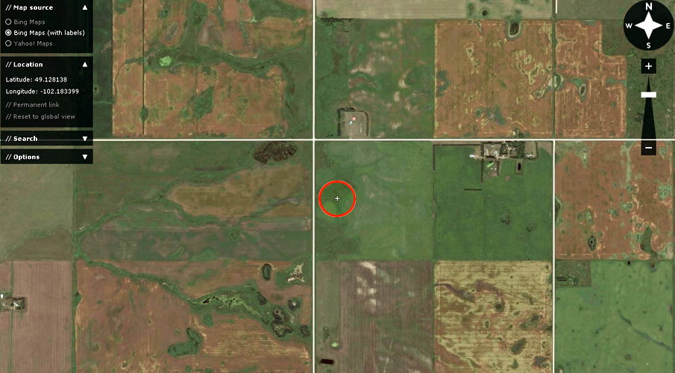

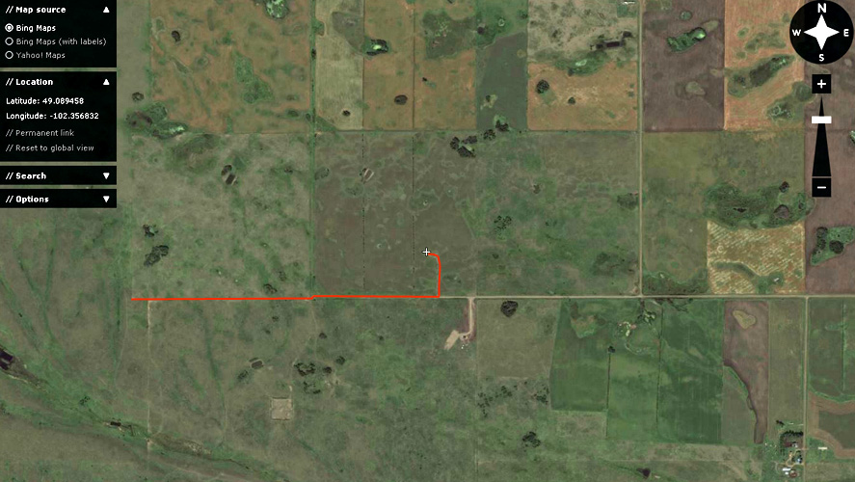

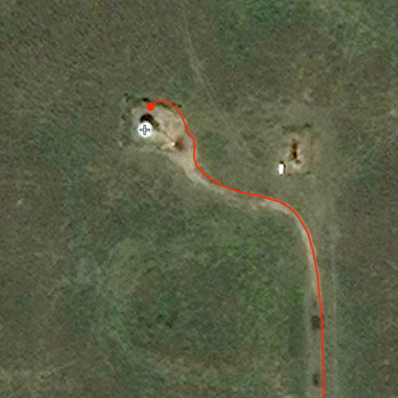

OPENING FORMATION

Midale /Frobisher | 1529.5-1535.0 m and 1536.8-1538.7 m

SUMMARY ANALYSIS

Summary analysis of geological and geophysical data for the oil well Barracuda Pinto 03-04-002-03W2 (74G003)
Baseline:

► Log of the well 03-04-002-03W2, complex GIS analysis, tests results of oil and gas.
► Geological and geophysical data on nearby wells not represented.
► When tested in an open hole of the interval 1528.0-1545.0 m (5013.0 – 5069.0 ft) Midale formation (21.07.1974) was obtained a weak flow of oil.
► When tested in an open hole of the interval 1549.0-1565.7 m (5082.0 – 5137.0 ft) Frobisher formation (21.07.1974) was obtained a weak flow of oil and water.
► GIS data collectors are highlighted in the following ranges:

Top  (m) | Bottom  (m) | Effective thickness  (m) | Saturation of the test results in an open hole
1538.0 | 1539.5 | 1.5 | Oil
1544.0 | 1545.3 | 1.3 | Oil + water
1553.5 | 1554.8 | 1.3 | Oil + water
1562.8 | 1564.0 | 1.2 | Oil + water
1565.2 | 1566.6 | 1.4 | Oil + water

CONCLUSION

► On the basis of the submissions and comparison with the well 07-27-004-07W2 (Midale formation) for slotted perforations in the well 03-04-002-03W2 is recommended the following intervals :

Number of interval | Interval  (m) | Formation | Between the cuts  (m) | Between the intervals  (m)
1538.0 | 1538.0 - 1539.5 | Midale | - | -
1544.0 | 1544.0 - 1545.3 | Frobisher | - | -
1553.5 | 1553.5 - 1554.8 | Frobisher | - | -
1562.8 | 1562.8 - 1564.0 | Frobisher | - | -
1565.2 | 1565.2 - 1566.6 | Frobisher | - | -

► The casing OD diameter is 114.3 mm. Internal diameter (ID) 103.89 mm.

► The temperature in the production interval 57ºC. The working fluid must be heated to a temperature 30ºC.

► Specified intervals in the Frobisher formation cutting can be changed along the way. In the interval 1538.0 - 1539.5 m not excluded the presence of water.

► Figure 1 shows the geophysical characteristics of the well 03-04-002-03W2in the range of 1500.0 - 1575.0 m:

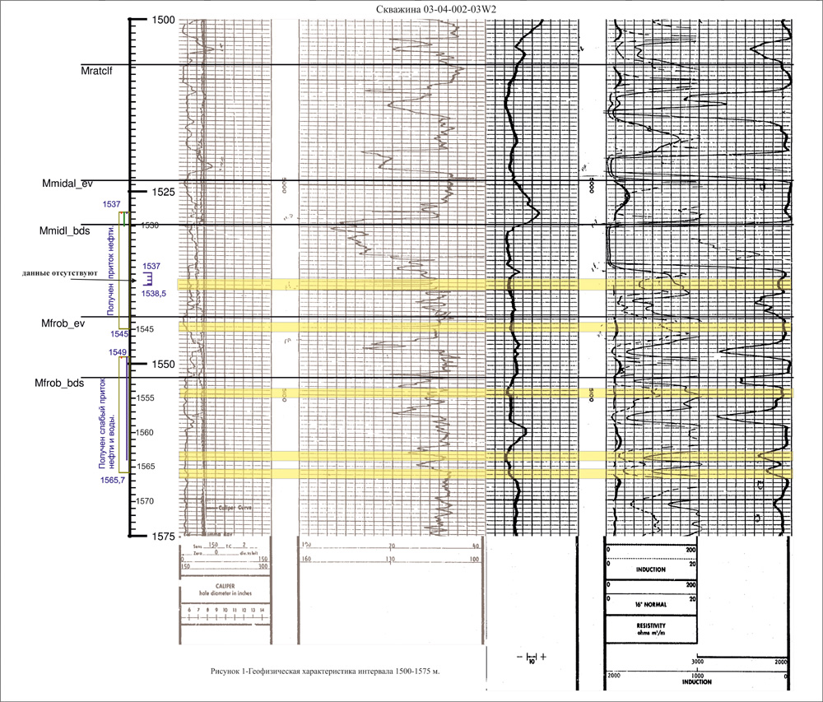

► Figure 2 correlation diagram of wells 03-04-002-03W2, 07-27-004-07W2:

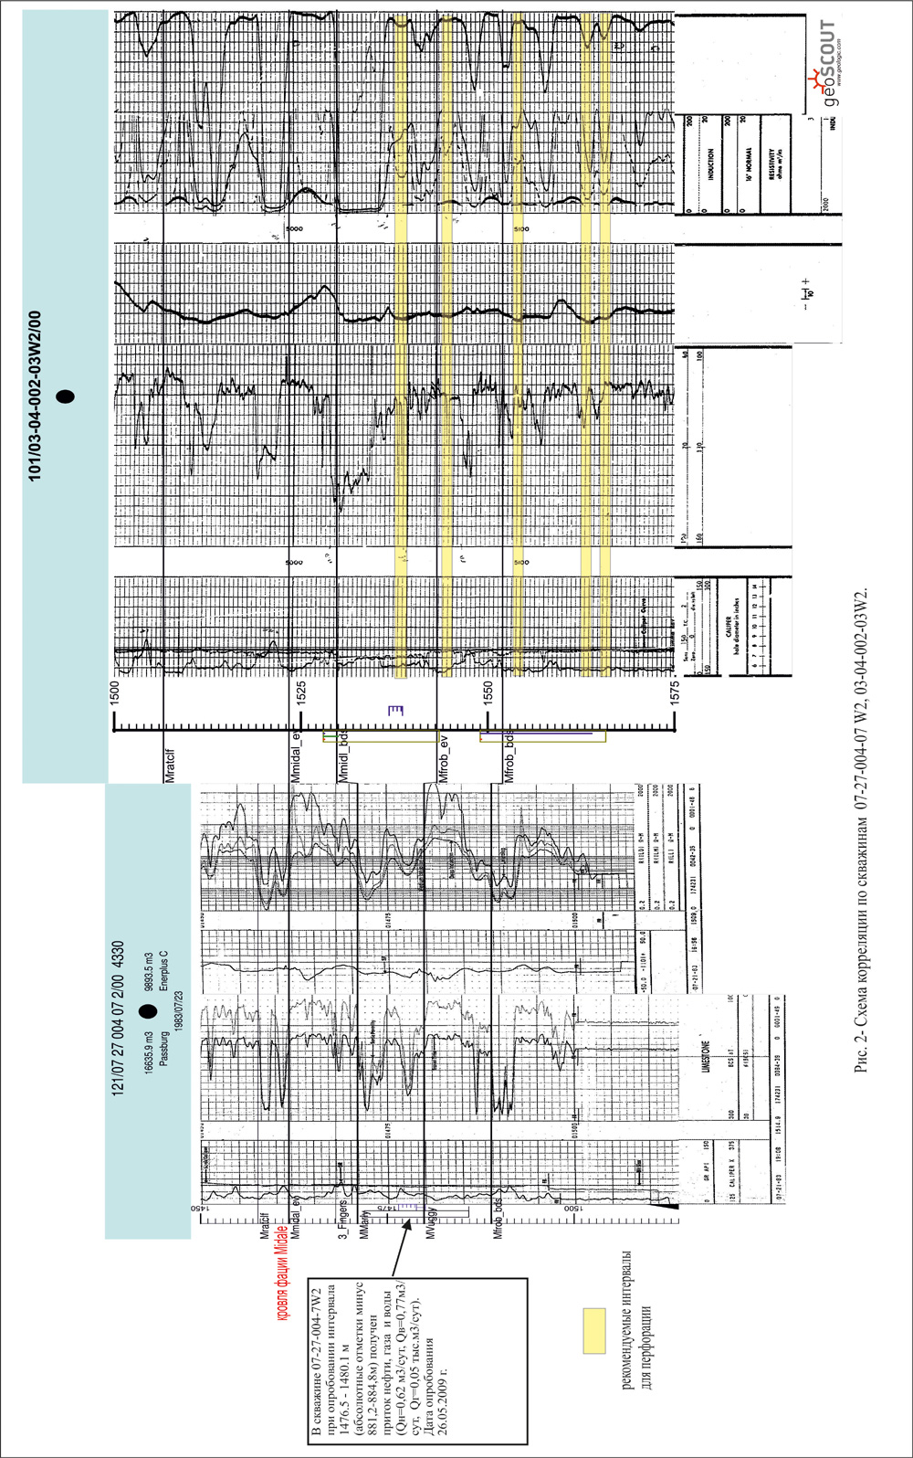

► According to the results highlighted the following intervals for cutting. Taken into account that the upper interval is the best, it is taken fully. In the lower ranges, given that the breed is more saturated with water, taken for cutting the upper parts of these intervals:

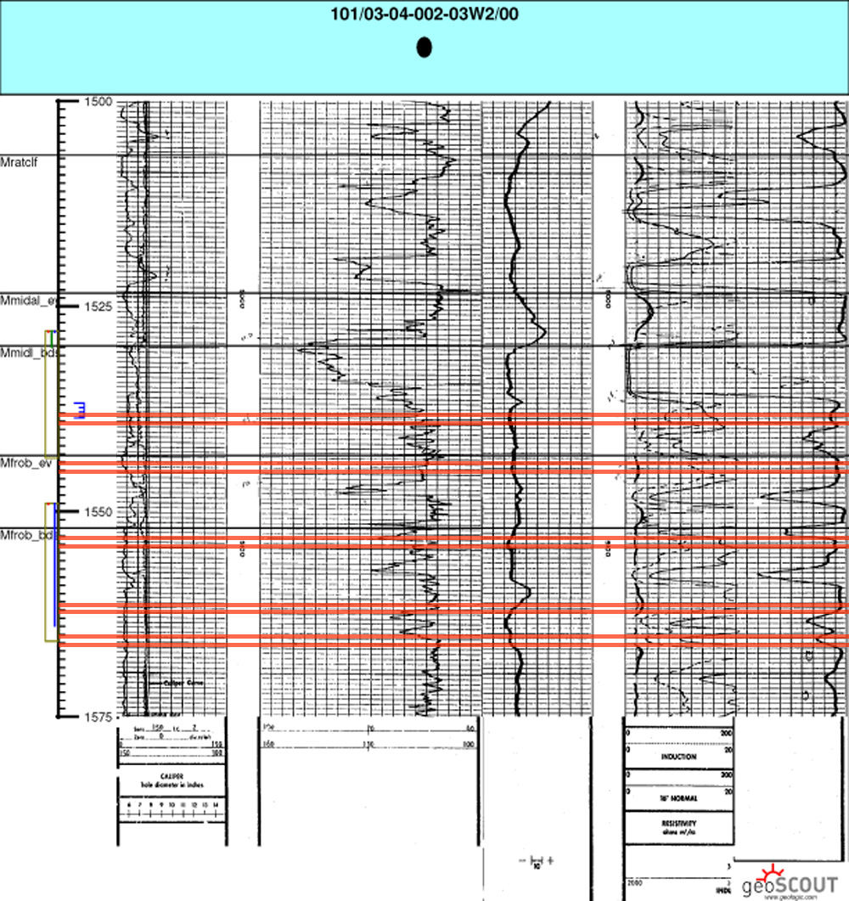

Addition conclusion for the well Barracuda Pinto 03-04-002-03W2 (74G003).
► In the well 03-04-002-3W2 (74G003) interval 1536.8 - 1538.6 m according to hydrodynamic studies (HDS) is not characterized as a collector. The top of the collector curve by receptivity bounces at a depth 1538.0 m. According to hydrodynamic studies (HDS) for slotting perforation is possible to recommend interval 1538,0-1539,5 m.
► The collector in the interval 1530,0-1535,5 m has low resistance by induction logging (IL). This interval was not tested after drilling. It was perforated interval 1537,0-1538,5 m, but the data of the results of the influx is absent.
► If in the neighbouring well is opened similar to the interval 1530,0-1535,5 m in the well 03-04-002-3W2 (74G003), and it is working without water, so in this interval is possible to conduct the slotting perforation.

► The intervals 1544,0-1545,3 m, 1553,5-1554,8 m,1562,8-1564,0 m and 1565,2-1566,6 m in the Frobisher formation are possible additional sources of the production growth.

► It is possible to recommend intervals for the slotting perforation are shown in Figure 2. and Table 2.
Table 2.
top (m) | bottom (m) | distance (m) | saturation
1530.0 | 1530.4 | 0.4 | oil
1530.6 | 1531.0 | 0.4
1531.2 | 1531.6 | 0.4
1531.8 | 1532.2 | 0.4
1532.4 | 1532.8 | 0.4
1533.0 | 1533.4 | 0.4
1533.6 | 1534.0 | 0.4
1534.2 | 1534.6 | 0.4
1534.8 | 1535.1 | 0.3
1535.2 | 1535.5 | 0.3
total: |  | 3.8 m
1538.0 | 1538.4 | 0.4 | oil
1538.6 | 1539.0 | 0.4
1539.2 | 1539.5 | 0.3
total: |  | 1.1 m
top (m) | bottom (m) | distance (m) | saturation
1544.0 | 1544.3 | 0.3 | oil + water
1544.5 | 1544.8 | 0.3
1545.0 | 1545.3 | 0.3
total: |  | 0.9 m

CUTTING INTERVALS

Primary (upper) zone (1536.8 - 1538.7 m)
(practically continuous slot, with a distances between cuts 0.2 m)

Interval 1 | 1538.2 - 1538.7 m
Interval 2 | 1537.5 - 1538.0 m
Interval 3 | 1536.8 - 1537.3 m
Total intervals : | 1.5 m (1.8 m)
Total time : | ~ 6.0 hours

Secondary (down) zone (1529.5 - 1535.0 m)
(with a distance between cuts 0.5 m)

Interval 1 | 1534.5 - 1535.0 m
Interval 2 | 1533.5 - 1534.0 m
Interval 3 | 1532.5 - 1533.0 m
Interval 4 | 1531.5 - 1532.0 m
Interval 5 | 1530.5 - 1531.0 m
Interval 6 | 1529.5 - 1530.0 m
Total intervals : | 3.0 m (5.50 m)
Total time : | ~ 12.0 hours

STATISTICS

initial level | 1538.2 m
final level | 1529.5 m
total distance | 8.7 m
total slot | 1.5 m (1.8 m) + 3.0 m (5.5 m) = 4.5 m (7.3 m)
continuous slot | 4.5 m (7.3 m)
gross surface drainage | ~ 40.0 m² (2 nozzles) ~ 70.0 m² (4 nozzles)
continuous surface drainage | ~ 25.0 m² (2 nozzles) ~ 50.0 m² (4 nozzles)

APPROXIMATE SETTINGS

Abrasive quartz sand (~ 10/35) optional (~20/40)
2 nozzles | ~ 22.0 tons
4 nozzles | ~ 44.0 tons
Net cutting time
cutting speed 3.0 mm/min | ~ 25 hours 00 min
cutting speed 3.5 mm/min | ~ 21 hours 30 min
cutting speed 4.0 mm/min | ~ 18 hours 45 min
cutting speed 4.5 mm/min | ~ 16 hours 40 min
cutting speed 5.0 mm/min | ~ 15 hours 00 min
cutting speed 5.5 mm/min | ~ 13 hours 40 min
Pumping settings (with 2 nozzles)
start slurry rate | ~ 0.3 m³/min
final slurry rate | ~ 0.7 m³/min
working pressure | ~ 27.5 - 41.5 MPa
Pumping settings (with 4 nozzles)
start slurry rate | ~ 0.6 m³/min
final slurry rate | ~ 1.94 m³/min
working pressure | ~ 27.5 - 41.5 MPa

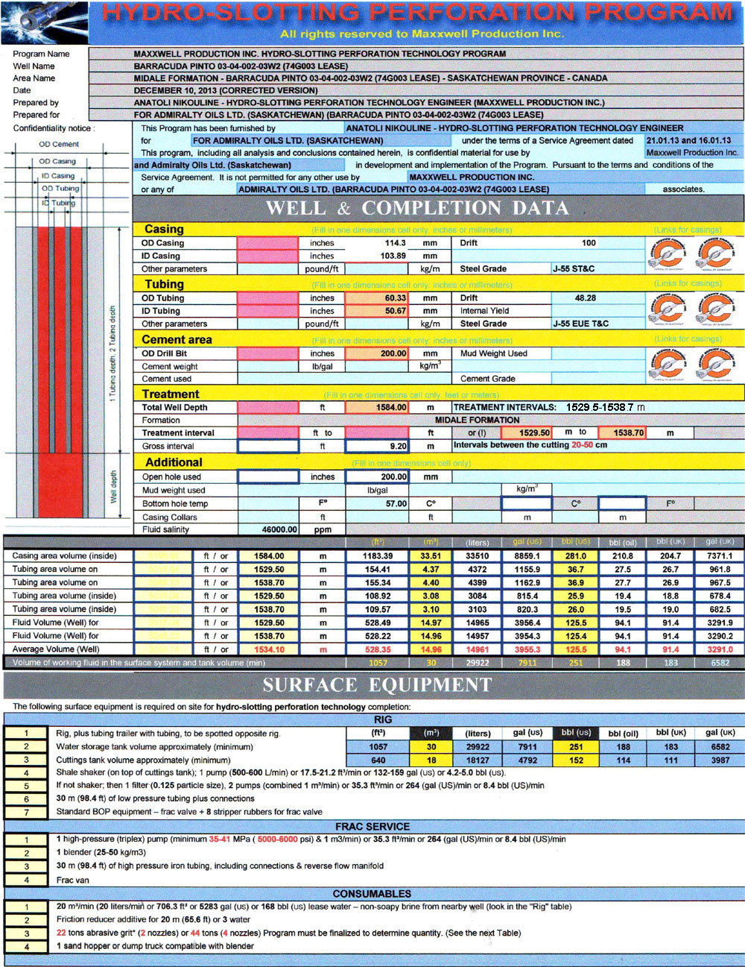
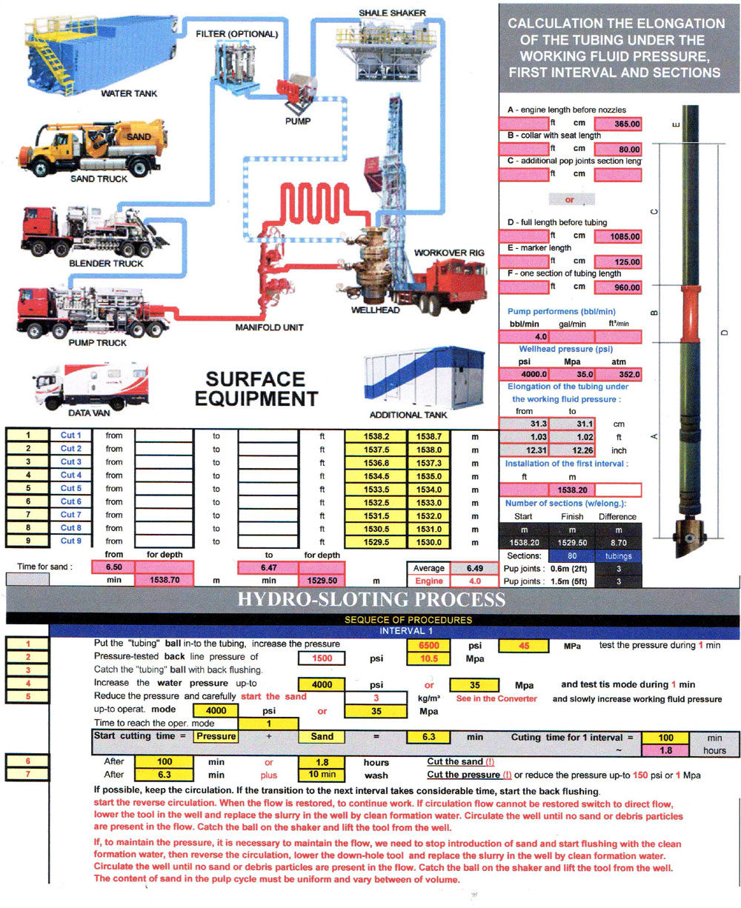

PREPARATION FOR HYDRO-SLOTTING PERFORATION

DAY 1

a. Prepare site. MIRU. Spot rig, spot tubing trailer opposite rig if derrick cannot stand up tubing, cuttings tank, water storage tank, other equipment according to Surface Equipment schematic. Set up surface flow lines to be able to reverse flow csg/tbg (Manifold for csg/tbg reverse flow). Vacuum trucks bring _ m³ (total: in the tank and in the well) brine and fill water storage tank. Record well pressure before taking off gauge. Bleed off any pressure (< 0.7 MPa). ND tree & NU Frac Valve. Pressure test Frac Valve. Kill well. (2 hours).

► During the process of hydro-slotting perforation it is recommended heating the water in the system (possibly steam generator). The temperature inside the well is 57ºC. For prevent the cooling of the temperature during the process the water gets into the well from the surface, recommended heating water on the surface before the temperature of the working fluid in the pipes 30ºC.

► Measure the length of the equipment assembly. During the lowering of equipment into the well to measure sections of tubing. Lower equipment to the well so that the perforator’s nozzle at a depth ~ 1466.0 m.

b. (Stage 1 in the Tab) Make up and tally hydro-slotting equipment downhole assembly (equipment + transition adapter + test sub (marker) (~ 1 x 1.25 m) + pup joints (~ 2 x 2 m, 1 x 1 m). RIH with equipment and PU (~ 1 m) tubing from trailer & drift & tally in hole. RIH with pup joints (~ 2 x 2 m, 1 x 1 m).

c. (Stage 2 in the Tab) Optional RU wireline loggers. RIH with 125.0 mm gauge ring. If casing is new and no deformation is expected, and no fill is expected, well ID does not need to be.

d. Secure well & SDFN.

stage | operation (procedure) | the depth (level) | distance | approximate time
1 | Lowering the tool for 1 interval | ~ 1538.0 m | Elongation 30 cm | ~ 2 hour 30 min
2 | Correlation log |  |  | ~ 3 hour 00 min
3 | Correction the installation | 1538.2 m |  | ~ 0 hour 10 min
 |  |  |  | ~ 0 hour 20 min
TOTAL TIME : |  |  |  | ~ 6 hour 00 min

HYDRO-SLOTTING PERFORATION STAGES

DAY 2

a. Warm up. RU frac equipment (pumps, blender, hopper, high-pressure lines, manifold, frac van). RU sand truck and conveyor belt to blender. Record water temperature and viscosity. Record SI pressure of tbg/csg. Test stripper rubber. Test surface lines.

► During the process of hydro-slotting perforation it is recommended heating the water in the system (possibly steam generator). The temperature inside the well is 57ºC. For prevent the cooling of the temperature during the process the water gets into the well from the surface, recommended heating water on the surface before the temperature of the working fluid in the pipes 30ºC.

b. Conduct operational and safety meeting with all personnel on location, detailing all procedures and pressure limitations.

► Hydro-slotting operations. Refer to hydro-slotting procedures (next section). Program will be comprised of 41 stages and include the following vertical intervals, in order of excavation (from deepest to shallowest) (to be varied to avoid casing collars).

► Abrasive quartz sand (abrasive grit*) 22 tons -2 nozzles, 44 tons-4 nozzles (abrasive quartz sand 1.5 - 3.0mm size of grains) ~ 10/35, optional ~20/40.
► During the process can be adjusted the final intervals (depth).
► Take into consideration the elongation of tubing ~ 300 mm.
► The content of sand in the pulp cycle must be uniform and vary between 5% - 7% of volume.
► If the pressure increase over 41.5 MPa , accompanied by drop the tempo of pumping down, it is necessary to stop supply the sand, and turn reverse flushing.
► If the rate resumption - continue the process.
► If the circulation rate fails, turn reverse flushing.
► If the operating pressure drop below 10 Mpa the equipment automatic charging to its original start position (interval).

► Lowering up the tool
► Cutting process

stage | operation (procedure) | the depth (level) | distance | approximate time
4 | Drop the testing ball |  |  | ~ 0 hour 20 min
5 | Tubing pressure testing | (within 1 min) |  | ~ 0 hour 05 min
6 | Reverse flushing |  |  | ~ 0 hour 30 min
7 | Catching the testing ball | (within 10 min) |  | ~ 0 hour 10 min
8 | Drop the valve (cutting) ball |  |  | ~ 0 hour 20 min
9 | Cutting 1 interval (cutting down) | 1538.2 ► 1538.7 m | 0.5 m | ~ 1 hour 50 min
10 | Direct flushing |  |  | ~ 0 hour 20 min
11 | Lifting UP the tool for the 2 interval | 1538.2 ► 1537.5 m | 0.7 m | ~ 0 hour 05 min
12 | Cutting 2 interval (cutting down) | 1537.5 ► 1538.0 m | 0.5 m | ~ 1 hour 50 min
13 | Direct flushing |  |  | ~ 0 hour 20 min
14 | Lifting UP the tool for the 3 interval | 1537.5 ► 1536.8 m | 0.7 m | ~ 0 hour 05 min
15 | Cutting 3 interval (cutting down) | 1536.8 ► 1537.3 m | 0.5 m | ~ 1 hour 50 min
16 | Direct flushing |  |  | ~ 0 hour 20 min
17 | Lifting UP the tool for the 4 interval | 1536.8 ► 1534.5 m | 2.3 m | ~ 0 hour 10 min
18 | Cutting 4 interval (cutting down) | 1534.5 ► 1535.0 m | 0.5 m | ~ 1 hour 50 min
22 | Direct flushing with lowering the tool from 1534.5 ► 1538.7 m 4.2 m |  |  | ~ 0 hour 50 min
23 | Lifting UP the tool on the surface with marks on the tubing. |  |  | ~ 1 hour 30 min
24 | Inspection the tool. Replacement nozzles, perforator or tool. |  |  | ~ 1 hour 00 min
PUMPING SERVICE WORKING TIME : |  |  |  | ~ 10 hour 45 min
RIG SERVICE WORKING TIME : |  |  |  | ~ 12 hour 15 min
TOTAL TIME : |  |  |  | ~ 13 hour 15 min

HYDRO-SLOTTING PERFORATION STAGES

DAY 3

stage | operation (procedure) | the depth (level) | distance | approximate time
25 | Lowering the tool for 6 interval | ~ 1533.5 m | Elongation 30 cm | ~ 2 hour 30 min
26 | Cutting 6 interval (cutting down) | 1533.5 ► 1534.0 m | 0.5 m | ~ 1 hour 50 min
27 | Direct flushing |  |  | ~ 0 hour 20 min
28 | Lifting UP the tool for the 7 interval | 1533.5 ► 1532.5 m | 1.0 m | ~ 0 hour 15 min
29 | Cutting 7 interval (cutting down) | 1532.5 ► 1533.0 m | 0.3 m | ~ 1 hour 10 min
30 | Direct flushing |  |  | ~ 0 hour 20 min
31 | Lifting UP the tool for the 8 interval | 1532.5 ► 1531.5 m | 1.0 m | ~ 0 hour 05 min
32 | Cutting 8 interval (cutting down) | 1531.5 ► 1532.0 m | 0.5 m | ~ 1 hour 50 min
33 | Direct flushing |  |  | ~ 0 hour 20 min
34 | Lifting UP the tool for the 9 interval | 1531.5 ► 1530.5 m | 1.0 m | ~ 0 hour 10 min
35 | Cutting 9 interval (cutting down) | 1530.5 ► 1531.0 m | 0.5 m | ~ 1 hour 50 min
36 | Direct flushing |  |  | ~ 0 hour 20 min
37 | Lifting UP the tool for the 10 interval | 1530.5 ► 1529.5 m | 1.0 m | ~ 0 hour 15 min
38 | Cutting 10 interval (cutting down) | 1529.5 ► 1534.0 m | 0.5 m | ~ 1 hour 50 min
39 | Direct flushing |  |  | ~ 0 hour 20 min
40 | Direct flushing with lowering the tool from 1529.5 ► 1566.2 m 4.5 m |  |  | ~ 1 hour 30 min
41 | Lifting UP the tool on the surface with marks on the tubing. |  |  | ~ 1 hour 30 min
PUMPING SERVICE WORKING TIME : |  |  |  | ~ 12 hour 00 min
RIG SERVICE WORKING TIME : |  |  |  | ~ 16 hour 00 min
TOTAL TIME : |  |  |  | ~ 16 hour 00 min

ENTERING VALUES FOR THE CALCULATION
OF HYDRO-SLOTTING PERFORATION

OD Casing | 114.3 mm (4.5”)
ID Casing | 103.89 mm (4.09”)
Drift Casing | ~ 100.0 mm
OD Tubing | 60.33 mm
ID Tubing | 50.67 mm
Drift Tubing | 48.28 mm
OD Drill Bit | 200.0 mm
Cement weight | 1400 kg/m
Cement used | SpectraCem NP + 0.9% FL-5 + 0.8% LCB-1000
Total Well Depth | 1584.0 m
Formation | Midale / Frobisher formations
Treatment interval | 1529.5-1535.0 m and 1536.8-1538.7 m
Continuous interval | 4.5 m
Open hole used | 200.0 mm
Mud weight used | 1100 to 1300 kg/m³
Bottom hole temp | 57ºC
Casing Collars | -
Fluid salinity | 46000 ppm
RESULTS

Casing area volume (inside) 1584.0 m | 33.51 m³
Tubing area volume on 1529.5 m | 4.37 m³
Tubing area volume on 1538.7 m | 4.40 m³
Tubing area volume (inside) 1529.5 m | 3.08 m³
Tubing area volume (inside) 1538.7 m | 3.10 m³
Fluid Volume (Well) for 1529.5 m | 14.97 m³
Fluid Volume (Well) for 1538.7 m | 14.96 m³
Average Volume (Well) 1534.1 m | 14.96 m³
Pump performers | 0.3-0.7 m³/min (2 nozzles) 0.6 - 1.94 m³/min (4 nozzles)
Working pressure | 27.5 - 41.5 MPa
Equipment speed | 4.0 - 4.5 - 5.0 (corrected during the operation)
Full length of the equipment (before tubing) | 3.4 m
Marker length | ~ 1.25 m
One section of tubing length | ~ 9.6 m
Installation of the first interval | 1538.2 m (With elongation=30 cm= 1508.2 m)
Elongation of tubing (~ 30 MPa) | 300 mm
Time to reach the sand to nozzles | ~ 6 min 50 sec
Time to reach the sand to surface | ~ 18 min 30 sec
Pressure loss in tubing | ~ 2.0 MPa
Pressure drop across the nozzles | ~ 35.3 MPa
Friction coefficient | ~ 1.5
Pup joints | 0.6 m + 1.5 m
Volume of working fluid in the surface system | 30 m³
Water storage tank volume approximately (minimum) | 20 m³
Cutting tank volume approximately (minimum) | 20 m³
Shale shaker (on top of cuttings tank) | 1 pump (500-600 l/min)
If not shaker; then 1 filter | (0.125 particle size) 2 pumps (combined 1 m³/min)
Low pressure tubing plus connections | 30 m (98.4 ft)
Standard BOP equipment | Frac valve + 8 stripper rubbers for frac valve
1 high-pressure (triplex) pump | minimum 35 MPa & 1 m³/min
1 blender | 25-50 kg/ m³
High pressure iron tubing & reverse flow manifold | 30 m (98.4 ft) including connections
Frac van | 1
Non-soapy brine from nearby well | 50 m³ (46 m³)
Friction reducer additive for | 20 m (65.6 ft) or 3 water
Abrasive quartz sand (abrasive grit*) | 40 tonnes (abrasive quartz sand 1.5-3.0 mm size of grains)

15

14

13

12

11

10

9

8

7

6
LOSS PRESSURE WORKING PRESSURE WELLHEAD PRESSURE

POSSIBLE CHEMICAL TREATMENT

Continue completion, possible chemical treatment, and test well.
The approximate composition:

Acid: 15% HCl
Surface-active substances: 0.3%-0.5% (water-repellent agent for for debit wells)
Corrosion inhibitor: 0.5%
Stabilizer: 0.1%
Moderator of the reaction rate: 0.1% (in US three ready types).

Solution volume is calculated from the drainage radius equal 5 feet from the wellbore.

