Chevron USA Inc.
Mid-Continent Business Unit



JTM 1093W S202

WOLVERINE PROJECT

McElroy FMT
Crane County, TX

Title | Name | Signature
Workover Engineer | Danielle Reyna
Engineering Team Lead | Kristin Drain
Workover Superintendent | David Bohon

WellSafe Certification will be required for this well because the process is not a typical operation performed at the FMT.

This is a procedure to pull injection equipment, clean out, run in hole to hydroslot with Maxxwell equipment, and return the well to injection. This procedure is only meant to be a guide. It is up to the WSM, Workover Engineer and Production Engineer to make the decisions necessary to do safely what is best for the well. Refer to the H2S sheet and take all necessary precautions to mitigate any hazards you may encounter.

Contacts:
Title | Person | Office | Cell
Superintendent | David Bohon | (432) 687-7589 | (432) 238-2322
Workover Engineer | Danielle Reyna | (432) 687-7115 | (432) 413-8254
Operations Supervisor | Marcus Parham | (432) 664-3906 | (432) 558-1917
Planner | Troy Cooley | (432)-687-7576
ALCR | Jimmy Carrasco | (432) 558-1902
Baker Petrolite | Cody Smith |  | (432) 967-9900
Apollo Wireline | Steve Price |  | (432) 553-9809
Halliburton Nitrogen | Homer Moore |  | (432) 631-7501
Halliburton Flowback | Robert Sieker | (832) 490-6051 | (432) 683-0287
Halliburton Flowback | Chris Cabrera
Halliburton Pumping | Bryan Baca |  | (979) 200-0650
BTI BOP & Testing | Jason Wiggins | (432) 563-1243 | (307) 679-5133
EVCam | Colby Sramek | (281) 492-1300 | (210) 260-0057

High Level Plan
- Test csg from surface to injection PKR by pumping down backside (ensure Braden head valves are open).
- After testing BOPE, POOH with inj tbg & pkr. Injection tbg will be re-run at end.
- Use 2-7/8” 6.5# L-80 WS to work on well and stimulate.
- If csg did not hold when pumping down backside, set RBP ~2680’ to test csg for leaks.
- CO well to 3120’ (PBTD).
- RIH with Maxxwell tool on WS & perform hydroslotting process.
- RIH open ended & circulate well clean. RU WL and run downhole camera.
- Re-run 2-3/8” 4.7# J-55 TK15 injection tbg and redressed pkr back in hole.
- Official H-5 test & RTI

History
- 1989 – Drilled, Perf’d & Acidized
- 1994, 1996, 2006, 2012 – Acid stimulated
- 2012 – Shallow csg repair 14’ below surface. Welded new wellhead to production csg at surface, plated back surface x production csg annulus ~ 2’ below surface.

Wellhead
Current: 7-1/16” 3K Vetco (Verify with GE Tech on location)
Future: Hang tbg off with same flange. If in poor condition, then replace with new B1 or B5 flange.

Casing Details
 | Surface | Production
Size, in | 8-5/8 | 5-1/2
Weight, lb/ft | 24 | 15.5
Grade | K-55 | J-55
Connection | STC | LTC
Depth, ft | 670 | 3150
ID, in | 8.097 | 4.950
Drift ID, in | 7.972 | 4.825
Collapse, psi | 1370 | 4040
Burst, psi | 2950 | 4810
Joint Yield, Klbs | 244 | 329
Conn Yield, Klbs | 381 | 248
Top of Cement, ft | Surface | Surface
Sxs Cement | 450 | 730

Tubing Details:
Quantity | Item Description | OD, in | ID, in | Length, ft | Bttm Depth, ft
 | KB Correction |  |  | 11 | 11
1 | 2 3/8" TK15 IPC RW TBG sub | 2 3/8 | 1.995 | 3.74 | 14.7
2 | 2 3/8" 'A' TK15IPC/RW TBG | 2 3/8 | 1.995 | 64.80 | 79.5
80 | 2 3/8" CL 'A' TK15 IPC TBG | 2 3/8 | 1.995 | 2531.43 | 2611.0
1 | 2 3/8" TK15IPC/RW TBG sub | 2 3/8 | 1.995 | 4.15 | 2615.1
2 | 2 3/8" CL 'A' TK15 IPC TBG | 2 3/8 | 1.995 | 63.3 | 2678.4
1 | T-2 On/Off Tool w/ 1.78 'F' | 4 1/2 | 1.781 | 1.70 | 2680.1
1 | 2 3/8" x 5 1/2 AS1-X Pkr | 5 1/2 | 1.995 | 7.20 | 2687.3

Formation Info
Formation Name | TD, ft |  | TVD, ft |  | BHP, psi | PPG
 | Top | Bottom | Top | Bottom
Grayburg | 2,600 | 2,800 | 2,600 | 2,800 | 800 | 5.70

Current Perfs: PBTD = COTD: 3120’
2766’ – 2951’ TD: 3150’

Hydroslotting Intervals: Approved Inj Pkr Depth:
2775 – 2780’ 2600’
2787 – 2792’
2865 – 2875’
2890 – 2900’

Current WBD

PRE-WORK:

- Utilize the rig move check list.
- Check anchors and verify that pull test has been completed in the last 24 months.
- Ensure location of and distance to power lines is in accordance with MCBU SWP. Complete any electrical variance and RUMS if necessary.
- Ensure that location is of adequate build and construction.
- Verify that elevators and other lifting equipment are inspected. Caliper all lifting equipment at the beginning of each day and when sizes change.
- When NU anything over an open wellhead, ensure the hole is covered to avoid dropping anything down hole.
- Review H2S Radius of exposure area.
- Review JSA and hazards with rig crew. Visually inspect wellhead, casing and tubing valves. Decide whether tubing and casing valves can be used, repaired or replaced as needed. Isolate hazardous energy. Bleed down and monitor well as necessary.
- If pumping any cement, plugging back a well or changing producing intervals, always contact the TRRC and give the details.

Note:
- Two weeks prior to rigging up on this well, contact ALCR James Carrasco to have him schedule a gang to get the injection well dismantled and CVX electrical equipment moved off location. Maintenance will also need to be bleed down the well.
- Inspect condition of wellhead valves and replace if needed.
- BOPE Testing: Conduct low/high both 5 min pressure tests 250/500 psi with no allowable pressure loss. Accumulator tests must be conducted with pipe up in the casing (not in open hole).
  - Pressure tests shall be recorded on a round pressure recording chart or data acquisition device (print capable). Comments documenting any problems observed during testing shall be captured on the MCBU BOP Test Sheet. Upon termination of testing, MCBU BOP Test Sheet and pressure chart record shall be signed by tester, Rig Supervisor, and WSM.
  - The MCBU BOP Test Sheet, pressure charts, and BOP diagram must be retained at the rig site for the duration of the well and then filed by the WSM in the well packet and kept for a minimum of 2 years.
  - MMWW uses a Class III rated 7-1/16” 5M remotely-operated hydraulically-controlled BOP designed for wells that have a MASP between 2000 and 5000 psi and gas could be encountered.

PROCEDURE:

- Conduct safety meeting and review JSAs. MIRU Pulling Unit. Note tubing and casing pressure on well. Bleed down and kill well with 10 ppg brine if needed.
  - If well is not bled down prior to RU, then MIRU slickline with full lubricator, pack-off, and 2” 5K wireline valves for pressure control. Pressure test lubricator to 500 psi for 5 min. MU and RIH with gauge ring for 2-3/8'' or 2-7/8” tbg (determine which size tbg is in hole) and equalize pressure across the tree. RIH to PKR to ensure clearance down to 1.78” F profile nipple and POOH.
    - If successful gauge ring run is made, pressure test lubricator to 500 psi for 5 min again. RIH to set blanking plug with equalizing port in 1.78F profile. Once profile plug is set test plug down tubing with 1000 psi for 5 min. RDMO slickline unit.
    - Monitor backside annulus pressures throughout SL operations.
  - Pressure test backside to 550 psi for 5 min & chart to ensure BOPE test will pass when testing pipe rams. Leave braden head open for test to check for fluid.
    - Skip this step if it is known that production team has already pumped down backside and confirmed fluid leaking out of braden head.
- Monitor well condition for 30 min to ensure well is static before removing or replacing well control equipment.
- ND wellhead. NU 7-1/16" 3M x 7-1/16" 5M spool, 2-7/8” pipe rams (back-up) 7-1/16" 5M x 4-1/16” 5M flowcross with four 4-1/16” 5K valves and 4-1/16” 5K x 3” 1502 flanges, 7-1/16" x 5M Hydraulic BOPE with blinds on bottom, 2-7/8” rams in the middle, 2-3/8” rams on top, a & EPA equipment. Utilize 5K flowcross during all operations and keep valves on original tubing head closed. Use RX45 ring gaskets. Request test stump and pup joints with bull plugs to test all rams on trailer before installing. Function test blind rams on ground prior to NU BOP and document in WellView.
  - If stack is too high, wait to NU 5K annular preventer. After 2-3/8” tubing has been pulled from well, ND 2-3/8” pipe rams and NU 5K annular preventer.
    - Verify all in highlighted in yellow with Warrior/BTI on location for each well.
  - If 550 psi pressure test on backside was conducted and passed, then conduct low/high BOP pressure test for pipe rams and annular by pressuring up against the backside and packer to 250/500 psi for 5 min each.
  - If 550 psi pressure test on backside was not conducted or did not pass, then release from pkr with on/off tool. Pull ryt wrapped tubing out of hole. POOH with 1 jnt, PU cup type packer for 5-1/2" casing on test joint and pressure test BOP pipe rams and annular to low/high 250/500 psi for 5 min each and L/D cup type pkr.
  - Perform accumulator draw down test with test joint in the hole. Document in WellView closure times (seconds) and accumulator/manifold pressures.
  - If well starts flowing and plug is not set, circulate well clean and spot kill fluid.
  - If plug was set, latch back onto injection packer. MIRU slickline with full lubricator, pack-off, and 2” 5K wireline valves for pressure control and quick test sub. Conduct safety meeting. Pressure test lubricator to 500 psi for 5 min. RIH w/ prong on slickline and equalize pressure by bursting disk. Utilize quick test sub to pressure test between runs. RIH w/ slickline and 1.78" profile plug retrieval tool and POOH with profile plug on slickline. RDMO slickline.
- RIH and latch back onto injection packer. Release pkr, POOH and LD injection tbg, subs, on/off tool and injection packer. Pipe will be re-used since it was RIH new in 2012. Tally injection tbg out and confirm pkr set depth. Document in WellView.
  - Send AS1X pkr to Peak Completions to be redressed.
  - Use thread protectors and lay tubing above ground on top of pipe racks or on one side of the derrick if re-running back in hole. If needed, replace any injection tubing that was LD with new same size injection tbg (2-3/8” 4.7# J-55 IPC TK-15) at the end of procedure.
- MIUL sufficient amount of 2-7/8” 6.5# L-80, EUE 8rd WS.
- From Step 1, if 550 psi pressure test on backside was conducted and passed then it has been proven that there are no leaks in the csg and this step for hunting for casing leaks can be skipped. TIH w/ 5-1/2" Peak Completions 10K TS (or WLTC) RBP on WS. Set RBP around pulled pkr depth, but no deeper (~2680’). Circulate clean with FW at least 1 full circulation. Test csg to 550 psi for 5 min. If casing pressure test passes, TOH w/ RBP, SB WS & continue on with step 7 of procedure.
  - If it does not test, release from RBP, TOH & PU 5-1/2" 32A Tension PKR. RIH 1 jnt and set PKR to make an initial test down tubing to 550 psi for 5 min.
    - If csg test bad from PKR down to RBP, continue to RIH one jt above RBP. Set pkr and test down tubing to 550 psi for 5 min. If RBP tests good, isolate all CSG leak(s) and notify D&C engineer to discuss plan forward. Record volume pumped, rate and pressure in WellView when isolating leaks.
    - If csg tests good from PKR down to RBP, release PKR, POOH ½ way up, reset PKR & retest down tubing to 550 psi for 5 min.
    - After isolating all casing leaks, discuss if it will be necessary to run a 2nd RBP, setting depths, and the use of biocide in fluid between upper & lower RBPs (~3 gallons CRW 132 corrosion inhibitor per 100 bbl FW).
      - If leak is shallow (~15' or less from ground level), set 2nd (upper) RBP (+/- 500'), circulate hole clean w/ soap through the leak if possible to remove any residual oil. TOH, LD WS and dump 3 sxs sand on top of RBP. ND BOPE & install B1 flange. RDMO well service unit.
        - Prepare well with just under 20’ of shoring for a shallow surface casing repair. Shallow surface csg repair must be completed before addressing any other leak issues deeper in the well. See attached shallow csg repair procedure.
      - If there is no shallow surface csg leak, discuss plan forward with D&C engineer to determine if PU will stay on location to perform cmt sqz and/or 300 psi job. It may be decided to set a 2nd (upper) RBP shallow (+/- 500'), circulate hole clean, TOH, LD WS and dump 3 sxs sand on top of RBP. ND BOPE & install B1 flange. RDMO well service unit. If needed, additional csg repair procedure will follow.
- PU, RIH w/ 4-3/4" mill tooth bit on 2-7/8” L-80 WS. RIH and tag fill, record on morning report depth of fill. CO well with FW to COTD. Circulate well clean. POOH, SB 2-7/8" L-80 8rd WS & LD bit. Collect return samples, report returns to ALCR. Send samples to Cody Smith (432-967-9900) w/ Baker Petrolite for analysis.
  - If circulation cannot be established at any point during the job, then utilize foam air unit contingency plan.
  - Base final COTD on behavior of torque & ROP. If ROP is low and there is sufficient rathole (approximately 30’ below bottommost proposed slotting interval), then stop CO and call this depth new COTD.
- Review and verify successful pressure & function test documented by Maxxwell.

- To ensure tubing is good, hydrotest tubing as it is RIH to 7000 psi and hold for a min of 3 seconds. Orient all 4 nozzles of the tool. Follow the BHA diagram below.
  - MU Maxxwell slotting tool with adaptor to 3-1/2” blast joint.
  - Load 1” diameter ball inside Maxxwell tool before tool goes into wellhead at surface. Ball will be used to close central valve inside tool below perforating nozzles. Ball will be provided by Maxxwell.
  - A bowspring centralizer and limiting clamp will be installed on the bottom of the first joint of 2-7/8” 6.5# L-80, EUE 8rd tubing above the blast joint.
  - A second bowspring centralizer will be installed at the connection of the first and second joint of 2-7/8” 6.5# L-80, EUE 8rd tubing.
  - A non-magnetic marker will be used to determine the position of the radioactive logging.
  - MU sufficient length of 2-7/8” 6.5# L-80, EUE 8rd WS to reach bottommost slotting interval (2900’).
    - Pup joints will be used to ensure tool is on depth. Ensure top 2 jnts are full length tbg jnts so that pup jnts are not landed across BOP.
  - WS will be landed on slips. Secure well with pipe rams.
Quantity | Description | Length (ft) | OD (in) | ID (in) | Connection
1 | Maxxwell Slotting Tool | 12.3 | 3.5
1 | Adaptor (60 mm)? | ? |  |  | ?
1 | Blast Joint | 8 | 3.5 | 3.0
1 | 2-7/8" L-80 6.5# tbg w/ stop ring & 5.2" OD centralizer at bttm of jnt just above blast jnt. | 31.5 | 2.875 | 2.441 | 8rd EUE
1 | 2-7/8" L-80 6.5# tbg w/ 5.2" OD centralizer in between 1st & 2nd jnt of tbg. | 31.5 | 2.875 | 2.441 | 8rd EUE
1 | Non-Magnetic Marker
~ 87 | 2-7/8" L-80 6.5# tbg | ~ 2730 | 2.875 | 2.441 | 8rd EUE
~ 1 | 2-7/8" L-80 6.5# pup jnt | ~ 10 | 2.875 | 2.441 | 8rd EUE
2 | 2-7/8" L-80 6.5# tbg | 63 | 2.875 | 2.441 | 8rd EUE

BHA Schematic:
- MIRU wireline unit. Set up exclusion zone around WL unit. Install swedge into TIW valve, WL BOP and lubricator for pressure control. Function test WL BOP. Test lubricator against TIW valve to 500 psi for 5 min. Record in WellView. RIH through tubing with GR/CCL to ensure hydroslotting tool is on depth. Log slotting tool into place for the bottommost slotting depth (2900’) and tie into log provided from PE. Secure well and RD WL company.
- Have nitrogen crew on stand-by in case the formation is too weak to support of full column of water, sand, cuttings, and friction up the annulus. If circulation is lost and annulus starts packing off, Maxxwell will first reduce the amount of sand used in hydroslotting in attempt to regain circulation. If circulation still cannot be established, then nitrogen will be RU so that sand and water mixture used in hydroslotting with be nitrified.
  - If well starts to pack-off, consider cutting sand completely, regain circulation, then proceed.
  - Reservoir pressure is between 1300 -1500 psi and is not new formation.
  - Installing a float inside the tubing with nitrogen foam air will not be necessary as additional connections will not need to be made up during hydroslotting. The well will be killed through the tbg if needed. No float should be installed in case reverse circulation is needed. Also, cannot correlate with WL if float is inside hole.
  - Have additional nitrogen transport(s) on standby.
- MIRU pumping & flowback crew and equipment. Install pumping iron and plug valve to TIW.
  - Crew shall provide nitrogen foam air, pump truck, blender, pressure safety valves (PSV), flowback equipment, sand trap, gas buster and transfer pumps (see attached wellsite layout with equipment listed). Review P&ID during pre-job meeting.
    - Minimize any targeted Tees to sand trap
  - Conduct PJSM and Pressure test safety meeting. Set up exclusion zones around pressurized lines. Ensure surface equipment is 100% restrained.
  - Have Safety Rep on location to monitor for gas in returns.
  - Ensure sand 20/40 sand is sieved and document.
  - Pressure test surface lines to 6800 psi against low torque valve (rated for 15k psi). Set and test surface line PSV at 6,300 psi. Record PSV test on Job Log. Set pump kills at 5,800 psi.
  - Perform slotting from bottom towards surface, starting with the bottommost interval first. Hydroslotting for Interval 1 will start at 2900’ and end at 2890’.
    - Max pressure = 5800 psi / target rate = 5 to10 bbl/min This psi may need to be adjusted, speak to Maxxwell about expected psi required so we can set PSVs accordingly
    - Maxxwell pump schedule needed from Anatoli. Chart needs to be filled out and verified below for water and sand required.

JTM 1093W S202 (API: 42-103-33969)
Slot | Top | Bottom | Length | Sand (klb) | Water (bbl)
1 | 2890 | 2900 | 10 | 60
2 | 2865 | 2875 | 10 | 60
3 | 2787 | 2792 | 5 | 30
4 | 2775 | 2780 | 5 | 30
Total |  |  | 30 | 180
  - Kill well, monitor 30 min, ND low torque vlv, break connections, LD tbg to bring tool up to second slot interval (2875’). Tally and mark pipe. High pressure test all again.
  - Repeat slotting process for slot interval 2, 3 & 4 by slotting from bottom of slot interval towards surface for each slotting interval.
    - Interval 2 - Hydroslotting starts at 2875’ and ends at 2865’
    - Interval 3 - Hydroslotting starts at 2792’ and ends at 2787’
    - Interval 4 - Hydroslotting starts at 2780’ and ends at 2775’
  - After all intervals are hydroslot, run tool to bottommost cutting depth (2900’), reverse flush through Maxxwell tool and tubing. Ball will unseat and opens valve under perforating nozzles. Ball is recovered at surface.
  - Continue pumping 2 bottoms up to clean out the slot and remove any remaining sand from the well/slotting tool.

- Secure well with pipe rams. Release pressure off piped in equipment. RD pumping crew (and nitrogen if used). Keep flowback manifold on location and shut well in until morning.
- Check well for pressure. If well has pressure, flowback through dual sided choke manifold. Open well up at 20 bph and work up to 50 bph over the first 6 hours. Flow down well. Consult with the pumper and OS if flowback can be sent to flowline. Monitor well static 30 min before ND low torque valve.
- TOH with Maxxwell hydroslotting tool on 2-7/8" L-80 WS and SB WS. LD tool and send picture of tool faces to workover engineer. Secure well by closing blind rams. ND 5K annular preventer.
- Open blind rams and RIH open ended with SB 2-7/8” L-80 WS.
- MIRU WL company. NU WL adapter flange for lubricator (if needed). NU full lubricator, pack-off, wireline valves with WL BOP for pressure control and quick test sub. Function test WL BOP. Pressure test lubricator against closed blinds to 500 psi for 5 minutes. WL company will run downhole camera through WS.
- Ensure clean fluid is available to be pumped in front of camera while recording. RIH through 2-7/8” L-80 WS with downhole camera on WL.
- POOH with downhole camera on WL. RD WL company. Send results to workover engineer.
- POOH and LD 2-7/8” L-80 WS. Secure well by closing blind rams. NU 2-3/8” pipe rams if they were ND during operations and retest connection with 5-1/2” cup type pkr on test jnt (250 psi low/500 psi high, 5 min each).
- Prepare 2-3/8” 4.7# J-55 IPC TK-15 injection tubing that was pulled from well originally and redressed 5-1/2" AS1X Packer to be RIH. Notify TRRC 48 hrs prior performing official H-5 test since rig may not be on location and official test may be done with pump truck for cost savings purposes. TRRC may want to witness test.
  - Review CCL for well and have matching tbg size subs on location to adjust set depth of ASI-X injection packer up hole (5-10’) and away from csg collar.
- To ensure tubing is good, hydrotest tubing as it is RIH to 5,000 psi and hold for a min of 3 seconds. RIH with AS1-X (nickel coated ID) 5-1/2" injection packer and T-2 on/off tool with 1.78F profile with pump out plug on injection tbg (top two joints w/ ryt wrap). Pump out plug is pinned to blow at ~1,000 psi. Depending on if well is flowing after injection pkr is set, it could take more pressure to blow out plug.
Injection String Assembly:
  - 5-1/2" AS1X Injection Packer
  - On/Off tool with Profile Nipple: 1.78", F = full-bore
  - 2-3/8" 4.7# J-55 TK15 IPC injection tbg
  - Use ryt wrap tbg & subs at top

- After reviewing CCL, set redressed/new injection pkr approximately 5-10’ higher than pulled injection pkr depth and/or above RBP test depth if RBP was RIH. Do not set redressed/new injection pkr deeper than pulled injection pkr to ensure new injection pkr is set in good csg. Ensure no leaks at surface and perform preliminary pressure test by pressuring up on backside to 550 psi for 30 min with chart recorder. Come off packer and circulate packer fluid (21-42 gallons Baker CRW 132 corrosion inhibitor per 100 bbl FW) and ~5 gals of defoamer. Latch onto packer.
  - If pre-test fails, then release PKR and move up hole approximately 5-10’ and re-test until successful before circulating PKR fluid. Verify injection pkr is no higher than 2600’.
- Monitor to verify well is static for 30 min. Ensure well is covered to prevent foreign objects from entering well. ND EPA equipment & 7-1/16" x 5M Hydraulic BOPE. NU injection wellhead with B1 flange. NU 2-3/8" Demco 1500 series master valve (both valve sizes max working pressure = 3705 psi). Hydrotest Demco 1500 series master valve and B1 flange connection to 3,150 psi for 5 min. Close Demco 1500 series master valve.
- Blow pump out plug and inject ~100 bbl of FW down tbg at max rate and pressure for tbg with pump truck while monitoring backside for communication.
  - If communication is seen, notify D&C engineer. MIRU slickline with full lubricator, pack-off, and 2” 5K wireline valves for pressure control. Monitor backside annulus pressures throughout SL operations. Pressure test lubricator to 500 psi for 5 min. Equalize pressure across the tree. RIH to set blanking plug with equalizing port in 1.78F profile. Once profile plug is set test plug down tubing with 1000 psi for 5 min. RDMO slickline unit.
    - Perform step 2 & 3 of procedure and move injection pkr up hole above current csg jnt. Verify injection pkr is no higher than 2600’.
    - MIRU slickline with full lubricator, pack-off, and 2” 5K wireline valves for pressure control and quick test sub. Monitor backside annulus pressures throughout SL operations. Pressure test lubricator to 500 psi for 5 min. Equalize pressure across the tree. RIH w/ prong on slickline and equalize pressure by bursting disk. Utilize quick test sub to pressure test between runs. RIH w/ slickline and 1.78" F profile plug retrieval tool and POOH with profile plug on slickline. RDMO slickline.
    - Attempt step 20 of procedure again and notify D&C engineer of results.
- With pump truck, test to 550 psi for 30 min with chart recorder for official H-5. No leak off is allowed for a minimum of 30 minutes. Send chart to Delia Gomez (OA) at the production office.
- Clean location and RDMO well service unit. Turn well over to operations.
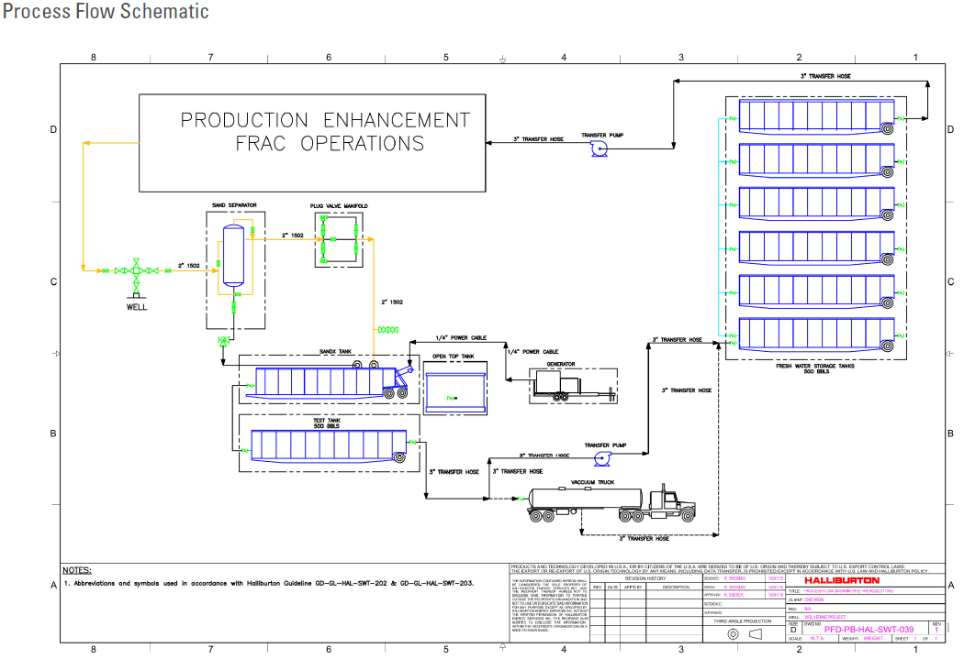

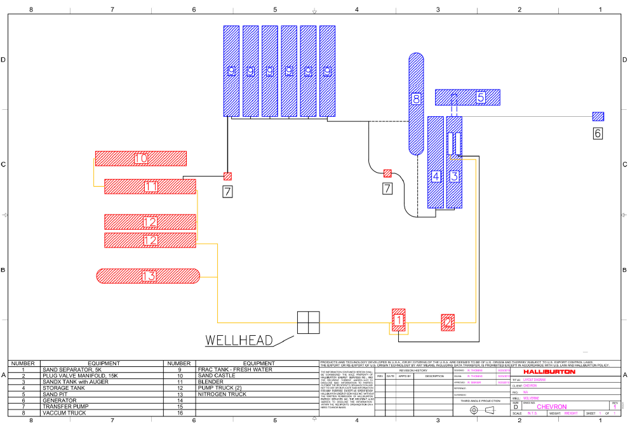
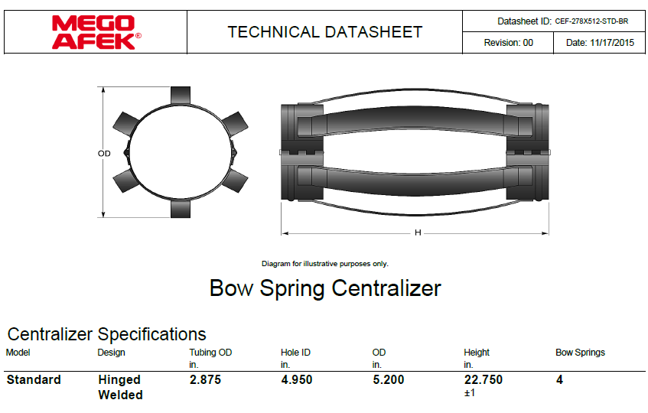

STANDARD GUIDELINES

Elevators
At every tubing size change, the elevators must be calipered and all lifting equipment must be visually inspected for the correct sizing, and rechecked daily. The elevators must also be checked for proper sizing by placing a pony sub in the elevators. Prior to picking up power swivel, caliper and visually inspect elevators and bail on swivel. Checks are to be documented in the JSA and elevator log.
ND/NU
Prior to N/D, N/U operations, if only one mechanical barrier to flow will be in place, visual monitoring of well condition by the WSM is necessary for 30 minutes or more to ensure that the well is static before removing or replacing well control equipment. For all deviations to 2B policy, check that MOC for exemption from 2B policy is in place and applicable. During ND/NU operations with only one barrier to flow in-place, constant visual monitoring of well condition during ND/NU by the WSM is necessary.
Installed Equipment
Any and all equipment installed at the surface on the wellbore is to be visually inspected (internally) by the WSM prior to N/U to the wellhead by the service provider to ensure no debris or other potential restrictions are present. During any NU ops over an open wellhead (BOP, EPA, etc.), ensure the hole is covered to avoid dropping anything downhole.
Hazard ID
Identify hazards with the crew as they come up during the job. Stop and review and discuss JSAs.
Scale and Paraffin Samples
When removing rods and/or tubing from a well, collect samples of any paraffin and/or scale.
When drilling, note, report and sample significant returns of scale or paraffin, or anything other significant returns. Assume that samples that come from different areas/environments in the well are different and require a different sample; e.g. top/bottom of well, inside outside of tubing. Always collect enough sets of samples for both Production and D&C Chemical Reps. Send any samples to Chemical Reps., both for
- Production (Baker), as well as for
- D&C (PetroPlex).
Discuss D&C’s Chemical Rep’s recommendations with Engineering, or simply implement as practical.

Trapped Pressure
Recognize whether the possibility of trapped pressure exists, check for possible obstructions by:
- Pumping through the fish/tubular – this is not guaranteed with an old fish as the possibility of a hole above the obstruction could yield inconclusive results
- Dummy run – make a dummy run through the fish/tubular with sandline, slickline, e-line or rods to verify no obstruction. If unable to verify that there is no obstruction above the connection to be broken, or if there is an obstruction:
- Hot Tap at the connection to check for pressure and bleed off
- Observe and watch for signs / indicators of pressure as connection is being broken. Use mud bucket (with seals removed) and clear all non-essential personnel from the floor.
Wireline
For all wireline and slickline jobs (except in new, cemented, tested and unperforated casing) install wireline packoff and lubricator. Follow Standard Guideline for installing equipment over wellhead. Test to 250 on the low end, and test on the high end based on SITP or max. anticipated pressure. Establish exclusion zone around wellhead area. Observe and enforce radio silence as needed for explosives. All wireline tools are to be calipered and documented on a diagram prior to PU and RIH. This is critical information in the event of fishing operations.
Kill String
Determine the length of kill string required for the well by performing the calculations as detailed.
  - Determine the cross-sectional area of tubing in inches² by multiplying ${(Pipe OD)}^{2} × .7854= {inches}^{2}$
  - Utilizing a 500 psi safety factor (may vary depending on area) determine pounds of force:
$$\left(Max Anticipated Pressure+500psi\right)× {inches}^{2} =Pounds of Force$$
  - Calculate length of tubing to balance pounds of force:
$$\frac{Pounds of Force}{Tubing Weight(\frac{lb}{ft})} =Required Tubing Length (ft)$$

