Lab # 4

Objective: Verify the operation of Decimal to BCD Converter.

Equipment:

  - 4516 Decimal to BCD Converter IC
  - 7-Segment Display
  - Breadboard
  - Connecting wires
  - LEDs
  - Resistors (220Ω)
  - Power supply (5V)
  - Switches
  - Multimeter/oscilloscope

Theory:
Decimal to BCD Converter translates decimal numbers into their BCD representation. The output can be used to drive BCD displays or other digital systems requiring binary-coded decimal inputs.

Procedure:

- Connect the power supply to the breadboard.
- Place the 4516 IC (Decimal to BCD Converter) on the breadboard.
- Connect a decimal input to the IC using switches.
- Connect the output of the IC to a 7-segment display or LED indicators.
- Set the decimal input values and observe the corresponding BCD output.
- Record the observed outputs for different decimal inputs.

Observation Table:

Decimal Input | BCD Output
0 | 0000
1 | 0001
2 | 0010
3 | 0011
4 | 0100
5 | 0101
6 | 0110
7 | 0111

Decimal Input | BCD Output
8 | 1000
9 | 1001
10 | Invalid
... | Invalid

Results:
The Decimal to BCD Converter accurately converts decimal numbers to their BCD representation, displayed on LEDs or a 7-segment display.

Conclusion:
The Decimal to BCD Converter functions correctly, providing accurate BCD outputs for valid decimal inputs.

Safety Precautions:

- Ensure the power supply is correctly set to 5V.
- Handle ICs an
- d displays carefully to avoid damage from static or improper connections.

Circuit Diagram:
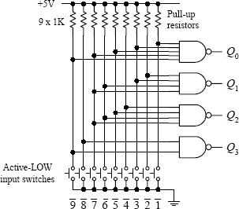

POST LAB:

- How does the Decimal to BCD Converter handle inputs greater than 9?

- Describe the function of the Decimal to BCD Converter IC in this circuit.

- What is the significance of BCD output in digital systems?

