Lab # 5

Objective: Assemble Binary Subtractor Circuit and verify its operation.

Equipment:

  - 7486 IC (XOR gate)
  - 7408 IC (AND gate)
  - 7432 IC (OR gate)
  - Breadboard
  - Connecting wires
  - LEDs
  - Resistors (220Ω)
  - Power supply (5V)
  - Switches
  - Multimeter/oscilloscope

Theory:
A Binary Subtractor subtracts one binary number from another and provides the result along with a borrow output. It uses XOR gates for the difference, AND gates, and OR gates to handle the borrow.

Procedure:

- Connect the power supply to the breadboard.
- Place the 7486 IC (XOR gate), 7408 IC (AND gate), and 7432 IC (OR gate) on the breadboard.
- Connect the inputs A and B to switches.
- Connect the output of the XOR gate (for Difference) to an LED.
- Implement the borrow logic using AND and OR gates, and connect the output to another LED.
- Test all combinations of input values (0, 1).
- Record the observed outputs for Difference and Borrow.

Observation Table:

Input A | Input B | Borrow-In | Difference (Output) | Borrow (Output)
0 | 0 | 0 | 0 | 0
0 | 1 | 0 | 1 | 1
1 | 0 | 0 | 1 | 0
1 | 1 | 0 | 0 | 0

Results:

The Binary Subtractor circuit provides the correct Difference and Borrow outputs for all input combinations.

Conclusion:
The Binary Subtractor circuit performs as expected, correctly computing the difference and borrow for all input combinations.

Safety Precautions:

- Ensure the power supply is properly connected and set to 5V.
- Avoid short circuits by carefully handling connections.

Circuit Diagram:
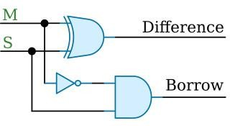

POST LAB:

- What is the function of the XOR gate in the Binary Subtractor circuit?

- How do the AND and OR gates work together to produce the Borrow output?

- Compare the Binary Subtractor with the Full Adder

Lab # 6

Objective: Assemble Binary Adder/Subtractor Circuit and verify its operation.

Equipment:

  - 7486 IC (XOR gate)
  - 7408 IC (AND gate)
  - 7432 IC (OR gate)
  - 7404 IC (NOT gate)
  - Breadboard
  - Connecting wires
  - LEDs
  - Resistors (220Ω)
  - Power supply (5V)
  - Switches
  - Multimeter/oscilloscope

Theory:
A Binary Adder/Subtractor circuit can perform both addition and subtraction of binary numbers. It uses XOR gates for the subtraction operation, combined with the Full Adder circuit, and the NOT gate to invert the inputs when subtracting.

Procedure:

- Connect the power supply to the breadboard.
- Place the 7486 IC (XOR gate), 7408 IC (AND gate), 7432 IC (OR gate), and 7404 IC (NOT gate) on the breadboard.
- Connect switches for inputs A, B, and a mode switch (Add/Subtract).
- Use the mode switch to select between addition and subtraction:
  - For addition, connect inputs directly to the Full Adder.
  - For subtraction, use the NOT gate to invert input B and connect it to the Full Adder.
- Connect the output of the Full Adder (Sum) to an LED.
- Connect the Carry output (or Borrow in case of subtraction) to another LED.
- Test all combinations of inputs and mode switch settings.
- Record the observed outputs.

Observation Table
Input A | Input B | Mode | Sum (Output) | Carry/Borrow (Output)
0 | 0 | Add | 0 | 0
0 | 1 | Add | 1 | 0
1 | 0 | Add | 1 | 0
1 | 1 | Add | 0 | 1

Input A | Input B | Mode | Sum (Output) | Carry/Borrow (Output)
0 | 0 | Sub | 0 | 0
0 | 1 | Sub | 1 | 1
1 | 0 | Sub | 1 | 0
1 | 1 | Sub | 0 | 0

Results:

The Binary Adder/Subtractor circuit successfully performs both addition and subtraction based on the mode selected.

Conclusion:
The Binary Adder/Subtractor circuit functions as intended, providing correct results for both addition and subtraction based on the mode switch setting.

Safety Precautions:

- Ensure the power supply is correctly set to 5V to avoid damage.
- Double-check all connections before powering up the circuit.

Circuit Diagram:
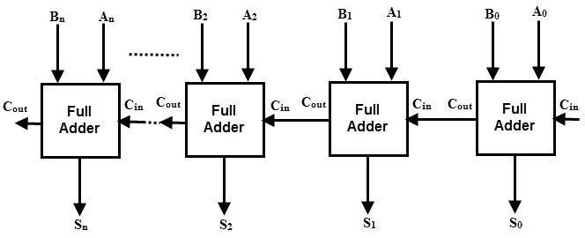

POST LAB:

- How does the mode switch alter the operation of the circuit between addition and subtraction?

- Explain the role of the NOT gate in the subtraction mode.

- What are the outputs of the circuit when performing addition and subtraction with inputs 1 and 0?

