ChatGPT Clone — Technical Workflow Document
Table of Contents

Sep 26, 2026 · Raveendra Battala · Online version: https://claude.ai/code/artifact/d23f87cb-22e5-4de1-bf8d-57f6ea4b9db1

1. Overview and architecture
The app is a three-tier ChatGPT clone: a React UI calls a FastAPI backend, which stores chats in SQLite and forwards requests to OpenRouter using only free models. The OpenRouter API key never leaves the backend.
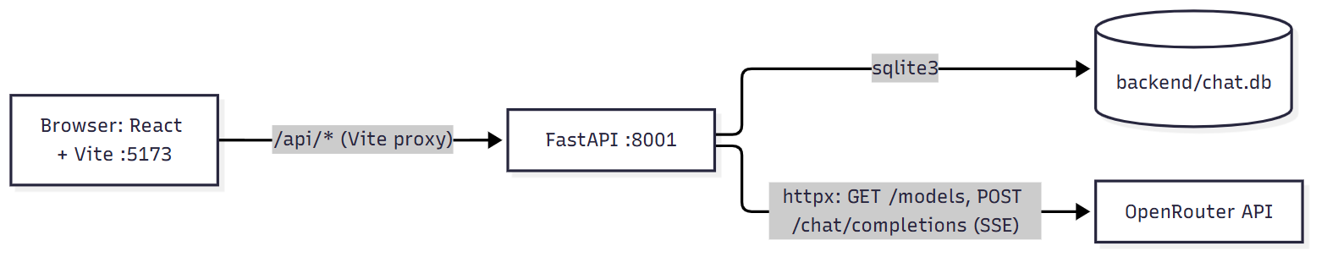
diagram
In development, Vite proxies every /api/* call to http://localhost:8001 (override with API_PROXY_TARGET). In production, set VITE_API_URL and CORS_ORIGINS, or serve frontend/dist from the same origin.

Module map
Layer | File | Responsibility
Frontend | src/App.tsx | App state, orchestrates every workflow (send, stop, regenerate, history, settings)
Frontend | src/api.ts | REST helpers (api.*) and the SSE stream reader streamChat()
Frontend | src/components/Composer.tsx | Auto-growing input, Enter to send, Send/Stop button
Frontend | src/components/ChatMessage.tsx | Markdown rendering, code copy, message copy, regenerate button
Frontend | src/components/Sidebar.tsx | Date-grouped history, rename, delete, settings and theme buttons
Frontend | src/components/ModelSelector.tsx | Searchable free-model dropdown
Frontend | src/components/SettingsModal.tsx | Custom instructions (system prompt) editor
Frontend | src/types.ts | Shared types: Message, Conversation, ModelInfo, StreamEvent
Backend | app/main.py | FastAPI app, CORS, routes, chat orchestration and SSE output
Backend | app/openrouter.py | Free-model listing and cache, streaming client for OpenRouter
Backend | app/db.py | SQLite schema and all queries
Backend | app/config.py | Loads backend/.env then temp/.env; exposes settings

2. App startup workflow
On first render, App.tsx fires three independent requests in one useEffect: history, health and the free-model list. The backend initialises the SQLite schema once, in the FastAPI lifespan hook, before serving requests.
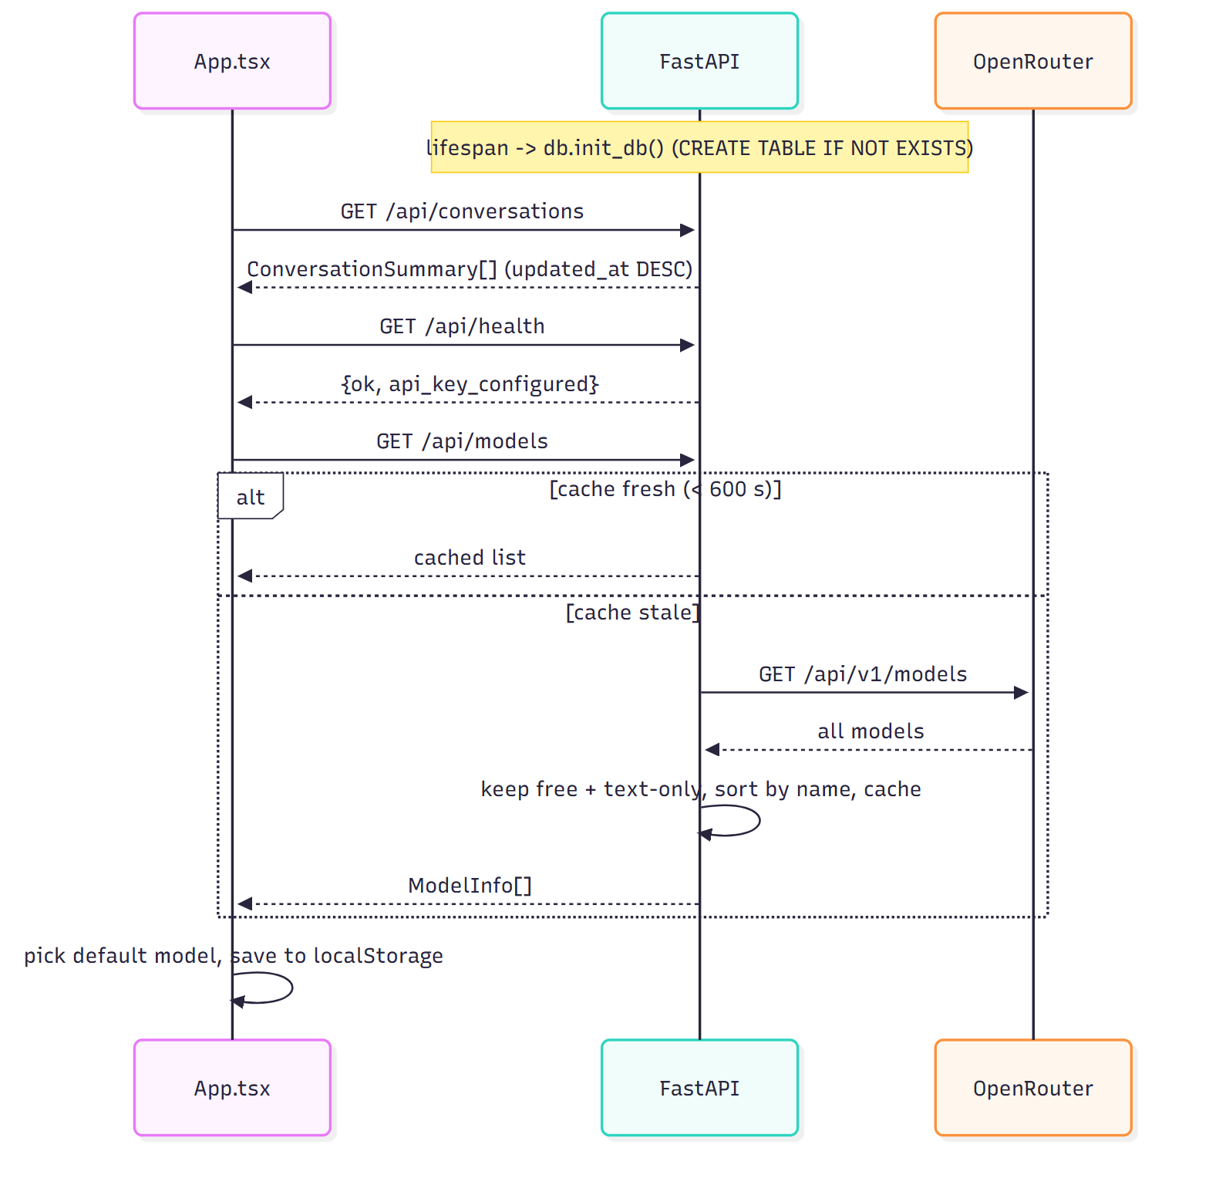
diagram
- Health. GET /api/health returns api_key_configured. If false, the UI shows a red banner asking for OPENROUTER_API_KEY.
- Model list (openrouter.list_free_models). A model is kept when both checks pass:
  - _is_free: the id ends in :free, or pricing.prompt and pricing.completion are both 0.
  - _is_text_chat: input modalities include text and output modalities are exactly ["text"] (drops audio and image generators).
- Cache. The filtered list is held in the in-process _models_cache for MODELS_CACHE_TTL (600 s default). A restart clears it.
- Default model. The UI keeps the model saved in localStorage if it is still in the list. Otherwise it picks the first match from PREFERRED: openrouter/free, then deepseek, llama-3.3, gemini, qwen, mistral, else the first model.
- History. The sidebar renders the conversation list, grouped by date (section 6).

3. Send message and streaming chat
A message travels Composer → App.send → App.run → streamChat → POST /api/chat, and tokens stream back as Server-Sent Events that the UI appends to one placeholder bubble. The backend saves the user message before calling OpenRouter and the assistant reply after the stream ends.
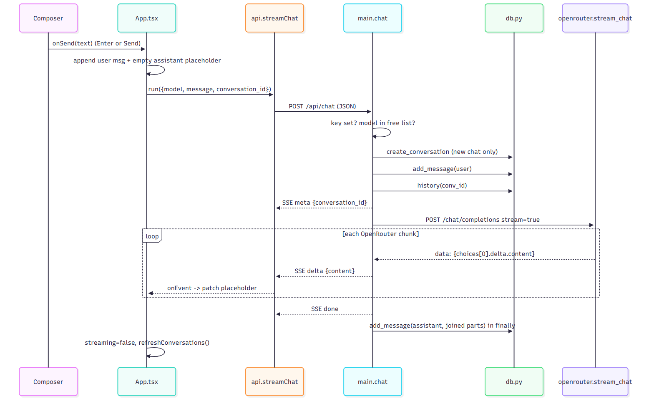
diagram

Frontend steps
- Composer (Composer.tsx). Enter submits and Shift+Enter adds a newline; IME composition is ignored. The textarea grows to 200 px. Empty text, no model or an active stream blocks sending.
- App.send(text) appends {role:'user'} locally, then calls run({model, message, conversation_id: activeId}). activeId is null for a new chat.
- App.run(params) adds an empty assistant placeholder with a local id and sets streaming=true. It creates an AbortController (kept in abortRef) and adds system_prompt from settings when set.
- streamChat (api.ts) POSTs JSON and reads res.body with a ReadableStream reader and TextDecoder. It splits the buffer on blank lines (\n\n) and parses each data: line as a StreamEvent.
- Event handling in run:
  - meta: sets activeId, so a new chat gets its server id before any text arrives.
  - delta: appends content to the placeholder. React re-renders, and ChatMessage shows a blinking cursor while streaming.
  - error: shows a red error box, or appends a warning quote if some text already arrived.
- Cleanup (finally): removes the placeholder if it is still empty, clears streaming and abortRef, and reloads the sidebar list.
- Rendering (ChatMessage.tsx). react-markdown renders with remark-gfm (tables, task lists) and rehype-highlight (syntax colours). CodeBlock adds a language label and a Copy code button.
- Auto-scroll. The message list sticks to the bottom only while the user is within 80 px of it, so scrolling up during a stream is not interrupted.

Backend steps (main.chat)
- Guards. Returns 503 if OPENROUTER_API_KEY is empty. Returns 400 if model is not in list_free_models(): the gateway only forwards free models.
- Conversation. With no conversation_id, it creates one titled by _make_title (first message, whitespace collapsed, cut to 50 chars). An unknown id returns 404. Empty messages return 400.
- Persist user turn. db.add_message(conv_id, 'user', message) also bumps updated_at.
- Build context. Messages = optional system prompt (request value, else DEFAULT_SYSTEM_PROMPT) + the full stored history, oldest first.
- Stream. event_stream() yields meta, then one delta per OpenRouter token chunk, then done. The response is text/event-stream with Cache-Control: no-cache and X-Accel-Buffering: no, so proxies do not buffer.
- OpenRouter client (stream_chat). It sends Authorization, HTTP-Referer and X-Title headers. Timeouts are 15 s connect and 120 s read. It skips : keep-alive comments, stops on data: [DONE], and raises OpenRouterError on non-200 or in-stream error chunks.
- Persist assistant turn. In finally, the joined parts are saved with the model id when any text arrived. This runs on success, on error and on client disconnect.

4. Stop generation
Stop aborts the browser’s fetch; the backend notices the dropped connection and still saves whatever text had streamed. Nothing extra is sent to the server.
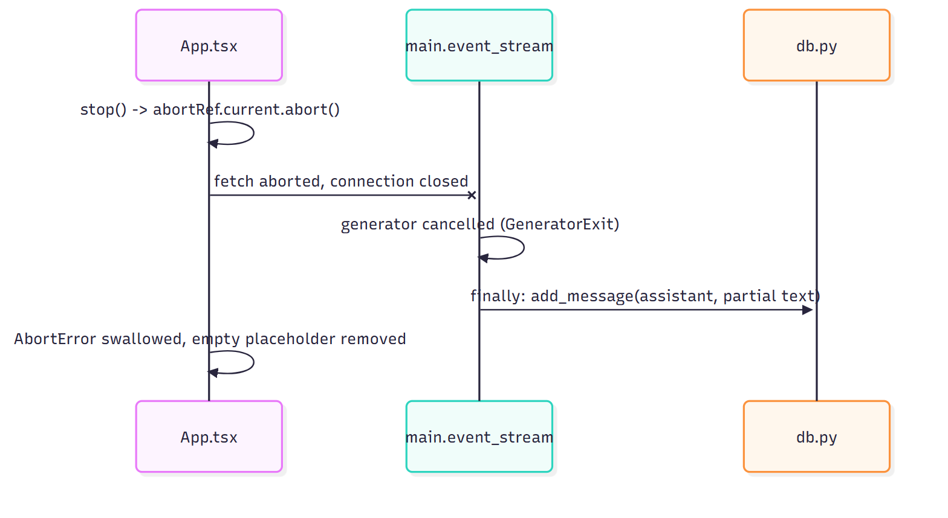
diagram
- While streaming is true, the Composer shows a Stop button that calls App.stop().
- abortRef.current?.abort() rejects the pending fetch or reader.read() with AbortError. run ignores that error, so no error bubble appears.
- Starlette cancels the event_stream generator when the client disconnects. Its finally block saves the partial reply, so reopening the chat shows the same text.
- stop() is also called by New chat and by opening another conversation, so a stream never writes into the wrong chat.

5. Regenerate
Regenerate replaces the last assistant reply: the UI drops it locally, and the backend deletes it from SQLite before streaming a new one from the same history.
- Button. ChatMessage shows Regenerate only on the last message, when it is an assistant reply, no stream is running and the chat has a server id.
- App.regenerate() removes the last message from state if its role is assistant. It then calls run({model, conversation_id: activeId, regenerate: true}) with no message text.
- Backend. With regenerate: true, main.chat checks the conversation exists (404 if not). It calls db.delete_last_assistant_message, which deletes the newest row only when its role is assistant. No user message is added.
- Stream. Context is rebuilt from the remaining history and streamed exactly as in section 3. The current model is used, so switching models then regenerating compares models on the same prompt.

6. Conversation history
Every history action is a single REST call followed by refreshConversations(), which re-fetches the list so the sidebar always mirrors SQLite.
Action | UI trigger (file) | Frontend call | Backend route → DB function | Result in UI
List | App mount, and after every stream, rename or delete (App.tsx) | api.conversations() | GET /api/conversations → list_conversations (ORDER BY updated_at DESC) | Sidebar grouped Today, Yesterday, Previous 7 days, Previous 30 days, Older by updated_at
Open | Click a history item (Sidebar.tsx) | api.conversation(id) | GET /api/conversations/{id} → get_conversation (row + messages by created_at) | Messages replace the thread; model switches to the chat’s model if still free; 404 clears the thread
New chat | New chat button or top-bar plus (Sidebar.tsx, App.tsx) | none | none; the row is created on the first send | Stream stopped, activeId null, empty state with suggestion cards
Rename | Pencil icon, then Enter or blur; Escape cancels (Sidebar.tsx) | api.rename(id, title) | PATCH /api/conversations/{id} → rename_conversation; title 1–200 chars | New title in sidebar
Delete | Trash icon + browser confirm (Sidebar.tsx) | api.remove(id) | DELETE /api/conversations/{id} → delete_conversation; messages removed by ON DELETE CASCADE | Row gone; if it was open, the view resets to New chat
Auto-title | First message of a new chat (main.py) | none | _make_title inside POST /api/chat | Title appears after the first stream ends
On phones (width ≤ 768 px) the sidebar is an overlay with a dark scrim. Choosing a chat or New chat closes it automatically.

7. Model selection, settings and theme
The selected model, system prompt and theme are per-browser preferences kept in localStorage; the server stores only which model produced each message. All storage access is wrapped in try/catch, so the app still works when storage is blocked.
Preference | UI | localStorage key | How it reaches the backend
Model | ModelSelector: dropdown with search over name and id, context size shown, closes on outside click | model | model field of every POST /api/chat; saved on each assistant message and as the conversation’s model
Custom instructions | SettingsModal from the sidebar Settings button | systemPrompt | system_prompt field; empty means the server’s DEFAULT_SYSTEM_PROMPT is used
Theme | Sidebar Light/Dark mode button | theme (first visit follows prefers-color-scheme) | Not sent; sets data-theme on <html>, which switches the CSS variables
The system prompt is sent on every request and never stored in SQLite. Changing it therefore affects the next reply in any conversation, including old ones.

8. Error handling and rate limits
Errors raised before streaming starts come back as HTTP errors; errors from OpenRouter mid-request come back as an SSE error event. In both cases the UI shows a red box in the assistant bubble rather than crashing.
Failure | Where detected | Response | What the user sees
API key missing | main.chat guard; /api/health | 503 {detail} | Red banner at top, plus error in the chat
Model not free or unknown | main.chat checks list_free_models() | 400 {detail} | Error bubble naming the model
Model list fetch fails | /api/models or the chat guard | 502 {detail} | Picker shows “Models unavailable”; send is disabled
Unknown conversation id | main.chat, GET/PATCH/DELETE routes | 404 {detail} | Error bubble, or empty thread when opening
Empty message | main.chat | 400 | Not reachable from the UI; the Send button is disabled
OpenRouter 429 (free-tier rate limit) | stream_chat non-200 branch | SSE error with a hint to retry or pick another model | Error bubble; switch model (Free Models Router recommended) and Regenerate
Other OpenRouter status or in-stream error | stream_chat | SSE error with the provider message | Error bubble, or a warning appended under the partial text
Network drop or timeout (120 s read) | event_stream generic except | SSE error “Upstream error: …” | Same as above; partial text is still saved
On the frontend, api.ts turns any non-2xx response into an Error using FastAPI’s detail field. run shows it in the bubble unless the error is an AbortError from Stop.
Free OpenRouter models are shared, so 429s are common. The default model openrouter/free routes each request to whichever free model is available, which avoids most of them.

9. Data model, API and SSE contract
Two SQLite tables hold everything: conversations and messages, linked by a cascading foreign key. Timestamps are Unix seconds (REAL) and ids are UUID4 strings.
Table | Column | Type | Notes
conversations | id | TEXT PK | UUID4
conversations | title | TEXT | From _make_title, editable
conversations | model | TEXT | Last model used
conversations | created_at / updated_at | REAL | updated_at bumped on every message; drives sort order
messages | id | TEXT PK | UUID4
messages | conversation_id | TEXT FK | ON DELETE CASCADE; index on (conversation_id, created_at)
messages | role | TEXT | user or assistant (system prompt is never stored)
messages | content | TEXT | Full text; partial if stopped
messages | model | TEXT | Model id for assistant rows, null for user rows
messages | created_at | REAL | Message order

REST endpoints
Method | Path | Request body | Response
GET | /api/health | none | {ok, api_key_configured}
GET | /api/models | none | [{id, name, context_length, description}]
GET | /api/conversations | none | [{id, title, model, created_at, updated_at}]
GET | /api/conversations/{id} | none | Conversation + messages[]
PATCH | /api/conversations/{id} | {title} | {ok: true}
DELETE | /api/conversations/{id} | none | {ok: true}
POST | /api/chat | {model, message?, conversation_id?, system_prompt?, regenerate?} | text/event-stream

SSE events from POST /api/chat
Each event is one data: <json> line followed by a blank line. Order is always meta, then zero or more delta, then exactly one done or error.
type | Fields | Meaning
meta | conversation_id | Sent first; gives a new chat its id
delta | content | Next chunk of assistant text
done | none | Stream finished normally
error | message | OpenRouter or network failure; stream ends

10. Configuration and running locally
Run start-backend.cmd and start-frontend.cmd from the project root in two terminals, then open http://localhost:5173. The backend script creates backend/.venv and installs dependencies on first run.
Variable | Default | Used by
OPENROUTER_API_KEY | none (required) | openrouter.py auth header; /api/health
OPENROUTER_BASE_URL | https://openrouter.ai/api/v1 | All OpenRouter calls
APP_URL, APP_NAME | http://localhost:5173, ChatGPT Clone | HTTP-Referer and X-Title headers (OpenRouter attribution)
DB_PATH | backend/chat.db | db.py
CORS_ORIGINS | http://localhost:5173 | CORS middleware, comma-separated
DEFAULT_SYSTEM_PROMPT | “You are a helpful assistant…” | Used when the UI sends no system prompt
MODELS_CACHE_TTL | 600 (seconds) | Free-model list cache
API_PROXY_TARGET (frontend) | http://localhost:8001 | Vite dev proxy target
VITE_API_URL (frontend) | empty (same origin) | API base URL in production builds
Backend variables load from backend/.env first, then from temp/.env at the project root; a value already set is not overwritten. Both files are gitignored. The backend runs on port 8001 because port 8000 is used by another app on the development machine.

